Using one of the establishments visited examine the strengths and weaknesses of their collection rationale.
The site I am writing about is Carew Castle and Tidal Mill: the site of the Castle dates back to the iron age with renovations and redesigns spanning centuries, while the origin of the Mill is uncertain, records of leasehold date back to at least the 16th century. The Castle itself was originally a Norman build and despite renovations some of the original building still stands proudly at the front of the Castle, showing off its rich heritage. The Mill house is one of only five in all of the United Kingdom and the only one in Wales, it was restored in the 1970s after it had laid unused and derelict for several decades previously. The change in styles and design for the exterior of the Castle act as evidence to display the changes in ownership and time periods in which Carew castle has evolved through: with a distinct Norman base, Sir Nicholas de Carew laid the foundations for the castle in around the twelfth century. The east and west wings were the first to undergo radical change a few centuries later when Rhys ap Thomas adapted them with the contemporary Tudor styles of Bath stone windows. The Northern wing was than later adapted to suit an Elizabethan manor rather than a Norman castle with great windows overlooking the mill pond. However, to the untrained eye these changes and developments in the castles structure are not overwhelmingly apparent as the grounds themselves contain very few information boards to indicate the change in architecture. The lack of information provided extends to the interior of the castle as most rooms contain only a single sign depicting the name of the room and maybe some plastic props.
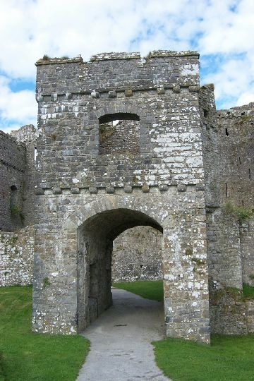
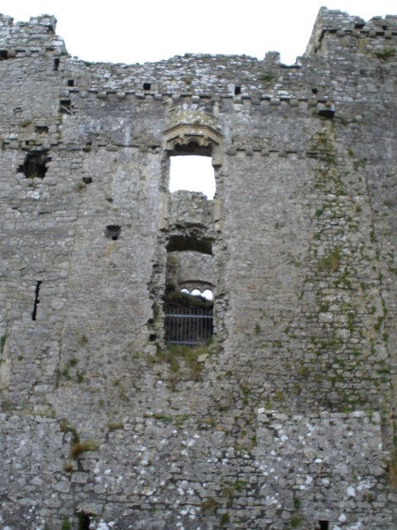
When Rhys ap Thomas renovated the east and west wings of the Castle in the 15th century, he did so with the original build in mind – not only did he adapt the walls and extend the castle itself but he added a gatehouse and outer wall to the eastern side. This gatehouse is particularly interesting as it points out from the castle at a slight angle and gets slightly narrower as it gets closer to the castle. This was done intentionally for two reasons, the first being defensive strategy: the gatehouse doesn’t open directly into the castle but into a small courtyard before a second gate and the walls of the castle in this courtyard are lined with arrowslits pointing directly down into the opening of the gatehouse in case of invaders. The second reason is far more subtle and done with displaying the heritage of the castle in mind instead: the angled gatehouse acts almost as a camera obscura as any visitors to the castle walk through the main gate and the first thing they can see through the narrowed gate is the original Norman wall unaltered by Rhys ap Thomas when he renovated the east wing. Thomas left the original double window in the centre of the wall that the Lord of the castle would look out from to address his people as an homage to the castles original design. The old wall is distinguishable from the renovated walls flanking it by observing the change in brick patterns along the two lines either sides of the window, however without prior research this knowledge is lost on the casual visitor as there are no tour guides, information boards or leaflets to point out this unique structure. The wall itself is rich with history from different centuries but this knowledge is not widely accessible to visitors and as such the very purpose of the gatehouse (to showcase the original architecture) is almost lost to time.
Figure 1 Front Gatehouse
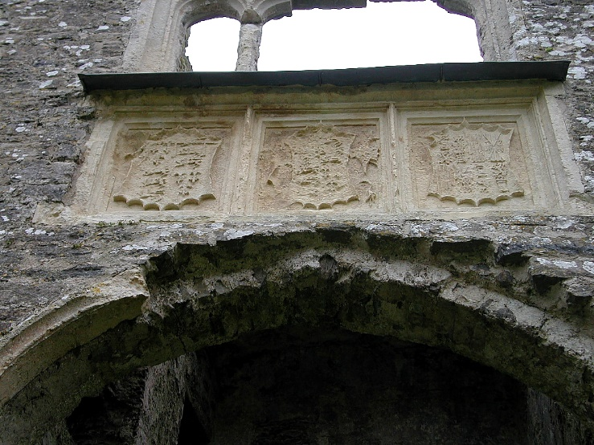
The interior of the castle did not prove to provide much more information in regard to the castle itself with only three information boards in the whole castle. One such board contains the story of John Perrot, who was one of the main contributors to renovations of the castle – although he was unable to see the castle completed as he died in the tower of London in 1592. Another information board displays the three coats of arms that hang above a porch in the courtyard, detailing their origins – namely of Henry VII, of Arthur, prince of Wales, and of Arthur's wife, Catherine of Aragon (left to right). However, none of the people presented ever lived in or owned Carew Castle and the plaques were likely left as a commemorative gift to them after they attended a tournament there in 1507. The final board can hardly be called informative as it only details the story of a “ghostly ape” that haunts the castle at night time, as a historian it feels like such a let-down to not have any history about the actual castle and its’ inhabitants but instead telling a children’s story about a ghost ape as a ploy to appeal to tourists. In the rest of the castle, visitors are left largely to their own devices with little other explanation as to what is being displayed. In the lesser hall a table has been lain with plastic food and decorated with mock table decorum, while in the Chapel the “stained glass window” has been clearly painted on to replicate what once stood there. Another room holds nothing except a large prop horse designed to be saddled by visitors. Many of the rooms in the castle are left bare, dimly lit, or just completely boarded up with no access to the public. It is these half-hearted displays of heritage in the castle that weaken the collection rationale as they provide no authenticity to the site and degrade it from a site of heritage and history to a tourist destination. The tone of the rooms in the castle is dingy, sad, and derelict, the low lighting and emptiness does nothing to raise spirits and the impression you get when you walk in is that most of the place has been forgotten to time and the props that have been put in are cheap and do not do the place any justice at all. It feels as if there is no pride in the place anymore and this is reflected in the lack of historical recordings, it gives the impression of a sub-rate tourist destination as opposed to a thousand-year-old fortress with a thousand years of history to retell.
Figure 2 Original Double Window
Figure 3 Coats of Arms
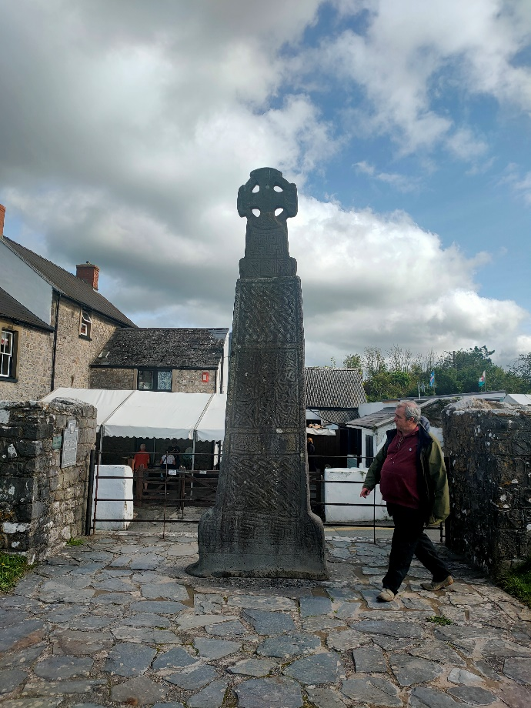
Potentially the oldest artifact on the grounds is the Celtic Cross that stands on the outskirts of the castle green, it was created in the 11th century to commemorate the Kingship of Maredudd ab Edwin of Deheubarth and the inscription at the bottom of the cross reads “[The Cross of] Maredudd son of Edwin”. The cross contains many Celtic knot patterns of various styles and origins. What is interesting to note about this inscription is that the plaque has two sections and one side has been left blank – presumably Maredudd’s brother Hywel was to be inscribed on the other side as the pair ruled the Kingdom together. However, shortly after Maredudd’s kingship was commemorated he died and Hywel became the sole ruler of Deheubarth. His name was never inscribed because a few years later he failed to prove himself as a worthy King and lost his throne and life to Gruffydd ap Llywelyn. It is widely accepted that the plaque was left unfinished by Gruffydd as a monument to the local people to show them that the rule of the brothers had failed and Hywel was unworthy to join his brother in commemoration. The cross itself is not the only piece of Welsh heritage being displayed and in fact the very ground upon which it stands is defiant Welsh history. The Cross stands upon a stoned floor made of Carmarthenshire limestones and not the grass that surrounds it, this is more than a mere platform and serves as a divider to keep the authentically Welsh cross standing on Welsh stone – this one square of land stands separate to the rest of the grounds and actually has an opposite motif to the Castle. Where the castle panders to tourism and does not fully embrace the rich Welsh history on the land, the Cross is standing proudly upon Welsh stone and separates itself from the land owned for generations by Englishmen. However, once again the monument is left wanting as the small plaque that details the cross omits much of this information and does not inform the observer what it is they are looking at.
Figure 4 Celtic Cross
Carew Tidal Mill did not fall at the same hurdle that the Castle did, where the Castle felt dilapidated and derelict with little care or love being taken in the upkeep, the Tidal Mill is fully renovated and in pristine working condition. It is obvious to see that there is great pride in the restoration of the mill as it is shown off to the public in excellently lit rooms with many detailed boards displaying the functions of the parts of the mill.
In recent years the Castle added a giftshop and tearoom on the grounds, this gift shop does little justice to the Castle’s heritage and sells very little actually about the Castle and even less that accurately retells the history of the place. Instead, pandering to the tourists on an even greater scale than inside the Castle by selling toy swords and shields and tea towels with generic images and texts about the Castle, Pembrokeshire fridge magnets and chocolate bars line the shelves next to named keyrings while the history of the Castle is left untold by those in charge of its upkeep.
Carew Castle is rich in history and has much history in its walls, from the very foundations up to the newest renovations the Castle spans hundreds of years with multiple different architects, owners and loyalties inhabiting its grounds. The Tidal Mill across the pond is almost as old with just as much of a story to tell while the Celtic Cross of Deheubarth is older still and tells the story of a Kingdom from a completely time. However, the impressive scale of knowledge that the grounds have to offer is lost to most visitors and historians looking to learn about the Castle would do better to go online, which is simply deplorable that by visiting the actual site of interest you will learn very little. The collection rationale suffers greatly in that very little of the heritage within the walls is proudly displayed to visitors and what is shown is cheap tourist grabs that are designed to win over the simple tourist - such as plastic props and cheap decorations. The Tidal Mill suffers no such issues and proudly exclaims to visitors exactly what is known about its history and its functions, the full functionality of the Mill is testament to the pride in which it is displayed. The Castle is in dire need of a historians touch to rejuvenate the energy in the building as it seems lacking in pride of its own heritage.

Bibliography
Online Articles
‘SHAPED BY CONQUEST AND CONFLICT’, Carew Castle History <https://www.pembrokeshirecoast.wales/carew-castle/carew-castle-history/>
Images
Fig 1 Second-gatehse.jpg, image file, resources.hwb.wales <http://resources.hwb.wales.gov.uk/VTC/ngfl/history/bdag/castles/projects/castles/units/carew/imagebank/second-gatehse.jpg>
Fig 2 old-wall2.jpg, image file, resources.hwb.wales <http://resources.hwb.wales.gov.uk/VTC/ngfl/history/bdag/castles/projects/castles/units/carew/imagebank/old-wall2.jpg>
Fig 3 coats-of-arms-above-porch.jpg, image file, resources.hwb.wales <http://resources.hwb.wales.gov.uk/VTC/ngfl/history/bdag/castles/projects/castles/units/carew/imagebank/coats-of-arms-above-porch.jpg>
Fig 4 Matthew Jordan, IMG20210923133856, image taken by me (23/09/2021)

Fig 1 Second-gatehse.jpg, image file, resources.hwb.wales <http://resources.hwb.wales.gov.uk/VTC/ngfl/history/bdag/castles/projects/castles/units/carew/imagebank/second-gatehse.jpg> [Date Accessed 01/10/2021]
Fig 2 old-wall2.jpg, image file, resources.hwb.wales <http://resources.hwb.wales.gov.uk/VTC/ngfl/history/bdag/castles/projects/castles/units/carew/imagebank/old-wall2.jpg> [Date Accessed 01/10/2021]
‘SHAPED BY CONQUEST AND CONFLICT’, Carew Castle History <https://www.pembrokeshirecoast.wales/carew-castle/carew-castle-history/> [Date Accessed 01/10/2021]
Fig 3 coats-of-arms-above-porch.jpg, image file, resources.hwb.wales <http://resources.hwb.wales.gov.uk/VTC/ngfl/history/bdag/castles/projects/castles/units/carew/imagebank/coats-of-arms-above-porch.jpg> [Date Accessed 01/10/2021]
Fig 4 Matthew Jordan, IMG20210923133856, image taken by me (23/09/2021) [Date Accessed 01/10/2021]

