Further Searching using forms

We have learned how to feed search data entered by the user from an HTML form through to a PHP query and return some results to the screen.
The database we have created has one table, people and looks something like this:

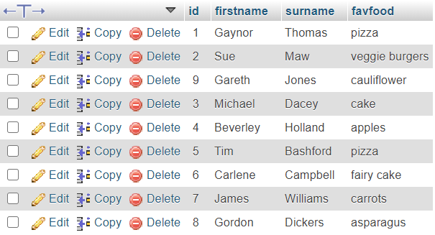
people

(Note: We have not considered security implications, particularly SQL Injection which our code is currently vulnerable to. Methods of avoiding this will come later in the module)

The code we used in class is shown below:
entersearch.php
<html>
<head>
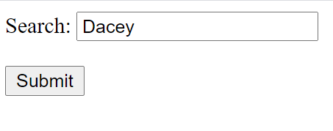
</head>
<body>
<form action="dosearch.php" method="post">

Search: <input type="text" name="mysearch"><br><br>
<input type="submit">

Dacey
</form>
</body>
</html>

dosearch.php
<?
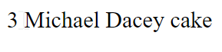
include "conninfo.php";

$search=$_POST["mysearch"];
Dacey

$query="SELECT * FROM people WHERE surname like '$search'";

$result=mysqli_query($link,$query);
$numrows=mysqli_num_rows($result);//how many rows were found?

if($numrows==0)//none found
{
echo "Sorry, nothing found";
}
else //print out rows found
{

while($r=mysqli_fetch_array($result))
{
echo $r["id"]." ";
echo $r["firstname"]." ";
echo $r["surname"]." ";
echo $r["favfood"]."<br>";
}
}
?>

Exercises for searching

- Extend your search so it works on ANY field (not just surname). For example, if I enter “Jones” or “Astronaut” or “Gordon” etc it will return some results.

Hint: you can have more than one filter in your WHERE clause by using AND/OR

Example output:

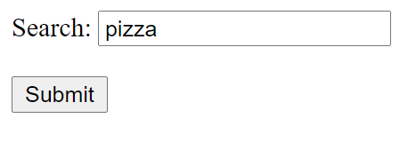


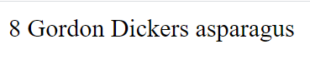
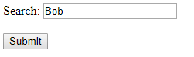
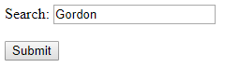
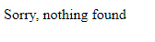
- Write a search so that you can search on both first name and surname.

- Write an EXACT match search (ie it will only find a match if the exact first name and surname is entered)


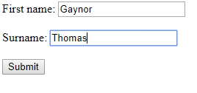

But not:

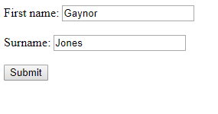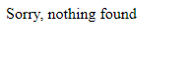

- Change your search so that it is less exact, and will match on either field:

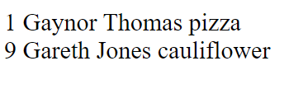

- Allow a wildcard search too (%)

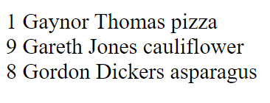
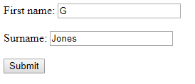

- Radio button search

Using a radio button, allow the user to select the field of their choice.
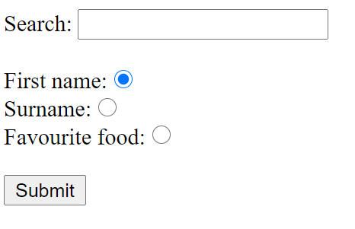

The code for your form might look something like this:

<html>
<head>
</head>
<body>
<form action="dosearch.php" method="post">

Search: <input type="text" name="search"><br><br>

First name: <input type="radio" name="fieldtype" value="f" checked="checked"><br>
Surname: <input type="radio" name="fieldtype" value="s"><br>
Favourite food: <input type="radio" name="fieldtype" value="o"><br><br>

<input type="submit">

</form>
</body>
</html>

Note that each radio button in a group has the same name, but can be differentiated by their values.

The output would look something like this:



