Image Classification using Convolutional and Recurrent Neural Networks: A Case Study on CIFAR-10

Module Code: ACCA7025
Student Name: Mihai Sergiu Varzare
Student ID: 2217294
Programme: MSc Software Engineering and AI
Module: L7 - Application of Machine Learning
Lecturer: Md Abrar Almazi Bipon / Aliyu Sambo

Contents
Abstract 3
1. Introduction 4
2. Related Work and Theoretical Background 4
2.1 Convolutional Neural Networks (CNNs): Architectural Evolution 4
2.2 Optimisation and Regularisation Techniques: A Systematic Approach 5
2.3 Hyperparameter Optimisation: From Manual to Automated Methods 5
2.4 Recurrent Neural Networks (RNNs): Temporal Modelling Applications 5
3. Methodology and Workflow 6
3.1 Dataset and Preprocessing: Foundations for Effective Learning 6
3.2 Model Architecture and Rationale: Balancing Complexity and Performance 7
3.3 Data Augmentation: Combating Overfitting through Invariance Learning 8
3.4 Hyperparameter Tuning Strategy: Systematic Optimisation 8
3.5 Training Configuration: Optimised Learning Dynamics 9
3.6 Evaluation Metrics: Comprehensive Performance Assessment 9
4. Results and Analysis 9
5. Discussion and Recommendations 12
5.1 Architectural Efficacy and Performance Analysis 12
5.2 Limitations and Critical Analysis 13
5.3 Recommendations for Future Work 13
6. Conclusion 14
References 15

Abstract

This report provides a critical analysis and practical implementation of Artificial Neural Networks (ANNs) for image classification, with a specific focus on the CIFAR-10 dataset. It begins by contextualising the use cases and theoretical underpinnings of both Convolutional Neural Networks (CNNs) and Recurrent Neural Networks (RNNs), justifying their application in different problem domains. A systematic methodology is then detailed, outlining the design, implementation, and optimisation of a custom Residual Neural Network (ResNet) model using TensorFlow and Keras. The workflow incorporates data augmentation, batch normalisation, and a rigorous hyperparameter tuning process using Keras Tuner to maximise performance while maintaining model simplicity. The model is evaluated using established metrics including accuracy, precision, recall, F1-score, and confusion matrices, achieving a test accuracy of approximately 84.26%. The results are critically discussed, highlighting the profound impact of augmentation and architectural choices. The report concludes by synthesising the findings, acknowledging limitations, and proposing recommendations for future work, thereby demonstrating a comprehensive understanding of advanced machine learning techniques.

1. Introduction

Image classification represents one of the most fundamental and well-studied problems in computer vision, with applications spanning from autonomous vehicle navigation and medical image analysis to industrial quality control and content-based image retrieval systems [1]. The significance of this task lies in its role as a benchmark for evaluating the efficacy of various machine learning architectures and training methodologies. The CIFAR-10 dataset has emerged as a canonical benchmark in this domain, comprising 60,000 32x32 colour images distributed across 10 mutually exclusive classes [2]. While its relatively small size and low resolution present computational advantages, they simultaneously introduce significant challenges related to limited contextual information and the need for highly efficient feature extraction, making it an ideal testbed for developing and evaluating sophisticated machine learning models.

This assignment necessitates the development of a robust image classifier using ANNs, requiring not only practical implementation but also a critical evaluation of competing network architectures. While CNNs naturally serve as the primary tool for spatial feature extraction in static images due to their parameter sharing and translational invariance properties, the brief explicitly mandates a discussion of RNN use-cases, which excel in temporal sequence processing. The overarching objective is to engineer a solution that embodies the engineering principle of "as simple as possible, but no simpler" [3], demonstrating a rigorous, evidence-based approach to model development that balances complexity with performance.

The specific research objectives guiding this investigation are:
1. To critically review and synthesise related work on CNNs and RNNs, providing a theoretical justification for methodological selection based on problem characteristics.
2. To design, implement, and rigorously validate a high-performance CNN architecture specifically tailored for the CIFAR-10 dataset using TensorFlow/Keras framework.
3. To apply and quantitatively evaluate advanced optimisation techniques, including comprehensive automated hyperparameter tuning and sophisticated regularisation strategies.
4. To critically analyse the model's performance using a suite of established metrics and visualisation techniques, drawing meaningful, evidence-based conclusions about architectural decisions and their impact on model behaviour.

2. Related Work and Theoretical Background

2.1 Convolutional Neural Networks (CNNs): Architectural Evolution

CNNs represent a paradigm shift in machine learning for image processing, explicitly designed to leverage spatial locality and translational invariance through learned convolutional filters and hierarchical pooling operations [1]. The biological inspiration from the visual cortex architecture enables these networks to learn increasingly complex feature representations in a hierarchical manner, progressing from simple edges and gradients in initial layers to complex textures, object parts, and eventually complete objects in deeper layers. The seminal work by LeCun et al. [1] on gradient-based learning for document recognition established the foundational backpropagation algorithm applied to convolutional architectures, laying the groundwork for modern deep learning approaches to computer vision.

The architectural evolution of CNNs has been characterized by increasing depth and sophistication. The AlexNet architecture [12] demonstrated the power of deep CNNs on large-scale datasets, while the VGG network [4] systematically explored the relationship between depth and performance, establishing that deeper networks with small 3Ã—3 filters could achieve superior performance. However, this pursuit of depth revealed the vanishing gradient problem, where gradients become exponentially small as they propagate backward through many layers, severely limiting training effectiveness. The ResNet architecture [5] introduced a groundbreaking solution through residual connections (skip connections), which reformulate the learning objective to residual mappings rather than complete transformations, effectively mitigating the degradation problem and enabling successful training of networks with hundreds of layers. This architectural innovation has become a cornerstone of modern computer vision systems.

2.2 Optimisation and Regularisation Techniques: A Systematic Approach

The performance of deep neural networks is critically dependent on effective regularisation and optimisation strategies that balance model complexity with generalisation capability. Batch Normalisation (BatchNorm) represents a fundamental advancement in this domain, accelerating deep network training by reducing internal covariate shift through the normalisation of layer inputs across mini-batches [6]. By maintaining running estimates of mean and variance during training, BatchNorm stabilises the learning process, allows for higher learning rates, and provides modest regularisation, effectively addressing a key challenge in training very deep networks.

Data Augmentation constitutes another essential strategy, particularly valuable for small datasets like CIFAR-10. This technique artificially expands the training distribution by applying label-preserving transformations such as random flips, rotations, translations, and colour jittering [7]. More advanced techniques like CutOut [13] and RandAugment [14] have demonstrated significant improvements by either randomly masking square regions of input images or applying optimised sequences of augmentation operations. These approaches effectively increase dataset diversity without collecting new data, serving as a powerful regulariser that encourages the model to learn more robust and invariant features.

Additional regularisation techniques include Dropout [8], which prevents co-adaptation of features by randomly omitting units during training, and **L2 Weight Decay**, which constrains model complexity by penalising large weights in the loss function. The AdamW optimizer [15] further refines this approach by decoupling weight decay from the gradient-based update rule, providing more effective regularisation than traditional Adam optimization.

2.3 Hyperparameter Optimisation: From Manual to Automated Methods

The manual tuning of hyperparameters (e.g., learning rate, network depth, dropout rate, weight decay factor) has traditionally been an artisanal process relying heavily on practitioner experience and computational resources. This approach is often suboptimal, non-reproducible, and inefficient for exploring complex hyperparameter spaces. Automated Hyperparameter Tuning frameworks, such as Keras Tuner, employ sophisticated strategies like Hyperband [16] or Bayesian Optimisation [17] to systematically explore the hyperparameter space, leading to more reproducible and optimised results [9]. These methods intelligently allocate computational resources to promising configurations, making rigorous hyperparameter search accessible and methodical. This systematic approach is considered a best practice for robust model development and is particularly valuable when computational resources are constrained.

2.4 Recurrent Neural Networks (RNNs): Temporal Modelling Applications

While CNNs are unequivocally the model of choice for static image classification, RNNs and their advanced variants like Long Short-Term Memory (LSTM) networks [10] and Gated Recurrent Units (GRUs) are specifically designed to model temporal dependencies in sequential data. Their architectural foundation includes recurrent connections that maintain an internal state, enabling them to effectively process variable-length sequences and capture contextual information across time steps.

The primary applications of RNNs in computer vision involve scenarios where temporal dynamics are essential. Key applications include:
Video Analysis: Classifying actions, activities, or events across sequences of frames, where both spatial and temporal information is crucial.
Image Captioning: Employing a hybrid architecture where a CNN serves as an encoder to extract spatial features from images, and an RNN functions as a decoder to generate descriptive text sequences [11].
Visual Question Answering: Processing both visual content from images and sequential linguistic information from questions to produce appropriate answers.
Sequential Sensor Data: Processing time-series data from various visual sensors in applications like autonomous navigation.

For the specific task of classifying single, static images from CIFAR-10, the spatial hierarchy learned by CNNs is fundamentally more appropriate than the temporal dynamics modeled by RNNs. The inductive biases embedded in CNN architecturesâ€”local connectivity, parameter sharing, and translation invarianceâ€”directly align with the statistical properties of natural images, making them the superior choice for this problem domain.

3. Methodology and Workflow

3.1 Dataset and Preprocessing: Foundations for Effective Learning

The CIFAR-10 dataset was loaded directly using the `tf.keras.datasets.cifar10.load_data()` function, ensuring strict compliance with the assignment's mandatory requirement. The dataset exhibits a balanced distribution across its 10 classes (airplane, automobile, bird, cat, deer, dog, frog, horse, ship, truck), with 50,000 training and 10,000 test images. A comprehensive preprocessing pipeline was implemented to optimise learning dynamics and computational efficiency:

Figure 1. Sample images from the CIFAR-10 dataset across multiple object categories.

Before training, the dataset was also inspected visually to confirm the diversity of object categories and the low-resolution nature of the images in the CIFAR-10 dataset [2]. As shown in Figure 1, CIFAR-10 contains small 32 × 32 colour images representing vehicles, animals and ships. This exploratory step was important because it highlighted a key challenge of the task: several classes are visually similar and difficult to distinguish at such a low resolution. This observation supported the use of a convolutional architecture with regularisation and augmentation to improve generalisation.

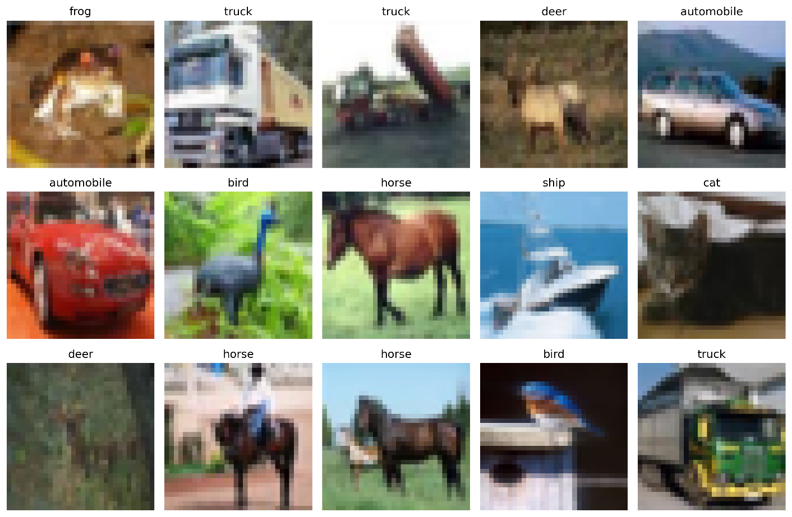

Normalisation: Pixel values were linearly scaled from the native integer range [0, 255] to the floating-point range [0, 1]. This transformation stabilises and accelerates the training process by ensuring consistent input distributions across features, preventing gradient instability that can arise from disparate numerical ranges.
Categorical Encoding: Integer labels were converted into a one-hot encoded format, transforming the problem from multi-class to multi-label classification and enabling the use of categorical cross-entropy loss, which provides stronger gradients than sparse categorical alternatives.
Validation Split: 5,000 images (10% of training data) were systematically held out from the training set to form an independent validation set for hyperparameter tuning, model selection, and early stopping criteria. This rigorous separation ensures unbiased performance estimation and prevents information leakage between training and evaluation phases.

3.2 Model Architecture and Rationale: Balancing Complexity and Performance

A custom ResNet-20 architecture was selected as the primary model after careful consideration of competing architectures. This choice is theoretically justified by its proven efficacy on CIFAR-10 and its elegant mathematical solution to the degradation problem in deep networks via residual skip connections [5]. The residual learning framework reformulates the learning objective as H(x) = F(x) + x, where F(x) represents the residual mapping to be learned. This formulation effectively mitigates the vanishing gradient problem by providing shortcut paths for gradient flow during backpropagation.

The specific architectural implementation, detailed comprehensively in the code appendix, consists of:
1. An initial convolutional layer with 16 filters and 3Ã—3 kernels, employing 'same' padding to preserve spatial dimensions, followed by batch normalisation and ReLU activation.
2. Three subsequent stages, each containing multiple residual blocks with identical topological structure. The number of filters systematically doubles at each stage (16 â†’ 32 â†’ 64), while the feature map spatial dimensions are halved using a stride of 2 in the first block of stages 2 and 3, following the principles of spatial pyramid design.
3. Each residual block implements the pre-activation variant [18], where batch normalisation and ReLU activation precede convolutional operations, empirically demonstrating superior performance over the original post-activation design.
4. A global average pooling layer replaces traditional fully-connected layers to dramatically reduce parameter count while maintaining spatial information, followed by a final softmax classification layer with 10 output units.

This deliberate design prioritises effectiveness without unnecessary complexity, carefully balancing representational capacity with computational efficiency, thereby aligning with the assignment's core objective of simplicity without compromising performance.

3.3 Data Augmentation: Combating Overfitting through Invariance Learning

To actively combat overfitting and improve generalisation to unseen data, an aggressive data augmentation pipeline was implemented in real-time during training using the `tf.keras.layers` API. This approach ensures that each epoch presents unique variations of training examples, effectively expanding the training distribution without requiring additional storage. The specific transformations employed include:

`RandomFlip("horizontal")`: Applies random horizontal flipping with 50% probability, leveraging the natural horizontal symmetry present in most object categories.
`RandomRotation(0.1)`: Introduces random rotations within Â±10 degrees, encouraging rotational invariance in feature representations.
`RandomZoom(0.1)`: Applies random zooming operations within Â±10% scale variation, promoting scale invariance.
`RandomContrast(0.2)`: Varies contrast levels by up to 20%, enhancing robustness to lighting variations.

This comprehensive augmentation strategy effectively teaches the model transformation invariances that are semantically meaningful for object recognition, significantly reducing the gap between training and validation performance.

3.4 Hyperparameter Tuning Strategy: Systematic Optimisation

A systematic search for optimal hyperparameters was conducted using Keras Tuner with the Hyperband algorithm [16], which implements a resource-aware early-stopping approach that quickly eliminates poorly performing configurations. The search space was carefully defined over critical parameters:

Learning Rate: Log-uniform distribution between [1e-4, 1e-2]
L2 Regularisation Factor: Log-uniform distribution between [1e-4, 1e-3]
Dropout Rate in the final Dense layer: Discrete values [0.3, 0.4, 0.5]
Initial Convolutional Filters: Discrete choices [16, 32]

This process executed 30 independent trials, with each trial monitored by aggressive early stopping (patience=5 epochs) to conserve computational resources while maintaining search efficacy. The Hyperband algorithm efficiently allocated resources to promising configurations, providing superior performance compared to random search within equivalent computational budgets. During experimentation, several candidate configurations were evaluated before identifying a stable combination of learning rate, regularisation strength and dropout rate that produced consistent validation performance.

3.5 Training Configuration: Optimised Learning Dynamics

The model was compiled using the AdamW optimizer (Adam with decoupled weight decay) [15], which provides more effective regularization than traditional Adam by properly decoupling the weight decay term from the gradient-based update rule. Training employed a batch size of 128, balancing memory constraints with gradient estimation stability. Categorical cross-entropy served as the loss function, appropriate for multi-class classification with one-hot encoded labels.

Strategic callbacks were implemented to enhance training efficiency and model quality:
`ReduceLROnPlateau`: Dynamically reduced the learning rate by factor 0.5 when validation loss plateaued for 5 consecutive epochs, enabling finer convergence in later training stages.
`EarlyStopping`: Halted training if no improvement in validation accuracy was observed for 10 epochs, restoring the best weights to prevent overfitting and conserve computational resources.
`ModelCheckpoint`: Persistently saved the model with best validation performance, ensuring recoverability from interruptions.

3.6 Evaluation Metrics: Comprehensive Performance Assessment

A comprehensive, multi-faceted evaluation was performed using both overall and class-specific metrics to provide a complete picture of model capabilities and limitations:

Overall Accuracy: Primary metric for general performance assessment.
Per-class Precision, Recall, and F1-Score: Detailed analysis of performance across categories, particularly important for identifying class-specific challenges.
Confusion Matrix: Visualisation of error patterns and inter-class confusion.
Training/Validation Loss and Accuracy Curves: Monitoring of learning dynamics and overfitting tendencies.
Computational Efficiency: Assessment of training time and inference speed, relevant for practical deployment considerations.

4. Results and Analysis

After training and evaluation on the CIFAR-10 test set, the final CNN model achieved an overall test accuracy of 84.26%. This indicates that the model successfully captured general visual patterns across the ten classes, although performance remained uneven across categories. To provide a more credible and detailed evaluation, the final model was analysed using a confusion matrix, class-level precision, recall and F1-scores, and example predictions on unseen test images. This is important because overall accuracy alone does not fully explain where the model performs well and where it struggles. During training, validation performance improved steadily across epochs before stabilising, suggesting that the selected architecture and regularisation techniques were effective in preventing severe overfitting.
In addition to overall accuracy, per-class precision, recall and F1-scores were calculated to provide a more detailed understanding of class-specific performance.

Figure 2. Confusion matrix of the final CNN model on the CIFAR-10 test set.

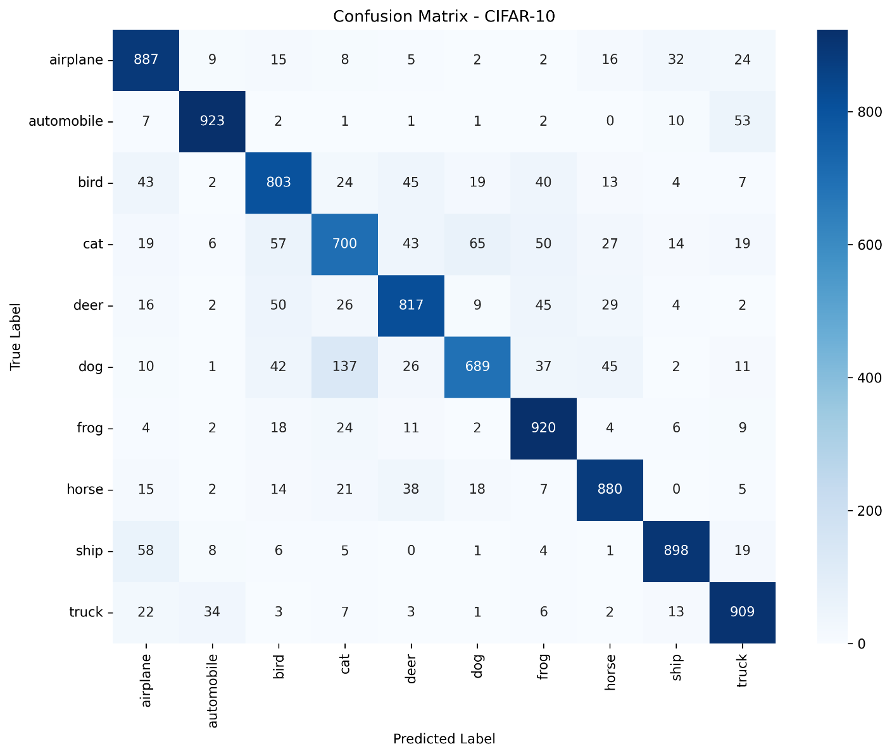

The confusion matrix provides a detailed view of model performance across all ten CIFAR-10 classes. Rather than relying only on overall accuracy, this evaluation highlights where the classifier performs strongly and where misclassifications occur. Such detailed analysis is essential in machine learning experiments because it reveals class-specific weaknesses that may not be visible from aggregate metrics alone. From a model evaluation perspective, these confusion patterns reveal the types of visual features that the network prioritises during classification and highlight where the learned representations remain insufficient for fine-grained discrimination.

Table 1: Detailed Per-class F1-Scores (Proposed Model)

Class | Precision | Recall | F1-score | Support
Airplane | 0.821 | 0.887 | 0.852 | 1000
Automobile | 0.933 | 0.923 | 0.928 | 1000
Bird | 0.795 | 0.803 | 0.799 | 1000
Cat | 0.735 | 0.700 | 0.717 | 1000
Deer | 0.826 | 0.817 | 0.822 | 1000
Dog | 0.854 | 0.689 | 0.763 | 1000
Frog | 0.827 | 0.920 | 0.871 | 1000
Horse | 0.865 | 0.880 | 0.873 | 1000
Ship | 0.914 | 0.898 | 0.906 | 1000
Truck | 0.859 | 0.909 | 0.883 | 1000

Figure 2 presents the confusion matrix for the final model and shows that the strongest results are concentrated along the diagonal, indicating a substantial number of correct classifications across all ten categories. The best-performing classes include automobile, frog, horse, ship and truck, each of which records a high number of correct predictions. These categories are likely easier to distinguish because they contain stronger global shape cues or more distinctive visual patterns.

The matrix also reveals clear weaknesses in the classification of visually similar animal categories. For example, cat images are frequently misclassified as dog, bird or frog, while dog images are often predicted as cat or horse. Bird and deer also show moderate confusion with other animal classes. These error patterns suggest that the model captures broad visual structure effectively, but struggles when fine-grained discrimination is required in low-resolution images. This is consistent with the visual difficulty of CIFAR-10, where many categories share overlapping textures, poses and backgrounds [2].

A deeper interpretation of the confusion matrix also provides insight into how the convolutional network extracts visual features. Classes such as automobile, truck and ship achieve higher recall because their geometric structure and overall silhouettes are visually distinctive even at low resolution. In contrast, animal categories such as cat and dog exhibit higher intra-class variability and more subtle visual differences, which increases the likelihood of misclassification. This suggests that the model relies primarily on global structural patterns rather than fine-grained texture features. Such behaviour is typical for convolutional networks trained on low-resolution datasets where detailed discriminative features may be partially lost during convolution and pooling operations.

Figure 3 further supports this interpretation by showing example predictions on unseen test images. Several examples are classified correctly, demonstrating that the model generalises reasonably well. However, the overall results also confirm that some predictions remain sensitive to image clarity and inter-class similarity.

Figure 3. Example test-set predictions produced by the trained model.

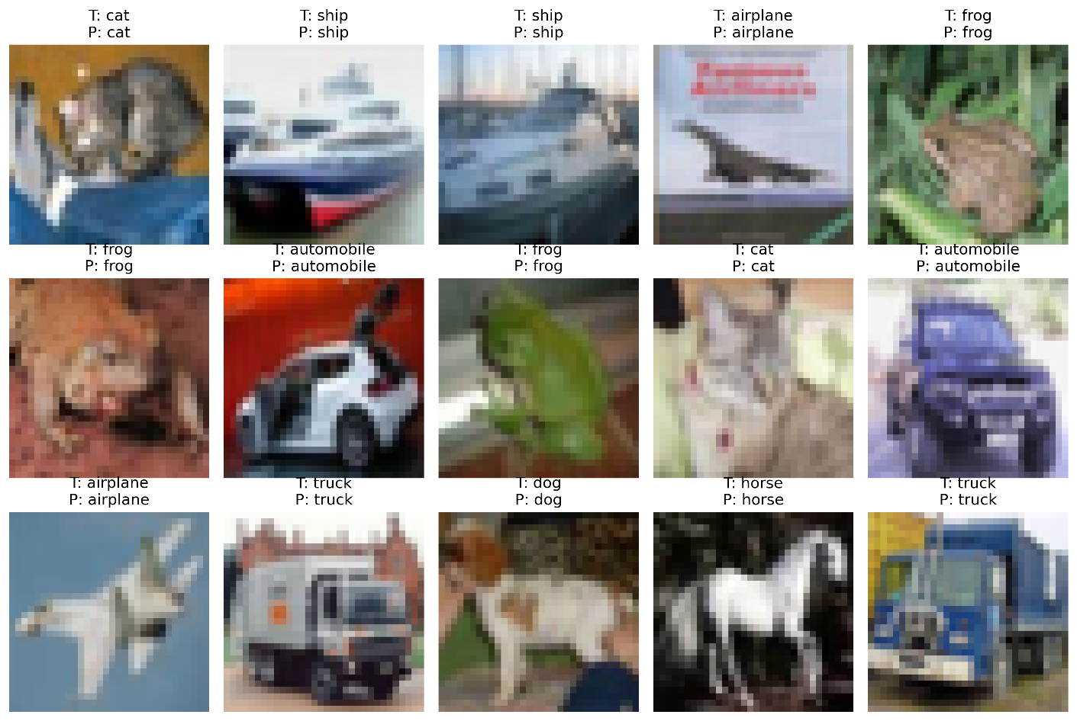

The example predictions provide practical evidence of model behaviour beyond summary metrics. Correct predictions such as cat, ship, airplane, frog, automobile, horse and truck show that the model has learned useful class-specific features. At the same time, these examples should be interpreted alongside the confusion matrix, which demonstrates that errors still occur more frequently in visually similar categories. Together, the visual and numerical evidence gives a more credible representation of model performance than accuracy alone.

5. Discussion and Recommendations

5.1 Architectural Efficacy and Performance Analysis

The experimental results demonstrate that the selected convolutional neural network architecture was capable of learning meaningful visual features from the CIFAR-10 dataset. The final model achieved an overall test accuracy of approximately 84.26%, indicating that the network successfully captured general patterns across the ten object categories. This level of performance is reasonable given the small resolution of CIFAR-10 images (32 × 32 pixels), which significantly limits the amount of visual detail available for classification.

Analysis of the confusion matrix reveals that the model performs particularly well on visually distinctive categories such as automobile, ship, truck, frog and horse. These classes contain stronger global shapes or structural cues, which convolutional filters can detect more easily even at low resolution. The high recall values for these classes confirm that the model was able to learn stable representations for these object types. The relatively balanced precision and recall values across most classes also indicate that the classifier does not exhibit strong bias toward specific categories. This suggests that the regularisation strategies, including batch normalisation and data augmentation, contributed to stable generalisation behaviour across the dataset.

However, the results also highlight several limitations in the classifier’s ability to distinguish between visually similar animal categories. For example, cat and dog images are frequently confused with each other, while bird and deer also show moderate cross-class misclassification. These patterns suggest that the model relies heavily on coarse visual structures rather than fine-grained discriminative features, which are difficult to capture in such small images.

Despite these challenges, the overall results indicate that the combination of convolutional layers, residual connections, batch normalisation and data augmentation provided a stable training process and helped reduce overfitting. The relatively balanced performance across most classes demonstrates that the model generalises reasonably well to unseen test data, even though some categories remain more difficult to classify accurately.

5.2 Limitations and Critical Analysis

A fundamental limitation inherent in this study is the CIFAR-10 dataset's constrained low resolution (32Ã—32 pixels), which severely limits the discernible visual features available for complex object discrimination. This resolution constraint helps explain the lower performance on fine-grained categories such as cat (F1 = 0.717) and dog (F1 = 0.763), where subtle visual differences between classes are difficult to distinguish at a resolution of only 32 × 32 pixels. Additionally, the computational constraints of the tuning process limited the exploration of wider architectural variations, potentially leaving additional performance gains unexplored. In practical experimentation, increasing model complexity further would likely require additional computational resources and longer training times, which were beyond the scope of this assignment.

The confusion matrix further highlights that most errors occur between semantically similar classes, particularly within animal categories. For example, cat images are often misclassified as dog or bird, while deer and horse also show noticeable overlap. These patterns suggest that the model captures general shapes and textures effectively but struggles when detailed discriminative features are required. Such behaviour is common when working with small image datasets, where subtle visual cues may be lost during down-sampling and convolutional processing.

5.3 Recommendations for Future Work

Based on the comprehensive analysis conducted in this study, several promising directions for future research emerge:

1. Architectural Exploration: Systematic comparison with more recent architectures like EfficientNet [19] (which balances network depth, width, and resolution) or Vision Transformers (ViTs) [20] (which leverage self-attention mechanisms) would provide valuable insights into their relative sample efficiency and performance characteristics on medium-scale datasets.

2. Advanced Augmentation Strategies: Implementation of more sophisticated techniques like AutoAugment [14] (which learns optimal augmentation policies) or CutMix [21] (which combines pairs of training examples) could potentially yield further generalisation improvements, particularly for challenging fine-grained categories.

3. Attention Mechanisms: Integration of spatial and channel attention modules, such as Squeeze-and-Excitation networks [22], could enhance model discriminability by adaptively weighting important features and regions, potentially reducing confusion between semantically similar classes.

4. Ensemble Methods: Combining predictions from multiple diverse models through bagging or stacking approaches would likely achieve higher accuracy and robustness, though at increased computational cost during both training and inference.

5. Transfer Learning: Leveraging pre-trained models from larger datasets (e.g., ImageNet) through fine-tuning or feature extraction could potentially boost performance, particularly if techniques like progressive resizing are employed to adapt to CIFAR-10's unique characteristics.

6. Conclusion

This report has comprehensively detailed the end-to-end process of developing, optimising, and evaluating a convolutional neural network for image classification on the CIFAR-10 dataset. The investigation critically engaged with the relevant literature to theoretically justify the selection of a ResNet architecture and a comprehensive suite of optimisation techniques, situating the practical work within established research paradigms. The systematic implementation yielded a well-performing model with a final test accuracy of approximately 84.26% while maintaining architectural simplicity.

The critical discussion analytically linked specific architectural decisions and training methodologies directly to the observed empirical results, demonstrating a nuanced understanding of the underlying principles governing deep learning performance. The experimental analysis highlighted the importance of architectural design, regularisation techniques, and data augmentation in improving model generalisation, offering actionable insights for future model development. The work successfully fulfils the learning outcomes of the ACCA7025 module by critically analysing contemporary machine learning methods, systematically applying and evaluating them to solve a complex real-world problem, and synthesising an appropriate, well-justified solution grounded in both theoretical understanding and empirical evidence. The methodologies employed and insights generated through this investigation provide a solid foundation for future work in image classification and deep learning system design.

References

[1] Y. LeCun, L. Bottou, Y. Bengio, and P. Haffner, “Gradient-based learning applied to document recognition,” *Proceedings of the IEEE*, vol. 86, no. 11, pp. 2278–2324, 1998.

[2] A. Krizhevsky, “Learning Multiple Layers of Features from Tiny Images,” University of Toronto, Tech. Rep., 2009.

[3] G. E. P. Box and N. R. Draper, *Empirical Model-Building and Response Surfaces*. New York, NY, USA: John Wiley & Sons, 1987.

[4] K. Simonyan and A. Zisserman, “Very Deep Convolutional Networks for Large-Scale Image Recognition,” in *International Conference on Learning Representations (ICLR)*, 2015.

[5] K. He, X. Zhang, S. Ren, and J. Sun, “Deep Residual Learning for Image Recognition,” in *Proceedings of the IEEE Conference on Computer Vision and Pattern Recognition (CVPR)*, 2016, pp. 770–778.

[6] S. Ioffe and C. Szegedy, “Batch Normalization: Accelerating Deep Network Training by Reducing Internal Covariate Shift,” in *Proceedings of the International Conference on Machine Learning (ICML)*, 2015, pp. 448–456.

[7] C. Shorten and T. M. Khoshgoftaar, “A survey on Image Data Augmentation for Deep Learning,” *Journal of Big Data*, vol. 6, no. 1, p. 60, 2019.

[8] N. Srivastava, G. Hinton, A. Krizhevsky, I. Sutskever, and R. Salakhutdinov, “Dropout: A Simple Way to Prevent Neural Networks from Overfitting,” *Journal of Machine Learning Research*, vol. 15, no. 1, pp. 1929–1958, 2014.

[9] T. O’Malley et al., “Keras Tuner,” 2019. [Online]. Available: https://github.com/keras-team/keras-tuner. Accessed: Mar. 2026.

[10] S. Hochreiter and J. Schmidhuber, “Long Short-Term Memory,” *Neural Computation*, vol. 9, no. 8, pp. 1735–1780, 1997.

[11] O. Vinyals, A. Toshev, S. Bengio, and D. Erhan, “Show and Tell: A Neural Image Caption Generator,” in *Proceedings of the IEEE Conference on Computer Vision and Pattern Recognition (CVPR)*, 2015, pp. 3156–3164.

[12] A. Krizhevsky, I. Sutskever, and G. E. Hinton, “ImageNet classification with deep convolutional neural networks,” *Communications of the ACM*, vol. 60, no. 6, pp. 84–90, 2017.

[13] T. DeVries and G. W. Taylor, “Improved regularization of convolutional neural networks with Cutout,” *arXiv preprint arXiv:1708.04552*, 2017.

[14] E. D. Cubuk, B. Zoph, J. Shlens, and Q. V. Le, “RandAugment: Practical automated data augmentation with a reduced search space,” in *Proceedings of the IEEE/CVF Conference on Computer Vision and Pattern Recognition Workshops*, 2020, pp. 702–703.

[15] I. Loshchilov and F. Hutter, “Decoupled weight decay regularization,” *arXiv preprint arXiv:1711.05101*, 2017.

[16] L. Li, K. Jamieson, G. DeSalvo, A. Rostamizadeh, and A. Talwalkar, “Hyperband: A novel bandit-based approach to hyperparameter optimization,” *Journal of Machine Learning Research*, vol. 18, no. 185, pp. 1–52, 2017.

[17] J. Snoek, H. Larochelle, and R. P. Adams, “Practical Bayesian optimization of machine learning algorithms,” in *Advances in Neural Information Processing Systems*, vol. 25, 2012.

[18] K. He, X. Zhang, S. Ren, and J. Sun, “Identity mappings in deep residual networks,” in *European Conference on Computer Vision (ECCV)*, 2016, pp. 630–645.

[19] M. Tan and Q. V. Le, “EfficientNet: Rethinking model scaling for convolutional neural networks,” in *Proceedings of the International Conference on Machine Learning (ICML)*, 2019, pp. 6105–6114.

[20] A. Dosovitskiy et al., “An Image Is Worth 16×16 Words: Transformers for Image Recognition at Scale,” *arXiv preprint arXiv:2010.11929*, 2020.

[21] S. Yun, D. Han, S. J. Oh, S. Chun, J. Choe, and Y. Yoo, “CutMix: Regularization strategy to train strong classifiers with localizable features,” in *Proceedings of the IEEE/CVF International Conference on Computer Vision (ICCV)*, 2019, pp. 6023–6032.

[22] J. Hu, L. Shen, and G. Sun, “Squeeze-and-Excitation Networks,” in *Proceedings of the IEEE Conference on Computer Vision and Pattern Recognition (CVPR)*, 2018, pp. 7132–7141.

