DS 1 Template

My Screenshots/Photos
- Please add 4–6 screenshots or photos of your digital life.
- You can use your phone or laptop.
- For each screenshot, write one or two sentences explaining what it shows.

Screenshot/Photo 1
University learning platform
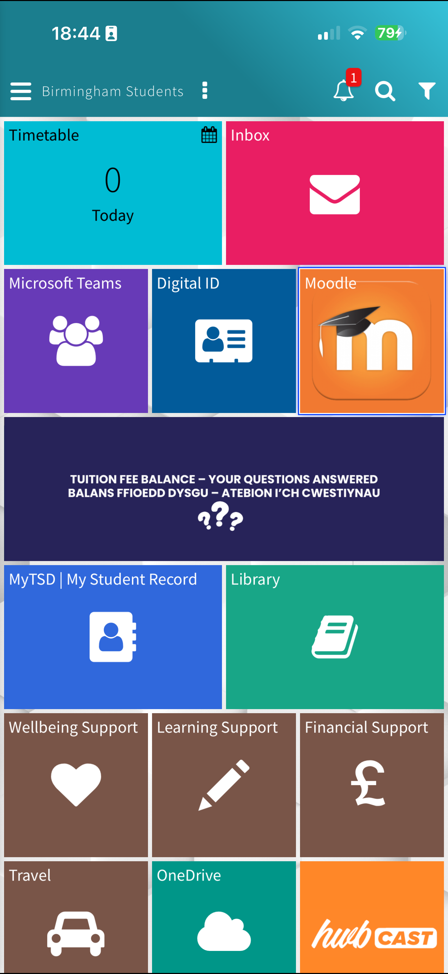
This shows the university learning platform I use to access assignments, submit works easily. It also helps me to get through lots of different websites which links to the university digital tools. It also helps me to check my deadlines, and being able to manage my studies and find course materials I need.

Screenshot/Photo 2
messages
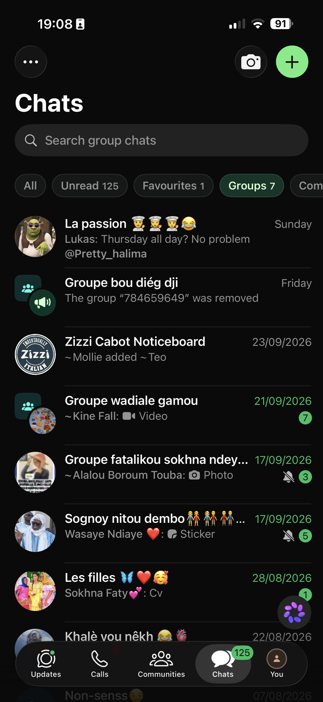
This shows how I use messaging apps every day to keep in touch with family, friends, and classmates. I send message, photos, and voice notes to stay connected, and being able to communicate with loved ones.

Screenshot/Photo 3
Calendar, notes list to do.
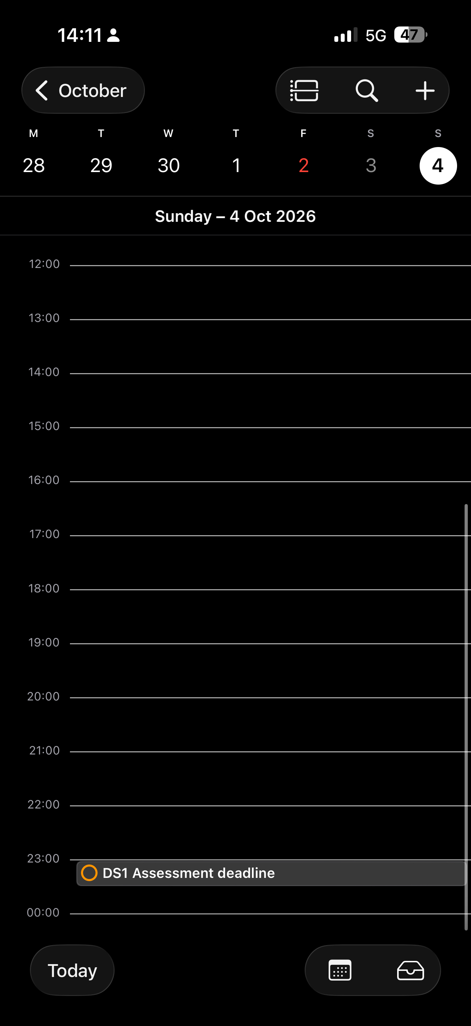

​​
This shows notes, and list to do. It's a digital tool I use to plan my week, and track my assignment due dates, and write down important information. It keeps me organised and helps me manage my times well.

Screenshot/Photo 4
Google research
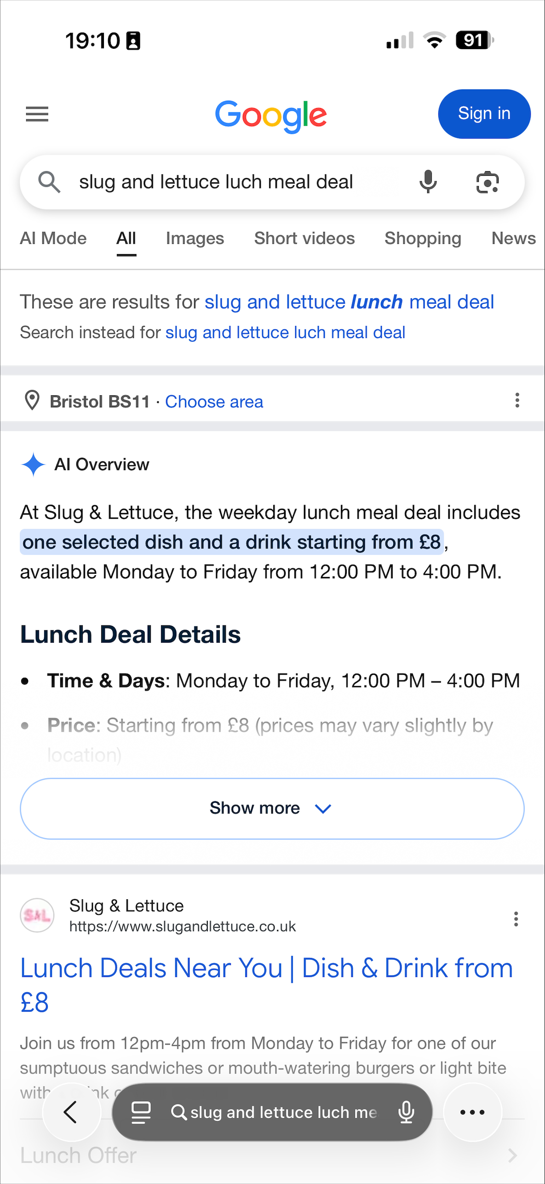

This shows a google research which is a digital tool use to find information and learn now things. It helps me as well to understand topics I’m learning, also I can watch videos to better understand the ideas of what I’m studying.

Screenshot/Photo 5
English language program.
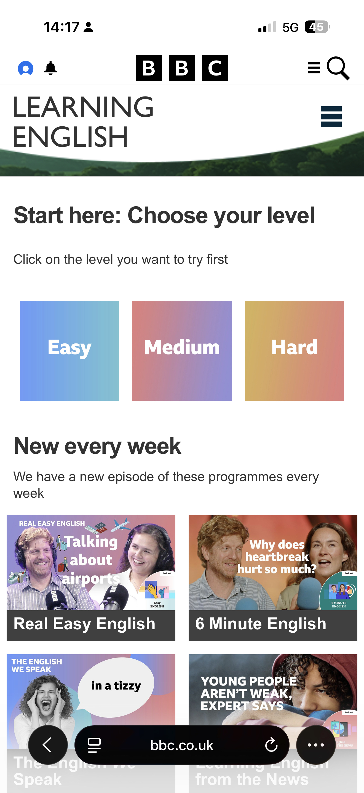
This shows an app I use to edit my grammar and correct my mistakes, and is a very simple way to use as well. It can be used to study and type assignment, save files. Most of the IT programme use to find missing document.

Screenshot/Photo 6
App for bus ticket
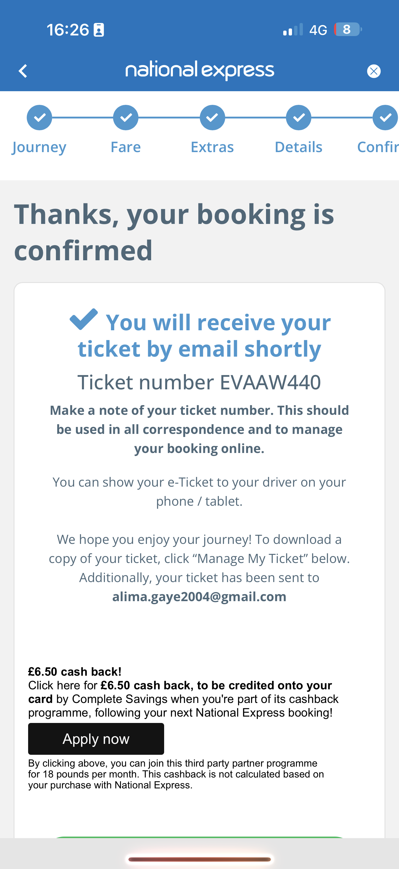
This shows a digital tool I use to buy my bus tickets. It's very cheap and easy to use. I use it all the time to buy ticket from national express buses, and it's very affordable. Most people use it as well

My Short Reflection
- Write 5–8 simple sentences about your digital life.
- You can use the sentence starters below if helpful.
I use many different digital tools every single day the main ones are messaging apps like WhatsApp, the university Moodle site, google calendar, and writing tools such as google documents. I also use social media online videos to learn and connect with people.

I feel good at communication digitally. I can send messages, share files, use apps confidentially. I am also able to find information online and use basic writing and editing tools to present my work. Also, I'm getting betters at staying organised with calendars, reminders too.

There are things I still want to improve. I would like to learn how to use spreadsheets to organise data and numbers better. I also want to get faster at typing and learn how to make documents look more professional. I would like to understand more about staying safe online and protecting my personal information as well.

These digital skills matter a lot because almost every job and course use technology now. Being able to use these tools helps me succeed in my studies, works well with others. And it will help me to get prepare working in business and finance for the future as well. Digital skills make tasks easer. I use many different digital tools every single day, save time and, open more opportunities for me as I move forward.

Sentence starters
- I use digital tools to …
- I feel confident when I …
- I want to improve …
- I often use these tools: …
- I sometimes feel nervous about …
- I hope this module will help me …
- Digital skills are important for me because …
You can write more if you want.

Submission Checklist
Before you submit, please check:
​​​ ☒ I added 4–6 screenshots
☒ I wrote short sentences for each screenshot
☒ I wrote my short reflection
☒ My work is my own
☐ My file opens correctly
​​☐ My file opens correctly

