MODULE NAME: DISSERTATION

MODULE CODE: LCBB6000

SUPERVISOR: DR ALFRED MENSAH

ASSIGNMENT TITLE: COMPONENT 1: COURSEWORK – A WRITTEN RESEARCH PROPOSAL

STUDENT NAME: CERASELA LAVINIA STOICA
STUDENT ID: 2125057

THE IMPACT OF MARKETING SKILLS ON MARKETING PERFORMANCE OF BAMFORD UK
Table of Contents
Introduction 4
Research Background 4
Research Aim 5
Research Objectives 5
Research Questions 5
Justification of the Research 5
Literature Review 5
Marketing Overview 5
Skills Required for an Effective Marketing in Online Business 6
Benefits of Various Skills and Talent for Effective Marking for Online Business 6
Challenges Skills and Talent Shortage for Effective Marking for Online Business 7
Strategies to Mitigate the Skill and Talent Shortage Problem in Online Marketing 7
Literature Gap 7
Methodology 8
Research Philosophy 8
Research Approach 8
Research Design 9
Data Collection Method 9
Sampling 9
Data Analysis Technique 9
Research Validity and Reliability 10
Ethical Consideration 10
Limitation 10
Research Timeline 10
References 11

Introduction

Research Background
The rapid growth in digital marketing increases the demand for skilled professionals running online businesses. Like any other company, Bamford UK is suffering from a deficiency of marketing talent (Collins, 2020). In fact, it affects the efficiency of its operations to a great extent. The ability to develop new skills and strategies, hence becomes very important to maintain competitive advantage. The proposed study will explore how the skills gap affects Bamford UK's marketing efficiency.

Figure 1: Products of Bamford UK
(Source: bamford.com, 2024)
Brief background of Bamford UK
Bamford UK is a notable British luxury brand, established by Carole Bamford in 2003 (bloomberg.com, 2024). It works on the concept of creating items for a sustainable luxury lifestyle with highly-demanded organic skincare products, clothing, and homeware. Bamford works to ensure ethical procedures that combine craftsmanship, sustainability, and holistic well-being; the brand looks to create an equilibrium between tradition and modernity (bamford.com, 2024).

Research Aim
This study has the aim of investigating the impact of skill gaps on marketing performance of Bamford UK.

Research Objectives
- To identify the different skills needed for effective marketing for online businesses.
- To analyse the necessity of various skills for effective marking of Bamford UK.
- To evaluate the challenges faced associated with marketing skills gap for effective marketing in Bamford UK and assessing different ways.

Research Questions
- How do the different skills impact effective marketing for online business?
- Why are marketing skills crucial for effective marketing?
- What are the key challenges faced by online business due to skills and talent shortage for effective marketing?

Justification of the Research
The research purpose is to identify the reasons for skill gaps and their impact on Bamford UK. This research is justified by having a direct link of digital marketing with operational efficiency. This research will also reflect on the challenges faced by online businesses due to skills and talent shortage for effective marketing. For all these reasons, the research on Bamford UK will be significant.

Literature Review

Marketing Overview
As per the opinion of Darmawan and Grenier (2021), marketing has been the strategic process of determining, developing, and delivering value to satisfy the needs of a target market. It has required an understanding of what customers need and how they act, developing products that meet those needs, and then communicating the benefits so that they will sell (Kegoro and Justus, 2020).

Skills Required for an Effective Marketing in Online Business
Effective marketing in online business has been required as a balance among technical, creative, and analytical capabilities. One has to need digital marketing skills such as search engine optimization, social media marketing, content creation, and email marketing. Knowledge of data analytics has been quite important in tracking performance, interpreting customer behaviour, and optimising campaigns. It has been found that evaluation of website performance does not match the marketing plan's success (Al Adwan et al., 2023). One must have effective content creation skills to come up with engaging and persuasive content across multiple platforms, from blogs to videos. UX/UI design awareness has made it possible to create smooth user experiences that eventually convert visitors into customers. Attention has to be paid to the development of project management skills in effective marketers for running coordinated campaigns across teams. Tarabasz (2020), has found that to measure campaign influence, it is useful for a manager of a campaign to be familiar with some tools. It also has a deep rooting in branding and customer psychology to build and maintain a rich brand presence online.

Benefits of Various Skills and Talent for Effective Marking for Online Business
Diverse skills and many talents in online marketing have been extremely beneficial. The most significant future digital skills have included communication and online marketing skills, MS Office skills, social media skills, and so on (Carlisle, Ivanov and Dijkmans, 2023). Digital marketing expertise ensures targeting the campaigns correctly for a better reach and engagement. SEO skills have driven organic traffic, reducing reliance on paid advertisements and gaining a long-term line of sight. Content creation ability has enabled one to produce compelling and shareable content that strengthens brand presence and drives customer interaction. It has allowed marketers to make informed decisions, optimise campaigns for better ROI, and personalise customer experiences in driving higher conversion rates. The findings of Potter and Favour Olaoye (2024), have indicated that data-driven approaches make the marketers gain insights into automate campaign optimization, personalise messaging and content, target audiences and make more informed, evidence-based decisions. One is data analytics skills, which has given one the power to make informed decisions, optimise campaigns in pursuit of higher conversion rates. Being adept at social media has helped build communities, facilitate direct communication that instils loyalty and brand advocacy among customers. Paid advertisement expertise has ensured efficient budget use, targeted demographics, and increasing ROI. UX/UI design awareness improves website navigation and user experience to achieve better customer satisfaction. Finally, project management skills ensure coordination, timing, and business goal alignment of marketing efforts to maximise overall campaigns' effectiveness. The explosion of technology over the past 20 years has made multitudes of ways for marketers to engage, attract and delight customers (Ewel, 2020).

Challenges Skills and Talent Shortage for Effective Marking for Online Business
As stated by Ferreira, Robertson and Pitt (2023), scarcity of communication between marketers has been considered to be a problem associated with the shortage of skill and talent in online marketing. The scarcity of the training for the new marketer has been a challenge connected to the shortage of skill and talent for the online marketing which has appeared to be effective. On account of the lack of collaboration the marketers cannot develop the skills and knowledge in marketing and it has created a problem of creating consumer personae in marketing depending on the taste, choice and the fiscal background of the consumers. The scarcity of the awareness has been found to be a challenge associated with the effective marketing which has been known as online marketing (Karaboga et al., 2021). The lack of awareness has caused lack of knowledge of marketing and from which the employees and markets cannot develop their skill and improve talent. Instances of integration failure have given a significant window into the neural and cognitive awareness bases (Schubert et al., 2020). Difficulty to find employees who have been found to be qualified has been a problem associated with the talent and skill shortage.

Strategies to Mitigate the Skill and Talent Shortage Problem in Online Marketing
As acknowledged by Tabuena et al. (2022), understanding the volatile digital marketing landscape has been a strategy to mitigate the challenge of the society of skills and talent of all the employees while conducting online marketing research. Providing training to all the employees or marketing so that they can get knowledge of marketing has appeared as a strategy to mitigate marketing. Proper training has made the markets provinces and improved their skill to understand the demand of the consumers and create consumer personae. Proper employee onboarding or motivating staff has been a strategy to mitigate the shortage of skill and the talent which have been considered to be crucial. The proper collaboration can create interest among the marketers and they have appeared to be motivated which has eradicated shortage of skill and talent. This all has been considered to be the strategies to mitigate the problem connected to the shortage of the skill and the shortage of labour. These all strategies have been inter associated with each other (Tomcikova, Svetozarevo and Coculova, 2021).

Literature Gap
There have been many gaps that have been figured out from the literature review. Although there has been good coverage of the literature on skills needed to be effective in online marketing and how to overcome talent shortages. There has not been sufficient discussion regarding the impact of skill gaps on marketing performance of Bamford UK. The ways the fast flux of digital technologies has impacted the long-term sustainability of such skills is not well covered.

Methodology
This research will follow the methodology which will be associated with primary quantitative research.
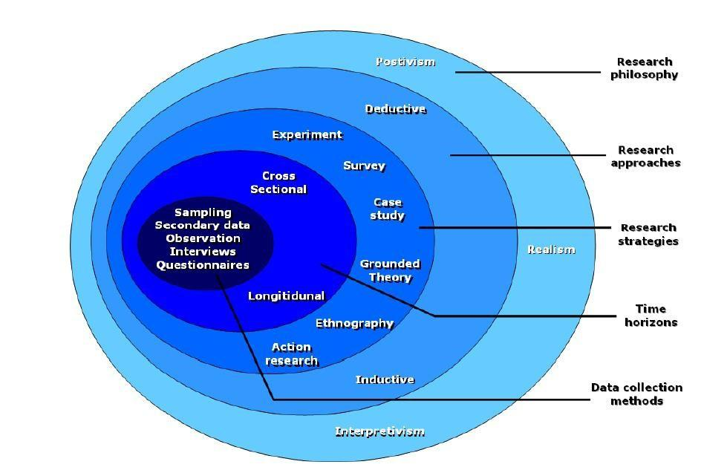
Figure 2: Research onion
(Source: Saunders and Tosey, 2012)

Research Philosophy
As reported by Al Aina and Atan (2020), in this research primary research philosophy which is positivism philosophy will be used. Positivism research philosophy is considered to be a paradigm which is considered to be centred on the belief that is considered to be ontological. This philosophy will be dependent on the proper observation and analysis of objective data in relation to Bamford’s marketing aspects. In the Bamford company proper observation will be necessary to conduct the research in order to solve the shortage of the skills and talent in the marketing aspects. The principles of this philosophy will enable proper knowledge to be collected by depending on the proper observation and interpretation.

Research Approach
In this particular research deductive research approach will be used. This research approach will be associated with proper drawings. This research approach will be a primary research approach which will be commenced with a specific theory. Observation and data procurement will be connected to this approach. In this research this approach will be used to know the problems of the scarcity of skills and talent of marketing in online marketing by depending on proper talent management theory and making several rhetorical drawings which will all be informative.

Research Design
In this research exploratory research design will be utilised. The exploratory research design in this research will make use of the strategy of survey to collect the primary type of data for this research. A survey will be conducted including the employees of Bamford UK, while informing them about the purpose of the research and maintaining proper ethics in data collection. In this research the survey will consist of several questions that directly or indirectly meet the objectives of the research. This will be done in order to know the quantity of the problem of the skill and talent shortage associated with online marketing in Bamford company.

Data Collection Method
In this research primary data will be used which are associated with marketing special about the shortage of talent and skills. In this research, survey methods will be used for collecting the data. Here, a total of 10 questions will be included within the questionnaire which the participants need to answer during the survey (Jooss, Lenz and Burbach 2023). The data will be collected from 20 respondents of this research who are the employees of Bamford company. All questions of the survey questionnaire will be closed-ended. The inclusion criteria of this research will be data that should be specific to marketing, planning marketing and skills connected to the marketing and should consider the marketing skill planning of Bamford only. The exclusion criteria will be those data which have no relation to the marketing will not be used here.

Sampling
Data sampling will be considered to be an analysis depending on statistical data of the research. This is a technique utilised to choose, manipulate and analyse a basic representative subset associated with data points. In this research purposive sampling will be utilised to conduct this research flawlessly. This sampling will be used by identifying the 20 respondents who are the employees of Bamford to know their experience associated with the problem of research. Only the marketers will be taken in this research and this will be considered to be crucial.

Data Analysis Technique
As opined by Singh Dubey, Paul and Tewari (2022), quantitative data analysis techniques will be exploited to conduct this research. This data analysis technique will be relied on analysing the statistical data. In this research the researcher will analyse the data about how many markets are suffering from the shortage of the skill and talent in marketing.

Research Validity and Reliability
In this research the secondary data collected from the researcher will be valid because from this research will provide the number of the sufferers from the shortage of skill and talent and marketing. Even from this research the strategies to solve the problem can be made. This data will be completely reliable as from this data will be tested and analysed and the authenticity of this data will be measured.

Ethical Consideration
This research has been completely unbiased and all the data of this research have been authentic data. No unethical activities have been found here in this research. All the data have been verified in this research. Before conducting this primary research, the researcher has taken the consent of the respondent and no respondent has been forced here. The primary data collected from this research have not been used unethically and used for noble purposes.

Limitation
A lot of information was impossible to collect because in order to collect this research, this information was encrypted and needed money. As the research has not too much money to subscribe to this information this has been a limitation of this research.

Research Timeline
Week | Week 1 | Week 2 | Week 3 | Week 4 | Week 5 | Week 6
Planning of the topic of research
Interpreting and objectives aim

Describing literature
Methods to be exploited
Procuring data
Analysis of data
Conclusion of the research

References
Al Adwan, A., Kokash, H., Al Adwan, R. and Khattak, A., (2023). Data analytics in digital marketing for tracking the effectiveness of campaigns and inform strategy. International Journal of data and network science.
Al Aina, R. and Atan, T., (2020). The impact of implementing talent management practices on sustainable organizational performance. Sustainability, 12(20), p.8372.
bamford.com. (2024). Bamford. [Online]. Available at: https://www.bamford.com/?srsltid=AfmBOopMfVoshRIGq15ttGNuXVsOXyBQ8iYJdaHnE6yDZkee9A5X1cWC [Accessed on 11th August, 2024]
bloomberg.com. (2024). Bamford Ltd. [Online]. Available at: https://www.bloomberg.com/profile/company/2058227Z:LN [Accessed on 11th August, 2024]
Collins, B., (2020). Aston Martin: Made in Britain. Hachette UK.
Darmawan, D. and Grenier, E., (2021). Competitive advantage and service marketing mix. Journal of Social Science Studies (JOS3), 1(2), pp.75-80.
Ewel, J., (2020). The six disciplines of agile marketing: Proven practices for more effective marketing and better business results. John Wiley & Sons.
Ferreira, C., Robertson, J. and Pitt, L., (2023). Business (un) usual: Critical skills for the next normal. Thunderbird International Business Review, 65(1), pp.39-47.
Jooss, S., Lenz, J. and Burbach, R., (2023). Beyond competing for talent: an integrative framework for coopetition in talent management in SMEs. International Journal of Contemporary Hospitality Management, 35(8), pp.2691-2707.
Karaboga, T., Gurol, Y.D., Binici, C.M. and Sarp, P., (2021). Sustainable digital talent ecosystem in the new era: impacts on businesses, governments and universities. Istanbul business research, 49(2), pp.360-379.
Kegoro, H.O. and Justus, M., (2020). Critical review of literature on brand equity and customer loyalty. International Journal of Business, Economics and Management, 7(3), pp.146-165.
Potter, K. and Favour Olaoye, L.D., 2024. Evaluating the Effectiveness of Data-Driven Approaches in Optimizing Digital Marketing Campaigns.
Saunders, M. and Tosey, P., (2012). Research Design
Singh Dubey, R., Paul, J. and Tewari, V., 2022. The soft skills gap: a bottleneck in the talent supply in emerging economies. The International Journal of Human Resource Management, 33(13), pp.2630-2661.
Tabuena, A.C., Necio, S.M.L., Macaspac, K.K., Bernardo, M.P.E., Domingo, D.I. and De Leon, P.D.M., (2022). A literature review on digital marketing strategies and its impact on online business sellers during the COVID-19 crisis. Asian Journal of Management, Entrepreneurship and Social Science, 2(01), pp.141-153.
Tarabasz, A., (2020). Campaign planning and project management. In Digital and Social Media Marketing (pp. 123-148). Routledge.
Tomcikova, L., Svetozarovova, N. and Coculova, J., (2021). Challenges and priorities in talent management during the global pandemic caused by COVID-19. Marketing i menedžment innovacij, (2), pp.94-103.
Carlisle, S., Ivanov, S. and Dijkmans, C., (2023). The digital skills divide: evidence from the European tourism industry. Journal of tourism futures, 9(2), pp.240-266.
Schubert, T.M., Rothlein, D., Brothers, T., Coderre, E.L., Ledoux, K., Gordon, B. and McCloskey, M., (2020). Lack of awareness despite complex visual processing: Evidence from event-related potentials in a case of selective metamorphopsia. Proceedings of the National Academy of Sciences, 117(27), pp.16055-16064.

