An Exemplar of Modern Architecture – The Tugendhat House

Historical Background
The Tugendhat House was designed by Ludwig Mies Van der Rohe and Lilly Reich as a family home for Fritz Tugendhat and his wife Grete Tugendhat, members of wealthy and influential Jewish families with successful businesses in the textiles industry. (Mertins, 2020) The house was constructed in Brno, Czech Republic in 1930 where the Tugendhats lived for just 8 years before fleeing their home due to the signing of the Munich agreement which lead to the movement of German troops into Czechoslovakia in 1938
Grete Tugendhat had been greatly impressed by Mies’ Weissenhof housing estate in Stuttgart, Germany. She would also often visit the house designed by Mies for the art collector and dealer, Hugo Perls in Berlin, Germany. This particular home influenced her decision of choosing Mies as an architect for the Tugendhat house. (The commissioners 2022)
During World War 2, in 1939 the Nazi Gestapo moved some of their offices and flats into the empty home and in 1942, the building became property of Nazi Germany. The building had also been home to a private dance school during 1945-1950 and has been used as a rehabilitation centre for children with spine defects up until the late 1960s. (The building 2022) The house has since been renovated and has opened as a museum, however, the furniture designed by Mies and Lilly Reich had already been lost to theft. (Gianakos, 2011)

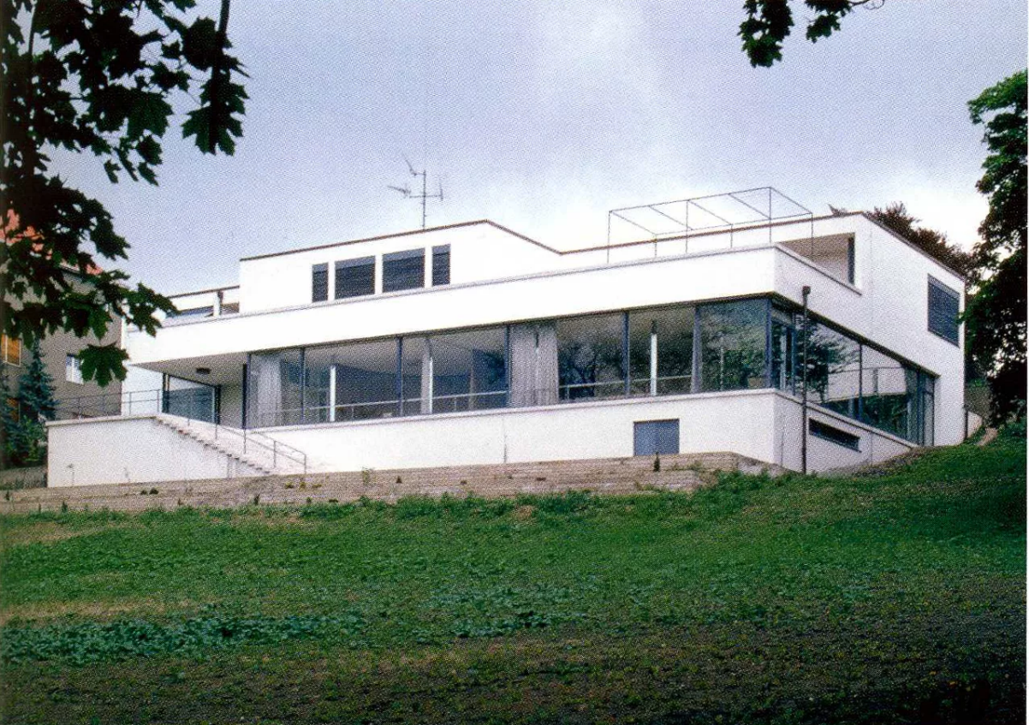
Figure 1 – A view of the Tugendhat House from the garden Paz, M.de la (2017)

Plan and Section
The building consists of 3 stories; the first floor is comprised of the main entrance, the bedrooms, and the garage. The ground floor is where the main living area and the social areas are located which include partitions dividing the different functional areas such as the dining area, the study area, and the living room. The basement houses the casing for the retractable glass panels and other service rooms. (The building 2022)

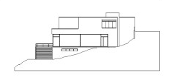
Basement
Ground Floor
First Floor and Entrance

Figure 2 – The West elevation of the Tugendhat House (Chu, 2019)
The general aesthetic of the house appears mostly rectilinear; however, this firm geometry is broken in areas of importance such as the main entrance of the house, extending down into the stairway leading into the large foyer, and the partition of the dining area, both of which are structured with a semi-circular shape.

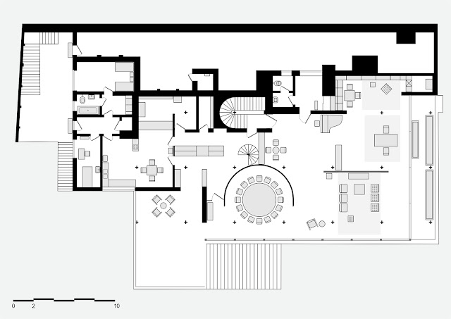
Dining area
Retractable glass facade
Study
Main living/ social area
Onyx Partition
Figure 3 – The Ground Floor Plan of the Tugendhat House (Chu, 2019)

The most acknowledgeable aspect of this house is the living area which is spread over an area of approximately 220 square metres. (Villa Tugendhat, n.d) The floor plan shows the freestanding cruciform structural steel columns in a grid-like formation, this allowed for Mies Van der Rohe to design the large, open space with more freedom without requiring additional internal load bearing walls, this concept of the gridded columns was also incorporated into his design of the Barcelona Pavilion in 1929. (Mertins, 2020) The living area is divided up with the implementation of partitions into their respective spaces, and as there are no internal load-bearing walls here the spaces flow seamlessly into one another which fulfilled Mies’ aim of creating one continuous space while also allowing for the layout of each level to be distinct, truly permitting the designs to be influenced by the function of the space. Along with this, Mies also aimed to erase the boundary between the outside and the interior of the house by treating the garden and living space as one whole unit. This was aided by the floor-to-ceiling windows on the south and west sides of the building.
The mantra, ‘Form follows function’ was coined by Louis H. Sullivan in an essay written by him in 1896 titled, ‘The Tall Office Building Artistically Considered’. (Junior, 2020) It means that an object’s design should reflect its use. In terms of architecture, this means that a building’s exterior design should reflect the interior’s functions, the Tugendhat house demonstrates this with its large, open floor plans and full glass façade design of the ground floor which determine the social function areas and provides a welcoming and friendly space for people to congregate as it was apparent by the high seating capacity of the dining table and the large foyer at the entrance that the Tugendhat’s were a relatively social family.

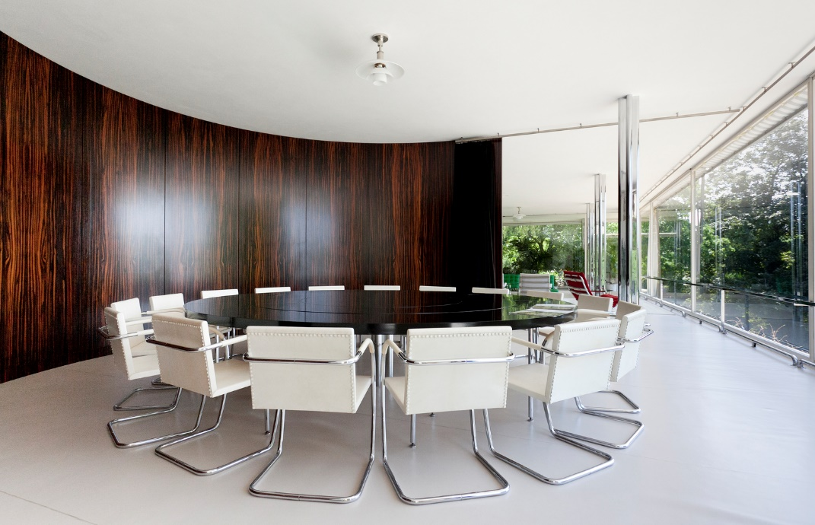
Figure 4 – A photograph of the dining area, with the cured partition in view to the left (Timpau. A)

Materials and light
The main structure of the house was constructed with reinforced concrete, supported by a steel frame, with some exposed chromium-cladded cruciform steel columns within the main living area. (Mertins, 2020) This method of construction allowed for the design to consist of large, open spaces while eliminating the requirement for internal load-bearing walls.
Glass is used extensively throughout the design of the Tugendhat House, the use of floor-to-ceiling retractable glass panels in the living room helps create the feeling of continuity throughout the open floor plan into the garden and when opened the room and the garden become one element. The vast use of glass also allows for large amounts of light to enter, ensuring the room remains well-lit during the day and giving the true modern aesthetic while also providing great, panoramic views of the landscape.

The Interior materials
The partition in the living area dividing the study and the social space is made of carefully cut and polished onyx, an exotic stone sourced from the Atlas Mountains in Morocco. As onyx is translucent, the sunlight during the winter sun path illuminates the stone and produces an orange glow, creating an impressive aesthetic.

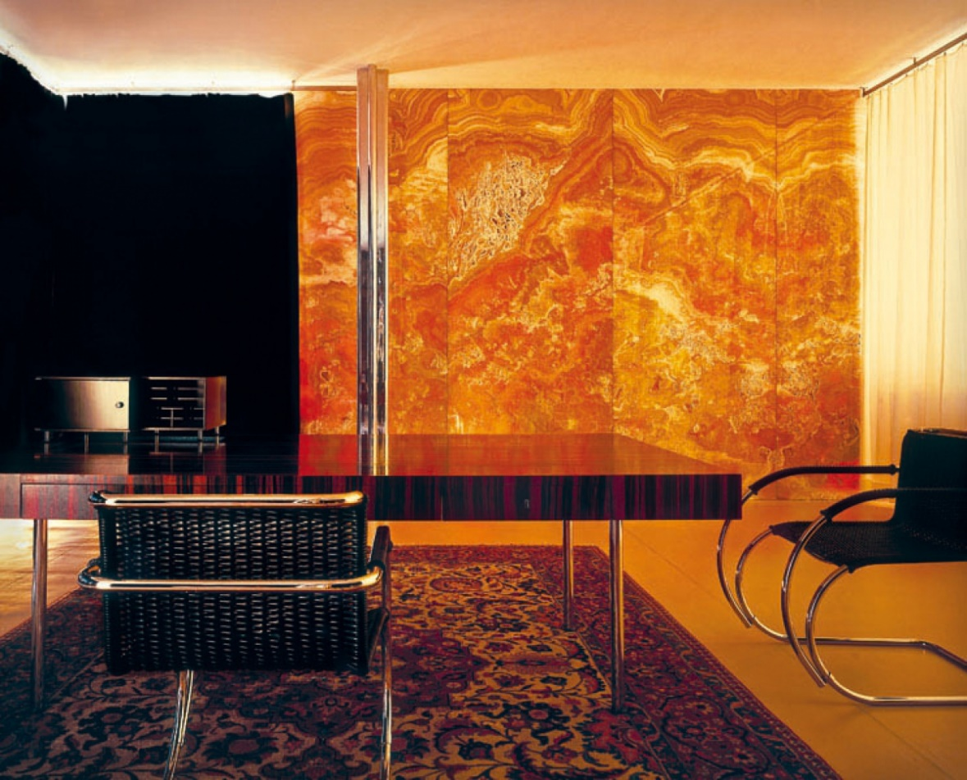
Figure 5 – An image showing the onyx partition illuminating the study area as light penetrates through.

The dining area is backed by an arched partition of Macassar ebony wood, an exotic and expensive wood that gives a modern and ‘premium’ aesthetic. (Materials - google arts & culture) The semi-circular shape helps confine people’s attention to the dining area itself while keeping the views of the windows unrestricted to further support the principle of continuity out into the garden and to reinforce the ideology of the villa and the garden as one body. The bench on the terrace is also of a semi-circular shape that also helps direct the views out over the garden, as most likely intended by the architect.
The materials included in the Tugendhat house were carefully selected to give the ‘Modernist’ aesthetic, the use of reinforced concrete and steel, along with large windows reflected the improvements in technology and construction as the manufacture and use of these industrial materials were only made possible by what was modern machinery at the time.
The ‘Modernist’ style lacks ornamentation and generally utilises a basic colour scheme to give the minimalist quality, in this case, mostly consisting of whites and greys. This specific choice of materials such as onyx and exotic woods also prevents the building from seeming bland or boring as a consequence of the lack of ornamentation. (Antonia, 2020)

Idea and theories underpinning the design
The Tugendhat House is an example of the International style, a style influenced by the Bauhaus design school which saw the start of the modern movement. The aim was to highlight the structure of the building by using simple geometric shapes within the designs along with industrial materials such as concrete and steel, this was done in order to express the functionality of the building and the great advancements made in technology.
The Tugendhat’s were looking for a house with ‘lightness, airiness and clarity’. They wanted a modern, yet functional home design with social areas to accommodate guests, along with nice views of the surroundings. (Curtis, 2013) Each of these aims was attained by the large open spaces to accommodate guests and the large retractable windows to improve lightness, airflow and provide impressive views.
The Bauhaus was founded in Weimar, Germany in 1919 by Walter Gropius. One of the main principles of the Bauhaus was that the design of an object should be based on or reflect its intended function, it related itself closely to the mantra, ‘form follows function’. (Duke, 2023) This is reflected in the design of the Tugendhat house as each space has its own specific function, ultimately influencing the overall design.
Mies’ style was heavily influenced by the Bauhaus movement, which emphasised simplicity, functionality, and the use of innovative materials and technologies. The Tugendhat house reflects these principles through its clean lines, use of steel and glass, and integration of indoor and outdoor spaces.

Conclusion
To conclude, the Tugendhat house was completely revolutionary, with its innovative design and functionalist approach, the villa continues to influence modern architecture today. The home succeeded in achieving the client’s requirements as well as the architect’s aims. The open floor plan allowed for the ground floor to be designed freely, meaning that the designs of the social areas were not constrained by the interference of load-bearing elements. The use of industrial materials introduced a minimalist aesthetic that emphasised simplicity and functionality, satisfying principles of the Bauhaus and Mies’ modernist style.
The Tugendhat house managed to redefine what a house may be by incorporating one consecutive space with a series of attached rooms, rather than the conventional style of having one room lead to another, these spaces flow naturally into each other and are connected without physical barriers such as doorways, the retractable glass façade also allows for the ground floor to flow out into the landscape. This goes to show that it is possible to give character to a large, open space and that a house and its garden need not be separate elements.

Reference List
Antonia (2020) What is modernist architecture?, MidCenturyModerns.org. Available at: https://midcenturymoderns.org/history/modernist-architecture/ (Accessed: March 31, 2023).
Brno City Museum (n.d) Materials - google arts & culture, Google. Google. Available at: https://artsandculture.google.com/story/BQXhPKxvDVhX-Q (Accessed: March 31, 2023).
Chu, R. (2019) Ground Floor Plan of the Tugendhat House, BlogSpot. Available at: https://rchuvillatugendhat.blogspot.com/2019/09/plans-sections-and-elevations-of-villa.html (Accessed: March 31, 2023).
Chu, R. (2019) West Elevation of the Tugendhat House, BlogSpot. Available at: https://rchuvillatugendhat.blogspot.com/2019/09/plans-sections-and-elevations-of-villa.html (Accessed: March 31, 2023).
Curtis, W.J.R. (2013) Modern Architecture since 1900. London: Phaidon.
Duke, H. (2023) Bauhaus architecture and design - origins and Influence, Yoair Blog. Available at: https://www.yoair.com/blog/bauhaus-architecture-and-design-origins-and-influence/#:~:text=Despite%20only%20existing%20as%20a%20school%20of%20architecture,modern%20has%20been%20influenced%20or%20inspired%20by%20Bauhaus. (Accessed: March 31, 2023).
Gianakos, J. (2011) Ad classics: Villa tugendhat / mies van der rohe, ArchDaily. ArchDaily. Available at: https://www.archdaily.com/157555/ad-classics-villa-tugendhat-mies-van-der-rohe (Accessed: March 31, 2023).
Junior, D. (2020) "form follows function" - design mantra of the modernist., Visonic Dome. Available at: https://visonicdome.com/2020/10/21/form-follows-function/ (Accessed: March 31, 2023).
Mertins, D. (2020) Mies. New York: Phaidon.
Paz, M.de la (2017) Tugendhat House, WikiArquitectura. Available at: https://en.wikiarquitectura.com/mansic3b3n_tugendhat5-2/ (Accessed: March 31, 2023).
Teplý , L. (n.d) An image showing the onyx partition, Archiweb. Available at: https://www.archiweb.cz/b/vila-tugendhat%C2%A0 (Accessed: March 31, 2023).
The building (2022) Vila Tugendhat. Available at: https://www.tugendhat.eu/en/about-the-house/dum/ (Accessed: March 31, 2023).
The commissioners (2022) Vila Tugendhat. Available at: https://www.tugendhat.eu/en/about-the-house/stavebnici/ (Accessed: March 31, 2023).
Timpau, A. (n.d) An image showing the dining area, ArchDaily. Available at: https://www.archdaily.com/157555/ad-classics-villa-tugendhat-mies-van-der-rohe/572a18f2e58ece2f08000010-ad-classics-villa-tugendhat-mies-van-der-rohe-photo?next_project=no (Accessed: March 31, 2023).
Villa Tugendhat (n.d) 20th Century Architecture. Available at: http://architecture-history.org/architects/architects/MIES%20VAN%20DER%20ROHE/objects/Villa%20Tugendhat.html (Accessed: March 31, 2023).

