BMIH50074 Financial Management for the Hotel Industry

Assignment 1: Comparison of Two

Hospitality Organisations: Marriot International and Hilton Hotels

Student Name: Elena Roxana Popa
Student ID: 2118844

Table of Contents
Introduction 3
Main body 3
Marriot hotel 3
Total Revenue 3
Market position 4
Growth potential 5
Financial commitment 6
Recommendations 6
Hilton Hotel 6
Total Revenue 7
Growth Potential: 7
Recommendation 8
Conclusion 9
References 10

List of figures:
Figure 1 Total Revenue of Marriot hotel 4
Figure 2 Total Revenue of Marriott Region-wise. 4
Figure 3 Operating Income of Marriott Hotel 5
Figure 4 Total Revenue of Hilton Hotel 7

Introduction
According to Paramasivan (2009), in the business industry, financial management refers to understanding and analysing the amount of money the organisation needs and how that money will be used to fulfil the needs. The author has further stated that it focuses on using different standard management techniques on the financial asset of a business. Furthermore, hospitality financial management refers to managing and organising the financial areas of a hospitality business, such as restaurants or hotels (Drury, 2015). As per the findings of Shim (2022), the majority of organisations face different challenges, including advertising costs, staff compensation, and returns. It is important to note that managing financial aspects is a highly prioritised task for the hospitability finance manager. For managing the tasks, it is essential to understand the significant areas of the hotel industry, such as cutthroat and advanced level efficiency for being afloat (Hayes and Miller, 2011). The report highlights all the financial areas of Marriot and Hilton Hotels by considering their total revenue, growth potential, market position and financial commitment to CSR. Some recommendations are also provided by focusing on the potential source of growth and outsourcing.

Main body

Marriot hotel
Spechler (2017) indicated that Marriot Hotel is one of the recognised hotel chains, timeshare franchisors and licensed in the USA. In addition, there are around 6000 guest rooms with 30 brands, 8000 hotels, and 1,423,044 rooms in around 131 countries worldwide. It is important to note that from 8,000 properties, 2,149 are directly managed by Marriot, whereas the rest franchises have independent owners.

Total Revenue
The image below shows the revenue of Marriott from 1992 to 2022. It has been identified by Neves (2022) that the sales of the hospitability industry have been highly reduced during the pandemic times. It can be seen from the image that in 1992, the total revenue was 7.02, which continues to increase every year. In 2009, it was increased to 10.91, and till 2019, the revenue was 20.97. After the covid'19 pandemic, the revenue started to reduce. In 2021, the revenue was 10.57, which slightly increased in 2021 to 13.86. In 2022, the travelling restrictions were ended, and people started to travel again, which increased the revenue to 20.77. All the data has been summarised below in the image.
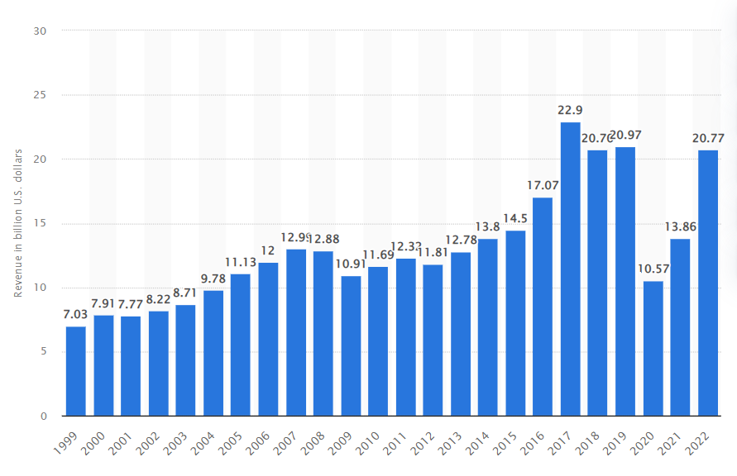
Figure 1 Total Revenue of Marriot hotel
Source: (Neves, 2022).
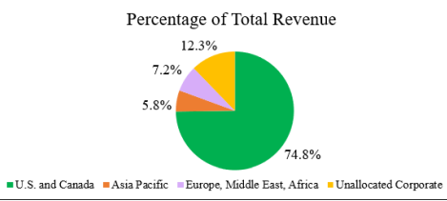
Figure 2 Total Revenue of Marriott Region-wise.
Source: (Neves, 2022).

Market position
It has been identified by Wei (2018) that the market industry has become highly competitive, and the competitors of Marriot Hotel include Hilton Hotel, Carlson and Wyndham worldwide corp. The author has further stated that the overall market share of Marriot Hotel in 2022 was 17.95 per cent. It is imperative to note that the in the third quarter of 2022, the revenue of international Marriot was $ 5,313,000,000, which was increased to around 35% in a year (Neves, 2022).
One of the studies conducted by Darsin et al. (2019) stated that the hospitality industry had increased their business because around 18 companies identified a visible increase in their revenues. However, Catana and Toma (2021) indicated that the revenue growth of Marriott International Inc was around 35 per cent in the third quarter of 2022. In addition, it was placed at the 804th position in the world. It has been identified from the findings of Correia (2022) that the company could not focus more on them due to the increasing salaries of employees. The operating income of Marriott increased by 76% in a year to $958 million.
Considering the image below, the operating income in 2016 was $1,424, which was increased to $2,50 in 2017 and $2,366 in 2018. Furthermore, the income started to reduce in 2019 due to pandemic effects, and the operating income was $1,800, which was highly reduced in 2020 to $84 (Jiang, 2023).
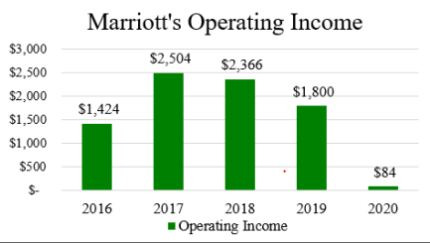
Figure 3 Operating Income of Marriott Hotel
Source: (Catana and Toma, 2021)
Furthermore, as 2021 was completed, Marriot Hotel has around 8000 hotels in 139 nations. In 2022, the business had more than 30 brands, and they are more focused towards providing better opportunities to their customers for engaging, exploring and being competitive in the industry.

Growth potential

Brand Expansion
It has been revealed by the presentation given by the CCO (Chief commercial officer) of Marriott International INC that the eight properly established brands of Marriott are responsible for more than 70% of worldwide distribution and around 55% of its pipeline. In addition, the Marriott company's overall expansion has been highly increased over the past three years (Jiang, 2023).

Targeting midrange customer
Marriott has announced that they plan to join the low – midrange hospitability market. In addition, the company has also started negotiating with other hoteling companies such as, Hotel city express and SAB de Cv because they are planning to purchase the brand portfolio of city express (Atrill and Mclaney, 2007).

Extending the stay period
It has been found that the extended stay market has been increasing rapidly because people are combining their business and pleasure travel. In addition, there is a high percentage in the agreements of most top hospitality companies such as Residence Inn by Marriot, elements by Westin and TownePlace Suites by Marriott.

Financial commitment
As per the findings of Correia (2022), Marriott international inc. has spent around 2 per cent of its average net profit from the financial year on CSR activities as mentioned by the Act. Furthermore, the initiative of Serve360 is highly focused towards efforts and investments. The team's primary focus is “do good in every direction". It is imperative to note that it was a difficult task requiring much effort in different areas. One of the studies conducted by Correia (2022) indicated that Marriot Hotel is currently operating in four spheres, including developing a healthy planet, moving forward with accountability, opening the doors that lead towards empowerment, and promoting human rights.

Recommendations
Considering the above findings, it is found that Marriot Hotel is lagging behind its competitors in the growth of operating income and overall profit. This issue is because the company is spending more money on salaries. It is found that sometimes, the number of employees is more than the total number of guests. Therefore, it is suggested that the company reduce its expenses by outsourcing the employees. It is important to note that outsourcing will help lower the operation cost by 50 per cent.

Hilton Hotel
According to Huckestein and Duboff (1999), Hilton Hotel is one of the most recognised hospitality names worldwide. This hotel was introduced in 1919, and from then on, the company started to improve and expand their business. Currently, the business has around 550 properties in more than 67 countries. It is imperative to note that due to the team members' outstanding performance, Hilton introduced itself as the innovative leader in the hospitality market (Chen et al., 2011).

Total Revenue
As per the recent financial statement of Hilton Worldwide, it was found that the revenue of TTM is $8.16 billion. It can be seen from the image below that from 2009 till 2016, the business had some timeshares, whereas, after 2016, there was no timeshare in the overall revenue of the company. In addition, it was found that the revenues from owned and leased hotels were highly increased from 2009 to 2016, which eventually started to decrease from 2017 to 2022 (Cardoso, 2022).
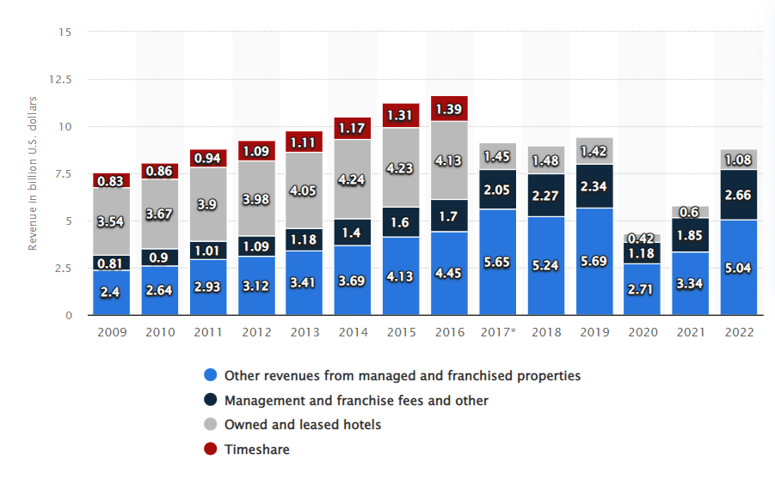
Figure 4 Total Revenue of Hilton Hotel
Source: (Cardoso, 2022)
Furthermore, it has been revealed from the findings of Helmold and Helmold, 2020.) that the revenue of Hilton’s hotel increased by 41 per cent compared to the last year. It is important to note that in the last year, the revenue was around 5.78 billion. The covid'19 pandemic has reduced the number of tourists and has highly affected the company's profit since 2019.

Growth Potential:

Market position
Hilton Hotel is one of the most recognised names, and it has many competitors worldwide, including Marriott Hotel, intercontinental hotel Group, group plaza, holiday inn hotel and many others. One of the studies presented by Zheng and Forgacs (2017) stated that the overall market share of Hilton Hotel is around 8%, which is much higher than its competitors. Furthermore, the overall brand value of the hotel is 12 billion, making this hotel one of the most recognised and famous worldwide.
Furthermore, the revenue growth of the company is much higher as compared to Marriott, but the profit of Hilton is less than Marriott. It has been revealed from the study of Neves (2022) that the operating income of Hilton holdings till September 2022 was $1.923 billion, and 298.9 per cent was increased as compared to the last year, 2021.

Potential growth of Hilton hotel
Till the end of the year 2023, it was found that Hilton has planned to expand by around 30% in Europe. In addition to this, around 35,000 rooms are already constructed in more than 217 buildings (Mekhruza et al., 2022). The expansion of the hotel is the main focus of other business brands such as the Curio collection, tapestry collection, canopy collection and vice versa. Moreover, the collection of Hilton and lifestyle brands were planned to develop with 15 new properties across all seven nations of Europe in 2021 (Bakirtas and Gulpinar Demirci, 2022).

Financial Commitment to CSR
As per the findings of Rocha (2022) that the Hilton has announced to make some changes in their CSR performance. The changes include social effects caused by the workers, respect for the natural world and ethical manufacturing processes. In addition, "travel with purpose" acted as a guiding philosophy for the CSR of Hilton. The business can reduce its environmental impact by reducing waste, recycling food, and donating. The main aim is to reduce and cut waste in all ways till the year 2030. In the year 2021, Hilton invested 26 million in their CSR. The company also planned to make high investments in decreasing its carbon footprint.

Recommendation
Considering the above analysis, it is found that the company is performing very well by highlighting all its aspects. However, it is also revealed that the company's profit is less than Marriott Hotel. Therefore, it is suggested that the company work on expanding its market. In addition to this, the company also have the opportunity to focus on a market development strategy by which the company will be able to expand its business in a new market by using its existing products and services. The company also has the option to expand its product portfolio to attract more customers and be competitive in the hospitality industry.

Conclusion
It has been identified from the assignment that managing financial aspects is one of the highly prioritised tasks for the hospitability finance manager. For managing the tasks, it is essential to understand the significant areas of the hotel industry, such as cutthroat and advanced level efficiency for being afloat. Marriott Hotels and Hilton Hotels have been highlighted in the study. It is found that Marriot Hotel needs to catch up to its competitors in the growth of operating income and overall profit. This issue is because the company is spending more money on salaries. In addition to this, the revenue growth of the company is much higher as compared to Marriott, but the profit of Hilton is less than Marriott. Both companies are highly focused on CSR activity. Hilton Hotel has announced to make some changes in their CSR performance. The changes include social effects caused by the workers, respect for the natural world and ethical manufacturing processes. Marriott international inc. has spent around 2 per cent of its average net profit from the financial year on CSR activities as mentioned by the Act. It is recommended in the study that Marriott needs to focus on outsourcing employees. In contrast, Hilton Hotel needs to work on expanding its business by implementing a market development or product development strategy.

References
Atrill, P. and Mclaney, E. (2007). Management Accounting for Decision Makers. Harlow, Essex Pearson Education.
Bakirtas, H. and Gulpinar Demirci, V. (2022). Can Google Trends data provide information on consumers' perceptions regarding hotel brands? Information Technology & Tourism, 24(1), pp.57-83.
Cardoso, L.E. (2022). Hilton worldwide holdings in the travel & tourism industry (Doctoral dissertation).
Catana, Ş.A. and Toma, S.G. (2021). Entrepreneurship in the hospitality industry. Case study: Marriott International. SEA-Practical Application of Science, (27), pp.221-225.
Chen, Y.C., Wang, W.C. and Chu, Y.C. (2011). A case study on the business performance management of Hilton Hotels Corp. International Business Research, 4(2), p.213.
Correia, H.F.P.R.N. (2022). Marriott international inc. equity research-consolidating a leading position amid recovery (Doctoral dissertation).
Darwin, J., Rosner, J., Urdaneta, C. and Yepes, M. (2019). Marriott International: Exploring and Understanding Disruption in the Hospitality Industry in South Florida. Journal of Multidisciplinary Research, 11(1), pp.99-119.
Drury, C. (2015). Management and cost accounting 11E. 9th ed. S.L.: Cengage Learning EMEA.
Hayes, D.K. and Miller, A.A. (2011). Revenue Management for the Hospitality Industry. Hoboken, N.J.: Wiley.
Helmold, M. and Helmold, M. (2020). Total revenue management (trm) (pp. 1-12). Springer International Publishing.
Huckestein, D. and Duboff, R. (1999). Hilton Hotels: A comprehensive approach to delivering value for all stakeholders. Cornell Hotel and Restaurant Administration Quarterly, 40(4), 28–38.
Jiang, B. (2023). Analysis of Marriott's Financial Position under the Epidemic. Highlights in Business, Economics and Management, 10, pp.122–126.
Mekhruza, V., Malokhat, S., Rustam, T. and Bakhora, R. (2022). PERFORMANCE OF HILTON: HOW HILTON TACKLES THE EPIDEMIC COVID-19 DISEASE. Thematics Journal of Business Management, 5(2).
Neves, D.D. (2022). Marriott international inc. equity research-the Hotel Giant's recovery (Doctoral dissertation).
Paramasivan, C. (2009). Financial management. New Age International.
Rocha, R.A. (2022). Hilton equity research-the value under Hilton's strong brand portfolio (Doctoral dissertation).
Shim, J.K. (2022). Financial management. Professor of Finance and Accounting Queens College City University of New York.
Spechler, J.W. (2017). Marriott International, Inc. In Reasonable Accommodation (pp. 173–185). Routledge.
Wei, L. (2018). Marriott International, Inc: A Financial Analysis.
Zheng, C. and Forgacs, G. (2017). The emerging trend of hotel total revenue management. Journal of Revenue and Pricing Management, 16, pp.238-245.

