MBA- MASTERS OF BUSINESS ADMINISTRATION
INTERNATIONAL BUSINESS
LCMB7014
Student Name: MUHAMMED SHAMSHAD MANNINGACHALI
Student ID: 2243411

REPORT – STRATEGIC MANAGEMENT OF TOYOTA

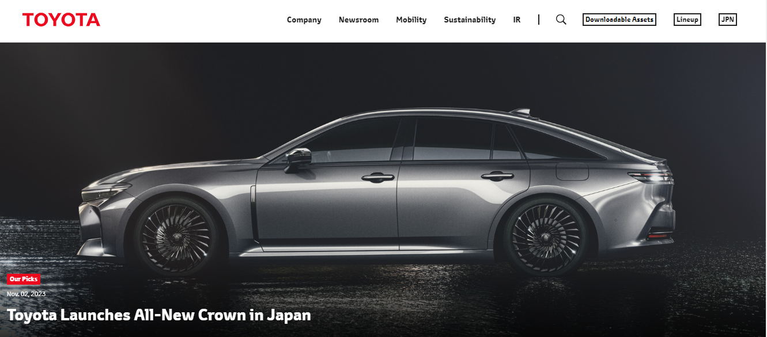

Executive Summary
This report thoroughly assesses Toyota Motor Corporation's strategy in China's dynamic automobile industry. Toyota's vision, goals, governance, and finances are examined to determine its market position. The research externally examines Toyota's China strategy utilizing PESTEL and Porter's Five Forces to evaluate macro and micro environmental issues. Internal SWOT and value chain analyses examine TMC's strengths, weaknesses, opportunities, threats, and operational procedures. The proposed approach emphasizes product differentiation, market development, innovation, and local preferences. Resource allocation, market segmentation, strategic alliances, personnel development, and monitoring are implementation phases. The report also recommends supply chain management, technology integration, and organizational culture transformation to support the plan and prosper in the competitive Chinese automotive industry.
The importance of evaluation and control and its impact on the internationalisation process has been elaborated. Alongside this, the ways to monitor and evaluate the existing strategies have been assessed. Also, this section provided an in-depth understanding related to risk analysis, TQM, balanced scorecard and performance management tools. Finally, the impact of the recommended strategies including differentiation, cost-leadership, Ficus, Integration as well as Diversification on the financial plan of Toyota has been highlighted. Also, it assessed the key highlights of a financial plan such as income statement, cash flow, and EIBT.

Table of Contents
Introduction 4
Current Situation 4
External Audit 6
Internal Audit 10
Strategy Formulation 13
Strategy Implementation 16
Evaluation and Control 18
Financial Plan 21
Recommendations and Conclusion 22
References 25
Appendices 29
Appendix 1 – Financial Performance of Toyota 29
Appendix 2 - Toyota – one of the top-selling automobile brands in China 32

Introduction
The report examines Toyota Motor Corporation (TMC)’s strategic business unit for the dynamic Chinese automobile sector. Global automotive leader Toyota has a long history in Japan. Its industry leadership in innovation, quality, and sustainability allows for a full assessment of its China operations. The Chinese car market is essential because of rapid economic growth, changing client demands, and technology. The complex Chinese market presents numerous opportunities and challenges for Toyota (Batth, 2021). The size, increasing middle class, and rising car demand in China are important to Toyota’s strategy. Toyota’s vision, purpose, objectives, governance structure, and finances will be explored in this investigation. A full external audit utilising PESTEL and Porter's Five Forces will assess Toyota's China strategy's macro and microenvironmental components.
The research will include an internal SWOT analysis of TMC and a value chain analysis. This research analyses internal and external factors to fulfil TMC’s strategic environment. Strategically establishing and executing TMC’s strategy in China is crucial as the auto industry transforms globally (Kawai, 2022). The following sections will explain the strategy formulation process, important execution procedures, and areas that require restructuring or reengineering to meet the firm’s objectives in the competitive and ever-changing Chinese automotive sector.

Current Situation
Toyota Motor Corporation, a Japanese automaker, is a worldwide leader. Kiichiro Toyoda founded TMC in 1937, and it has grown into a worldwide automotive powerhouse. The company’s vision, purpose, goals, ownership or governance, structure, industry position, products/services, market presence, and financial status are critical to its trajectory, especially in the strategically important Chinese vehicle market.
Objectives, Vision, and Mission
Toyota’s objective exceeds traditional automotive goals. TMC develops and implements sustainable mobility solutions to better lives and the globe. The mission emphasizes quality, safety, and environmental responsibility, aligning with TMC’s aims. These aims include ongoing technological improvement, commercial domination, and fiscal security (Soliman, 2020). TMC combines a visionary approach with realistic aims to be a global leader in creating a sustainable and meaningful future for communities worldwide. TMC promotes innovations that reinvent vehicles’ position in society's evolution via a seamless blend of vision, purpose, and objectives.
Ownership/Governance
TMC mixes family ownership with professional governance. Family heritage and commitment have been preserved by the 1937-founded Toyoda family firm. A board of directors and professional management make strategic choices jointly, showing stability and adaptability. This dual structure blends the founding family’s values with professional managers’ diverse skills. TMC’s ownership and governance model blends tradition and current management, allowing it to handle the global auto market strategically and comprehensively.
Company Structure
Toyota Motor Corporation is dispersed and divisional to enhance agility and specialism. The company has sedan, SUV, hybrid, and electric automobile divisions. TMC’s divisional structure allows it to respond swiftly to industry market requirements and technological developments while maintaining strategy coherence (Morgan and Liker, 2020). Decentralization promotes innovation and efficiency by letting units work independently. The automobile industry is always evolving, therefore TMC’s organizational model allows it to build on each unit’s strengths and navigate worldwide markets and client preferences.
Industrial Position
Toyota Motor Corporation (TMC) controls the worldwide automotive business with its innovative, high-quality, and diversified vehicles. Industry sustainability and innovation criteria are established by TMC. As per Dillon (2019), the company prioritizes hybrid and electric cars for the environment. TMC has much potential and fierce competition in China, the biggest motor market. In this evolving business, gaining market share, capitalizing on trends, and maintaining its high-quality automobile image requires a sophisticated approach. TMC’s position reflects its past accomplishments and commitment to leading in a changing automotive market.
Products/Services
The large Toyota Motor Corporation car line-up displays the company’s dedication to customer pleasure and automotive technology. Fuel-efficient compact vehicles, SUVs, hybrids, and electric cars are available. Prius hybrid and Mirai fuel cell cars are TMC’s green innovations. TMC has tailored its goods to Chinese tastes by incorporating cutting-edge technology and aesthetics. TMC’s diverse product line demonstrates its dedication to producing high-quality, dependable, and technologically sophisticated cars for global consumers and the dynamic Chinese automotive market.
Market Share
China’s rising middle class and vehicle sales have benefited Toyota Motor Corporation. Besides sales, TMC has manufacturing, R&D, and local business connections in China. Toyota came in third with sales of 160,845 automobiles, representing 7.73% of the market [Refer to Appendix 2]. By growing domestically, TMC hopes to impress Chinese customers and manage the harsh regulatory atmosphere (Yamamoto et al. 2019). TMC must comprehend China’s urbanization and shifting customer tastes to grow and compete. The company’s large presence in China reflects its worldwide strategy of flexibility and localization to succeed in various industries.
Financial Situation
Toyota Motor Corporation remained financially stable despite global automobile sector competition. TMC’s market valuation, profit margins, and sales show long-term investment worth. TMC can strategically invest in R&D to satisfy expanding customer and regulatory expectations with a consistent pipeline of innovative goods due to its financial stability (Moi and Sing, 2021). Excellent financial practices and devotion to efficiency and quality get TMC ahead. TMC needs strong Chinese finances to seize opportunities and manage risks in the fast-changing automotive industry.

External Audit
External causes and pressures affect the organization’s performance, strategy, and operations. Understanding the external environment is crucial for Toyota Motor Corporation in China since it affects strategic objectives. PESTEL refers to political, economic, social, technical, environmental, and legal issues in the external environment. Porter’s Five Forces theory examines industry dynamics and competition. TMC can detect opportunities and challenges, forecast changes, and adapt its strategy to market circumstances by analysing the external environment.
PESTEL Analysis

Figure 1: PESTEL Analysis
Source: (Self-Developed)
Elements | Description
Political Factors | The Chinese car industry is politically affected. TMC is affected by government rules, including pollution, safety, and commerce. China's push for electric automobiles (EVs) and tight emission regulations to combat environmental issues presents both opportunities and problems for Toyota. Compliance and utilization of these standards may help TMC in the fast-growing electric vehicle industry.
Economic Factors | Toyota relies on China's economic growth and stability. The Chinese economy, currency exchange rates, and income impact automobile demand and consumer expenditure. Economic downturns or uncertainties may hurt sales and earnings. TMC market possibilities may increase with economic success as demand for premium cars and innovative automotive technologies rises.
Social Factors | China's urbanization, lifestyle changes, and rising middle class affect automobile purchases (Ortega et al. 2019). TMC must meet consumer demand for eco-friendly and innovative cars. Demographics, culture, and lifestyle changes impact product design, marketing, and customer expectations.
Technological Factors | China excels in electric and autonomous vehicle technologies. TMC must adopt connection, autonomous driving, and green technologies. Toyota must engage with local IT firms and invest in R&D to maintain technological leadership in China.
Environmental Factors | China's growing environmental and sustainability concerns influence TMC's goods. Based on the statement of Roy, Kumar, and Satpathy (2021), Government efforts promoting green technology and environmental awareness boost eco-friendly automobile sales. Hybrid and electric vehicle technology from TMC aligns with these environmental concerns, promising sustainable mobility industry leadership.
Legal Factors | China has competition, intellectual property, and product safety regulations. Certain conditions must be met for TMC to survive. Taxes and import/export rules may impact production costs and market access.
Table 1: PESTLE Analysis
Porter's Five Forces Analysis
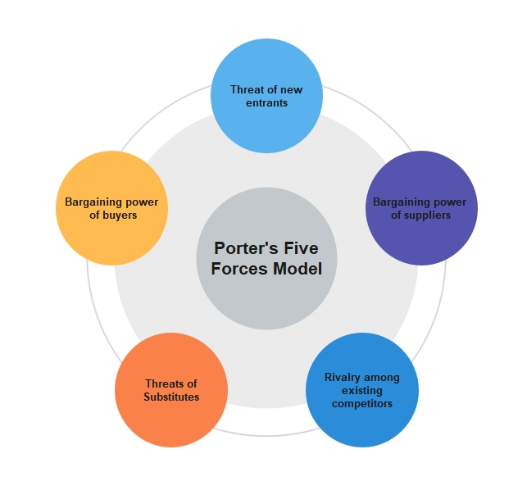
Figure 2: Porter’s Five Forces Analysis
(Source: Samson and Swink, 2023)
Threat of New Entrants
There are several obstacles to breaking into China's automobile market, such as the need for huge initial investments, economies of scale, and customer loyalty to well-known brands. According to Saad et al. (2020), While TMC's longevity and brand recognition provide the company with an edge in the industry, new entrants and innovative approaches to doing business need constant vigilance.
Bargaining Power of Buyers
There is a correlation between consumer choice and access to information. TMC must pay attention to product differentiation, quality, and customer service in China, where customers are growing more discriminating, to keep its competitive edge. The proliferation of car-buying websites boosts openness, putting more power in the hands of shoppers.
Bargaining Power of Suppliers
In the context of the Chinese market, TMC's connections with its suppliers are critical. Reducing suppliers' leverage requires maintaining a reliable supply chain, striking advantageous deals, and cultivating long-term relationships (Baxter, 2019). Disruptions in the automotive supply chain may have far-reaching effects on production and prices because of the industry's complexity.
Threat of Substitutes
The rise of ride-hailing apps and public transit systems in China has increased the competitive pressure from replacements. Mobility preferences are shifting, and innovations in transport services might threaten the status quo of car ownership.
Intensity of Competitive Rivalry
Numerous local and foreign companies compete aggressively in China's automobile industry. TMC is up against established manufacturers as well as upstarts with a focus on autonomous and electrified cars. To stay ahead of the competition, need to form strategic partnerships, innovate constantly, and streamline processes.
Emerging Concerns
- EV Market Dynamics: Government regulations driving electric car adoption provide TMC with possibilities and difficulties. Production line changes and EV technology investments are essential.
- Regulatory Compliance: TMC's performance in China depends on being current on emissions and safety laws.
- Technological Innovation: To match Chinese customer aspirations, linked automobiles, autonomous driving, and green technology must advance.
- Changing Consumer Tastes: Understanding customer behaviour and preferences is crucial to marketing and distribution strategies due to online platforms and shifting mobility choices.

Internal Audit
The internal environment of an organization encompasses its components, resources, capabilities, and processes. Culture, structure, HR, technology, and money are covered. Internal knowledge is essential for effective approaches. According to Samudra (2023), It helps companies make strategic decisions by recognizing their strengths, weaknesses, and unique talents. Toyota Motor Corporation must perform a thorough internal audit in China, where consumer preferences and legislative limits affect market dynamics. This analysis informs TMC's strategy, resource allocation, and Chinese automobile industry responses.
SWOT Analysis

Figure 3: SWOT Analysis
(Source: Self-Developed)
Elements | Description
Strengths | TMC's strengths include its worldwide reputation for quality and dependability, a diversified and creative product line, and a longstanding commitment to sustainability. The company's hybrid technological expertise matches China's growing demand for eco-friendly cars. TMC's solid finances and well-established supply network also provide it an edge.
Weaknesses | Internal challenges for TMC include potential inefficiencies arising from its decentralized structure, the need for continuous adaptation to rapidly evolving technologies, and the risk of over-reliance on specific markets or product segments (Benzaghta et al. 2021). Balancing the preservation of the Toyota Production System's principles with the demand for local adaptation poses a challenge in the Chinese context.
Opportunities | TMC's opportunities in China stem from the country's growing middle class, the increasing demand for electric vehicles (EVs), and the potential for collaboration with local partners. Leveraging its hybrid and EV technologies, TMC can tap into the evolving preferences of Chinese consumers. Strategic alliances and joint ventures with local companies can facilitate a deeper understanding of the market.
Threats | The internal environment must also account for concerns including fierce competition from existing and new entrants, changing customer preferences, and supply chain disruptions (SERIKI, 2022). TMC must manage regulatory and geopolitical risks that affect its operations.
Table 2: SWOT Analysis of Toyota
Value Chain Analysis
Primary Activities
Inbound logistics, operations, outbound logistics, marketing & sales, and service comprise TMC's value chain. Supply chain and inventory control maintain a consistent flow of quality components in incoming logistics. The operations phase uses Toyota's manufacturing system to maximize efficiency and reduce waste (Benkarim and Imbeau, 2022). Outbound logistics and marketing tactics tailored to China help product positioning and sales. Customer satisfaction and loyalty depend on customer support and after-sales services.
Support Activities
Support operations including infrastructure, HR, technology development, and procurement underpin TMC's internal environment. An organizational structure that follows Toyota's principles ensures smooth operations (Jae-Hoon and Dae-Hee, 2021). HR management promotes talent development and ongoing improvement. Technological advancement in the automobile business requires research & development and innovation. Toyota's high manufacturing standards depend on component procurement procedures that ensure quality and dependability.
Emerging Concerns
- Decentralized Structure: Toyota's decentralized structure promotes flexibility but may cause divisional coordination and consistency issues. Local adaption and global standards must be managed carefully to maximize operational efficiency.
- Technology Integration: Electric and autonomous cars are advancing rapidly in the automobile sector. TMC must seamlessly integrate these technologies into its vehicle selection while retaining Toyota's quality and dependability.
- Talent Management: Toyota's manufacturing system depends on competent workers. Attracting, developing, and keeping top individuals who can navigate the Chinese market and advance technology is difficult (Zhang, 2023).
- Supply Chain Resilience: Geopolitical or unanticipated supply chain disruptions may delay production and delivery. Supply chain resilience is crucial for risk mitigation and quality component delivery.

Strategy Formulation
Strategy formulation involves creating well-defined, integrated strategies that support an organization's vision, purpose, and goals. Assessing internal and external variables, identifying strengths and weaknesses, opportunities, and threats, and then developing strategies to harness strengths, minimize weaknesses, capitalize on opportunities, and counter threats. As per Lodgaard et al. 2023), Toyota Motor Corporation's (TMC) China operations need a strategy design to navigate the Chinese automotive industry, solve internal and external difficulties, and seize sustainable growth prospects.
Key Strategy Formulation
Cost-leadership
- Strives to be the cheapest manufacturer.
- Integrates operational efficiency, size, and cost management.
- Ideal for price-competitive markets.
Differentiation
- Highlights product quality, inventiveness, and uniqueness.
- Promotes a unique brand and charges high costs.
- Suitable when consumers seek distinct items.
Focus
- Focuses on a market, product, or region.
- Specialises and better serve niche markets.
- A focused strategy is more lucrative than a wide one.
Integration
- entails either purchasing rival businesses or expanding into related markets (horizontal integration).
- Improves command of production and sales channels (Arsy, 2021).
- Useful when resource security is paramount or when consolidation might provide cost savings.
Diversification
- Distributes corporate operations across a variety of goods, services, or consumer markets.
- Aims to lessen the risk by not depending on a single source of income.
- Ideal when possibilities arise to use current skills in new contexts.
Ansoff's Matrix Strategy
Toyota's operations in China face several problems and opportunities that may be mitigated with a strategy that combines elements of distinction and concentration. Igor Ansoff's Ansoff Matrix is a framework for evaluating various approaches to expansion. Based on the statement of Calendar (2020), Ansoff's Matrix provides a framework for understanding complicated markets like the Chinese automobile industry, and for Toyota Motor Corporation in China, the combination of product differentiation and market development provides a comprehensive strategy.
- Market Access: This entails selling more of current items to established markets. The competitive environment in China may need a more sophisticated approach, but this method is useful for preserving and expanding market share.
- Grow the market: The goal of this plan is to sell more of the same items in different markets. In China, expanding the TMC market might include focusing on certain subsets of consumers, regions, or demographics with high unrealized potential (Agustina et al. 2019).
- Development of Products: This tactic involves penetrating already established markets with brand-new offerings. Given the dynamic nature of the Chinese automobile industry, this technique may be beneficial, particularly if it corresponds with growing trends and customer preferences.
- Diversification: Taking the risk of releasing a product into an untested market may pay off in the long run. Strategic diversification is an option in the Chinese setting due to the automobile industry's high pace of change.
Recommended Strategy Explanation
According to Ansoff's Matrix, Toyota Motor Corporation should concentrate on product differentiation and market expansion in China. This approach targets particular market sectors to adapt to fast technology change and Chinese consumer preferences. TMC differentiates its goods with quality and creativity. TMC advances sustainability, safety, and technology with cutting-edge technologies, notably in electric and driverless cars. This aligns with customer expectations and worldwide eco-friendly and sophisticated transportation trends. Chinese customer preferences are needed for this technique. Smart connectivity will assist TMC in localizing customer experiences. This customer-centric approach, which respects cultural differences and individual preferences, makes Toyota automobiles part of the Chinese lifestyle.
TMC anticipates a shift from broad market growth to China's specialism. This involves aggressively targeting densely populated urban zones with high small and electric vehicle demand to suit their mobility needs (Agustina et al. 2019). TMC customizes goods for certain demographics. Strategies and collaborations drive market growth. To exploit local expertise, TMC works with Chinese companies, IT businesses, and governments. These ties help TMC understand the local market and regulatory environment, ensuring its products conform with Chinese legislation.
Recommended Strategy Justification
TMC in China benefits from product diversification and market development for numerous reasons.
- Consumer preferences change: Toyota can meet Chinese customers' constantly changing desires for sustainable and technologically sophisticated automobiles by innovating and focusing on certain market niches.
- Leveraging Technological Advancements: As the automotive industry advances rapidly, especially in electric and driverless cars, TMC can use its innovation skills to remain ahead of the curve and fulfil Chinese consumer expectations.
- Optimising Resource Allocation: Targeting certain market segments ensures that resources are allocated to areas with the greatest development potential and aligned with the organization's strategic objectives.
- Enhancing Local Adaptation: Strategic alliances and collaborations help understand the local market. This helps TMC tailor its offerings to Chinese customers' tastes.

Strategy Implementation
Strategy implementation involves executing a strategy. It entails turning strategic plans into actionable steps and guaranteeing their success. The proposed strategy of product differentiation and market development demands a systematic and well-coordinated approach across organizational functions at Toyota Motor Corporation in China.
Key Strategy Implementation Steps
- Allocate resources: According to Muniz Jr, Ribeiro, and Pradhan (2021), Financial, human, and technical resources should be efficiently allocated to support product differentiation research and development. Investment in cutting-edge electric and autonomous vehicle technology aligns with the strategy's emphasis on innovation and quality.
- Market and distribute: Strategic market segmentation helps target Chinese consumers with targeted marketing. Market research helps understand cultural differences and tailor advertising and promotions to the target demographic. Create an effective distribution network to reach key markets, particularly metropolitan regions with significant compact and electric car demand.
- Develop Partnerships: Strategic collaborations with local enterprises, IT firms, and governments will help TMC understand the Chinese market. Work with these organizations to understand regulations, customer behaviour, and market trends. These alliances may also stimulate localized innovation and market relevance via joint ventures or co-development.
- Development of Employees: Train personnel to navigate the volatile Chinese market. Cross-cultural, technical, and leadership training are needed to comprehend and accept local differences, keep up with automotive technology, and create adaptation and a continuous improvement mentality (Dave, 2020).
- Monitoring/Evaluating: Implement a rigorous monitoring and evaluation mechanism to evaluate strategy efficacy. Review market share, customer happiness, and financial performance metrics regularly. Monitoring industry trends, customer input, and competition activity may help adjust and develop.
Method of implementation
Toyota Motor Corporation will conduct extensive market research to identify Chinese automobile customer categories and preferences. This requires understanding the growing demand for electric and small automobiles, preferences for sophisticated connection technologies, and critical purchase determinants. TMC uses market information to establish a sophisticated picture of the Chinese customer to produce goods and marketing tactics that match local likes and preferences (Soviar et al. 2019). TMC will spend a lot of money on R&D, focusing on electric and driverless car technology. Strategic financial distribution will assist R&D, marketing, distribution, and strategic alliances. Regular financial assessments will help TMC allocate resources and maximize financial resources by measuring return on investment. TMC will capitalize on its manufacturing system and quality focus. Effective communication and extensive training will match staff with strategic goals. The flexibility of internal processes and structures must be assessed to ensure they align with the proposed approach to seamlessly integrate new practices and a culture change needed for success in the dynamic Chinese automotive industry.
Restructuring or Reengineering Need
Toyota Motor Corporation may require strategic restructuring and reengineering in three areas to achieve the China strategy. Focusing on electric and small automobiles needs supply chain reengineering. TMC must assess suppliers, manage logistics, and use agile manufacturing to maintain component flow for varied product lines. Adapting to shifting needs and being efficient in a dynamic market necessitates this method. Reengineer internal procedures to include technology. Improve TMC's IT infrastructure, data analytics, and R&D innovation (Moi and Sing, 2021). This proactive approach keeps TMC at the forefront of automotive technology, especially electrified and driverless cars. Organizational cultural adaption is key. TMC must reorganize its HR, communication, and decision-making processes to serve Chinese clients. This cultural adaption respects Chinese culture and involves local customers and stakeholders. These reorganizations are essential to align internal procedures with the approved strategy and ensure TMC's success in the tough Chinese car market.

Evaluation and Control
Importance of evaluation and control
Evaluation and Control are the process of observing and understanding the success of an implemented strategy in order to achieve optimum growth and to meet all the organisational objectives. This process is utterly important for evaluating potential risks and issues and accelerates the effectiveness of change management and risk management. Thus, the internationalisation of a company is inextricably related to evaluation and control. It provides practical and valid information and considerations for organisations like Toyota. As the digitalisation of marketing and organisational processes is increasing the risk factors related to malware, data theft and identity crisis are also budding (Ahmad and Murray). Thus, in order to identify and prevent the risk factors Toyota needs to adopt appropriate evaluation and control strategies.
In the case of Toyota, the implementation of evaluation and control strategies may lead to improvements in their digitalisation and internationalisation processes. Moreover, the evaluation and control strategies in organisations like Toyota are important for identifying where they are doing wrong and where they are doing right. This distinction is beneficial for improving the organisational processes and promoting solutions for several issues.
Ways to monitor and control strategies
There are various ways to evaluate, control and monitor the already implemented strategies. In this case, Toyota can easily monitor the effectiveness of its internationalisation strategies with the help of the application of the following processes.
Risk Analysis
This is an integral part of the process of controlling and monitoring existing strategies in an organisation. Henceforth, the potential risks associated with system security or digital services can be identified. Thus, it will make the customer experience seamless and the overall growth of Toyota in the international market will be heightened.
Sensitivity Analysis
It can be observed that sensitivity analysis is beneficial for suggesting appropriate choices for decision-making and risk management as well as change management. In the organisational environment of Toyota, this could help the company to make accurate decisions to improve internationalisation and derive tangible benefits.
Balanced Scorecard
This management tool aims to reach the organisational goals and objectives (Tibbs and Langat, 2016). For example, strategies implemented by Toyota including the internationalisation strategy of Toyota can be monitored and their success can be evaluated with the help of it. The balanced Scorecard of Toyota lets the organisation control the internal business functions in order to ensure optimum external outcomes.
Balanced Scorecard of Toyota
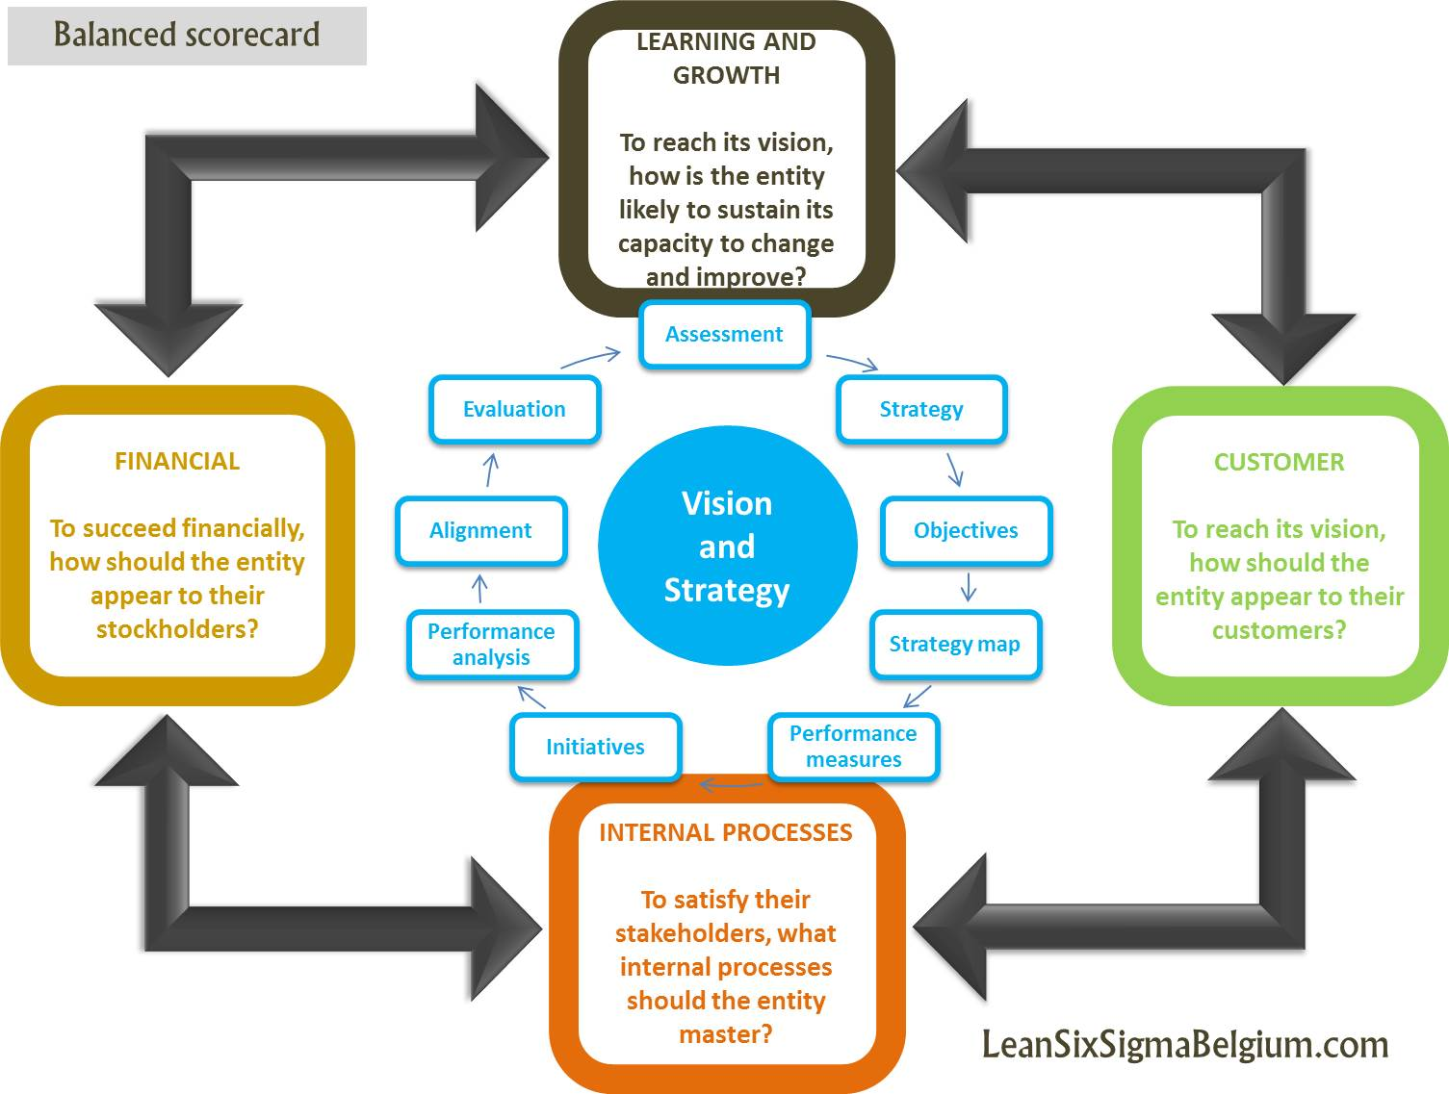
Figure 4: Balanced Scorecard
(Source: Tibbs and Langat, 2016)
Balanced Scorecard Aspects | Description in terms of Toyota
Financial | - In order to showcase Toyota’s financial situation, its shareholders can observe how company shares accelerate, how Toyota’s assets are usually being utilised and how its capital generally returns
Customers | - Quality management is important  - Improvement in consumer services  - Prioritising serving Toyota’s communities
Internal Processes | - Improve its product quality  - Must focus on customer satisfaction by incorporating different perspectives related to product designing, manufacturing, marketing, etc.
Learning and Growth | - The abilities of workers must be prioritised  - Focusing on the Information Systems of Toyota  - Workers should be empowered and inspired
Table 3: Balanced Scorecard Perspectives of Toyota
(Source: Global.toyota, 2023)
Total Quality Management
The Kanban system of Toyota is supposedly one of the best examples of TQM. Kanban is a type of signal that tends to provide a chain reaction which leads to a specific action. Kanban is considered an effective inventory control process employed in JIT (“Just-In-Time”) manufacturing in order to look into its production systems and order fully new shipments of both materials and parts (Htun et al. 2019). The effectiveness of this TQM approach leads to improving the quality of manufacturing, cultural development as well as customer satisfaction. Eventually, it leads to access monitoring and evaluation of the existing strategies of Toyota.
Performance Management Systems
This system of Toyota is concerned about decision-making, problem-solving, critical thinking as well as employee training programmes. This is an employee-centric approach to ensure optimum employee satisfaction and productivity. Also, a performance management system is potential enough to assess and monitor the performance standard of the workers and so the performance standard of the existing strategies (Forbes, 2022).

Financial Plan
Impact of strategies on financial position
The implementation of a cost-leadership strategy is going to help the organisation achieve higher profit margins while limiting the cost of production and generating substantial revenue flow. Besides, the incorporation of a differentiation strategy is effective for sustaining the current performance (Islami et al. 2020). It influences economic decisions and affects the effectiveness of financial variables. Additionally, the main goal of the differentiation strategy is to enable the firm to sell its products at a higher price than the rivals in the concerned industry.
Focus strategy and market financial performance are integrally correlated with each other. Focus strategy is beneficial for fulfilling a need or requirement in a better way which eventually optimises customer satisfaction and engagement. Henceforth, optimum customer reliability and engagement lead to an overflow of revenue flow and profitability (Żyminkowska et al. 2017). On the other hand, the implementation of the integration strategy in Toyota will streamline the financial reporting, forecasting and optimising, and this eventually influences the economic stability. Finally, the application of a diversification strategy allows the company to lower its exposure and let it invest in multiple assets to prevent the negative effects of market events.
Key highlights of the financial system
There are some key aspects of the financial system which are inextricably involved with the overall financial performance of the company. The role of cash flow, balance sheet, income statement as well as EBIT in the total financial plan is going to be analysed. Firstly, cash flow statements play an integral role in the business finance sector [Refer to Appendix 1]. A cash flow can be referred to as net cash and cash-related equivalents which are transferred in and out of the company. Unlike money flow, cash flow represents inflows. Also, it ensures that the company can assess their spending needs regularly.
Besides, the balance sheet is a snapshot of the finances of the company (Forbes, 2022). It is supposed to be published quarterly or yearly in order to provide in-depth insights into the cash flow and debt rates. Additionally, the role of an income statement is vital in this case as it showcases income gains, expenses, and losses in a mathematical reasoning format for better understanding. Also, one can track the net profit and loss of the company with respect to a certain period. Finally, the role of EBIT is to analyse the business operations and economic performances. It helps the investors to identify the economic potential and chances of profitability. When it comes to tax and debts, EBIT plays a significant role in maintaining profitability.

Recommendations and Conclusion
Recommendations
Some certain issues and challenges have been identified with the help of certain frameworks like SWOT, Porter's Value Chain and PESTLE. These issues and risks should be mitigated properly to ensure the optimum success of the internationalisation of Toyota.
Technology innovation
The issue of changing customer needs and increasing rivalry in the automobile industry can be dealt with through the application of innovative technologies. This not only makes the process smoother and faster but also improves the quality of customer service. Thus, technology will make the company aware of the needs and requirements of the market and implement strategies accordingly.
Group Cohesiveness and Intercommunication
The issue of misunderstanding and unwanted conflicts makes the group weak and lowers productivity. Therefore, training and meetings should be arranged to improve the intercommunication between the employees and increase the level of understanding. Additionally, recognition and reward programmes are beneficial in this case for boosting the effectiveness and engagement of the employees.
Differentiation via effective marketing
In order to prevent the risk of product duplication and imitation, the company needs to promote their products in a better way. Thus, the digitalization of marketing operations can enlarge the reach of the company to a large number of audiences.
Conclusion
Toyota Motor Corporation must adjust strategically to thrive in China's competitive car industry. TMC's global leadership and relevance in China despite economic and technical advancement were emphasized in the introduction. TMC's vision, purpose, objectives, ownership, structure, industry position, products/services, market presence, and finances were analysed in this report. The external audit identified political, economic, social, technical, environmental, legal, and industry dynamics issues using PESTEL and Porter's Five Forces. The internal audit's SWOT and value chain analyses highlighted TMC's primary and support operations' opportunities, threats, strengths, weaknesses, and competitive advantages. Ansoff's Matrix advocated product diversification and market expansion for China's complexity strategy. This focus on niche goods and market segmentation helps TMC innovate and survive.
The implementation plan focused on resource allocation, market and distribution strategies, collaborations, personnel development, and rigorous monitoring and assessment. Market research, strategic financial distribution, and TMC's production system and quality emphasis were used for implementation. Supply chain reorganization, technological integration, and cultural adaptation were advised to achieve the goal. These initiatives attempt to streamline component flow, remain ahead in technology, and match internal procedures with Chinese culture.
To conclude, the entire business plan is based on one of the leading automobile companies, Toyota. After a brief introduction about the company, the study has analysed the current situation of the company. The vision, mission, and governance have been discussed lucidly. Additionally, the key products and services of the automobile brand Toyota along with its market and financial position have been analysed. Along with the implementation of PESTLE analysis, the study has observed the external causes and pressures that impact the performance and operations of Toyota. Also, Porter's Five Forces Model analysed the threats and weaknesses that affect Toyota. Thus, the issues and challenges in the organisation have been raised in this way. There is a SWOT analysis for identifying the internal audit related to the internal culture and technology matters. Porter's Value Chain model is effective in this case for emerging certain concerns. Thus, key strategies including cost-leadership, differentiation, focus, integration, and diversification strategies are the recommended strategies that have been formulated. Besides, an in-depth understanding of Ansoff Matrix is there to dig deep into the matter of developing some key financial intermediaries. Additionally, the importance of evaluation and control has been discussed lucidly along with various ways for monitoring and controlling these strategies. Therefore, this portion has mentioned the role of risk analysis, balanced Scorecard, TQM as well as sensitivity analysis and performance management for improving the strategic performance of Toyota eventually promoting its internationalisation performance. Finally, a discussion on the impact of strategies on the overall financial position of Toyota has been provided.

References

Agustina, A., Dalimunthe, R.F. and Sinulingga, S., 2019. The Effect Of Recruitment, Training And Placement On The Performance Of Employees In PT Astra International Tbk, Toyota Auto 2000 SM. Raja Medan. European Journal of Human Resource Management Studies.
Ahmad, M.U. and Murray, J., 2019. Understanding the connect between digitalisation, sustainability and performance of an organisation. International Journal of Business Excellence, 17(1), pp.83-96.
Arsy, F.A., 2021. Demand forecasting of toyota avanza cars in indonesia: grey systems approach. International Journal of Grey Systems, 1(1), pp.38-47.
Batth, V., 2021. Toyota motor corporation: Just in time (jit) management strategy or beyond. Journal of Case Research, 12(1), pp.18-27.
Baxter, G., 2019. A strategic analysis of Cargolux Airlines International position in the global air cargo supply chain using Porter’s Five Forces Model. Infrastructures, 4(1), p.6.
Benkarim, A. and Imbeau, D., 2022. Investigating the implementation of Toyota’s human resources management practices in the aerospace industry. Merits, 2(3), pp.126-145.
Benzaghta, M.A., Elwalda, A., Mousa, M.M., Erkan, I. and Rahman, M., 2021. SWOT analysis applications: An integrative literature review. Journal of Global Business Insights, 6(1), pp.55-73.
Carnewschina.com, (2023), top-selling-car-brands-in-september-2023-in-china. Available at: https://carnewschina.com/2023/10/11/top-selling-car-brands-in-september-2023-in-china/ [Accessed on: 15-11-2023]
Dave, P.Y., 2020. The history of lean manufacturing by the view of Toyota-Ford. International Journal of Scientific & Engineering Research, 11(8), pp.1598-1602.
Dillon, A.P., 2019. A study of the Toyota production system: From an Industrial Engineering Viewpoint. Routledge.
Forbes, (2022), balance-sheet. Available at: https://www.forbes.com/advisor/business/balance-sheet/ [Accessed on: 15-11-2023]
Forbes, (2022), the-importance-of-performance-management. Available at: https://www.forbes.com/sites/forbesbusinesscouncil/2022/08/09/the-importance-of-performance-management/?sh=9ce13356c7bf [Accessed on: 15-11-2023]
Global.toyota, (2023), Financial Results. Available at: https://global.toyota/pages/global_toyota/ir/financial-results/2023_4q_summary_en.pdf [Accessed on: 15-11-2023]
Global.toyota, (2023), official website. Available at: https://global.toyota/en/ [Accessed on: 15-11-2023]
Htun, A.R.K.A.R., Maw, T.T. and Khaing, C., 2019. Lean manufacturing, just in time and Kanban of Toyota production system (TPS). International Journal of Scientific Engineering and Technology Research, 8(1), pp.469-474.
Islami, X., Topuzovska Latkovikj, M., Drakulevski, L. and Borota Popovska, M., 2020. Does differentiation strategy model matter? Designation of organizational performance using differentiation strategy instruments–an empirical analysis. Designation of organizational performance using differentiation strategy instruments–an empirical analysis (February 14, 2020). Islami, X., Latkovikj, MT, Drakulevski, L., & Popovska, MB, pp.158-177.
Jae-Hoon, K.I.M. and Dae-Hee, C.H.O., 2021. The Transformation and Evolution of Japans Manufacturing Industries: A Case Study about Toyota and Toshiba after the Global Financial Crisis. Drishtikon: A Management Journal, 12(2), p.77.
Kawai, T., 2022. Evaluation of Toyota’s Strategy for Electric Vehicles in Counteracting Platformers—Based on the Theories of Dynamic Managerial Capabilities and Dynamic Platform Strategy—. Journal of Strategic Management Studies, 14(1), pp.67-87.
Kelendar, H., 2020. Lean thinking from Toyota manufacturing to the health care sector. Res Med Eng Sci, 8(5), pp.913-923.
Lodgaard, E., Iakymenko, N. and Mogos, M.F., 2023. Toyota Kata for continuous improvement; an action research project in the construction industry. International Journal of Lean Six Sigma.
Moi, W.A. and Sing, S.H., 2021. Application of Toyota way incorporating kaizen, Kaikaku and 5S in agricultural sector. International Journal for Research in Applied Science and Engineering Technology, 9(10), pp.1565-1579.
Morgan, J. and Liker, J.K., 2020. The Toyota product development system: integrating people, process, and technology. CRC Press.
Muniz Jr, J., Ribeiro, V.B. and Pradhan, N., 2021. Knowledge-Based Assessment Applied to Lean Brazilian Toyota Plants: Employees' Perceptions. International Journal of Knowledge Management (IJKM), 17(2), pp.1-22.
Ortega, R.G., Rodríguez, M.D.O., Vázquez, M.L., Ricardo, J.E., Figueiredo, J.A.S. and Smarandache, F., 2019. Pestel analysis based on neutrosophic cognitive maps and neutrosophic numbers for the sinos river basin management. Infinite Study.
Prasetyo, S.J., Lubis, M., Witjaksono, R.W. and Azizah, A.H., 2019, October. Critical failure factors in enterprise resource planning (ERP) implementation: case study of PT. Toyota astra motor Indonesia. In 2019 Fourth International Conference on Informatics and Computing (ICIC) (pp. 1-5). IEEE.
Roy, S., Kumar, K. and Satpathy, B., 2021. Strategic planning of optimising productivity: a'5S under lean quality'approach. International Journal of Productivity and Quality Management, 32(1), pp.53-71.
Saad, N.H., Khalid, Q.M., Halim, N.H.A. and Khusaini, N.S., 2020. A case study: Framework of gap analysis on integration of audit system between IATF 16949 and Toyota production system. Applied Mechanics and Materials, 899, pp.219-229.
Samson, D. and Swink, M., 2023. People, performance and transition: A case study of psychological contract and stakeholder orientation in the Toyota Australia plant closure. Journal of Operations Management, 69(1), pp.67-101.
Samudra, A., 2023. The effectiveness of internal control in the payroll accounting system Case Study at PT. Sumber Bahtera Motor Authorized Toyota Yogyakarta. Indonesia Accounting Research Journal, 10(4), pp.135-141.
SERIKI, O.B., 2022. EFFECTS OF CONFLICT MANAGEMENT ON ORGANISATIONAL PERFORMANCE.(A study of Toyota Nigeria Limited).
Soliman, M.H.A., 2020. Jidoka: The Toyota Principle of Building Quality into the Process. Mohammed Hamed Ahmed Soliman.
Soviar, J., Holubčík, M., Vodák, J., Rechtorík, M. and Pollák, F., 2019. The Presentation of Automotive Brands in the On-Line Environment—The Perspective of KIA, Peugeot, Toyota and VW in the Slovak Republic. Sustainability, 11(7), p.2132.
Tibbs, C.Y. and Langat, L.K., 2016. Internal process, learning perspective of balance scorecard and organisational performance. International Journal of Economics, Commerce and Management, 4(11), pp.458-474.
Yamamoto, K., Milstead, M. and LIoyd, R., 2019. A review of the development of lean manufacturing and related lean practices: The case of Toyota Production System and managerial thinking. International Management Review, 15(2), pp.21-90.
Zhang, R., 2023. Whether the Lean Management can Affect The Innovative Performance in the Manufacturing Industry–a Case Study of a Chinese State-Owned Company. In SHS Web of Conferences (Vol. 170, p. 03003). EDP Sciences.
Żyminkowska, K., Żyminkowski, T. and Błaszczyk, R., 2017. Effects of customer engagement behavior. Journal of economics and management, 28, pp.133-154.

Appendices

Appendix 1 – Financial Performance of Toyota
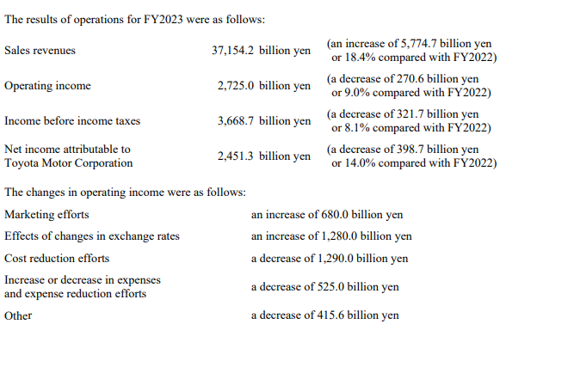
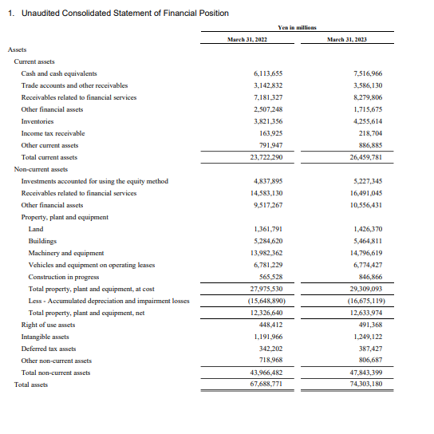
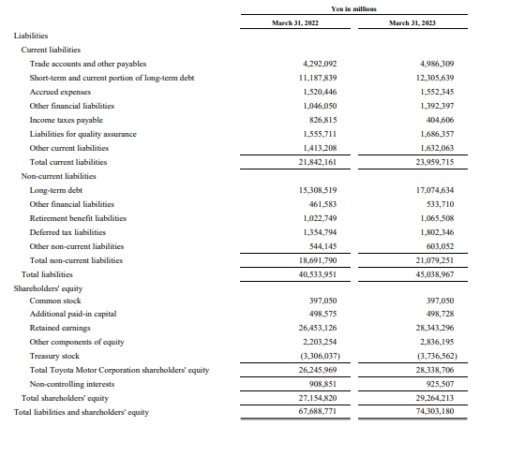
(Source: Global.toyota, 2023)

Appendix 2 - Toyota – one of the top-selling automobile brands in China

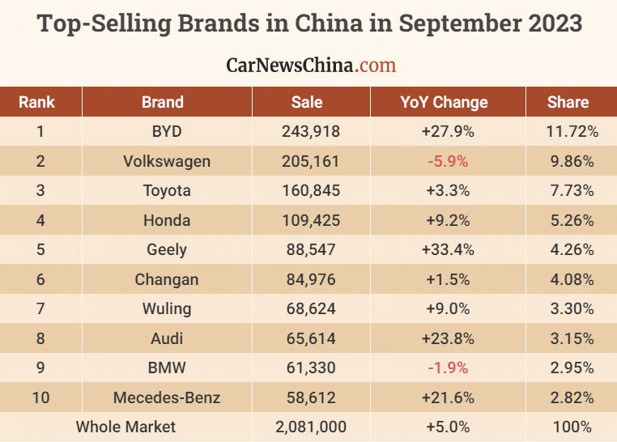
(Source: Carnewschina.com, 2023)

