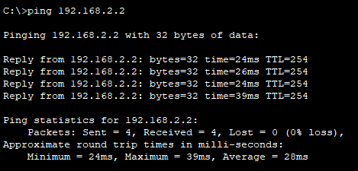
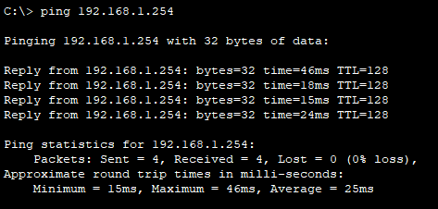
Server0 Router1

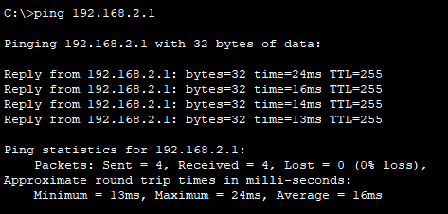
Router0 Printer0
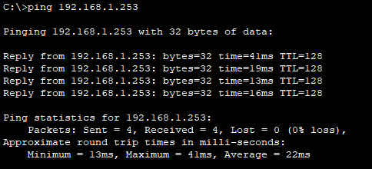

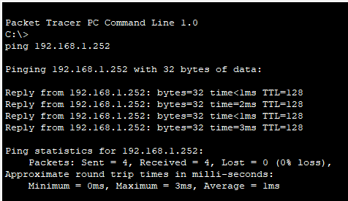
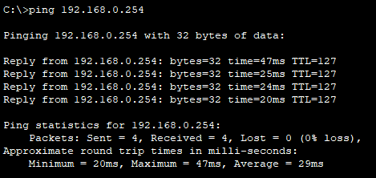
PC0 Laptop1

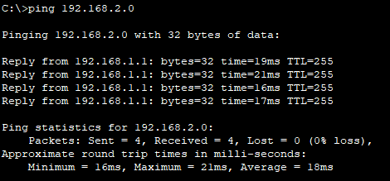
Default Gateway2 Default Gateway1
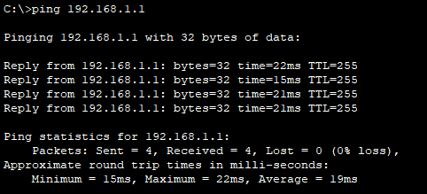

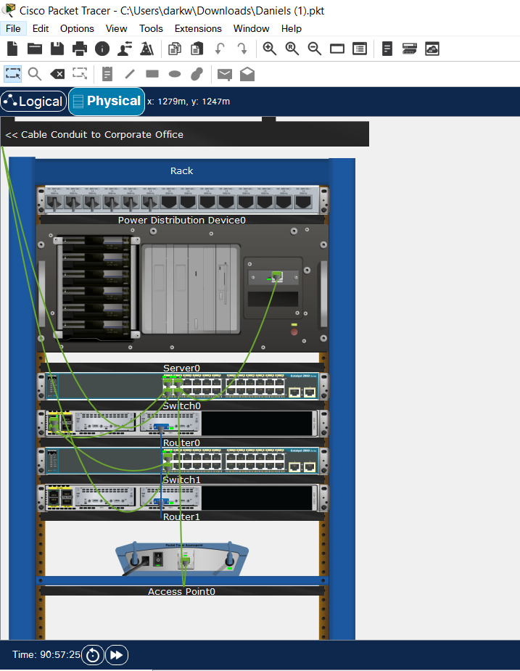
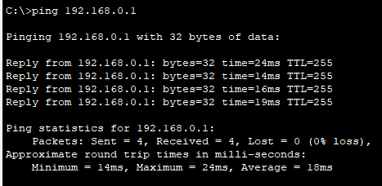
Default Gateway0 Physical1

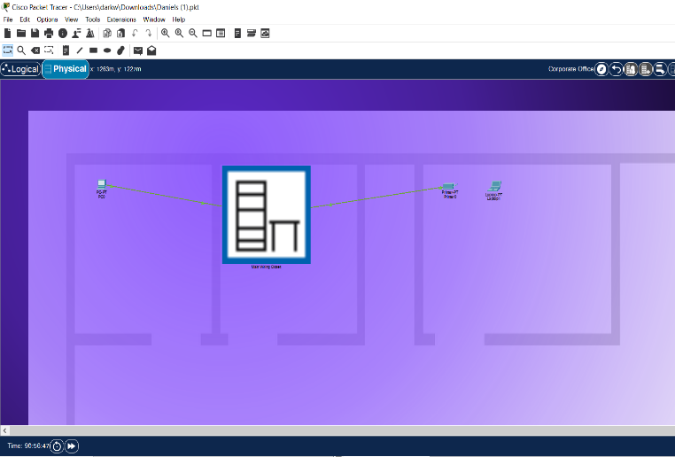
Physical0

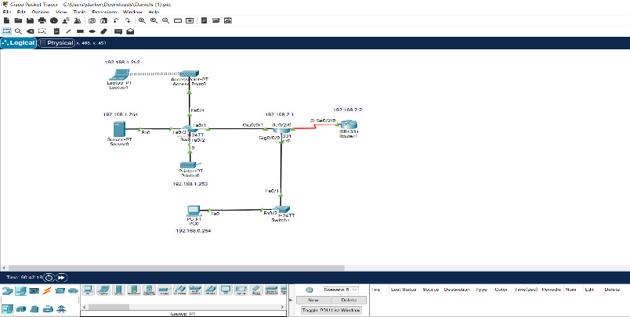
Logical

Device | Interface | IP Address | Subnet Mask | Default Gateway
Router1 | NIC | 192.168.2.2 | 255.255.255.0 | 192.168.2.0
Router0 | NIC | 192.168.2.1 | 255.255.255.0 | 192.168.2.0
PC0 | NIC | 192.168.0.254 | 255.255.255.0 | 192.168.0.1
Server0 | NIC | 192.168.1.254 | 255.255.255.0 | 192.168.1.1
Printer0 | NIC | 192.168.1.253 | 255.255.255.0 | 192.168.1.1
Laptop1 | NIC | 192.168.1.252 | 255.255.255.0 | 192.168.1.1
Logical Topology
PC1: NIC: 192.168.0.254 – 255.255.255.0 – 192.168.0.1
Server0: NIC: 192.168.1.254 – 255.255.255.0 – 192.168.1.1
Printer0: NIC: 192.168.1.253 – 255.255.255.0 – 192.168.1.1
Laptop1: NIC: 192.168.1.252 – 255.255.255.0 – 192.168.1.1
Router0: NIC: 192.168.2.1 – 255.255.255.0
Router0:
Gig0/0/0 192.168.0.1 – 255.255.255.0
Gig0/0/0 192.168.1.1 – 255.255.255.0
Se0/2/0 192.168.2.1 – 255.255.255.0


