Introducing Effective Team Working in Costa Coffee

Table of Content

Introduction…….................................... ………………………………………………… ..1
What is a team?..…….………………………………………………………………………2 Benefits of teamworking….……………………...……………………………………….....3
Stages of Team development……………………...………………………………………....5
Team roles.......................….……………………...……………………………………….....7
Managing conflicts..........….……………………...……………………………………….....10
Successful team development..…………………...……………………………………….....15
Conclusion…………………………………………………………………………………....17

Slide 1: Student name: Valeria Costina Petcu

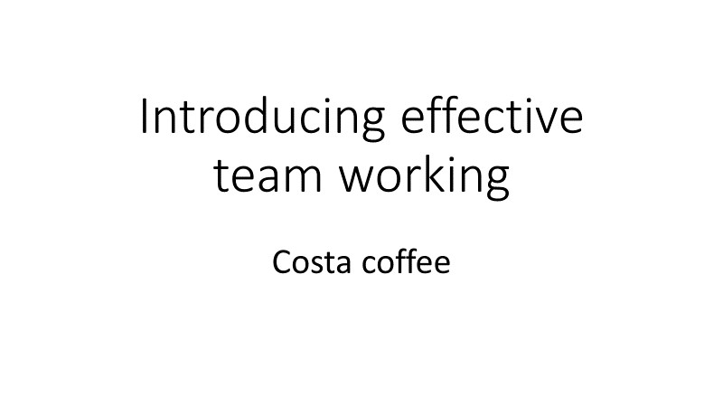

BENEFITS OF TEAM WORKING-VALERIA COSTINA PETCU-1913756
STAGES OF TEAM DEVELOPMENT-CATALINA ROSU-1917494
TEAM ROLES-KOFI ASANTE FREMPONG-1915172
MANAGING CONFLICT-ANDREEA RIZESCU-1917493
SUCCESSFUL TEAM DEVELOPMENT-FAITH AKAMO-1916095

Slide 2
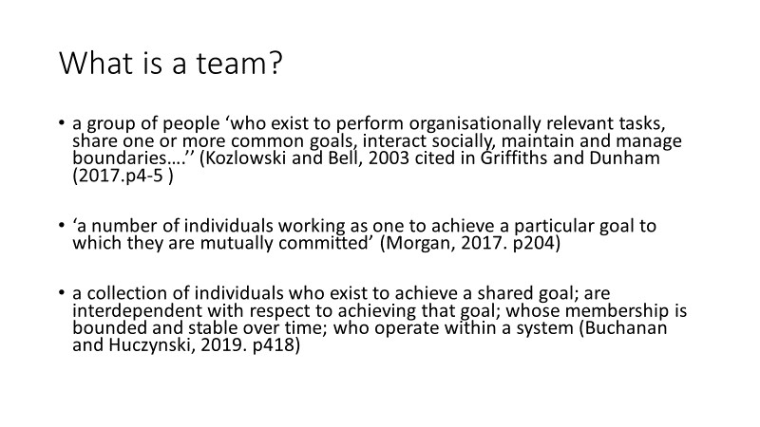

Slide 3
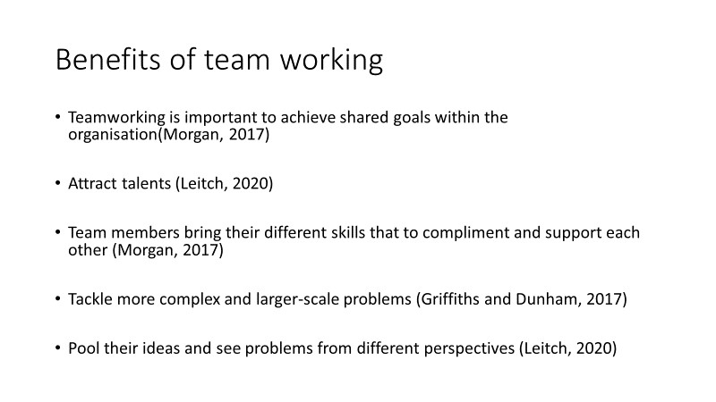

Slide 4
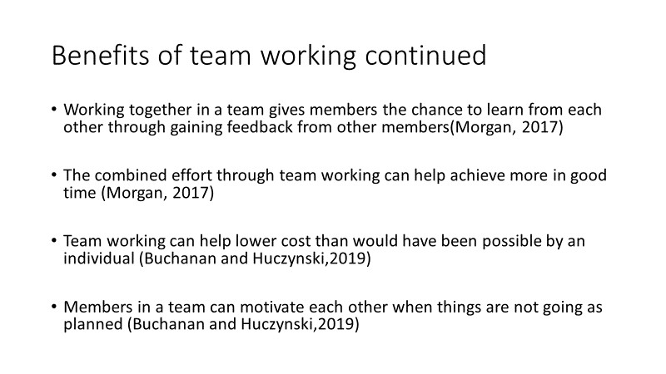

Slide 5
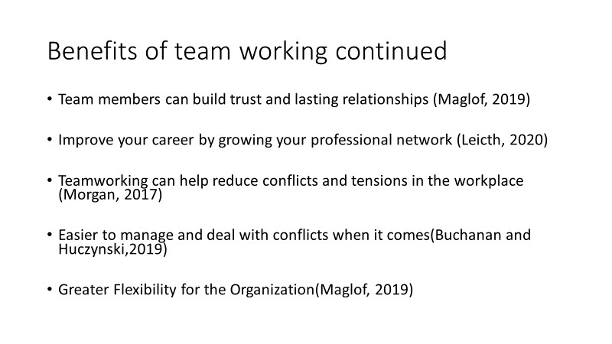

Slide 6
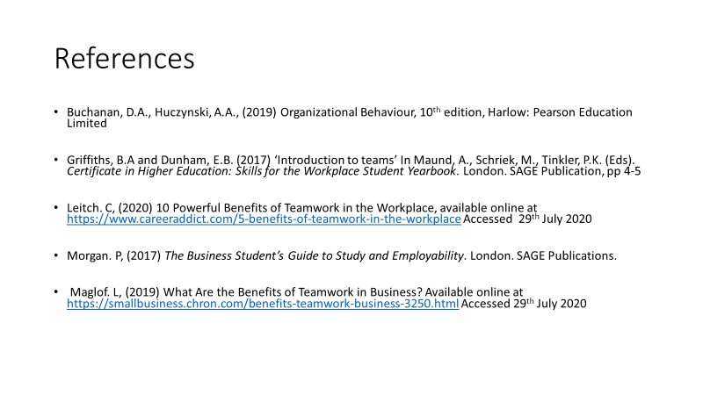

Slide 7: Student name: Catalina Rosu (1917494)
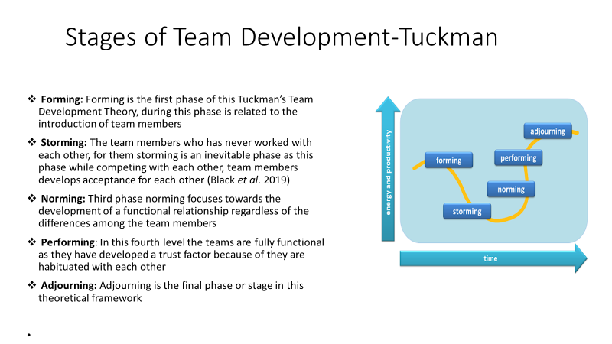

Slide 8

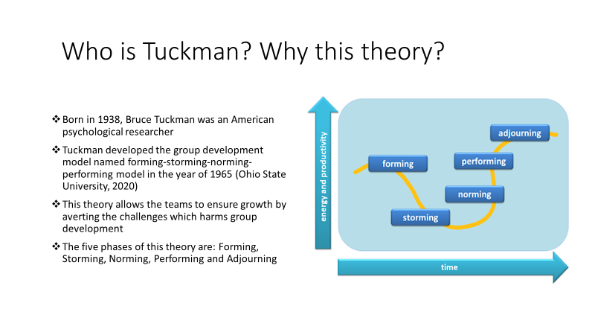
Slide 9
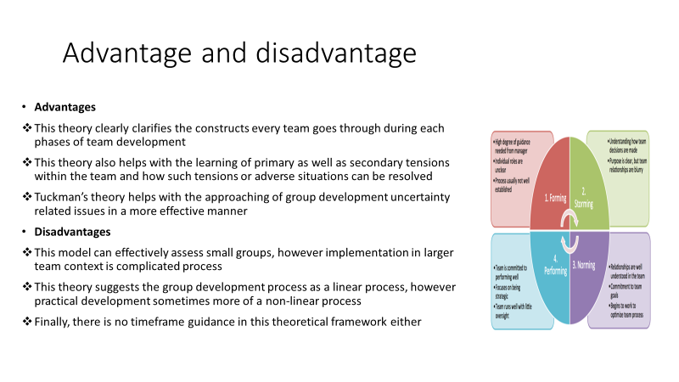

Slide 10
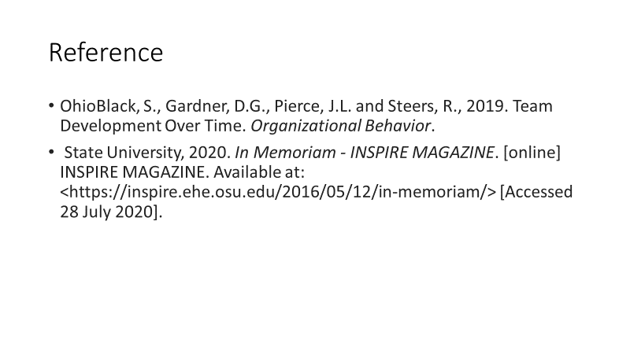
Slide 11
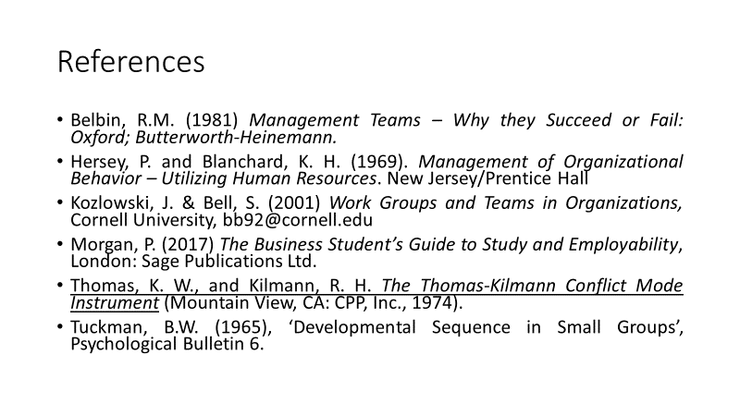

Slide 12 Student name: Kofi Asante Frempong (1915172)
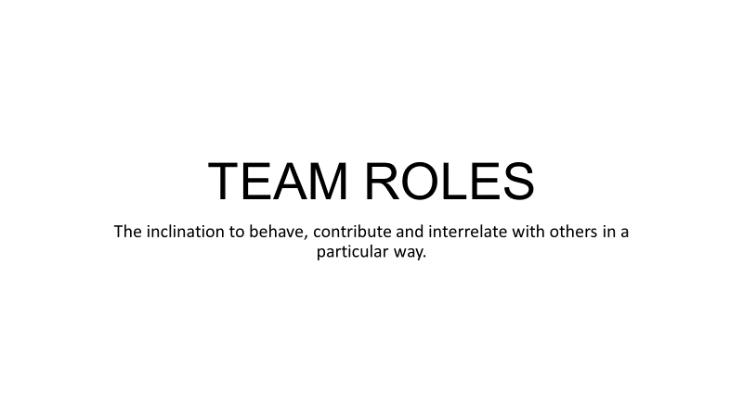

Slide 13
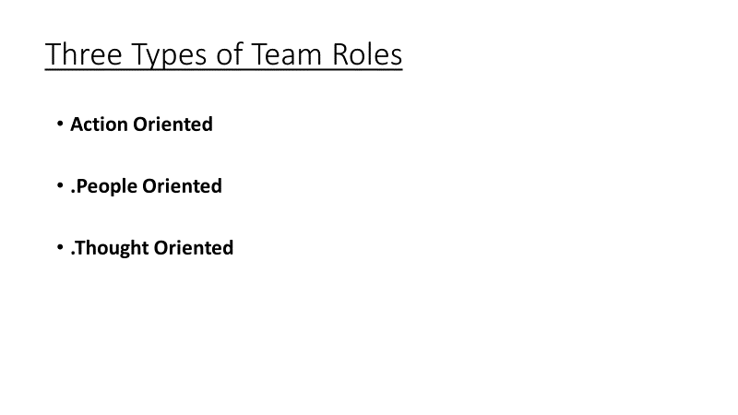

Slide 14
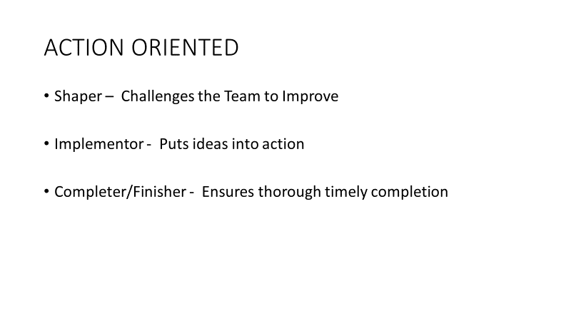
Slide 15
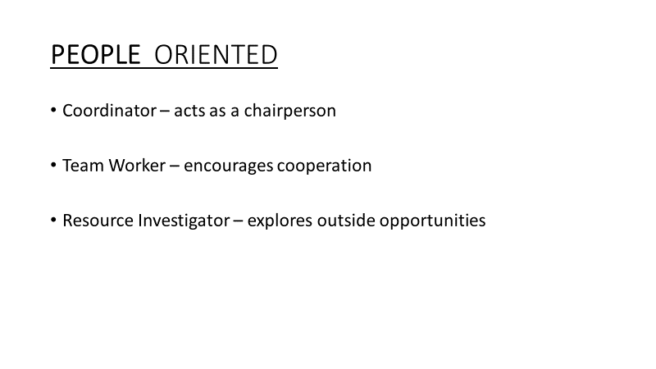

Slide 16
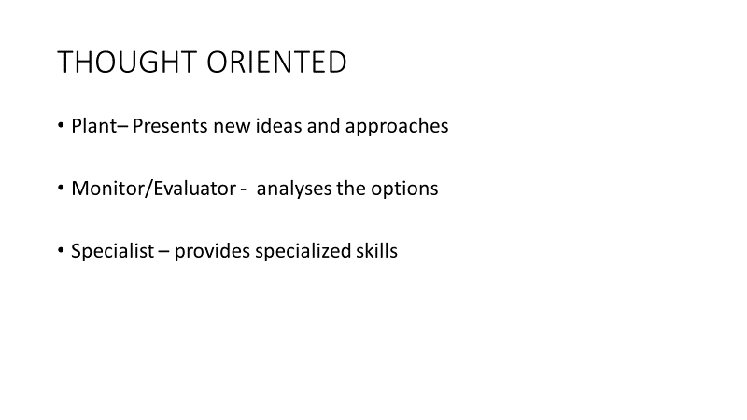

Slide 17

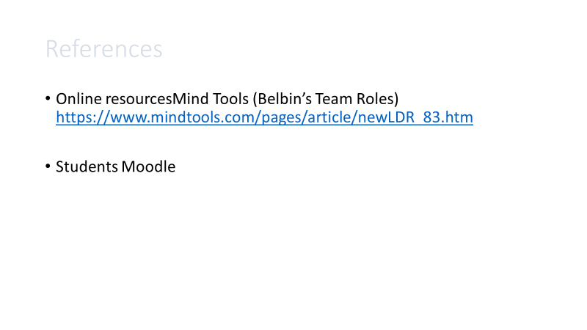
Slide 18: Student name Andreea Rizescu
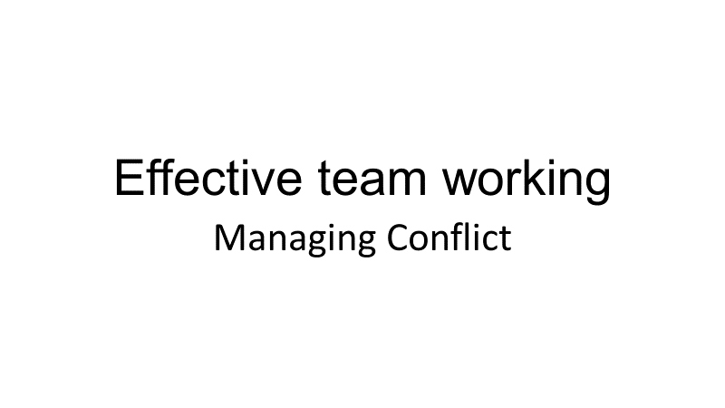
Slide 19
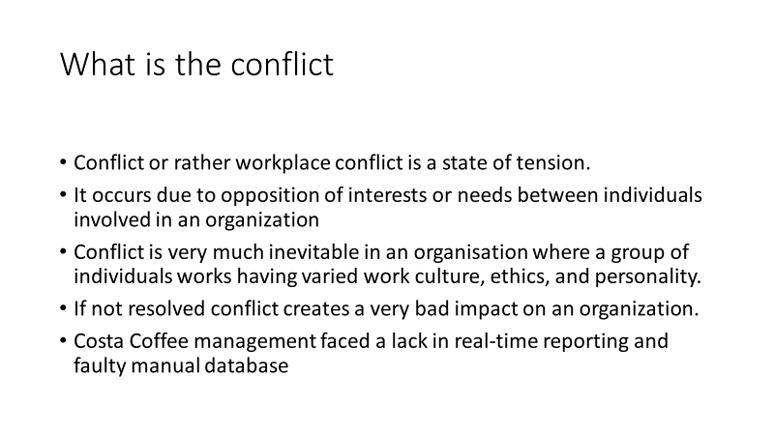

Slide 20
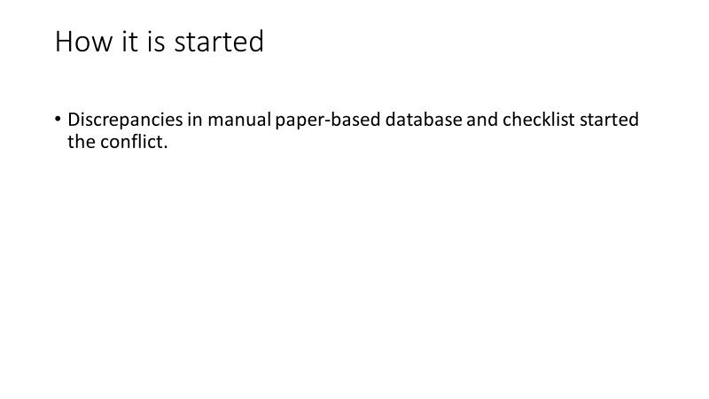

Slide 21:
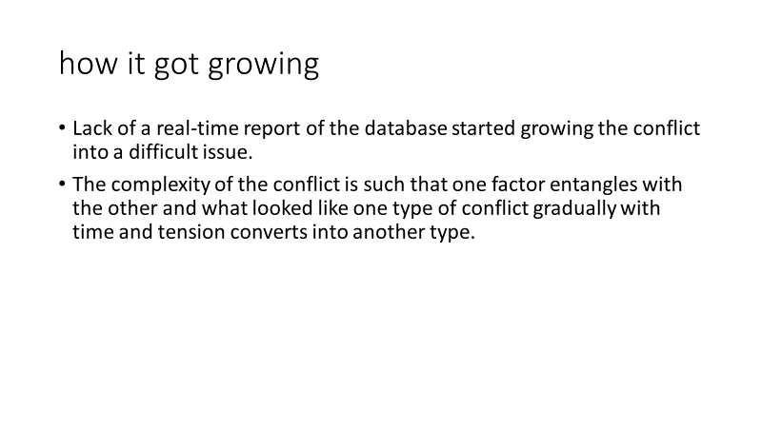

Slide 22
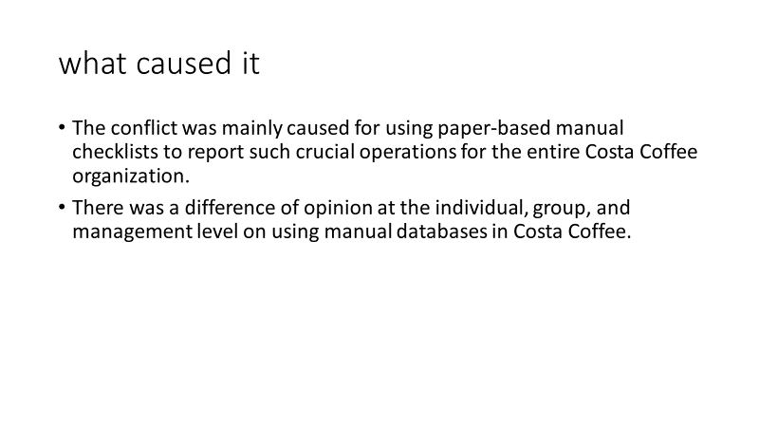
Slide 23:
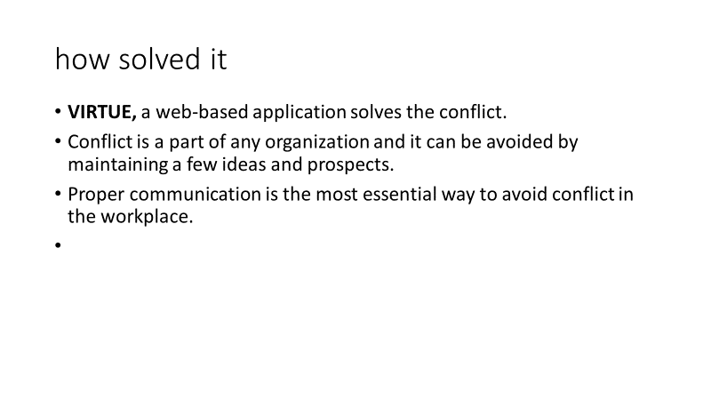

Slide 24:
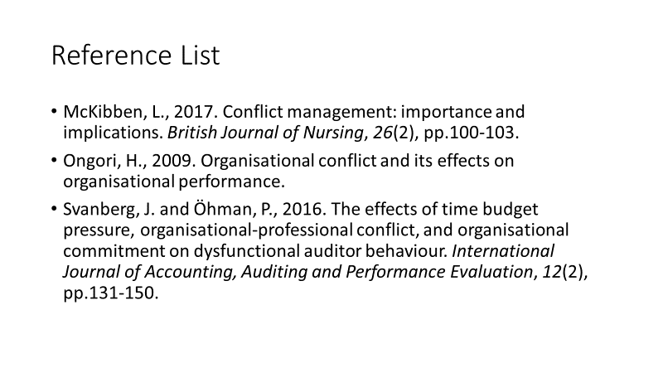

Slide 25: Student name: Faith Akamo (1916095)
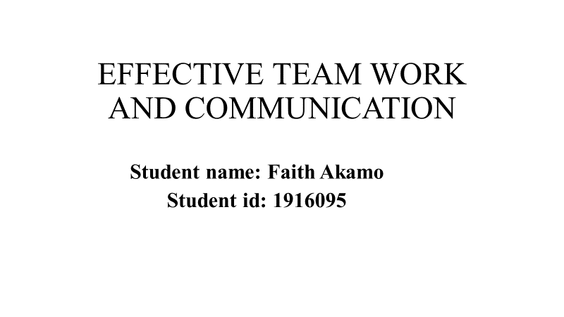

Slide 26
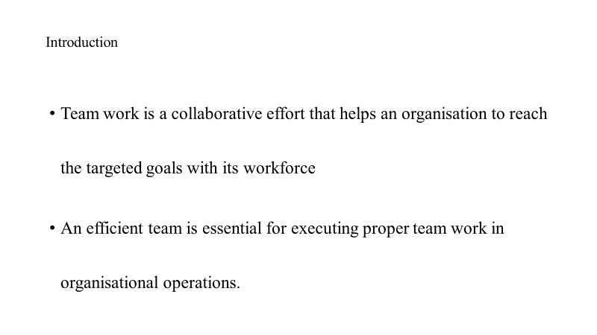

Slide 27
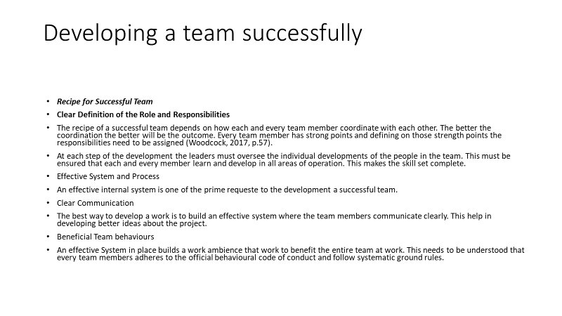
Slide 28
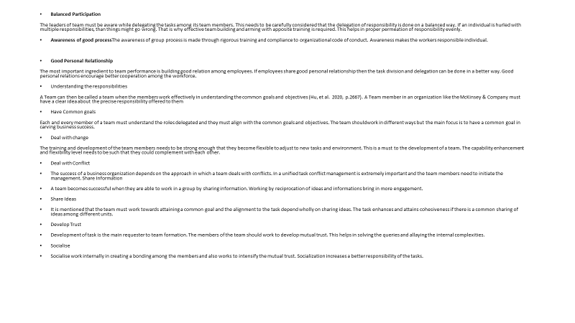

Slide 29
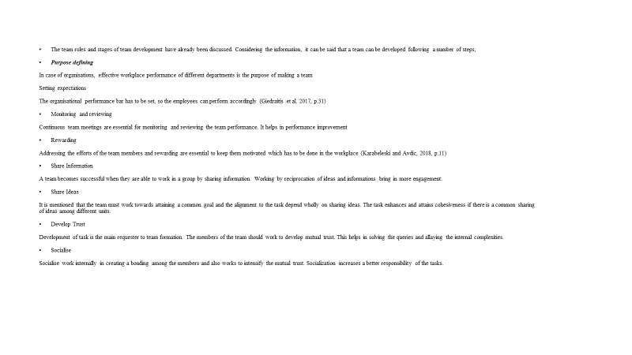
Slide 30


