Student name: Anca Mirela Dula
Student ID: 2112863
Lecturer name: Anupam Mazumdar
Date: 13/01/2023
Business management
Data Handling & Business Intelligence
LCBB5000
Assessment 2

Contents
Contents 1
INTRODUCTION 3
Part 1 3
Data handling and data visualisation by utilising MS excel 3
Data Handling in excel 4
Data analysis in Excel 5
Representation of the functions of excel and visualisation of data 5
Pivot table 5
LOOKUP Function 7
Representation of the data 8
Part 2 9
2.1 How many students like vanilla flavour of ice-cream? 9
2.2 How many students are Male and Female? 10
2.3 What are the Mean and Median of participants who likes chocolate and strawberry flavour ice-cream? 10
2.4 Explain the most common data mining and text mining methods that can be used in business with real world examples. 11
2.5 Explain the most common data mining and text mining methods that can be used in business with real world examples 19
2.6 Discuss the advantages and disadvantages of using SPSS and Excel using relevant practical examples and present your discussions in a table. 20
SPSS 20
Advantages and disadvantages of SPSS 21
Excel:- It is a software floated by Microsoft in its package of Office 365 suite. Almost ninety percent of the companies use this and finds compatible. It is useful because of its versatility. Its main use is data analysis. It provides users with a wide range of formulas to perform complex calculations. 21
Advantages and disadvantages of MS EXCEL:- 21
Conclusion 22
References 23

INTRODUCTION
Data handling is the analysis and interpretation of the information that can be derived from a data set. The analysis of the data set is the visual representation of the processed data, the visualisation helps in better analysis of the data and the required information from the data set can be derived in a better way. The visualisation of data can be in the forms of graphs, pie charts and plots. The tools used for the representation of the data are business intelligence tools such as power BI, tableau and MS excel. The report is about the data of super store and various tools from MS excel have been used been used to analyse the sales data that is the decline in sales data over the years and the region by region look at the sales performed the Excel tools used fro such are, Pivot table, pie chart, graphs, and lookup.

Part 1

Data handling and data visualisation by utilising MS excel
MS excel is the spread software most used by professional for the purpose of data handling and visualisation. The purpose of data analysis is to be able to use the data set available to formulate the plans for the future of the business and thus tools such as business intelligence and MS excel are very useful. MS excel includes many tools for the handling of the data and management of the raw data. The uses of the spreadsheet software include management of the data set, balancing the financial accounts and the further analysis of the financial statements, the visualisation the data in forms of pie charts and graphs. The software can even provide filtered data.
The Excel software is comprised of various functions for the analysis and filtration of big data sets, these functions include Vlookup, Hlookup, average function, mathematics equations, functions of trigonometry, extraction tools and IF analysis. All these functions make sorting and analysing the big data set much easier and hence professional and businesses can derive the desired information from the data set much easily hence making the handling big unorganised data easier.
Excel spreadsheet software also contains advanced tools for the visualisation of any given data in the forms of graphs and charts, this allows business and professional to easily formulate plans and interpret the data visually.

Data Handling in excel
Data handling can also be performed using the this is the conversion of data that is raw and unstructured into a structured and understandable form. The functions used for the purpose of data processing are:
IF function: IF function refers to the conditional function as in it gives values true or false. If the given data agrees for the condition applied the function retunes it as true and if the given data disagrees then the function returns false. For an example take if the value is considered for the condition that it is greater than 4, however the cell chosen contains the value of 1 then it would return as false.
IF error: The IF error function is also known as the trouble shooter function, as its name suggests this function is used to handle the errors when they may arise, example the user tries to find the value of something that does not exist the error arises.
Left and right function: The primary issue of the function is to return the values from the left side and the right side of a given data string. If the left function is used, then it would return the value set from the left and the same is true for the right side. This enables non programmes to use excel to its fullest potential.
Data analysis using excel
The raw data by using excel can be converted into data that is easy to interpret. The second step after converting the data then analysis of the data is performed to draw findings from the data set and to formulate future based on the data that is analysed. The tools for analysis of the data are.
Conditional Formatting: This function helps in formatting the data as per the desires of the user. This function can be used on multiple cells in one sheet.
Pivot Charts: Pivot chart is a reformatting tool that is used to group and summarise a large data set. This tool is found useful to interpret big data and summarise the data for users.
Extraction function: This function is used to compare two value sets and if the two values are an exact match or not.
Mathematical Functions: Mathematical functions include tools like sum, average, subtract, count, count if, standard deviation etc. these functions are used to perform basic mathematical functions in a data set.

Data analysis in Excel
This tool contains various basic and advanced statistical functions for the purposes of data analysis. These functions include regression analysis, standard deviation, and descriptive analysis. These tools enable the faster analysis of the given data set.
The biggest benefit of excel is that it contains all the functions will require the limited understanding to perform the basic functions related to the fields of data handling and data analysis of raw unfiltered data of a very large scale.

Representation of the functions of excel and visualisation of data
The representation of the functions of data includes the representation of the pivot table function which is used to summarise the data and the lookup function which is the tool used to look for a specific function in the data sheet made in excel.
The visual representation includes the graphs and charts of the data to give a more detailed analysis of the data.

Pivot table
The function of pivot table is used to present a basic summary and arrange the large data in a way that a short summary can be drawn from it. This make it easier for the business to do comparisons and analyse trends in the data. This summarisation makes the data more presentable and helps in the better visualisation of the data.
The pivot table efficiently compiles the data in an innovative way so that the amounts related to sales and profit for a specific period can be calculated easily. This data can also be filtered and sorted for more accuracy in the set. This also supports data mining with special formatting, random values, row column basis and fields in each data set. In this report the data of super store is analysed over a period of multiple years from 2009 to 2012. the data set contains around 8400 rows of data which is a very large volume. The requirement out of this data is the sales per year and the profit from the sales, the order quantity of each year is also filtered to provide a comparison in the data. The sales figure of the superstore has suffered a decrease year by year. the decline from 2009 to 2010 was at 15% this resulted in total difference of 68,178.69 in the subsequent profits. The decrease in 2011 was recorded at 130142 and the fall was 3429944.981 however the profit levels increased. The sale level then increased in 2012 by 285727 and then profit decreased by 37866.4 margin. The ordered quantity also increased by 3067 units. Grand total of the sales over the period was 14915600.82 and total quantity of units sold was 214780.
Pivot Table
Row Labels | Sum of Sales | Sum of Profit | Sum of Order Quantity
2009 | 4209896.846 | 434096.02 | 54508
2010 | 3560087.045 | 364917.33 | 54379
2011 | 3429944.981 | 380310.5 | 51413
2012 | 3715671.953 | 342444.13 | 54480
Grand Total | 14915600.82 | 1521767.98 | 214780

decreased or increased value of sales and profit for each year
sales | profit
0 | 0
-649810 | -69178.7
-130142 | 15393.17
285727 | -37866.4

LOOKUP Function
The lookup function is a tool used to get the given value of a condition in a large data set. The lookup function can fetch the data from both horizontal and vertical data placed in either of rows or columns. The Hlookup is a function used to find data value according to the rows of a data set. The function of Vlookup is used to find the values in columns of a data set. The function works on recovering the data from a range of a given array, it can search for an exact match or the closest value to search array. If it returns an exact match, then the return value given should be 0 or false and if the return value is closest then the return value should be 1 or true. The function used for getting the data from large data set manually as searching data individually in the data set is impossible the function makes this task easier. In the given data set the function of Vlookup is used to find the row Id. The formula for accessing Vlookup is
=VLOOKUP (Lookup value, Table array, column index number, lookup value)
The formula can be broken down and explained as Lookup value refers to the value for which the search is being conducted, table array refers to the range of data where the function should search in order to find the value that is being looked up. Column index refers to the column under which the value looked up will be found and the look up value is the part where the command is given to if exact value is being looked up then '0' or 'FALSE' is the input and if closest value is being looked up then '1' or 'TRUE' is the input.
In the given data set the function of vlookup is used on row 100 hence it will be done in the following way.
Firstly, the selection of a blank cell is done where the data will be fetched after this the selection of table array from which the data will be fetched is done. The third step is the selection of the profit column which lies at the 9th column from the starting position. And finally, the lookup value is entered at 0 for an exact match of data or 1 for closest value.
The formula for such will look like =VLOOKUP (G3, SHEET1! A2:K8401,9, TRUE)
VLOOKUP
Row ID | 100
get profit- | 127.7

Representation of the data
Representation of data is done for a visual presentation of the data so that it can be easily interpreted. Excel provides better representation of a data set as it enables the data to be visualised using tools such as line charts, pie chart and column graphs. These charts and graphs can be used to define relation between multiple data, each type of tools used for representation has its own benefits and the preference for the tools is on the business or professional using it.

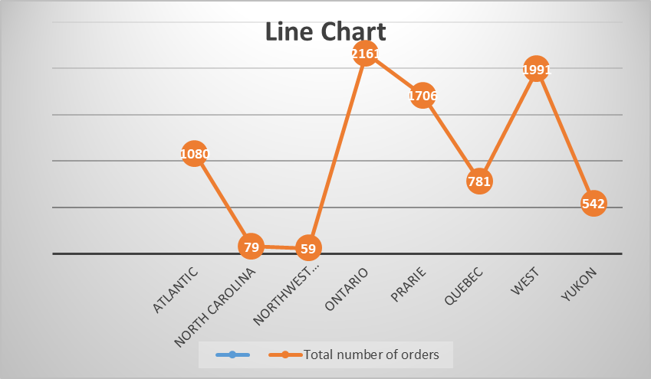
Region | Total number of orders
Atlantic | 1080
North Carolina | 79
Northwest Territories | 59
Ontario | 2161
Prarie | 1706
Quebec | 781
West | 1991
Yukon | 542

The line chart represents the number of orders from different regions
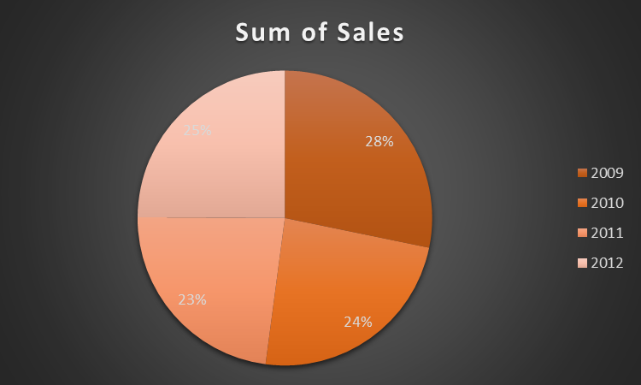
The pie chart is the representation sum of sales of the super store

Part 2

2.1 How many students like vanilla flavour of ice-cream?
2.1
COUNT | FAV. FLAVOR
95 | Vanilla
47 | Chocolate
58 | Strawberry
From the above table it is analysed that the students who likes vanilla flavour of ice-cream are 95 which is analysed with calculation through COUNTIF formula (Abu-Bader and Jones,2021).

2.2 How many students are Male and Female?
2.2
91 | Male
109 | Female
200 | total
From above table it is analysed that out of total students 91 of them are male and 109 are female as per the formula of COUNT IF.

2.3 What are the Mean and Median of participants who likes chocolate and strawberry flavour ice-cream?
2.3
52.5 | Mean
63 | Median of Chocolate
101.5 | Median of Strawberry
It is analysed from the above median of the participants who likes chocolate is 63 and that of strawberry is 101.5

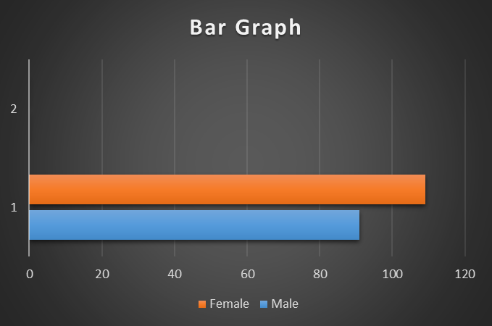

Fig: Bar Graph showing number of males and females in the given data

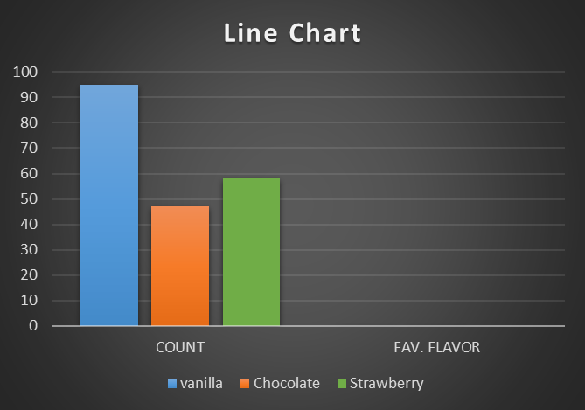
Fig: Line Chart showing number of people in the data who likes Vanilla, Chocolate and Strawberry flavour respectively.

2.4 Explain the most common data mining and text mining methods that can be used in business with real world examples.
Table 1: -
Initial Cluster Centres
 | Cluster
 | 1 | 2 | 3
Gender | .00 | 1.00 | 1.00
Favorite Flavor | 2.00 | 1.00 | 3.00
It is identified from the above Initial cluster table that three of the clusters refers to Vanilla (first cluster), Chocolate (second Cluster), Strawberry (third cluster) whose values are based on 2 variables i.e., Favourite Flavour and Gender.
Table 2: -
Iteration Historyª
Change in Cluster Centers  1 | Change in Cluster Centers
Change in Cluster Centers  1 | 1 | 1
.298 | .298 | .298
.363 | .363 | .363
.000 | .000 | .000

It has been identified from the above table that the number of the iterations and the changes in the cluster centres has been identified. .298 of change has been identified in the first cluster, from .363 to .500 is identified as the second cluster change and no change has been identified in the third cluster.

Table 3: -
Cluster Membership
Case Number | Cluster | Distance
1 | 1 | .605
2 | 2 | .000
3 | 3 | .500
4 | 3 | .500
5 | 1 | .605
6 | 1 | .605
7 | 1 | .605
8 | 1 | .605
9 | 1 | .605
10 | 1 | .605
11 | 1 | .605
12 | 1 | .605
13 | 3 | .500
14 | 3 | .500
15 | 1 | .605
16 | 1 | .605
17 | 3 | .500
18 | 1 | .605
19 | 3 | .500
20 | 1 | .605
21 | 1 | .605
22 | 1 | .605
23 | 1 | .605
24 | 3 | .500
25 | 1 | .605
26 | 1 | .605
27 | 3 | .500
28 | 1 | .605
29 | 3 | .500
30 | 1 | .605
31 | 1 | .605
32 | 3 | .500
33 | 3 | .500
34 | 1 | .605
35 | 3 | .500
36 | 3 | .500
37 | 1 | .605
38 | 3 | .500
39 | 1 | .605
40 | 1 | .605
41 | 1 | .605
42 | 1 | .605
43 | 1 | .605
44 | 1 | .605
45 | 3 | .500
46 | 1 | .605
47 | 3 | .500
48 | 1 | .605
49 | 1 | .605
50 | 1 | .605
51 | 1 | .605
52 | 3 | .500
53 | 1 | .605
54 | 1 | .605
55 | 1 | .605
56 | 3 | .500
57 | 1 | .605
58 | 1 | .605
59 | 1 | .605
60 | 1 | .605
61 | 1 | .605
62 | 3 | .500
63 | 1 | .605
64 | 1 | .605
65 | 3 | .500
66 | 1 | .605
67 | 1 | .605
68 | 1 | .605
69 | 1 | .605
70 | 1 | .605
71 | 1 | .605
72 | 3 | .500
73 | 1 | .605
74 | 1 | .605
75 | 1 | .605
76 | 1 | .605
77 | 3 | .500
78 | 3 | .500
79 | 1 | .605
80 | 3 | .500
81 | 3 | .500
82 | 1 | .605
83 | 1 | .605
84 | 1 | .605
85 | 1 | .605
86 | 3 | .500
87 | 3 | .500
88 | 3 | .500
89 | 1 | .605
90 | 3 | .500
91 | 1 | .605
92 | 1 | .605
93 | 3 | .500
94 | 1 | .828
95 | 1 | .828
96 | 1 | .828
97 | 2 | .000
98 | 3 | .500
99 | 1 | .828
100 | 3 | .500
101 | 3 | .500
102 | 3 | .500
103 | 1 | .828
104 | 3 | .500
105 | 2 | .000
106 | 2 | .000
107 | 3 | .500
108 | 1 | .828
109 | 1 | .828
110 | 3 | .500
111 | 2 | .000
112 | 1 | .828
113 | 3 | .500
114 | 1 | .828
115 | 3 | .500
116 | 2 | .000
117 | 3 | .500
118 | 3 | .500
119 | 1 | .828
120 | 1 | .828
121 | 1 | .828
122 | 2 | .000
123 | 2 | .000
124 | 2 | .000
125 | 1 | .828
126 | 3 | .500
127 | 2 | .000
128 | 2 | .000
129 | 3 | .500
130 | 1 | .828
131 | 2 | .000
132 | 1 | .828
133 | 2 | .000
134 | 2 | .000
135 | 1 | .828
136 | 3 | .500
137 | 2 | .000
138 | 2 | .000
139 | 2 | .000
140 | 2 | .000
141 | 1 | .828
142 | 3 | .500
143 | 2 | .000
144 | 2 | .000
145 | 2 | .000
146 | 3 | .500
147 | 2 | .000
148 | 2 | .000
149 | 1 | .828
150 | 1 | .828
151 | 1 | .828
152 | 3 | .500
153 | 2 | .000
154 | 2 | .000
155 | 2 | .000
156 | 2 | .000
157 | 2 | .000
158 | 2 | .000
159 | 2 | .000
160 | 3 | .500
161 | 1 | .828
162 | 2 | .000
163 | 3 | .500
164 | 1 | .828
165 | 2 | .000
166 | 1 | .828
167 | 2 | .000
168 | 1 | .828
169 | 2 | .000
170 | 1 | .828
171 | 1 | .828
172 | 2 | .000
173 | 3 | .500
174 | 3 | .500
175 | 1 | .828
176 | 1 | .828
177 | 2 | .000
178 | 2 | .000
179 | 3 | .500
180 | 1 | .828
181 | 2 | .000
182 | 2 | .000
183 | 3 | .500
184 | 2 | .000
185 | 3 | .500
186 | 1 | .828
187 | 2 | .000
188 | 2 | .000
189 | 3 | .500
190 | 1 | .828
191 | 1 | .828
192 | 3 | .500
193 | 2 | .000
194 | 3 | .500
195 | 2 | .000
196 | 2 | .000
197 | 2 | .000
198 | 2 | .000
199 | 2 | .000
200 | 3 | .500

Table 4: -
Final Cluster Centers
 | Cluster
 | 1 | 2 | 3
Gender | .34 | 1.00 | .50
FavoriteFlavor | 1.50 | 1.00 | 3.00

From the above table it is identified that from final cluster centre, .34 is the change in gender from 1, in cluster 2, the change identified is 1 and in the cluster 3, identified change is .50(Li and et. al., 2020).
Table 6: -

Distances between Final Cluster Centers
Cluster | 1 | 2 | 3
1 |  | .828 | 1.508
2 | .828 |  | 2.062
3 | 1.508 | 2.062
From the above table it is analysed that by making comparison of the result of table 1 and table 4 the cluster of 3 is not changing. The result from the analysis is completely descriptive.
Table 7: -

ANOVA
 |  | Cluster |  | Error |  | F
 |  | Mean Square | df | Mean Square | df | F
Gender |  | 6.994 | 2 | .181 | 197 | 38.698
Favourite Flavour |  | 61.328 | 2 | .119 | 197 | 514.107

Number of Cases in each Cluster
Cluster | 1
Cluster | 2
Cluster | 3
Valid
Missing
According to the above data vanilla flavour affect the forming of cluster maximum and Chocolate is affecting least.

2.5 Explain the most common data mining and text mining methods that can be used in business with real world examples
The process of choosing and analysing text and data sources in huge amount in order to search, discovering relations, finding patterns and analysing how the content is relatable with the ideas and requirements is termed as Text and data mining (TDM). Following is some of the data mining tools:
SAS data mining: Statistical Analysis System (SAS) is a tool supports to analyse and manage the data by aid the user in mining, changing, and managing different sets of data from various sources. It also provides a particular graphical user interface which is not technically equipped adequate for the users (Chu and et. al., 2021). This kind of mining tool will allow in taking decisions quickly while serving the reason of data mining and optimising too. It is also utilised to remove and clean the data errors and remove fake and useless sets of data.
Oracle data mining: This tool is helpful for the analysts in building and implementing various models. Different tasks could be done with the support of it including classification, regression, prediction, detecting anomaly and others. It is also helpful in building models to support determined behaviour of customer, segment, and target profiles, identify theft and analyse the first strength to target.
Weka: This is helpful in graphical interface which supports in performing tasks without efforts, for each task clustering, processing, and visualising in built machine learned algorithm is given which aid in fast testing of concepts and puts the models without coding. It is very helpful in educational sector and in exploring domain to show data in appropriate forms.
Ayleen: This mining is implemented AI, machine learning and language processor and base on cloud to assist the process of automation of understanding human created documents and forms. It becomes more useful tool with the presence of: entity extraction, categorisation and topic discovery.
Thematic: It is also powered by AI which helps in transforming feedbacks into acknowledgeable and actionable data. Two distinct products of this data are Thematic intelligence which helps to highlight the feedback and then compound the phrases that are similar when seen. The other one is Thematic catalyst which proceeds to group those phrases in the positive as well as negative category. Different patterns and relationships are formed between much feedbacks which can easily be analysed by making sub themes, grouping customers or incorporating metrics to learn about the deep consequences along with their solutions.
Thematic catalyst also supports to make dashboards of the derived information’s from the received set of data. This helps in influencing partners and management to take quick measures on customer's complaints (Wagner III, 2019).
Comprehend by Amazon- This processor is a natural language processor which make use of the machine learning for revealing the useful information. This processor also finds the various relationships in texts. It is used to extract places, phrases, brands, people, and meanings in terms of emotions behind the phrases or texts. This processor is helpful in decision making, maintaining, and creating the data.
IBM Watson- This is a platform used to unveil values from the data. Some of the tools of this platform are personality insights and tone analysers. The tone analyser helps in examining the emotions and tones of the feedbacks given by the clients. The personality insight foretells the habits, preferences, and personality traits of the customers with linguistic analysers.

2.6 Discuss the advantages and disadvantages of using SPSS and Excel using relevant practical examples and present your discussions in a table.

SPSS
The full form of SPSS is statistical package for the social sciences. It is a quite popular tool used for performing experiments, doing analysis and research while the decision-making process of financial and management decisions (Morgan and et. al., 2019). It is a software developed by IBM. It is a data mining tool as it helps to extract data to perform various calculations like trigonometry, algebra etc. some of the advantages and disadvantages of this tool are as follows: -

Advantages and disadvantages of SPSS
Advantages | Disadvantages
It is a time saving software which helps to perform tasks within minutes. | It is not very useful when it comes to analysing big sets of data.
Time saving further leads to better efficiency and optimum utilisation of resources. | It fails to give accurate answers in case of biasedness or any kind of fault in the collection of data.
It is helpful in evaluating large number of complex data by using samples and variables. | It only gives answers of complex problems. It does not provide proper justification of the answers.
This software focuses on both the conceptual and technical part. | The graph features are too complicated and not very easy to use.

Excel: - It is a software floated by Microsoft in its package of Office 365 suite. Almost ninety percent of the companies use this and finds compatible. It is useful because of its versatility. Its main use is data analysis. It provides users with a wide range of formulas to perform complex calculations.

Advantages and disadvantages of MS EXCEL: -
Advantages | Disadvantages
It has a wide range of templates which enables users to be creative in data research and analysis. | This software lacks behind in providing security and other controls.
It is useful in creating presentable data visualisations. | It is difficult to consolidate all the data in single sheet.
It does not require any hard training as it is easy to use with minimum guidance. | It does not help in aiding in delivering fast decision making.
It gives access to multiple number of spreadsheets to the users. | It is not appropriate for teamwork or collaborating.
It is very useful while inserting tables. It is also useful while inserting charts and graphs. | Its rules of advance pricing are difficult to manage.

Conclusion
To conclude the report, it reflects the analysis and visualisation of two different sets. The first is superstore set. The profits and sales of each year have been derived in this with the help of MS Excel. The sales have been decreasing since 2009 and the region with highest sales is Ontario. The second set has been visualised through pie charts. Some questions with the help of analytical tools have been answered.

References
Chu, X., and et. al. (2021). Metal organic framework derived porous carbon materials excel as an excellent platform for high-performance packaged supercapacitors. Nanoscale, 13(11), pp.5570-5593.
Li, X., and et. al. (2020). GeoBalance: An Excel VBA program for mass balance calculation in geosciences. Geochemistry, 80(2), p.125629.
Abu-Bader, S. and Jones, T.V. (2021). Statistical mediation analysis using the Sobel test and Hayes SPSS process macro. International Journal of Quantitative and Qualitative Research Methods.
Morgan, G.A. and et. al. (2019). IBM SPSS for Introductory Statistics: Use and Interpretation: Use and Interpretation. Routledge.
Wagner III, W.E. (2019). Using IBM® SPSS® statistics for research methods and social science statistics. Sage Publications.
Aldrich, J.O. (2018). Using IBM SPSS statistics: An interactive hands-on approach. Sage Publications.

