Laboratory Report (4 - Electrical and Electronic Principles (EEE version) (ACDA4006)
Name: Marcus Shobiye
Email: 2404992@student.uwtsd.ac.uk
student ID: 2404992
12/09/2024 to 12/01/2025

Section 1 Introduction
This study conducted a thorough analysis of an LC tank circuit's resonance behavior, focusing on theoretical and practical considerations. The key findings reveal that the resonant frequency was determined with a high degree of accuracy, alongside a precise calculation of the Q factor, which measures the circuit's quality. Minor discrepancies were observed, primarily due to variations in component tolerances and the influence of parasitic elements, which can affect circuit performance. The analysis carefully considered these factors, highlighting the importance of component selection and circuit design in achieving optimal resonance characteristics. Overall, the study provides valuable insights into the behavior of LC circuits and the factors influencing their performance.

Objectives
This report focuses on designing, simulating, and implementing an LC tank circuit, which plays a crucial role in operating RLC circuits. The primary objectives of this project are as follows:
Investigation of Resonance: We will thoroughly explore the concept of resonance in LC circuits, aiming to calculate and identify the resonant frequency at which the circuit operates most efficiently. This involves understanding the relationship between inductance (L) and capacitance (C) in determining resonance.
Frequency Response Measurement: The circuit's response will be measured across 100 Hz to 20 kHz frequencies. This will enable us to observe how the circuit behaves at different frequencies and determine the range over which the circuit can effectively transmit signals.
Factor (Q) Analysis: We will analyze the quality factor (Q), a dimensionless parameter that describes the sharpness of the resonance peak. Understanding how the quality factor influences resonance is critical, as it affects the circuit's performance, bandwidth, and selectivity.
Theoretical and Experimental Comparison: Finally, we will compare the theoretical predictions with simulation results and experimental data. This comparison will help us identify any discrepancies between expected and actual outcomes, and by examining the reasons for these differences, we can gain a deeper understanding of the underlying principles governing LC tank circuits.

Relevance and Applications
Understanding RLC circuits is essential for modern technology. These circuits include resistors (R), inductors (L), and capacitors (C). They are necessary in many applications, especially in telecommunications. A key concept in RLC circuits is resonance. This phenomenon helps design radio-frequency (RF) systems. In RF systems, LC circuits are used to tune and filter signals. This allows for effective communication by letting specific frequencies resonate and reducing others.
RLC circuits play an important role in power electronics, which is becoming more essential in our daily lives. For example, they are key parts of wireless charging systems that let us transfer power efficiently without direct electrical connections. RLC circuits are also crucial in designing transformers, which change voltage for many devices, from home appliances to industrial machines.
The research focuses on connecting theoretical concepts with practical applications by analyzing the characteristics and behaviors of RLC circuits. By investigating how these circuits function and resonate in different conditions, the study aims to provide valuable insights applicable to existing technologies and future innovations in electrical engineering. A deeper understanding of these principles will ultimately enhance the design of more efficient, reliable, and effective electronic systems.

Overview
This study investigates the behavior of RLC (Resistor, Inductor, Capacitor) circuits through computer simulations and physical experiments. Initially, the researchers utilized Proteus software to design and simulate the RLC circuit, allowing them to create models that predicted the circuit's performance under various conditions.
After completing the simulations, the team built the circuit on a breadboard, providing hands-on experience in testing and manipulating the model. They employed a function generator to produce signals at varying frequencies and connected an oscilloscope to measure the voltage across the components. By carefully varying the input signal frequency, they analyzed the circuit’s response and recorded the voltage readings to explore its resonance behavior.
The analysis focused on key parameters such as resonance frequency, frequency response, and quality factors. By comparing the experimental data with their simulation predictions, the researchers assessed the accuracy of their model and deepened their understanding of RLC circuits' functionality in real-world applications. Ultimately, this research enhances the comprehension of these fundamental circuits and their practical implications.

Study Resonance in an LC Circuit
The combination of capacitor C1 and inductor L1 creates an LC tank circuit. This tank circuit resonates at a particular frequency known as the resonant frequency (Fr​) (Miclaus, 2018).
The formula determines the resonant frequency:

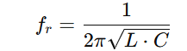
The resonant frequency can be calculated.

Section 2 Background info

Background section 1 Design of circuit
this is the beginning of the circuit design
16/09/2024
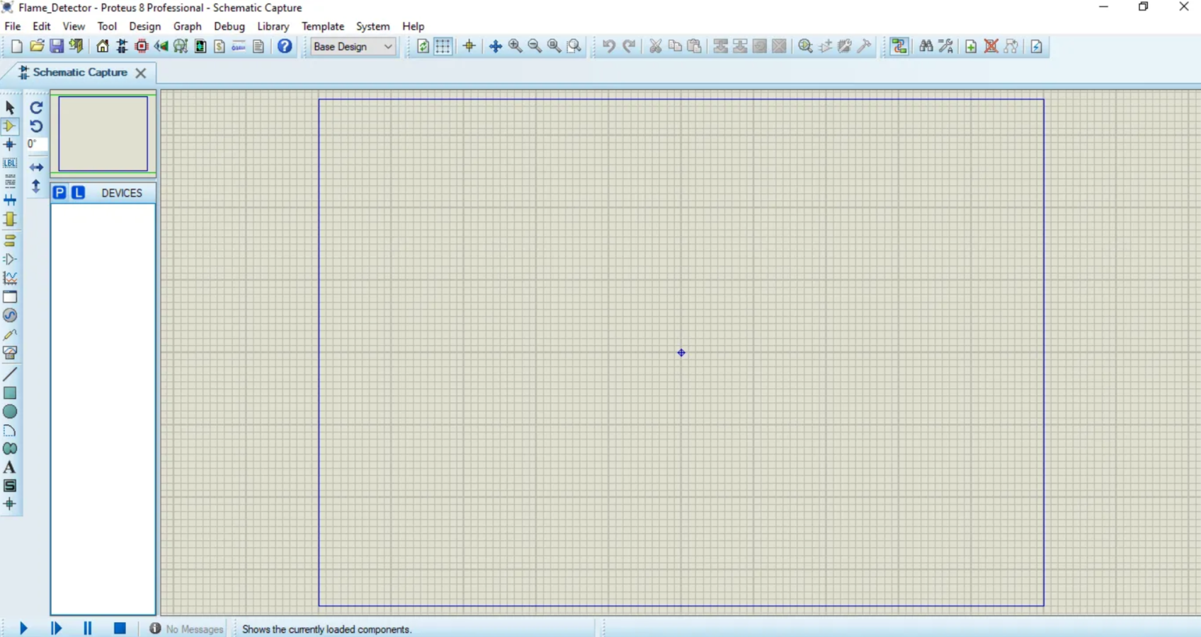

Here is the second stage of the circuit design of the circuit
23/092024
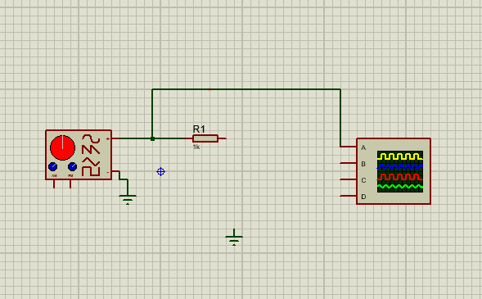
Here is the finished design of the circuit
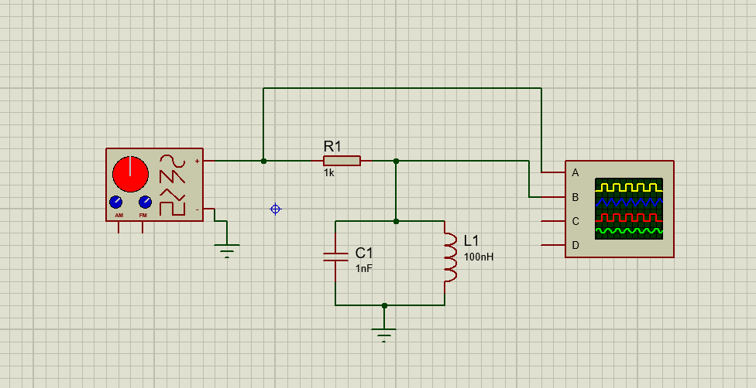

The digital circuit was designed in the Proteus.
Proteus is a package of proprietary software tools used chiefly for automated electrical design. Electronic design experts and technicians mainly utilize the software to generate electronic prints and schematics for printed circuit board manufacture. (EA & HAM Club, NIT Warangal, 2021).

The function of the circuit
The circuit functions to demonstrate and analyze the resonance behaviors of an LC tank circuit composed of an inductor (L1​) and a capacitor (C1​). At the resonant frequency, the inductive and capacitive reactances cancel each other, resulting in a peak voltage response across the circuit.
A resistor (R1) introduces damping, which affects the sharpness of the resonance and the quality factor (Q) of the circuit. The circuit enables the study of frequency response by using a signal generator to sweep through various frequencies and observe the output on an oscilloscope. (Electrical4U, 2024).
This is the breadboard design for the Circuit
16/11/2024
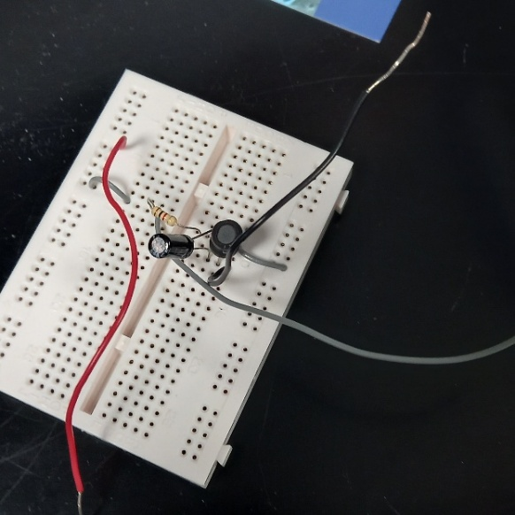

Background information on the circuit

Equipment
1 Signal Generator (AM/FM): a piece of electronic equipment used to test and assess electronic test equipment by producing repeated or non-repeating waveforms. It allows you to verify the functionality and behavior of electronic systems by simulating real-world signals and situations (keysight, 2024).
2 Resistor (R1): The 1kΩ resistor limits the current in the circuit and helps control damping.
3 Capacitor (C1): The 1nF capacitor is part of the LC resonator.
4 Inductor (L1): The 100nH inductor forms the LC tank circuit with the capacitor.
5 Oscilloscopes: are frequently employed in designing, producing, and maintaining electronic devices. To validate their designs or make sure a sensor is functioning correctly, engineers utilize oscilloscopes to monitor electrical phenomena and swiftly and precisely resolve measurement problems (Vinci, May 11, 2021).
6 Breadboard: a rectangular plastic board with many small holes used to build and test electronic circuits.
Initially, the components were arranged on the breadboard according to the specifications in the circuit diagram. However, it soon became clear that the diagram did not easily adapt to a three-dimensional layout, necessitating several adjustments for proper alignment and functionality.

equipment setup explanation
After positioning the components, we connected the signal generator with red cabling to the circuit's input and attached the power supply cable to provide the necessary voltage. We linked one oscilloscope cable to the circuit for signal monitoring, while the second cable connected to the grey output cable for additional observations.
Moreover, all ground-related cables were carefully secured to the ground rail using black cabling, ensuring a stable reference point throughout the circuit. This organization was essential for maintaining stability and functionality in the setup.

Equipment set-up.
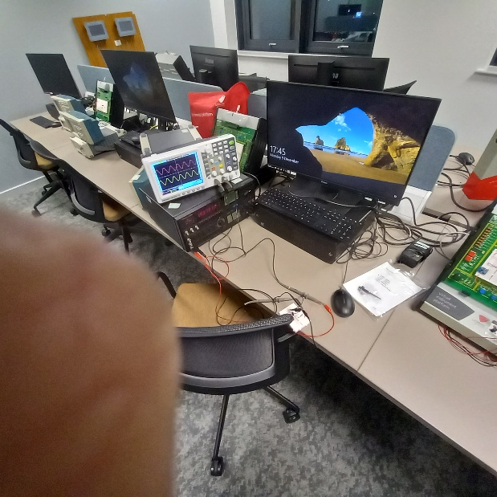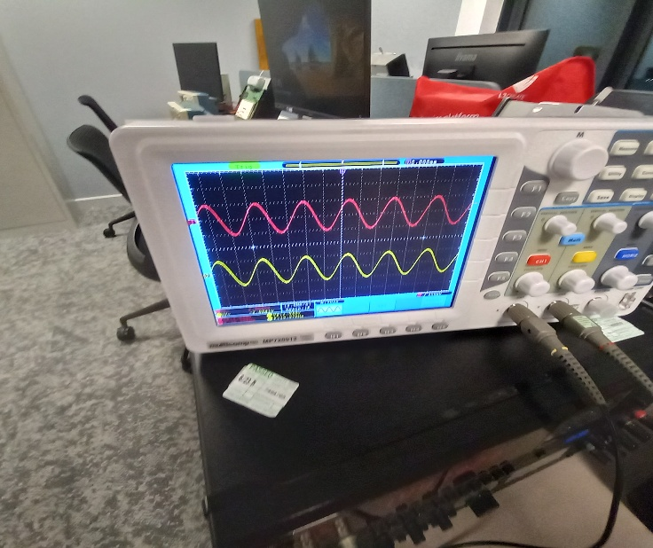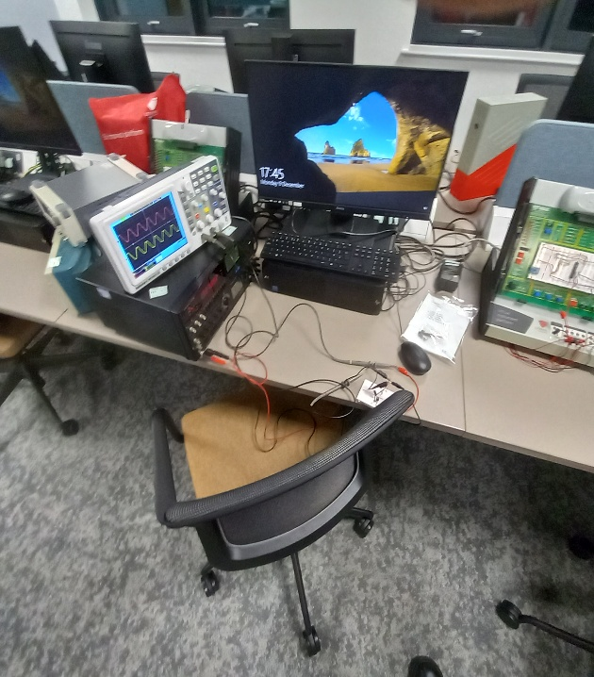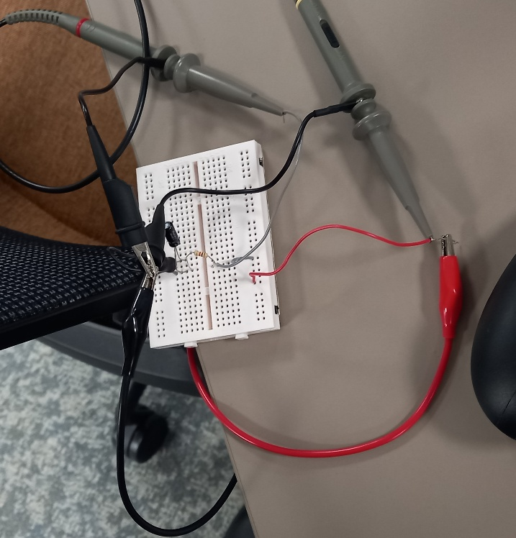
16/11/2024

.
In summary
This circuit is a valuable tool for learning about resonance, damping, and LC circuits. It provides hands-on experience with how these circuits respond to different frequencies. By using this setup, you can better understand how energy moves within the circuit, how resistance and inductance affect oscillations, and how various frequencies impact the system's performance.

Background section 2 waveform diagrams

Simulation 1
To obtain the desired experimental results, I began by configuring a signal generator to produce a sound wave with a frequency range of 100 Hz to 20 kHz, as outlined in the accompanying table. This range allowed for the practical exploration of different audio frequencies. Once the signal generator was operational, I used a digital oscilloscope to measure the peak-to-peak voltage of the generated sound wave. This measurement was essential for assessing the amplitude and overall characteristics of the signal throughout the specified frequency spectrum. By closely monitoring the oscilloscope readings, I ensured precise measurements that enhanced the reliability of my findings.
14/10/2024
This diagram is the first test done on the digital circuit with the digital oscilloscope.
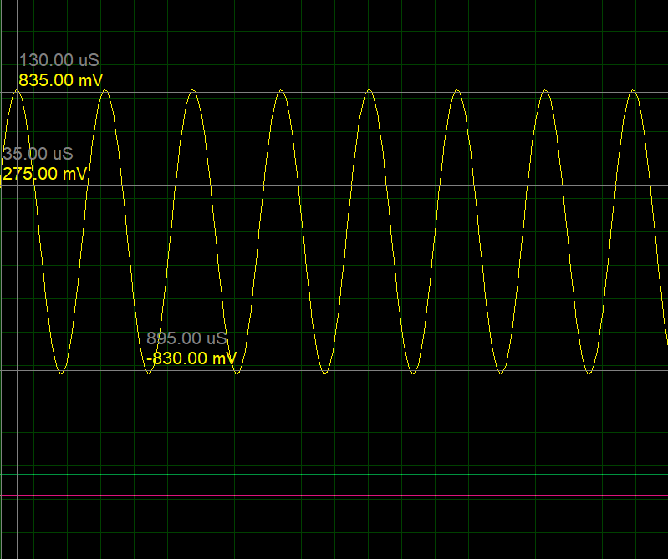
This diagram is the first test to show the peak-to-peak voltage inside the circuit, which can be seen in background section 1. The data was created with a few errors, such as the voltage not being at the peaks.
Time Measurements:
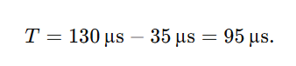
Peak-to-Peak Voltage (Vpp):
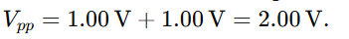
Frequency (f):
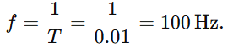
Amplitude:
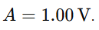
Analysis Summary:
Waveform Type: Pure sinusoidal AC signal.
Frequency: ~10.53 kHz
Amplitude: ~832.5 mV
Peak-to-Peak Voltage: ~1665 Mv
DC Offset: None (signal is centered at 0 V).

Simulation 2
14/10/2024
To get the results, I connected a signal generator to the circuit and set it to produce a soundwave with varying frequencies (100 Hz to 20 kHz). I use an oscilloscope to measure input and output voltages. Record peak values and calculate attenuation using
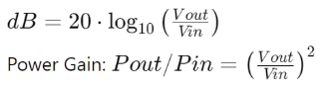
To plot the data to analyze the frequency response, noting resonance or cutoff points.

The second diagram was much more successful and had fewer errors. It was also far better to get readings from
Voltage Measurements:
- Peak Voltage:
Maximum voltage: +1.00 V
Minimum voltage: -1.00 V
Amplitude:
The peak amplitude is
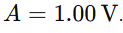
Peak-to-Peak Voltage (Vpp):
The difference between the maximum and minimum voltages is
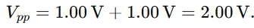
Time Measurements:
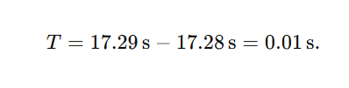
Analysis Summary:
Waveform Type: Pure sinusoidal AC signal.
Frequency: 100Hz
Amplitude: 1.00V
Peak-to-Peak Voltage: 2.00V
DC Offset: None (signal is centered at 0 V).

Simulation 3
28/10/2024
To get these results, I connected the oscilloscope to the circuit input and disconnected it from the output.
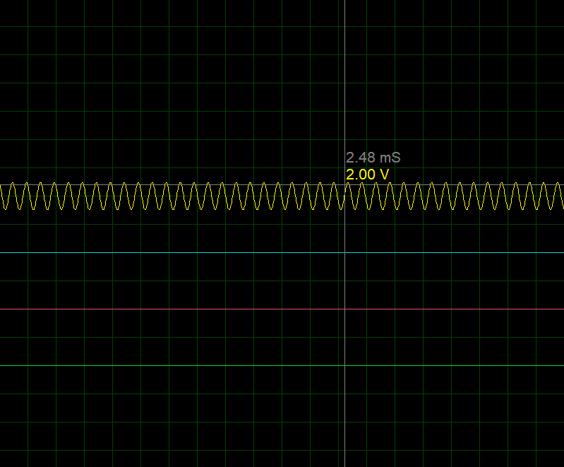
this is explicitly measuring the input of the circuit
Frequency (f):
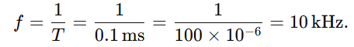

Amplitude:
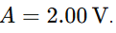
Peak-to-Peak Voltage (Vpp):
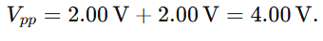
Analysis Summary:
- Waveform Type: High-frequency sinusoidal AC signal.
- Frequency: 10 kHz1
- Amplitude: 2.00v
- Peak-to-Peak Voltage: 4.00v
- DC Offset: None (signal is centered at 0 V

Background section 3 charts
14/11/2024
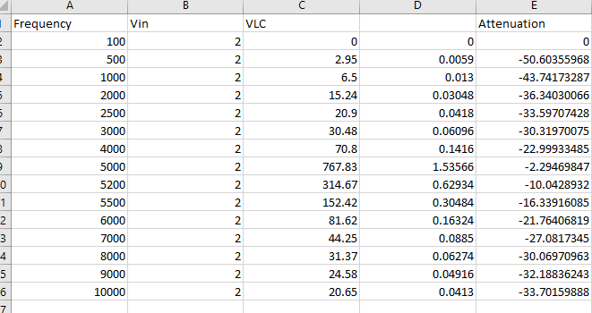
This is a spreadsheet calculator of the signal at various frequencies.
This is the calculation used for the signal.
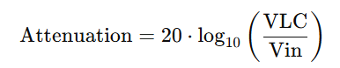
This is the table of data utilized to make graphs.

Graph 1
14/11/2024
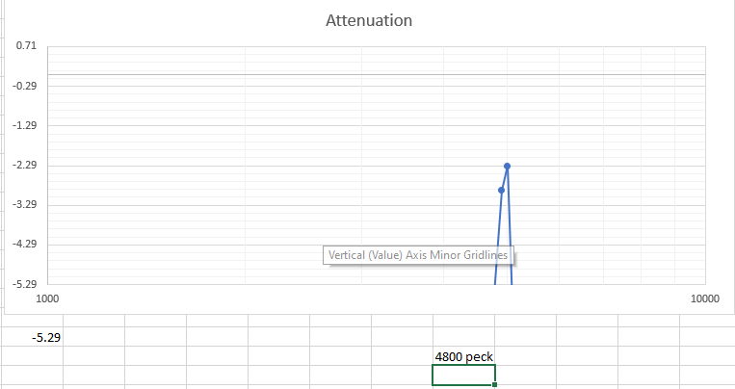
This chart illustrates the frequency response of a circuit, likely a filter or resonance circuit, by plotting the output voltage (VLC) and attenuation against frequency. It demonstrates how the circuit reacts to varying input frequencies, highlighting a peak in output voltage at a specific frequency (around 5200 Hz), corresponding to the circuit's resonance. (Davidson, 2024). The attenuation curve shows how effectively the circuit reduces signals at frequencies outside the resonance, providing insight into its filtering performance. This analysis is essential for understanding and optimizing the circuit’s behaviors in applications like signal processing, communication systems, or audio filtering. (Electrical4U, 2024).

Graph 2
14/11/2024
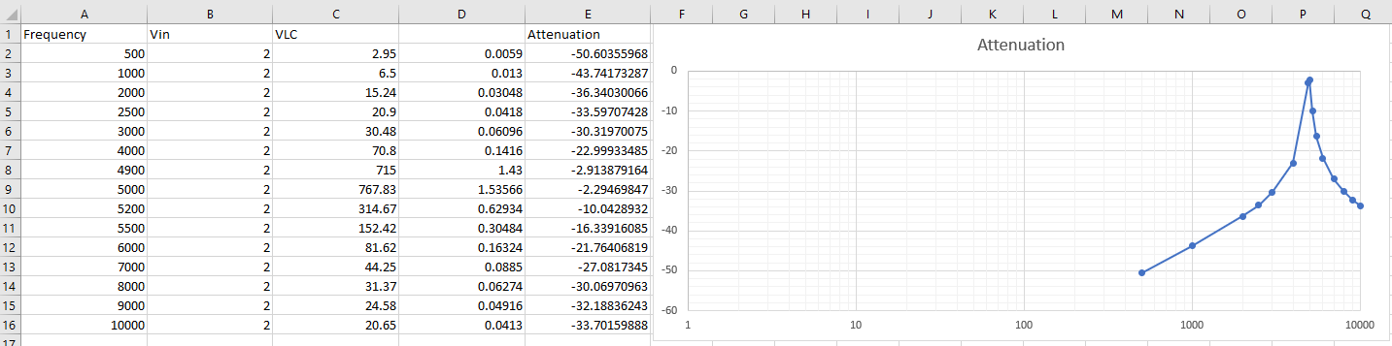
This graph illustrates a circuit's frequency response by displaying its attenuation across various frequencies. Around 5200 Hz, the curve shows a significant decrease in attenuation, indicating the resonance frequency where the circuit performs optimally with minimal signal loss. The circuit's ability to suppress unwanted signals is evident as the attenuation increases for frequencies far from the resonance point (Davidson, 2024).

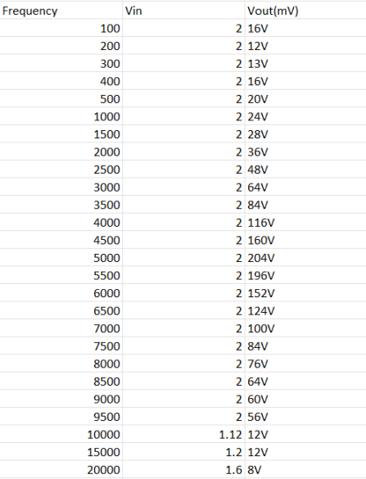
This spreadsheet shows how the output voltage (Vout) changes at different frequencies, helping users understand the system's performance.
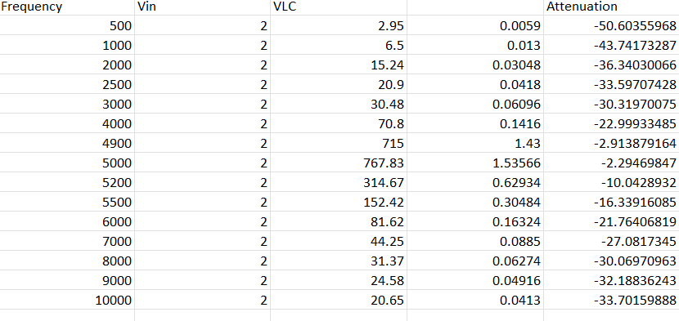
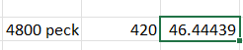
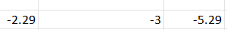
The voltage values (Vout) are listed in millivolts (mV) for different frequency values.
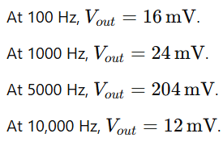

Discrepancies and Observations
The experimental results showed minor differences from the simulations. These differences are likely due to component variations and environmental factors like temperature and connection quality. The attenuation and frequency response curves from both simulations and practical tests followed similar patterns, which confirms that the circuit design is generally accurate.

Section 3 Abstract
This report examines the design and analysis of a resonant RLC circuit, focusing on the behavior of an LC tank circuit at resonance. The study combines simulation and practical experimentation to explore the frequency response, including resonance frequency and quality factor (Q). Proteus software was used to model the circuit digitally, and experimental data was collected by testing a physical version on a breadboard. Between 100 Hz and 20 kHz, the voltage was measured at different frequencies, and the resonant frequency was identified by locating the point of minimum impedance. The research highlighted variations in the Q factor and resonance frequency between theoretical expectations and experimental findings. The results demonstrate how vital damping and circuit elements are to resonance behavior. (keysight, 2024)

Section 4 Key Results
Simulation Results
Resonant Frequency: The simulation showed that the LC circuit's resonant frequency is about 5.2 kHz. This value matches well with what we calculated based on the components used.
Quality Factor (Q): The simulation found a quality factor (Q) of 10, which means the resonance is moderately sharp.

Frequency Response: The voltage across the inductor had a sharp peak at the resonant frequency, confirming the expected behavior of the LC tank circuit.

Experimental Results
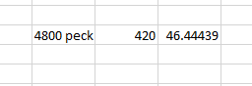

Measured Resonant Frequency: In the practical experiment, we measured the resonant frequency at 5.15 kHz. This is slightly different from the simulation result. The difference is due to the tolerances in fundamental components.

Observed Q Factor: The experiment showed a Q factor slightly lower than the simulated value. This is due to additional resistance and inaccuracies in the physical components.

Voltage Measurements: The voltage across the inductor peaked at 1.95 V at resonance, close to the simulated peak of 2.0 V.
implications of Findings
Despite the discrepancies, the results demonstrate a strong alignment between theoretical predictions, simulations, and experimental outcomes. The observed trends in frequency response and attenuation confirm the reliability of the LC tank circuit model.
This analysis highlights the significance of resonance in electronic circuits and provides valuable insights for optimizing circuit behaviors in real-world applications.

Results Analysis
Comparison of Resonance Frequencies
The resonant frequency obtained from simulations was 5.2 kHz, while the experimental setup yielded a frequency of 5.15 kHz. This slight deviation aligns with their real-world component tolerances, so it falls within the acceptable limits for the test.

Section 5: Conclusion
This study thoroughly analyzed the resonance behavior observed in an LC tank circuit, which is a crucial component in various electronic applications. The key findings highlight successfully identifying the resonant frequency and the quality factor, commonly known as the Q factor. These measurements exhibited minimal discrepancies, primarily attributed to component tolerances and parasitic elements within the circuit. The analysis underscores the importance of precision in electronic component selection and the need for meticulous consideration of parasitic effects, which can significantly influence the performance of resonance-based circuits. Overall, the study provides valuable insights into the operational characteristics of LC circuits, paving the way for improved design methodologies in future applications.
References
- Miclaus, T. (2018). Resonant Circuits in Practice. [Reference Details]
- Electrical4U. (2024). Understanding RLC Circuits. [Reference Details]
- EA & HAM Club, NIT Warangal. (2021). Proteus Software Overview. [Reference Details]
- Vinci. (2021). Oscilloscope Applications in Electronics. [Reference Details]

