The Transformation of Service Methods -
Bala Jewelry Chain Store

MODULE NAME : Change and Stability Management(BMMB7000)
NAME : Zefeng Zhang
STUDENT NUMBER : 2217959

Contents
Executive Summary 3
1. Introduction 4
2. Planned Change 4
3. Kurt Lewin Force Field Analysis 5
3.1 Driving force of change 6
3.2 Resistance to change 5
4. Lewin's three-step model --Freezing and refreezing 8
5. Kotter's Eight Step Model for Leading Change--Change Strategies 9
6. Evaluation of Change and Effectiveness 11
7. Conclusion 11
8. Recommendations 12
Reference List 12

Executive Summary
This paper introduces the transformation process and principles of Bala Jewelry Company. Many people believe that organizational change is caused by serious problems within the objective environment and organization. In fact, enterprise managers also play a significant and even decisive role in organizational change. The author deeply recognizes the important role of leadership in the process of change by studying the course of enterprise change and combining it with the example of change at Bala Jewelry Company. This paper also utilized Lewin et al.'s organizational change model to conduct in-depth analysis and evaluation of the company's change situation, and further understood the theoretical significance of the change model through examples.

- Introduction
Bala Company is a jewelry chain company located in Guangzhou, China. The company was founded in 2001. The founder of Bala Company is a person who enjoys innovation and product research. Through years of operation, it has expanded multiple branches. The COVID-19 in 2019 has brought a heavy blow to the company. After the impact of the epidemic for nearly three years, the company's senior management clearly felt that the company and its own suppliers are changing, and the styles and samples of the raw material market are no longer as fast updated and rich as before the epidemic (Chuprov, 2015). Performance growth is turning rapidly, and bad news is coming one after another. Everyone is in the midst of it, with poor expectations for the future and anxiety about reality. The three-year epidemic has almost caused the company to lose more than half of its performance. During the epidemic, the company's senior management also tried to lead the team to carry out Livestreaming sales and online sales, but the effect was not very good, and no truly effective sales channel strategy was formed. The founder of the company realizes that the crisis has arrived, and if the company is not prepared to take measures, it will enter an irreversible situation. Finally, the company has undergone changes in the past two years, including changes in the service methods and employee management of each store. This paper will analyze Bala's transformation process and results. It will determine through analysis what are the dominant factors behind this change, what are the reasons behind it, and what forces and factors have perfectly opposed the forces that hinder it. And it will also critically evaluate whether this change is beneficial or hindering for the organization. In this process, this paper will evaluate key internal and external drivers such as culture, leadership, power, and economic environment by examining them.

This document will utilize and reference theoretical models, ideas, and concepts to identify the factors that hinder change and their causes in the process of change. This article will utilize a series of data sources, including theoretical models, published literature, secondary research, and network diagrams, to provide information, tools, and arguments for the author's analysis process.

- Planned Change

This is a plan that has been brewing for two or even three years, which is a global plan made by the company's senior management after comprehensive and systematic research on the diagnosed problems. The senior management of the company will plan to hold multiple meetings, conduct investigations and research, and come up with the best action plan. Then, the plan will be implemented step by step, and the changes will be carried out simultaneously with the adjustment of organizational policies, work systems and management methods, and personnel training. Because from the moment of the outbreak of the epidemic, at the end of the Chinese lunar calendar in 2019, on the Chinese New Year's Eve, military doctors from Shanghai were urgently deployed to Wuhan, which also has a branch of the company. At that time, the senior management of the company had already sensed that things were not going well. Three long years have passed, and the CEO of Bala Jewelry Company has never relaxed his nerves. Every day, his expenses and revenue hover at the financial critical point(Jeffrey et al. 2013). Although online sales also generate some revenue, the management understands that the end of the epidemic is the beginning of change.
3. Kurt Lewin Force Field Analysis

The occurrence of the COVID-19 has directly led to a sharp decline in the number of consumers. At the same time, more consumers are willing to shop through the Internet, The digital marketing model has gradually become the mainstream of the market. These negative effects have directly led to the reduction of the company's income. As a profit making organization, it will have a strong overwhelming force to pursue profits, and ultimately lead to the proposal of reform.

Lewin (1947) proposed the field theory, where the force field analysis method is the core content of the field theory. After analyzing the process of company change, we have identified the following factors that encourage and inhibit change. If the force that ultimately promotes change is greater than the force that hinders it, as shown in the figure below, change will inevitably occur.

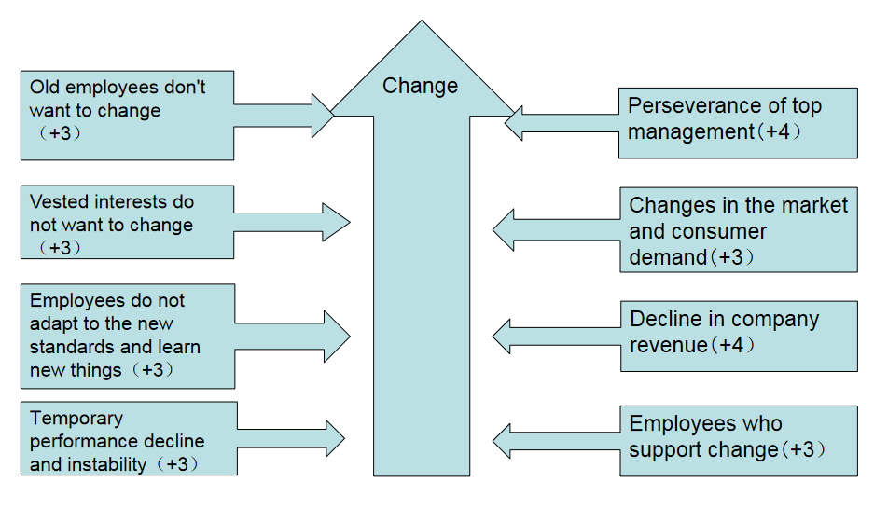
Figure 1: Force Field Analysis (Lewin, 1947)

3.1 Driving force of change
The external reason for the change is that the change of the market environment leads to the reduction of the company's consumers. The internal reason for the change is that the company's senior management realizes that the development of the enterprise is entering a bottleneck and needs to be further upgraded. A grain of sand from the times, falling on a person's head, is a mountain. Any industry or enterprise is a trend oriented product of this era, and cannot escape without it. The so-called worst-case plan is not to sit idly by, but to focus on the worst, make the fullest preparation, work in the right direction, and strive for the best results. The epidemic is the biggest crisis and problem that Bala Jewelry Company has encountered in its industry for 20 years. Every crisis is a reshuffle of the industry, and every crisis is a restructuring of the industry. The epidemic has brought negative impacts to the jewelry industry, but it is also giving birth to consumption methods, production methods, and the formation of new industries, bringing some new development opportunities and new space to the jewelry industry. As long as enterprises comply with historical changes, have firm confidence in development, and seek opportunities for change from crises, they will definitely achieve a new round of development.

Secondly, the senior management of Bala Company belongs to transformational leadership, which has become one of the most popular leadership theories since its introduction in the 1980s. When a company needs to undergo change, the power of leadership is also demonstrated through aspects such as company development orientation, organizational culture vision, personal development, and organizational change strategies, providing a leading role for organizational change.

Thirdly, some middle-level and grassroots managers of Bala Company will also recognize the necessity of change and provide organizational motivation and guidance for change.

Fourth, customer needs are the Weather vane of every enterprise's action. In the past three years of epidemic prevention, without the support of e-commerce and the digital economy, Bala jewelry stores would no longer exist. Because customers are forcing merchants to explore and strive in e-commerce and the digital economy. During the epidemic, customers need the company's products and can only purchase them online. If the company does not provide such services, they will lose customers. This feeling is mutual, and the company also realizes that e-commerce and Digital transformation must be the most important development trend and innovation direction of the company. This is a cause that fits in well. Only in the Digital transformation can the online and offline resources be fully integrated and applied. The popularization of e-commerce and digital technology has promoted the Digital transformation of the clothing industry, as well as the jewelry industry. The company is being pushed onto the path of change by this invisible force. From marketing methods to service methods, Bala Company is being driven forward by customer demands.

3.2 Resistances to change
The manifestation of resistance to change is divided into open and direct resistance, as well as potential or delayed resistance. Direct and public resistance is relatively easy to detect, and managers can instantly recognize it(Ahmed, 2010). Addressing potential or delayed resistance to change will face greater challenges. The potential resistance is very subtle, as it may reduce employees' loyalty to the organization, lose work enthusiasm, increase error rates, and increase absenteeism due to illness. Managers need to observe carefully to discover. Similarly, when a change first appears, it may only produce a small reaction, but after a few weeks or months, the resistance is exposed (Sherif, 2013). Bala Company is facing such a problem. Bala Company was founded successfully by one person, and the company's management model is vertical management. The managers of employees in each branch often do not participate in the decision-making of major matters in the company. When the top management of the company feels that a change is being made and has an impact on them, employees at the grassroots level will not obstruct it before the change. This brings hidden dangers to the company's transformation(Sasidharan, 2012).

Before the change, Bala Company's resistance to change mainly came from the opposition and lack of understanding of individual investors, which is easy to solve for a group of people with common interests and goals. When all senior executives recognize the necessity and benefits of change, they will naturally eliminate resistance. For the obstacles from grassroots and middle-level managers in the process of change, Bala Company adheres to its own ideas and decisions during the change process, and is not affected by external resistance, because the economic environment and historical trends do not allow the company to stand still.
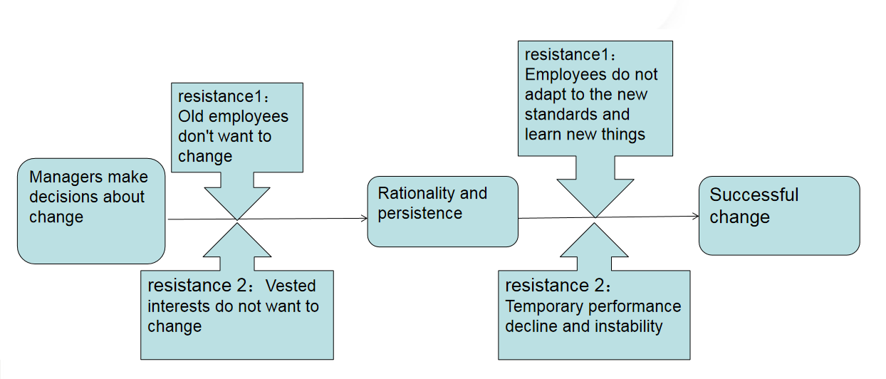
Figure 2: Resistance to change (

As shown in the above figure, Bara jewelry store has made changes despite numerous obstacles. After several rounds of expert training and planning, the store staff began to complain. The reason is simple. Now, experts require employees to develop standards, procedures, and norms. Although employees feel good, they find it difficult to operate. Most employees say that the new theories and methods proposed by experts are too difficult for them to implement. But they have a rational and determined decision-maker. No matter how employees complain, they cannot shake the decision-maker's decision. If someone fails to comply with the requirements and regulations of the consultant, they will also be punished. Decision makers still firmly support the new standards of experts, and Bara Jewelry Management Company remains firmly on the path of change and has achieved success(Bernoux, 2002). Through literature review, the author has also identified different coping strategies that managers can implement in response to different resistance to change (Hussain et al, 2016):

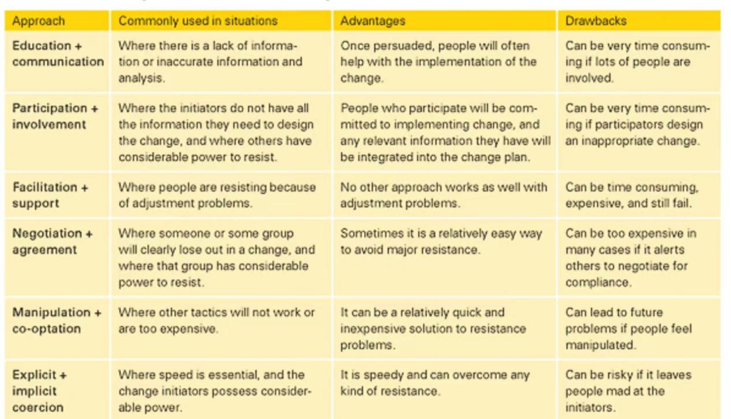
Figure 3:Methods for dealing with resistance to change (John & Leonard, 2008)

4.Lewin's three-step model--Freezing and refreezing

Lewins proposed that the three important components of change are thawing, change, and refreezing(Meredith & Minkler, 2016). According to the example of Bala Jewelry Company, the company is in the "thawing" stage, making all employees understand and accept why the change is needed. Do a good job in ideological work, communicate clearly with employees about the current situation, vision, gaps, and how to change the company. After the thawing process is completed, the company begins to make changes. The company will propose a new plan and have all employees and teams execute it according to the plan.

Figure 4:

In the stage of "re-freezing", the company will realize that everyone has inertia. Therefore, in the process of transforming new and old behaviors, the company will use methods such as rewards and punishments to solidify the new behavior patterns generated by employees according to the new system and plan, ensuring that the change will not recur. Bala's approach has made the outcome of this change a habit for everyone in the company and made everyone aware that the company has undergone a change, rather than an event. For example, during the epidemic, the reward and punishment mechanism of Bala Company was limited by frequent changes in workplace and working hours, and the reward and punishment mechanism did not fully play its role in human resource management. Having been under a loose and relatively unstructured management mechanism, some employees often exploit loopholes in company management, such as being late, absent, not actively working online, and having inadequate service attitudes; Although some employees mechanically adhere to the basic management system, they are also affected by employees who do not comply with the system, resulting in a decrease in work efficiency. The senior management of the company has been aware of this issue during these three years and plans to change the current situation in the latest change. The senior management of the company will establish a more comprehensive and reasonable reward and punishment mechanism, which is applicable to both online and offline employees. As long as people follow the company's new transformation requirements and procedures, everyone will receive corresponding rewards. If the team or individual has achieved good performance on this basis, the rewards will be doubled. On the contrary, if someone intentionally violates the company's new system or even damages the company's changes, the company will also impose punishment.

Of course, whether in a stable stage of enterprise development or when the enterprise encounters a crisis, the senior management of the company cannot tell every employee what specific work should be done, but they have always ensured that all employees are aware of the company's vision and goals, which is to enable every female employee entering the store to leave with a smile, and even become more beautiful due to the products of the store. Everyone from the district manager to the store manager, and then from the store manager to the staff, places their focus on this determination and vision, ultimately enabling each store to achieve organizational change in a flexible and ever-changing manner. The interaction and daily management of processes are also served around this vision, and the entire company operates with a value orientation that has become the soul of the enterprise(Derman et al, 2010). The goal of achieving the consolidation of change through continuous practice of the company's vision works together with the aforementioned reward and punishment system. In short, Lewins' theoretical model of change not only provides theoretical support for the transformation of Bala Company, but also serves as a theoretical driving force in the transformation process of Bala Company(Gileva, 2021).

5.Kotter's Eight Step Model for Leading Change--Change Strategies
The company uses Kotter's "Eight Steps for Leading Change" process model, which is often referred to as an extension of Lewin's three-step approach(Alhaderi, 2021). The basic idea of this model is to stimulate a sense of urgency for change and maintain this momentum. This guideline is very suitable for the current situation of Bala Company, and senior management needs an effective action plan that can adapt the company to the current market environment. This action plan should be formed under the guidance of this model(Finney & Corbett, 2007).

The first step of the Kotter model is to create a sense of urgency in the company's change plan. Bala company has done a great job in promoting this aspect, and every employee is aware of the current market situation of the company. During the nearly three years of the epidemic, the company's senior management has continuously promoted the importance of change and the change plan to employees. The second step of the model is to establish a guiding alliance. According to the plan, the company's senior management held multiple meetings, investigations, and studies to make the best action plan, which was unanimously approved by all department managers at the grassroots, middle, and senior levels. This change was proposed by the main controlling shareholder of the company, who conducted market analysis and environmental forecasting on other shareholders and members, and presented the company's declining performance and internal situation to investors, jointly analyzing the pros and cons, and establishing their own alliance. In addition, the company founder hired a completely independent change consultant specifically responsible for the execution of change plans. In addition to helping the company provide the best change plan and design draft, the change consultant will spend most of their time conducting relevant employee training work with the human resources department(Cai et al, 2017).

The third step of the Kotter model is the formation of strategic ideas. Bala Company has made changes in three aspects. Firstly, the company further upgrades its stores to improve their service levels. The advantage of a store comes from its uniqueness. When asked about the reason for going to physical stores for shopping, consumers often respond with "being able to see, touch, and use the product", "being able to get the product immediately", and "I am more certain if the product is suitable". The proportion of these answers reached 60%, 53%, and 33%, respectively. It is worth noting that these factors are usually unique advantages of physical stores that e-commerce cannot meet. When the reasons are examined by why consumers shop online, there are only two that are unique to e-commerce and cannot be replicated in physical stores. They are "shopping online 24 hours a day" to attract "no need to go to physical stores". This indicates that physical stores will still have an irreplaceable position, at least for the foreseeable future. People often use the term 'showroom phenomenon' to describe the awkward position of stores, and survey data confirms the existence of this phenomenon: up to 68% of respondents said they would deliberately visit physical stores to view products and ultimately complete their purchases online. But another piece of data confirms that the "reverse showroom phenomenon" also exists: 70% of respondents said they would deliberately view products online, but ultimately go to physical stores to complete consumption. That is to say, there is no subordinate relationship between the online and offline channels. In the eyes of consumers, the boundary between digital and physical channels has become insignificant, and they are more accustomed to switching back and forth between the two channels. Therefore, the company's storefront must be upgraded, and the decoration of storefronts in various regions should be vivid and consistent. Not only should the storefront be consistent with each other, but the store style should also be consistent with that of online stores. At the same time, the salesperson's sales and service methods should also have the unique characteristics and characteristics of the company. The company's change consultant will provide training specifically for both online and offline employees(Spencer & Winn, 2005). Secondly, the company needs to improve its service and sales methods. The Digital transformation of the jewelry industry is accelerating from the demand side to the supplier side. The company has established digital stores at the fastest speed, and has increased efforts to carry out live broadcast, community marketing, cross-border e-commerce, online exhibition and other activities to promote the complementary advantages of multiple channels and platforms. At the same time, the existing service methods were changed, and the change consultant provided unified training to the teams of various stores in the company. Because this fundamentally changed service and sales approach requires efforts from both hardware and software, with hardware settings mainly focused on digital labor tools, online store design, and offline store adjustment measures; In terms of software, all employees need to work together. In addition to using a powerful digital platform for product trading, sales strategies such as customer management, service standards, membership management, and market development should also be emphasized. These strategies should be translated into work regulations and behavioral guidelines among employees, identifying customers from both online and offline perspectives, establishing customer profiles, managing customers, and increasing product exposure in front of customers. The third point seems simple: the company will further improve its reward and punishment system. This is a means of motivation and the determination of senior management to implement the reform system(Hao et al, 2020. ).

The fourth step of the Kotter model is to mobilize more people to support change, forming a source of strength within the organization. This was only reflected in the later stages of Bala Company. In the early and middle stages of the change, from middle-level managers to grassroots managers, and even ordinary employees, there were complaints and criticisms about the training of change consultants and the new assessment system. On the one hand, it is due to not adapting to new service methods, and on the other hand, it is unable to continue the inertia during the epidemic, which has touched the interests of multiple parties(Nebojša, 2012).

The fifth step of the Kotter model is to use different methods to eliminate obstacles in the change process. Bala Company gradually adapts its employees to the implementation of change through strong leadership and determination to change, after all, if the change is not successful, the company will face even more painful crises. When it comes to the sixth step of the Kotter model, the company puts the change into action. In order to maintain the enthusiasm of all employees for change, Bala company managers can identify some short-term achievements in this process and reward relevant personnel to ensure the enthusiasm and motivation of all personnel. Subsequently, the company entered the steps of maintaining a state of change and accelerating the process of change. In the end, the company will complete the change and make the changed state a work habit for everyone(Okoth, 2013).

- Evaluation of change and Effectiveness
Firstly, the changes did not lead to the company entering into management chaos and causing economic losses. As the result of the position analysis, in an era when the market enters a low growth stage and consumers are no longer enthusiastic about consumption, if the enterprise remains unchanged, it may lead to a significant reduction in the company's revenue. Bala's revenue has remained stable, indicating that the company's transformation has minimized its losses.

Secondly, this change has improved and optimized the service philosophy and methods of all personnel, improved their learning ability and service awareness, and laid a solid foundation for future company changes and service upgrades. This has indirectly reduced the future training and development costs of the enterprise. Thirdly, there is no doubt that after this transformation, Bala Company's market competitiveness has been significantly improved.

7.Conclusion
It is easy for companies to evaluate and judge the success of changes in enterprise hardware. Whether the company's online sales platform has taken on a new look, whether there is a cooperative link between offline physical stores and online storefronts, whether the store decoration style is consistent, whether the supply chain can provide products to the sales and logistics ends in real-time on demand, and whether cross-border sales business is smooth can be detected through daily observation. However, the evaluation of software changes still requires professional change consultants and professional assessments from the human resources department, and even requires further evaluation through weeks or even months of sales performance. Fortunately, one of the transformation projects of Bala Jewelry Company is the upgrade of the human resource assessment system. The company not only intuitively affirmed the results of the hardware management reform, but also utilized the latest company assessment system to fully understand the changes in personnel service level and service awareness, confirming that the company's transformation was relatively successful(Aristova &Bachurin, 2014).
8. Recommendations
This change provides a guarantee for the survival of Bala Company, but the harsh market environment has not changed, and Bala Company still faces many challenges in product sales. One of the contents of this transformation is the improvement of stores and the upgrading of services. The company's change consultant disseminates the latest service concepts and values to every employee, and at the same time, employees' learning ability and ability to transform knowledge into practice are also improved in their work. Therefore, Bala company should not give up such opportunities, and should regularly pass on advanced service concepts and methods to employees, making the organization a learning and innovative organization, and integrating employees' career paths with the company's vision. Ultimately, the organization unites with all the forces that can be united to improve its competitiveness.
Secondly, with the implementation and development of digital, Platform economy and online and offline combined sales, enterprises need to make in-depth research while using these sales channels to establish a more systematic, mutual aid and more operable multi-channel marketing system, so as to further amplify the results of this reform. Finally, while maintaining the company's good performance, it is necessary to strengthen the establishment of human resource management and evaluation systems, pay attention to the improvement of employee salaries and benefits, and ensure the stability of the company's various resources.

Reference List

Ahmed Hassin (2010) “Effective Diagnosis in Organisation Change Management”, Journal of Law and Governance, 5(2), pp. 23–30. doi: 10.15209/jbsge.v5i2.182.
Aristova O M and Bachurin E I (2014) ‘Tools of improvement of the enterprise activity for goods and service promotion’, Journal of Russian Entrepreneurship
Bernoux, P (2002).’Organizational change: the link between structures and interactions’. Relations Industrielles, 57(1), 77-99.
Boutros, T (2014). The Process Improvement Handbook: A Blueprint for Managing Change and Increasing Organizational Performance. London: Mc Graw Hill Education
Chen Wenbing (2012) ‘Research on the Relationship between Leadership Style and Enterprise Innovation Performance’. Doctoral dispersion, Zhejiang University of Technology
Cai Tejin, Zhou Wencheng, Yao Tingting (2017). Analysis on the evaluation of the change management ability of listed companies, Human Resources Management, 2017 (8): 3
Chuprov S V .(2015). ‘Industrial Enterprise Stability Management in Competitive Environment of the Global Economy’, Northeast Asia Academic Forum 2015.
Chiara, V., & Karen, V.(2013). ‘Managing risks in smes: a literature review and research agenda’. Journal of Technology Management & Innovation, 8.
Clay, B. (2021). Kotter, john: a pragmatic observer of managers' life worlds. Springer Books.
Doroshenko M V, Kudryashova I A.(2020). ‘Process approach to enterprise management as a factor of the increase in economic stability’. WORLD OF ECONOMICS AND MANAGEMENT, 2020, 20(1):67-85.
El-Sherif H M ..(2013). ‘Leadership Model’. [Online] ResearchGate, DOI:10.13140/RG.2.2.18252.82567. Available at: https://www.researchgate.net/publication/269093563_Leadership_Model (Accessed October, 2013).
Finney, S., & Corbett, M.. (2007) ‘Erp implementation: a compilation and analysis of critical success factors’. Business Process Management Journal, 13(3), 226-228.
Fjellstedt, L (2015) ‘Examining multidimensional resistance to organizational change: a strong structuration approach’. Dissertations & Theses - Gradworks.
Guo Mount Taishan (2014) ‘Research on the implementation and model of Lean manufacturing based on organizational change theory’ Modernization of shopping malls (15), 1.
Gileva, T. A. , Galimova, M. P, Babkin, A.V, and Gorshenina, M. E. (2021) Strategic management of industrial enterprise digital maturity in a global economic space of the ecosystem economy. IOP Conference Series: Earth and Environmental Science, 816(1), 012022 (9pp).
Githumbi, R. (2013). ‘Strategic change management at the kenya citizens and foreign nationals management service’. Degree of Master of Business Administration.
Hao, Yu, Suwei, Liu, Xinqian, & Huang'. 2020. Analysis of the Impact of Enterprise Digital Transformation on a Business Model.
Hussain S T, Lei S, and Akram(2016). ‘Kurt Lewin's process model for organizational change: The role of leadership and employee involvement: A critical review’. Journal of Innovation & Knowledge, 2016.
Jeffrey Schwartz, Pablo Gaito and Doug Lenick (2013). ‘Use brain science to guide company reform’, Business Review, 2013.
John P. Kotter & Leonard A.Schlesinger (2008) ‘Choosing Strategies for Change’ [Online] Available at: https://hbr.org/2008/07/choosing-strategies-for-change, Accessed 2008, July-August
Kulatunga, A. (2007) Literature review on leadership: three suggestions for reading lists on leadership. Social Science Electronic Publishing.
Lü Hong, & Xue, L. (2013). ‘Research on the Influential Mechanism of Strategic Thinking to Enterprise Innovation-Based on the Perspective of Entropy and Dissipative Structure Theory’. International Conference on Strategic Management
Lynch, R. P. (2011). Carnegie, jaques and requisite organization: a meeting of minds at conzinc riotinto australia 1977-1993. Lynch Ronald Paul.
Lewis, S. (2021) Kotter's eight steps to transforming your organization from "leading change: why transformation efforts fail". Healthcarepapers.
Martin Hladík, & Libor Gála. (2016). ‘Framework for Strategic Change Management – Theory and Praxis’. 27th IBIMA Conference.
Meredith, Minkler (2016) ‘"Unfreezing" Lewin: The Case for Alternative Change Strategies in Health Education’. International Quarterly of Community Health Education, 2016, 1(2).
Okoth, L. A. (2013). Challenges of strategic change management at the kenyatta national hospital in kenya.
Oreg S, Michel A, By R T.(2013).’The Psychology of Organizational Change: The interplay between change and the organization’. 10.1017/CBO9781139096690(7):145-172.
Pang Peifeng, Sun Weipeng (2022). ‘Corporate transformation and transformation: Q Group faces the challenges and opportunities of the changes in the new asset management regulations and policies’, Vitality, 2022 (10): 3.
Partners, H. (2018) Digital factories: the hidden revolution in Australian manufacturing.
Runtian Jing, Andrew H. Van de Ven, Management and Organization Review, & Arie Y. Lewin. (2019) ‘A yin-yang model of organizational change: the case of chengdu bus group. Organizational change model from the perspective of Chinese Yin Yang culture: a Case study based on CBG’, Management and Organization Review.
Spencer, M. H., & Winn, B. A.(2005). ‘Evaluating the success of strategic change against kotter's eight steps’. Planning for Higher Education, 33(2), 15-22.
Sasidharan, S.(2012). Change management and erp implementation success.pp.56-58.
Sun, A. Y. (2007). ‘A research on the impact of corporate culture on the choice of
enterprise control mechanism’. Economic Survey.
Sun Xiaodong (2013) ‘Research on human resource management strategy in the transformation of NF Company’, Tianjin University
Özalp Vayvay, Derman, I., & Beceren, E. (2010) ‘Change Management Strategies for ERP Implementation in SME and a Case Study in Turkey: Anadolu Bilisim Hizmetleri (ABH) Success Story’. IGI Global.
Stepanek C and Costa J (2007) ‘Process Management as a Strategy for Managing Organizational Change, Chattanooga’, TN(US). Aerospace Testing Alliance, 2007.
Zhi-Feng, Z., Ren-Bin, X., and Mei-Ling, L. (2007). ‘Research on entropy change model for enterprise system based on dissipative structure’. Industrial Engineering & Management.

