SJSS4003 - Assignment 1 Mental Health and Wellbeing
Question: What should schools and local authorities do to ensure the well-being of their pupils? In answering this question, you should refer to legislation, policy, best practice and theory.
What is Wellbeing?
A satisfactory condition of existence; usually characterised by happiness, good health and welfare.
Introduction.
Within the United Kingdom there are thousands of schools each of these schools has its own policies to ensure the wellbeing of its staff and students, however this essay will only focus on what schools and local authorities do to ensure the wellbeing of its students. Each of these schools is told by its local authorities that they must use current legislations when it comes to the wellbeing of its students, these are legislations such as the ‘Wellbeing of Future Generations (Wales) Act 2015’.
Legislation.
Within this section of work there will be a brief description of an act stated in the above paragraph, which is the ‘Wellbeing of Future Generations (Wales) Act 2015’. The first act that will be discussed is the ‘Wellbeing of Future Generations (Wales) Act 2015, this act was created by the welsh government and is a legislation that requires local authorities, health boards (hospitals and local GP’s) and youth organisations/general organisations such as the Arts and Sports Council to create a long term sustainability plan at the cutting edge of their thinking, alongside this they can work with local authorities and organisation to prevent and tackle problems. The next point is that this legislation has seven goals these goals were produced to achieve a Wales with wellbeing at its best, here they are:
- A healthier Wales
- A resilient Wales
- A Wales of cohesive communities
- A more equal Wales
- A globally responsible Wales
- A prosperous Wales
- A Wales of vibrant culture and thriving welsh language
The Wales Council of Voluntary Action (WCVA) also stated that as part of this legislation there are the five ways of thinking and how they are used:
- Prevention – prevent a harmful or threatening situation occurring.
- Integration – unsegregate people back into a lifestyle or groups that they may have been segregated from.
- Involvement – involve groups such as third sector organisations and public sectors within the same group meetings and or meetings so they can both have their say towards matters within the communities.
- Collaboration – allow third sector organisation and the public sector to create partnerships for future events and purposes.
- Long term – Create something long term, such as support systems, partnerships, friendships, something that will last a lifetime, not for a short time.

The Wales Council of Voluntary Action (WCVA) (2018)
Schools.
Throughout this essay there be a comparison made between school A and schools B, one of the schools is based in the United Kingdom in South Wales, and the other in southern Spain. In the United Kingdom there are two school and college inspection board in England it is Ofsted and in Wales it is Estyn. These two inspection boards inspect not only the teaching but the facilities within the educational establishment, their main priority is ensuring that the school is following the wellbeing policy set out by the government and the local authorities.
School A is a secondary school located in Bridgend, South Wales, this school is one of sixty schools within the Bridgend area. This school has around a thousand students and round 100 teachers and teaching assistants. In the past this particular school has been scrutinised on its wellbeing policy as there have been many complaints about self-harm and suicide from parents throughout years. This school also made headlines on welsh news where its Head teacher at the time spoke on television and said “There is no bullying in my school” when in fact a pupil actually took his own life due to constant bullying by his peers.
School B, this school is a school for children from the ages of eighteen months to eighteen years old this school is in Cadiz, Andalucía, Southern Spain, this school is a private school with a small fee that is paid to fund the school. This school is known for its high graduation levels at the age of eighteen, however this school has a low number is students coming in at around 285 students, and a total of twenty-six teachers, and six teaching assistants.
As you can see the two schools are different due to the amount pupils and staff that they have as stated above School B is a Private school, on the other hand School A is a public school, this school takes on eleven-year olds for year seven from four primary schools that have students for many different family backgrounds. What also makes them different is that the private school has a graduation ceremony and the public school has a small award ceremony with just staff and pupils, they are very different with parent-teacher interaction. This can play a large part in a child/teenager’s life as they may sometimes feel alone with no one to talk too.
School Policies.
School A has no overall wellbeing policy but it has many individual policies such as anti -bullying, behavioural policy, safe guarding and child protection policy, inclusion policy, health and safety policy and many more. In this section of work, the policy that will be spoken about is the anti-bullying policy. Within this anti-bulling policy, it has six objectives that include:
1. To develop in the school a caring community, exercising concern and respect for the welfare of others and emphasizing the importance of good human relationships.

2. To establish an ethos and atmosphere within the school which will make bullying unacceptable.
3. To identify the causes and effects of bullying.
4. To develop a series of approaches which are designed to prevent bullying.
5. To deal with an incident of bullying as soon as it arises.
6. To clearly identify what is expected of all staff and pupils in order to achieve these objectives.
(Stated by School A 2011)
As part of this policy School A gave a brief definition on what they think bulling is, alongside this they gave other definitions on the forms of bulling, those being verbal, physical and psychological. For verbal they said it was; name calling, teasing, threats and telling lies, physical being; slapping, punching, assault and damage to personal belongings and finally psychological; threatening, ignoring, and disregarding. However, as part of this policy it has a very sexist point of view as it is stated that “boys are more inclined to use a more physical means of bullying”, however I feel that this is untrue as a lot of girls/women engage in physical bullying such as hair pulling of slapping. It is also stated that that “Male bullies tend to pick on victims from both sexes” and “female bullies generally and predominantly bully other girls.” This is not necessarily true as young girls aren’t afraid to lash out at a male if she feels threatened by him.
In comparison school B, the school has an ‘open door policy’ allowing students to talk to all adults within the school and tell then what is wrong and if they feel upset, threatened or bullied, this reduces the amount of bullying that occurs because students are not afraid to share information with their teachers, the wellbeing of their students is highly important so to ensure that every student is given a healthy Mediterranean lunch while at school and also a water supply located around the school this ensures that the students have an active mind throughout the day. However, a positive outcome from this is high grades and active students willing to engage in lessons. School B also has a school nurse and psychologist on site at all times, both of them communicate with both parents and students on their issues, they also make contact teachers. the school, psychologist not only talks with the students it also takes to families if there are issues at home and they can resolve it and it will not Affect the child’s health, welfare and wellbeing whilst they are studying. As the school has a small number of students it is easy to manage them, this being said each child is assigned a mentor, whether that be a teacher or a learning assistant, by having this mentoring scheme the student can independently talk to someone and then that mentor can relay it higher if the matter is a very serious one. This school is very family friendly and is not as regimented as most schools in the United Kingdom.

Statistics.
Linking this bulling policy to bulling here is a graph showing the level of bullying from close to average/ normal, to slightly raised, and then high to very high. The results taken from the Office of National Statistics website, below in figure one shows some statistics as stated above.
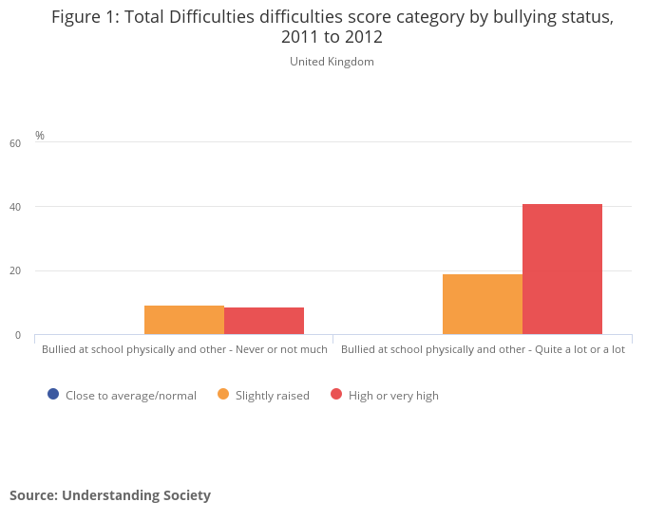
Figure 1

(Resourced form; Office of National Statistics 2018)

As shown in this image above the statistics that are being used are out dated as they are from 2011-2012, whereas now it is 2018 around six years later and that this study was conducted on children/ teenagers between the ages of 10 and 15. Upon studying the two left hand columns this representing ‘never to not much’ it was discovered that the percentage of slightly raised orange column is 9.1% and in the red column which represents high to very high is at 8.5%. moving over to the two right hand columns this representing ‘quite a lot to a lot of bullying’ had statistics as high as 18.9% in the slightly raised column and as high as 40.9% in the high to very high red column. To conclude there is an overall rise in bullying from 2011 to 2012 and over the years it has quite possibly risen higher as more and more young people have access to social media which is a gateway to cyber bullying, but also society now has an ‘image’ and if you as a person don’t fit that ‘image’ then you are bullied and segregated from groups.

Estyn.
Estyn is Her Majesty's Inspectorate of Education and Training in Wales, it was founded in 1907, the word Estyn means in English “to reach out”, it is an independently funded inspection service that is set out to improve the quality and standards of all education establishments including schools and colleges within Wales.

Estyn inspects thousands of schools and colleges every year, School A was inspected in the year 2016, so fairly recently, the school overall had a review of “Excellent” as stated by Estyn. Estyn uploaded the report about School A online as it does with all other educational establishments. Within this report the section of focus is the one labelled ‘Wellbeing’, so what did Estyn have to say?
Well Estyn said that the level of wellbeing was again excellent! As stated in the report “all pupils demonstrate particularly high levels of maturity”. It also states that “Nearly all feel safe in school and believe that the school deals very well with the very few instances of bullying”, Analysing the words “Nearly all” this suggests that not all students are happy within the school and maybe not all bullying issues are resolved as quickly as they should, or maybe the bullying issue may have psychologically scared that young person. I feel that a percentage would have been better to describe how many students felt safe. The reports also stated that “Most pupils display positive attitudes towards healthy eating and exercise”, again a percentage would have been better in describe this however healthy eating and exercise is very important within everyday life, as if you are dehydrated or feeling hollow then as a student you will struggle to concentrate when in classes. The report also stated that “Over the last three years, these rates place the school in the top quarter of similar schools based on free-school-meal eligibility”, this meaning that the amount of students having free school has risen and is statistically saying that a lot of its students cannot afford school meals and relies on the school to produce a meal for them. There are many good and bad points in relation to this, a good point is that all students are eating and are healthy and aware in lessons, but on the other hand there may not be enough money in the budget left for other resources such as new and updated sports equipment or academic resources such as books in the library and text books. The second to last comment of discussion is that the report stated “The school council and eco council contribute suitably to the life of the school. They have been effective in ensuring provision of water fountains for pupils and in saving the school money” this allows parents to know that their child will stay hydrated all day and will work to the best of their ability, having access to clean water resources is vitally to wellbeing, a hydrated mind is a happy mind. The finally comment of discussion is that “Many pupils make very worthwhile contributions to the community such as donating blood and charity work” this isn’t only wellbeing whilst in school this creates outstanding wellbeing in all walks of life.
(Estyn Bryntirion Comprehensive School report 2016)

Unfortunately, there cannot be a comparison of inspection reports with School B as I can find no evidence.

Theory.
A theory in relation to wellbeing is Maslow’s hierarchy of Needs, this particular theory is also known as “A theory of human motivation”, Maslow set out his theory into a pyramid of five levels each of them being one of the need. They are Self-actualisation at the top, then Esteem, followed by Love/belonging, then Safety and then at the bottom Physiological needs. Each of these needs is vital to a person’s wellbeing starting with:
- Self-actualisation; for a person to have “good wellbeing” then that person must be achieving their full potential not only in a work environment but in everyday life even if that is just getting out of bed on time.
- Esteem; as stated by Oxford dictionary, esteem is “Widespread respect and admiration felt for someone or something on the basis of a perception of their achievements or quality.”
(Oxford University Press, 2018)
- Love and Belonging; having supportive friends, loving/intimate partners around you can make a person feel like they belong and give them happiness.
- Safety; the feeling of security whether it be with a home, job or relationship, feeling safe is key to “good wellbeing”
- Physiological Needs; this need is the need for food, water and shelter, this is quite possibly the most important need in the pyramid, without a well fed and hydrated body and mind there is no wellbeing, feeling hollow and dehydrated can and will stop a person thinking and acting to their full potential. Of course without shelter a person will feel cold, vulnerable, and alone all factors to bad wellbeing.
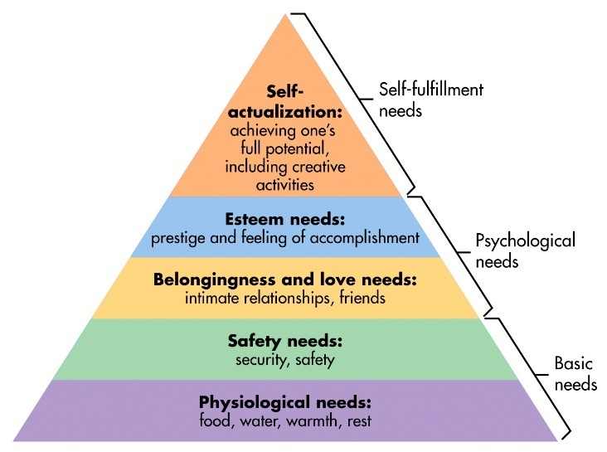(Resourced from google images 2018)

Conclusion.
In conclusion, upon studying legislations, reports and theories there is adequate support and resources to help individuals in society to improve their wellbeing an standard of life, as well as the resources schools seem to be taking the wellbeing of their student very seriously compared to past time such as the Victorian time, where hitting children in school gave them discipline and not good mental health and wellbeing.

References.
Bryntiorion Comprehensive (2016), School policy, http://www.bryntirioncs.bridgend.sch.uk/content/school-policies. Accessed 22/03/2018
Dictionary.com (2018), Wellbeing, http://www.dictionary.com/browse/well-being. Accessed 20/03/2018
Estyn (2018), Inspection reports, https://www.estyn.gov.wales/. Accessed 20/03/2018
Estyn (2016), A report on Bryntirion Comprehensive School https://www.estyn.gov.wales/sites/default/files/documents/Bryntirion%20Comprehensive%20School.pdf. Accessed 19/03/2018
Gov.Wales (2016), This Act is about improving the social, economic, environmental and cultural well-being of Wales.http://gov.wales/topics/people-and-communities/people/future-generations-act/?lang=en. Accessed 21/03/2018
ONS (2018), Measuring National Well-being: Insights into children's mental health and well-being,https://www.ons.gov.uk/peoplepopulationandcommunity/wellbeing/articles/measuringnationalwellbeing/2015-10-20 Accessed 20/03/2018
WCVA (2018), The Well-being of Future Generations (Wales) Act - All You Need To Know, https://www.wcva.org.uk/what-we-do/the-future-generations-(wales)-act-all-you-need-to-known. Accessed 22/03/2018
Originality Statement
“By submitting my work I 1703042 confirm that this is my original work and that I have adhered to the College |Policy on Plagiarism.” “I have also submitted my work to Turnitin UK for checking or have included a disk if this assignment is submitted as a paper copy.”

