Mobile App Dev using Xamarin

Student: AshleY Vessey (P132979)
Course: BSc Mobile Computing & Application Development
Module: Advanced Mobile Application Development (M6X01082)
Lecturer: Kemi Ademoye

Table of Contents
Abstract - 4 -
Introduction - 5 -
Implementation - 6 -
Requirements - 6 -
Must - 6 -
Should - 6 -
Could - 6 -
Won’t - 7 -
Images of completed application - 8 -
Android - 8 -
iOS - 11 -
Website - 13 -
Evaluation - 14 -
Future Improvements - 14 -
Errors/Issues Encountered - 14 -
Reflection on passed experiences - 15 -
Why develop cross-platform apps - 15 -
Why develop native apps - 16 -
References - 17 -
Appendix - 18 -
Firebase Database - 18 -

Table of Contents

Figure 1 List view - empty listview - 7 -
Figure 2 Item view - create new post item - 8 -
Figure 3 List view saved item - 8 -
Figure 4 Item view - edit post item - 9 -
Figure 5 List view - blank list - 10 -
Figure 6 Item view - new post item - 10 -
Figure 7 List view - new blog entry - 11 -
Figure 8 Item view - edit post item - 11 -
Figure 9 Webpage - no articles yet - 12 -
Figure 10 Webpage - articles displayed after refresh - 12 -
Figure 11 Firebase database structure - 17 -

Abstract
Report outlines the implementation and evaluation of a cross-platform application using Xamarin. Written in C#, app lets the user produce, edit, and delete blog posts on the mobile device, which reflects the changes on the website. To conclude the report, the author reflects on their past experience developing native applications, and how it compares to this approach developing cross-platform. Author found development in Xamarin to be most difficult, experiencing many errors throughout the process. Future recommendations are to consider learning the platform specific languages.

Introduction

Report is split into two sections. First, implementation section requires you to describe how the cross-platform application was implemented. Section includes a description of the app, requirements, or desirable features under MoSCoW criteria, features added to the application, and screenshots of the completed app.

The final section evaluates the completed app, taking into consideration certain aspects, reflect and recommend future improvements, and to reflect on past experiences of native development in contrast to the current cross-platform approach.

Implementation

Written in C# using Xamarin.Forms [1], application allows the user to create blog posts that can then be viewed in a web browser. Features include the ability to create, edit and delete a post item.

When changes are made, the website can be refreshed, displaying the new content. Website is developed in AngularJS [2], with the app using Firebase [3] to store the data. App is suitable for bloggers and businesses who have a company blog, those who are interested in the content can interact with it by navigating to the website.

Requirements

Based on MoSCoW criteria, the following requirements are as follows.
Items highlighted are currently implemented.

Must

- Support iOS and Android platforms.
- Use some form of server-side backend, including storage.
- Be able to see what posts are published.
- Offer CRUD functionality.
- Web: when content is updated/removed changes must not reflect in real-time as users reading the article will be affected, impacting user experience.

Should

- Function offline – Will work offline as it stores local submissions in SQLite, however as the Firebase library used does not include disk persistence, changes do no sync when offline.
- Blog posts ordered by newest first.
- UI look fairly native to the respective OS – App is to some extent native looking; iOS version looks more native, had to change clickable highlight colour in Android as default was coloured orange not native to Android whatsoever.

Could

- If user leaves application, and returns, activity is not re-created losing progress.
- Allow the user to insert featured image from library, or capture a photo using camera.
- Allow the insertion of post categories, and tags to the post.
- UI changes based on whether the user is creating a new post or editing an existing one, elements that do not need to be there should be hidden.
- Error messages, when post inputs are left blank.
- Error handling if failed to connect with web service, or failure to perform CRUD operations on service.
- Web: hide post items that have published set as false.
- Implement authentication, so that valid users can publish articles from their accounts.
- Display toast messages giving the user feedback to certain activities, post added/saved/removed.
- Web: Order post items by newest first.
- Web + platform: Search support, and the ability to filter by category, tags, date and time.

Won’t

- Implement mobile menu for web browser, currently outside of project scope.

Images of completed application

In the following figures, content inputted into application is sourced from UWTSD newsroom [4].

Android


Figure 1 List view - empty listview
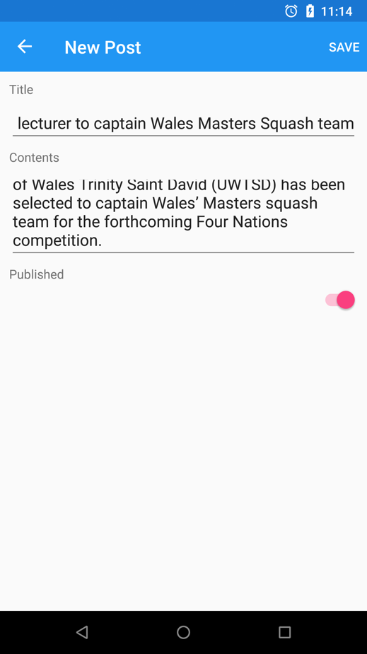
Figure 2 Item view - create new post item
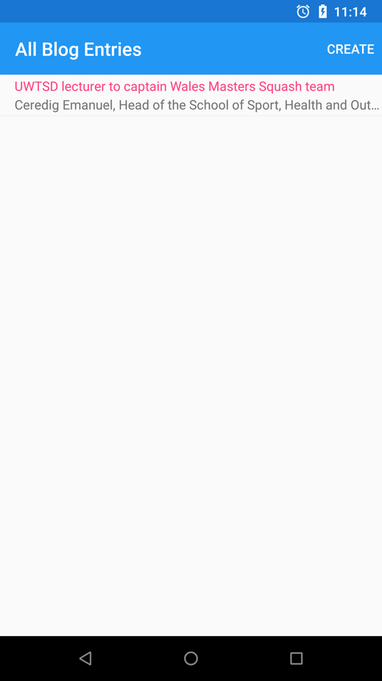
Figure 3 List view saved item
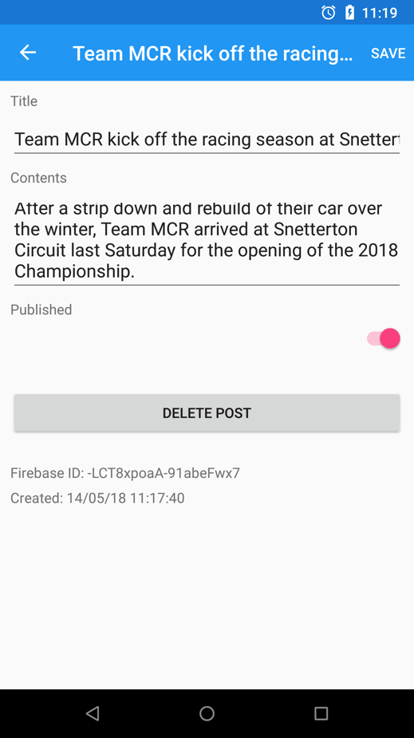
Figure 4 Item view - edit post item

iOS

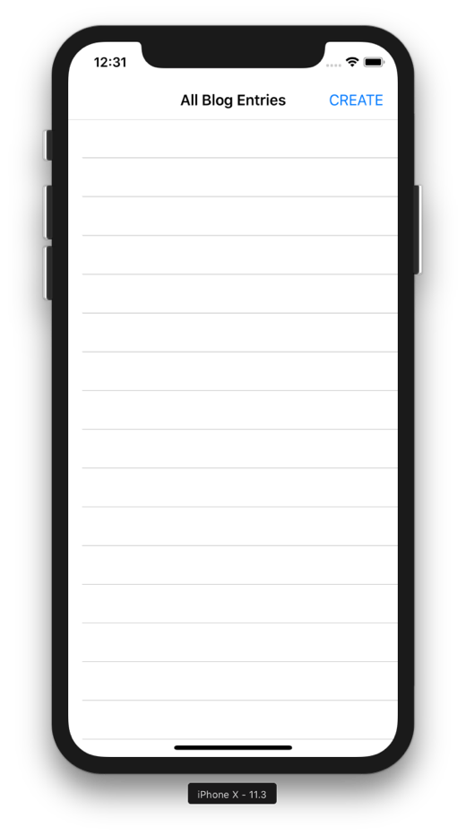
Figure 5 List view - blank list
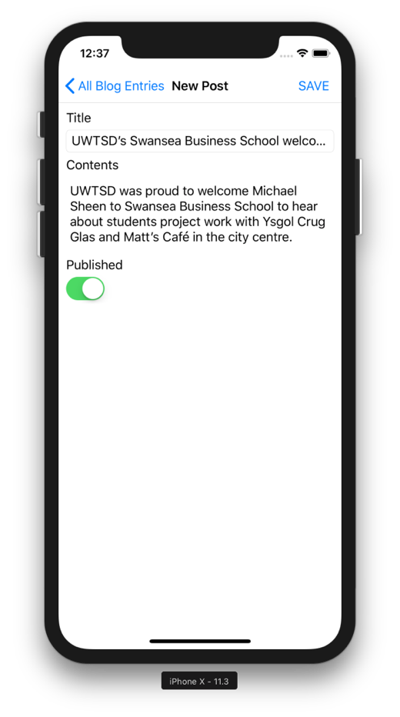
Figure 6 Item view - new post item
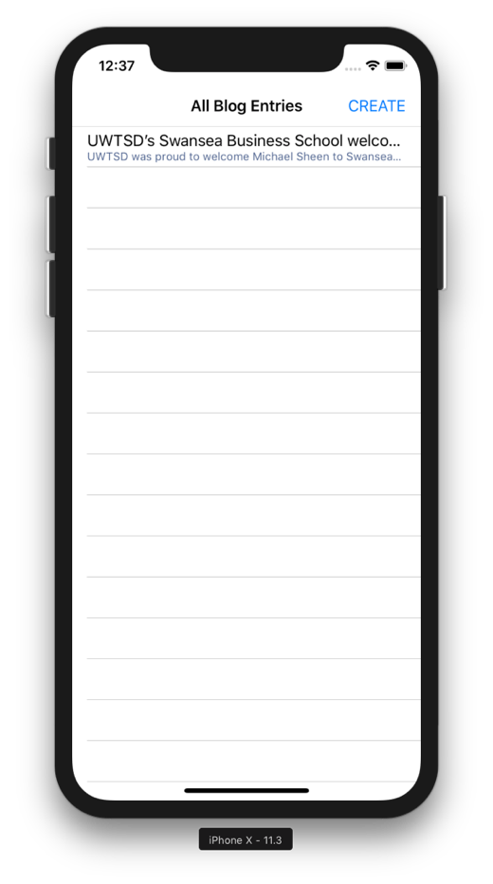
Figure 7 List view - new blog entry
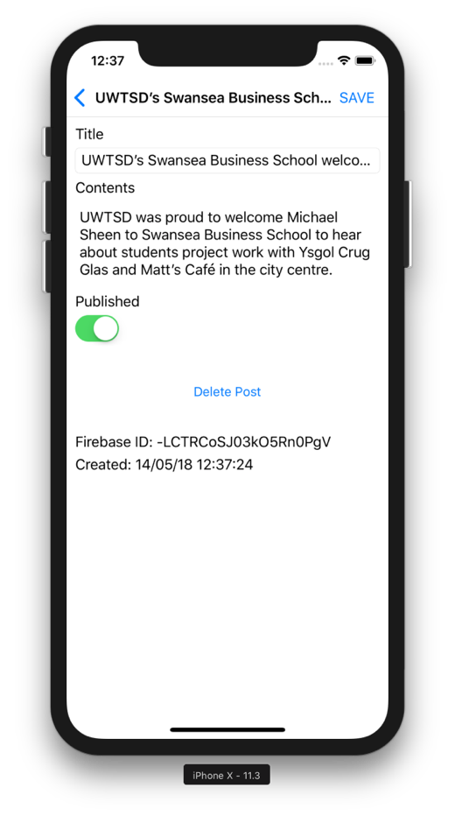
Figure 8 Item view - edit post item

Website

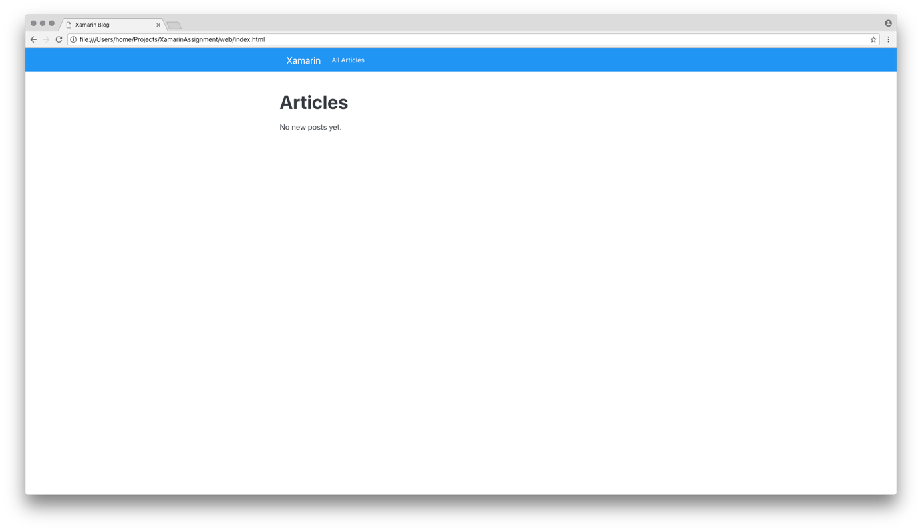
Figure 9 Webpage - no articles yet
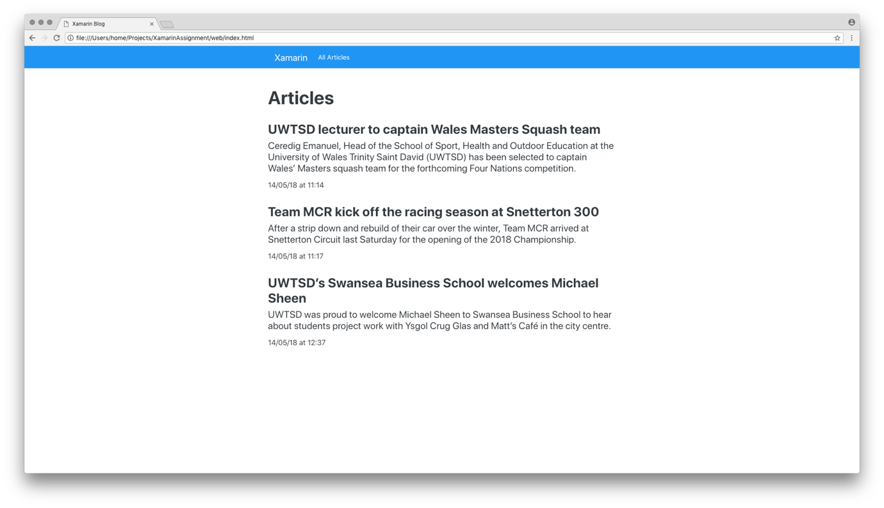
Figure 10 Webpage - articles displayed after refresh

Evaluation

After evaluating the app, in certain places it feels native, but a developer of the platform would be able to identify the difference, however these differences may go unnoticed with the casual user. UI is rather consistent which was not entirely expected, only the positioning of switch on iOS is different. Application is very easy to use, although it would have benefited from confirmation messages when the user completed an action.

Future Improvements

The first improvement would be to allow users to signup/login. Only enable users of the same domain to register for an account. To migrate from using SQLite, and to fully utilise Firebase, using it to retrieve all list items, so that they synchronise between devices. Will also need to try and get disk persistence working so that post items will be synchronised when device is not connected to a network.

The website will need improvement and converted from AngularJS to Angular, which uses the latest Firebase libraries. Following the changes to add authentication, Firebase rules will require adjustment to reflect these changes (currently set to allow read/write without authentication) so that only authenticated users can submit, modify or delete entries.

The following list includes additional improvements:

- Ability to add tags and categories.
- Featured image to post submission either by camera or device library.
- Some form of WYSIWYG or Markdown editor for contents input so that users can add lists, numbered list, bold/underline/italic highlighted font.
- Android: tester was not able to highlight text in the contents field of an edited post, issue needs further investigation.
- Display toast messages and prompts after performing certain actions.
- Web: order post items by newest first.

Errors/Issues Encountered

After producing a cross-platform application, author has found development using Xamarin to be highly error prone, wasting a substantial amount of the development time trying to fix issues. Below list a few errors/issues that regularly occurred:

- Upon creating a blank solution in Xamarin, received three errors which needed fixing before being able to compile.
- IDE regularly freezing without reason.
- Visual Studio not installing app to device for debugging.
- Five errors from Android Strings.xml ‘Could not find schema information for the name/resource by creating schema’ which remained persistent throughout the project.
- One major error from an empty debug file ‘Error APT0000: Error parsing XML: no element found (APT0000)’. This error was difficult to remove, with solutions recommending to either change to API 26 (currently set as), or clean and rebuild, neither of which resolved the issue. Issue was eventually fixed by uninstalling and re-downloading API 26.

Reflection on passed experiences

When reflecting on passed experiences using native app development, I found native to be easier to use than Xamarin. I appreciate what Xamarin is trying to do, but after hitting many barriers with the development to this application, I feel that learning multiple programming languages to be a safer option, at least until Xamarin is more stable.

The following headings outline the reasons and issues to using either platform.

Why develop cross-platform apps

Advantages

Development costs will be cheaper versus native, developer can also use one programming language to build apps on several platforms without needing to learn the nuances of certain languages.

Cross-platform is better suited for simpler applications. When comparing to native apps, it is quicker to prototype applications, and maintenance can be performed quicker as it does not need to go through multiple channels like in Android.

Disadvantages

Platform relies on developers to support the latest API’s, providing they choose to support them. After producing the Xamarin app, documentation was found to be lacking, with much of the official documentation missing content in certain areas. Also, present content expects the developer to already know what they are doing. This higher barrier of entry may discourage new developers who are interested in learning Xamarin.

Xamarin.Forms can be used to quickly develop an app but will perform tasks slower than Xamarin Native apps. Also, cross-platform apps will struggle to carry out complex tasks or apps that heavily rely on graphics. Frameworks such as Unity [5] would be better suited to the task of graphics.

Xamarin UI for the corresponding platforms is not the same as native UI found on Android/iOS. Animation transitions in Xamarin would react differently to native applications. With changes to how it looks, feels, and performs, users of native apps will not receive the same User Experience.

When an exception has been thrown, reviewing the stack trace offers little to no help on Visual Studio Mac. Compared to the likes of Android Studio or Xcode, these stack trace logs offered more clarity into what went wrong in the application and where in the code.

When reviewing the app file size, it appears that Xamarin native and Xamarin.Forms apps are much larger in sizes when comparing to native applications with ~50% of the total size allocated to user data.

Why develop native apps

Advantages

Native applications are more stable, and benefits from a speed boost. When running an application in native development, features like instant-run [6] meant that you could view changes much faster. When comparing to cross-platform, building, and running would take several minutes each time, affecting development time especially when encountering an error.

Developers of native application will receive access and updates to the latest API’s before cross-platform, and will also have access to all available device API’s, cross-platform will support only the main API’s such as location, camera etc.

Native offer better user experience, has larger community support, and the likelihood that Android will receive continued support is more likely to continue than some cross-platforms.

Disadvantages

Development costs for an Android or iOS developer is higher, with Android considered to be the highest of the two by ~30% [7], also development will take longer. Bugs are likely to occur on specific platforms as identified in personal final project with crashing on Samsung devices. As the application is split between platforms, maintenance costs will be higher.

References

[1] Microsoft Corporation, “Xamarin.Forms - Xamarin.” [Online]. Available: https://docs.microsoft.com/en-us/xamarin/xamarin-forms/. [Accessed: 14-May-2018].
[2] Google Inc., “AngularJS — Superheroic JavaScript MVW Framework.” [Online]. Available: https://angularjs.org/. [Accessed: 14-May-2018].
[3] Google Inc., “Firebase,” 2018. [Online]. Available: https://firebase.google.com/. [Accessed: 14-May-2018].
[4] UWTSD, “Newsroom | University of Wales Trinity Saint David,” 2018. [Online]. Available: https://www.uwtsd.ac.uk/news/. [Accessed: 14-May-2018].
[5] Unity, “Unity - Multiplatform - Publish your game to over 25 platforms,” 2018. [Online]. Available: https://unity3d.com/unity/features/multiplatform. [Accessed: 14-May-2018].
[6] Android Developers, “Build and Run Your App | Android Developers,” 2018. [Online]. Available: https://developer.android.com/studio/run/. [Accessed: 12-May-2018].
[7] Infinum, “Android development is 30% more expensive than iOS. And we have the numbers to prove it!” [Online]. Available: https://infinum.co/the-capsized-eight/android-development-is-30-percent-more-expensive-than-ios. [Accessed: 14-May-2018].

Appendix

Firebase Database

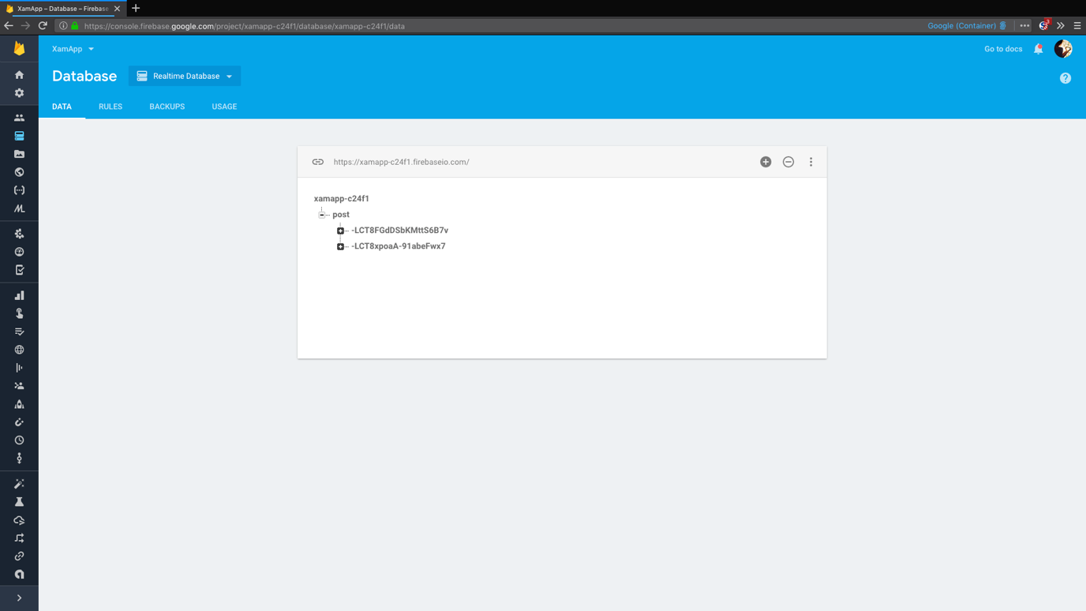
Figure 11 Firebase database structure

marking criteria and Student FEEDBACK

This section details the assessment criteria. The extent to which these are demonstrated by you determines your mark. The marks available for each criterion are shown. Lecturers will use the space provided to comment on the achievement of the task(s), including those areas in which you have performed well and areas that would benefit from development/improvement.

Common Assessment Criteria Applied (Assignment 2) | Marks available | Marks  awarded
1. Research-informed Literature
Extent of research and/or own reading, selection of credible sources, application of appropriate referencing conventions.
Demonstrates a good level of research. (Grade mark: 60.00%) | 5 | 3
2. Knowledge and Understanding of Subject
Extent of knowledge and understanding of concepts and underlying principles associated with the discipline.
Demonstrates satisfactory knowledge of the technologies and practices for developing a cross-platform mobile app with Xamarin. I would have liked to see the use of some more advanced techniques. (Grade mark: 45.00%) | 20 | 9
3. Analysis
Analysis, evaluation and synthesis; logic, argument and judgement; analytical reflection; organisation of ideas and evidence
A fair evaluation of the implemented app has been provided. Generally, a more critical review and evaluation of Xamarin as a cross-platform development tool is required. It would have been nice if you had extended your discussions beyond the frustrations experienced during the development and a set of generic advantages/disadvantages. (Grade mark: 50.00%) | 20 | 10
4. Practical Application and Deployment
Deployment of methods, materials, tools and techniques; application of concepts; formulation of innovative and creative solutions to solve problems.
A satisfactory attempt featuring a simple application, but I would not have recommended Xamarin.Forms. The implemented app is a bit too simple and the main area for improvement is extending its functionality. (Grade mark: 48.00%) | 50 | 24
5. Skills for Professional Practice
Attributes in professional practice: individual and collaborative working; deployment of appropriate media; presentation and organisation.
The report is of a good standard. (Grade mark: 60.00%) | 5 | 3

Assignment Mark (Assessment marks are subject to ratification at the Exam Board. These comments and marks are to give feedback on module work and are for guidance only until they are confirmed. ) | Late Submission Penalties (tick if appropriate) |  | 49%
 | Up to one week late |  | 49%
 | 1st/2nd/3rd attempt? |  | 49%

