NAME: ALINA PRECUP
STUDENT NUMBER:1816777
MODULE TITLE : The Global Business Environment LCBB4005
ASSESMENT 2 RESIT/REWORK
MODULE LECTURES NAME: GREGORY COWAN

Contents
Introduction 3
Porter's Value Chain Analysis 4
Porter's Value Chain Analysis in Tesla 4
Value Chain Analysis in the Tesla 5
Primary Activities 5
1. Inbound Logistics 5
2. Operations 6
3. Outbound Logistics 6
4. Marketing and Sales 6
5. Product and Services 7
Support activities 7
1. Technology 7
2. Infrastructure 7
3. HRM 8
4. Procurement 8
Conclusion 9
References 10

Table of figures
Figure 1: Porter's value chain 5
Figure 2: Inbound 6
Figure 3: Operations 6
Figure 4: technology 8

Introduction
This report includes the value chain analysis of the porter in the company Tesla. Tesla is an electric vehicle and clean energy company which is located in America and headquarters of the Tesla is in Palo Alto. The current product of Tesla includes the various electric cars. The Tesla is a type of public company which was founded in 2003 by two engineers namely Martin Eberhard and Marc Trepanning and they named the company as Tesla for the tribute to the Nikola Tesla who was an electrical engineer and inventor. So, this report has included the value chain analysis in Tesla to know that how they are working and operating their daily work and how they are achieving the objective successfully.

Porter's Value Chain Analysis
An analysis of the value chain is a way to analyze the company activities or their performance visually (Benito, Petersen and Welch, 2019). Companies are used this value chin analysis to see how the company can create a competitive advantage for itself. The value chain analysis helps the company to understand that how they can add values in something and also that how they can sell their service and product in more than the actual cost by adding the cost of values to it, so there they are generating the margins of profit (Benito, Petersen and Welch, 2019).
The value chain analysis is the conceptual methods of value-added in the way of the value chain. It is the theory of Michael porter which was originated in the 1980s. Based on this theory the organization has to split into two activities i.e., primary activities and support activities (Benito, Petersen and Welch, 2019).

Porter's Value Chain Analysis in Tesla
Value and Value chain
Value is referring to as the total amount that the purchaser has willing to pay for the additional feature of the Car in Tesla. The Tesla is that type of company which provides the best feature in their cars from the beginning. So, the difference between the total value and total cost of the car including all the activities of the firm provides the margin profit to the company (Kumar and Rajeev, 2016).
Margin refers to that when Tesla realizes the profit margin that depends on the ability of their work and ability to manage all the linkage between all the activities in the value chain. In other words, Tesla can deliver the service in their electronic car for those the customer has willing to pay more than their cost (Kumar and Rajeev, 2016).
The value chain is the process which gives more focus on the activities that is starting from the raw material in the company. It refers to that Tesla has purchased raw material from its suppliers and to final goods or the service. Competitive advantage for Tesla can be seen through various discrete activities of Tesla (Kumar and Rajeev, 2016).

Value Chain Analysis in the Tesla
The Tesla has engaged in the hundred and thousand activities in the process converting the inputs to the effective outputs (Teece, 2018). They are applying various modern technologies in making their electronic cars. So, for making the cars it's a proper process which starts from acquiring the raw material from other collaborative company to make the finished product (Teece, 2018).So, the value chain analysis of Tesla includes two types of activities which are as follows:

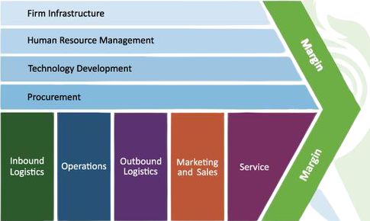
Figure 1: Porter's value chain

Primary Activities
In this activity of value chain have makes a direct contact with the making of the product and services. In Tesla there are also some primary activities have a relationship with the making of the product and services. Following are some of the primary activities of Tesla:
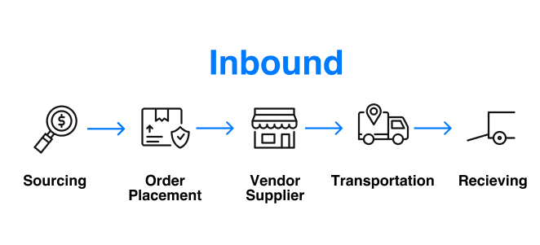
- Inbound Logistics: It defines as the inward flow of the good and services into the Tesla which includes various activities such as transport, delivery and storage. Tesla owns a large number of warehouses in the United States in which one is located in Taiwan and most of the warehouses are having leases facilities (Pitakaso and Sethanan, 2019). There is the most important facility of manufacturing of Tesla which is situated at Fremont, California, United States. It is used by the company meant for manufacturing and for warehousing also. Facility has spread in 5.5 million square feet approximately (Pitakaso and Sethanan, 2019). There are also some warehouses apart from them which are located as:
- Lathrop
- Taiwan
- Maryland
- Pennsylvania
Figure 2: Inbound
- Livermore, California
Tesla is using the facilities intended for distribution and also for storage. Warehouse which is located in Taipei, Taiwan is for the service and administration also. Company also owned various former facilities and this is in the other areas of the world which includes Asia, Europe and North America.
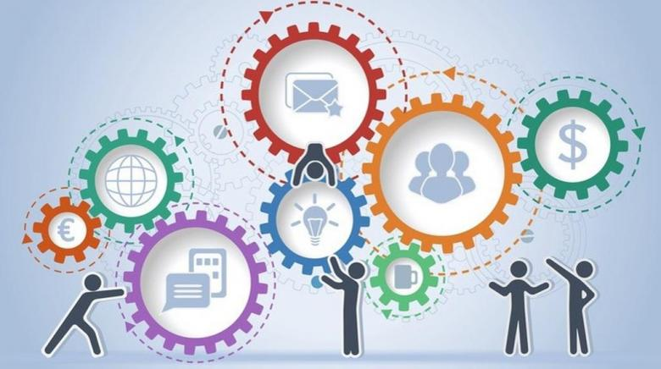
- Operations: In 2003 the company was founded by the skilled and knowledgeable group of engineers who wants to make a possibility of electric mobility for everyone in the world. In the year of 2008, Tesla has launched their Roadster and after some times its launches Model S. The company has a headquarters in Palo Alto (Golev and Corder, 2017). The Tesla Company has spread its operations and sales, industrialized and supply network to the different corner of world. Tesla owned a mechanized facility at Tilburg in which their operations has the last stage of assembly, checking and the control of the quality for the Model X and S which has to be delivered to Europe. Giga factory 1 of the Tesla is situated at outer part of Nevada (Golev and Corder, 2017). Giga factory manufactures the battery packs which are used by the company in its energy storage products and vehicles. There is also manufacturing of the model 3 drives at Giga factory.
Figure 3: Operations
- Outbound Logistics: Facility of the Tesla which is located at Fremont, California includes the various manufacturing operations which includeassembly of the final vehicle and also an end of the line testing (Khadartseva and Sanakoeva, 2016). Tilburg operation includes the part distribution centre for the service centre of the company in Europe. Tesla also owns various god owns at the US and much of them are having leased facilities in which the company has stored their ship parts and also the finished vehicles. The making has also started at the Shanghai which is the Giga factory by which the Chinese customers also gets the Model 3 cars (Khadartseva and Sanakoeva, 2016).
- Marketing and Sales: In comparison to the other automobile brands Tesla has invested in the market too less. Tesla has used its website and also the other digital channels for marketing. CEO of Tesla also uses the social media platform for engaging the Tesla fans and followers all over the globe (Banerjee and Bhardwaj, 2019). The company also establishes a very big network of the stores and galleries which is owned by the company, both are used for marketing and as well as for the sales. The company has expanded its system of the service when it has noticed that the new start up of the stores can help in increasing the demand for Cars. On a one point, these supplies have helped the Tesla to encourage and make stronger the brand Tesla, while on the other thing they also enable it to get the feedback of the customer (Banerjee and Bhardwaj, 2019). These types of galleries and stores are premium located at the major metropolitan market where they are enjoying the higher visibility. Many stores combined sales with the sales with the facility.
- Services and Product: The Tesla has generated their foremost product namely roadster in 2008 and after that, they launch the Model S. Tesla has included the various product portfolio which are Model S, Model X, Model 3, Model Y, Roadster and Cyber truck and also the energy product. Tesla has recently introduced a truck namely Cybertruck. The company also offers varieties of power products which includes the storage product and also the solar tiles among the others (Nagy et al., 2018).

Support activities
The first activity in chain analysis has a link to this activities. The support activities in Tesla are as follows:
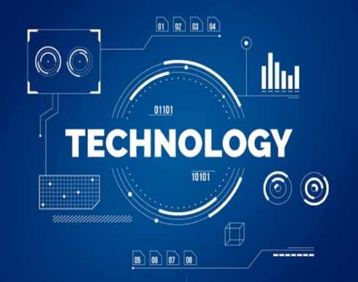
- Technology: In today's world the automobile industry has facing intense competition. Today’s market for alternate fuels vehicles has also introduced now a day’smostly (Quan, Sauzade and Brouzes, 2018).Several competitors of the Tesla such as BMW get up new electric cars also planned for expanding their range of hybrid and electric vehicles. Driving and also mobility is the trending technology in the automobile industry and Tesla is best company in both of these areas. In the year of 2018 Tesla has invested $1.46 billion is the programme of research and development. Investment in the technology has helped Tesla too much in regularly improving their products and grows its potential in the market (Quan, Sauzade and Brouzes, 2018).
Figure 4: technology
- Infrastructure:Tesla has organized mainly in the two-division according to the product categories. Structure of the administration is different in Tesla. Elon musk is the top leading decision-maker in all over the company (Sundram et al., 2018). As a CEO of the company Elon Musk has the power to make a decision either on management or infrastructure. Chief Financial officer of the Tesla is Zachary J Kirkhorn who is responsible for all the accounting, finance and other areas of finance. There is also a presence of the Vide in the president who is responsible for making some decision such as production, sales, engineering, and finance etc (Sundram et al., 2018).
- HRM: The HRM process in Tesla is very effective. The HR department in Tesla has recruited engineers who have knowledgeable and skilled persons. According to 2018, Tesla has around 48000 full-time employees. Tesla has depends on om the various thousands of employees for running the company and maintaining the high efficiency of the operations (Michael, 2019). Management of the HR has played an important role in the area of the focus for the most technology company from it is important to get and retain the employees who are talented because they want to make their products more effective as the customer gets attract to their organization and purchase their cars. So, Tesla has given more focus on the HR management for finding the fast growth and also to increase the strength for the competitive (Michael, 2019).
- Procurement: The Vehicles which are manufactured and assemble by Tesla has used the thousands of parts that the company has brought from the thousands of the suppliers in the world. Tesla has made a great and strong relationship with the many suppliers in the world (Bienhaus and Haddud, 2018). There are some important parts such as cells and other parts of the key system for procurement for those the company has makes a close relationship with the suppliers.Tesla has some various suppliers of the raw material and also for many others it depends on a single source. The leading supplier of Tesla is the Panasonic. It's been a very long time supplier for Tesla(Bienhaus and Haddud, 2018).

Conclusion
This report concludes the various activities in the value chain analysis which is bases on the Tesla Company. It is concluded that there is a compliance of Porter's value chain analysis to understand the operational and business environment of Tesla. Value chain analysis has included the two main activities of Tesla which is Primary activities and support activities. So, this report concludes all the activities in these both the activities.

References
Banerjee, S. and Bhardwaj, P., 2019. Aligning marketing and sales in multi-channel marketing: Compensation design for online lead generation and offline sales conversion. Journal of Business Research, 105, pp.293-305.
Benito, G.R., Petersen, B. and Welch, L.S., 2019. The global value chain and internalization theory. Journal of International Business Studies, 50(8), pp.1414-1423.
Bienhaus, F. and Haddud, A., 2018. Procurement 4.0: factors influencing the digitisation of procurement and supply chains. Business Process Management Journal.
Golev, A. and Corder, G.D., 2017. Quantifying metal values in e-waste in Australia: The value chain perspective. Minerals Engineering, 107, pp.81-87.
Khadartseva, L.S. and Sanakoeva, K.A., 2016. LOGISTICS BASED ON THE VALUE CHAIN OF PORTER. НАУЧНЫЕ ПРЕОБРАЗОВАНИЯ В ЭПОХУ ГЛОБАЛИЗАЦИИ: сборник, p.290.
Kumar, D. and Rajeev, P.V., 2016. Value chain: a conceptual framework. International Journal of Engineering and Management Sciences, 7(1), pp.74-77.
Michael, A., 2019. A handbook of human resource management practice.
Nagy, J., Oláh, J., Erdei, E., Máté, D. and Popp, J., 2018. The role and impact of Industry 4.0 and the internet of things on the business strategy of the value chain—the case of Hungary. Sustainability, 10(10), p.3491.
Pitakaso, R. and Sethanan, K., 2019. Adaptive large neighborhood search for scheduling sugarcane inbound logistics equipment and machinery under a sharing infield resource system. Computers and Electronics in Agriculture, 158, pp.313-325.
Quan, P.L., Sauzade, M. and Brouzes, E., 2018. dPCR: a technology review. Sensors, 18(4), p.1271.
Sundram, V.P.K., Bahrin, A.S., Munir, Z.B.A. and Zolait, A.H., 2018. The effect of supply chain information management and information system infrastructure. Journal of Enterprise Information Management.
Teece, D.J., 2018. Tesla and the reshaping of the auto industry. Management and Organization Review, 14(3), pp.501-512.

