Streets of Rage [1]
Assignment Name: CW2: Retrofitting Existing Games: Creating A Game Design Document
Module Code: ACCA4033 Module Name: Game Design & History

INTENDED PLATFORMS | PC will be the main platform, with the possibility of Xbox, PlayStation, and mobile releases depending on success.

TARGET AGE / DEMOGRAPHIC OF PLAYERS
The target range will be from the age 13 and up, this game will resonate with all genders and backgrounds. The main demographic that is expected to play this game will be people who enjoy the side scrolling beat ‘em up genre with constant flow of gameplay that isn’t too overwhelming.

INTENDED PEGI / ESRB RATING
Pegi 12 [2]

CONTRIBUTING TEAM MEMBER: | Name: Ellie Saunders Student number:2502179

SECTION 2: GAME OUTLINE

GAME STORY SUMMARY
A once peaceful city has been overrun by a criminal organisation run by Mr X, they have taken over everything including the police force leading the city into violence. With the city falling to crime a group of ex police rise up, consisting of Axel Stone, Adam Hunter, and Blaze Fielding, to try take back the city with their lives on the streets. They will fight their way through the city until they reach the headquarters and take back power or die trying.

GAME FLOW
A side scrolling beat ‘em up where either Axel Stone, Adam Hunter, or Blaze Fielding fights their way through the streets of Oak Wood to the criminal organisation’s headquarters in order to take down the man leading the organisation, Mr X, to restore the city.

CONTRIBUTING TEAM MEMBER: | Ellie Saunders Student number:2502179

SECTION 3: MAIN CHARACTER(S)
& PLAYER CONTROLS

CHARACTER APPEARANCE
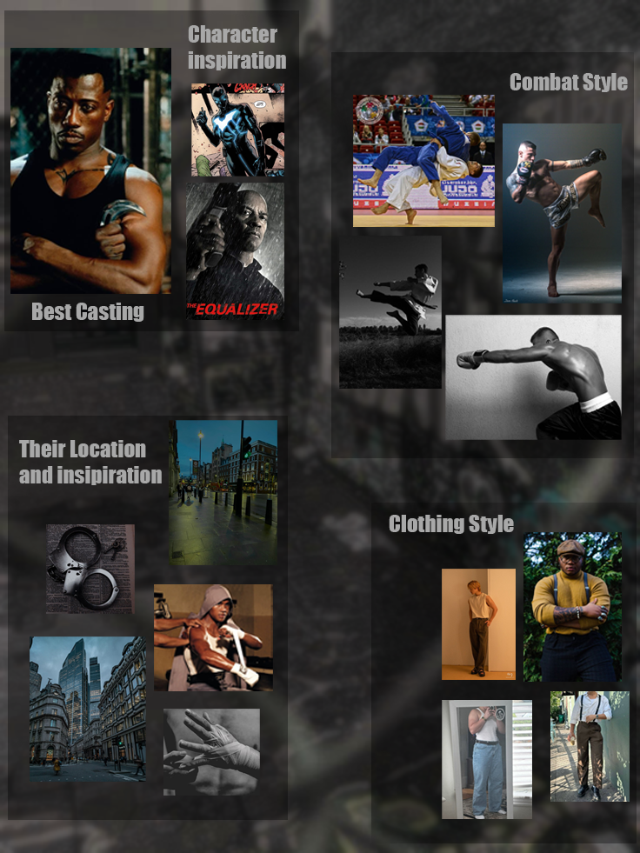  [3]  [4]  [5]  [6]  [7]  [8]  [9]  [10]  [11]  [12]  [13]  [14]  [15]  [16]  [17]  [18] | Adam Hunter:
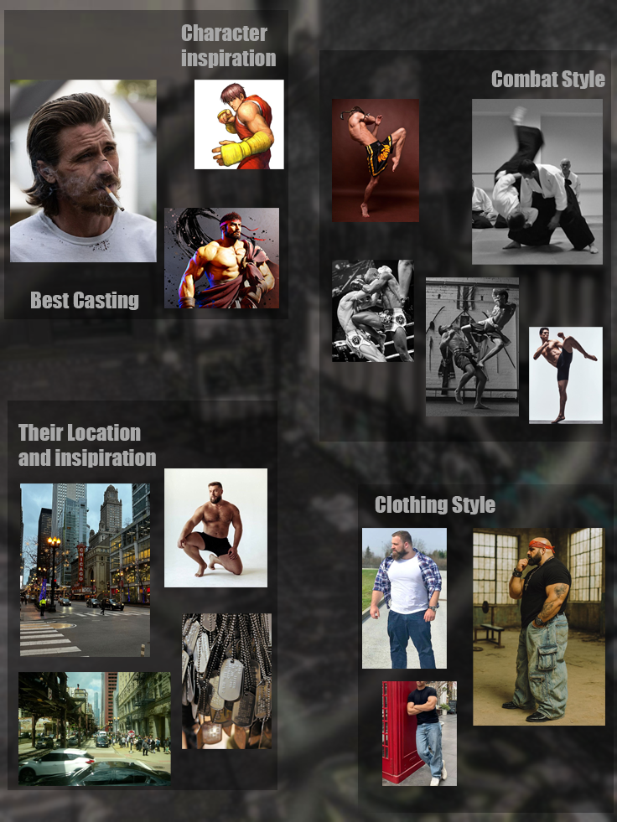  [19]  [20]  [21]  [22]  [23]  [24]  [25]  [26]  [27]  [28]  [29]  [30]  [31]  [32]  [33] | Axel Stone:
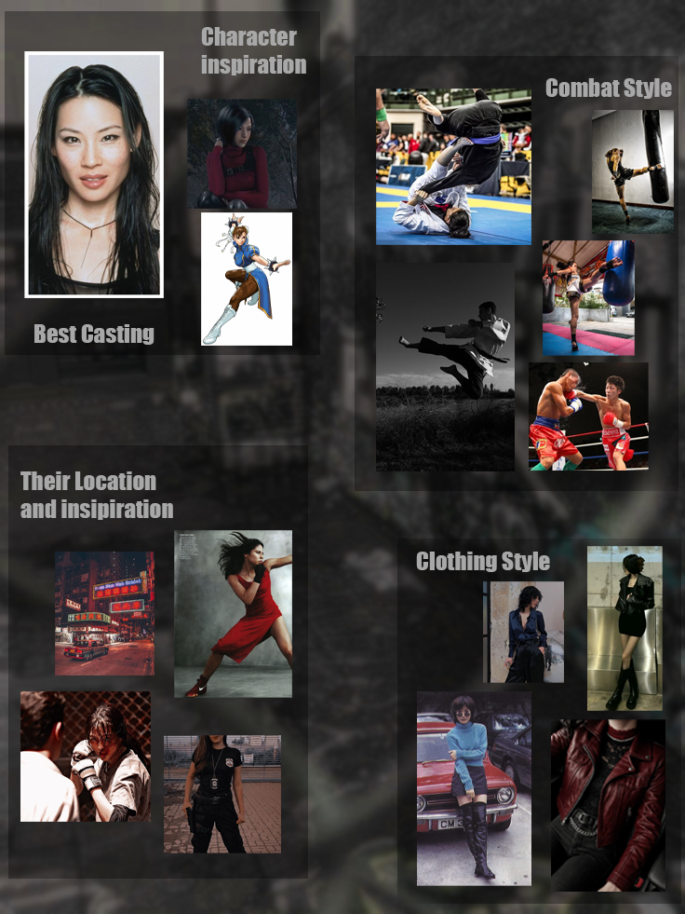  [34]  [35]  [36]  [37]  [38]  [8]  [39]  [40]  [41]  [42]  [43]  [44]  [45]  [46]  [47]  [48] | Blaze Fielding:

CHARACTER DOSSIER / DETAILS
NAME: | Adam Hunter
GENDER: | Male
SPECIES: | Human
AGE: | 23
HISTORY: | Ex-Cop
HOBBY: | Bonsai
ABILITY: | Boxing
POWER: | A
JUMP: | A
SPEED: | B

CHARACTER’S BACKSTORY
Adam is one of three cops who quit the police force after it was corrupted to fight against Mr. X and the syndicate. He has a high-power stat and the best jump ability however he is slower than the other two. Does not have any different moves than the others, however his fighting style is close to boxing style moves.

CHARACTER DOSSIER / DETAILS
NAME: | Axel Stone
GENDER: | Male
SPECIES: | Human
AGE: | 22
HISTORY: | Ex-Cop
HOBBY: | Video games
ABILITY: | Martial arts
POWER: | A
JUMP: | B
SPEED: | A

CHARACTER’S BACKSTORY
Axel is one of three cops who quit the police force after it was corrupted to fight against Mr. X and the syndicate. He has a high-power stat and a high-speed stat, however, can’t jump very high. He does not have any different moves than the others, his fighting style is closer to martial arts type moves.

CHARACTER DOSSIER / DETAILS
NAME: | Blaze Fielding
GENDER: | Female
SPECIES: | Human
AGE: | 21
HISTORY: | Ex-Cop
HOBBY: | Lambada
ABILITY: | Judo
POWER: | B
JUMP: | A
SPEED: | A

CHARACTER’S BACKSTORY
Blaze is one of three cops who quit the police force after it was corrupted to fight against Mr. X and the syndicate. She has the lowest attack stat of the 3 but has high jumps and high speed. She does not have any different moves than the others, however her moves are more agile and judo style.

CHARACTER CONTROLS / PLAYER CONTROLS
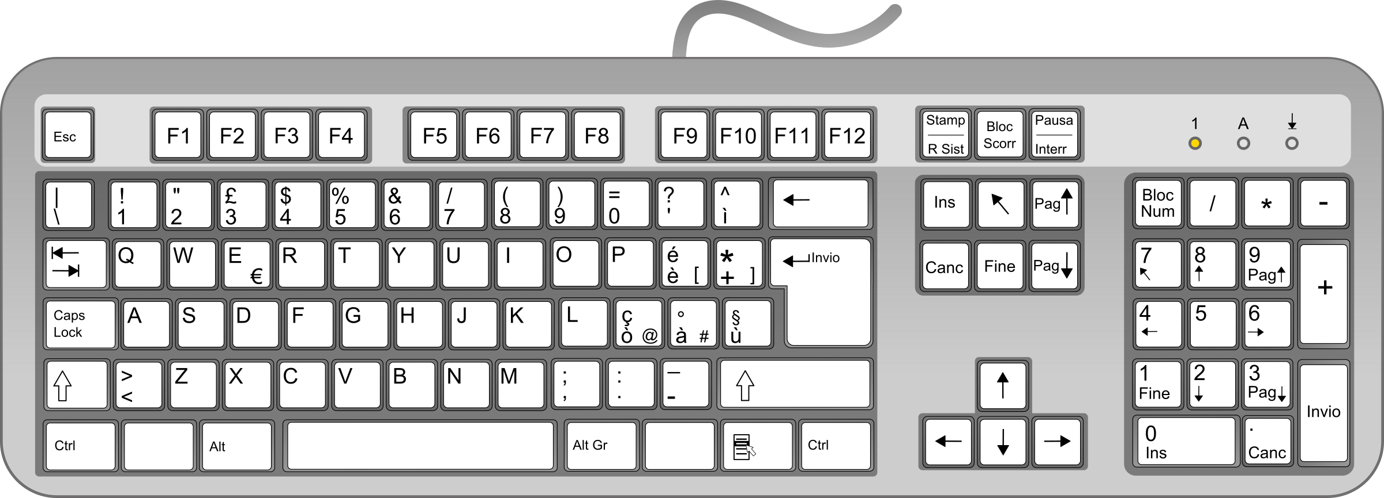
[49] [50]

For PC The basic controls are ESC to start the game, pause and un-pause the game. W, A, S, D will be used to move Axel, Adam, and Blaze in any direction. The space bar will be used to make the characters jump. Left and right click can be changed in the options menu between attack and special attack/call for help.

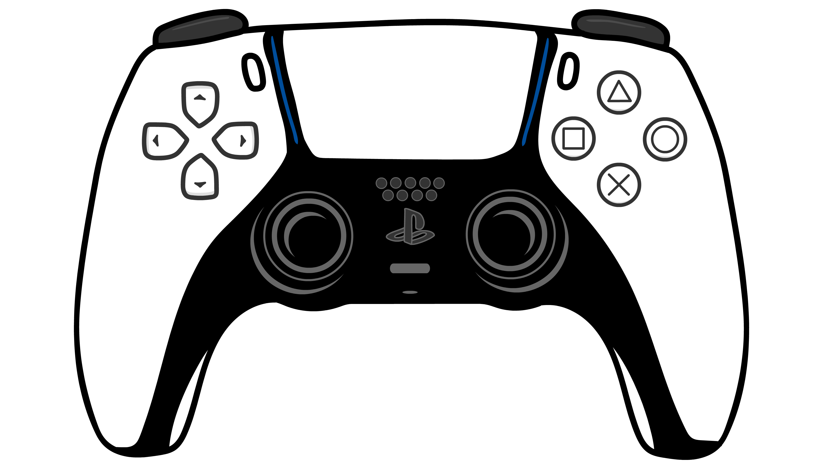
[51]

On a controller, the select button will be used to start the game, pause and un-pause the game. The left stick will be used to move Axel, Adam, and Blaze in any direction. The triangle, square, X, and circle buttons or A, B, Y, and X buttons can be changed in the options menu between attack, jump and special attack/call for help.

CONTRIBUTING TEAM MEMBER: | Ellie Saunders Student number:2502179

SECTION 4: GAMEPLAY

SEQUENCE OF PLAY
The game will be set out into a number of rounds; there will be 8 in total. Each round will have basic win and lose conditions. For the player to win they must defeat all the opponents presented to them, if they fail then they will lose a life. When the player runs out of lives the game will be over. At the end of each round the player is presented with a boss fight which increases in difficulty over rounds, once the boss is defeated the player will move onto the next round.

The levels are very repetitive in terms of gameplay. The player will load in when the level starts, enemies will spawn and attack the player to which they are expected to fight back and defeat all the enemies. During this time players can destroy destructible objects to get items as well as take weapons from enemies when they are knocked down. Once the player has defeated all the basic enemies they will be put into a boss battle, once defeated the player will move on to the next round where the same sequence will play out.

The game is very linear with the only choices the player can make to affect the story will be the final decision whether they side with Mr X or not. If the player was to refuse, they will need to defeat Mr X and the true ending will play where peace is restores to the city.

UNIQUE SELLING POINTS (USPs)
The game will feature 2 player cooperative play which will be one of its main unique selling points. Players will be able to join each other on local play and play through the game together as different characters. This will make the game feel more interesting and unique which will encourage players to replay the game.

The game will also have experimental electronic dance music that will fit the intensity of the gameplay and will be separately released in albums depending on success.

PLATFORM-SPECIFIC FEATURES
If the game was to be successful enough to release on mobile, touch screen would need to be added for mobile.

CONTRIBUTING TEAM MEMBER: | Ellie Saunders Student number:2502179

SECTION 5: GAME WORLD

GAME WORLD
The scenery will be the characters moving through the city and going to the criminal organisation and Mr X’s base in a 16-bit arcade visual and audio style. One third of the screen will be the floor to allow the player to move on every map, the rest of the screen can be utilised as background. All maps up until round 2 will be the streets of the city, up until round 6 the player will be fighting along a beach, bridge and ship, rounds 6 and 7 will be the player walking through a factory and an elevator. At round 8 the player will finally reach Mr X’s headquarters which will lead into his office for the final battle. The maps will all be side scrolling so the player will have limited space to move.

LOCATION DETAILS
NAME: | ROUND 1: City Street
WHAT DOES IT LOOK LIKE? | 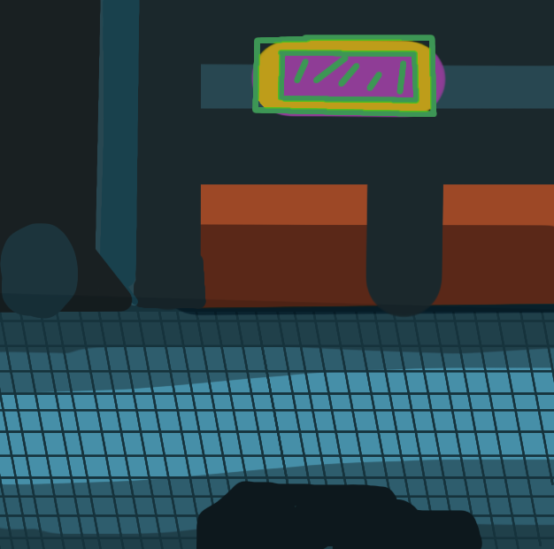
WHAT MOOD IS BEING INVOKED IN THIS LOCATION? | Gives the player the idea that the area is rough  And dark, like the streets have been abandoned and overrun by criminals. Should make the player want to fight enemies and restore the city.
WHAT KIND OF MUSIC WILL BE USED FOR THIS LOCATION? | Upbeat, Electronic and fast to match with the tension and fighting in the gameplay.
HOW ARE THE LOCATIONS CONNECTED IN THE GAME WORLD? | Linear progression, unlocks after starting the game and character selection.

LOCATION DETAILS
NAME: | ROUND 3: Beach
WHAT DOES IT LOOK LIKE? | 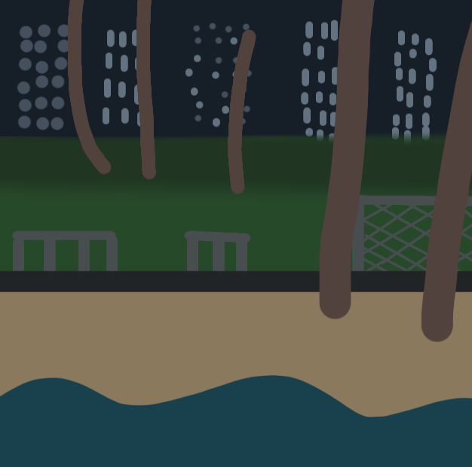
WHAT MOOD IS BEING INVOKED IN THIS LOCATION? | By this point the player should be feeling more confident and in the zone, the music should replicate this while having a dance vibe to it.
WHAT KIND OF MUSIC WILL BE USED FOR THIS LOCATION? | Upbeat, electronic house style.
HOW ARE THE LOCATIONS CONNECTED IN THE GAME WORLD? | Linear progression, unlocks after completing round 2.

LOCATION DETAILS
NAME: | ROUND 5:Factory
WHAT DOES IT LOOK LIKE? | 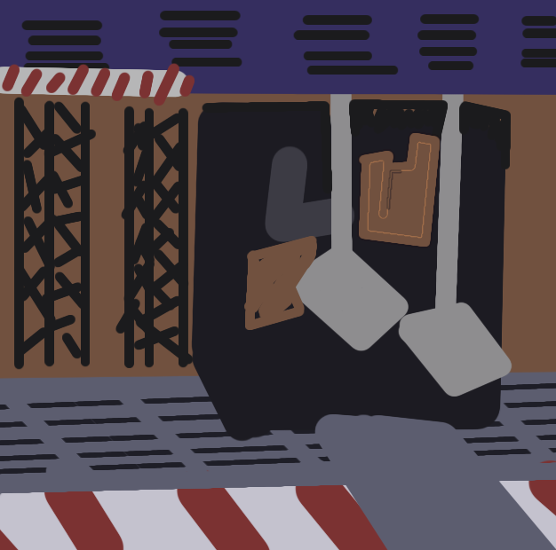
WHAT MOOD IS BEING INVOKED IN THIS LOCATION? | The player should feel as though they are close to the end, there should be more tension for the player and anticipation.
WHAT KIND OF MUSIC WILL BE USED FOR THIS LOCATION? | Electronic house style with arcade sounds.
HOW ARE THE LOCATIONS CONNECTED IN THE GAME WORLD? | Linear progression, unlocks after completing round 4.

LOCATION DETAILS
NAME: | ROUND 8: Headquarters
WHAT DOES IT LOOK LIKE? | 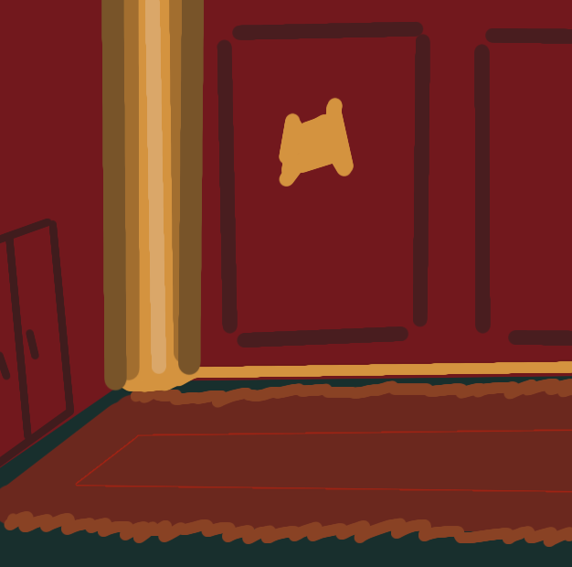  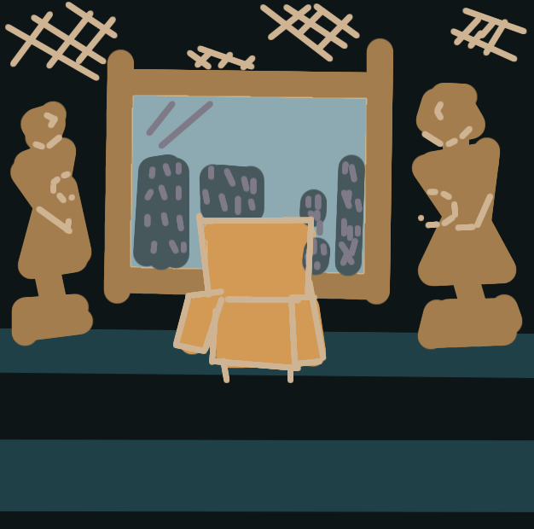
WHAT MOOD IS BEING INVOKED IN THIS LOCATION? | The player should be focused on what is going on with their full attention on the gameplay. There should be a lot of anticipation within this area as this is the final stop and make or break of the game.
WHAT KIND OF MUSIC WILL BE USED FOR THIS LOCATION? | The music should be slow but still have the electric house vibe to it. The music in the first area should build up anticipation while keeping with the flow of gameplay. During the final fight with Mr X the music will change to be faster with more of an eerie feel.
HOW ARE THE LOCATIONS CONNECTED IN THE GAME WORLD? | Linear progression, unlocks after completing round 7.

GAME FLOW
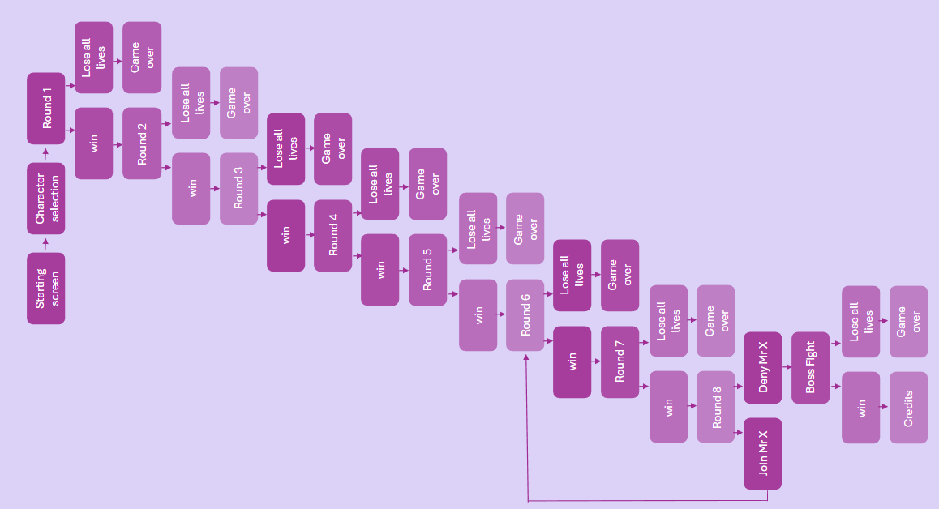

CONTRIBUTING TEAM MEMBER: | Ellie Saunders Student number:2502179

SECTION 6: GAME EXPERIENCE

GAME EXPERIENCE
The game experience will be very serious and focused heavily around restoring the city. The streets are gloomy and silent apart from the members of the criminal organisation who are there to stop the player. The gameplay will be made to be very simple and easy to grasp to encourage a more diverse number of players. The scenery will often be dark to reflect how the city has fell to ruin and force the player to focus more on the gameplay and story.

HOW IS THIS FEELING GOING TO BE PRESENTED TO THE PLAYER?
This is presented to the player through moderately paced gameplay and dark scenery; on average the player should spend between 5 and 10 minutes on each level without dying. Through the dark scenery and amount of time the player should be spending on each level, the player should feel invested in seeing the city as it was before while being slow enough for new players to understand and gain confidence with the gameplay. The music should be upbeat in areas while slowing in more gloomy areas such as the city street to set the scene and give the player that general feeling of unease.

ARE THERE ANY SPECIAL MODES OR INTERFACES FOR GAMEPLAY?
No

WHAT DOES THE PLAYER FIRST SEE WHEN THEY START THE GAME?
When the player first launches the game the opening cutscene will play which introduces the player to the story and the motive of the characters. The screen will then fade to black and bring up the description of the 3 playable characters, then will transition into the starting screen. When the player interacts with this screen, the player will get the option between player selection and the options menu where they can choose the sound level, difficulty, and controls. The scene will then transition into character selection where the player can choose.

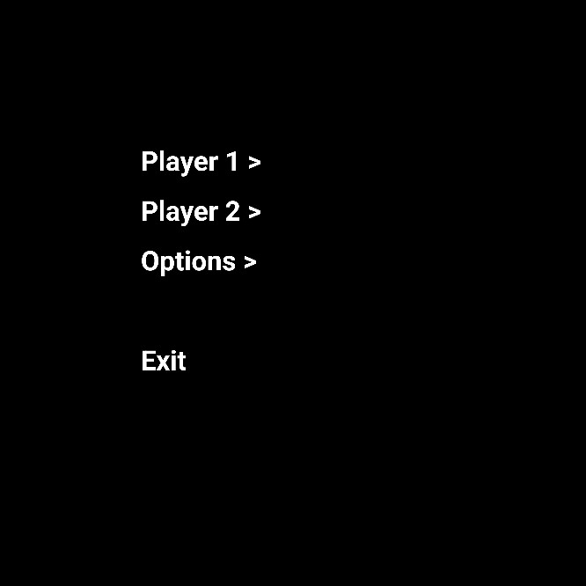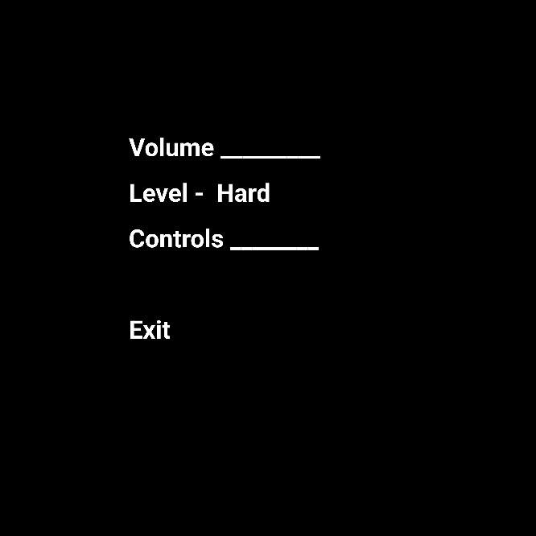

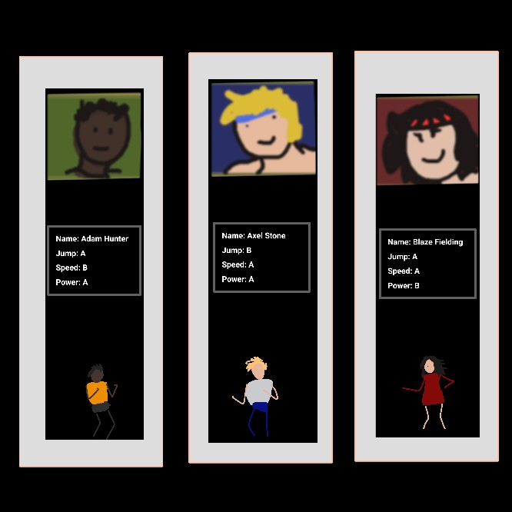

WHAT EMOTIONS ARE MEANT TO BE INVOKED BY THE GAME?
The player should constantly have a feeling of unease as they walk through the streets knowing they are in constant danger, in the same way the player should feel for the characters and have the same sense of justice that they have. Throughout the game the player should grow an attachment to the character they chose, they should feel like they are working with the character they chose and share the same goals as them.

HOW ARE MUSIC AND SOUND GOING TO BE USED?
Sound is used mainly in the game to set the scene with music and give audio feedback. Every time the player hits something there will be a sound that plays to make sure the player is aware, the same will go for whenever an enemy dies though the sound is different. The music will aways shift during a boss battle to signify that there is one coming so the player can prepare themselves a second beforehand and fill them with a sense of dread.

HOW DOES THE PLAYER NAVIGATE THE SHELL MENUS/ SCREENS OF THE GAME?
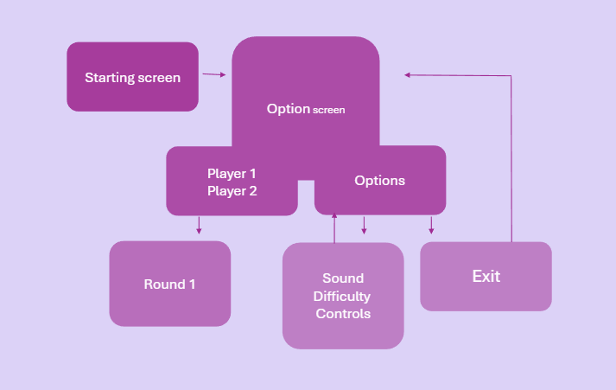

CONTRIBUTING TEAM MEMBER: | Ellie Saunders Student number:2502179

SECTION 7: GAMEPLAY MECHANICS

GAMEPLAY MECHANICS
The game will have minimal mechanics and hazards as the core gameplay revolves around combat. The player does however have a special attack they should only be able to use at certain points of the game where they call for help which could be considered as a mechanic as it aids their gameplay and the player will be able to pick up weapons from knocked enemies and destructible objects. As for hazards the game, the game will have very few. In round 5 the factory, the player will have to fight around a pressing machine which will slam into the floor every few seconds. In a similar way there will be holes in the floor in the later maps which both enemies and the player can fall which will cost a life.

MECHANIC DETAILS
NAME: | Special attack/Call for help
WHAT DOES IT LOOK LIKE? | The screen will pan to a man in a cop car who launches an aerial assault at the enemies on screen
EFFECT ON PLAYER: | Kills smaller enemies and deals big damage to larger ones, allows the player to get out of tight situations and aids in battle.
WHEN WILL IT FEATURE IN THE GAME? | Can be used once per life or found as an item.

MECHANIC DETAILS
NAME: | Pipe
WHAT DOES IT LOOK LIKE? | A long silver pole with a curve at the end
EFFECT ON PLAYER: | Serves as a weapon the player can use.
WHEN WILL IT FEATURE IN THE GAME? | Can be used until broken or dropped twice

MECHANIC DETAILS
NAME: | Bottle
WHAT DOES IT LOOK LIKE? | An orange empty beer bottle
EFFECT ON PLAYER: | Serves as a weapon the player can use.
WHEN WILL IT FEATURE IN THE GAME? | Can be used until broken or dropped twice.

HAZARD DETAILS
NAME: | Pressing machine
WHAT DOES IT LOOK LIKE? | Two large panes of metal that slams up and down every few seconds, the machine operating this will stick out from the wall limiting space for the player.
EFFECT ON PLAYER: | Can crush the player and enemies.
WHEN WILL IT FEATURE IN THE GAME? | Round 5

HAZARD DETAILS
NAME: | Holes
WHAT DOES IT LOOK LIKE? | Large black holes along the floor outlined with red and white caution tape.
EFFECT ON PLAYER: | Enemies and players can fall in making the player lose a life.
WHEN WILL IT FEATURE IN THE GAME? | Mid way through round 4 and 7

POWER-UP DETAILS
NAME: | Apple
WHAT DOES IT LOOK LIKE? | A red apple
EFFECT ON PLAYER: | Restores some of the players health when walked over
WHEN WILL IT FEATURE IN THE GAME? | At least once in every round after a destructible object is broken.

POWER-UP DETAILS
NAME: | Police car
WHAT DOES IT LOOK LIKE? | A blue police car
EFFECT ON PLAYER: | Gives the player another charge of their special attack when walked over.
WHEN WILL IT FEATURE IN THE GAME? | Rare chance to appear on round 5 and 6 after a destructible object is broken.

COLLECTIBLE ITEMS
This game will not feature any collectibles or currency.

GAME ECONOMY
This game will not have an economy system.

CONTRIBUTING TEAM MEMBER: | Ellie Saunders Student number:2502179

SECTION 8: ENEMIES

LIST OF ENEMIES
There will be a total of 6 different basic enemies within the game, most of the bosses from rounds will turn into regular enemies after they are defeated in future rounds. Every enemy will have a different colour variant which means that the same combat rules apply however they are stronger and take longer to kill.

ENEMY DETAILS
NAME: | Thug 1
WHAT DOES IT LOOK LIKE? | Wears a blue jumpsuit with orange hair
ATTACKS: | Either uses fists, knife which can be thrown, or baseball bat
WHEN WILL IT FEATURE IN THE GAME? | Up to round 4 and comes back later in round 8.
HOW DOES THE PLAYER DEFEAT IT? | Attacking with either fists or weapons.
WHAT DOES THE PLAYER EARN FOR DEFEATING THEM? | Progression in game

ENEMY DETAILS
NAME: | Women
WHAT DOES IT LOOK LIKE? | Women in knee high boots and body suit with police hats on and whips. This enemy will come in 3 colour variants, black, red, and silver.
ATTACKS: | Will whip the player.
WHEN WILL IT FEATURE IN THE GAME? | Round 2 and after.
HOW DOES THE PLAYER DEFEAT IT? | Attacking with either fists or weapons.
WHAT DOES THE PLAYER EARN FOR DEFEATING THEM? | Progression in game

ENEMY DETAILS
NAME: | Kung Fu Guys
WHAT DOES IT LOOK LIKE? | A man in a Gi with no sleeves there are 3 variants in black, silver, and red.
ATTACKS: | They high kick the player and jump away.
WHEN WILL IT FEATURE IN THE GAME? | In all rounds.
HOW DOES THE PLAYER DEFEAT IT? | Attacking with either fists or weapons.
WHAT DOES THE PLAYER EARN FOR DEFEATING THEM? | Progression in game

LIST OF BOSS CHARACTERS
There will be a total of 7 different bosses. Each round has its own boss apart from round 7. Each boss should be around 2 times as large as the player and should be more powerful than the usual enemies, during these boss fights smaller enemies also come in and fight with the boss. These bosses are reused in the 7th round before the player gets to Mr X.

BOSS CHARACTER DETAILS
NAME: | Fat Burner
WHAT DOES IT LOOK LIKE? | Large man with yellow top and red suspenders.
ATTACKS: | Spits fire in a sweeping motion
WHEN WILL IT FEATURE IN THE GAME? | Round 5 and round 7
HOW DOES THE PLAYER DEFEAT IT? | Attacking with either fists or weapons.
WHAT DOES THE PLAYER EARN FOR DEFEATING THEM? | Progression in game

BOSS CHARACTER DETAILS
NAME: | Blaze
WHAT DOES IT LOOK LIKE? | An exact duplicate of the playable character Blaze Fielding except she is wearing black not red.
ATTACKS: | Jump kick and body slam.
WHEN WILL IT FEATURE IN THE GAME? | Round 7 before Mr X
HOW DOES THE PLAYER DEFEAT IT? | Attacking with either fists or weapons.
WHAT DOES THE PLAYER EARN FOR DEFEATING THEM? | Progression in game

BOSS CHARACTER DETAILS
NAME: | Round 7 before Mr X
WHAT DOES IT LOOK LIKE? | Man wearing green suit with black hair and red tie.
ATTACKS: | knocks the player over with gun, and shoots spraying the room with his gun.
WHEN WILL IT FEATURE IN THE GAME? | At the end of round 7 after the player selects not to join Mr X.
HOW DOES THE PLAYER DEFEAT IT? | Attacking with either fists or weapons.
WHAT DOES THE PLAYER EARN FOR DEFEATING THEM? | Completion of game

CONTRIBUTING TEAM MEMBER: | Ellie Saunders Student number:2502179

SECTION 9: CUTSCENES

CUTSCENES
Introduction cutscene:

 -> 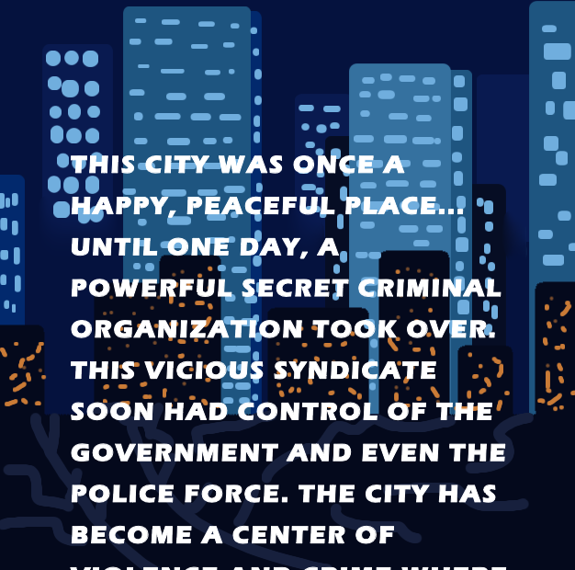
-> 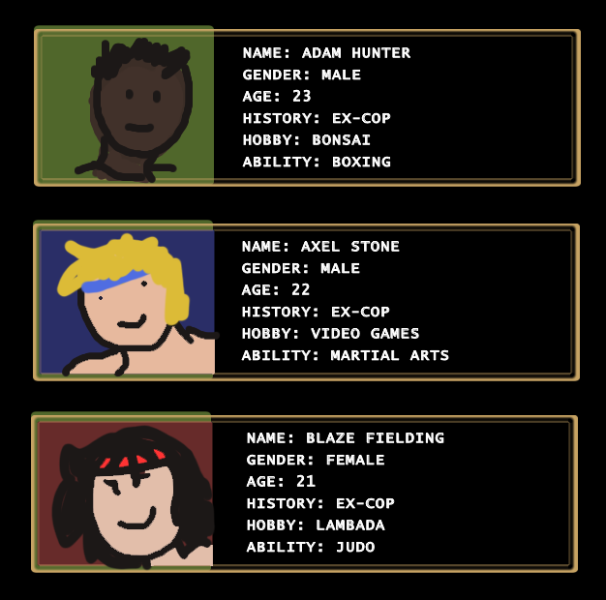
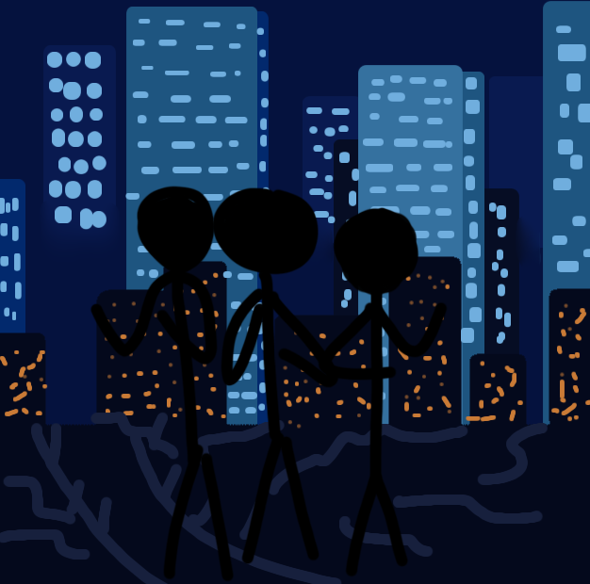 -> 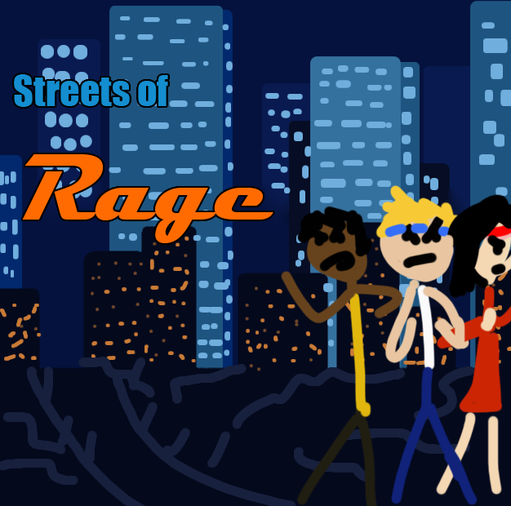

CUTSCENE DETAILS
VISUAL STYLE: | 16-bit scrolling text, fading and sliding images.
BRIEF DESCRIPTION OF SCENE: | - Screen fades in to a scene with buildings at night slowly sliding to the right continuously.  - 16-bit text scrolls up from the bottom saying “THIS CITY WAS ONCE A HAPPY, PEACEFUL PLACE... UNTIL ONE DAY, A POWERFUL SECRET CRIMINAL ORGANIZATION TOOK OVER. THIS VICIOUS SYNDICATE SOON HAD CONTROL OF THE GOVERNMENT AND EVEN THE POLICE FORCE. THE CITY HAS BECOME A CENTER OF VIOLENCE AND CRIME WHERE NO ONE IS SAFE.  - AMID THIS TURMOIL. A GROUP OF DETERMINED YOUNG POLICE OFFICERS HAS SWORN TO CLEAN UP THE CITY. AMONG THEM ARE ADAM HUNTER, AXEL STONE, AND BLAZE FIELDING. THEY ARE WILLING TO RISK ANYTHING... EVEN THEIR LIVES... ON THE... STREETS OF RAGE”.  - The screen fades to black and all 3 characters are shown with their icon, name, gender, age, history, hobby, and abilities in boxes sliding in from the left of the screen.  - They slide away and the screen scrolls over the view of the city from the start of the scene and blacked out silhouettes of the characters fade and slide in.  - The screen flashes white and the characters gain colour.  - The cutscene turns to the starting scene.
WHEN WILL IT FEATURE IN THE GAME? | At the beginning of the game when it is launched.
PURPOSE: | Introduces the player to the story and the 3 playable characters.

CUTSCENE DETAILS
VISUAL STYLE: | 16-bit fading text and fading images.
BRIEF DESCRIPTION OF SCENE: | - Screen fades to black, the word “STAFF” in white fades in and fades out after a second. The image of all 3 playable characters in the final room fades in and out.  - Design team credits fade in and out.  - An image of all 3 playable characters walking out of the headquarters to a cop car with a cop waving from the car door fades in and out.  - A screen of credits fades in and out.  - An image of Axel and a cop celebrating fades in and out.  - A screen of credits fades in and out.  - An image of all 3 playable characters standing on a bridge looking out at the city and sunset fades in, a cop car slides out of the image as if driving away. White text fades in underneath the image “PRESENTED BY _____”. The sun gradually sets in the image, and the sky darkens with clouds sliding across the image.  - The text fades and the images changes to night. Text in yellow fades in below the image at the right “THE END”. The star in the sky twinkles and the screen fades to black.  - END SCENE
WHEN WILL IT FEATURE IN THE GAME? | At the end of the game with credits between images.
PURPOSE: | To show the player the aftermath from the events in the game and show game credits.

CONTRIBUTING TEAM MEMBER: | Ellie Saunders Student number:2502179

SECTION 10: BONUS MATERIALS

BONUS MATERIALS
Will include high scores and Cooperative play.

REPLAY VALUE
- Try out different characters
- Cooperative play
- High score system
- Use different items/weapons
- Explore different ending

CONTRIBUTING TEAM MEMBER: | Ellie Saunders Student number:2502179

SECTION 11: BIBLIOGRAPHY

[1]
“Streets of Rage,” Streets of Rage Wiki, 2018. https://streetsofrage.fandom.com/wiki/Streets_of_Rage (accessed Nov. 20, 2025).
[2]
PEGI, “What do the labels mean? | Pegi Public Site,” Pegi.info, 2017. https://pegi.info/what-do-the-labels-mean
[3]
Blade (1998). 1998. Accessed: Nov. 14, 2025. [Online Image]. Available: https://au.pinterest.com/pin/49258189662657910/
[4]
Batwing. Accessed: Nov. 14, 2025. [Online Image]. Available: https://uk.pinterest.com/pin/737886720242343463/
[5]
R. Wenk, Equalizer Theatrical Release Poster. Accessed: Nov. 14, 2025. [Online Image]. Available: https://en.wikipedia.org/wiki/The_Equalizer_%28film%29
[6]
Paris Olympics. Accessed: Nov. 14, 2025. [Online Image]. Available: https://uk.pinterest.com/pin/737886720242339320/
[7]
Man Kicking with Boxing Gloves on. Accessed: Nov. 15, 2025. [Online Image]. Available: https://au.pinterest.com/pin/737886720242339700/
[8]
Flying side kick. Accessed: Nov. 15, 2025. [Online Image]. Available: https://au.pinterest.com/pin/737886720242339759/
[9]
vishstudio, Spirit of Fighting. 2011. Accessed: Nov. 15, 2025. [Online Image]. Available: https://au.pinterest.com/pin/737886720242343068/
[10]
London Green. Accessed: Nov. 15, 2025. [Online Image]. Available: https://au.pinterest.com/pin/737886720242339742/
[11]
Hand Cuffs on a Newspaper with Keys. Accessed: Nov. 15, 2025. [Online Image]. Available: https://au.pinterest.com/pin/737886720242339219/
[12]
The Lookout 22 Bishopsgate. Accessed: Nov. 15, 2025. [Online Image]. Available: https://au.pinterest.com/pin/737886720242339720/
[13]
Man Preparing Himself for a Fight. Accessed: Nov. 15, 2025. [Online Image]. Available: https://au.pinterest.com/pin/737886720242339704/
[14]
Wrapping Hand. Accessed: Nov. 15, 2025. [Online Image]. Available: https://au.pinterest.com/pin/737886720242339258/
[15]
Man Leaning against Wall with White Tank Top and Straight Trousers. Accessed: Nov. 15, 2025. [Online Image]. Available: https://au.pinterest.com/pin/737886720242339788/
[16]
BANTON FRAMEWORKS, 17 Best Hipster Glasses. Accessed: Nov. 15, 2025. [Online Image]. Available: https://au.pinterest.com/pin/737886720242339947/
[17]
Man in the Mirror with Blue Jeans and White Tank Top. Accessed: Nov. 15, 2025. [Online Image]. Available: https://au.pinterest.com/pin/737886720242339938/
[18]
Tailored Gentleman Outfit. Accessed: Nov. 15, 2025. [Online Image]. Available: https://au.pinterest.com/pin/737886720242339877/
[19]
Garrett Hedlund. Accessed: Nov. 16, 2025. [Online Image]. Available: https://au.pinterest.com/pin/737886720242340349/
[20]
Guy Street Fighter. Accessed: Nov. 16, 2025. [Online Image]. Available: https://au.pinterest.com/pin/737886720242343461/
[21]
Capcom, RYU | STREET FIGHTER 6 . Accessed: Nov. 16, 2025. [Online Image]. Available: https://www.streetfighter.com/6/character/ryu
[22]
Man Kicking to the Right. Accessed: Nov. 16, 2025. [Online Image]. Available: https://au.pinterest.com/pin/737886720242340033/
[23]
Atakan Utku Sensei Aikido Dojo . Accessed: Nov. 16, 2025. [Online Image]. Available: https://au.pinterest.com/pin/737886720242340065/
[24]
Two Men Fighting in a Boxing Ring. Accessed: Nov. 16, 2025. [Online Image]. Available: https://au.pinterest.com/pin/737886720242340067/
[25]
Man Jump Kicking Another Man . Accessed: Nov. 16, 2025. [Online Image]. Available: https://au.pinterest.com/pin/737886720242340063/
[26]
Man Upper Kicking the Air. Accessed: Nov. 16, 2025. [Online Image]. Available: https://au.pinterest.com/pin/737886720242340058/
[27]
Chicago . Accessed: Nov. 16, 2025. [Online Image]. Available: https://au.pinterest.com/pin/737886720242339980/
[28]
Man Kneeling . Accessed: Nov. 16, 2025. [Online Image]. Available: https://au.pinterest.com/pin/737886720242340101/
[29]
Chicago City. Accessed: Nov. 16, 2025. [Online Image]. Available: https://au.pinterest.com/pin/737886720242339990/
[30]
Dog Tags. Accessed: Nov. 16, 2025. [Online Image]. Available: https://au.pinterest.com/pin/737886720242339256/
[31]
Man looking to the left with a white top and blue jeans. Accessed: Nov. 16, 2025. [Online Image]. Available: https://au.pinterest.com/pin/737886720242339953/
[32]
Man Leaning against Red Phone Box . Accessed: Nov. 16, 2025. [Online Image]. Available: https://au.pinterest.com/pin/737886720242339924/
[33]
Man Standing Looking Left with Black Top and Blue Jeans. Accessed: Nov. 16, 2025. [Online Image]. Available: https://au.pinterest.com/pin/737886720242339954/
[34]
lucy lu. Accessed: Nov. 17, 2025. [Online Image]. Available: https://au.pinterest.com/pin/737886720242339663/
[35]
Ada Wong. Accessed: Nov. 17, 2025. [Online Image]. Available: https://au.pinterest.com/pin/737886720242339539/
[36]
Chun Li. Accessed: Nov. 17, 2025. [Online Image]. Available: https://au.pinterest.com/pin/737886720242344035/
[37]
Tominagi Throw. Accessed: Nov. 17, 2025. [Online Image]. Available: https://au.pinterest.com/pin/737886720242343976/
[38]
P. Pires, Woman Kicking a Punching Bag. Accessed: Nov. 17, 2025. [Online Image]. Available: https://au.pinterest.com/pin/737886720242343989/
[39]
Woman Kicking Punching Bag . Accessed: Nov. 17, 2025. [Online Image]. Available: https://au.pinterest.com/pin/737886720242344011/
[40]
Man Punching Another Man in a Boxing Ring. Accessed: Nov. 17, 2025. [Online Image]. Available: https://au.pinterest.com/pin/737886720242344022/
[41]
Hong Kong. Accessed: Nov. 17, 2025. [Online Image]. Available: https://au.pinterest.com/pin/737886720242339301/
[42]
Daily Mail, Team USA’s record-breaking Boxing Star . Accessed: Nov. 17, 2025. [Online Image]. Available: https://au.pinterest.com/pin/737886720242339387/
[43]
Woman Guarding. Accessed: Nov. 17, 2025. [Online Image]. Available: https://au.pinterest.com/pin/737886720242339314/
[44]
Police Woman . Accessed: Nov. 17, 2025. [Online Image]. Available: https://au.pinterest.com/pin/737886720242339213/
[45]
Woman Looking off to the Right with a Blue Blouse. Accessed: Nov. 17, 2025. [Online Image]. Available: https://uk.pinterest.com/pin/618330223873609884/
[46]
Woman in Black Dress and Jacket . Accessed: Nov. 17, 2025. [Online Image]. Available: https://in.pinterest.com/pin/898608931905537453/
[47]
Woman Leaning against Red Car. Accessed: Nov. 17, 2025. [Online Image]. Available: https://au.pinterest.com/pin/737886720242339434/
[48]
A Red Leather Jacket and Black Jeans. 2026. Accessed: Jan. 13, 2026. [Online Image]. Available: https://x.com/Bllury/status/2007809689900503220
[49]
Attribution-NonCommercial 4.0 International (CC BY-NC 4.0), Keyboard PNG. [Online Image]. Available: https://pngimg.com/image/101855
[50]
Uxwing, Computer Mouse Icon. [Online Image]. Available: https://uxwing.com/computer-mouse-icon/
[51]
Game Controller. [Online Image]. Available: https://www.pngplay.com/image/327118

