Mavis Frimpomaa
Student ID2639611
Lecture: Dr. Besty Jose
Module title: Professional Development within Health and Social Care
Assignment title: Personal Development Portfolio.

Content pages:
Job role advertisement page……… 3
Professional CV………………………. 5
Personal statement……………….7
SWOT Analysis………………8
Personal Development Plan (PDP)……9-10
Personal reflection………………….11
References……………….13

Job role advertisement:

Job Advert
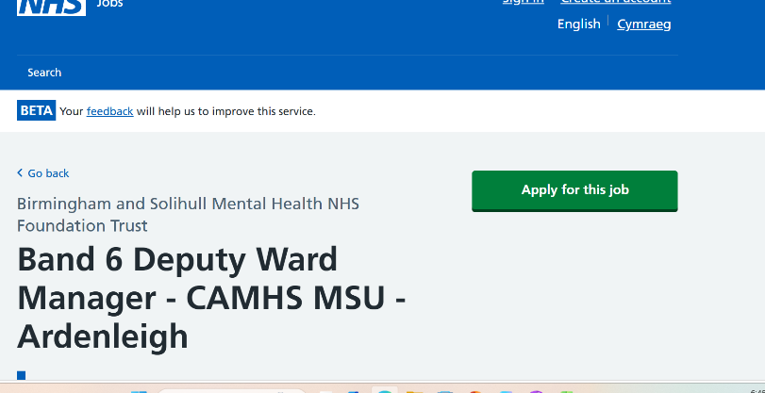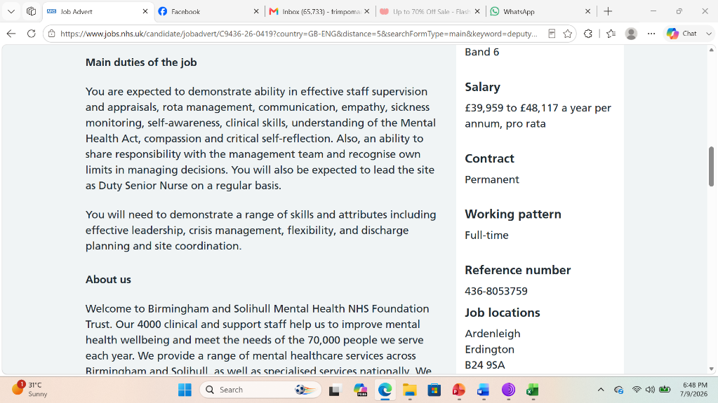
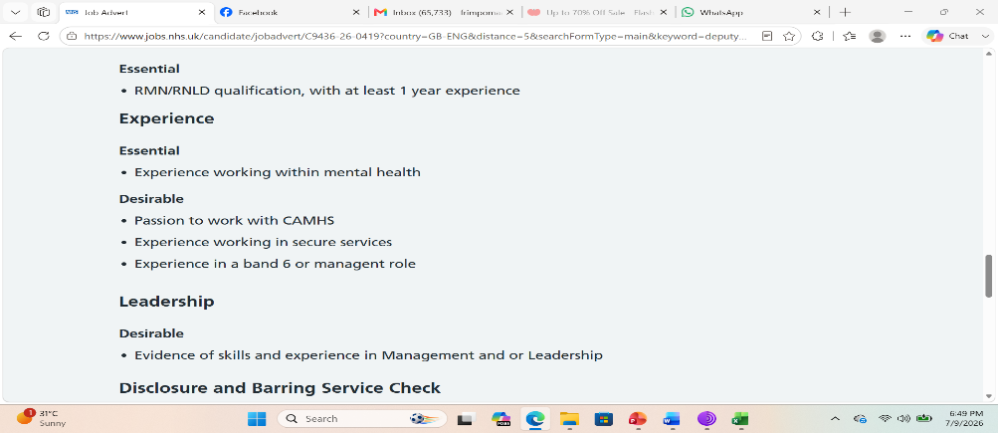

Task 1 of 4:
Professional CV:
Mavis Frimpomaa
Contact

Profile
My career aim is to progress into a senior leadership role within ward management, where I can contribute to high‑quality patient care, effective team coordination, and continuous service improvement. Applying for the Deputy Ward Manager position represents a natural and exciting step in my professional development, allowing me to build on my clinical expertise, leadership capability, and commitment to safe, compassionate care.

Education
• BSc (Hons) Adult Nursing, [University of Birmingham, [Sept 2015-June 2018] Developed strong foundations in evidence-based practice, clinical reasoning, patient assessment, and professional accountability.
• Level 3 Diploma in Health & Social Care, [College of Aston], [Sept 2007-June 2014] Gained essential knowledge of safeguarding, communication, and care delivery across diverse settings.
Additional Training & Certifications
- Clinical Leadership & Supervision
- Medication Management & Safety
- Infection Prevention & Control
- Safeguarding Adults & Children
- Conflict Resolution & De-escalation
- Mandatory Trust Training (BLS, Manual Handling, Equality & Diversity)

Skills
Clinical Leadership: supervising staff, coordinating shifts, supporting safe delegation.

Patient Assessment: managing complex needs, monitoring deterioration, escalating concerns.

Safeguarding: confident in identifying risk, reporting concerns, and ensuring compliance.

Communication: clear, compassionate, and effective with patients and families.

Quality Improvement: audit participation, documentation review, service‑enhancement initiatives.

Team Support: mentoring students, supporting newly qualified nurses, promoting learning.

Organization & Prioritization: managing workload efficiently in fast‑paced environments.

Digital Competence: confident using EPR systems, digital documentation, and patient‑flow tools.

Work experience

Registered Nurse – [Ward/neonatal nurse], NHS Trust
- Deliver high-quality, evidence-based care to patients with complex medical needs.
- Coordinate daily ward activity, including staff allocation, patient flow, and safe discharge planning.
- Mentor student nurses and support junior staff, promoting reflective practice and professional development.
- Lead on documentation audits, infection-control checks, and safety initiatives.
- Communicate effectively with multidisciplinary teams to ensure seamless care delivery.
- Respond to emergencies, manage clinical risk, and escalate concerns appropriately.

Staff Nurse – [neonatal nurse], NHS Trust
- Provided compassionate, person-centered care across a busy acute ward.
- Supported medication administration, care planning, and clinical observations.
- Built strong rapport with patients and families, ensuring dignity and respect.
- Contributed to ward improvements, including patient-experience projects and communication initiatives.

Interests & hobbies
Community Volunteering: committed to improving wellbeing beyond the clinical setting.
Fitness & Wellbeing: running, yoga, and mindfulness.
Creative Activities: journaling, crafts, and photography.

Personal achievements
• Recognized for excellence in patient communication and compassionate care.
• Received positive feedback from students and junior staff for supportive leadership.
• Contributed to a ward-based initiative that improved patient flow and reduced delays.

Task 2 of 4:
I am applying for the role of Deputy Manager with a clear ambition to contribute to a high‑performing team, strengthen operational excellence, and continue developing as a strategic leader. My career aim is to progress into senior management, and I see this role as the ideal opportunity to apply my experience, expand my responsibilities, and support an organization committed to quality, efficiency, and positive workplace culture.
One of my key strengths is my ability to build strong working relationships; colleagues often describe me as approachable, calm under pressure, and able to motivate others through clear communication and fairness. I believe that effective leadership is rooted in trust, consistency, and a willingness to listen.
Ultimately, I am motivated by the opportunity to help shape a positive, productive environment where staff feel supported and customers receive excellent service. As Deputy Manager, I would bring commitment, integrity, and a strong work ethic. I am eager to contribute my experience while continuing to grow professionally, and I believe my combination of education, personal strengths, and leadership skills would add real value to your team.

Task 3 of 4:
SWOT analysis:
A SWOT analysis is a structured method for examining internal factors (strengths, weaknesses) and external factors (opportunities, threats) to guide strategy and planning (Peterdy,2022).
Strengths: Internal capabilities that give an advantage.
Weaknesses: Internal limitations that reduce performance.
Opportunities: External factors that could be exploited for benefit.
Threats: External risks that could harm performance.
STRENGTHS:  Leadership capability  Operational knowledge  Communication skills  Problem‑solving | WEAKNESSES:  Limited strategic authority  High workload pressure  Skill gaps (Areas such as advanced budgeting, HR law, or strategic planning may need further development to progress into senior management (Armstrong & Taylor, 2020).  Dependence on senior leadership.
OPPORTUNITIES:  Professional development  Mentoring and coaching  Organizational growth (Expansion, restructuring, or new services can create pathways for promotion or role diversification (Kotler & Keller, 2016).  Technology adoption | THREATS:  Increased competition  Policy or regulatory changes (New compliance requirements can increase workload or require rapid adaptation (Armstrong & Taylor, 2020).  Staff turnover  Resource constraints

A Personal Development Plan (PDP) is a structured, written roadmap that helps you understand where you are now, where you want to be, and the specific steps you need to take to get there. It is used in education, workplaces, and personal life to support continuous growth, self‑reflection, and goal achievement (Dziak, 2020).
GOALS | LIST THE ACTIONS TO ACHIEVE THE GOAL | SUPPORT/ RESOURCE NEEDED | TARGET DATE | REVIEW DATE
Strengthen Strategic Leadership Skills | - Attend leadership training.  - Shadow senior managers during planning meetings to observe decision‑making.  - Read monthly management literature to deepen theoretical understanding. | - Access to organizational leadership courses or external providers.  - Mentoring from senior managers.  - Time allocated for project leadership.  - Access to organizational strategic plans and meeting notes.  - Recommended reading list provided by senior leadership. | 19-24 months | Every 4 months
Improve People‑Management and Coaching Skills | Complete a coaching or mentoring course.  Hold monthly one‑to‑one development meetings with staff.  Practice conflict‑resolution techniques and reflective listening.  Take responsibility for onboarding new staff to build confidence in leading others. | Access to coaching/mentoring training.  HR support for managing performance or conflict.  Senior manager feedback on your supervision style.  Staff development templates and supervision tools.  Opportunities to lead team briefings or training sessions.
Strengthening Operational and Compliance Expertise | Complete training in HR procedures, safeguarding, and regulatory compliance.  Review and update operational policies every six months.  Lead internal audits or quality checks to gain hands‑on experience.  Work with senior managers to understand budgeting and resource allocation. | Access to HR, safeguarding, and compliance training.  Support from quality assurance teams.  Policy documents, audit tools, and regulatory guidance.  Coaching from senior managers on budgeting.  Time allocated for policy review and audit preparation.

Task 4 of 4:
REFLECTION:
For this task, I delivered a presentation on the importance of reflective practice in professional development. The presentation covered key concepts such as self‑evaluation, reflective models, and the role of reflection in improving workplace performance. I prepared slides, spoke for approximately five minutes, and responded to questions from my lecturer. After the presentation, I received verbal feedback highlighting strengths in clarity and structure.
Before presenting, I felt a mixture of anxiety and anticipation. Although I had prepared thoroughly, I was concerned about speaking in front of my lecturer and whether I would remember all key points. During the presentation, I became more comfortable, especially when I noticed my lecturer responding positively. However, I also felt moments of self‑doubt, particularly when transitioning between sections.
After receiving feedback, I felt relieved that my lecturer recognized the clarity of my explanation, but I also felt slightly disappointed that my critical depth and confidence needed improvement. These feelings align with common emotional responses to public speaking described in reflective practice literature, where anxiety often decreases as familiarity increases.
Reflecting on my performance, I recognize that my preparation focused more on content accuracy than delivery. According to Gibbs, deeper reflection requires examining why things happened the way they did. My anxiety likely contributed to rushing through key points, which limited my ability to provide deeper critical insight. Research on presentation skills suggests that confidence improves with repeated practice and familiarity with the material beyond memorization. Additionally, my reliance on slides indicates that I may need to strengthen my verbal communication skills and reduce dependence on visual prompts. The lecturer’s feedback supports this, noting that my ideas were strong but needed more elaboration and critical depth. This suggests that future presentations should include more rehearsal focused on delivery, not just content.

References list:

Armstrong, M., & Taylor, S. (2020). Armstrong’s Handbook of Human Resource Management Practice.

Dziak, Mark. (2020). Personal Development Planning, available at: Personal Development Planning | Psychology | Research Starters | EBSCO Research

Kotler, P., & Keller, K. (2016). Marketing Management.
Peterdy, K. ( 2022) SWOT Analysis, available at: SWOT - Definition, Examples, Process, Uses

