Should graffiti be considered high culture?

Oliver Rowe
1706452
BA Advertising and Brand Design
Word Count: 1801
Sarah Tombs and Louise Burston

Should graffiti be considered high culture?

Graffiti has been a prominent form of art in urban landscapes since its initial conception in the 1960s, where two writers known as Cornbread and Cool Earl began writing their names around Philadelphia as a marketing scheme to gain the attention of their local community and media. After this graffiti as grown significantly into mainstream media with the rise of artists such as Keith Haring spreading positive messages about equality through New York City, Jean-Michel Basquiat selling his artwork on clothing and postcards as a way to spread his artwork and most notoriously Banksy sharing his views through his street art about modern culture, war and politics, but does graffiti being accepted by mainstream media defeat the original counter culture which it was conceived as, “street art is both an expression of our culture and a counterculture in itself” (Manco, 2002).

Graffiti is commonly on display in almost every city in the world whether it's on subway cars, tagged on bridges or a mural on a wall the art form has spread to all corners of the world, it has always been a reflection of the culture of the time by making statements about politics, empowerment, art and identity while simultaneously being synonymous with crime and destruction. Graffiti can be compared to Romans inscribing public messages on walls throughout their cities, Mayans scratching images into surfaces and in Pompeii citizens would write messages to congratulate or encourage their favorite warriors, but it wasn't until centuries later that graffiti became synonymous with the term vandalism, this came around during the French revolution due to the defacing of art around this time, this is still one of the reason why graffiti is still an underground art movement and part of low culture.

Graffiti and street art have always been an expression of modern culture whilst simultaneously being a counterculture. Due to high culture communication flooding city streets with various advertisements in the forms of billboards, flyers and corporate advertisements a counter culture response arose in the form of street art. For various artists the street became a canvas where they were able to compete against large corporations and could convey their messages to the public on the same level as the advertising come from large companies and businesses. Large corporations began to flood urban landscapes with high priced imagery therefore street artist reacted with a cheap alternative to put their imagery and communicate messages to the public in an illegal manner which added something special to the artist’s work as it shows that they are passionate enough to possibly get in trouble with the law when attempted to express themselves and their beliefs to the public, “participation in a cat and mouse game to create illegal acts of creation in the name of art and freedom of expressions” (Manco, 2002).

Graffiti became synonymous with vandalism and crime which resulted in street art became rejected by high culture art and mainstream media, these assumptions were made without any consideration for what the person was trying to communicate through their work or what positive impacts it could have communities and street artists became labelled as common criminals. Overall the art community and the public simply wrote off people who would partake in graffiti as criminals rather than artists in their own right, “uncommisioned artworks, donated to the public on the streets are motivated by creativity alone. The artists and makers are as free as the works they create” (Kuittinen, 2015).

Graffiti was completely neglected by the high cultured art community for being common criminality and uncreative with no artistic value which is an extremely false statement as it was a way of artists being able to put their work into the public eye as they did not have a platform to show their work like traditional artists. The argument that the art community used saying that graffiti has no artistic value or uncreative can also be just as easily be made against modern art, modern art is strongly regarded as being high culture but can often also been having no artistic value or being uncreative. With modern art the lines between what is art and what is not have been blurred due to the obscurity of what is now considered art. People are beginning to believe that you can place any inanimate object with a museum and it can be considered art and people will begin to try interpret it artistically and find meaning from something within a gallery which has no message to convey what so ever, for example in 2016 a pair of glasses was left in the San Francisco Museum of Modern Art and people began keeping a safe distance away and taking pictures of the glasses assuming it was a piece of modern art.

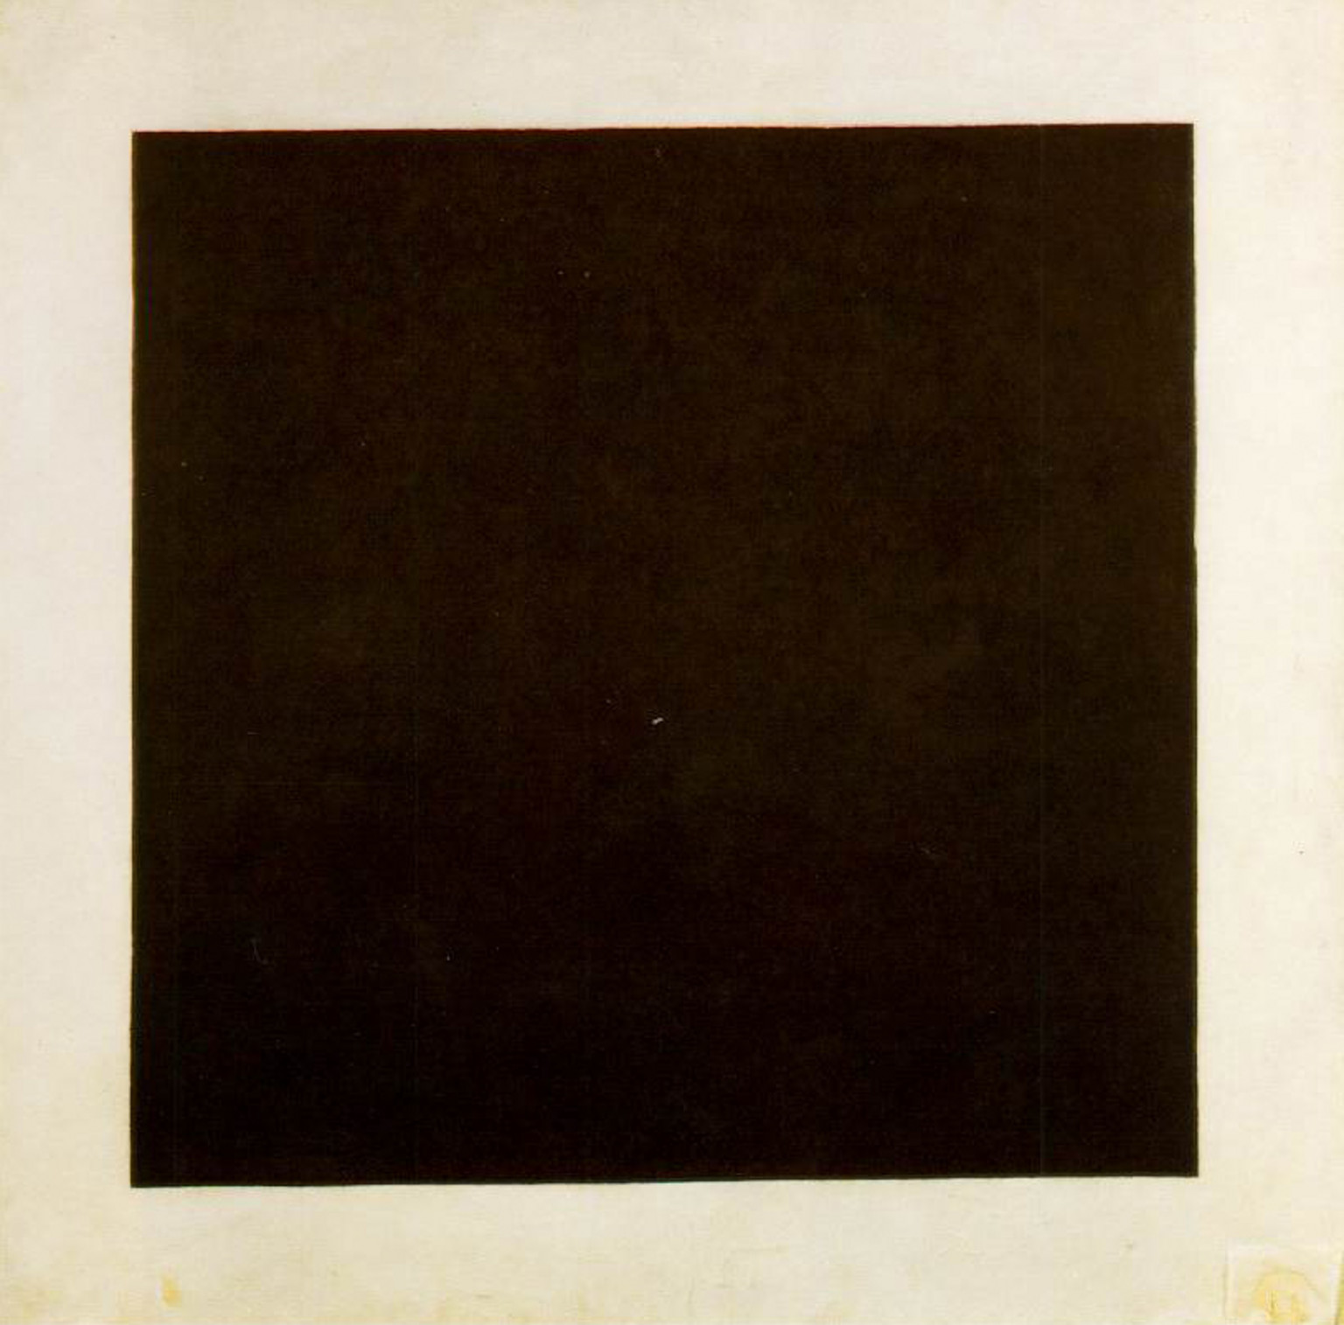
A piece of modern art which fits the claims of having no artistic value or creativity is Kasimir Malevich’s Black Square, this piece of work was created when Malevich was asked to design the costume and the set for an opera called Victory Over the Sun, during the finale of the opera the backdrop for the scene was a singular black square against a black backdrop. Malevich describes his work as “suprematism”, a genuinely original artistic expression at the time as it was abstraction in its purest form being removed from all visual cues so that the viewer can have the “experience of non-objectivity… the supremacy of pure feeling” (Malevich, 1959). I believe that any piece of work can be called art but the demographic of high culture art should not be able to deem something as artistic or not, therefore graffiti should be regarded as art if a black square on a canvas can be considered art, seeming as if modern art takes less effort than graffiti it reflects Tom Stoppard stating that “skill without imagination is craftsmanship and gives us many useful objects such as wickerwork picnic baskets. Imagination without skill gives us modern art” (Stoppard, 1988).
Malevich, K. (1915). Black Square. [paint on canvas] London: Tate Modern.

After being neglected by the art community, graffiti was mostly accepted by the high culture of art and began being curated into art museums and street art pieces were being sold at extremely high prices, but in a sense, this defeats the purpose of what graffiti is. Graffiti was initially conceived as putting your work into the eyes of the community as a way to compete with the high culture and corporations spreading their own imagery through advertisements, but once graffiti is considered as high art it becomes the initial thing it was originally countering, Banksy has been quoted saying that what making graffiti unique is that it is accessible by all and is free, “writing graffiti is about the most honest way that you can be an artist, it takes no money to do it, you don't need an education to understand it and there's no admission fee” (Manco, 2002).

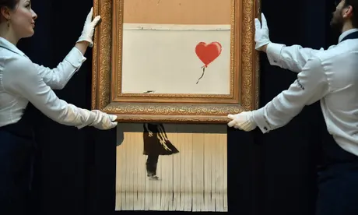
Various graffiti artists have starting revolting against graffiti being converted to high culture art through their work, the most recent example of this is Banksy shredding his famous painting girl with a balloon once it sold at an auction for $1.4 million. Banksy strongly rejects when people attempt to sell his work as people who own the building where his work has been displayed have been known to remove the wall to sell in an auction, therefore Banksy had installed a makeshift shredder within the frame in case the painting ever was sold at an auction and defended his actions by quoting Picasso stating that “the urge to destroy is also a creative urge”. This is the Banksy showing a complete rejection of his work becoming high culture as he believes that graffiti is a pure art form that should be experienced for free by everyone and remain as a low culture art movement. Even after Banksy reacted to high culture art by shredding his work to make a statement that his work should be free for all people to experience, this has had the opposite effect because after the original artwork being shredded during this publicity stunt it has now raised the price of the painting to over $2 million dollars showing that the high culture art movement are oblivious to the message the artist is trying to convey to them and they are solely focused on the price tag of the artwork.
Love is in the bin. (2018). [Spray Paint] London: Sotheby’s.

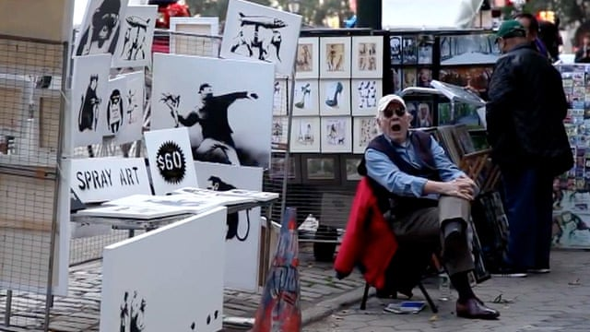
Banksy has previously done another publicity stunt to try to prove to the public that his work should not be auctioned to make a profit and should not be considered as high culture art, the publicity stunt took place in Central Park in New York during 2013 where he commissioned an old man to sell some of his original works of art for $60 each for pieces that could sell for 6 figures in an art auction, the stunt was part of Banksy's “better out than in” residency in New York. Many people assumed these to be reprints or knockoffs of the original pieces of art and didn't buy anything, overall the stall made a total of $420 and it took over four hours for the first sale to occur. One woman was able to negotiate the price to be $60 for two of the canvas’ and a man purchased four of the original prints and explained to the elderly man that he “was just looking something for his walls”. Banksy understood that the stall wouldn’t be successful as a way for people to re-evaluate the perception of worth for original pieces of art within the marketplace, this publicity reflects John Berger's beliefs surrounding the market value of original artwork, “the bogus religiosity which now surrounds original works of art, and which is ultimately dependent upon their market value, has become the substitute for what paintings lost when the camera made them reproducible” (Berger, 1972).
Banksy Street Stall. (2013). [Spray Paint] New York: Central Park.

Personally, I believe that graffiti shouldn't be regarded as high culture art as it was originally conceived as a counter culture to corporate imagery and high culture art due to street artists being denied the label of artistic by the high culture art community. Due to graffiti being visible in almost every town and city worldwide I believe that street art would thrive best as a low culture art movement freely accessible for everyone and be an art culture for the people. I also believe that graffiti can never be fully accepted as high culture as the crime and vandalism aspect of the art movement is engrained strongly with the general public and due to this, I believe that street art will remain as a low culture and counterculture art movement.

Bibliography

Manco, T. (2002). Stencil Graffiti. London: Thames and Hudson.

Kuittinen, R. (2015). Street Craft. London: Thames and Hudson.

Malevich, K. (2003). The Non-Objective Wold. USA: Dover Publications.

Artist descending a staircase, (1988). [Radio Broadcast] Tom Stoppard: BBC.

Berger, J. (1972). Ways of seeing. London: Penguin.

Malevich, K. (1915). Black Square. [paint on canvas] London: Tate Modern.

Love is in the bin. (2018). [Spray Paint] London: Sotheby’s.

Banksy Street Stall. (2013). [Spray Paint] New York: Central Park.

