Construction organization

Resources optimization

1 Introduction
The construction project we are expected to do is a confined building which is a five-floor hotel planned to located at an area adjacent to the train station, Mariner St. With a case study of a previous hotel project, we are separated into different tasks to fulfill the project with Ianto works on Gantt Chart, Mark works on site layout, Tomas works on cash-flow chart and me work on resources optimization. In the following discussion, I will focus on and describe the task of resources optimization.

1.1 Background (Techniques used)
There are several processes associated with the construction organization, first one is defining activities, then is the task of ordering activities which is followed by estimating the duration and resources of activities. After that, we start on the task of resource smooth and schedule control. As the first three tasks have been fulfilled by Ianto, what this report about is the following tasks, estimating resources and optimizing resources.

According to the PMBOK Guide published by project management institute(2013 p.164), there are several tools for estimating activity resources, they are 1.Expert judgment. 2.Alternative analysis. 3.Published estimating data. 4.Bottom-up estimating. 5.Project management software. And the following part will use the Published estimating data and Alternative analysis to estimate resources needed in each activity because they are the two most available and effective methods we can access.

And the PMBOK Guide published by project management institute (2013 p.179-180) also mentioned some techniques on resources optimization, they are resource leveling and resource smoothing. As there is no exact restriction on the availability of resources, so the following part will optimize resources through resource smoothing which combined with the bar chart and the network. Besides, the critical path method also will be used in optimizing resources.

1.2 Purpose
There are two main purposes of the construction organization, the first purpose is to arrange the specific activities in the construction process and optimize these activities, another one is to meet the requirement of the five primary goals of a project, they are the quality goal, the time goal, the cost goal, the security goal and the sustainability goal. (Wei, 2017)

Zhu and Sherali also illustrated the importance of construction organization in their research that“Cost-effective workforce organization is one of the crucial issues which attracts the attention of management, especially in labor-intensive and customer-oriented industry.” (2009)

As the construction industry always have an intensive workforce and luge consumption of energy, to organize the workforce and other machines or facilities can lead to a dramatical decline on the investment and also can reduce the energy consumption which contributes to the sustainability of the construction industry.

As my task in the group work is to smooth the workforce and other resources for the confined building, my key goal is to avoid the overload and extream peaks of the labor and energy consumption. Normally the five primary goals cannot be taken into consideration respectively in the process of construction organization, but in this procedure, I should intend to focus more on the time goal and optimization as they are the main task of my work. However, the ultimate goal of our group work is to meet these five goals equally in order to the success of the confined building. In the following part, I will arrange the workforce and breakdown activities in the construction process and optimize the arrangement to evade form intensive labor which has a potential threaten on the security and can add the investment. Besides that, I also would consider other resources and make the whole process of the confined building efficiently.

1.3 Initial documents
The initial document for my tasks is the Gantt chart which including the activities description and activities order ( the activities relationship). And normally the relationship can be separated into four categories. They are the one cannot start until the predecessor start SS, the one cannot be finished until the predecessor starts FS, the one cannot be finished before the predecessor is finished FF, the one cannot start before the predecessor is finished SF. With the Gantt chart and the relationship between each activity, I can make a network, which would be more effective on the procedure of the construction organization.

And my initial file is provided by Ianto with the relationship between each activity. To describe them in brief, they were separated into three types of work according to the different period where these activities happen, they are preliminary activities, substructural activities and superstructural activities. As Ianto has specified the activity in each category, there are 3 activities in the preliminary, 11 activities in the substructure, 20 activities in the superstructure, my task could begin at changing them into a network which has a more specific relationship between each work with the total float which is a significant figure could influence the construction organization.

2 Construction organization

2.1 The importance of construction organization
The construction organization arranges activities of the project with limited time, duration and an organizational principle then arranges different resources to each activity, gives activities different rankings, according to these, we can optimize the construction process in order to guarantee the employer’s investment. (Bin, 2017)

In spite of the function of controlling the investment, the construction organization also related to the other important factors like the time and the quality, and the terminal goal of construction organization is to control the time, the cost, the quality, the security and the sustainability of the construction project, these features have a direct influence on the success of a construction project.

And in my task of the confined building, the two essential goals of the construction organization are to ensure the duration of the project which means to fulfill the project on time and to smooth the constructional resources, avoiding intensive labor. Finally, the goal of our group work is to ensure the productivity of the project and promote the success of the confined building.

2.2 Strategies for resource optimization
- Optimize the order of activities
Wei illustrated in his research that “The smooth of the activities in a project is alternating the order of each activity, attributing to that, we can fulfill some activities simultaneously, we also can make the resource supplement centralized and make use of the resource of land more efficiently.” (2017)

- Arrangement of equipment
Before a high level of detailed schedule is purposed, a simpler bar-chart is used to arrange the time used for ordering the long lead time equipment, which might be purchased before the final design is completed. (Elshout and Garcia, 2009) Some types of equipment and materials should be purchased as early as they can, due to the procrastination of the supplement might cause a delay of the whole project, so we should decide which equipment or material is necessary for the project and make the supplement completed reasonably, normally a few days before the equipment implementing in the project since the idle equipment and materials as need money to maintain.

- Coordination meetings
Elshout and Garcia also mentioned that “Coordination meetings are necessary for the efficient use of the workforce, changes in a plan may be needed when we suffer unexpected obstacles.” (2009) Definitely, we would encounter unexpected difficulties during the construction of the project, then we have to change our plan with overtime work or hire more labor beyond our anticipation or even have to delay the project. And which one is the most reasonable solution, that needs a meeting to put it down to earth, which can meet the requirement of most of the participants. According to that, a coordination meeting is really in need when dealing with the unpredict events happen during the construction process.

- The important role of the project manager
According to Lei and her research on human resource organization in the construction industry, a project manager should respond to the market rather than the leader in his or the employer’s organization. (2018) The project manager who needs sufficient expertise in management area plays an important role in the construction industry, the lack of his knowledge may lead to failure of the construction project and the partiality of the project manager may result in the deficiency of the labors’ performance. So we need to hire a skilled project manager who would promote the success of the project.

3 Case study

3.1 Preliminary
As my task is smoothing the resource of the project which cannot start until getting some initial documents. And at first, I was confused about what I can do as there are some obstacles to the language which influences my communication and understanding with my group members. So, actually at the first few weeks, what I do is just waiting for the initial document from my group member.

And after a few weeks’ study, I come up with an idea that I can start searching some theoretical knowledge which would play as a supplement for my report and help me with my scheduling. At that time, I still confused about what I can do to contribute to the group as I may not have enough ability to help my group member. And in fact, what I do for the case study and my group is only my task.

After the class of smooth the resource, then I begin to concentrate on my tasks and starts working on the labor capacity calculating and the workforce smooth and other things.

3.2 Optimization process
The first step of my resource optimization is that to change the Gantt chart into a network which fixes the resources optimization more. As the relationship is more complex than a simple predecessor and successor relationship, so I add some relationship between activities and I would give my interpretations. For instance, activity 11. Foul sewer connections outside of raft and activity 12 External drainage SW and connection to LA S.W System, the continuous two activities, before these two activities are finished, activity 23 firstly fix plumbing cannot start as the principle of the plumbing work is that firstly fix the underground line then the overground line, firstly fix the larger line then the smaller line, firstly fix the main line then the branch line. The same, activity 11 and activity 12 is the predecessor of activity 31 carriageway surfacing since all the pipeline should be covered by the carriageway. Because of that the activity 12 is one of the indirect predecessors of activity 23 and activity 31, their direct predecessor which could be done later than activity 12 and have a tight joint with them. Then the final network would show in the following figure 1.
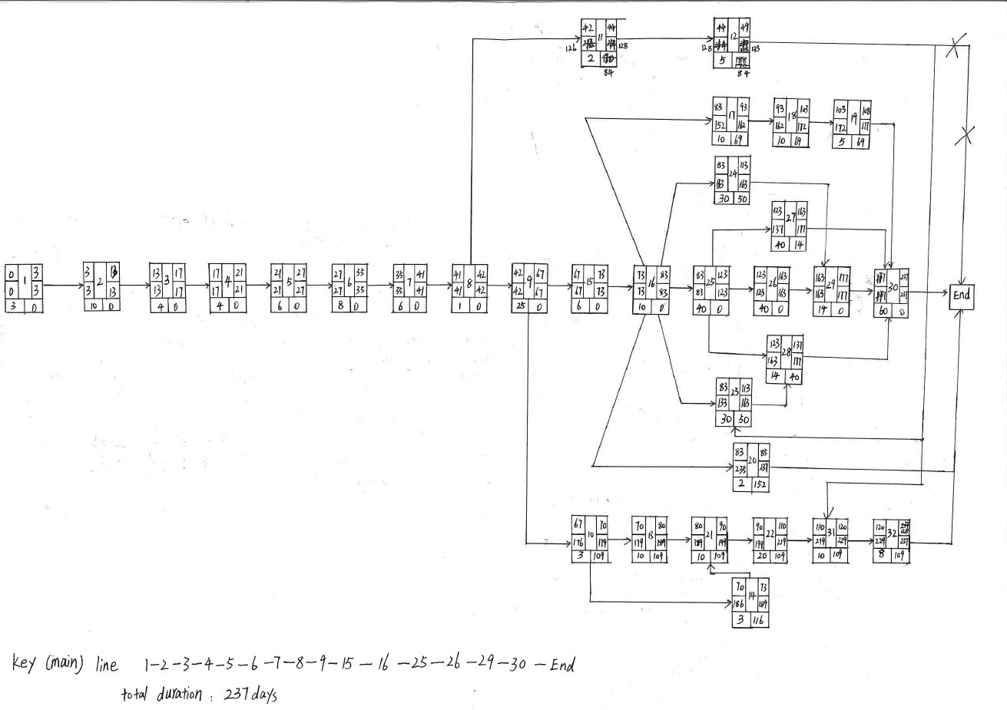
Figure 1 network with activity ID and early start, final start, early finish, final finish and the total float and necessary relationship.

The second step of my resource optimization is to estimate the workforce needed. As it is mentioned in Guide to good practice in the management of time in complex projects (2011, p.23) that the formula of duration is that: $Duration=\frac{work quantity}{Productivity quotient*quantity of resource}$
Then we can deduce that the formula: $Resource quantity= \frac{work quantity}{duration*productivity quotient}$ which can be used once the duration is planned.

And the result of this step will be shown in figure 2 below which is based on the Gantt Chart by Ianto, and actually, my work is only adding the activity ID and the workforce.
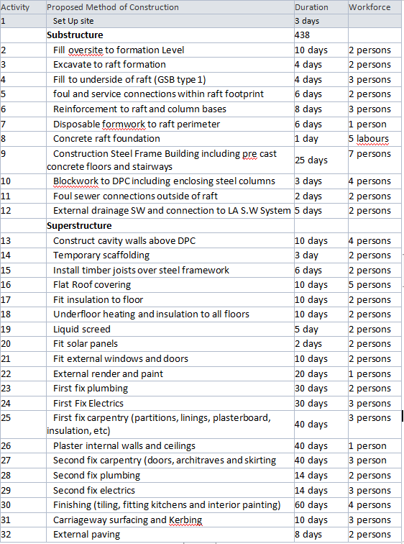
Figure 2 the list of activities, duration and workforce needed.

The estimation is based on the Spon’s architect and builders’ price book 2018. For example, the confined building takes up almost 240 m² land, and the foundation depth is almost 1.5 meters. According to the Spon’s book, the excavation by the machine to reduce the levels and the maximum not exceeding 2m is that 0.04 hour/m³, and by hand is 1.8 hours/m³. (2018) As the quantity of excavation is 240*1.5=360m³. Then the time needed by machine is14.4 hours (360*0.04=14.4) and the time needed by hand is 648 hours (360*1.8=648 hours). As the labor hour should be limited in 8 hours or we need to pay for the overtime work. Thus if we want to finish this activity on time with the planned duration of the Gantt chart which is 4 days. We need one machine or at least 81 (648/8=81labors) labors excavating by hand. Then we would better choose the suitable machine to excavate the soil, and as the machine needs a driver and a supervisor as a gang work, so estimation of this activity’s workforce is 2 labor.

The third step of my work is to organize the construction process and optimize the workforce in order to avoid the intensive labor during the construction which is a risk for both the employer and the contractors. The optimized Gantt Chart would be shown in figure 3 (3 pictures).
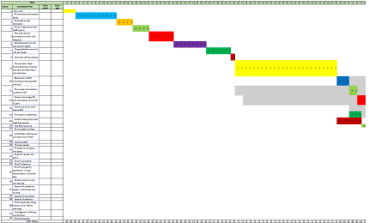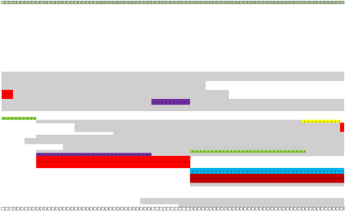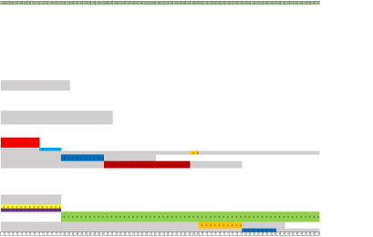
Figure 3 the optimized Gantt Chart.

And after optimization, the peak of the labor is 8 labors in a day which will be arrived at 153 days after the beginning of the confined building, and only that day will arrive that level of labor. Attributing to that, we can make a plan in advance to prepare the project for that day and reduce the risk to an acceptable level,

3.3 Difficulties during the construction organization
One of the difficulties in my task is the scarcity of resources. It is also said in the Guide to good practice in the management of time in complex projects (2011, p.23) that “At low and medium density, the reference to productivity and resources alone is not sufficient and available to make a calculation of duration.” And in my task the resource is really limited, even though we can take a reference of the Spon’s book to get the average productivity, however without the precise quantity of the resource and the quantity of the activity needs to finish, the estimation is unconvincing and would have a variability which may lead to a huge difference from prediction in the actual construction work. And it would also result in some issues in project scheduling. Project scheduling is a significant mission in project management but a lack of resources and precedence relationship between activities makes project scheduling a complex work. ( Hartmann and Briskorn, 2010) Even though it is not my task in the group work, but it is a common situation that we did not have enough resource when we were doing our tasks. And the scarcity of communication and information sharing might deteriorate the situation.

Another difficulty I encountered during computation is that it is complex to arrange the construction activities. As there are a lot of possibilities of arrangement, which one is the best one and can avoid the intensive labor mostly, and to how to prove is another problem. According to the process of my resource optimization, I first try to find out the most intensive date then alter the suitable activities to a date where the labor is loosened. However, after few alternations, the process becomes complex to proceed, which may push me to alter the previous activities which have altered once or twice. In a word, the process of my optimization is quite turbulent and time-consuming, despite that I finally reach a conclusion. But that issue is a theoretical issue, which can be avoided if I have a developed method, and my suggestion on that issue is to start on the intensive labor activities rather the intensive labor dates. The more detailed description in the solution discussion part.

3.4 Other resources
Charter Institute of Building illustrated in their book, Guide to good practice in the management of time in complex projects (2011, p.25 and p.23) that “the crucial resources must be arranged first then the influence on the other resources can be shown visible by individual resource histograms” and they also figure out that on another page “ in most construction projects, the labor will be the most ordinary variable through most activities, but in earthworks, machine types, numbers and production capability of plant are more relevant.”

According to that, the machine as one category of earthworks machine which would impose a more significant impact on the underpinning work, so that kind of machine should be well organized or even more important than the labor organization. Attributing to that we should decide on the category of the machine used to excavate and the date when it should arrive.

The same as other machines, such as the cranes should be available before the activity 9 the steel frame construction since it is a five-floor building, the crane is necessary for the construction work. The same as the concrete pump truck which should be available before activity 13.

And other materials such as the formwork, the insulation material as well as the scaffold should be available before the corresponding activities displayed in the Gantt Chart. And these machines materials should not arrive too early, that would take up the land resource and the management resource.

4 Discussion of solution
At this part, I will have a discussion about the solution of the difficulties I mentioned in my task of resource optimization.

The first problem is the uncertainty of the resource and construction organization activities which will fluctuate during a different period. Even though this issue cannot be eradicated, but the impact of that factor can be reduced. Hui suggested in his research that “When the duration of the construction activities is uncertain, people always use Program Evaluation and Review Technique, the PERT method. Which three times, the optimistic time, the highest possible time, the pessimistic time. Average these durations according to the possibility of them, then we can achieve a more reasonable duration about the construction activities.” (2017)

And this method also can be extended into the estimation of the consumption of materials, consequently, it can reduce the uncertainty of the construction project dramatically.

Another problem maybe can be solved by a branch of the Operation Research, and it, in a way, belongs to the Operation Research area. Besides that, I have a purpose that we can develop an activity leveling system which can order the rank of the importance of construction activities, then we can organize these activities according to the rank. And in this purpose, two parameters of the system are the quantity of labor and the total float. However, it is only a purpose, to develop it to a system still need a lot of experiments and practices. Anyway, it a complex to arrange activities with the complexity of the project increasing.

5. Conclusion
In my task, I used the technique of published data estimating and resources smooth as well as the network to fulfill the work of the construction organization. The significance of construction organization is that it can help the employer to achieve the goals of the project which not only include the cost but also the goal of time and construction quality. The process of construction organization can be refined into 1. Define and order activities 2. Estimating the duration of activities 3. Estimating resources including workforce 4. Controlling the resources and schedule. And among these processes, the resource smooth which mostly involved with workforce and construction machines have a dramatical influence not only on the investment but also on the quality of the construction project.

After resources smooth, there is a considerable difference of the workforce arrangement between the initial Gantt Chart and the optimized one. With the peak of the workforce which is 14 labors in the initial chart down to 8 labors and only one day reaches the peak of the workforce. Attributing to that, the productivity and safety of the construction team can be well guaranteed.

However, it is complex to estimate and control the duration and resources of a construction project. Which is a hybrid science area where related to construction science, management science, and operation research. And there still need further research on that field. In a word, the technique is needed to bridge the gap between estimation and practice. And the construction organization design can provide a preliminary for the construction project which can promote the success of the project.

6 Reference
1. Chartered Institute of Building, & Institute of Building. (2011). Guide to good practice in the management of time in complex projects. Chichester: Wiley-Blackwell.
2. Elshout, R., & Garcia, D. (2009). Revamps: Strategies for A Smooth Turnaround. Chemical Engineering, 116(7), 34-39.
3. Hartmann, & Briskorn. (2010). A survey of variants and extensions of the resource-constrained project scheduling problem. European Journal of Operational Research,207(1), 1-14.
4. Hui, H., (2017) Study on the Optimization of the Design of Century Garden Construction Organization. Southwest University of Science and Technology.
(黄辉. 世纪花园施工组织设计进度优化研究[M]. 西南科技大学. 2017)
5. Lei, X., (2018) Research on Optimized Allocation of HR in Construction Projects —— Take HD-ICEC Project as an example. Qingdao University.
(邢蕾. 建设工程人际资源优化配置研究——以HD国际会展中心项目为例[M]. 青岛大学. 2018.)
6. Project Management Institute. (2013). A guide to the project management body of knowledge (PMBOK® Guide). (Fifth ed.). Newtown Square, Pennsylvania: Project Management Institute.
7. Wei, X., (2017). Optimization of Construction Design of the HuaiHua Nan Railway Station. Shijiazhuang Tiedao University.
(熊巍. 怀化南站施工组织设计优化研究[M]. 石家庄铁道大学. 2017.)
8. Zhu, X., & Sherali, H. (2009). Two-Stage Workforce Planning under Demand Fluctuations and
Uncertainty. The Journal of the Operational Research Society, 60(1), 94-103.

