
project planning and management in work place
Runa Begum

December 20, 2019
University of Wales Trinity Saint David

Table of Contents
Introduction 2
Main body 3
Conclusion 14
Reference 15

Introduction

MEND is community-funded organisation and has the largest following of any Muslim organisation in the UK (MEND 2019). MEND aims to work with Muslim and non-Muslim organisations to ensure that anti-Muslim influence is regarded just as socially unacceptable as other forms of racism. Their aim is also to equip Muslims with the skills, resources and materials that is needed to play an active role in the society to contribute to the positive and sustained developed of a Britain where all members society are valued and respected whatever their religious, racial, ethnic background or gender.

Project management is a process, skills, methods, and knowledge required to organize and manage resources needed to complete a project (Lock, 2013). Project involves different tasks that are required to be completed in order to reach a certain outcome, with a vision, scope and work effort that is needed for the project work, to be agreed and performed in relation to the project plan (Young, 2003). A project follows a lifecycle that can be broken down into phases that takes the project from the beginning to the end through different tools and techniques (APM, 2019).

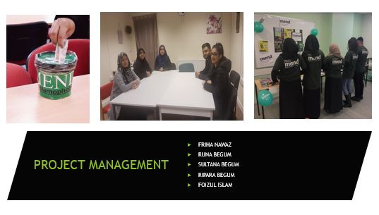

Main body

UWTSD and MEND gave the opportunity to do a project for the Project Management Module in a group of four to five people. Project management is important because it helps to focus on deliveries that are set around what needs to be delivered by set time and budget (Aston, 2017). For the project to be effective the project manager should know how to negotiate reasonable and achievable deadlines with the stakeholders, teams and management according to Carroll (2012). Therefore, the team roles for the project were decided according to the qualities and skills that relate to the Belbin’s team roles (Belbin, 2019). As a group a project manager was chosen. A project manager has the responsibility of making decisions both large and small and this can be done by following the Project Life Cycle with different tools.

Project Life Cycle
Project life cycle has four phases that helps managers to move through the project completion. The purpose of the project life cycle is to identify how the project is progressing with defined activities and outputs for each phase. There are four phases of the project life cycle, which include initiation, planning, execution, monitoring and evaluating at the closing phase according to Westland (2006).

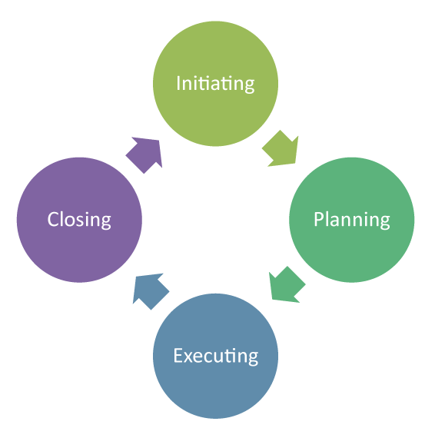

Initiation phase
Initiation stage is the beginning of a new project where ideas are explored and identifies its objectives, scope, purpose and deliverables that need to be produced (Method123, 2019). At this stage the group had a meeting with Mend and decided on the project activities, which include, workshop presentation for awareness of islamophobia with food sale and fundraising by collecting donations from class members, friends and family. At this stage the project manager implemented a tool called the Quad chart to the project.
Quad chart
Quad chart is a one-page documentation that is visual and descriptive of a project. Quad chart is very effective tool for planning and communication also when explaining what the project is all about (Chegg Study, 2019).
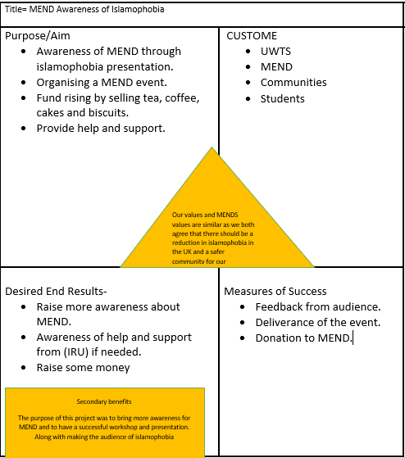
The quad chart was used for the project at the initiation stage because it can help put ideas into manageable pieces and define what needs to be done before starting a project (Chegg study, 2019).

The planning phases
After the project has been chosen and the project team has been decided, then comes the planning stage which is important because it tells everyone what they are doing through a documented plan where the deliverables and requirement are defined. The purpose of the planning phase is to establish business requirements, list of deliverables, resource plans to proceed to the next level. The process to do this is by creating a Work Breakdown Structure (Gardiner, 2005).
Work Breakdown Structure (WBS)
A work breakdown structure WBS is a key project deliverable that organizes the team’s work into manageable sections of the work to be executed by the project team members ((Tausworthe, 1980). The purpose of WBS is to reduce complicated activities to a collection of tasks therefore, the project manager can oversee the tasks more effectively to make sure that the tasks are measurable with clearly defined limits (Miller2008).
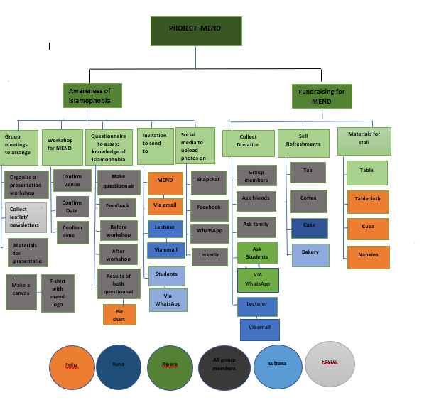

At the planning stage of the project life it was the wright time to break down the actives and delegate tasks between the group, therefore the group decided on the WBS top down framework. The WBS was implemented by using the brainstorming process (Lucas, 2019), to come up with main deliverables of the project and by gathering information from the Quad chart that was created at the initial stage of the project life cycle. WBS has helped to decided what needs to be done within the main deliverables and break them in to smaller tasks (Markgraf, 2019). By applying this method, it has helped to plan and manage the work effectively and prioritise work accordingly to complete the project and will also help in completing the Gantt chart. The reason why the top down approach was chosen and not the bottom up approach or the network diagram, was because the top down approach was easy to understand and is an important part of planning activities, also the group were clear about the main activities and sub activities from the beginning as the group had the opportunity to do own project. therefore, the top down approach was right structure for the project, where the bottom up approach is a brain-storming exercise and the network diagram does not breakdown tasks into activities (Sherman, 2019).

Execution phase
After passing the planning stage successfully it is time for execution. This phase of the project life cycle is all about deliverables and outputs and getting approval from the stakeholders for the intended product or service. This phase involves regular communication with the stakeholders for changes or approval according to Goulden (2017).
Stakeholders
Stakeholders is an individual, group or an organisation who can affect, be affected by or feel to be affected by a decision, outcome or activity of a project. Stakeholders are important because they can provide information related project limitations and risks. Also, by engaging and having regular involvement with the stakeholders will help reduce and uncover risks of the project (Freeman, 2010).
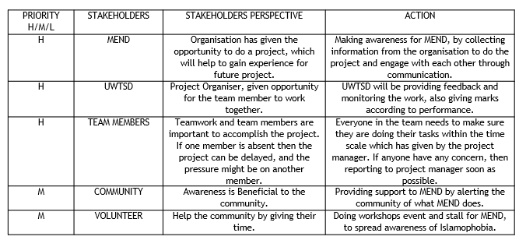
The stakeholder analysis was created by gathering information from the Quad chart that was created at Initiation stage and focusing on who the stakeholders are, priority level, stakeholder’s perspective and the action needed (Roeder, 2013). At This stage the tool was used to identify and analyse the stakeholders needs by communicating through emails, WhatsApp.
For example: stakeholders are MEND, they are at high priory level because MEND has given the opportunity to do a project. The action will be arranging a workshop presentation about islamophobia awareness.

Monitoring
Monitoring allows to get results that can be documented and used to make decision while checking progress against plans. Evaluation assess data and information that shows strategic decisions. (Gudda, 2011). Monitoring and evaluation are important because it identifies important and efficient use of resources.
Monitoring focuses on reviewing all tasks duration, that include team performance and problems that arise during a project also taking necessary actions when problems are identified. To stay in line with projects aim and scheduled deadline, monitoring is important part of project success VIEDOR, 2017). Therefore, a tool called Gant chart was created.
Gantt chart
Gantt chart is useful tool that displays activities or tasks completed against time with start and finish dates of different section of the project (APM, 2019). Gantt charts purpose is to demonstrate how the project runs by viewing tasks, their duration, arranging these task, overall timeline of project and expected finish date according to Anderson (2016).
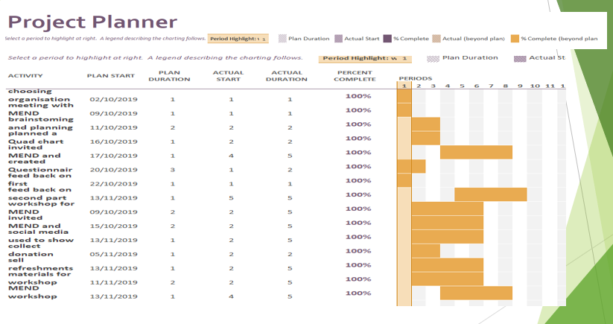
The Gantt chart was structured by gathering information form the WBS that was created at the planning phase. This tool was used to keep activities and tasks on track, providing team members a visual description of activities to help them focus on scheduled layout, expected completion date and time of the project (Kashyap, 2018). The Gantt chart had a scheduled layout activity of MEND workshop on 6th November but due to students not turning up the date had to be changed to the 13th November.
Before the event a questionnaire ware given to the audience to monitor the awareness of MEND and Islamophobia. Questionnaire is a simple, quick and cost-effective way to gather data straight from the sources (McLeod, 2018). This is a first soft outcome of the project and the question was to see what knowledge do they have on reporting an incident of Islamophobia?

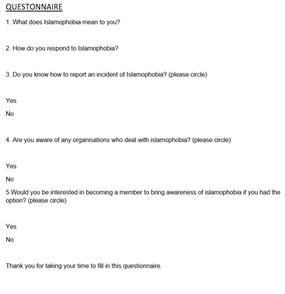
Pie chart result
Pie chart is used to show percentage or proportional data which is divided into slices to show numerical proportion (University of Leicester, 2019). Pie chart is the first hard outcome of the monitoring process.
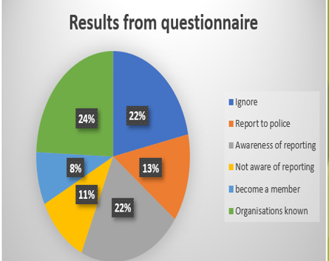
The result shows 11% are not aware of how to report an incident of islamophobia, that is related to question 3 on the questionnaire.

Evaluating at the Closure phase
Iron Triangle
Project management triangle or Iron triangle has triple constraint which include time, cost and scope/product suggested by Westland (2018).

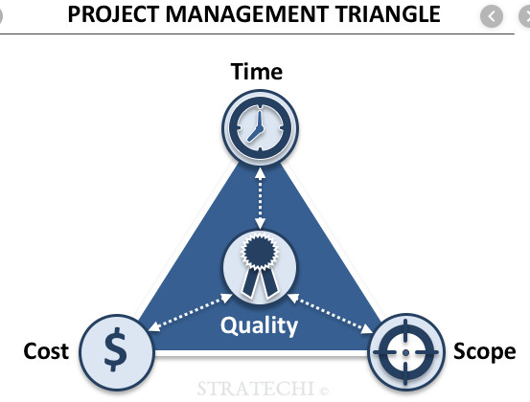
The iron triangle was used to ensure quality improvements and helping the project manager to focus on different constraint that might affect the quality of the project outcome. Also used to make effective decision regarding the project according to Dhillon (2018).
Cost – no funds, full contribution by the team members.
Time – limited time, due to not enough communication.
Product – a workshop to raise awareness of islamophobia for MEND, which includes donations, presentation and food sale.

Risk Analysis
Risk assessment identifies possible risks that might happen on the project (Lavanya and Malarvizhi, 2008). Assessing the potential risk impact and reviewing them reduces the negative effects for the whole project.
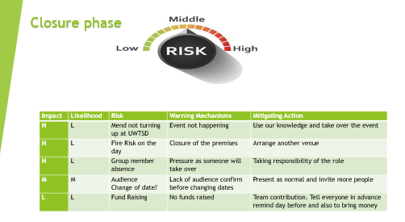
Risk analysis was used to minimise and prevent things from going wrong (Rouse, 2019). As a group the risk analysis was created by listing the potential risks, the likelihood, impact, warning and action, such as high impact risk would be MEND not turning up, therefore the workshop would not be as successful, however the action would be to do the presentation by a group member with what knowledge they have.
Evaluation
At this stage the project manager evaluates by focusing on the outcome of the project. Although the event was a success with few points that can be evaluated, includes: a bigger venue with more people for fundraising and to spread awareness. For the project to run smoothly more communication would have ideal. However, the event and fundraising were successful. The group member enjoyed doing the project. The soft outcome was a second questionnaire on the impact of the Islamophobia awareness workshop, also includes MEND champion and class members telling the group verbally the event was great success and they enjoyed it.
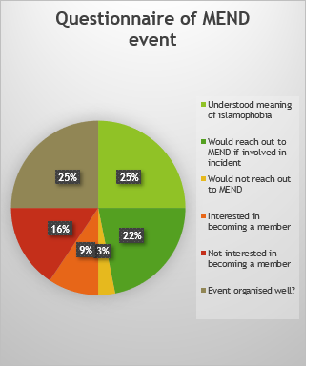
The second hard outcome of the project where it shows 22% would reach out to MEND if involved in an incident because they know how to report it now.
These are the hard outcome of the project
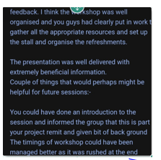 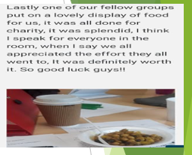 During fundraising the group raised £191.44 by collecting donations and food sale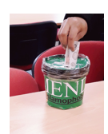 



Gibbs (1988), is a reflective cycle which will help to evaluate the project.
Description
MEND and UWTSD gave a project to do in a group of 4-5 people. Manage the project by using the project life cycle phase and different tools.
Feeling
Felt excited about doing the project, using tools and working in a group.
Evaluation
Communicated with the group through WhatsApp and face to face meetings. Worked comfortably with other members. There was no negativity in the group, helped each other where it was possible.
Analyse
Constant contribution to the project was made through physical activities which include, making a poster, buying refreshments for food sale, collecting donations, arranging resources while organizing the event.
Conclusion
The workshop and fundraising went well, everyone enjoyed doing the project, it was all a team effort.
Action
Recommendation for the next project would be to arrange a bigger venue to attract more people and the fundraising can be at bigger scale. To improve own performance would record personal development and attend different types of learning process, (Gary, 2018).
SWOT
SWOT focuses on internal factor that effects an organisation. Not everyone knows about MEND and their work is the organisations weakness. Doing the project mend will be recognised by community which will strengthen the organisation (MEND, 2019).
PESTEL
PESTEL analysis is the external factor that impacts the organisational performances. PESTEL analysis shows how much influences the organisation has when making strategic decision of the organisation (CIPD, 2018). Political factor, MEND has contributed in changing government legislation and challenging the law on discrimination of Islamophobia according to MEND (2019).

Conclusion

To conclude the group have done the project by following the project life cycle phases with different tools and techniques to a successful outcome of the project. The group communicated effectively and had excellent teamwork throughout the project by focusing on the smart objectives from the beginning to the end, and the soft and hard outcomes of the project, it indicates the workshop presentation on Islamophobia awareness, fundraising and MEND as an organisation, has made an impact to the audience and to the organisation from this project.

Reference

Anderson, B. (2019), ‘Purpose of a Gantt Chart – Successful Projects’, [Online] Available: at https://www.successfulprojects.com.au>purpose-of-a-gantt-chart, [Accessed: 15 December 2019].
APM (2019), ‘What is a Gantt chart? | APM’, [Online] Available: at https://www.apm.org.uk.uk>resources>find-a-resource>gantt-chart, [Accessed: 15 December 2019].
APM, (2019), ‘what is project management? | APM’, [Online] Available: https://www.apm.org.uk>resources>what-is-project-management, [Accessed: 13 December 2019].
Belbin (2019), ‘The Nine Belbin Team Roles’, [Online]. Available: at https://www.belbin.com/about/belbin-teams-roles, [Accessed: 16 October 2019].
Carroll, J. (2012), Effective Project Management in Easy steps. (Second Edition) Warwickshire: Easy Steps Limited.
Dennis, L. (2013), Project Management. (Tenth Edition) England: Gower Publishing Limited.
Dhillon, H. (2019), ‘Iron Triangle – Triple Constraints of Project Management’, [Online] Available: https://www.medium.com>iron-triangle-triple-constraint-of-project-management..., [Available: 17 December 2019].
DPM (2016), ‘Project Management Life Cycle: Complete Guide To Project…’, [Online] Available: at https://thedigitalprojectmanager.com>project-management-life-cycle, [Accessed: 13 December 2019].
Freeman, R. E. (2010), Strategic Management: A Stakeholder Approach. Cambridge: Cambridge University Press.
Gardiner, P. D. (2005), Project Management: A Strategic Planning Approach. London: RED GLOBE PRESS.
Gary, M. (2018), ‘How to find the inspiration to become a more creative person’, [Online] Available: at https://www.penguin.co.uk, [Accessed 18 December 2018].
Gibbs, G. (1988), Learning by doing: a guide to teaching and learning methods. Oxford: Further Education Unit.
Goulden, D. (2017), ‘Project Management Execution Phase: Best Practice – Clarizen’, [Online] Available: at https://www.clarizen.com>project-management-execution-phase-best-prac..., [Accessed: 18 December 2019].
Gudda, P. (2011), A Guide to Project Monitoring and evaluation. USA: Author House publishing limited.
Kashyap, S. (2018), ‘Why use Gantt Chart for your next project | Gantt Chart uses’, [Online] Available: at https://www.proofhub.com>artcles>uses-of-gantt-chart, [Accessed: 16 December 2019].
Lavanya, N. and Malarvizhi, T. (2008), ‘Risk analysis and management – PMI’, [Online] Available: at https://www.pmi.org>learning>library, [Accessed: 17 December 2019].
Lucas (2019), ‘Steps to Generate Effective Ideas Using Brainstorming’, [Online] Available: at https://www.thebalancecareers.com>workplaceCommunication, [Accessed: 13 December 2019].
Markgraf, B. (2019) ‘The Importance of a Work Breakdown Structure | Chorn.com’, [Online]. Available: at https://www.smallbusiness.chorn.com>importance-work-breakdown-structure, [Accessed: 18 November 2019].
McLeod, S. (2018), ‘Questionnaire | Simply Psychology’, [Online] Available: at https://www.simplypsychology>questionnair, [Accessed: 16 December 2019].
MEND
MEND (2019), ‘MEND’ [Online]. Available: at https://www.mend.org.uk, [Accessed 28 November 2019].
Method123 (2019), ‘Initiation Phase – project Initiation Phase – Method123’, [Online] Available: at https://www.method123.com>project-initation-phase, [Accessed: 13 December 2019].
Miller, P. D. (2008), Building a Project Work Breakdown Structure – Visualizing Objectives, Deliverables, Activities, and Schedules. London: CRC Press.
Nediger, M (2019), ‘The 4 Stages of the Project Life Cycle’, [Online] Available: at https://www.venngage.com, [Accessed 16 October 2019]
Roeder, T. (2013), Managing Project Stakeholders: Building a Foundation to Achieve Project Goals. London: John Wiley & Sons.
Rouse, M. (2019), ‘What is risk analysis? – Definition from Whalts.com’, [online] Available: at https://www.searchsecurity.techtarget.com>risk-analysis, [Accessed: 18 December 2019].
Sherman, F. (2019), ‘Why Not Go Straight to a Network & Forget the WBS? | Chorn’, [Online] Available: at https://www.smallbusiness.chorn.com, [Accessed: 14 December 2019].
Tausworthe, R. C. (1980), the work breakdown structure in software project management. Journal of System and Software, Vol. 1, pp. 181-186.
University of Leicester (2019), ‘Pie charts – University of Leicester’, [Online] Available: at https://www2.le.ac.uk>offices>resources>numerical-data>pie-charts, [Accessed: 16 December 2019].
VIEDOR (2017), ‘How Important Is Project Monitoring And How Do We Implemented’, [Online] Available: at https://www.project-management.com>how-important-is-project-monitoring-and-..., [Accessed: 14 December 2019].
Westland, J. (2006), The Project Management Life Cycle – A complete step-by-step methodology for initiating, planning, executing & closing a project successfully. London: Kogan Page Limited.
Westland, J. (2018), ‘The Triple Constraint in Project Management: Time, Scope…’, [Online] Available: at https://www.projectmanager.com>blog>triple-constraint-project-manager..., [Accessed: 17 December 2019].
Young, T. L. (2003), Successful Project Management. (Second Edition) London: Kogan Page Limited.

