Marketing Essentials

Table of Contents
Component A 3
Introduction 3
Situation analyses of the Premier Inn by using the 5CS model 4
Analysis of Premier Inn. 4
Analysis of customer 5
Analysis of the competitors 5
Analysis of collaborators 7
Analysis of macro environment. 8
SMART objectives 9
Proposed Marketing Strategy 10
Proposed tactics 11
Action 13
Control 14
Conclusion 15
Reference List 16
Component B (Presentation) 17

Component A

Introduction
A marketing plan is a comprehensive document that outlines a company's overall marketing strategy, objectives, and tactics for achieving those objectives. It serves as a roadmap for businesses to identify and target their ideal customers, develop effective promotional campaigns, and ultimately drive sales and revenue growth (Kotler, 2020). In line with the purpose of the marketing plan, this marketing plan is prepared for the Premier Inn. Premier Inn is a hotel chain in the United Kingdom, with over 800 hotels and more than 80,000 rooms. They offer affordable and comfortable accommodations, with amenities such as free Wi-Fi, on-site restaurants, and 24-hour reception. Their slogan is "A good night's sleep, guaranteed." It will cover some key areas including situations and analyses by applying the 5CS model, objectives of the plan, strategy, and tactics of the plan, action, plan, and control plan.

Application of SOSTAC analysis
SOSTAC analysis is a strategic planning framework that stands for Situation analysis, Objectives, Strategy, Tactics, Action, and Control. It is used to guide the development of marketing plans and campaigns by breaking down the process into six key components. The model helps businesses to create comprehensive and effective marketing plans that address all necessary areas for success, from understanding the market and setting clear objectives to implementing the tactics and monitoring progress.

Situation analyses of the Premier Inn by using the 5CS model

Analysis of Premier Inn.
Here, the SWOT model is applied to analyze the Premier Inn. The analyses are given below:
Strengths
- Strong brand recognition in the UK hospitality industry
- Large number of hotels and rooms, providing wide coverage and availability
- High customer satisfaction ratings, with a focus on comfortable accommodations and good service
- Affordable pricing compared to competitors
- Strong parent company (Whitbread) providing financial stability and resources (Miracle, 2021)
Weaknesses
- Limited international presence compared to competitors
- Dependence on the UK market, leaving them vulnerable to economic downturns or political instability
- Limited range of amenities compared to some competitors
Opportunities
- Expansion into international markets, particularly in high-growth regions
- Development of new hotel concepts or amenities to attract more customers
- Increased focus on sustainable practices to appeal to environmentally conscious consumers
Threats
- Competition from other hotel chains, particularly those with a stronger international presence
- Economic downturns and political instability can impact travel and tourism
- Changes in consumer preferences and technology can disrupt the industry (Miracle, 2021).

Analysis of customer
For the analysis of customer market segmentation and targeting/customer profile analyses of the Premier Inn is used. The analyses are given below:
Premier Inn segments its target market primarily by price and location, aiming to provide affordable accommodations in convenient locations for both leisure and business travellers. Their customer profile includes budget-conscious individuals, families, and business travellers who prioritize comfort, cleanliness, and convenience over luxury amenities. They have a strong presence in the UK market and attract both domestic and international travellers (Cespedes, 2021). Premier Inn targets customers who value a good night's sleep and reliable service, and who are looking for a simple, hassle-free hotel experience.

Analysis of the competitors
The competitor analysis of Premier Inn is conducted by using the perceptual positioning map and Bowman's strategy clock. The analysis is given below:
Perceptual positioning map
Premier Inn can be positioned as a mid-range hotel chain that provides affordable and comfortable accommodations, with a focus on delivering a good night's sleep. In terms of perceived value, they are positioned between budget hotels and higher-end hotels, offering good quality at a reasonable price point (Miracle, 2021).
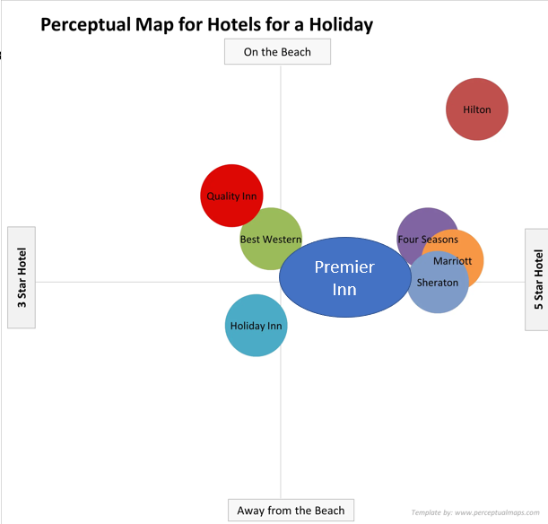
Figure: Perceptual map of Premier Inn (Miracle, 2021)

Bowman's strategy clock
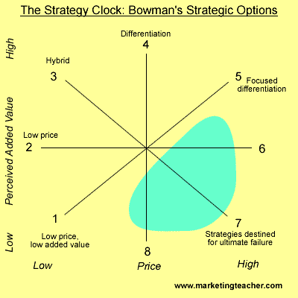
Bowman's strategy clock (Miracle, 2021)
Premier Inn employs a hybrid strategy, with a focus on low cost and differentiation. They offer affordable accommodations with a range of basic amenities, while also emphasizing cleanliness, comfort, and good service. This allows them to compete on price while also differentiating themselves from other budget hotels (Miracle, 2021).

Analysis of collaborators
The collaborator analysis of premier is given below:
Premier Inn has developed strong B2B relationships and partnerships within the hospitality industry. They have established partnerships with major travel companies and airlines, such as British Airways and Eurostar, to offer bundled packages that include hotel stays. Additionally, Premier Inn has developed partnerships with major UK cities to provide accommodations for conferences and events (Cespedes, 2021).
In terms of franchises, Premier Inn operates a franchise model in some international markets, allowing them to expand their presence without incurring the full costs of ownership and operation. For example, they have franchised hotels in the Middle East and Southeast Asia.
Furthermore, Premier Inn has formed partnerships with third-party developers and investors to finance and build new hotels, allowing them to expand their portfolio more quickly. These partnerships enable Premier Inn to benefit from the expertise of local developers while leveraging their strong brand and operational know-how (Cespedes, 2021).

Analysis of macro environment.
The PESTLE analysis framework is used for macro environment analysis of Premier Inn. The analysis is given below:
Political: Changes in regulations related to travel, immigration, and taxation can impact the hospitality industry, including Premier Inn.
Economic: Economic factors such as inflation, recession, and currency fluctuations can impact consumer spending on travel and tourism, affecting the demand for Premier Inn's services (Cespedes, 2021).
Social: Changes in consumer behavior, preferences, and demographics can impact the demand for Premier Inn's services. For example, increasing demand for sustainable and eco-friendly accommodations may impact the company's operations and strategy.
Technological: Technological advancements such as online booking systems and mobile apps have enabled Premier Inn to reach a wider audience and streamline operations. However, they also face competition from online travel agencies.
Legal: Changes in employment laws and regulations can impact Premier Inn's labor costs and operations. Compliance with health and safety regulations is also crucial (Bowie, 2017).
Environmental: Premier Inn has made efforts to reduce their carbon footprint and promote sustainability, but changing environmental regulations and consumer preferences can impact their operations and strategy.

SMART objectives
Some specific, measurable, attainable, realistic, and time-bound objectives (SMART objectives) of this plan are given below:
SMART objective 1:
Increase online bookings by 20% within the next 12 months by investing in targeted digital marketing campaigns, website optimization, and improving customer reviews and ratings.
SMART objective 2:
Expand their international presence by opening 5 new franchised hotels in high-growth regions within the next 24 months, leveraging local partnerships and market insights.
SMART objective 3:
Increase brand awareness and customer loyalty by launching a new loyalty program that rewards frequent guests with discounts, exclusive offers, and personalized experiences, aiming to increase repeat bookings and customer retention by 15% within the next 18 months (Cespedes, 2021).

Proposed Marketing Strategy
Here, the value proposition, communication, mix, and the link between the value proposition and to target customer segment will be analyzed. The analyses are given below:
The value proposition of Premier Inn is centred around providing customers with a good night's sleep at an affordable price, with a focus on comfort, cleanliness, and friendly service. Premier Inn differentiates itself from competitors by offering a consistently high standard of accommodations across their entire chain, along with a satisfaction guarantee that promises guests a good night's sleep. This differentiates them from budget hotels by emphasizing comfort and cleanliness, and from higher-end hotels by offering affordable rates (Sharker, 2020).
To communicate this value proposition, Premier Inn could utilize marketing campaigns that emphasize their commitment to providing comfortable and hassle-free accommodations, along with customer testimonials and online reviews that highlight the quality of their service. Delivering on their value proposition requires maintaining high standards of cleanliness and service across all their properties, investing in comfortable beds and amenities, and training staff to provide friendly and attentive service (Cespedes, 2021).
This value proposition affects targeting and positioning by allowing Premier Inn to focus on providing value for money to their target market, while also differentiating themselves from other budget hotels by emphasizing their quality and consistency. This enables them to position themselves between budget hotels and higher-end hotels, and target customers who prioritize a good night's sleep and reliable service over luxury amenities (Morgan, 2019). Ultimately, this value proposition helps Premier Inn to attract and retain customers who are looking for a simple and comfortable hotel experience at an affordable price.

Proposed tactics
Marketing mix
Marketing mix refers to a set of tools and strategies used by companies to promote and sell their products or services. It includes the four Ps: product, price, place, and promotion, which are used to create a comprehensive marketing plan that meets the needs of customers while achieving the goals of the company.
Marketing mix of Premier Inn
Product
Premier Inn's product is its hotel accommodations, which are designed to provide customers with a comfortable and convenient experience at an affordable price. Premier Inn offers different room types to cater to the diverse needs of customers, including family rooms, accessible rooms, and executive rooms. The rooms come equipped with modern amenities such as comfortable beds, power showers, and flat-screen TVs. To differentiate itself from other budget hotels, Premier Inn also emphasizes cleanliness and service quality (Ferrell, 2021). For example, they offer a satisfaction guarantee that promises guests a good night's sleep, or they will refund their money.
Price
Premier Inn's pricing strategy is aimed at providing value for money to customers, while also ensuring profitability for the company. They offer competitive rates that are lower than those of higher-end hotels, but higher than those of budget hotels (CIM, 2020). Premier Inn also employs dynamic pricing, where prices are adjusted based on demand and occupancy rates. They also offer special rates for corporate customers and group bookings.
Place
Premier Inn has a strong presence in the UK, with over 800 hotels across the country, including major cities and popular tourist destinations. They have also expanded their operations internationally, with franchised hotels in the Middle East and Southeast Asia. Premier Inn's distribution strategy includes direct bookings through their website and call centre, as well as partnerships with online travel agencies, travel companies, and airlines (Jobber, 2020).
Promotion
Premier Inn's marketing strategy includes a mix of above-the-line and below-the-line activities. Above-the-line activities include TV ads, print ads, and online ads that emphasize their value proposition of providing comfortable and affordable accommodations. Below-the-line activities include email marketing, social media, and customer reviews and ratings. Premier Inn also engages in public relations activities, such as sponsoring events and charity initiatives, to build brand awareness and goodwill (Jobber, 2020). It will use the similarweb for online promotion.
Overall, Premier Inn's marketing mix is designed to deliver value to customers while maintaining profitability for the company. They achieve this by offering competitive rates, investing in comfortable accommodations and quality service, and leveraging partnerships and distribution channels to reach a wide audience. Through their value proposition and marketing mix, Premier Inn has become one of the most recognized and trusted hotel brands in the UK and beyond (Kotler, 2020).

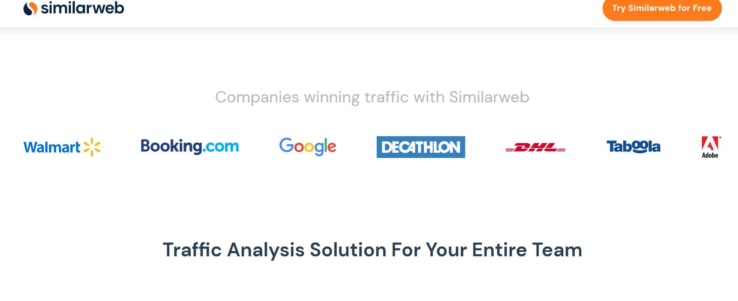
Figure: Similarweb for promotion (Kotler, 2020)

Action
This action plan aims at outlying how the marketing plan will be executed by justifying the decisions.
Figure: Gantt chart of the plan
The above Gantt Chart is prepared for the Premier Inn. There are three stages of the chart, including planning, execution, and closure. The plan is prepared for 12 months weeks a month and it will be continued for all 12 months in a year. The plan covers online marketing, search engine, marketing, text, mass, marketing, newspaper, TV ads, business cards, etc. (Jobber, 2020). All the plans have a specific time frame. As a result, the target is supposed to be achieved after the completion of the plan within the target date. Proper execution of the plan might help to achieve the goal of this marketing plan.

Control
The exploration of the objectives of the plan will be the success criteria. Success criteria depend on the increase in online booking rate by 20%, expanding the presence by opening five franchises in high-growth regions, and increasing brand loyalty measured by a 15% customer retention rate. The execution of this plan will be controlled and monitored on a monthly basis. The target success of each month will depend on the objectives of the plan (Kotler, 2020). Since the objectives of the plan show a 20% targeted increase in the booking rate in the next six months, so monthly target is 3.5% and for the customer retention rate, the monthly average target is 10%. Any deviation from this will be a subject of applying the controlling measures by finding the lacking and improving the weakness.

Conclusion
This report was a marketing plan for the Premier Inn. To prepare this marketing plan, the report deeply analyzed different types of situational factors. It analyzed Premier Inn by using the SWOT model, analyzed customers by using market segmentation and targeting/customer profile, analyzed competitors by using a perceptual positioning map and Bowman’s strategy clock, analyzed collaborators by using different types of collaboration models and analyzed macro environment by using the PESTLE model. Then it set up 3 SMART objectives for the marketing plan and developed strategies and tactics to explore the objectives. It prepared an action plan by outlining a Gantt Chart and showed the control plan to monitor, implement and evaluate the performance of the plan. Appropriate implementation and execution of the plan might ensure the exploration of the objectives of the plan.

Reference List
Bowie, D. Buttle, F. Brookes, M & Mariussen, A (2017), Hospitality Marketing. 3rd ed, Routledge,
London
Cespedes, F.V. and Piercy, N.F., 2021. Implementing marketing strategy. Journal of Marketing Management, 12(1-3), pp.135-160.
CIM (2020) Marketing qualifications, training and membership, CIM. Available at: https://www.cim.co.uk/ (Accessed: February 25, 2023).
Ferrell, O.C., Hartline, M. and Hochstein, B.W., 2021. Marketing strategy. Cengage Learning.
Kotler, P., Armstrong, G., Harris, L. and He, H., 2020. Principles of marketing. 8th European ed,
London: Pearson Education Limited.
Jobber, D. and Ellis-Chadwick, F (2020), Principles and practice of marketing. 9th ed. London:
Kotler, P., Armstrong, G., Harris, L. and He, H., 2020. Principles of marketing. 8th European ed,
London: Pearson Education Limited.
Miracle, G.E., 2021. Product characteristics and marketing strategy. Journal of Marketing, 29(1), pp.18-24.
Morgan, N.A., Whitler, K.A., Feng, H. and Chari, S., 2019. Research in marketing strategy. Journal of the Academy of Marketing Science, 47, pp.4-29.
Kotler, P., Armstrong, G., Harris, L. and He, H., 2020. Principles of marketing. 8th European ed,
London: Pearson Education Limited.
Shankar, V., Carpenter, G.S. and Farley, J. eds., 2020. Handbook of marketing strategy. Edward Elgar Publishing.

Component B (Presentation)



