

MSc Public Health and Social Care in Practice

Social Epidemiology and Public Health Development (LCHS7000)

Component 2 Analytical Report

Student Name- Ronak Yusuf Sheikh

Student ID- 2436884

Lecturer Name- Jolly Nwankwo

Word Count - 2400

Submission Date- 19 December 2025

Table of Contents
Task 1: Addressing Inequality in Disability and Health Among British Older Adults 3
1.0 Introduction 3
2.0 Contextual background and underlying factors 3
2.1 Higher rates of Mental Health Issues 3
2.2 Low Rates of Access to Healthcare and Social Services 4
2.3 Mortality rates among the Elderly group 4
2.4 Social Isolation and Loneliness 4
2.5 Poverty and Housing Issues 5
3.0 National Response to Reduce Health Inequalities 6
4.0 Organisations that Support Chosen Group 6
5.0 Conclusion 6
Task 2: Epidemiological Analysis of Asthma Among Younger Adults aged 18 to 30 years in the London Borough of Lambeth 7
1.0 Introduction 7
1.1 Overview 7
1.2 Definition and Consequences 7
1.3 Incidence and Prevalence 7
2.0 Main Body 8
2.1 Public Health Measures 8
2.2 Risk Factors associated to the Disease 8
2.3 Epidemiological Studies and a Health Needs Assessment 9
2.4 Public Health Approaches and Strategies 9
2.5 Impact Assessment 10
2.6 Health Intervention Programme 10
2.7 Conclusion 11
References 12

Task 1: Addressing Inequality in Disability and Health Among British Older Adults

1.0 Introduction
The prevalence of inequalities related to disabilities and health is quite common among the population of the British older adults. The target age group for the study is from the age of 60 to 80 years. The disabilities among the older adults increase due to chronic illness and degenerative diseases (Thomson et al., 2021). The older adults with disabilities encounter higher risk of health inequalities as compared to those without disabilities. This is because the people with disabilities are completely dependent on care givers and often suffer from negligence (Choi et al., 2022). This study thus addresses the disability and health inequalities faced by the British Older adults.

2.0 Contextual background and underlying factors

2.1 Higher rates of Mental Health Issues
The adults with disabilities belonging to the age group of 60 to 80 years are prone to mental health problems such as anxiety and depression. The disabled adults living with chronic diseases have lesser life satisfaction and more anxiety as compared to the non-disabled people. These disabled people are at risks of developing mental health diseases as they are highly neglected by their care givers and are abandoned (Buffel et al., 2023). The loss of independence and untreated conditions leads to higher rates of mental health illness. As per the data of NHS UK, nearly half of the adults in the UK over the age of 55 are suffering depression (7.7 million) and anxiety (7.3 million). The patient care models for these people must be transformed such that friendly interactions can reduce their depression and anxiety (NHS UK, 2023b).
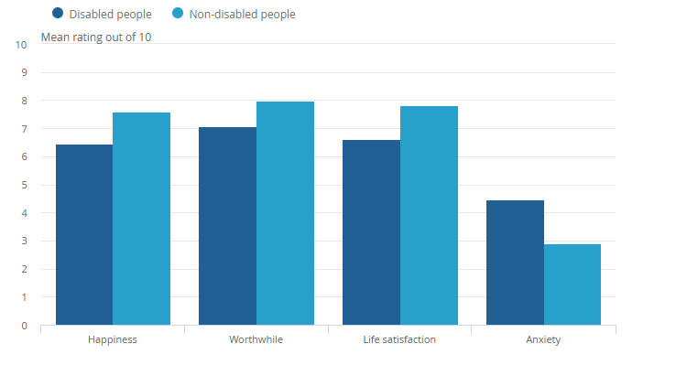
Figure 1: Variation in rates of life satisfaction and anxiety among disabled and non-disabled older adults
(Source: Foubert, 2021)

2.2 Low Rates of Access to Healthcare and Social Services
The older adults with mobility impairments in the UK are reported to miss their appointments. About one this of the older adult population faces problems for getting future appointments. Moreover, 56% of the disabled old adults receive medical interventions while the number stands at 72% for the non-disabled elders (Aitken et al., 2022). As per the study of Cabañero-Garcia et al. (2025), the barriers faced by the older adults for healthcare services include poor health outcomes, delayed treatment and unmet healthcare needs. The integrated service models which combine both healthcare and social services can be probable solutions.

2.3 Mortality rates among the Elderly group
The mortality rates vary among the disabled and non-disabled older adults in the United Kingdom. The disabled older adults show higher mortality rates due to poor monitoring and care provided by the health care professionals (Kuper et al., 2024). The socio-economic status of the older people also influences the kind of treatment they receive and thus their mortality rate is affected. The regular assessment of the patients can reduce the mortality rates among the elderly group (Goodwin et al., 2023).

2.4 Social Isolation and Loneliness
There are various factors which lead to social isolation and loneliness of the older adults with disabilities. These factors include loss of hearing and vision leads to decrease in communication (Huo and Kim, 2022). Thus, the older adults withdraw themselves from participation in social environments. The support from friends and families can help this situation and they can recover from their loneliness (Emerson et al., 2021).
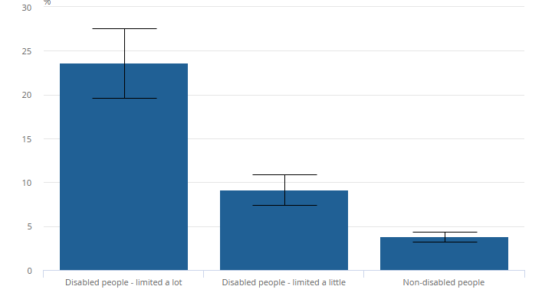
Figure 2: Social Isolation and Loneliness of Older Adults in the UK
(Source: Foubert, 2021)

2.5 Poverty and Housing Issues
The poverty and housing issues are more prevalent among the non-disabled people than disabled older adults in the United Kingdom (Goodwin et al., 2023). This is because the people with disabilities often make sure, they are not deprived of their homes with the help of legal procedures. However quite a good number of disabled adults suffer from this problem (Huo and Kim, 2022). The UK government must take initiative to ensure that the disabled people are not deprived of their shelter.
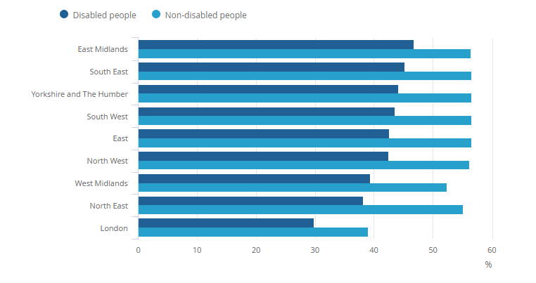

Figure 3: Variation in poverty and housing issues among disabled and non-disabled adults
(Source: Foubert, 2021)

3.0 National Response to Reduce Health Inequalities
The UK government and the NHS UK develop a range of coordinated national strategies and programmes to address the health inequalities faced by the disabled older adults in the UK (Ramsey et al., 2022). The long-term care plan by the NHS ensures that the disabled older adults are given proper care and treatment by the health care professionals (Nicholls et al., 2024). The Health and Care Act 2022 has been developed to ensure the care systems for the disabled people remain integrated and they get the best quality of treatment (Sinclair et al., 2022).

4.0 Organisations that Support Chosen Group
The organisations such as Age UK and Disabled Living Foundation provide support to the older disabled adults in the United Kingdom. These organisations ensure that the community support is provided and the health inequalities are reduced (Nicholls et al., 2024). They furthermore look after the fact that the patients are given adequate care and treatment. The National UK Charity provides free advice to the families and care givers of the disabled patients. Moreover, the public health organisations such as NHS UK ensure the prevalence of integrated care systems to reduce healthcare barriers (Kavanagh et al., 2022).

5.0 Conclusion
The older adults in the United Kingdom face significant inequalities in health and disability, particularly those aged 60 to 80 years. Factors such as higher rates of mental health issues, limited access to healthcare and social services, social isolation, and poverty contribute to these disparities. The national response through NHS strategies, the Health and Care Act 2022, and support from organisations like Age UK and the Disabled Living Foundation plays a vital role in addressing these challenges. Ensuring integrated care, community support, and targeted interventions can improve wellbeing and reduce inequalities among the older disabled population in the UK.

Task 2: Epidemiological Analysis of Asthma Among Younger Adults aged 18 to 30 years in the London Borough of Lambeth

1.0 Introduction

1.1 Overview
The London Borough of Lambeth is a densely populated area in South London and is bounded by the River Thames. Since the area is inhabited by a huge population, the air becomes quite polluted. Consequently, most people, particularly the young adults belonging to the age group of 18 to 30 years develop asthma (Ashworth et al., 2021). This section will focus on the epidemiological analysis of asthma for this age cohort.

1.2 Definition and Consequences
Asthma is defined as long term non communicable disease which involves airway hyperresponsiveness and chronic inflammation. It basically occurs due to poor quality of air and inhalation of toxic gases and excessive smoking tobacco (Ledwaba-Chapman et al., 2021). The consequences of asthma include limiting daily activities, chest tightness, coughing and shortness of breath and often leads to life threatening conditions.

1.3 Incidence and Prevalence
As per the Health Profile for Lambeth 2022, asthma is recognised as one of the most common causes of mortality among the younger population in the area. It is observed that around 5% of young people are suffering from asthma in Lambeth. The data of WHO indicates that around 262 million people worldwide suffer from asthma.
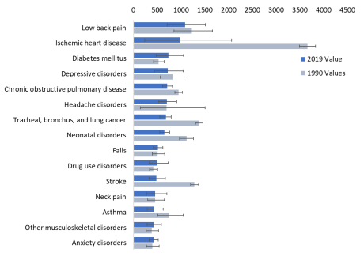
Figure 4: Common causes of death worldwide
(Source: Kuper et al., 2024)

2.0 Main Body

2.1 Public Health Measures
The various public health measures which are taken up by the healthcare organisation to reduce the prevalence of asthma among the young population in Lambeth includes tobacco control and smoking cessation policies and development of clear air zones. The other measures include public awareness campaigns and vaccination campaigns. Smoking tobacco is one of the significant reasons for asthma among the young people in Lambeth (Ronaldson et al., 2023). The health organisation develops policies for no smoking as per the guidelines given by WHO. Moreover, the enforcement of smoke free indoor public places is another public health initiative in this regard. The clean air zones are developed through planting of trees in the university campuses and workplaces (Lu et al., 2025). The awareness and vaccination campaigns are conducted in Lambeth after regular intervals of time. The young people are made aware of the consequences of smoking tobacco which readily leads to development of asthma (Ma et al., 2023).

2.2 Risk Factors associated to the Disease
The various risk factors associated with asthma include air pollution, smoking, lifestyle of the young adults, psychological factors and socio-economic status of the people. The exposure to particulate matter (PM_{2.5}) is quite high in Lambeth which leads to onset of asthma among the younger adult population. Moreover, active and passive smoking are popular among the targeted age group. It must be noticed that passive smoking at times causes more damage than personal smoking (He et al., 2024). Moreover, the eating habits, casual lifestyle, and obesity are significant risk factors. The higher body fat percentages increase airway irritation and inflammation leading to asthma. Furthermore, the young people from weaker socio-economic groups are at higher risks of developing the disease as they have limited access to healthcare facilities. The young people who suffer from mental health problems neglect their medical conditions and continue with excessive smoking (Shetty et al., 2025). Hence this risk factors associated with asthma must be taken care of by the healthcare organisations in the London Borough of Lambeth.

2.3 Epidemiological Studies and a Health Needs Assessment
The study of Simms-Williams et al., (2024) reveals that asthma related hospital admissions have increased dramatically from 2017 to 2023. Moreover, it is observed that 1.3 million patients in the age group 18 to 30 years suffer from asthma worldwide. In Lambeth, the female young adults are more frequently affected by the disease than the males. Particularly the younger adults from the lower socio-economic backgrounds are more prone to the risk factors. The underlying health inequalities are one of the major reasons for such conditions. In recent years, with the advent of urbanisation, the air pollution has also increased in Lambeth (Jayesinghe et al., 2022). The risk factors are not well managed by the healthcare organisations which leads to more prevalence of asthma in the area. The findings of this study indicates that the growing demand for the local health needs assessments in the urban conditions of Lambeth. The various risk factors must be taken into account and possible prevention measures must be implemented (Simms-Williams et al., 2024). Moreover, the demographic diversity, socio economic challenges and environmental exposures for the younger adult population must be considered in this regard. Furthermore, the needs assessment will include analysis of the primary care for asthma, hospital admissions data and sociodemographic patterns of the young people aged 18 to 30 years of age.

2.4 Public Health Approaches and Strategies
The public health approaches and strategies which must be adhered to for reducing the prevalence of asthma among the young adults in Lambeth includes prevention focused primary care management, patient education and self-care management. The other strategies include correct inhaler techniques and adherence to medication, integrated patient care models and development of policies to reduce smoking practices (Skolnik et al., 2024). A key public health strategy which can be implemented in Lambeth is structured patient education such that the younger adult’s population become aware about the consequences of asthma. The young people must be enlightened about the technique of using an inhaler as it is one of the main causes for which the prevalence of asthma is so high in Lambeth (de Freitas et al., 2022). Moreover, adherence to medication is also quite important for the young people as they try to avoid taking medicines which results in prolonged conditions of asthma. Thus, these strategies can help to reduce the prevalence of asthma among the young adult population in Lambeth.

2.5 Impact Assessment
The young adults of London Borough of Lambeth are affected by the problem of asthma significantly because of such factors as the urban population, air pollution, and social concerns linked to the deprivation. The study of Orlovic et al. (2024) reveals that uncontrolled asthma consequences are higher levels of healthcare costs and usage, lack of productivity, and low quality of life. The findings have a high relevance to Lambeth in which the youth adults tend to seek emergency assistance in the event of poorly managed asthma symptoms. Among the population aged between 18-30 years old, uncontrolled asthma may cause frequent work or school absences, poor daily activities, and chronic health effects. The paper also indicates that productivity losses and poor wellbeing are the major contributors of the burden that comes with asthma and not the cost of the medical treatment (Sobczyńska-Malefora et al., 2025). This shows how the social and economic burden of asthma is widespread in Lambeth and how the better control of the disease and prevention activities in the general population can help avoid unnecessary pressure on local health services.

2.6 Health Intervention Programme
There is a need to implement effective health intervention programmes that will support the asthma outcomes of young adults in Lambeth. According to Damery et al. (2024), integrated asthma care pathways can meaningfully enhance the management of the disease, and the number of hospital admissions decreased. The intervention program was aimed at enhancing the cooperation of primary and secondary care, improved training of GPs, and timely access to specialized services. The implementation of a similar programme in Lambeth may assist in recognising the poorly controlled asthma in young adults at an earlier age and offer suitable treatment during an earlier period before the symptoms get deeper (Fonderson et al., 2025). Since the population of the borough is diverse, and the health disparities in the area are common, that approach would have the potential to increase access to care among individuals who are less likely to use regular health service providers. The implementation of these measures in the local area would help decrease the utilization of emergency care as well as contribute to improved health results of young adults suffering from asthma in Lambeth in the long run.

2.7 Conclusion
Asthma remains a major public health concern among young adults aged 18 to 30 years in the London Borough of Lambeth, largely due to urbanisation, air pollution, smoking behaviours, and socioeconomic inequalities. The epidemiological analysis highlights that asthma prevalence and poor disease control place a significant burden on both individuals and local health services. Factors such as limited access to care, low medication adherence, and unmanaged risk exposures further worsen outcomes. Implementing prevention-focused public health strategies, integrated care pathways, and targeted health intervention programmes can improve asthma control and reduce emergency admissions. Addressing these issues is essential to achieving better long-term health outcomes for young adults in Lambeth.

References
Aitken, Z., Bishop, G.M., Disney, G., Emerson, E. and Kavanagh, A.M., 2022. Disability-related inequalities in health and well-being are mediated by barriers to participation faced by people with disability. A causal mediation analysis. Social Science & Medicine, 315, p.115500. https://doi.org/10.1016/j.socscimed.2022.115500
Ashworth, M., Analitis, A., Whitney, D., Samoli, E., Zafeiratou, S., Atkinson, R., Dimakopoulou, K., Beavers, S., Schwartz, J., Katsouyanni, K. and STEAM project research group, 2021. Spatio-temporal associations of air pollutant concentrations, GP respiratory consultations and respiratory inhaler prescriptions: a 5-year study of primary care in the borough of Lambeth, South London. Environmental Health, 20(1), p.54. https://doi.org/10.1186/s12940-021-00730-1
Buffel, T., Yarker, S., Phillipson, C., Lang, L., Lewis, C., Doran, P. and Goff, M., 2023. Locked down by inequality: Older people and the COVID-19 pandemic. Urban Studies, 60(8), pp.1465-1482. https://doi.org/10.1177/00420980211041018
Cabañero-Garcia, E., Martinez-Lacoba, R., Pardo-Garcia, I. and Amo-Saus, E., 2025. Barriers to health, social and long-term care access among older adults: a systematic review of reviews. International Journal for Equity in Health, 24(1), pp.1-13. https://doi.org/10.1186/s12939-025-02429-y
Choi, H., Schoeni, R.F., Steptoe, A., Cho, T.C. and Langa, K.M., 2022. Differential trends in disability among rich and poor adults in the United States and England from 2002 to 2016. The Journals of Gerontology: Series B, 77(Supplement_2), pp.S189-S198. https://doi.org/10.1093/geronb/gbac029
Damery, S., Jones, J., Idris, E., Cooper, A., Minshall, H., Clowes, C. and Jolly, K., 2024. Mixed-methods evaluation of an enhanced asthma biologics clinical pathway in the West Midlands UK. NPJ Primary Care Respiratory Medicine, 34(1), p.7. https://doi.org/10.1038/s41533-024-00365-y
de Freitas, D.F., Pritchard, M., Shetty, H., Khondoker, M., Nazroo, J., Hayes, R.D. and Bhui, K., 2022. Ethnic inequities in multimorbidity among people with psychosis: a retrospective cohort study. Epidemiology and Psychiatric Sciences, 31, p.e52. https://doi.org/10.1017/S2045796022000385
Emerson, E., Stancliffe, R., Fortune, N. and Llewellyn, G., 2021. Disability, Loneliness and Health in the UK: cross-sectional survey. European journal of public health, 31(3), pp.533-538. https://doi.org/10.1093/eurpub/ckab018
Fonderson, M.S., van Meel, E.R., Willers, S., Bindels, P.J.E., Burdorf, A., Bohnen, A. and van den Elshout, S., 2025. Short-term effects of air pollution on childhood respiratory symptoms in general practice: a time-series analysis. BMJ Paediatrics Open, 9(1), p.e002892. https://doi.org/10.1136/bmjpo-2024-002892
Foubert, C.P.I.S. and J., 2021 Outcomes for disabled people in the UK - Office for National Statistics. https://www.ons.gov.uk/peoplepopulationandcommunity/healthandsocialcare/disability/articles/outcomesfordisabledpeopleintheuk/2020?
Goodwin, V.A., Low, M.S., Quinn, T.J., Cockcroft, E.J., Shepherd, V., Evans, P.H., Henderson, E.J., Mahmood, F., Ni Lochlainn, M., Needham, C. and Underwood, B.R., 2023. Including older people in health and social care research: best practice recommendations based on the INCLUDE framework. Age and Ageing, 52(6), p.afad082. https://doi.org/10.1093/ageing/afad082
He, J., Wu, J., He, Y., Shen, D., Huang, X., Yao, X., Tang, W., Chen, G.B. and Ye, C., 2024. Associations of lifestyle, ambient air pollution with progression of asthma in adults: a comprehensive analysis of UK biobank cohort. International Journal of Public Health, 69, p.1607640. https://doi.org/10.3389/ijph.2024.1607640
Huo, M. and Kim, K., 2022. Volunteering dynamics and life satisfaction: Self-perceptions of aging as a buffer. The Journals of Gerontology: Series B, 77(2), pp.321-331. https://doi.org/10.1093/geronb/gbab104
Jayesinghe, R., Moriarty, F., Khatter, A., Durbaba, S., Ashworth, M. and Redmond, P., 2022. Cost outcomes of potentially inappropriate prescribing in middle‐aged adults: A Delphi consensus and cross‐sectional study. British Journal of Clinical Pharmacology, 88(7), pp.3404-3420. https://doi.org/10.1111/bcp.15295
Kavanagh, A., Hatton, C., Stancliffe, R.J., Aitken, Z., King, T., Hastings, R., Totsika, V., Llewellyn, G. and Emerson, E., 2022. Health and healthcare for people with disabilities in the UK during the COVID-19 pandemic. Disability and Health Journal, 15(1), p.101171. https://doi.org/10.1016/j.dhjo.2021.101171
Kuper, H., Rotenberg, S., Banks, L.M. and Smythe, T., 2024. The association between disability and mortality: a mixed-methods study. The Lancet Public Health, 9(5), pp.e306-e315. https://doi.org/10.1016/S2468-2667(24)00054-9
Ledwaba-Chapman, L., Bisquera, A., Gulliford, M., Dodhia, H., Durbaba, S., Ashworth, M. and Wang, Y., 2021. Applying resolved and remission codes reduced prevalence of multimorbidity in an urban multi-ethnic population. Journal of Clinical Epidemiology, 140, pp.135-148. https://doi.org/10.1016/j.jclinepi.2021.09.005
Lu, W., Rylance, S., Schotte, K., Aarsand, R., Lebedeva, E., Bill, W., Han, J., Lam, D.C., Soriano, J.B., Yorgancioglu, A. and Sohal, S.S., 2025. Tobacco and asthma: presenting the world health organization (WHO) tobacco knowledge summary. Substance Abuse Treatment, Prevention, and Policy, 20(1), p.34. https://doi.org/10.1186/s13011-025-00673-7
Ma, R., Romano, E., Ashworth, M., Yadegarfar, M.E., Dregan, A., Ronaldson, A., De Oliveira, C., Jacobs, R., Stewart, R. and Stubbs, B., 2023. Multimorbidity clusters among people with serious mental illness: a representative primary and secondary data linkage cohort study. Psychological medicine, 53(10), pp.4333-4344. https://doi.org/10.1017/S003329172200109X
NHS UK., 2023b. NHS England » Half of adults aged 55 and over have experienced common mental health problems, say Age UK. https://www.england.nhs.uk/2017/10/half-of-adults-aged-55-and-over-have-experienced-common-mental-health-problems-say-age-uk/?utm
Nicholls, L., McKinlay, A., Berger, R., Fancourt, D. and Burton, A., 2024. The impact of UK social distancing guidance on the ability to access support and the health and wellbeing of disabled people during the COVID-19 pandemic: a qualitative exploration. BMC Public Health, 24(1), p.1749. https://doi.org/10.1186/s12889-024-19285-0
Orlovic, M., Tzelis, D., Guerra, I., Bar-Katz, V., Woolley, N., Bray, H., Hanslot, M., Usmani, O. and Madoni, A., 2024. Environmental, healthcare and societal impacts of asthma: a UK model-based assessment. ERJ Open Research, 10(4). https://doi.org/10.1183/23120541.00577-2023
Ramsey, L., Albutt, A., Perfetto, K., Quinton, N., Baker, J., Louch, G. and O’Hara, J., 2022. Systemic safety inequities for people with learning disabilities: a qualitative integrative analysis of the experiences of English health and social care for people with learning disabilities, their families and carers. International Journal for Equity in Health, 21(1), p.13. https://doi.org/10.1186/s12939-021-01612-1
Ronaldson, A., De La Torre, J.A., Broadbent, M., Ashworth, M., Armstrong, D., Bakolis, I., Hatch, S.L., Hotopf, M. and Dregan, A., 2023. Ethnic differences in physical and mental multimorbidity in working age adults with a history of depression and/or anxiety. Psychological Medicine, 53(13), pp.6212-6222. https://doi.org/10.1017/S0033291722003488
Shetty, S., Scuffell, J., Aitken, D. and Ashworth, M., 2025. Chronic pain-prevalence, demographic inequalities and healthcare utilisation: a primary care database analysis. BJGP open. https://doi.org/10.3399/BJGPO.2024.0147
Simms-Williams, N., Nagakumar, P., Thayakaran, R., Adderley, N.J., Hotham, R., Mansur, A.H., Nirantharakumar, K. and Haroon, S., 2024. Risk factors for asthma-related hospital and intensive care admissions in children, adolescents and adults: a cohort study using primary and secondary care data. BMJ Open Respiratory Research, 11(1). https://doi.org/10.1136/bmjresp-2023-001746
Sinclair, D.R., Maharani, A., Chandola, T., Bower, P., Hanratty, B., Nazroo, J., O’Neill, T.W., Tampubolon, G., Todd, C., Wittenberg, R. and Matthews, F.E., 2022. Frailty among older adults and its distribution in England. The Journal of Frailty & Aging, 11(2), pp.163-168. https://doi.org/10.14283/jfa.2021.55
Skolnik, N., Yawn, B.P., Correia de Sousa, J., Vázquez, M.M.M., Barnard, A., Wright, W.L., Ulrich, A., Winders, T. and Brunton, S., 2024. Best practice advice for asthma exacerbation prevention and management in primary care: an international expert consensus. NPJ Primary Care Respiratory Medicine, 34(1), p.39. https://doi.org/10.1038/s41533-024-00399-2
Sobczyńska-Malefora, A., Sulkowski, A., Harbige, L., Steed, D. and Harrington, D.J., 2025. Vitamin D status in a large, ethnically diverse patient population living in South East London at the onset of the COVID-19 pandemic: a cross-sectional study Including a SARS-CoV-2 positive patient subset. Nutrients, 17(17), p.2861. https://doi.org/10.3390/nu17172861
Thomson, L.J., Gordon-Nesbitt, R., Elsden, E. and Chatterjee, H.J., 2021. The role of cultural, community and natural assets in addressing societal and structural health inequalities in the UK: future research priorities. International Journal for Equity in Health, 20(1), p.249. https://doi.org/10.1186/s12939-021-01590-4

