Resonance

Joe Williams 2413881
BEng Electrical and Electronic Engineering
Electrical & Electronic Principles

Table of Contents

Abstract
  - 1.1. Brief Description of the work
  - 1.2. Statement of results
  - 1.2.1. Virtual Results
  - 1.2.2. Physical Results

Introduction
  - 2.1. Background information on the circuit
  - 2.2. Description of the circuit
  - 2.3. Description of the theory you’ll be using
  - 2.4. Main points that will be covered in the rest of the report

Simulation steps
3.1. Description of what will be simulated

Results
  - 4.1. Graph of results

Discussion
  - 5.1. Description and explanation of results

Conclusion
  - 6.1. Statement of findings

References

Abstract
  - 1.1. Brief Description of the work
  - This task aims to create a virtual circuit using Proteus software and then test it with a digital oscilloscope and a signal generator. After that, the same test will be done with real components on a breadboard. The results will be used to make a graph in Excel to find important parameters like the Q factor, Fr value, bandwidth, and resonance. Finally, the results from both tests will be compared to identify differences.
  - 1.2. Statement of results
  - The findings support the theory of electrical resonance in an RLC circuit. At resonance, the circuit shows the lowest impedance, the highest current, and only resistive impedance. The observed voltage phase relationships and power behaviour match what resonance theory predicts. Calculating the quality factor and bandwidth gives more details about the sharpness and energy loss of the resonance.
  - 1.2.1. Virtual Results
The virtual results obtained using Proteus software demonstrate that attenuation reaches its peak at a frequency of 5000 Hz. This phenomenon occurs due to the intrinsic properties of the circuit when operating at its resonant frequency. At this point, the inductive and capacitive reactances are equal in magnitude but opposite in phase, resulting in their mutual cancellation. This creates a condition where the overall reactive impedance of the circuit is minimised, allowing the attenuation to reach its maximum value.
The concept of resonance plays a pivotal role in understanding this behaviour. When a circuit is at its resonant frequency, the energy exchange between the inductor and capacitor is at its most efficient, with energy oscillating back and forth between the two components. This balance results in a significant increase in the voltage or current at specific points in the circuit, which in turn causes the attenuation to peak.
The simulated results provide a clear and idealized visualization of this phenomenon, free from the practical imperfections encountered in real-world components. This makes Proteus an invaluable tool for analysing and understanding the theoretical underpinnings of circuit behaviour. However, it is essential to recognize that while the virtual results align closely with theoretical expectations, practical factors such as component tolerances may lead to slight deviations when the experiment is performed with physical components. Nevertheless, the virtual results effectively illustrate the fundamental principles of attenuation and resonance within an RLC circuit.
  - 1.2.2. Physical Results
The empirical findings obtained from the breadboard indicate that attenuation reaches its zenith at a frequency of 5100 Hz. This phenomenon is consistent with the principles of resonance, where attenuation peaks at a specific frequency due to the interplay of reactive components in the circuit. Like the virtual results, this peak occurs when the inductive and capacitive reactances are equal in magnitude but opposite in phase, effectively cancelling each other out. This balance minimizes the overall reactive impedance of the circuit, leaving only the resistive component to influence the signal.
The slightly higher resonant frequency observed in the breadboard setup compared to the simulation could be attributed to various factors, such as tolerances in physical components, parasitic inductance or capacitance, and environmental influences like temperature or wiring layout. These practical considerations often result in slight deviations from theoretical or simulated values. Nevertheless, the fundamental behaviour of the circuit aligns closely between the simulated and practical tests, affirming the validity of the theoretical model while highlighting the nuanced differences introduced by real-world conditions. [1]

Introduction

  - 2.1. Background information on the circuit
The circuit is an RLC circuit which means it contains a resistor, an Inductor and a capacitor.
RLC circuits serve as essential elements within the field of electrical engineering, demonstrating intricate behaviours including resonance, damping, and the unique responses of the circuit to various input signals. Their complexity is matched by their necessity, as RLC circuits form the basis for comprehending sophisticated systems in electrical engineering. [2]
These circuits are frequently employed in the field of electronics for a range of applications, including radio technology and the processing of audio and video signals. They can be categorized into two main types: series and parallel configurations. [2]
  - 2.2. Description of the circuit
RLC circuits consist of electrical components, specifically resistors, inductors, and capacitors, arranged in either series or parallel configurations. The designation "RLC" is derived from the symbols that denote these components in circuit diagrams, where "R" represents resistors, "L" signifies inductors, and "C" stands for capacitors. [3]
  - This circuit also incorporates an oscilloscope and signal generator to measure readings.
  - 2.3. Description of the theory used
Electrical resonance.
Electrical resonance takes place when an inductor and a capacitor are linked within a circuit, resulting in a scenario where the frequency of the applied voltage causes the inductive and capacitive reactance to negate one another. This phenomenon results in a minimized impedance in the circuit, allowing the current to achieve its peak value. [4]
  - 2.4. Main points that will be covered in the rest of the report
The main points covered in this report will be:
Simulation steps – Description of what will be simulated.
Results – Graph of results
Discussion – What do my results show?
Conclusion – Statement of findings
References

Simulation steps
3.1. Description of what will be simulated in the circuit shown In Fig 1.
The RLC circuit shown in Fig.1 will be used.
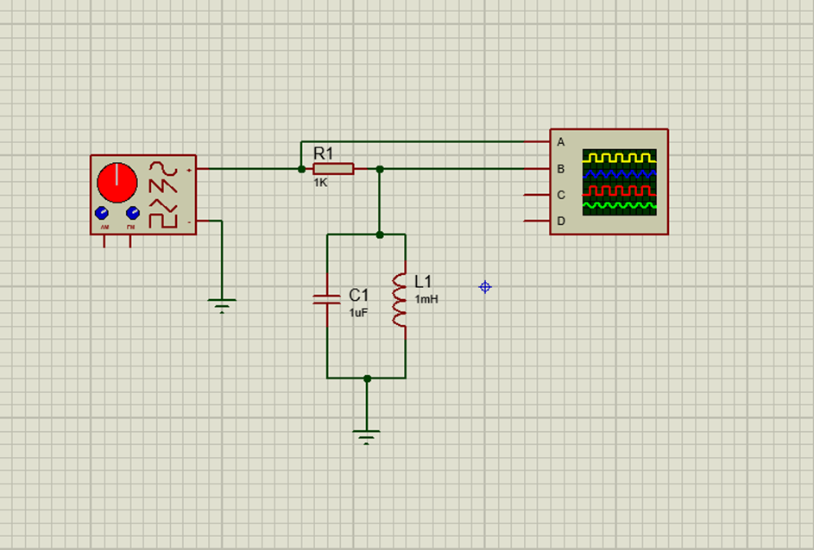
  - To perform the experiment, the circuit is first constructed as shown using an appropriate software simulator (Proteus). The signal generator is configured to output 2 Vpk-pk at 100 Hz, ensuring this voltage remains constant throughout the process. The voltages across the resistor and the inductor or capacitor are measured over a frequency range from 100 Hz to a maximum of 20 kHz (10 kHz was used in this experiment).
Fig.1 RLC circuit to be tested
The signal generator's frequency is adjusted to identify the point where the voltage across the inductor reaches its maximum, and this frequency and voltage are recorded. Subsequently, the frequency is further adjusted until the voltage across the inductor decreases to half of its maximum value, occurring at two distinct frequencies above and below the previously recorded maximum frequency. Both frequencies and their corresponding values are recorded.
Using spreadsheet software, such as Excel, the attenuation of the circuit is computed using the given equation. A fully labelled graph of attenuation versus frequency is created, with the frequency plotted on the x-axis using a logarithmic scale. The resonant frequency (fr​) is determined from the graph and compared to the theoretical value. Similarly, the quality factor (Q) is calculated from the graph and compared with theoretical expectations. The procedure is then repeated using physical components in a laboratory setting on a breadboard. Finally, the resonant frequencies and Q factors from the simulated and practical circuits are analysed and compared, with any differences highlighted and potential reasons for these discrepancies discussed.

Using a 1K Ohm Resistor, 1uF Capacitor, and 1mH Inductor. Values such as:
F1, F2, Bandwidth, Q factor, Fr value, Attenuation and resonance. Will be calculated
  - F1 and F2 Values.
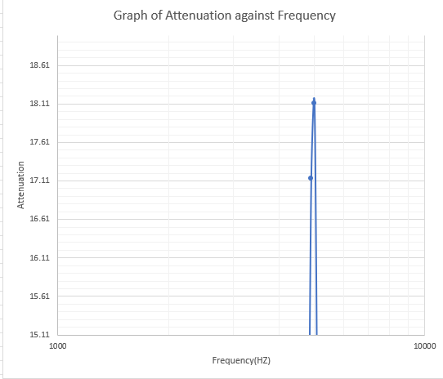
To determine the F1 and F2 values, it is essential to format the axes appropriately to facilitate the clear identification of the peak value. This approach enables the visualization of the graph lines' positions along the x-axis, thereby assisting in the identification of the bandwidth.

Fig.2 Shows F1 and F2.
  - F1 is the blue line on the left Fig 2.

F2 is the blue line on the right
You must read the graph to Estimate the values
F1 = 4900
F2 = 5050
  - Bandwidth.
The bandwidth is the gap between F1 and F2.
5050 – 4900 = 150Hz

  - Fr Value.
To find the Fr Value you must use the Equation f_{r} = 1/ 2ℼ √LC
f_{r} = 1/ 2ℼ √LC
f_{r} = 1/ 2ℼ √1x1
Resonant Frequency (Fr) = 5.03292121 KHz
  - Q factor
In electronics, the Q factor, or quality factor, is a measure that indicates how well a circuit or component performs. It compares the energy stored in the system to the speed at which that energy is lost.

Equation:
Q = 1/R × √(L/C)
Q = 0.03162

Results
  - 4.1. Graph of results
Fig 3. Shows a graph of Attenuation against Frequency on an RLC circuit on proteus using simulated components.
Graph Analysis: Attenuation vs. Frequency in an RLC Circuit (Simulation)
This graph, presented as Fig. 3, depicts the relationship between attenuation and frequency for an RLC circuit simulated using Proteus. It provides a detailed visualization of the circuit's behaviour under idealized conditions, capturing key aspects of its frequency response.
Attenuation Peak: The graph prominently displays the point of maximum attenuation, corresponding to the resonant frequency of the circuit. This peak represents the condition where the circuit's impedance minimizes, allowing maximum current flow and producing the highest attenuation in the signal.
- Lead-Up to Resonance: The gradual rise in attenuation, as the frequency approaches resonance, is evident, showcasing how the circuit reacts to frequencies leading up to its resonance point.
- Attenuation Fall-Off: Beyond the peak, the graph also highlights the attenuation decrease as the frequency moves away from resonance. This decline is crucial for understanding the circuit's bandwidth and selectivity.
This graph serves as a foundational reference for understanding the RLC circuit's theoretical behaviour. The characteristics observed here will be further analysed and compared with the real-world results (as shown in the breadboard graph) in the discussion section of this report, providing a comprehensive examination of the circuit's performance.

Fig.4 Shows a graph of Attenuation against Frequency on an RLC circuit on a breadboard using physical components.
Graph Analysis: Attenuation vs. Frequency in an RLC Circuit (Real Components)
This graph illustrates the relationship between attenuation and frequency in an RLC circuit built on a breadboard using real physical components. It replicates the general shape observed in Fig. 3, highlighting the essential behaviour of the circuit but with notable differences due to practical factors.
Key features of this graph include:
Attenuation Peak: The graph clearly shows the point at which attenuation reaches its maximum, demonstrating the circuit's resonant frequency.
Lead-Up to Resonance: The gradual increase in attenuation leading up to the peak is evident, providing insights into the behaviour of the circuit before resonance is achieved.
Attenuation Fall-Off: After the peak, the graph also captures the attenuation decrease as the frequency moves away from resonance, characteristic of the circuit's bandwidth.
While the overall pattern resembles the theoretical graph in Fig. 3, the physical implementation introduces subtler transitions, making the peak less dramatic and the slopes less steep. This variation highlights the impact of real-world factors such as component tolerances, parasitic elements, and breadboard layout effects.

Discussion
  - 5.1. Description and explanation of results
The Proteus simulation and actual laboratory experiments each possess distinct advantages and drawbacks. Simulations are particularly effective for design purposes and theoretical investigations, whereas real experiments offer essential hands-on experience and a deeper understanding of the intricacies involved in physical circuits. Integrating both methodologies is an optimal approach for thoroughly learning and comprehending electronics.
The results from both the simulation graph and the breadboard graph indicate that attenuation peaks at approximately 5000 Hz. While this suggests a general similarity between the two experiments, closer analysis reveals a notable difference: the rate at which the attenuation curve rises in the simulation is significantly steeper compared to the breadboard test. This observation highlights variations in circuit behaviour between the simulated and practical implementations.
Resonance refers to the phenomenon in which a network exhibits either maximum or minimum impedance at a specific frequency, such as an open or short circuit. In an RLC circuit, resonance occurs when the inductive and capacitive reactances are equal in magnitude but opposite in phase, effectively cancelling each other out. At the resonant frequency, the imaginary component of the circuit's admittance becomes zero, leaving only the resistive component. The sharpness of this impedance minimum is determined by the resistance (R) and is characterised by the circuit's quality factor, or "Q." [5]

Conclusion
  - 6.1. Statement of findings
In conclusion, this task provides a thorough exploration of RLC circuit behaviour through both simulation and practical experimentation, offering a blend of theoretical analysis and hands-on application. The use of Proteus software to construct a virtual circuit, paired with tools such as a digital oscilloscope and signal generator, enables precise control and observation of circuit parameters. Following this, replicating the experiment with real components on a breadboard introduces practical considerations, such as component tolerances and environmental factors, that influence circuit performance.
The data collected from both tests is processed to generate graphs in Excel, facilitating the analysis of key parameters such as the quality factor (Q), resonant frequency (fr​), bandwidth, and resonance characteristics. This dual approach not only enhances comprehension of circuit theory but also bridges the gap between idealized models and real-world performance. Comparing the results from the simulation and practical experiments reveals any discrepancies, providing valuable insights into the limitations of theoretical models and the complexities of practical implementation. Overall, this task serves as an effective means of building both conceptual understanding and practical skills in circuit analysis.
Furthermore, the task highlights the importance of combining simulation tools with real-world experimentation to fully grasp circuit dynamics. Simulations offer a controlled environment to test and predict outcomes under ideal conditions, while practical experiments provide an opportunity to observe the impact of non-ideal factors such as manufacturing tolerances, and environmental influences. This combination ensures a more holistic understanding of circuit behaviour, preparing learners to troubleshoot and optimize circuits in real-world scenarios. Additionally, the process of data visualization through graphs enhances analytical skills and provides a clear representation of complex relationships between variables. By comparing theoretical, simulated, and practical results, this task fosters critical thinking and a deeper appreciation for the interplay between theory and application in electrical engineering. This well-rounded approach ensures that learners are equipped with the knowledge and skills needed to excel in both academic and professional contexts.

References

References

[1] | K. Carroll, “Study.com,” 21 11 2023. [Online]. Available: https://study.com/academy/lesson/resonance-definition-transmission-of-waves.html#:~:text=What%20is%20a%20simple%20definition,frequency%20of%20the%20second%20object.. [Accessed 30 12 2024].
[2] | “Keysight,” [Online]. Available: https://www.keysight.com/used/us/en/knowledge/glossary/oscilloscopes/rlc-circuit. [Accessed 26 11 2024].
[3] | “Ansys,” [Online]. Available: https://www.ansys.com/en-gb/simulation-topics/what-are-rlc-circuits. [Accessed 26 11 2024].
[4] | “testbook,” 23 9 2024. [Online]. Available: https://testbook.com/electrical-engineering/resonance#:~:text=Electrical%20resonance%20occurs%20when%20an,/2%CF%80%E2%88%9A(LC)%2C. [Accessed 26 11 24].
[5] | “Microwaves101,” [Online]. Available: https://www.microwaves101.com/encyclopedias/resonance-of-rlc-circuits. [Accessed 30 12 2024].
[6] | “elandcables,” [Online]. Available: https://www.elandcables.com/the-cable-lab/faqs/faq-what-is-attenuation-in-an-electrical-system#:~:text=Attenuation%20is%20a%20result%20of,it%20will%20reduce%20the%20attenuation.. [Accessed 26 11 2024].

