(ECAD6007)
Who am I teaching?

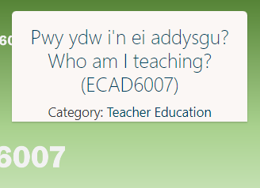

PGCE Primary

Lecturer: Karl Jones/Ian Jones
Submission date: 07/11/22
Max Green

Student number: 1900420



Contents

- Introduction…………………………………………………(Page. 3)
- The role of critical reflection……………………………… (Page. 3)
- Observation school & class context……………………(Page. 5)
- Critical incident linked to Donaldson’s Four Purposes…(Page. 5)
- Literature review………………………………………….(Page. 7)
- Reflection and evaluation of next steps……………….(Page. 11)
- Conclusion………………………………………………..(Page. 12)
- Bibliography……………………………………………..(Page. 13)


Introduction
Leading educational theorists, including David Tripp, is in consensus regarding the significance and purpose of utilising critical incidents within the teaching profession. In his 2012 thesis, Tripp defined a critical incident ‘as an action in which can provide a broader understanding of teacher judgment and practice, whilst interpreting the classrooms as situations to be explained’ (Tripp, 2012, p.12). Critical incidents, therefore, are observed by other scholars such as Peter Wood as a valuable and effective resource that provides teaching practitioners, with an opportunity for an analysis of development, which holds the potential to gain a greater understanding of the Professional standards for teaching in Wales (Wood, 1993, p.35). This assignment will aim to uncover a particular incident that has occurred in a classroom setting in which the researcher has interpreted as ‘critical’ as it catalyses a broader discussion regarding Constructivism in education and The Zone of Proximal Development (ZPD). To evaluate the observed critical incident in a wider and more detailed context this assignment will assess several areas such as the role of critical reflection and an observation as to where the incident took place. A wealth of secondary literature and a detailed evaluation of several theorists including Jean Piaget and Lev Vygotsky will be consulted throughout. A primary element of this assignment includes a literature review in which varied secondary research is compared to uncover the strengths and limitations of literature surrounding the observed critical incident. According to Tripp, the use of critical incidents enables a ‘reflective approach which is essential to a professional teaching practice’ (2012, p.19). Thus, this assignment proves to be significant as recent educational reform in Wales as part of the Senedd’s new approach to Professional Learning greatly emphasises the importance of reflective practice (The New Curriculum for Wales, 2015).
The role of critical reflection
Professor Graham Donaldson’s Independent Review of the Curriculum Arrangements elucidated a new vision for teaching and suggested several radical and innovative proposals to education in Wales (Successful Futures, 2015). A detailed evaluation of Chapter 5 of his ‘Successful Futures’ report clarifies the significance of critical reflection and its incorporation into Welsh teacher practice (Successful Futures, 2015). Several theorists have reinforced this sentiment and have assessed the importance of teachers undertaking critical reflection and research surrounding their profession. For example, Jan Fook in her study, Reflective Practise, and Critical Reflection demonstrated an awareness of why this theory is important within teaching, stating that it enables the practice to become more accountable through a continuous process of scrutinising theories and principles (Fook, 2007, p.362). A thorough assessment of the New Curriculum for Wales elucidates how its founders wanted to explicitly instil the significance of reflective practice (The New Curriculum for Wales, 2015). Under the five new Professional Standards, Professional Learning demonstrates an essential element of teacher practice in Wales (Professional standards, 2020).
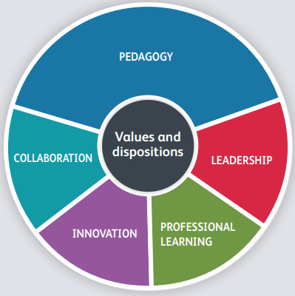

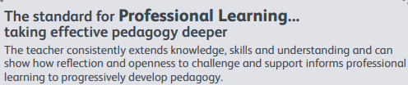

Figure One: Professional standards (2020) Hwb. Available at: https://hwb.gov.wales/professional-development/professional-standards (Accessed: October 20, 2022).
As Figure One demonstrates the Welsh government’s new approach to Professional Learning encapsulates the importance of the teacher’s ability to demonstrate critical reflection. The developing role of teaching as a profession ensures that educators consistently question their practice and monitor their skills and knowledge to underpin the Professional teaching standards (Professional standards, 2020). The Director of the 2020 Welsh Curriculum, Professor Michael Waters signified the role of critical reflection stating that ‘Schools under the New Curriculum must consider their practice through a process of reflection and development, delivering a syllabus that is thought through and not re-visited (BBC Wales, 2018). Thus, the New Curriculum for Wales has significantly reformed the roles of teachers so that practitioners recognise the importance of critical reflection and develop their practice accordingly.
Due to the significance critical reflection exemplifies within the New Curriculum it is necessary to consider the different reflective models that will provide a broader and more detailed context to the observed critical incident. David Kolb’s 1974 Experimental Learning Cycle poses an intriguing reflective theory and one which this assignment will utilise when reflecting on the focus of my critical incident and identifying my next steps (Kolb, 1984, p.33). This reflective model follows a four-stage cycle that identifies, Concrete Experience, Reflective Observation, Abstract Conceptualisation, and Active Experimentation (1984, p.56). Critical reflection from Kolb’s perspective enables teachers to change because of experience which then leads to an analysis of concepts and theories (Kolb, 1984, p.74). This then enables school practitioners to experiment with their ideas in various classroom situations.
Observation school & class context
To provide contextual evidence regarding the critical incident this assignment will follow the 2018 BERA guidelines to ensure anonymity. Under their Ethical Guidelines for Educational Research, BERA regulations state “At all times, researchers follow an agreement on confidentiality and anonymity and should be taken after careful and thorough deliberation (BEERA, 2018). Following these guidelines, this assignment will safeguard the identity of the school, teaching staff, and pupils and respect anonymity throughout.
Between the 26th and the 27th of September 2022, I undertook the role of a non-participant observer to identify ‘critical incidents’ within a classroom setting. During this placement, I was sent to a village school based in Margam near the suburb of Port Talbot in the county borough of Neath, Wales. This English medium Primary School has an estimated of 180 pupils aged 3-11, including 23 who attend part-time in the nursery (BEERA, 2018). The school currently has an estimate of 13 teaching staff supported by 6 Teaching Assistants. Around 6% of pupils are eligible for free school meals (BEERA, 2018). This is notably lower than the national average of 19% (BEERA, 2018). Very few pupils speak Welsh as their first language and no pupil speaks English as an additional language (BEERA, 2018). The school identifies around 10% of pupils as having additional learning needs (BEERA, 2018). This is below the national average of 22%. Pupils have positive attitudes to learning, behave well and display high levels of independence. The school’s engaging curriculum ensures that pupils develop effective literacy and numeracy skills, especially through grouped tasks (BEERA, 2018).
Critical incident linked to Donaldson’s Four Purposes
The observed incident that I have chosen to evaluate and one which I believe is ‘critical’, took place in an afternoon Key Stage Two lesson. Displayed on his touch-screen whiteboard, Mr. X had several broad, open-ended questions that had been headlining the news that week. Mr. X gave the class the choice as to which of the questions they would like to explore and discuss further and as a class, they agreed upon the issue; ‘Discuss the food crisis and how you as a class might help the local community during this time’. The learners were then faced with the task of splitting into groups to embark on research and ultimately debate about ways in which they could support the local area regarding the food crisis. Three groups were established and each of them chose a unique variety of ways to learn and discuss the topic such as utilising ipads, using textbooks, forming mind-maps, or even just discussing with fellow peers. Mr. X then brought the learners back from their groups, for a whole-class discussion regarding what research they had learned to find a proposal that the entire class could undertake. Collectively the class agreed to grow a vegetable patch in the school garden to which the whole community could have access too. The afternoon lesson was then concluded with the pupils returning into their groups discovering ways in which vegetables grow and how to make the local community aware of the vegetable patch and its purpose.
Following this observation, this assignment will specifically reflect upon the significance of group learning in relation to peer interaction and the importance utilising different learning resources according to learner ability. Assessing this specific area of the critical incident catalyses a broader discussion regarding the importance of Constructivism in education and the ZPD.
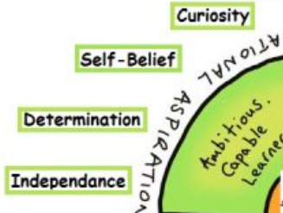
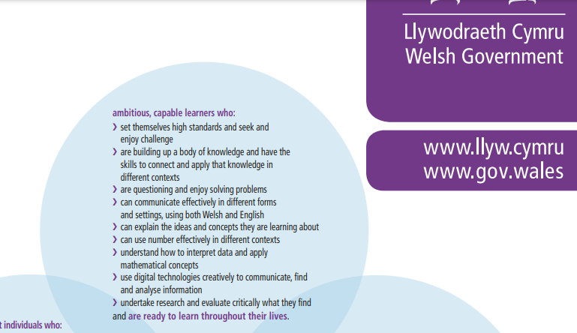
The New Curriculum is underpinned by four assertions of purpose which provide the foundations learners need to succeed in a changing world and equip them with the necessary skills and knowledge for employer’s state they want to see (Four Purposes Hwb, 2020). A detailed evaluation of my observation reveals that my critical incident explicitly links to the first purpose that pupils should develop through education as Ambitious Capable Learners. I believe that this link between my incident and the first purpose is evident as the Government Guide to the Curriculum states that Ambitious Capable Learners enjoy solving problems, can explain concepts they have learned about and undertake grouped research and work as a team to critically evaluate what they find (Four Purposes Hwb, 2020).
Figures Two and Three: Gov.Wales. (2020) available at: https://gov.wales/new-curriculum-poster (Accessed on 29th September 2022)
Figures Two and Three further reinforce the sentiment that my critical incident connects to the purpose of Ambitious Capable Learners. Figure Three, for example, provides key terms in the Welsh government commonly associate with this purpose (Four Purposes Hwb, 2020). During the afternoon lesson, I believe that the learners gained knowledge on these terms by attempting to question and research the food crisis whilst also working as a group to communicate critically what they had found on the topic. Thus, reflecting upon my critical incident as well as the Four Purposes framework, it is evident that there is an explicit link between my observation and the purpose that pupils should develop through education as Ambitious Capable Learners.
Literature Review
The critical incident reflected a high level of collaborative group work in which learners actively constructed their knowledge through interaction that appeared to develop their problem-solving and discovery skills. This aspect of the observation catalyses a further discussion into the importance of Constructivism in education and proposes the question of whether learners constructing their knowledge is a relevant learning theory to adopt within teaching. Furthermore, the critical incident also witnessed a specific selection of learning resources that actively supported learners to research, understand and meet the learning objective. This element of the observation uncovers the significance of the ZPD framework and whether this supports all learners to meet the required objective of a lesson.
Constructivism in education
Constructivist pedagogy has been largely cited for many years advocating the significance of interaction, and discovery within a classroom setting (Steffe, 1995, p.12). The critical incident observation witnessed a significant level of peer communication through group work whilst also developing learners’ discovery and problem-solving skills. This educational theory is highly advocated within studies linked to Constructivist ideology. Many Constructivist scholars quote Jean Piaget and accredit their work to his research arguing how he established the basis for a dynamic Constructivist theory of knowledge in education (1995, p.111). Piaget conducted numerous experiments to assess learners’ development in various areas including their intellectual and social abilities. A detailed evaluation of his study reveals that a key element of his thesis is Cognitive Development to which he states that ‘discovery and interaction with peers are crucial’ (Piaget, 1966, p.36). According to Piaget, how children ultimately learn, is by them finding their education in which ‘knowledge is not merely transmitted verbally by a teacher but must be constructed by the discovery and interaction with peers’ (1966, p.67). However, opponents of this thesis suggest that the discovery concept is inaccurate. In 1992 Amy Weiten published a study that sought to investigate and challenge Piaget’s thesis (Weiten, 1992, p.27). The trial suggested how learners can become distracted and often confused if there is an excess of discovery in lessons in which some learners do not appear to engage with the lesson objective, (1992, p.27). This sentiment is somewhat reinforced by the observed critical incident whereby some learners appeared to be unfocused from the task as the discovery element did not provide enough structure or direction from the lesson plan.
Alternatively, Paul Cooper cited how Constructivism exemplifies several different variants including Lev Vygotsky’s theory on Social Constructivism (Cooper, 1993, p.24). Vygotsky challenges Piaget’s study proposing that the theorist over-emphasises the significance of an individual learner (Vygotsky, 1997, p.58). Vygotsky coined the theory of Social Constructivism highlighting the significance of collaboration and peer communication (1997, p.66). The observed critical incident supports this sentiment as, during the lesson, learners were encouraged to collaborate and discuss proposals in groups to gain a greater understanding of the task. This concept is further cemented by a study conducted by a Professor of Education at the University of Warwick, David Wray. According to his thesis, ‘learning is developed through pupil interaction with each other. Pupils rely on peers for communication during learning to construct their knowledge (Wray, 1995, p.148). Wray further adds that the exchange of knowledge between pupils also encourages growth in other areas such as social and confidence skills (1995, p.148). However, Charlotte Liu disputes against Social Constructivism, arguing that learners may not be motivated enough to engage in group discussions and need a greater sense of guidance and direction within lesson plans (Liu, 2011, p.58). Although during the observed critical incident, social interaction within group sessions served as a beneficial resource, Lie’s perspective should not be neglected and the importance of seeking a suitable learning theory for all learners should be considered within teacher planning.
Furthermore, the critical incident was noted to be valuable for learners in providing an authentic and real-life learning environment by discussing the food crisis and thus, developing their understanding of the world and the local community. This sentiment has been rooted in Constructivist theory in which scholars openly advocate the significance of authenticity and that learning should resemble realistic situations for pupils to gain an understating of their society (Dewey, 1966, p.48). As cited by Constructivist, John Dewey, ‘Education is not an affair of ‘telling’ and being told, but an active and constructive process in which learners are educated about the world around them (1966, p.57). In in 1966 thesis, Dewey coins the concept of ‘The School and Society for which advocates the importance of an ‘individualistic and authentic learning experience’ which enables learners to understand their global and social environment (1966, p.60). However, a study released in 2009 by Laurence Splitter challenges this interpretation and rejects Dewey’s concept that a learning experience requires validation from the “real” world (Splitter, 2009, p.200). Splitter suggests that it is often ‘problematic’ within a teaching setting to provide authentic lesson plans as not all learners have the same understating of their community or society (2009, p.199). Thus, a critical conclusion for providing authentic and real-life learning is that it is important to consider the learner’s viewpoint and clarify what pupils consider to be problems within their society or the world.
The Zone of Proximal Development
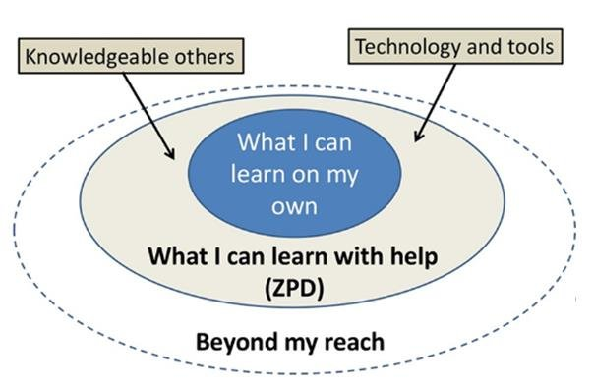
A detailed evaluation of the critical incident elucidates how Mr. X considered what the learners could potentially do independently and what the learners could do with the help of more knowledgeable peers or specific learning resources such as technology or books. This sentiment explicitly relates to the psychologist Lev Vygotsky’s theory on the ZPD (Vygotsky, 1978, p.47). Volume three of Vygotsky’s Critical Assessment thesis uncovers his theory relating to the ZPD and its significance and purpose within a classroom setting (1978, p.54). Vygotsky’s ZPD concept defines what learners can do without assistance and what learners can do with different learning resources such as interaction with a more capable peer, technology, or teacher intervention (1978, p.74).

Figure Four: Zone of Proximal Development Source: (2018) available at: https://www.researchgate.net/ (Accessed on 20th October 2022)
Vygotsky’s concept represented in Figure Four was mirrored within the observed critical incident whereby Mr. X set different groups according to different learner abilities whilst also providing suitable educational resources. According to Sivan, Vygotsky’s concept is significantly efficient within a classroom setting as tasks are specifically tailored to the learner’s ability, while sufficient support from peers and the teacher ensures that the learning objective can be successfully met (Sivan, 2010, p.271). Sivan further adds that adopting the ZPD framework enables pupils to become motivated within their learning as it transmits control from the teacher to a more capable and confident learner (2010, p.277). This theory is supported by the observed critical incident as several learners appeared to enjoy explaining the task or research, which they found to other learners which solidified their understanding of the objective and enhanced skills such as communication and confidence. This observation has been further strengthened by a study conducted by Goldstein who suggested that utilising the ZPD concept enables pupils to gain both ‘control and independence within their learning (Goldstein, 1999, p.48). Goldstein also emphasizes the importance of the interaction element within ZPD. According to Goldstein, the ZPD framework elucidates the importance of pupil interaction which is likely to catalyse the pupil’s attention and interest in the learning objective as the learner ‘happens to value and respect the knowledge, of their more capable peers (1999, p.98). However, in 2003 Chaiklin defined Vygotsky’s ZPD approach as ‘unclear’ (Chaiklin, 2003, p.47). Chaiklin reinforced this sentiment stating that the ZPD theory does not incorporate the importance of a learner’s additional needs and can often make those pupils feel isolated within the classroom context (2003, p.52). Although Vygotsky’s ZPD framework appeared to be a valuable and effective concept within the critical incident it is significant to consider Chaiklin’s perspective and ensure that those learners who demonstrate additional learning needs are considered within planning.
A detailed evaluation of Vygotsky’s ZPD concept reveals that it is necessary to clarify the importance of scaffolded learning and its purpose within the observed critical incident. Scaffolded learning is directly associated with ZPD in that it is the support system that helps a learner successfully perform a task and meet the required learning objective. Within the observed critical incident, several elements can be perceived as scaffolding resources such as the use of technology, the interaction with more capable others, or teacher intervention. According to Jerome Bruner, the scaffolding theory demonstrates significant benefits for both the learners and teaching practitioners (Bruner, 1977, p.56). In his 1977 study, Bruner stated how scaffolded learning allows the learner to achieve their highest level of success and development by utilising a variety of learning resources that those pupils find helpful and structured to accomplish the learning objective (1977, p.59). Bruner further adds, that utilising educational scaffolding in a classroom setting engages learners to partake in a profound and energetic discussion in small or large groups (1977, p.60). This concept is cemented by the observed critical incident whereby learners appeared to enjoy partaking in engaging discussions and debates about the task catalysing further interest in the learning objective. However, critics of scaffolded learning such as Rachel Van Der suggest that adopting this concept within a classroom setting is highly time-consuming (Van Der, 2022, p.158). In 2002, Van Der published a study that interpreted the disadvantages of scaffolded learning, stating that teachers might spend too much time with a particular learner that requires further attention meaning that they must cut short the time spend with other learners to accommodate the whole class (2022, p.160).
Reflection and evaluation of next steps
As previously stated, reflective and evaluative practice demonstrates a critical role in teaching because of recent educational reform in Wales. It is, therefore, necessary to reflect upon my observations relating to the critical incident and identify the next steps which I will undertake within my role as a reflective teaching practitioner.
Upon reflection, I believe that the use of Constructivist ideology within the critical incident was effective and enabled learners to become more engaged with the task and succeed in meeting the lesson objective. Under Kolb’s reflective model cycle, witnessing Constructivist techniques within a classroom setting served as a ‘Concrete Experience’ (1984, p.68). In my opinion, observing Constructivist teaching methods served as a benefit in that pupils were centred within their learning and education which encouraged a more active and dynamic learning experience. Under the ‘Reflective Observation’ cycle, adopting Constructivist techniques within my future planning could be potentially beneficial due to the close connection it demonstrates to the Professional standards for teaching in Wales (Hwb.gov). Under the ‘Listening to the learners’ Standard Title, the Welsh government advises teachers to incorporate student voices within their planning and ensure that learners are encouraged to suggest ways in which they want to learn (Hwb.gov). This standard was certainly mirrored within the critical incident and one which I will adopt within my future planning due to the educational benefits it demonstrated for the learners. This sentiment has been cemented by secondary literature whereby Piaget confirms that incorporating Constructivist pedagogy promotes advanced skills for learners such as critical thinking, creation, and communication (1966, p.112). Upon reflection, I believe that the use of the Constructivist theory was a valuable technique within the critical incident. However, this observation could have been improved by Mr. X partaking in a greater number of whole class discussions rather than small group discussions as in future this could potentially save time and keep learners interested and on the set task. Within my future planning, I could adopt a similar learning theory in that my learners choose a particular topic they wish to discuss further whilst also utilising learning resources such as discussion groups. This I believe will encourage learners to engage within tasks and enable them to successfully meet the learning objective as they have been centred within their own learning experience.
Upon reflection, the use of Vygotsky’s ZPD theory demonstrated some educational benefits for the learners. As part of Kolb’s reflective cycle, recognising that Mr. X had considered that some learners could achieve work independently whereas other learners could only achieve with scaffolded learning served as a ‘Concrete Experience’. This somewhat served as a beneficial technique to the lesson as more knowledgeable learners were enthusiastic to explain the research, they had found to other group members. This encouraged valuable skills for those learners such as problem-solving, confidence, and communication. Under Kolb’s ‘Abstract Conceptualisation’ cycle, this observation could have been improved by utilising a greater number of groups. Deploying this strategy for future planning could potentially improve engagement from learners as I could have a greater number of resources that will enable learners to keep on task and complete the lesson objective.
Based upon the evidence provided by the secondary literature and the observed critical incident I think that it is important that I consider Constructivist learning and the significance of the ZPD framework within my next steps as a teacher. I can do this by evaluating different learning theories when conducting planning and ensuring I incorporate some Constructivist learning techniques within my lessons. To ensure I utilise Vygotsky’s ZPD framework within my planning I should regularly refer to scaffolded learning to develop as a reflective teaching practitioner. This I believe will also be beneficial for the learners as they are more likely to engage in tasks and gain a greater sense of confidence in achieving their targets.
Conclusion

Bibliography
Books:
Tripp, D. (2012) Critical incidents in teaching: developing professional judgement. Classic ed. London: Routledge.
Woods, P. (1993) British Journal of Sociology of Education Vol. 14, No. 4 pp. 355-371 Published by: Taylor & Francis, Ltd.
Fook, J. (2007) Reflective Practice and Critical Reflection. Second Edition: Knowledge and Theory. Jessica Kingsley, pp. 363-75.
Kolb, D.A. (1984) Experiential learning: experience as the source of learning and development. Englewood Cliffs, NJ: Prentice Hall.
Steffe, L.P. and Gale, J. (1995) Constructivism in education. Hillsdale; Erlbaum.
Piaget, J., Inhelder Bärbel and Weaver, H. (1966) The psychology of the child. New York: Basic Books.
Weiten, A. (1992) Psychology: Themes and Variations. Belmont: Brooks/Cole.
Cooper, A. (1993) Learning from Pupils’ Perspectives. London: Penguin.
Vygotsky L. S., Davidov, V. and Silverman, R.J. (1997) Educational psychology. Boca Raton, FL: St. Lucie Press.
Wray, D. (1995) English 7-11: developing primary teaching skills. London: Routledge.
Liu, C. (2011) ‘Vygotsky’s psycho-semiotics; theories, instrument and interpretive analyses’ Reference & Research Book News. Portland: Ringgold, Inc.
Dewey, J. (1966) Dewey on education: appraisals. s.l: Randon House.
Splitter, J. (2009) Authenticity and Constructivism in Education Laurance Studies in Philosophy and Education 28 (2):135-151
Vygotsky, L. S. (1978). Mind in society: The development of higher psychological processes. Cambridge, MA: Harvard University Press.
Sivan, E. (2010). Motivation in Social Constructivist Theory Taylor & Francis Online.
Goldstein, L. S. (1999). The Relational Zone: The Role of Caring Relationships in the Co-Construction of Mind. American Educational Research Journal, 36(3), 647–673.
Chaiklin, S. (2003). The zone of proximal development in Vygotsky's analysis of learning and instruction. In A. Kozulin, B. Gindis, V. S. Ageyev, & S. M. Miller (Eds.), Vygotsky's educational theory in cultural context (pp. 39–64). Cambridge University Press
Bruner, J.S. (1977) The process of Education. Cambridge: Harvard University Press.
Van Der Stuyf, R.R. (2002). Scaffolding as a teaching strategy. Adolescent learning and development, 52(3), pp.5-18.
Websites:
Curriculum for Wales (2020) Hwb. Welsh Government. Available at: https://hwb.gov.wales/curriculum-for-wales (Accessed: October 2022).
Successful Futures (2015) GOV.WALES. Welsh Government. Available at: https://gov.wales/publications (Accessed: October 20, 2022).
Four Purposes (2020) Hwb. Available at: https://hwb.gov.wales/curriculum-for-wales/introduction (Accessed: November 2022).
BERA (2018) Ethical guidelines for educational research, Fourth edition (2018), BERA. Available at: https://www.bera.ac.uk/publication/ethical-guidelines-for-educational-research-2018-online (Accessed: October 2022).
Interview:
BBC Wales (2018) GOV.WALES. Available at: https://gov.wales/publications (Accessed: October 2, 2022).
List of Figures
Figure One: Professional standards (2020) Hwb. Available at: https://hwb.gov.wales/professional-development/professional-standards (Accessed: October 20, 2022).
Figures Two and Three: Gov.Wales. (2020) available at: https://gov.wales/new-curriculum-poster (Accessed on 29th September 2022)
Figure Four: Zone of Proximal Development Source: (2018) available at: https://www.researchgate.net/ (Accessed on 20th October 2022)

