
Module Name: Changemakers: Building your Personal Brand for Sustainable Employment
Module Code: BMHP5015
Assignment Title: Component 2: Assignment

Student Name: Tania Habib
Student ID: 2336623
Word Count: 2086
Date of Submission: 26.04.2026

Declaration: To prepare this report I, Tania Habib did not used any support of AI. Microsoft word spelling and grammar checking system only utilize for correction.

Table of Contents

1. Introduction 3
Figure 1: NHS Jobs advertisement for HR Administrator role (NHS Job 2026) 3
2. Analyze the Personal Employability Skills Required 4
3. Evaluate My Own Skills 5
SWOT Analysis of My Skills for the HR Administrator Role 6
4. Building a Personal Brand and Professional Identity 8
Figure 2: My LinkedIn Profile (Author) 9
5. Action Plan and Timeline 9
SMART Goals Table 10
Development Activities and Resources 10
6. Conclusion 11
References 12

1. Introduction
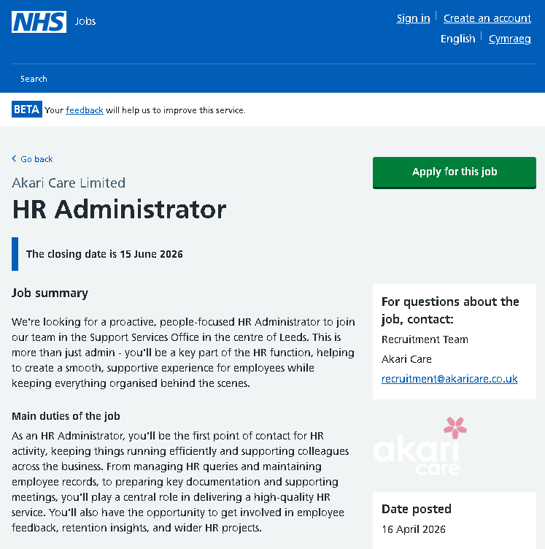
This report concentrates on the function of an HR Administrator in the field of Health and Social Care in an NHS Trust in the UK. The HR Administrator is important to facilitate the recruitment, to maintain staff records, to facilitate compliance with safeguarding processes, and to assist in the management of healthcare staff. This position plays a significant role in providing safe and quality care to organizations by managing the workforce (Asad et al., 2023). I am interested in pursuing this role as it aligns with my previous experience in human resources, as well as my current studies in Health and Social Care. It also mirrors my professional ambition of moving to the UK healthcare industry and benefiting organizational performance and patient care (Sholl et al., 2017). This report will focus on the employability skills in the position, my self-skills analysis, personal branding and professional identity, and an action plan for developing the career.

Figure 1: NHS Jobs advertisement for HR Administrator role (NHS Job 2026)

2. Analyze the Personal Employability Skills Required
The NHS HR Administrator is a position that needs a blend of administrative efficiency, interpersonal skills, and professional conduct to facilitate the proper management of the workforce. The NHS job advertisement (NHS Jobs, 2025) categorizes the responsibilities related to the job as management of recruitment, employee records, onboarding support, and safeguarding and data protection policy compliance. The person specification demonstrates the requirement to be a good communicator, organizer, and have IT skills and can cooperate in a multidisciplinary healthcare setting.
One of the most essential employability skills is communication, which is critical when liaising with healthcare professionals, applicants, and external bodies (Sisodia and Agarwal, 2017). As an illustration, the HR administrators should be communicative in inviting interviews or clarifying employment processes. This is in line with the 6Cs of Nursing: Care, Compassion, Competence, Communication, Courage, and Commitment, especially communication and care, because good communication partners patient safety and the quality provision of care indirectly.
Resiliency makes a difference as well since HR personnel are frequently dealing with significant workloads, deadlines, and sensitive topics, including staffing shortages or discipline. In the NHS scenario, resilience aids professionalism during pressure, especially during high demand, i.e. during winter pressures or staffing crises. This reflects the Skills for Care Core Skills Framework, which emphasizes adaptability and emotional intelligence in care settings (Verma et al., 2025).
Another important skill is teamwork because the HR administrators collaborate with clinical and non-clinical staff. An example of such is working with department managers when recruiting the right employees to meet patient care requirements. The STAR model (Situation, Task, Action, Result) can be applied to exemplify the application of teamwork in practice, employing coordination to recruit new employees urgently to maintain continuity of care in case of staffing shortages (Nagy et al., 2023).
Secondly, the digital literacy capacity is becoming an important element because HR administrators utilize the system like Electronic Staff Records (ESR) software, payroll system and recruitment systems. Accurate data management is essential to maintain confidentiality and comply with legal requirements such as GDPR (Caruccio et al., 2020). This echoes the wider Employability Skills Framework, in which digital competence is a necessity in contemporary workplaces.
On the theoretical level, the Learning Cycle by Kolb describes the process of development of these skills based on experience (Generoso and Cassiano, 2024). As an example, an HR administrator can have a difficult recruiting experience (concrete experience), reflect on the result, learn the lesson, and implement better strategies in future experiences. In a care home, a support worker can be called upon to diffuse a situation in which a resident is agitated or not at ease, etc. Through emotional intelligence, including staying calm, empathy, and communicating effectively, the worker may alleviate tension and keep everyone safe (Skills for Care, 2023).
All in all, the HR Administrator position demands an equal set of technical, interpersonal, and reflective capabilities, all efficient in facilitating the successful spread of health and social care services.

3. Evaluate My Own Skills
Self-assessment has enabled me to evaluate my appropriateness for the HR Administrator position within the NHS, and I have utilized a SWOT analysis, skills audit and unofficial career reflection quizzes. The tools have assisted me in critically assessing my present abilities against the job requirements as shown above.

SWOT Analysis of My Skills for the HR Administrator Role

An additional skills audit reveals that I am competent in the areas of communication, teamwork and problem-solving (McGuire et al., 2022). I have also been working frequently with senior management and employees of different departments, and this has been empowering my workforce in multidisciplinary teams. Moreover, HRIS and payroll systems experience reinforces my digital literacy, which is a critical prerequisite in up-to-date healthcare organizations. I also learned to cope with a professional setting in the UK through my volunteering experience as a receptionist in a law firm, located in the UK, which has enhanced my interpersonal skills and customer service.
Nonetheless, there are significant development areas despite these strengths. In self-assessment, one of the gaps, which I have been able to identify, is my lack of first-hand experience in the UK health and social care system, and in the NHS, in particular. Although I have solid HR expertise, I still require further insight into employment laws specific to the UK, protection processes, and systems, including the NHS Electronic Staff Record (ESR). This brings out a transition gap between my past international experience and expectations of the UK healthcare sector (Anderson et al., 2022).
Mentorship and supervision feedback have always noted my capability in leadership and strategy formation; nonetheless, indicating that I have to change my organizational culture to fit newer organizational settings. On the same lines, the lecturer's feedback about the course has also helped highlight the need to put my current skills in the context of the health and social care setting, especially in patient-centered care and adherence.
I will use Gibbs Reflective Cycle to view my development more critically.
Description: During my initial volunteering experience in the UK, I found challenges with workplace communication and expectations.
Feelings: At first, I was not sure, and I did not feel confident.
Evaluation: This experience taught me to be culturally aware and actively listen.
Analysis: I got to know that it is significant to observe others and adjust the style of communication.
Conclusion: This enhanced my self-confidence and knowledge in the workplace.
Action Plan: I will remain to work on my communication and cultural awareness skills.
Moreover, my motivation can be analyzed as the advancement of the Hierarchy of Needs created by Maslow between the basic career stability and the self-actualization. With the necessary experience and qualifications already obtained, I am now paying particular attention to career growth in the UK health and social care sector, where competency building and skills revision are necessary.
To sum up, I have strong transferable HR skills and a rich experience base, but I need to cover certain gaps in terms of the UK healthcare setting. These points are development opportunities and will be the foundation of my action plan in the next section.

4. Building a Personal Brand and Professional Identity
Developing a good personal brand is critical to be able to shine in the competitive world of Health and Social Care employment (Azad et al., 2024). My values, such as professionalism, integrity, empathy, and organizational commitment, are parallel to values needed in the health and social care environment. These values promote proper workforce management and form an indirect part in quality patient care, especially in positions like HR Administrator. I use important platforms like my CV, LinkedIn profile and professional portfolio to advance my professional identity. In my CV, I noted that I have over 16 years of experience in human resources (recruitment, payroll, and employee relations). My LinkedIn profile has my career history, expertise, and accomplishments presented in an organized and professional way, which enables me to network with recruiters and professionals in the UK healthcare industry. Also, I intend to create an online portfolio of my HR skills, qualifications, and professional growth efforts. The Unique Selling Point (USP) that I possess is a combination of vast experience in the field of HR and my up-to-date studies in Health and Social Care in the UK. This makes me one of the candidates who not only know the functions of HR but also acquire sector-related knowledge, which would allow me to work efficiently in a healthcare setting (Ouanhlee, 2023). The network and building a personal brand also include professional networking. I am also an active LinkedIn group member and professional community member (HR- and health and social care-related). These foster sharing of knowledge, growth and career visibility. The Social Capital Theory posits that through developing networks, information, as well as opportunities, are generated, vital in career advancement. Moreover, it is proposed by Holland's Theory of Career Choice that people tend to be successful in pursuing the career that corresponds to their personality and their interests (Erdogan, 2022). The HR Administrator position fits my background and future career direction because it is an administrative, people-oriented position. Employability, as emphasized by the Career EDGE Model, emphasizes experience, degree knowledge, and emotional intelligence, all of which help me develop a professional identity (Pool, 2020).
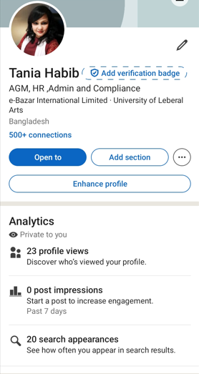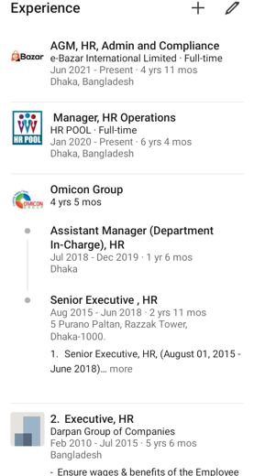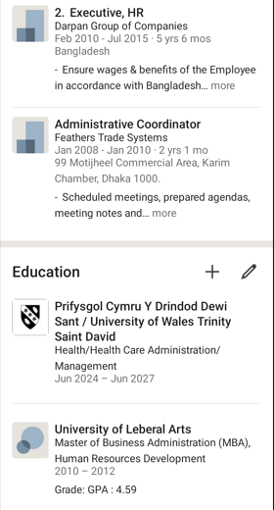

Figure 2: My LinkedIn Profile (Author)

5. Action Plan and Timeline
In order to realize my SMART-goal-based action plan, I have created a structured action plan to accomplish my aim of becoming an HR Administrator within the NHS. This plan aims to fill in my recognized skill gaps, especially between the UK health and social care systems.
Short-term goals (0–12 months)
- Complete my Level 5 Health and Social Care degree
- Learn about UK employment law and policies in the NHS.
- Enhance computer literacy (e.g., Excel, HR systems)
- Volunteer or work on entry-level positions in healthcare.
Long-term goals (1–5 years)
- Find employment as an HR Administrator in the NHS or the caring industry.
- Gain experience in NHS systems (e.g., ESR, recruitment processes)
- Progress towards HR Officer or HR Manager roles in healthcare

SMART Goals Table
Goal | Specific Action | Measure | Timeframe
Gain UK healthcare knowledge. | Degree in Complete Health and Social Care. | Degree completion | Within 1 year
Improve HR system skills | Training on the NHS ESR Learn and HR software. | Practical use or certification | 6–12 months
Gain UK work experience | Get involved in a care setting as a volunteer or take a part-time position. | Work experience gained | 6–12 months
Build a professional network. | Be at events and utilize LinkedIn. | Number of connections and interactions | Ongoing
Secure an HR Administrator role | Get an application to the NHS or healthcare HR. | Job applications and interview invitations | 1–2 years
Progress to HR Officer level | Achieve NHS HR experience and undertake CPD training. | Promotion or expanded HR responsibilities | 3–5 years
Develop long-term HR career growth | level to HR Manager or senior HR. | Career progression and leadership duties | 5 years

Development Activities and Resources
Activity | Purpose | Resources Needed
CPD courses (HR & NHS systems) | Develop technical knowledge | Time, funding
Volunteering in healthcare | Gain UK sector experience | Placement opportunities
Networking (LinkedIn, events) | Build professional connections | Online access, engagement
Mentoring/guidance | Career advice and support | Access to mentors
The Self-Efficacy Theory by Bandura supports this action plan, which stresses that the ability to believe that a person can achieve it is created through experience, learning, and achievement (SAMIA, 2024). Gaining pertinent skills and experience over time will make me more confident and willing to work in the UK health and social care sector.
This plan has a realistic but ambitious timeline, which will warrant constant growth. My short-term goals are centered around education and skill development, whereas my long-term objectives include getting a professional HR position and advancing in the field of healthcare.

6. Conclusion
To sum up, this report has identified my mission to become an HR Administrator in the UK health and social care industry. While I possess extensive experience in human resources, key areas for development include gaining knowledge of UK healthcare systems, NHS policies, and relevant legislation. The action plan offers a systematic and achievable method of filling these gaps with specific learning, practice, and networking among professionals. It has helped me to improve my knowledge of skills needed in the sector and how current competencies can be modified and applied in a new professional environment. Going forward, I am inspired to keep on honing my abilities and work towards a successful HR career in the healthcare industry with a lot of confidence.

References
Anderson, M., Pitchforth, E., Edwards, N., Alderwick, H., & Mossialos, E. (2022). United Kingdom: Health System Review. Health Systems in Transition, 24(1), 1–194. https://www.researchgate.net/publication/360684713_United_Kingdom_Health_System_Review
Asad, M. U., Ali, A., Mushtaq, A., & Ullah, R. (2023). EMPLOYEE AND EMPLOYER'S ROLE IN ENSURING A SAFE WORKING ENVIRONMENT BY MAINTAINING HEALTH AND SAFETY IN THE WORKPLACE. Pakistan Journal of Science, 75(1), 106–116. https://doi.org/10.57041/pjs.v75i1.828
Azad, T., Razu, K. S. A., Sikder, S., Bhuyan, M. S. H., & Ahmed, M. S. (2024). Building a Personal Brand: Strategies for Standing Out in a Competitive Job Market. International Journal of Novel Research in Marketing Management and Economics, 11(1), 147–154. https://doi.org/10.5281/zenodo.10939572
Caruccio, L., Desiato, D., Polese, G., & Tortora, G. (2020). GDPR compliant information confidentiality preservation in Big Data processing. IEEE Access, 1–1. https://doi.org/10.1109/access.2020.3036916
Erdogan, A. (2022, January). (PDF) HOLLAND’S THEORY OF CAREERS AND VOCATIONAL CHOIC. Www.researchgate.net. https://www.researchgate.net/publication/358119611_HOLLAND
Generoso, L., & Cassiano, F. (2024). The approach to experiential learning by David Kolb and its influence on the development of professional competencies in leadership. Contribuciones a Las Ciencias Sociales, 17(10), e12179–e12179. https://doi.org/10.55905/revconv.17n.10-474
McGuire, D., McVicar, O., & Tariq, U. E. H. (2022). Skills Audits: an Integrative Literature Review. Industrial and Commercial Training, 55(1), 34–46. https://doi.org/10.1108/ict-06-2021-0042
Nagy, S., Pelser, A.-M., & Vaiman, V. (2023). The improvement of Skills & Talents in the workplace. ResearchGate; Axiom Academic Publishers. https://www.researchgate.net/publication/369661218_The_improvement_of_Skills_Talents_in_the_workplace
NHS Jobs (2025) HR Administrator jobs. Available at: https://beta.jobs.nhs.uk/candidate/search/results?keyword=HR+Administrator (Accessed: 17 April 2026).
Ouanhlee, T. (2023, January 12). Learning Human Resources and Applying it to Real-Life Situations. ResearchGate; Canadian Center of Science and Education. https://www.researchgate.net/publication/367075478_Learning_Human_Resources_and_Applying_it_to_Real-Life_Situations
Pool, L. D. (2020). Revisiting the CareerEDGE model of graduate employability. Journal of the National Institute for Career Education and Counselling, 44(1), 51–56. https://doi.org/10.20856/jnicec.4408
SAMIA, S. (2024). Understanding Self-Efficacy: The Foundation for Personal and Academic Success. Ziglôbitha, 02(009). https://doi.org/10.60632/ziglobitha.n009.07.2024.vol3
Sholl, S., Ajjawi, R., Allbutt, H., Butler, J., Jindal-Snape, D., Morrison, J., & Rees, C. (2017). Balancing health care education and patient care in the UK workplace: a realist synthesis. Medical Education, 51(8), 787–801. https://doi.org/10.1111/medu.13290
Sisodia, S., & Agarwal, N. (2017). Employability Skills Essential for Healthcare Industry. Procedia Computer Science, 122, 431–438. https://doi.org/10.1016/j.procs.2017.11.390
Skills for Care (2023) Core skills for care. Available at: https://www.skillsforcare.org.uk (Accessed: 17 April 2026).
Verma, R., Yadav, M., Sharma, N. K., & Khare, S. (2025). The Power of Emotional Intelligence in Healthcare: A Narrative Review of its Neurobiological Basis, Clinical Leadership and Patient-centric Care. JOURNAL of CLINICAL and DIAGNOSTIC RESEARCH. https://doi.org/10.7860/jcdr/2025/79158.21564

