Reporting the Benefits and Implementation of AI for Teronix
Oliver Bird
Apprentice Software Engineer – BT, Data Services
Applicable word count ~ 2850
1910716@student.uwtsd.ac.uk

ABSTRACT – This report details the benefits of using AI and Machine Learning in a small scale, international retail organisation called Teronix. It encompasses a literature review of potential benefits to Teronix, followed by an AI/ML model applied to the dataset provided by the company. Conclusions about potential business decisions are made with suggestions for future work.
1. Introduction
AI is the future of enterprise data analytics and interpretation. Within the last 20 years, AI has become much more than just rule based actioning systems (like robotic arms or calculators), and now has the potential to unlock tangible insights on masses of data [1]. Not only have the tools and techniques improved, but accessibility to these newer methods is becoming easier by the year [2]. Gartner details the onset of the Citizen Developer and Citizen Data scientist, who are able to learn many high-level techniques outside of an organisation. Small enterprises and users can have access to the same tools and analytics as massive corporations through the use of in-house software, open-source libraries, and cloud computing. This report will act as a high level introduction to AI and Machine Learning techniques which can provide financial and personal benefits to the owners and employees of Teronix. Using the data provided, this report will endeavour to detail some of the potential improvements, and current key product indicators under Teronix. The results found are not exhaustive of all possible machine learning techniques, however, will provide a human readable, and AI model for the board and CEO.
2. Literature Review
A literature review has been conducted in order to demonstrate and discuss the benefits and uses of AI in the supermarket and global retail sector. Search engines used were:
- IEEE Xplore
- UWTSD Library
- Google Scholar
- Springer Link
Further sources are included from reputable sources and large enterprises which are either industry leaders or provide software / expertise in the specific fields being discussed.
AI and machine learning are important to businesses (generally) and in particular the retail market for a large number of reasons. These are detailed in terms of general benefits and then a specific example for Teronix:
- Automation – through the use of intelligent agents (programable actors which can take either a set of instructions or make decisions based on a set of conditions or stimuli) and other forms of intelligence, systems can be automated to enact functions. Within an enterprise there are many use cases and examples of these, such as automated warehouses [3] (e.g. Ocado), including product ordering and restocking, customer appreciation and satisfaction levels (using fuzzy logic [4]) alongside many others. For the right price, a vast array of automation is possible. This may be enacted via the automation of labelling and tracking packages through their internal warehousing phase to move stock to the appropriate areas for shipping [5].
- Forecasting – potentially one of the most useful applications of AI and machine learning for an enterprise. The use of these techniques can allow for the prediction of potential popular items, frequent buys, busy periods / times etc. depending on the data provided. Many business needs and KPIs [6] can be estimated using methods like polynomic and linear regression [7] to try to quantify the relationships between data fields, in which both a relationship defining equation and its respective correlation coefficient or goodness of fit measure. This will allow for both forecasting of potential future values respective of the data. [8] proposes that with extensive forecasting with a large enough data set, it becomes possible to even predict products a customer may not want in the short term, but also in the distant future. For Teronix this may take the form of estimating potential sales in the short term in order to attain further investment from stakeholders, therefore allowing for growth.
- Patterns – similar to forecasting, these regression algorithms can also attempt to find patterns within a given dataset. The resultant values from these will aid in determining if the relationships between data are meaningful and hence drive business decisions to further the growth and revenue of the business [9]. A key example of the use cases for this within Teronix would be to identify potentially unknown periods / items of particular sales value. This could take the form of a particular seasonal holiday which was not known by Teronix, however the data patterns could highlight increased periods of particular sales of seemingly unrelated items. This would allow the organisation to ensure they had stocks of those items for future periods and also aid in driving advertising (as is discussed below).
- Advertising – A number of data feeds can be analysed to aid in producing more appropriate advertising for Teronix both in their online and physical presence. Patterns found within the sales data can be used to promote products to users which may be more sought after based on many factors. For example, as above, seasonal sales can be advertised to users at specific times of the year. Furthermore, in the online space shopping habits for particular users or organisations can be analysed to predict what purchases they may be looking for at a given time. This may come from previous purchases, browser cookies or similar purchases from other clients. For Teronix this would provide a potentially improved shopping experience as it could reduce user frustration in finding the products they want. [10] describes multiple implementations for recommendation systems and finds an algorithmic approach to reduce computation time (which can occur with large datasets) and increase user satisfaction given a small set of initial data about an individual user.
- Waste – The results of data analytics and implementation of AI can reduce the waste included within an organisation. This may take the form of shipping errors, employee turnover, overproduction, data mismanagement / interpretation along with many others. By handing over stock management to an expert intelligent agent, there is less availability for human error in stock handling and delivery as the product information is handled by a machine. In the case of Teronix, the dataset provided appeared to have a large amount of missing / in-accurate data. Before committing data to a record, it can be checked via a number of methods (a neural network, naïve or polynomial bayes for example) to determine the likelihood that the data is accurate and complete. Furthermore, clustering algorithms can be used to further categorise current data into groups. Should a new piece of data be received, it can be compared to known clusters to determine if the data is new, and hence can then either be discarded or accepted as a new category of data. The use of these systems could then aid in cleaning incoming business data from Teronix to allow for more optimal use of said data.
- Sales – As discussed above, the use of AI technologies and machine learning can greatly increase the number of sales an organisation is able to make. This may be due to more effective stock allocations, better advertising, more efficient shipping resulting in higher customer satisfaction, improved product recommendations and product offerings. Data analytics will provide the knowledge which underpins all of the above advantages. A specific use case advantage for Teronix may be the use of Natural Language Processing. This may allow them to reach non-native English speaking nations via automated translation of their outreach into various languages.
- Productivity – [11] The use of AI allows for the potential reduction or reassignment of the human elements of the business. This reduces costs of the overall workforce or allows humans to work on tasks better suited to our skillset when compared to a machine (for example creation of business advertising, people management, business decisions etc).
3. Data Handling and Processing
A) Data handling Suggestions
In order for Teronix to move forward with more advanced data processing strategies, a number of issues were found within the provided dataset which may cause inaccuracies / extensions in future works as the data must be suitably cleaned before it can be analysed. Some of these issues are avoidable as they can be treated differently upon data collection.
Firstly, a segregation of data should be enacted for easier analysis and usability. Rows should attempt to be unique in their purpose, for example discounts applied to orders should be attributed back to the same invoices which orders were made upon (in the case of bulk buys or similar organisational ‘deals’). Separating these into more referential fields (such as adding a discount code to accurately track why a discount was added) would more easily detail the nature of discounts across the organisation.
Similarly, storing returns in the same table requires additional analysis to check that the values match correctly. To not interfere with indicators found from the data analysis, it must be ensured that these returns are zero sum [12]. Else there is some potential skew in profit and loss calculation, and more so in prediction. There is also no direct link to suggest that a return value corresponds precisely with a given purchase.
Fig. 1 – Returns Example
In the above example, a return is detailed for a given order, however the invoice codes are different. Notably, returns values appear to be prefixed with a C, but the associated numeric code does not reflect the original invoice the return is tied to. In addition, the times at which these returns were made is not coherent, as the return was processed prior to the time of purchase. It would be easier to categorise returns in a different manner, either with an additional table or by matching returns using the prefix, but relate it to the original order.
In the same vein, there are a number of other associated charges within this data set which are not easily distinguished from other sales data, such as damages and bank charges. These should further be separated out, as with such a large quantity of data these values can easily become lost.
Finally, null, incorrect, or empty values should be handled via a strategy. A system should be implemented to determine if a null value is correct, to fill it or discard it. This may be autonomous or rely on human intervention depending on the cases. A number of these were observed within the dataset.
There are a host of various tools which Teronix can use both for free and via subscription which would allow the organisation to analyse their data in the moment and going forward. These are discussed below:
B) Visualisation tools
Data is easier to humanise via the use of visualisation tools. These present data in a more human readable format, such as graphs, charts, maps, data tables to list only a small number. These types of data presentations more easily identify KPIs, potential trends, spending etc which can provide a both simple and detailed analytics for Teronix. These can be constantly updated automatically to detail current business data in the form of a dashboard [13]. Tools such ss Qlik Sense [14], Looker [15], PowerBI [16] and Tableu [17] are popular choices for these however come at additional costs to the business. Simple data analytics and visualisations can be accomplished using Excel, and furthermore as is discussed below some of the Machine Learning platforms also can be used for simple visualisations.
C) Artificial Intelligence
For further insights, data manipulation and machine learning, there are apps and tools more suited to these types of use case. Code free solutions such as KNIME Analytics [18] and Orange [19] are machine learning and data analytics platforms designed to allow for rapid data manipulation and modelling solutions. These have many in built AI and ML tools which can be configured and connected with a GUI.
Fig. 4 - Total Rows after Missing Values Excluded
For finer grained and personal data control requirements, there are a large number of libraries available for the Python code language with the same AI and data management tools, but at a more user-controlled level. [20] describes solutions to issues with performance of Python libraries during a machine learning problem. Libraries such as pandas [21] and matplotlib [22] allow for simple data management and visualisation, whereas modules like TensorFlow [23] for Neural Networks or PyCaret [24] for Clustering or for more general modelling and analysis Genism [25].
4. Teronix Data Analytics
The dataset provided by the business has been analysed to look for potential patterns or useful KPIs to help drive further business decisions using Microsoft Excel as a data manager and KNIME as a data engineering platform.
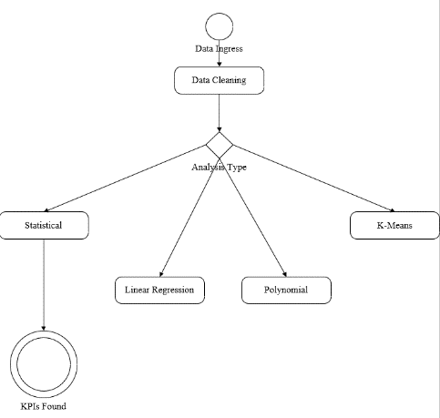
The general format of the analysis undertaken is below:
Fig. 2 - Simplified Analytics Algorithm

Initially the data was concatenated into a single Excel sheet and imported into KNIME. The data was then cleansed of null rows, notably no prediction or natural language processing were used to attempt to rectify empty cells. It is noticed a row count difference of around 180,000 rows in which data was found to be missing. This may highlight a potential data collection issue within Teronix.
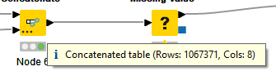
Fig. 3 - Total rows ingested into KNIME

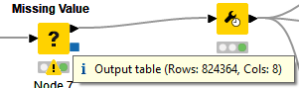
The analytic process was split within the KNIME application into data processing and data analysis.
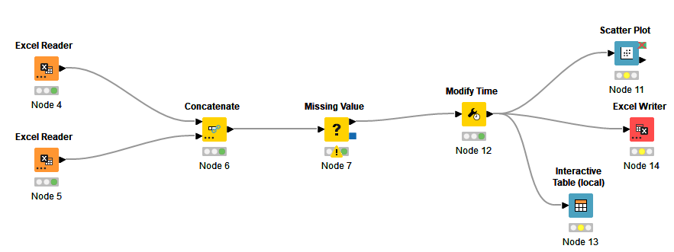
Fig. 5 - Data Processing
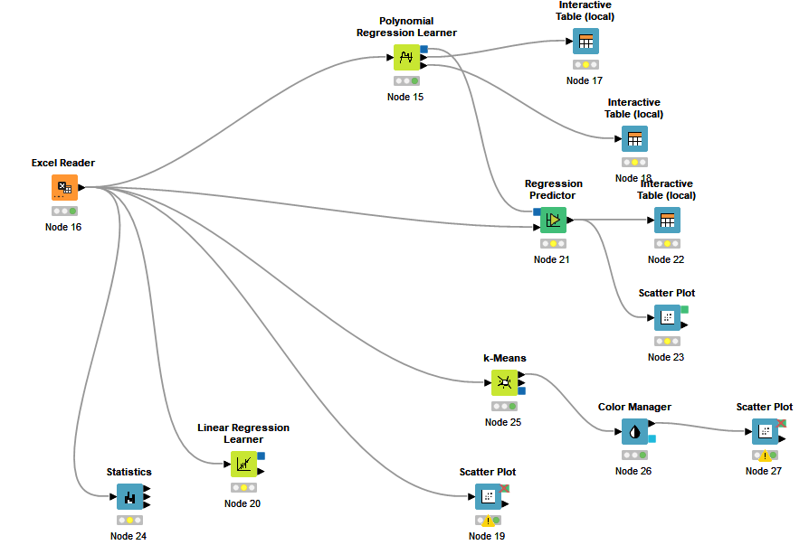
Fig. 4 - Data Analytics

a) KPIs
General statistical analysis was performed on the data to determine common data values for a plethora of potential notable metrics. Data has been taken at face value, regardless of potential errors (for example a max quantity value of 80995) and it is hoped mistakes have been made zero sum prior to the analysis below.
- Average Sales Value per Day - £5018
- Maximum Sales Daily Value - £42,469
- Minimum Daily Sales Value - £649
- Average Sale Price for a set of matching products - £3.68
- Highest Single product set sale - £ 38,970
- Average number of item sets sold per day – Daily Average/ Average sale set = 1367
- Average quantity of items per set – 12.4
- Majority of Sales locations – UK/ Western Europe
The above KPIs paint a picture of a UK based company prioritising in shipping cheap items in large quantities. This is further evidenced by the histograms below:
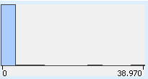

Fig. 6- Histogram of Prices per Set
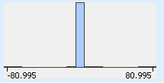
Fig. 7- Histogram of Quantities Within Order Sets
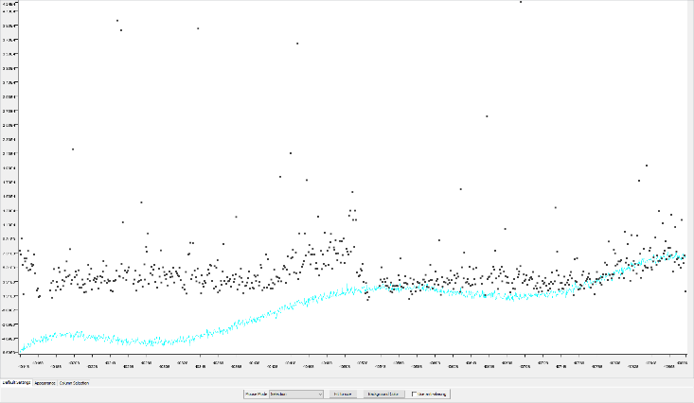
Fig. 5 - 10th Degree Polynomial plot against Sales Data

These histograms show a small average price of sets alongside a relatively small number of items within said set. When combined with the considerations of average set value vs the total profit made per day, it must mean that a large number of these sets are sold. Therefore, given the primary regions of sale are western Europe and the UK, these types of sale should be prioritised.
b) Linear Regression
A linear regression evaluation of a correlation between order dates and their total sales value for each day has been undertaken. The date fields in the original dataset have been converted to a relative integer value to allow for use in a regression algorithm. A very weak correlation coefficient of 0.03 was found from this, resulting in the determination that there is little correlation between the two cases in a strictly linear format.
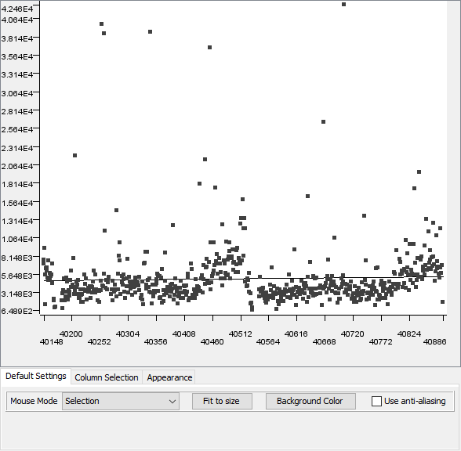
Fig. 8- Plot of Total Sales Profit (Y) against Date (Normalised X)
c) Polynomial Regression
Polynomial regression algorithms were then applied to the same above dataset to attempt to model the data set more accurately. These were applied to degrees up to 10 with the goal of maximising the $R^{2}$. This value represents how well the model fits the data provided. The results show that no polynomial equation found fit the data particularly well, with the maximum value of 0.1142. This indicated that the data when viewed in its entirety did not follow any kind of polynomial sequence.
It should be noted in the analysis of the data that a clear increase in sales is found during the seasonal period in both of the studied years. Outside of this time the data appears linear with spikes of random events of large sales.

d) Logarithmic Regression
A comparison of the quantities and sales values of sets was done which details a logarithmic relationship between the two. This means that in the majority of cases, as the quantity of items in a set rises, the average price remains low. Similarly with price of set, as the price goes up the average quantity associated with that is low. This further details cheap, high quantity sales as shown previously. KNIME does not support the plotting of such a line, however a view of the data does corroborate it in the magnitude of 1/x.
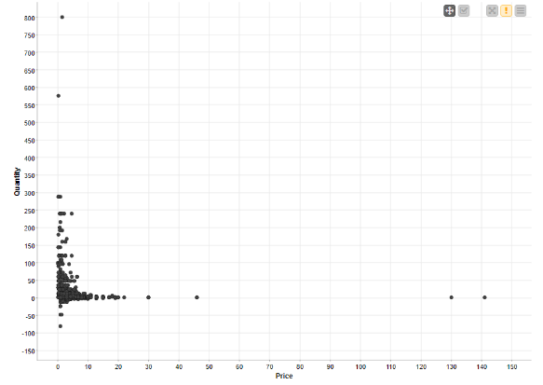
Fig. 6 - Potential Logarithmic Regression Plot

e) K- Means
A K-means analysis was attempted on the dataset with the goal of grouping customers against their potential value to the business. The results of this clustering were not tangible and hence did not provide any meaningful data. Further data pre-processing and mining would have needed to have been required in order to gain more useful data. An example of this is shown here, which details the need to push the most profitable customers with the most advertising and best service [26].
5. Conclusions
Based on the analysis conducted, Teronix should most likely tailor their marketing towards their current largest customers. Additional analysis of the specific customers could be undertaken in the future to target specific product types. When expanding their inventory, their current consumer base is for low cost, medium volume goods, which should in turn drive choices on new products. Based on their out of season data, no significant rise is noted in these areas. A seasonal peak of sales in noted in the later months / Christmas period, and hence the organisation should prepare for that. Finally, the majority of their business is within Europe, so they should continue to focus on stocking products and marketing towards clients within that region.
There is further work to be undertaken in deeper analysis of potential growth in regions and markets outside of Teronix’s currently most common. Additional data from other similar businesses would be useful in modelling this.

References

[1] | IBM, "IBM Global AI Adpotion Index 2022," IBM, Armonk, 2022.
[2] | Gartner, 5 Key Actions for IT Leaders for Effective Decision Making, London: Gartner, 2021.
[3] | Ocado Group, "What is an Ocado CFC," 2021. [Online]. Available: https://www.ocadogroup.com/about-us/what-we-do/automated-ocado-customer-fulfilment-centre/. [Accessed 02 01 2022].
[4] | A. Kumar, "A conceptual model for automation of product dynamic pricing and sales promotion for a retail organization," Kybernetes, vol. 45, no. 3, pp. 490-507, 2015.
[5] | Amazon Inc, "10 years of Amazon robotics: how robots help sort packages, move product, and improve safety," 21 June 2022. [Online]. Available: https://www.aboutamazon.com/news/operations/10-years-of-amazon-robotics-how-robots-help-sort-packages-move-product-and-improve-safety?asc_refurl=https%3A%2F%2Fwww.businessinsider.com%2F&asc_source=browser&asc_campaign=commerce-pra&tag=thebusiinsi-20. [Accessed 03 01 2023].
[6] | B. Panay, N. Baloian, J. Pino and S. Penafiel, "Forecasting Key Retail Performance Indicators Using Interpretable Regression," Sensors, vol. 21, no. 5, p. 1874, 2021.
[7] | M. Blachnik, "Estimating the Performance Indicators of Promotion Efficiency in FMCG Retail," in Neural Information Processing, Bangkok, 2022.
[8] | S. Ren, H. Chan and T. Siqin, "Demand forecasting in retail operations for fashionable products: methods, practices, and real case study," Annals of Operations Research, vol. 291, pp. 761-777, 2020.
[9] | K. Ko, M. Chang, E. Bae and D. Kim, "Efficiency Analysis of Retail Chain Stores in Korea," Sustainability, vol. 9, p. 1629, 2017.
[10] | "Collaborative recommender systems: Combining effectiveness and efficiency," Expert Systems with Applications, vol. 34, no. 4, pp. 2995-3013, 2008.
[11] | M. Tunguturi, "ARTIFICIAL INTELLIGENCE AND MACHINE LEARNING IN THE ENTERPRISE," TRANSACTIONS ON LATEST TRENDS IN HEALTH SECTOR, vol. 2, no. 2, 2010.
[12] | Corporate Financial Institute, "Zero Sum Game (and Non Zero Sum)," 22 12 2022. [Online]. Available: https://corporatefinanceinstitute.com/resources/economics/zero-sum-game-non-zero-sum/. [Accessed 10 01 2023].
[13] | Salesforce, "What is a dashboard? A complete overview," 2023. [Online]. Available: https://www.tableau.com/learn/articles/dashboards/what-is. [Accessed 11 01 2023].
[14] | Qlik, "Qlik Sense," 2023. [Online]. Available: https://www.qlik.com/us/lp/ppc/qlik-sense-business. [Accessed 11 01 2023].
[15] | Google Inc, "Find true power in your data," 2023. [Online]. Available: https://www.looker.com/. [Accessed 11 01 2023].
[16] | Microsoft, "Turn your data into immediate impact," 2023. [Online]. Available: https://powerbi.microsoft.com/en-au/. [Accessed 11 01 2023].
[17] | Salesforce, "The world's leading analytics platform," 2023. [Online]. Available: https://www.tableau.com/en-gb. [Accessed 11 01 2023].
[18] | KNIME, "End to End Data Science," 2023. [Online]. Available: https://www.knime.com/. [Accessed 12 01 2023].
[19] | Orange, "Data Mining Fruitful and Fun," 2023. [Online]. Available: https://orangedatamining.com/. [Accessed 12 01 2023].
[20] | P. Fua and K. Lis, "Comparing Python, Go, and C++ on the N-Queens Problem," University of Cornell, Cornell , 2020.
[21] | pandas, "pandas," 2023. [Online]. Available: https://pandas.pydata.org/. [Accessed 12 01 2023].
[22] | Matplotlib, "Matplotlib: Visualization with Python," [Online]. Available: https://matplotlib.org/. [Accessed 12 01 2023].
[23] | Tensorflow, "Create production-grade machine learning models with TensorFlow," [Online]. Available: https://www.tensorflow.org/. [Accessed 12 01 2023].
[24] | PYCARET, "low-code machine learning," [Online]. Available: https://pycaret.org/. [Accessed 13 01 2023].
[25] | R. Hurek, "Topic modelling for humans," [Online]. Available: https://radimrehurek.com/gensim/. [Accessed 13 01 2023].
[26] | X. Pu, N. Qi and J. Huang, "Data Analysis and Application of Retail Enterprises Based on Knime," in Materials Science and Engineering, Bristol, 2020.

