Introduction
An identified need to integrate health and social care within Wales resulted in the announcement of a multi-million-pound Welsh Government (WG) investment in a new IT system back in 2015. The national procurement process involved representatives from health boards and local authorities across Wales, with the intention that all would implement the Welsh Community Care Information System (WCCIS) (Audit Wales, 2020). In addition to a national business case, local Business Justification Cases (BJCs) developed internally by health boards identified intended benefits of local implementation, alternatives, and costings. Approval of BJCs would enable deployment orders to be signed without the need for internal procurement processes.
Aiming to support information sharing requirements, case management and workflow, the implementation of WCCIS intended to provide a “Once for Wales” solution, delivering strategic requirements outlined in the Integrated Health & Social Care, Social Services and Well-being (Wales) Act. With plans to interface with different systems used by local authorities and NHS organisations, WCCIS would cover processes undertaken by community health and social care workers, sharing data across community, primary and secondary care settings aiding efficient treatment (Cwm Taf University Health Board, 2016).
Functioning as the key digital enabler and part of WGs long-term plan for the NHS and social care, “A Healthier Wales”, the intention was that WCCIS would facilitate transformational change, leading to improved delivery of person-focused care. Supporting social services, mental health, therapy, and community services, ensuring services for individuals, families and communities are more effectively planned, co-ordinated, and delivered (Betsi Cadwallader University Health Board, 2016).
The supplier states WCCIS would be available on all devices, including mobile and offline, providing accessibility so citizens could view their patient record from their own home. Powered by Microsoft Dynamics CRM, the WCCIS CareDirector platform was said to provide flexibility, work across multiple-disciplines and be a fully interoperable and integrated solution (CareWorks, 2016).
Powys Teaching Health Board (PTHB) and Powys County Council (PCC) had the first joint implementation of the system in April 2017. Joint funding and a Section 33 agreement integrates both organisations ICT and WCCIS Application Support Team. PCC’s migration to WCCIS, like most other local authorities was from a local instance of the Draig system (which ceased support in April 2016). Despite having local instances of the Welsh Patient Administration System (WPAS) several community teams within PTHB were not using any electronic patient record system and reliant on paper-based documentation.
Initial estimation that all 22 local authorities and 7 health boards may be using WCCIS by the end of 2018 has not come to fruition, with only 13 local authorities and 2 health boards live on WCCIS as of 31 August 2020. Of the remaining organisations, 4 have signed deployment orders, 4 are in active negotiation and 6 are still to commit. The Auditor General for Wales quotes that “Welsh Government’s ambitious vision for WCCIS is still a long way from being realised” (Audit Wales, 2020).
Methods
Providing a useful framework for the assessment of factors influencing the success or failure of IT adoption, historic models provide limited consideration of sociotechnical factors and have often been too linear, especially when applied to complex areas such as health and care. The FITT framework (Figure 1.) can explain why depending on the setting an IT system can be adopted in different ways, have different effects and help to determine areas where the introduction of changes could be optimised (Ammenwerth et al. 2006). Developed specifically for the health care domain and based on the fit between three attributes: Individuals, Task and Technology, the FITT framework extends concepts from the Technology Acceptance Model (TAM) (Davis, 1993) and Task-Technology Fit (TTF) Model (Goodhue, 1995). As discussed by Tsiknakis and Kouroubali (2009) insufficient fit between the FITT attributes is often a reason for problems encountered during system implementation and use. Application of the FITT Framework will therefore be used to evaluate the relationships between task, technology, and individuals in the context of WCCIS.
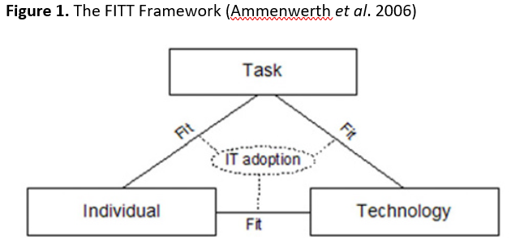
Using a mixed method approach collecting both qualitative and quantitative data will offer a deeper evaluation, which Scott (2016) describes as essential for evidence-based health informatics. Qualitative Data was collected from a range of sources, including newspaper articles, internal health board and local authority documents such as board and cabinet reports, business cases and meeting minutes/agendas. Audit reports conducted internally and by Audit Wales were also reviewed.
A WCCIS satisfaction survey developed within Microsoft Forms was circulated to both front line and non-operational users of WCCIS within PTHB, PCC and the WCCIS National Reporting Group. The decision was made to have an anonymous questionnaire so individuals would feel more comfortable expressing their true opinions, collecting more honest feedback. The survey questions were split into two main areas, those which gave respondents an opportunity to agree or disagree with certain statements, and those which listed elements of the system and gave users the ability to rate their level of satisfaction. The close-ended questions provide response uniformity facilitating quantitative analysis, whilst a final free-text question provided an opportunity to collect additional qualitative feedback based on specific positive experiences or concerns.
The survey questions can be aligned to areas associated with the FITT framework for relationship evaluation, for example questions relating to confidence in using the system, and general ease of use can be attributed to Individual-Technology, system functionality, performance and integration capabilities with Technology-Task, and the complexity of completing tasks to Individual-Task.
Creating tailored questions covering certain aspects of WCCIS provides a unique and rounded evaluation. There have been several standard questionnaires developed for the evaluating system satisfaction, usability, and acceptance, examples of which were compared by Hajesmaeel‑Gohari (2022), one of which was the System Usability Scale (SUS). Visible in Figure 2, SUS was developed in 1996 by Brooke as a low cost, “quick and dirty” way to assess usability in system evaluations. A study by Bangor et al. (2008) covering 10 years’ worth of use found SUS as a highly robust and versatile tool, supporting the quick and easy method of collecting an individual’s subjective rating of a product's usability and was therefore chosen to be used in conjunction.
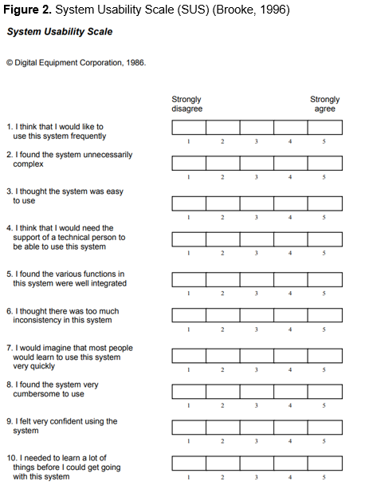
Results
41 responses were collected from the anonymous survey, with an almost-equal split between operational users of the system (n=22) and non-operational staff (n=19). Of the non-operational staff, 58% (n=11) were from a WCCIS application team with a system administration role, and the remainder either carried out WCCIS reporting functions or were operational management. 76% (n=31) of respondents reported having 3+ years of using WCCIS. Respondent characteristics collected from the survey are depicted in Figure 3.
Table 1 and 2 displays the results of the questionnaire as calculated percentages of agreement and satisfaction levels. As seen in Table 1, positive statements were most often disagreed with, the strongest of disagreements seen in the statement that “WCCIS is meeting its potential” (48.8%, n=20), closely followed by 47.5% (n=19) of participants who strongly disagreed with the statements “WCCIS enables me to carry out my role effectively” and “I find WCCIS functions smoothly and is well integrated”.
In a similar vein, the 3 negative statements regarding WCCIS were agreed with by over half of all respondents, with nearly 30% strongly agreeing that WCCIS was time consuming and had a lot of irregularities. 75.6% (n=31) of respondents did report agreement in having confidence in their own ability to use and navigate WCCIS.

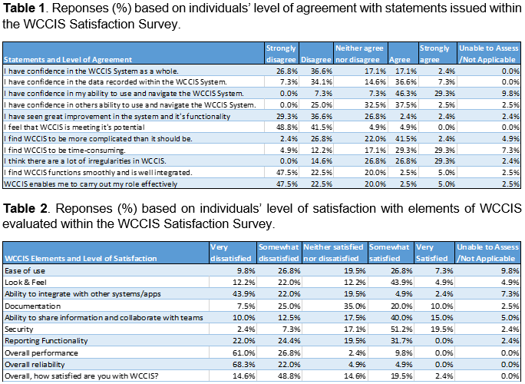
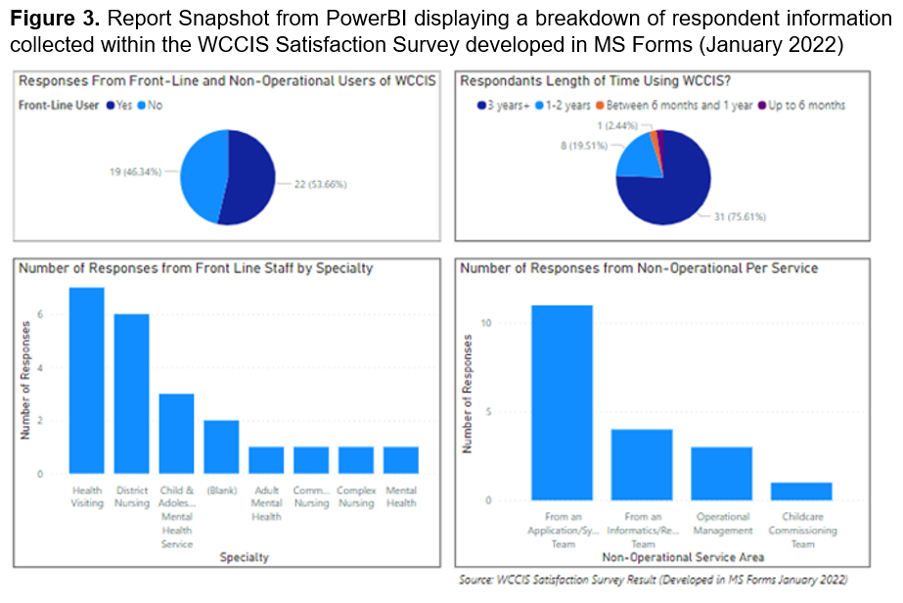

As seen in Table 2, in terms overall satisfaction, only 1 respondent reported being very satisfied, with 63.4% (n=26) feeling dissatisfied to some extent. There are two main areas of strong dissatisfaction, one being overall performance, where 61% (n=25) of responders are very dissatisfied and a further 26.8% (n=11) somewhat dissatisfied. Overall reliability was rated similarly, with 68.3% (n=28) feeling very dissatisfied, and an additional 22% (n=9) somewhat dissatisfied. Security was rated as the most satisfactory element of WCCIS followed by the ability to share information and collaborate with teams within WCCIS.
When the responses were split between front line and non-operational users’ analysis showed little difference, with a similar percentage split per question irrelevant of user group.
The SUS Score could only be calculated for 36 respondents due to 5 users being unable to assess all 10 elements. The score ranged from 15 to 82.5, with the average score of 45.6. The SUS scores are bimodal with a mode at 50 and 42.5 (42.5 is also the median value). Using the Lewis and Sauro (2018) curved grading scale the average score of 45.6 would result in the lowest grade of system usability, Grade F.
Within the free-text element of the survey for the most part comments received were negative, highlighting a real frustration and dissatisfaction with WCCIS. Thematic analysis identified eight common themes as highlighted in the Table 3.
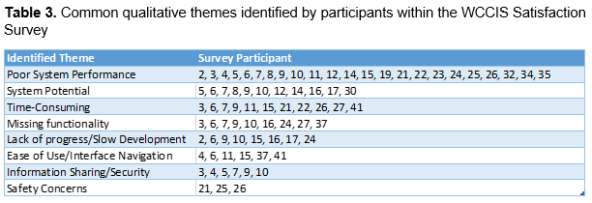
The most common qualitative theme found was poor system performance with over half of participants providing free text comments around this problem. Poor performance was referred to as occurring almost daily, leading to system unreliability, subsequently frustrating staff and contributing to low morale and confidence. For example, participant 19 commented that the only consistency WCCIS delivers is poor performance and participant 29 stated that they dislike WCCIS so much that they have thought about leaving to find alternative employment. To quote Participant 9; “We are 4 years on and it’s getting worse, hours are lost daily on a system being slow or not working and this is happening right across PTHB, which is adding stress to busy staff to try and complete simple tasks on WCCIS, which sometimes cannot be done.”.
Ease of use was also noted, with six reporting the system as difficult to navigate, however participants 6, 11 and 15 clarified that this has been exacerbated following the recent upgrade. Participant 33 also commented that they had based their responses on usage since go live rather than the previous 6 months “in an attempt to be pragmatic”. Only participant 23 commented that they had “always found it to be user friendly and straight forward”.
Linked with poor performance and ease of use, eleven respondents gave comments highlighting how time-consuming it was to complete work on the system, with basic system admin functions having to be completed outside of core hours. Performance issues are preventing the completion of basic tasks and leading to errors such as duplication, “especially when the system is down as there is no-back up in place”. As a result, staff reported falling behind in their work.
Potential for the system “to be good” and hope for future development was referenced by eleven participants before describing the current problems. As highlighted by participant 10, cases of services investigating new systems may not have occurred had the original requirements of WCCIS been met. Participant 30 also feels that the potential for WCCIS has been let down by the supplier.
Disappointment was expressed in terms of lack of progress and slow development of the system by eight participants, which is closely related to the frustrations felt with regards to the system missing functionality. Elements such as integration to other systems, printing case documentation, diary and appointments were referred to, along with the inability to access WCCIS within the community. Participant 7 commented that they “don't like the fact that we still have to use two systems and that we can't record all our appointments on WCCIS and retrieve the data we need for reporting”, however participant 5 did comment on the systems capability of “storing useful data and producing good reports”.
Concerns around safety were raised in the following comments from participant 21; “WCCIS needs to improve for the safety of our patients.”, participant 25; “It does not feel like safe record keeping in line with our NMC registration.”, and participant 26 stated “It is a very dangerous system”.
There were six comments around information sharing and security which were generally positive in terms of the system itself, but three touched on limitations resulting from internal governance and processes. Participant 3 provided feedback stating that “If children's services could agree to share their information, we would be able to share information as it was intended, and I believe this would be beneficial. Not a system issue but rather a process issue.” Similarly participant 5 referenced governance and sharing issues as a limiting factor, and participant 9 commented that health and social services needed to be more connected to avoid duplicating work. On a positive note, participant 7 noted the security of the system was a good part of WCCIS. Specific comparisons to paper notes such as the ability to “access from any location” and eliminating the risk of lost notes and participant 4 also referenced the timeliness WCCIS provides in being able to access “exactly what you are after”. Another positive highlighted by participant 10 is that WCCIS had delivered the benefit of a shared electronic patient record, digitising some services that previously had very little experience with digital technology.
Discussion
In a study utilising the FITT framework, Tsiknakis and Kouroubali (2009) reported that a tight fit between the organisation, strategy, management, roles, skills, and technology greatly facilitated adoption of ICT within healthcare. De Leeuw et al. (2020) found that clear distinctions between the fit dimensions can sometimes be difficult to make due to overlap, with certain elements interlinking. From the questionnaire results alone, despite some positives it appears that the WCCIS system has a poor fit against the FITT dimensions, with issues within the task-technical domain having a subsequent impact on the individual-technology and individual-task dimensions.
Task-Technology
A meeting held with the PCC Public Service Board Scrutiny Committee (PSBSC) in September 2018 highlighted frustration with WCCIS technology, connectivity issues and loss of data (Powys County Council, 2018) and WCCIS unreliability was added to PCC’s Strategic Risk Register following the 25th May 2021 meeting (Powys County Council, 2021a). Also evidenced within the survey, WCCIS performance and reliability is clearly a significant problem. Despite overall confidence in system security and confidentiality, the systems need to be usable, stable, and reliable is not met.
Proposed system developments have not happened meaning the system is missing functionality and has unworkable system modules. Necessities identified in the original statement of requirements including integration between other systems, the mobile application and the compliance to the Welsh Language Act 1993 and Welsh Language Measure 2011 are yet to be delivered (Audit Wales, 2020). Concerns were raised around WCCIS integration with other systems but there was hope that by Autumn 2018 mobile application delivery would ‘alleviate many of the issues’ (Powys County Council, 2018). Four years later there is still no viable mobile solution and as highlighted by survey participants the inability to access WCCIS in the community has greatly affected their ability to carry out certain tasks. Lack of integration to other system inhibits the provision of seamless care, for example hospital admissions recorded within WPAS are not automatically reflected in WCCIS, therefore continuity relies on manual communication. The lack of diary and appointment functionality means the location of staff members is unclear, posing a potential risk for lone-workers.
The inability to record basic details of appointments within WCCIS is a step backwards for teams already using WPAS and has resulted in a need to adopt dual entry between existing health board systems which undoubtedly has an impact on staff, potentially taking time away from caring for patients due to increased admin. For example, since going live on WCCIS purely due to missing functionality, District Nurses must carry out triple entry between WCCIS, WPAS and those within GP practices e.g., EMIS.
As reported by DHCW (2020), WCCIS has however proved to be of assistance during the COVID-19 response, aiding the identification of vulnerable people for the delivery of care packages as well as those self-isolating or requiring COVID rehabilitation. Supported by survey feedback, the systems security model and information sharing capabilities provides an opportunity to share information between users of the system across Wales.
WCCIS has been described in principle as a good system, a notion supported within the questionnaire, but noted problems since first roll-out have identified the system a “serious risk to Adult and Childrens services”. (Powys County Council, 2021b). Consideration has been given by PCC to moving to the previous DRAIG system and there are talks of searching for a new system which meets requirements due to the untenability of WCCIS. (Hearn, 2021). Whilst Malinko was procured for clinical appointment scheduling, making-up for failures of WCCIS, subsequent introduction of other systems such as the Welsh Nursing Care Record (WNCR) and Welsh Clinical Portal (WCP) have also shown better utilisation and interface capabilities.
Individual-Technology
It is clear some teams within PTHB have faced a technical challenge in moving from paper-based records to WCCIS as staff were used to the quick and easy method of writing activity details down on paper. The simplistic assumptions of TAM have previously failed to provide stable predictive capabilities for technology acceptance within health care, however, still form a basis for subsequent models (Ammenwerth et al. 2006). Evaluation of the primary elements proposed for technology acceptance in TAM (Davis, 1993), the perceived ease of use (PEOU) and the perceived usefulness (PU) of WCCIS reveals issues in both areas.

Cresswell et al. (2020) cite system usability as the most important prerequisite for successful adoption, so the poor results from the SUS scores suggest a significant problem with WCCIS. Results from the survey assessing whether WCCIS enables the participants to carry out their role effectively suggested this was not the case. Satisfaction was seen in elements of the system noting the usefulness of security and the ability to share information and collaborate with teams, however general disappointment around missing elements have hindered the systems usefulness.
Positives of WCCIS holding electronic notes compared to those on paper were highlighted but are overshadowed by the time-consuming nature to navigate through the system screens. There seems to be a generalised feeling that WCCIS is more complicated that it needs to be and that irregularities occur too frequently within the system. The look and feel of the system had a relatively high satisfaction rating within the survey, however comments around the system being time-consuming and hard to navigate were seen multiple times within the feedback evidencing a low PEOU.
It would perhaps have been beneficial to assess user’s general computer literacy however as most of the respondents reported having been using the system for 3 or more years, it is more likely that problems with system usability sit with the system interface rather than the users themselves. Generally, the respondents felt confident in their own and other’s ability to use WCCIS suggesting further training in this area would provide little benefit.
It is acknowledged that WCCIS is vital to the running of services, however system unreliability is reported as the biggest contributing factor to low staff morale. PCC’s Adult Services reported that in exit interviews staff attributed issues with WCCIS as a reason for leaving the organisation (Powys County Council, 2018). Hearn (2021b) also reported that WCCIS was in fact “driving staff away from Powys”. This sentiment is reflected by one individual within the survey questionnaire who has considered leaving due to WCCIS.
Cresswell et al. (2020) highlight, users and implementers tend to lose confidence in systems and data that are not dependable. This is supported by the survey responses and within PCC’s cabinet meeting on the 27th July 2021 which discussed on-going “major” concerns with WCCIS. The Director of People & Organisational Development commented that WCCIS performance was impacting staff morale and motivation, noting that the “system is failing on a regular basis” and making it harder for staff to perform well (Hearn, 2021).
Individual-Task
Participants from the WCCIS survey could see advantages to using an electronic system such as WCCIS for completing their tasks as data could be easily accessed, however internal governance, and lack of agreement around security has obstructed elements of information sharing. Most survey participants were satisfied with their ability to share information and collaborate with other teams, enabling elements of seamless care.
Individuals did however report that completing tasks within WCCIS took longer, especially when encountering poor performance, resulting in individuals falling behind in their work, making errors and creating duplicates.
National work to try and standardise workflow and business processes has not been easy. Initial development of national forms within WCCIS led to large numbers of mandated questions which weren’t always relevant or applicable. Efforts are being made to re-evaluate this because despite being agreed and requested by national joint working groups (made up of service representatives), the national forms proved to be impractical and time consuming.
Differences in work processes seen both locally and nationally means the fit between individuals and task is very complicated. Adding to the complexity, tasks individuals are required to carry out within WCCIS vary between the individual organisations, team, and situation. Within PTHB it has been acknowledged that unlike the social care teams, there are no clearly defined business processes highlighting what task they need to carry out when. System workarounds were not assessed within the questionnaire, but personal experience would suggest that there are many in use within WCCIS, with individuals working differently to complete the same tasks.
Alternative Approach
Prgomet et al. (2019) proposed extending the FITT framework to FITTE having found the environment as a key factor influencing optimal use of technology. This can be particularly important and is relevant to this study. Considering the environment in which community teams work in, the need for a mobile version of WCCIS becomes more significant and certainly has an impact on system use.
Similarly, the formative evaluation framework for health information technology (HIT) implementations developed by Cresswell et al. (2020) considers the wider environment providing a more wholistic evaluation compared to the FITT framework. Known as TPOM, the provision of key considerations within dimensions and example descriptions guides the evaluation of relationships between Technology, People, Organizations, and Macroenvironmental factors as seen in Table 4.
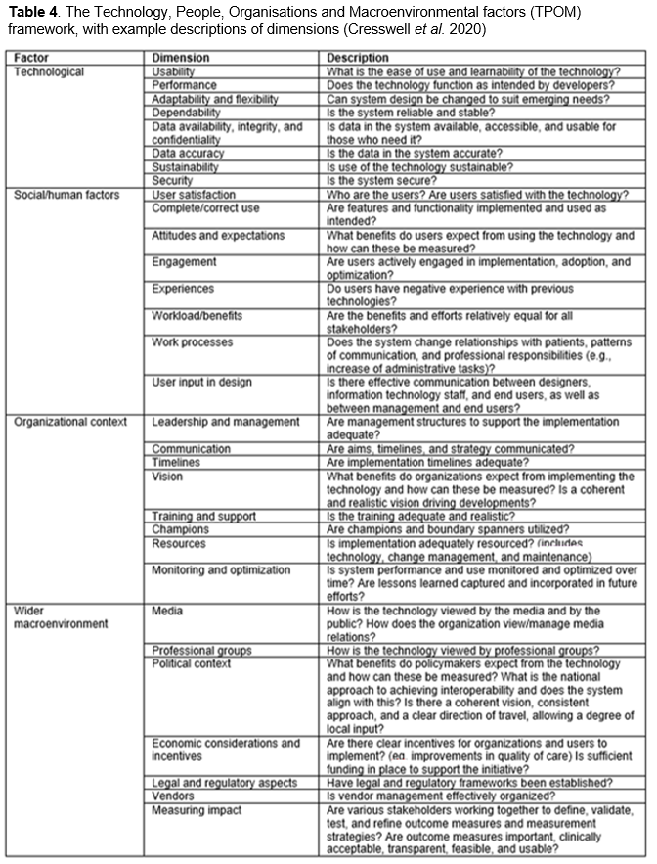
Considering the organisational context and macroenvironments are especially relevant in public sector organisations such as the NHS and local government where decisions for implementation and technological design are not necessarily in the hands of the users themselves. High profile implementations such as WCCIS which receive significant investment are expected to succeed and have an expected level of perseverance.
Reflecting on the Leadership and Management dimension within the organisational context as proposed by Cresswell et al. (2020), since go-live in 2017, PTHB information team has noted concerns with lack of engagement from management. Assessments carried out by PTHB assessing activity recorded within WCCIS evidenced users and teams ‘live’ on WCCIS who were not entering data and, in some cases, had never logged into the system. Lack of management intervention could be attributed as a cause for the decrease in system usage. Within the WCCIS satisfaction survey issued to staff for this study, Individual 9 responded that to no avail, they “spend hours weekly talking to our ICT/ WCCIS and management” sharing problems to try and raise awareness of the subsequent impact.
Over a third of staff reported having confidence in the data recorded on WCCIS, however internal concerns from the PTHB reporting team indicates a potential clinical risk if not all activity is being recorded. Some staff feel that the data they record on WCCIS “isn’t used for anything” and therefore it doesn’t matter if they record on the system or not. Considering the lack of motivation to use WCCIS could provide some insight into what needs to change for the desired behaviour to occur and lead to consistent use of WCCIS, in line with the capability, opportunity, and motivation behaviour (COM-B) System (Michie et al. 2011). Lack of system champions for WCCIS may contribute to problems associated with inconsistent approach to system use, for example within PTHB, the WPAS system has identified champions who engage with the applications team, understand new functionality, and support the use of WPAS in a positive and consistent way.
In terms of the training dimension, concerns have previously been raised within PTHB noting training documentation focuses on how to do something within WCCIS but not the context e.g. in what circumstance and when. Potential concerns around users accessing WCCIS with inadequate training is managed to an extent by the system application teams who only grant users access once core training has been completed. Training also helps to educate users on how to avoid errors and duplicate prevention, however as noted within the survey the system not only allows but makes it easy for errors to be made.
Delays in national roll-out of WCCIS have been linked to serious concerns over the safety of vulnerable patients including the potential for duplicate patient records to be created within the system, potentially providing an incomplete picture of an individual’s needs and risks incorrect decisions being made (Crichton-Smith, 2019). Potential for errors and duplication was also noted within the survey responses.
In terms of the wider macroenvrionment, there has been a transition with recent media presenting WCCIS in a negative light, detailing issues raised in PCC cabinet meetings (Hearn, 2021a and 2021b) and problems highlighted within the 2020 Audit Wales Report (Say, 2020). This is contrary to the positive media coverage seen when the system first went live within Powys; PTHB Chief Executive noted pride in the success of Powys’ joint implementation, commenting how for the first-time integrated teams can access client records across health and social care, providing a single point of access and reducing duplication (Welsh Government, 2017). Social Services Minister also commented that “Powys is truly pioneering this exciting new system representing genuine integration between our health and social care services” (UKAuthority, 2017).
It appears to be common knowledge that WCCIS implementation has not been smooth, with issues having further impact on the likes of the quantitative social services performance measures reported to WG, as shown by Stats Wales (2019) with the caveat that because of WCCIS implementation “data remains imperfect”, and that not all authorities have been able to provide fully completed returns.
In terms of the political context and descriptions provided by Cresswell et al. (2020), comments within the Audit Wales (2020) report recommending WG “take stock” and work with organisations to produce an updated business case setting expectations for further rollouts. This implies that there is too much flexibility in local approaches, and that the program lacks a consistent approach and clear direction of travel. This is supported by PTHB’s 2018 Risk Register for Mental Health and Learning Disabilities where WCCIS is recorded as being a major risk due to lack of infrastructure and roll out support.
The Audit Report also highlights that the different approaches to rollout have made benefit realisation more difficult, and that a benefits reporting framework is still to be developed. For live organisations, the varying degrees and deployment differences have limited opportunities for integrated working and raised other value for money issues (Audit Wales, 2020). Considering the economic dimension, as reported by Audit Wales the system rollout so far has cost more than expected with WG and Digital Health Care Wales (DHCW) so far having spent and committed over £30million, significantly more than the intended £6.7m.
Another important area which also falls within the wider macroenvrionment of the TPOM framework is vendor management. As already highlighted, items set out in the original statement of requirements have not been delivered by the supplier. The Audit Wales (2020) report also highlights previous problems with the CareWorks service desk not operating as required. The National Programme Team have tried to manage problems with the supplier and issued CareWorks with a contractual non-conformance notice. It is believed that the relationship with the supplier is improving since CareWorks was acquired by Advanced in 2019, however this is still an area worth considering in the assessment of WCCIS.
Limitations
Potential limitations to this study include the climate in which it was carried out; following an upgrade to WCCIS at the end of January 2022 there has been a significant drop in system performance, so the current poor performance could have resulted in more negative responses than what may have been received prior to the upgrade. Equally following the publication of the Wales Audit at the end of 2020, on-going concerns discussed within the media and internally may have also contributed to the depletion of users’ faith in the system.
Due to there being over 2000+ active users on WCCIS within PCC and PTHB alone, 41 survey responses may appear to be a low response rate, however some operational staff explicitly stated that they no longer use the system. There was not enough time or sufficient influence to circulate and generate a wider response.
Personal observation and user interaction of the system was not carried out directly for this study which could have highlighted elements of consistent use and potential workaround processes. However, if users altered their behaviour as per the Hawthorne affect, the work-as-observed may more closely align with work-imagined, demonstrating best practice and what should happen, rather than the actual work-as-done (Deutsch, 2017). Statistical data from system usage could have provided evidence in how the system is being used as well as the quality of data being recorded, however explicit permission would have had to have been sought to extract this data and known limitations in the audit report functionality within WCCIS may mean certain information is not possible to obtain.
Conclusion
Assessing fitness for purpose can be difficult as the purpose of the system varies between users and stakeholders, this is especially true for WCCIS where there is the need to meet many different complex requirements and situations. Easton and Waterson (2013) found systems fitting the purposes of strategic and managerial users were problematic for staff delivering care, with frontline staff subsequently resorting to workarounds. Efforts to address needs of frontline staff often are only made and assessed following system implementation. Unfortunately, as identified within the WCCIS FITT evaluation, the poor performance, undefined work process and missing functionality has made it difficult for the system to meet and adapt to the needs of staff. Not only staff but organisations themselves are clearly unhappy with WCCIS, namely due to unreliable performance and lack of functionality. Considering additional elements outside of the FITT Framework using TPOM has also highlighted difficulties with the national rollout, poor vendor management and lack of organisational leadership as contributing factors to problems relating to WCCIS.
As per the processes of design and evaluation (Coiera, E. 2015) the system is not fit for purpose and does not do what it is meant to do. One may question why a system was purchased and implemented when the requirements had not been met. If the relationship and management of the supplier had been handled differently perhaps improvements in the system would have been implemented faster. Holding the supplier to account for example by withholding payment based on the defined Service Level Agreements (SLAs) may provide incentive for the delivery of system uptime, improving performance. DevOps practices have been proven to increase the rate of software deployment, frequency, and product quality, therefore using a DevOps maturity model to assess the supplier could identify areas for improvement (Mishra and Otaiwi, 2020). A mature DevOps approach could reduce the number of poor releases which fail user acceptance testing, as has been seen with WCCIS, but also increase the speed that functionality is added.
Considering information value chain theory when choosing to adopt a HIT can assist in identifying areas where implementation may succeed or fail, identify specific system benefits, and provide a “comparative assessment of competing technologies”. By measuring throughout the value chain, from user interaction with the system through to the outcome and impact on a patient, predictions on system overall utilisation could save investing in a system which may lead to a deterioration in outcomes (Coiera, E. 2015).
Motivation is also a key factor, and for future software design and implementation, it is crucial for organisational management to engage with the teams it is intended for, considering clinical workflow and internal processes. Unless staff themselves are on-board with system adoption and can see clear usage benefits, being forced to use a system will likely result in staff frustration, reluctance, and system boycott. It is equally important to have management support, for example motivating staff using the carrot-and-stick approach, otherwise poor leadership could result in a system which is underutilised and subsequently abandoned.
Using an evidence-based approach for system design and implementation would more likely lead to a predictably acceptable, safe, affordable, and effective system (Wyatt, 2016). Evidence from research and evaluation studies can help to determine and test whether a system is clinically acceptable before implementation. One framework for design analysis of medical devices is Distributed Cognition Theory – Concentric Layers (DiCoT-CL). With the user–device interaction at the centre, Furniss et al. (2015) considers the increase in complexity at different layers of the sociotechnical system. If utilised within health informatics, this theory could help evaluate whether a proposed technology would fit within the required contexts, informing system design.

References
Ammenwerth, E. (2019) “Technology Acceptance Models in Health Informatics: TAM and UTAUT”, in Scott, P., de Keizer, N. and Georgiou, A. (Eds.) Applied Interdisciplinary Theory in Health Informatics pp.64-71. doi: 10.3233/SHTI190111
Ammenwerth, E., Iller, C. and Mahler, C. (2006) “IT-adoption and the interaction of task, technology and individuals: a fit framework and a case study”, BMC Medical Informatics and Decision Making, 6(3). doi:10.1186/1472-6947-6-3
Audit Wales (2020) Welsh Community Care Information System Report of the Auditor General for Wales - October 2020 [online] Available at: https://www.audit.wales/sites/default/files/WCCIS-Eng_10.pdf [Accessed 9 February 2022].
Bangor, A., Kortum, P.T. and Miller, J.T. (2008) ‘An Empirical Evaluation of the System Usability Scale’, International Journal of Human–Computer Interaction, 24(6), pp.574-594. doi: 10.1080/10447310802205776
Betsi Cadwallader University Health Board (2016) Welsh Community Care Information System (WCCIS) Business Justification Case. [online] Available at: http://www.wales.nhs.uk/sitesplus/documents/861/16_20%20Welsh%20Community%20Care%20Info%20System%20BJC.pdf [Accessed 15 February 2022].
Brooke, J. (1996). “SUS: A “quick and dirty” usability scale”, in Jordan, P.W. et al. (Eds) Usability evaluation in industry, pp.189–194. London: Taylor & Francis.
CareWorks Limited (2016) The WCCIS: The Welsh Community Care Information Solution [video]. Available at: https://www.youtube.com/watch?v=xOpDZVHMQnE [Accessed: 16 February 2021].
Chen, Y. and Banerjee, A. (2020) ‘Improving the digital health of the workforce in the COVID-19 context: an opportunity to future-proof medical training’. Future Healthcare Journal, 7(3), pp.189-192. doi: 10.7861/fhj.2020-0162
Coiera, E. (2015) Guide to Health Informatics (3rd Edition). 3rd ed. London: CRC Press.
Cresswell, K., Williams, R., and Sheikh, A. (2020) “Developing and Applying a Formative Evaluation Framework for Health Information Technology Implementations: Qualitative Investigation”. J Med Internet Res, 22(6):e15068. doi: 10.2196/15068
Crichton-Smith, J. (2019) “Roll-out of flagship computer system faces delays amid concerns over the safety of patients”. ITV, 21st February. Available at: https://www.itv.com/news/wales/2019-02-21/roll-out-of-flagship-computer-system-faces-delays-amid-concerns-over-the-safety-of-patients [Accessed 9 February 2022].
Cwm Taf University Health Board (2016) Health Board Report WELSH COMMUNITY CARE INFORMATION SOLUTION (WCCIS). [online] Available at: https://cwmtafmorgannwg.wales/Docs/Board_Papers/LEGACY%202016-2017/02%20NOV%202016/3.6%20WCCIS%20Cover%20paper%20BJC%20UHB%202%20November%202016.pdf [Accessed 15 February 2022].
De Leeuw, J.A., Woltjer, H. and Kool, R.B. (2020) “Identification of Factors Influencing the Adoption of Health Information Technology by Nurses Who Are Digitally Lagging: In-Depth Interview Study”, Journal of Medical Internet Research, 22(8): e15630. doi: 10.2196/15630
Deutsch, E. (2017) “Bridging the Gap between Work-as-Imagined and Work-as-Done.”, Penn Patient Safety Advisory, 14(2), pp.80-83. doi: 10.1177/1071181319631288
Digital Health Care Wales (2020) WCCIS supports COVID-19 information requirements, Available at: https://dhcw.nhs.wales/news/archived-news/wccis-supports-covid-19/ [Accessed 15 February 2022].
Eason, K. and Waterson, P. (2013) “Fitness for purpose when there are many different purposes: Who are electronic patient records for?”. Health Informatics Journal, 20(3), pp.189-198. doi:10.1177/1460458213501096
Furniss, D. et al. (2015) “Exploring medical device design and use through layers of Distributed Cognition: How a glucometer is coupled with its context”, Journal of Biomedical Informatics, 53, pp.330-341.doi: 10.1016/j.jbi.2014.12.006.
Hajesmaeel-Gohari, S. et al. (2022) “The most used questionnaires for evaluating satisfaction, usability, acceptance, and quality outcomes of mobile health”, BMC Medical Informatics and Decision Making, 22(22). doi: 10.1186/s12911‑022‑01764‑2
Hearn, E (2021a) “Rising cost of building materials ‘a concern’ for Powys councillors”, Wales News Online, 28th July. Available at: https://walesnewsonline.com/rising-cost-of-building-materials-a-concern-for-powys-councillors/ [Accessed 14 December 2021].
Hearn, E. (2021b) “Wales' care computer system driving staff away from Powys Council, meeting told”. County Times, 28th July. Available at: https://www.countytimes.co.uk/news/19473566.care-computer-system-driving-staff-away-powys-council [Accessed 9 February 2022].
Lewis, J. R., and Sauro, J. (2018) “Item benchmarks for the system usability scale”, Journal of Usability Studies, 13(3), pp.158–167. doi: 10.5555/3294033.3294037
Michie, S., van Stralen, M.M. and West, R. (2011) ‘The behaviour change wheel: A new method for characterising and designing behaviour change interventions’. Implementation Science, 6(1), pp.1–12. doi: 10.1186/1748-5908-6-42
Mishra, A. and Otaiwi,Z. (2020) “DevOps and software quality: A systematic mapping”. Computer Science Review, 38, doi: 10.1016/j.cosrev.2020.100308
Powys County Council (2021a) MINUTES OF A MEETING OF THE CABINET HELD BY TEAMS ON TUESDAY, 25 MAY 2021 [online] Available at: https://powys.moderngov.co.uk/documents/g6297/Printed%20minutes%2025th-May-2021%2010.30%20Cabinet.pdf?T=1 [Accessed 9 February 2022].
Powys County Council (2021b) MINUTES OF A MEETING OF THE HEALTH AND CARE SCRUTINY COMMITTEE HELD AT TEAMS LIVE ON WEDNESDAY, 26 MAY 2021 [online] Available at: https://powys.moderngov.co.uk/documents/g6637/Printed%20minutes%2026th-May-2021%2010.00%20Health%20and%20Care%20Scrutiny%20Committee.pdf?T=1 [Accessed 9 February 2022].
Powys County Council (2018) MINUTES OF A MEETING OF THE PUBLIC SERVICE BOARD SCRUTINY COMMITTEE HELD AT COUNCIL CHAMBER - COUNTY HALL, LLANDRINDOD WELLS, POWYS ON THURSDAY, 20 SEPTEMBER 2018
[online] Available at: https://powys.moderngov.co.uk/documents/g4359/Printed%20minutes%2020th-Sep-2018%2010.00%20Public%20Service%20Board%20Scrutiny%20Committee.pdf?T=1 [Accessed 9 February 2022].
Powys Teaching Health Board (2018) MENTAL HEALTH AND LEARNING DISABILITIES COMMITTEE RISK REGISTER August 2018 [online] Available at: http://www.powysthb.wales.nhs.uk/sitesplus/documents/1145/mh%26ld_item_2.1_committee%20risk%20register_appendix%201.pdf [Accessed 9 February 2022].
Prgometa, M. et al. (2019) “Fit Between Individuals, Tasks, Technology, and Environment (FITTE) Framework: A Proposed Extension of FITT to Evaluate and Optimise Health Information Technology Use”. Studies in health technology and informatics, 264, pp.744-748. doi: 10.3233/SHTI190322
Scott, P. (2016) “Mixed Methods: A Paradigm for Holistic Evaluation of Health IT”, in E. Ammenwerth and M. Rigby (Eds.) Evidence-Based Health Informatics, pp.102-113. doi:10.3233/978-1-61499-635-4-102
Shillabeer, C. (2019) Response to Public Service Board Scrutiny [online] Available at: https://powys.moderngov.co.uk/documents/s42241/Response%20to%20PSB%20Scrutiny%20-%20WCCIS.pdf [Accessed 16 February 2022].
Tsiknakis, M. and Kouroubali, A. (2009) “Organizational factors affecting successful adoption of innovative eHealth services: A case study employing the FITT framework”, International Journal of Medical Informatics, 78(1), pp.39–52. doi: 10.1016/j.ijmedinf.2008.07.001
UKAuthority (2017) “Powys provides first integration of Welsh health and care info system”, UKAuthority, 21st August. Available at: https://www.ukauthority.com/articles/powys-provides-first-integration-of-welsh-health-and-care-info-system [Accessed 9 February 2022].
Say, M (2020) “Auditor highlights problems with Welsh care information system”, UKAuthority, 16th October. Available at: https://www.ukauthority.com/articles/auditor-highlights-problems-with-welsh-care-information-system/ [Accessed 9 February 2022].
Stats Wales (2019) Quantitative social services performance measures - Adults. [online] Available at: https://statswales.gov.wales/Catalogue/Health-and-Social-Care/Social-Services/Performance-Measures/quantitativesocialservicesperformanceadults-by-measures [Accessed 9 February 2022].
Welsh Government (2017) “Minister praises Powys for pioneering new electronic health and care system” [Press Release]. 17 August. Available at: https://gov.wales/minister-praises-powys-pioneering-new-electronic-health-and-care-system-0 [Accessed 9 February 2022].
Wyatt, J. (2016) “Evidence-based Health Informatics and the Scientific Development of the Field”, in E. Ammenwerth and M. Rigby (Eds.) Evidence-Based Health Informatics, pp.14-24. doi:10.3233/978-1-61499-635-4-14

