KNN and Decision Tree Implementation on Fasion_MNIST
Jiaxin Zhong, 2203394
Abstract
In recent years, many efficient machine learning algorithms has been developed. Decision tree and KNN are regarded to be the most famous algorithms in classification area. Many researches have been conducted to extend these two algorithms. In this essay, conducted experiments on Fasion_MNIST by using decision tree and KNN. Literature of both algorithms are also provided. The basic ideas and principles are illustrated. Furthermore, the results of experiments are shown and analyzed. As a result, discussion and compare are made upon KNN and decision tree.
- Introduction
1. The Purposes
In this paper, two machine learning algorithms, KNN and decision tree, are used to classify the data in Fasion-mnist dataset, and different parameters are adjusted to achieve higher performance. Then, for each algorithm, estimate and compare its different results, and summarize the regularity. Next, compare the results of the KNN with the results of the decision tree. The performance will be demonstrated through confusion matrix, accuracy rate, F1-Score and other standards.
2. KNN and Applications
KNN is a very simple but efficient way to classify data. KNN trains by all training data and classifies new inputs based on k nearest neighbors according to its own features. k in KNN represents the number that indicates how many nearest neighbors should be involved, and then the new data would be labeled in the later majority voting process. A data sample is labeled by majority votes from its k nearest neighbors.
Searching the correct value of k is crucial for better accuracy in KNN. And the process of searching for the right k is called parameter tuning.
What we need is not a model that is too general or too specific. Our goal is to create a robust and accurate model.
Fig.1-1 shows a simple KNN example. In this case, the blue point is an unknown data point need to be classified. When K =4, there are 3 green points in the 4 nearest point around blue point, so blue point would be classified as the class which the green represent.
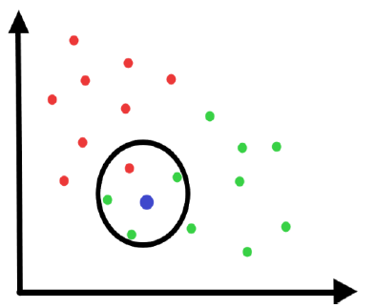
Fig.1-1. A simple KNN[1]
KNN has many advantages, it is simple, comprehensive and scalable. It takes a few times to train a model and make a good prediction afterward. It is suitable for large training datasets. KNN performs well in classification as well as regression. [1]
Among them, in the classification problem, KNN is used to predict the category. Generally, the "voting method" is used to select the category that appears most among the k samples as the category of the test sample.
In regression problems, KNN predicts a value by using the "average method", the average of the real-valued outputs of k samples is used as the output of the test sample.
KNN also has some disadvantages. It takes more time to calculate the distances between each known data point and unknown data point which need to be labeled. When the training dataset is not balance, which means it has a number of samples in one class but a few samples in another, in this case, KNN would not work very well.
KNN can be applied for many areas. Such as medical predictions, financial modeling and data mining. [1]
3. Decision tree and Applications
Decision tree is a supervised machine learning algorithm. It can be trained by labeled training tuples and construct a top-down decision tree model which can classify new data after. It is famous for its intuitive and comprehensive. It contents a root node and some sub-nodes and leaves. Those nodes are connected by branches and search through those nodes to the leaves is the process of classification. Fig. 1-1 shows a simple example of Decision tree.
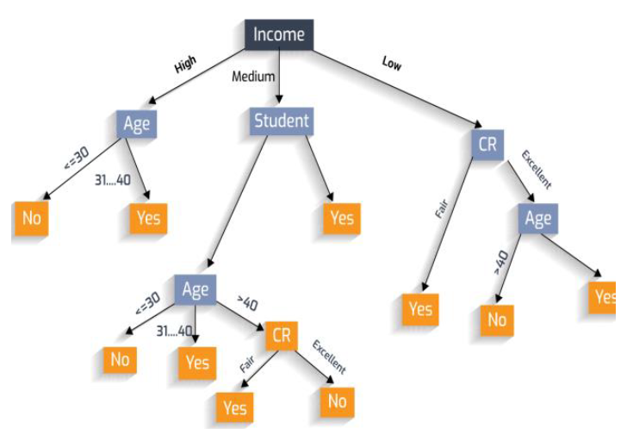
Fig. 1-2. Example on Decision Tree[2]
Attribute selection procedures are applied to choose the feature that best split the original dataset into different partitions during tree building process. There are some algorithms that popular in decision tree construction. ID3(Iterative Dichotomiser), which later expanded as C4.5(a successor of ID3). C4.5 became a standard to which other supervised classification algorithms are often compared. Another algorithm call CART(Classification and Regression Trees) , which defined the generation of binary decision trees. [3]
Advantages & Disadvantages
Decision trees can be easy understanded and explained, able to visualization. It can apply to discreet and continuous data. It responses well and fast to large data samples and has a good outcome.
Although decision tree has many advantages, it also has some disadvantages. Such as easy overfitting, result vary by using difference splitting algorithms. The model become more complex as the size of input dataset increased. [4]
Decision tree has been successfully applied to many fields[2] like medical disease analysis, images recognition, user smartphone classification, data mining and text classification.
4. Fasion-MNIST Dataset
Fasion-MNIST is an MNIST-like dataset that contains 70,000 28*28 images and each image with a label from 10 classes. Those ten labels are: pullover, coat, sandal, shirt, sneaker, bag ankle boot, dress, trouser and t-shirt.
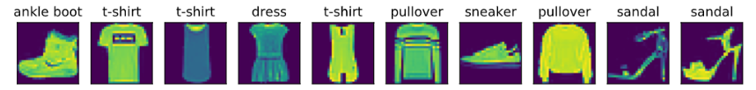
Fig. 1-3. Classes in Fasion-MNIST dataset
In this experiment, we use keras to load Fasion-MNIST and then divided to form a 60,000 training dataset and a 10,000 test set.
5. The Structure of Essay
For the structure of this essay, section I makes a brief introduction. Section II concludes some related work in literature about KNN and Decision tree. Section III explains the basic principles of KNN and Decision tree, the framework sklearn that used in this experiment also introduced in this section. Section IV shows the result of this experiment Section V make a discussion upon the result showed in section IV and make a reasonable analysis. Section VI make a conclusion of this essay. The code of this experiment can be found in the Appendix.
- Related Work in Literature
1. KNN Development
There are many developments and techniques of RNN.
[10] provides a locally adaptive KNN which selects the parameter k that would be used cross-validation examination in the related neighbors and then classify a new input based on those examinations
The algorithm by [11] indicates that the distances should be weighted when classify a new data point. Which can see in sklearn framework.
KNN keep the same number of k for every new data point. [12] provide an adaptive KNN which can search for a suitable value of K for each new data.
[13] presented an improved KNN algorithm by choosing communal and similar nearest neighbors which can calculate the distance between new input and its nearest neighbor data points. [1]
Normally, the setting of k depends on the datasets, causing it hard to select the parameter accordingly with different applications. [14] provided a novel method that dealings the informativeness of objects to be classified. It calculates the importance of data. It needs two inputs K and I in this algorithm, the main class of the majority informative training data will be the label of the new input. [1]
2. Decision Tree Development
In the past 30 years, lots of decision tree variant has been proposed by several pioneers. [4] Lim et al. [5], have compared 22 decision tree algorithms based on performance standards like accuracy and running cost.
Loh [6] made a remarkable survey on classification and regression tree models, those model have been applied in the past 5 decades. In his paper, he surveyed the most of the algorithms that have excellent performances and working well for a long time. His work also provided the development and key concepts that supporting those up-to-date algorithms.
Hu et al. [7] demonstrated the first applied algorithm to improve DT for binary classification. The method is a cooperate design of analysis limitations concerning a specific bit vector collection and data structures that narrow the search area. It shows a better form of construction and lower the running cost.[8]
Hussain et al. [9] proposed a recent method, call a Pixel Label Decision Tree(PLDT), and search if it can reach a improved dedicated femur segmentation effectiveness in DXA imaging. This method can be applied to discover secret patterns found in DXA images compare to photographic images. [8]
- Methodology
1. Basic Ideas of KNN and Related sklearn library
KNN algorithm classify new data by observe the K nearest neighbors and take the majority of votes by those neighbors as the label of new data.
To finds out the K nearest neighbors, we will calculate Euclidean distance.
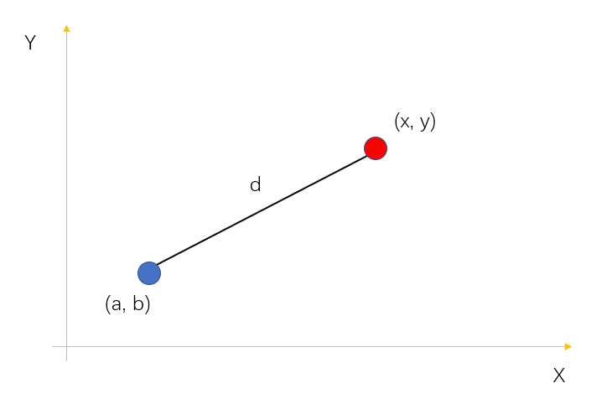
Fig.3-1. Two points in the plane
As in Euclidean distance, the distance between two points in the plane with coordinates (x, y) and (a, b) as shown in the Fig.3-1 is given by formular 1:
$$dⅈst\left(d\right)=\sqrt{{\left(x-a\right)}^{2}+{\left(y-b\right)}^{2}}$$ | (1)
After calculated the distances between the new data and each known data, select the first k nearest known point and the majority votes would be the class of the unknown data.
In this experiment, we used a module name neighbors in sklearn framework to conduct KNN algorithm on Fasion-Mnist dataset.
sklearn.neighbors.KNeighborsClassifier[15] can help implementing the k-nearest neighbors vote. You only have to set up some parameter that affect the performance. Here we try to tune two main parameters. First, “n_neighbors”, default=5, number of neighbors to use by default for kneighbors queries. Second, “weights”, can choose “uniform”, “distance”, callable or None. Default=”uniform”. [15]
By “uniform”, All k nearest neighbors has the same weight, which would be easy affected by noise and outlier. Therefore, there is another option is “distance”. In this option, closer neighbors have a greater weight than those neighbors which are more far away from the query data point.
2. Basic Ideas of Decision Tree and Related sklearn library
A decision tree is a top-down tree structure in which each internal node (non-leaf node) represents a test on an attribute, each branch represents the result of the test, and each leaf node (or terminal node) contents a class label. Given a new input X, its attribute values are tested against the decision tree. Start from the root node and form a path according to its own value until a meet a leaf node, which holds a class label for this new data. [3]
ID3, C4.5, and CART use a greedy method in which decision trees are built in a top-down recursive manner.
In each round of attribute selection, we want to split data partition D into smaller partitions and reach a “best” interest.
Here we will introduce the main concepts of those algorithms. [3]
There are several attribute selection criteria, gain ratio and gini are the most common used measures.
The criteria used by ID3 is information gain. We need to calculate the information of a given partition D of tuples which given by:
$$Info\left(D\right)= -\sum_{i=1}^{m}{Pi\log_{2}\left(P_{ⅈ}\right)}$$ | (2)
Where p_{i} is the nonzero probability that an arbitrary tuple in D belongs to class C_{i.} Info(D) is also called the entropy of D.
After the partitioning, we need to know how much more information we need to arrive at an exact classification which can be calculate by:
$$Info_{A}\left(D\right)=\sum_{j=1}^{ν}{\frac{\left|Dj\right|}{\left|D\right|}}×Info(Dj)$$ | (3)
Information gain is defined as the difference between the original information requirement and the new request (i.e., gained after splitting on A). Which is,
$$Gain\left(A\right)=Info\left(D\right)-Info_{A}\left(D\right)$$ | (4)
In short, Gain(A) indicates how much would be gained by split on A.
C4.5 algorithm uses gain ratio, which is an extension to information gain. Firstly we need to calculate a value knowns as “split information” by:
$$SplitIn{fo}_{A}\left(D\right)=-\sum_{j=1}^{ν}{\frac{\left|Dj\right|}{\left|D\right|}}×log_{2}\left(\frac{\left|Dj\right|}{\left|D\right|}\right)$$ | (5)
This value denotes the future information produced by splitting the training dataset, D, into v partitions, corresponding to the v results of a test on attribute A. The gain ratio can be calculated by :
$$GainRatio\left(A\right)=\frac{Gain\left(A\right)}{SplitIn{fo}_{A}\left(D\right)}$$ | (6)
The attribute with the highest gain ratio would be choose as next splitting attribute.
CART algorithm uses Gini index instead of gain information or gain ratio. The gini index calculate the impurity of D, a subset data or set of training dataset, as:
$$Gini\left(D\right)=1-\sum_{i=1}^{m}{p_{i}^{2}}$$ | (7)
Calculate the Gini of a partition A and then the reduction in impurity is defined by:
$$ΔGⅈnⅈ\left(A\right)=Gini\left(D\right)-Gⅈni_{A}\left(D\right)$$ | (8)
The attribute that maximizes the reduction in impurity is selected as the splitting attribute.
Decision tree can be overfitting and overgrow become a large tree due to noise or outliers. Tree pruning was introduced to solve this problem. Pruned trees usually faster and better at correctly classifying independent test data than unpruned trees.
When actually constructing a decision tree, pruning is usually performed to deal with the overfitting problem caused by noise and outliers in the data. There are two kinds of pruning: pre-pruning and post-pruning.
In this experiment, we use a module called “DecisionTreeClassifier” in sklearn framework. DecisionTreeClassifier provide a simple to implement a decision tree algorithm. User can use this module to construct a decision tree model and use it to make a prediction. This module has two parameters we need to tune in this experiment. First one is “criterion”, we can choose “gini”, “entropy”, “log_loss”, default=”gini”. Second one is “max_depth”, which we use to prune to decision tree.
- Results
1. The Result of KNN
The result of KNN is shown below, here we use brute force loop to find the best parameters for KNN in this experiment. There are two loops, first loop selects different weights and for each weight method run another loop which search k from 1 to 30.
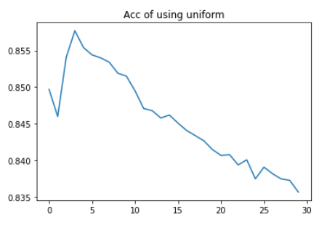
Fig.4-1 Accuracy of uniform weight
Fig.4.1, the horizontal axis represents the number of K and the vertical axis represents the accuracy, shows the accuracy for uniform weight which k from 1 to 30. The best acc is 0.8577, when K = 4. The lowest acc is 0.8357, when K = 30.
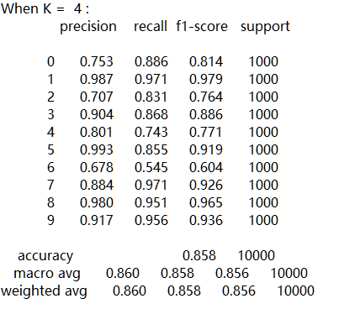
Fig.4-2 Performance matric when k=4
Fig.4.2 shows the performance matric of the best performance K with uniform weight. Precision, recall, f1-score can be seen in this table.
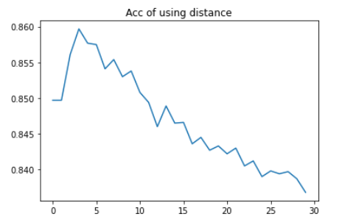
Fig.4-3 Accuracy of distance weight
Fig.4.3, where the horizontal axis represents the number of K and the vertical axis represents the accuracy, shows the accuracy for distance weight which k from 1 to 30.. The best acc is 0.8597, when K = 4. The lowest acc is 0.8357, when K = 30.
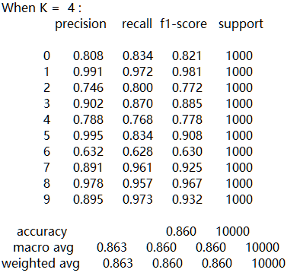
Fig.4-4 Performance matric when k=4
Fig.4.4 shows the performance matric of the best performance K with distance weight. Precision, recall, f1-score can be seen in this table.
2. The Result of Decision Tree
The result of decision tree is shown below, here we use brute force loop and GridSearch(a module in sklearn) to find the best parameters for decision tree in this experiment. There are two loops, first loop selects different criterion and for each criterion run another loop which search max_depth from 1 to 30.
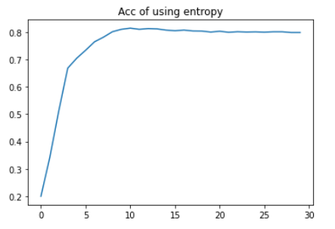
Fig.4-5 Accuracy of using entropy
Fig.4.5, where the horizontal axis represents the maximum depth and the vertical axis represents the accuracy, shows the accuracy for entropy criterion with a tree maximum depth from 1 to 30. The best accuracy is 0.8149 when max_Depth = 11.
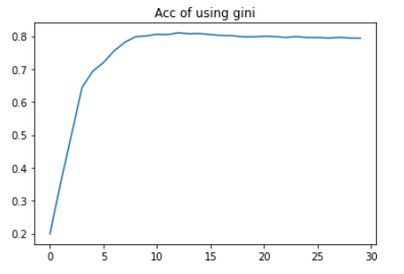
Fig.4-6 Accuracy of using gini
Fig.4.6, where the horizontal axis represents the maximum depth and the vertical axis represents the accuracy, shows the accuracy for gini criterion with a tree maximum depth from 1 to 30. The best accuracy is 0.8105 when max_Depth = 13.
In decision tree, also used a GridSearch module to find the best parameters for decision tree model construction.
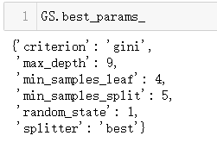
Fig.4-7 Best parameters search by GridSearch
By these parameters, the best accuracy is 0.804.
- Discussion
- KNN Result Analysis
Applying the KNN algorithm to the Fasion_MNIST dataset, after tuning the parameters using brute force algorithm, the best accuracy rate is 0.86. It can be seen that the accuracy rate of the KNN algorithm in image classification is comparatively low, and the performance is average. It can be seen from the performance matric that among all classes, the second and sixth classes are the most difficult to be classify, which is also the reason for the low accuracy rate.
When K increased the accuracy increased before K reach 4 and then continued to drop after. By this, we can guess that no need to try bigger number for K. Although there are papers suggest that the best K usually estimate around $\sqrt{n}$. Which n is the size of dataset. In this case, it would be around 240, which is much greater than the best k we found. Large value of k smooth over things, but can left only few samples in a category and it will always be out voted by other categories. And the default number of K in sklearn framework is 5, which very close to the best k in this experiment which is 4.
- Decision Tree Result Analysis
As we can see in section IV, accuracy increased as maximum depth increased. It reached the highest point when max_depth equals 11 in entropy criterion and equals 13 in gini criterion. After that, continued to increase maximum depth made almost no improvement.
The best accuracy is 0.815 when using entropy criterion with a 11 max_depth.
Used GridSearch to find better parameters matric which only reach a 0.804 accuracy, it is lower than the accuracy achieved in BF parameter searching. On the other hand, GridSearch took hours for searching each possible parameter in order to achieve a better performance. So it is not worth in this experiment.
- Comparison
The best accuracy of KNN is 0.86 which a little higher than decision tree’s best accuracy 0.815. Both algorithms using BF loop to search for best performance. KNN ran fast and cost less system resources. In fact, both KNN and decision tree did not work well in Fasion_MNIST. KNN can perform better due to its principle to classify new data which looking at data simplicity. Decision tree split dataset into sub-dataset by calculate each attribute’s impurity or gain ratio determent by the chosen criterion. In Fasion_MNIST, the attributes of each image are not distinguished that might be the reason that decision tree did not achieve a high accuracy. As for run cost, KNN is easy trained but need more time to classify new data. By contrary, decision tree is more complex to construct and can quickly classify new data. KNN and decision tree can set relatively few parameters, and the performance of the algorithm is prone to bottlenecks. The advantage is that the running speed of the two algorithms is relatively fast, the modeling is simple using the public API, and the results are obvious.
- Exploration
There are several ways that might make KNN and decision tree, such as normalize the training data and test data, use combination and variant KNN, use random forest to improve the performance of decision tree. According to other experiment in other machine learning like CNN, RNN, also achieve a much better accuracy in image classification and recognition.
- Conclusion
In this paper, KNN and decision tree are used to make an experiment on Fasion_MNIST dataset. It is difficult to choose the right K for KNN algorithm so a BF loop was introduced to search the best k. As for decision tree, both criterions were searched for best performance. KNN is popular due to its simplicity and comprehensibility. It achieved a higher accuracy than decision tree in Fasion_MNIST, a lot of other methods to find the best K can be explored further in this experiment. Decision Tree is an analytical decision making measures in risk management process and decide its probability by constructing a decision tree to indicate the next step. It is a diagrammatic method of an intuitive use of probability analysis. In machine learning, a decision tree is a model that can predict new input data into a mapping class based on data features.
In future, I should try more variants or combinations of both KNN and decision tree, and conduct another more specific experiment against Fasion_MNIST dataset to achieve a better performance.
References
[1] K. Taunk, S. De, S. Verma and A. Swetapadma, "A Brief Review of Nearest Neighbor Algorithm for Learning and Classification," 2019 International Conference on Intelligent Computing and Control Systems (ICCS), 2019, pp. 1255-1260, doi: 10.1109/ICCS45141.2019.9065747.
[2] Charbuty, Bahzad, and Adnan Abdulazeez. "Classification based on decision tree algorithm for machine learning." Journal of Applied Science and Technology Trends 2.01 (2021): 20-28.
[3] J. Han, M. Kamber, and J. Pei, Data Mining: Concepts and Techniques. Morgan Kaufmann, 3rd ed. , 2011
[4] Jena, Monalisa, and Satchidananda Dehuri. "DecisionTree for Classiﬁcation and Regression: A State-of-the Art Review." Informatica 44.4 (2020).
[5] Tjen-Sien Lim, Wei-Yin Loh, and Yu-Shan Shih (2000) A comparison of prediction accuracy, complexity, and training time of thirty-three old and new
classification algorithms, Machine learning, 40(3),
pp. 203–228.
[6] Wei-Yin Loh (2014) Fifty years of classification and regression trees, International Statistical Review, 82(3), pp. 329–348. https://doi.org/
10.1111/insr.12016
[7] X. Hu, C. Rudin, and M. Seltzer, “Optimal sparse decision trees,” in Advances in Neural Information Processing Systems, 2019, pp. 7267–7275.
[8] Charbuty, Bahzad, and Adnan Abdulazeez. "Classification based on decision tree algorithm for machine learning." Journal of Applied Science and Technology Trends 2.01 (2021): 20-28.
[9] D. Hussain, M. A. Al-Antari, M. A. Al-Masni, S.-M. Han, and T.-S. Kim, “Femur segmentation in DXA imaging using a machine learning decision tree,” Journal of X-ray Science and Technology, vol. 26, no. 5, pp. 727–746, 2018.
[10] D. Wett schereck and D. Thomas G., “ Locally adaptive nearest neighbour algorithms,” Adv. Neural Inf. Process. Syst ., pg. 184–186, 1994.
[11] Han EH.., Karypis G., Kumar V. (2001) “Text Categorization Using Weight Adjusted k-Nearest Neighbour Classification”. In: Cheung D., Williams G.J., Li Q. (eds) Advances in Knowledge Discovery and Data Mining. PAKDD 2001. Lecture Notes in Computer Science, vol 2035. Springer, Berlin, Heidelberg.
[12] Shiliang Sun ; Rongqing Huang,” An adaptive k-nearest neighbour algorithm”, in 2010 Seventh International Conference on Fuzzy Systems and Knowledge Discovery
[13] Wei Zheng,HaiDong Wang,Lin Ma,RuoYi Wang,”An Improved k-Nearest Neighbour Classification Algorithm
Using Shared Nearest Neighbour Similarity” ,Metallurgical & Mining Industry . (2015), Issue 10, pg. 133-137. 5p.
[14] Song Yang, Jian Huang, Ding Zhou, Hongyuan Zha, and C.Lee Giles, “Iknn: Informative k-nearest neighbour pattern classification,” in Knowledge Discovery in Databases, (2007), pg. 248– 264.
[15] “sklearn.neighbors.KNeighborsClassifier”, [Online]. Available: https://scikit-learn.org/stable/modules/generated/sklearn.neighbors.KNeighborsClassifier.html#sklearn.neighbors.KNeighborsClassifier
Appendix


