

Name: Sadik Husain

Student Number: 2433540

Module Code: ACCA4023
Course: CertHE Computing Skills for Workplace

Module: Introduction to Web and Database Concepts

Date: Date of Submission 25/03/2026

________________________________________

Table of Contents

1. Introduction ………………………………………….

2. Requirements…………………………………………

3. Implementation ………………………………………

4.Testing…………………………………………………….

4. Validation …………………………………………….

5. Evaluation …………………………………………….

6. Conclusion…………………………………………….

7. References ……………………………………………

________________________________________



1.Introduction

As websites have become more ubiquitous with the expansion of the internet in recent years, they have become one of the most important mediums for communication, trade, and information exchange. To be both aesthetically pleasing and functional, websites need to follow modern standards of websites allowing them to be accessible, compatible, and usable between multiple browsers, operating systems, and assistive technologies.

This was done with my EcoTravel Adventures website project. I built my website with a purpose in mind. To teach users about eco-friendly ways to travel or take part in sustainable tourism. My website follows modern web standards by being built with HTML5 and CSS3. It is also responsive, accessible, and search engine optimized (SEO).

I believe this project helps me follow best practices when building websites. It allowed me to focus on not only semantic code and validation but also usability and accessibility. By building my website with web standards in mind, I can guarantee that users of all technical backgrounds and devices will have a good experience on my website. I also can ensure that my website follows modern trends in web development. Lastly, this project allowed me to help spread awareness about eco-friendly tourism.

________________________________________

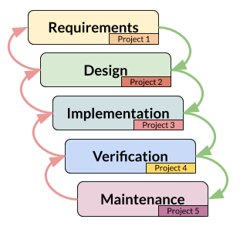

2. Requirements

Goals of the website were established as such:

Aesthetic Integrity: Clean layout with attractive colors that didn’t clash and fit the theme of sustainability. Primary colors used were greens, blues and neutrals to match this theme.

Intuitive: Allow users to easily find what they are looking for with as little confusion as possible. Navigation bar was consistent on all pages.

Responsive: Pages should work correctly on all screen sizes. Pages were developed on desktop, tablet and mobile sizes.

Accessible: Allow anyone to use the website, including those with visual and motor disabilities. Semantic HTML was used, as well as alt descriptions for images and high contrast colors.

Project Purpose: Educate visitors on eco-friendly traveling and sustainability when traveling.

Website Audience:

Eco-conscious travelers

Tourism and sustainability students and professionals

Public

Website Pages:

Home Page - index.html: Welcome users to EcoTravel Adventures and emphasize its purpose.

Destinations Page - destinations.html: Display sustainable destinations with images and description.

Tips Page - tips.html: Give users tips on how to travel eco-friendly.

Languages and Frameworks used:

Site was hand-coded in HTML5 and CSS3. CSS Grid was used to allow for a responsive website that rearranges based on screen size.

Purpose

To inform users about eco-friendly travel and sustainable tourism.

Audience 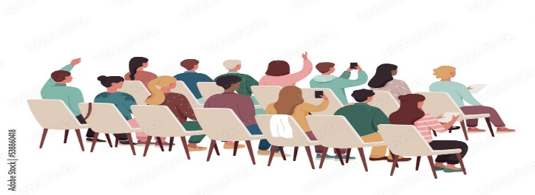

• Travelers who are environmentally conscious

• Tourism and sustainability students and professionals

• The public

Website Pages 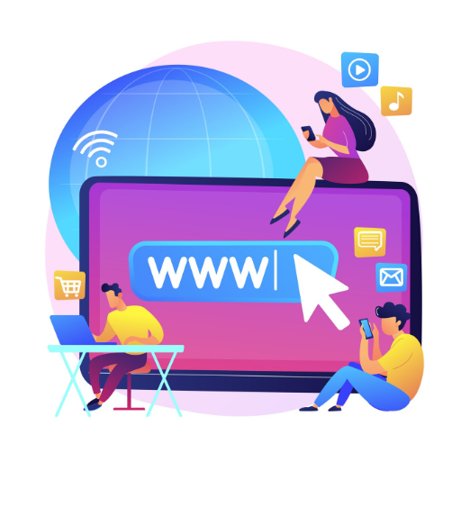

• Home Page(index.html)- This page will introduce EcoTravel Adventures.

• Destinations Page(destinations.html)- This page will display different travel destinations that follow sustainable practices. Images and descriptions will be provided.

• Tips Page(tips.html)- This page will provide helpful tips on how to travel in an eco-friendly manner.

Development Tools and Languages

HTML5 and CSS3 were used to hand code this website. CSS Grid was also implemented to help create a responsive layout that adapts to different screen sizes.

________________________________________



3. Implementation

Semantic HTML was used to create the site. This allows it to be easier to read, more accessible and rank better on search engines. The code was organised and indented to make it easy to follow. Links on every page took you to each page using the navigation bar.

CSS Styling

I added css to the site to make it look better. This included:

Layout, adding spacing etc. Colours Font Hover Effects Responsiveness

Grid was used to format the pages to look great on all screen sizes. Media queries were used to create responsiveness.

Other Information

Navigation bar available on all pages Alt descriptions were used on images Semantic HTML was used Minimalist Design

Usability

Interactions with the website were done during creation to check it worked. Clicking every link on every page made sure all pages linked correctly.

4.Testing 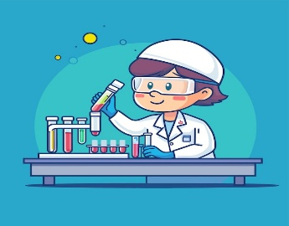

Testing websites is an important part of web development and deployment process. For this project several tests were performed to ensure functionality and usability.

Link functionality testing was completed to ensure that all page’s hyperlink correctly without errors. Links were manually checked between Home, Destinations, Tips and Contact pages.

Cross-browser compatibility was tested by opening the site in Google Chrome, Microsoft Edge, and Mozilla Firefox. The site was able to open correctly in all browsers with very little variation in styling which is not uncommon. Responsiveness testing was performed by resizing the browser window and previewing on different screens. Due to utilizing CSS Grid for layouts as well as flexible layouts the site is able to responsively scale between mobile, tablet and desktop displays.

User Experience testing was conducted with peers reviewing the site and providing feedback. Website reviewers stated the site was easy to use, easy to read and provided enough information. This validated that the website was easy to use as intended.

Features: 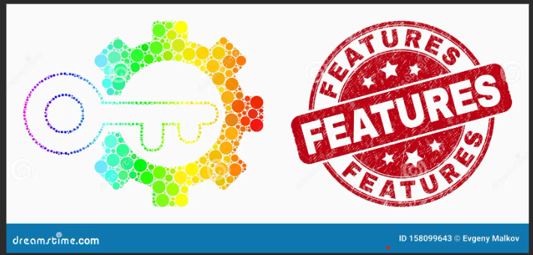

• The layout of this website is responsive. I accomplished this by using CSS Grid and media queries.

• The navigation bar is consistent on all pages.

• I stuck to a colour scheme that used natural tones and colours. (greens and blues and neutral colours)

• I used semantic HTML elements.

• I included alt descriptions for every image.

Screenshots: Figure.1

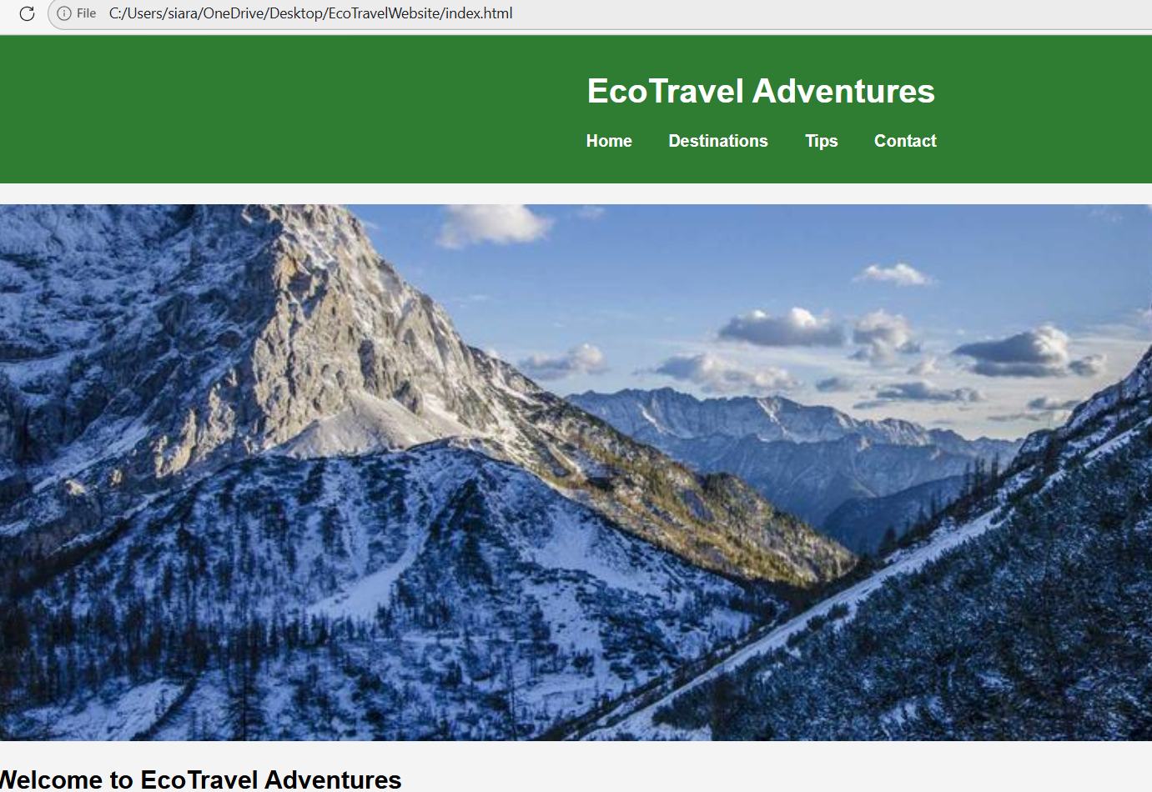

figure 2: Destinations Page(destinations.html)

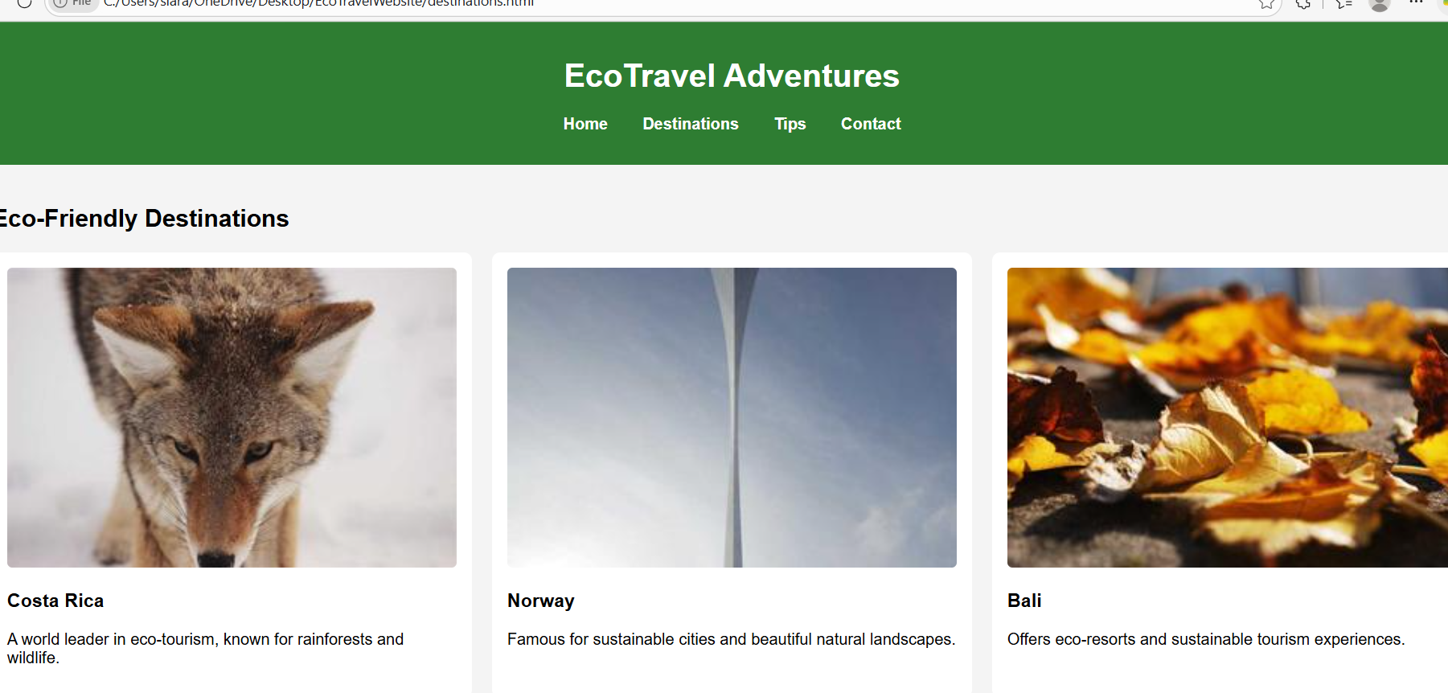

Figure 3: Tips Page(tips.html)

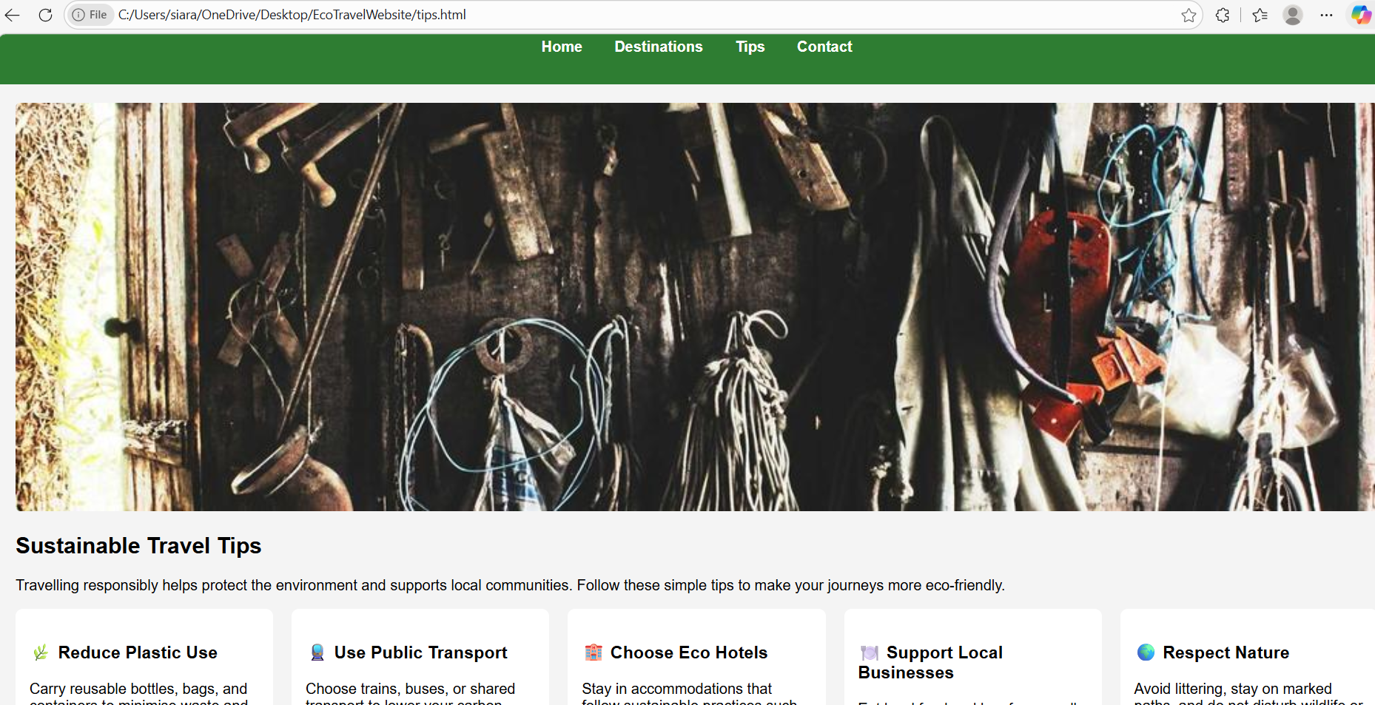

Figure 4: Website Displayed on Mobile Device

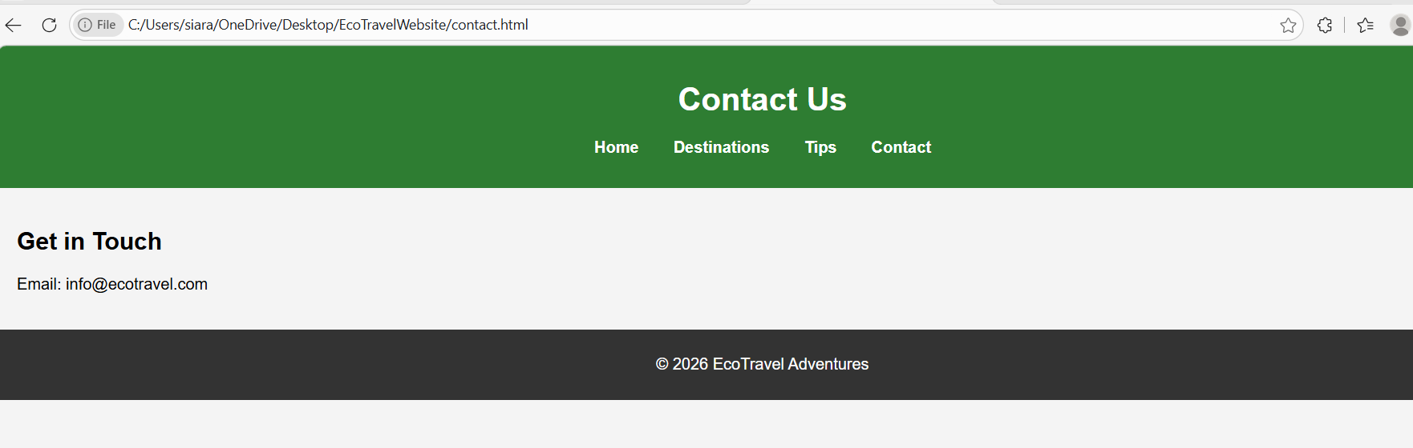

________________________________________

5. Validation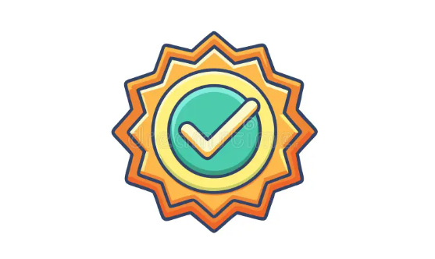

Validation refers to the process of checking web page code against standards. Validation also helps find potential errors and reduces the number of errors within code. HTML and CSS validators from W3C were used to validate this website.

Few errors were found during validation process. These errors included missing meta tag and there were some browser compatibility warnings.

Errors were fixed which allowed the website to have higher quality code. Valid code allows the web pages to load faster and be more compatible with all browsers and devices.

HTML Validation

Paste URL link of your homepage index.html into the W3C HTML Validator

✍🏽 W3C HTML Validator The W3C Markup Validation Service

Successful! There may be minor warnings. Review them for potential improvement.

Website File validated: index.html

Result: Passed

Corrections :

I added meta description for index.html page. this will help with SEO as well.

________________________________________

CSS Validation :

Paste a URL link of your stylesheet or link to your stylesheet inside your html file and click “check”. W3C CSS Validator

✍🏽 W3C CSS Validator

Successful! There may be minor warnings. Review them for potential improvement.

Website File validated: style.css

Result: Passed with 1 warning

Corrections

• I left the vendor prefixes because they help with cross browser support.

6. Limitations and Possible Future Improvements 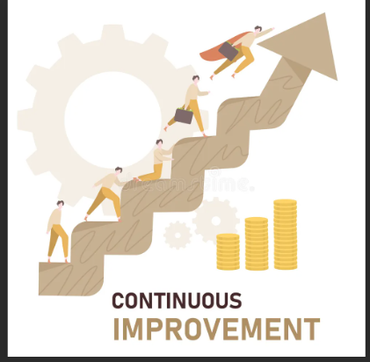

Although the project goals were achieved, there are some aspects of the project that can be seen as limitations and can be improved in future updates. The website is basic and doesn’t include any advanced functionalities like an interactive map, booking system, user accounts, etc.

The project includes some accessibility features but can be improved by becoming fully WCAG 2.1 compliant by supporting keyboard navigation and adding screen reader support.

The design can be improved by including animations and other interactive elements using JavaScript. It might also be beneficial to use a content management system to make it easier to scale.

________________________________________

7. Evaluation 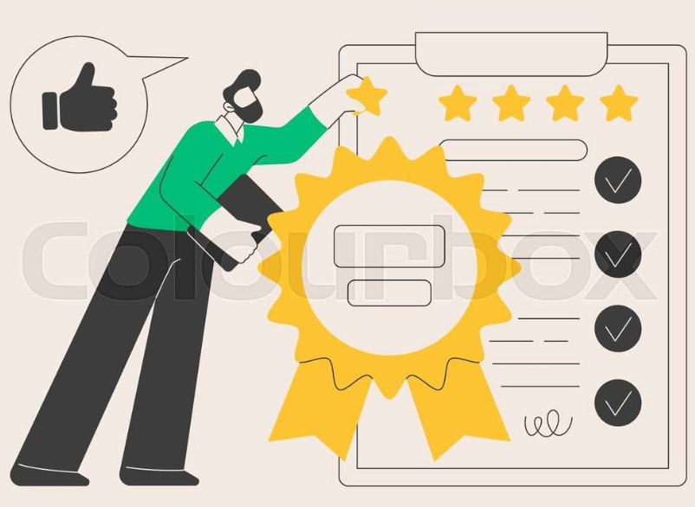

Usability, accessibility, SEO content is covered. When reviewing a website, you should also check if everything on the page is functioning properly and accomplishing its intended purpose. I believe EcoTravel has an excellent website as it allows the information to be read clearly and designed attractively. Website is easy to understand and navigate from page to page. The design of this website uses headings, pictures, and breaks up information to make content easy to read.

Providing alt descriptions for images and using semantic HTML improves accessibility of the website. A couple areas of improvement would be to add keyboard navigation and ARIA labels.

Including meta descriptions and structured content can help with SEO of a website. I would recommend trying to include more keywords and optimizing images.

Great understanding of website building and how it should be done. There is always room for improvement though such as interactions and more advanced responsiveness.

Usability

Website usability can be defined as the ease with which people can use the website. Research done by Alshamrani and Bahaddad (2022) proves that usability affects user experience and satisfaction on websites. Study focused on responsive web design and found that when websites have a clear navigation and consistent layout, users are more likely to stay on the website.

EcoTravel website was designed with usability in mind.

• The navigation menu is intuitive and easy to understand.

• Layout is consistent across all pages.

•Typography was chosen to be easy to read. Content was well structured.

Accessibility

Website accessibility can be defined as making sure that your website is usable by all people despite disabilities they may have. Study done by Al-Khalifa et al. (2023) showed that by following WCAG 2.1 guidelines, you can not only make your website accessible to all but improve the user experience for everyone.

Here are ways in which I improved the accessibility of EcoTravel website.

• Semantic HTML elements were used.

• Alt descriptions were provided for images.

• High contrast colour combinations were used.

• Easy to read typography was used and content was easy to navigate.

Search Engine Optimisation (SEO)

Website SEO can be defined as the optimisation of your website content to rank higher on search engine results. Zhang and Wang (2024) did a study that concluded using semantic structure as well as metadata can improve the SEO of your website.

Some techniques used on EcoTravel website to help with SEO:

• Page titles give the user an idea of what they’ll see when they land on the page.

• A description of each page is provided in meta description.

• Semantic HTML is used.

• Content is structured with headings helping to create a hierarchy.

________________________________________

8.Conclusion: 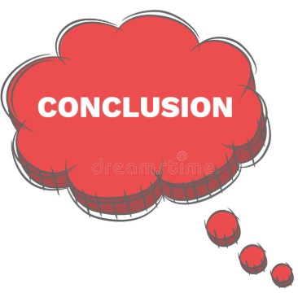

The EcoTravel Adventures site was coded entirely in HTML5 and CSS3 with proper demonstration of web design concepts. The goal of building a functional website that displays mobile responsiveness and engaging content related to eco-friendly travel was accomplished.

Utilizing navigation menus, layouts, and styling resulted in a positive user experience. The application of accessibility and search engine optimization were added bonuses.

This assignment demonstrates knowledge of how to design a website to certain standards, knowledge of how to make websites usable, and how to implement these into a website.

9. References: 

Alshamrani, A. and Bahaddad, A., 2022. Evaluating the Impact of Responsive Web Design on User Experience and Usability. IEEE Access , 10 , pp.125432–125445.

Al-Khalifa, H., AlQahtani, M. and Alharthi, S., 2023. Assessing Web Accessibility Compliance: A Study of WCAG 2.1 Implementation. IEEE Access , 11 , pp.78560–78572.

Zhang, Y. and Wang, L., 2024. Optimizing Web Content for Search Engines Using Semantic and Structural Analysis. IEEE Transactions on Computational Social Systems , 11 (2), pp.345–357.

