Changemakers: Building your Personal Brand for Sustainable Employment (BMHP5015_BIRM)

Name: Kareemot Adekilekun Tijani Tijani
Student ID: 2320438

Title - Online Portfolio of Set Exercises
Component 1
Lecturer Name: Danni Dunne
SUBMMITED DATE:18th November 2025

Table of Contents
Cover Page ---------------------------------------------------------------------------------------1
Table of Contents --------------------------------------------------------------------------------2
Task 1: Personal Brand--------------------------------------------------------------------------3
Task 2: Network Map and Rationale -----------------------------------------------------4 - 5
Task 3: Blog ----------------------------------------------------------------------------------------6
Task 4: NHS Equality, Diversity and Inclusion Quiz ---------------------------------------7
Task 5: A Letter to Yourself ---------------------------------------------------------------------- 8
Task 6: GANTT Chart (200 words equivalent) --------------------------------------- 9 - 10
Task 7: Making Changes Report --------------------------------------------------------------10
Task 8- Self-Reflection ---------------------------------------------------------------------------11
References ------------------------------------------------------------------------------------------12

Task 1: Personal Brand
Introduction
Personal branding is how I present my professional values, skills, and identity to employers and colleagues. In the housing directorate, especially within youth homelessness services, a strong brand reflects accountability, empathy, and commitment to social change.
My personal brand centres on being a compassionate, proactive, and resilient professional who advocates for vulnerable young people. I bring strong communication skills, organisational ability, and a non-judgemental attitude, shaped by voluntary experience in youth homelessness projects. These traits align with what employer’s value in housing roles trustworthiness, emotional intelligence, and safeguarding awareness (Shepherd, 2005).
To improve, I aim to strengthen my knowledge of housing law and supported accommodation frameworks. I will complete relevant CPD training, engage with sector-specific webinars, and develop my professional presence through LinkedIn. “Peters (1997) argues that individuals should manage their careers like a brand continually evolving and marketed with clarity and authenticity.” These efforts will reinforce my credibility and readiness for leadership in the housing sector. Enhancing my personal brand will allow me to better represent the values of the housing directorate, communicate my professional identity clearly, and secure a future leadership role supporting young people facing homelessness.

Task 2: Network Map and Rationale
Part 1: My Network Map
My Hybrid Network Map (Circular Layout)
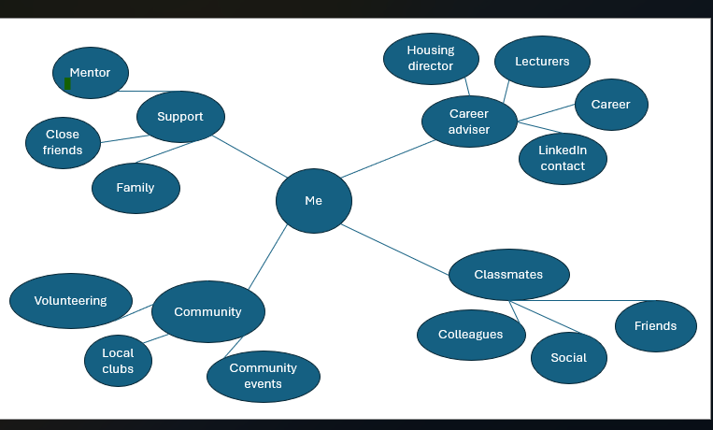
Figure 1: My Hybrid Network Map
This diagram illustrates my hybrid network, with myself at the centre and four key areas radiating out: career, social, support, and community. Each area shows examples of people and groups I am connected to. The map highlights how bonding ties (family, close friends) combine with bridging and linking connections (lecturers, volunteering, LinkedIn) to support both personal and professional development.
Part 2: Rationale
At present, I would describe my network as a hybrid network, combining aspects of both closed and open structures. I chose this model because it most accurately reflects how my personal and professional connections are currently balanced. A closed network of family and close friends provides strong bonding social capital, offering emotional support and stability (Putnam, 2000). While this is valuable, it would be too limiting if it was my only network type. On the other hand, an entirely open network could expose me to diverse contacts but might lack the trust and reliability that comes from strong ties. A selective network would not fit either, as I am not overly restrictive in choosing contacts and value a variety of interactions.
The hybrid network best represents my situation because it blends bonding support with bridging connections. My lecturers, classmates, and volunteering contacts form bridging ties that expose me to new perspectives (Burt, 2000). However, I recognise that I lack sufficient linking capital, meaning relationships with those in positions of authority such as housing managers or professional leaders. Strengthening these links will help me access career opportunities, mentorship, and specialist knowledge. I plan to expand this area through LinkedIn engagement, joining the Chartered Institute of Housing, and attending career events.

Analysis
The network map demonstrates that my connections extend across four areas: career, social, support, and community. My bonding capital is strongest within the support domain, where family and close friends provide trust and resilience. The career area reflects bridging capital through lecturers, advisers, and LinkedIn contacts, which broaden my opportunities. Community links, such as volunteering and local clubs, add further diversity but are less developed. While the map shows a balanced hybrid network, it also highlights a gap in linking capital, as I currently have limited connections with senior professionals or decision-makers in housing and social care.

Task 3: Blog
Blog Title: Mental Health Matters – Support for Young Adults in Supported Housing
Audience: Young Adults in Supported Housing (UK)
Mental Health Matters – Support for Young Adults in Supported Housing
Living in supported housing can be a fresh start a step towards independence. But it can also feel overwhelming, especially when you're dealing with mental health challenges. In the UK today, mental health is one of the biggest issues affecting young adults, particularly those in supported housing who may have experienced trauma, care placements, or homelessness.
According to Mind, 1 in 4 people experience a mental health problem each year. Anxiety, depression, and PTSD are especially common among young people living in supported accommodation. While support is available, it isn’t always easy to ask for help or to know where to find it.
The good news? There are services tailored for people like you. Many supported housing schemes now work closely with local NHS mental health teams, charities like Young Minds, and housing support workers who can connect you to counselling, GP services, and crisis support.
It’s also worth knowing that under the Care Act 2014, local authorities have a duty to support your wellbeing. That includes mental health support. If you're struggling, ask your keyworker or housing officer to help you access a mental health assessment you have the right to one.
Most importantly, you’re not alone. Talk to someone. Whether it’s a support worker, a peer, or a helpline, open- up is the first step to feeling better.

Need Support?
- Call Samaritans (24/7): 116 123
- Text Shout for free, anytime: Text “SHOUT” to 85258
- Visit www.mind.org.uk or YoungMinds.org.uk
Remember: Your mental health matters. Asking for help is a strength not a weakness.

Task 4: NHS Equality, Diversity and Inclusion Quiz
1. To create a more inclusive, fair, and equitable NHS workplace where all staff feel valued, supported, and able to thrive.
2. By promoting transparency in pay structures, improving access to career progression for women, and supporting flexible working arrangements.
3. It refers to how different aspects of a person’s identity such as race, gender, disability, and sexuality intersect and create overlapping systems of disadvantage or discrimination.
4. Because it encourages open communication, learning from mistakes, and staff well-being, which leads to better teamwork and patient care.
5. By providing better induction, ongoing support, and ensuring inclusive leadership practices that recognise and value cultural diversity.
6. Leaders are expected to model inclusive behaviours, hold others accountable, and embed EDI into organisational culture and decision-making.
7. By addressing disparities in career progression and access to health and wellbeing resources for underrepresented groups.
8.To identify disparities, inform targeted actions, and monitor progress towards greater equity and inclusion.
9. They support work - life balance, reduce barriers for carers and people with disabilities, and help create a more inclusive environment.
10. By introducing clear reporting mechanisms and holding managers accountable for creating respectful and inclusive team cultures.

Task 5- A Letter to Yourself
Dear Younger, Me,
I remember how challenging that time was during my Level 5 Health and Social Care course especially the pressure of writing the 3,600-word research report on Mental Health Issues in Homeless Young People. The topic was emotionally heavy, and I often felt overwhelmed, unsure where to start, and afraid of getting it wrong.
Looking back, I wish I had been introduced earlier to the value of emotional intelligence. Recognising and managing my emotions during that period would have helped me stay more focused and confident. Instead of allowing stress and self-doubt to take over, I could have paused, reflected, and responded with more self-compassion and clarity. Being emotionally intelligent also means understanding the emotions of others, a skill that could have deepened my connection with the subject matter without becoming emotionally drained by it.
Most importantly, resilience could have reminded you that challenges are a normal part of growth. There were moments you felt like giving up, but each time you persevered, you built strength. Learning to bounce back from setbacks whether it was writer’s block, feedback, or time pressure was just as important as the content of your report.
That experience shaped me more than you realise. You developed not only academically, but personally. Be proud of the determination you showed and carry that emotional awareness and resilience with you always.
With encouragement,
My Future Self.

Task 6 - GANTT Chart (200 words equivalent)
200-word equivalent description of a Gantt chart outlining tasks to achieve my future employment goals as Housing Directorate working with Homelessness Young People
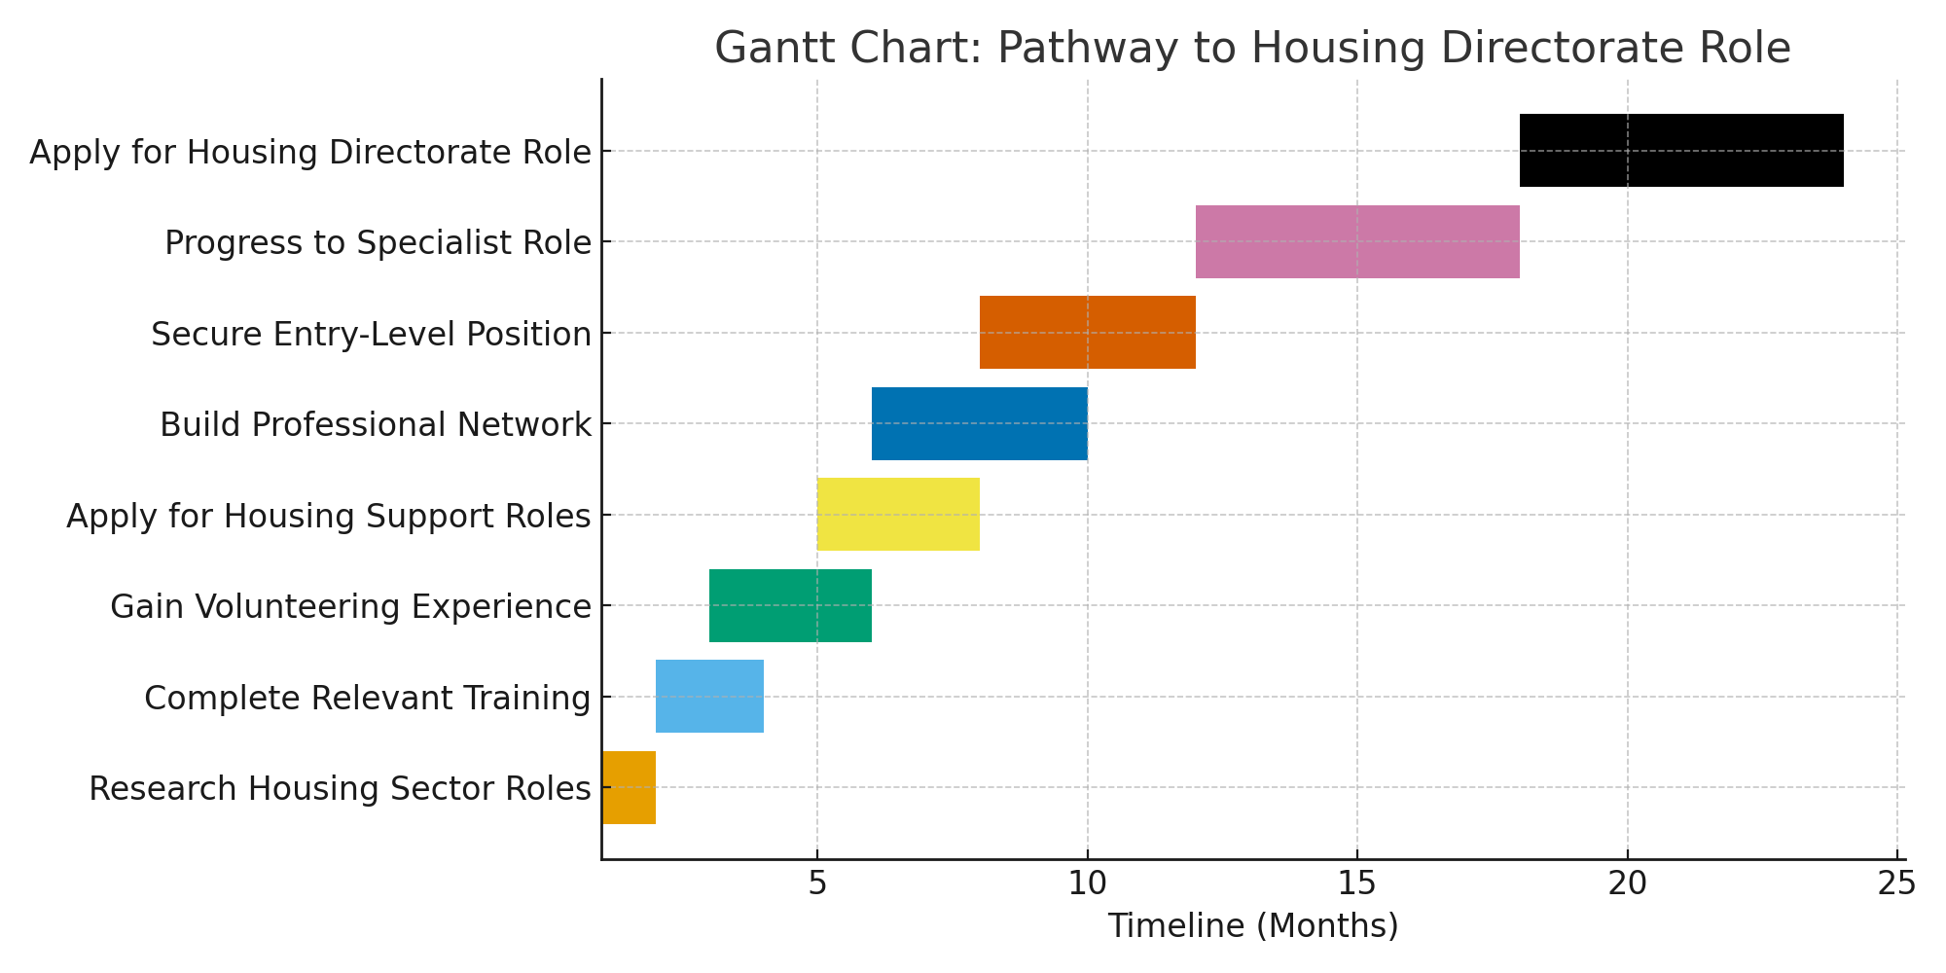
Gantt Chart Description – Achieving My Future Employment Goals
The Gantt chart above outlines a structured 24-month pathway towards achieving my long-term career goal of securing a Housing Directorate role supporting young people experiencing homelessness. The plan begins with building foundational knowledge of the housing and homelessness sector through research (Month 1), followed by completing relevant training and short courses such as safeguarding, trauma-informed practice, and youth homelessness awareness (Months 2 - 4). To develop frontline experience, I will gain volunteering placements within homelessness charities or local authority services (Months 3 - 6).
From Months 5 - 8, I will begin applying for paid Housing Support Worker roles while simultaneously developing a professional network through events, LinkedIn, and sector-specific forums. Securing an entry - level role (Months 8 -12) will provide essential practical skills in case management, multi-agency working, and risk assessment. Progressing to a specialist role such as a Senior Support Worker or Homelessness Prevention Officer (Months 12 - 18) will strengthen my leadership, supervision, and service-development skills.
The final stage focuses on preparing for and applying to Housing Directorate roles (Months 18 - 24), supported by CPD, mentoring, and reflective practice. This planned progression ensures continuous professional development while gaining the necessary experience and competencies to succeed in a senior strategic housing role.
References:
Chartered Institute of Housing (CIH) (2023) Continuing Professional Development for Housing Professionals. CIH: Coventry.
Homeless Link (2024) Supporting Young People Experiencing Homelessness: Practice Standards. Homeless Link: London.

Task 7: Making Changes Report
Title: Implementing a Digital Care Planning System in a Care Home
As the manager of a care home, I propose the implementation of a digital care planning system to replace outdated paper-based records. This change aims to improve accuracy, enhance person-centred care, and reduce administrative burden on care staff.
To achieve this, I will use Lewin’s Change Management Model (Lewin, 1951), which includes three stages: unfreezing, changing, and refreezing. In the unfreezing stage, I will engage staff through meetings and training to address concerns and explain the benefits of the new system. During the changing phase, we will roll out the digital platform in phases, supported by hands-on training and ongoing technical support. Finally, in the refreezing stage, we will embed the new system into daily routines and provide regular reviews to maintain progress.
Key skills needed include digital literacy, communication, and adaptability. Staff will require training to build confidence in using technology and to maintain compliance with data protection regulations.
Possible barriers include resistance to change, lack of confidence with technology, and potential technical issues. To overcome these, I will create digital champions within the team to offer peer support, and provide accessible training tailored to individual learning needs.
By managing the transition carefully and supporting staff throughout, we can ensure a smoother adoption and improved care quality.
References:
Lewin, K. (1951). Field Theory in Social Science. Harper & Row.
MindTools. (n.d.). Lewin's Change Management Model.

Task 8, Self-Reflection: Using Gibbs' Reflective Cycle (1988) as the chosen model. It’s structured to cover what I have learned about yourself, the knowledge gained, and how this will help my future practice.
During this module, I have learned a great deal about myself, especially in relation to emotional intelligence, resilience, and professional development in health and social care. Using Gibbs’ Reflective Cycle (1988), I can reflect more deeply on this learning process.
Description: One significant moment was completing the research report on Mental Health Issues in Homeless Young People. Initially, I felt anxious and unsure of my ability to complete such a large task.
Feelings: I often doubted myself and felt overwhelmed, but I also felt determined to finish it to the best of my ability.
Evaluation: Through this, I recognised my tendency to internalise pressure and underestimate my strengths. However, I also realised how committed and capable I am when I manage my time and emotions effectively.
Analysis: I now understand the importance of self-awareness, communication, and stress management in care roles. The module helped me see how emotional intelligence impacts not only how I work, but how I support others.
Conclusion: I have grown in confidence and learned that asking for help and reflecting on challenges can be powerful tools for personal growth.
Action Plan: Going forward, I will apply reflective practice regularly, use stress-reduction techniques during demanding situations, and continue building my communication and leadership skills for future roles in health and social care.
Reference:
Gibbs, G. (1988). Learning by Doing: A Guide to Teaching and Learning Methods. Oxford: Oxford Polytechnic.

References
Burt, R. S. (2000) ‘The network structure of social capital’, Research in Organizational Behaviour, 22, pp. 345–423. doi:10.1016/S0191-3085(00)22009-1.
Chartered Institute of Housing (CIH) (2023) Continuing Professional Development for Housing Professionals. CIH: Coventry.
Gibbs, G. (1988) Learning by Doing: A Guide to Teaching and Learning Methods. Oxford: Oxford Polytechnic.
Homeless Link (2024) Supporting Young People Experiencing Homelessness: Practice Standards. Homeless Link: London.
Kotter, J.P. (2012) Leading Change. Boston: Harvard Business Review Press.
NHS Transformation Directorate (2021) Digitising Social Care.
Lewin, K. (1951). Field Theory in Social Science. Harper & Row.
MindTools. (n.d.). Lewin's Change Management Model.
Mind (2020) Housing and Mental Health. Available at: https://www.mind.org.uk/information-support/tips-for-everyday-living/housing-and-mental-health/
Peters, T. (1997) ‘The brand called you’, Fast Company, (10), pp. 83–90. Available at: https://www.fastcompany.com/28905/brand-called-you (Accessed: 06 September 2025).
Putnam, R. D. (2000) Bowling alone: The collapse and revival of American community. New York: Simon & Schuster.
Shepherd, I.D.H. (2005) ‘From cattle and coke to Charlie: Meeting the challenge of self-marketing and personal branding’, Journal of Marketing Management, 21(5–6), pp. 589–606. doi:10.1362/0267257054307381.

