Name: Rubina Akbur
Student Number: 2118370
Module Code: BMSW4005_BIRM
Module Name: Professional Career Development
Assignment Title: Reflective Report
Lecturer Name: Olubukola Adegbite

Contents

Introduction………………………………………………………. Page 3
PDP………………………………………………………………. Page 3
Task 1:- Evaluation……………………………………………… Page 4
Task 2:- Gibbs Reflective Cycle………………………………. Page 6
Open Book Assessment……………………………………….. Page 7
CV and Cover Letter…………………………………………… Page 8
Mock Interview………………………………………………….. Page 9
Conclusion………………………………………………………. Page 10
References……………………………………………………… Page 11
Appendix………………………………………………………… Page 12

Introduction
The reflective report will show the career of my choice which is a Family Social Worker, and I will discuss the skills and attributes needed to achieve this role. It will also be identified if I already have some qualities and are they achievable. To do this I will discuss my personal development plan (PDP) show my long term and short-term goals. Finally, During task 2 I will discuss the open book assessment, CV and cover letter as well as the mock interview. The Gibbs Reflective Cycle will be used to identify the description, feelings, evaluation, analysis and the conclusion of the three choices.
PDP
Objective | Time | Activities | Success | Resources
Short – Term  Achieve my level 4 in Health and Social Care | Nov 17th, 2022 | Attend all my lessons and use the support given | Attend all my lessons and achieve 100% attendance as well as utalise the resources provided.  Level 4 certificate | Training  Books  Online university library  Teacher
To support my families with personal issues at work. | End of term 23/10/22 | To provide personal support for the parents.  Provide coffee mornings and workshops to support parents and their families. | Awareness of support agencies.  Giving parents more knowledge and understanding of how to manage their children and their family’s needs. | Computer  Colleagues
Being able to work effectively alongside my team. | End of term  23/10/22 | Undergo training that has been provided. | Being more professional and an effective communicator | Training  Webinars  Attending team meetings
Identifying the children’s needs that may affect their learning goals. | June 2023 | Safe and wellbeing checks.  1-1 support within school. | Meeting children’s barriers in their learning. Providing them with the right strategies to learn effectively. | Meeting with parents and agencies involved in the family.
Long Term  Family Support Worker | June 2023 | Work effectively alongside other agencies | To be able to make long term decisions without relying on others. | Agencies  Training

According to CPD Online College Limited (2021), a PDP offers you with clear goals and assists you in determining your strengths and weaknesses. It enhances your career prospects as well as your achievement and boosts your ambition. Finally, it aids in progress tracking and improving your sense of accomplishment.
Task 1: - Evaluation
In my previous roles as a teaching assistant in schools, I was able to observe children who were challenged at school or at home. Furthermore, having worked with parents when discussing their child's strengths and weaknesses. I've chosen to work as a Family Support Worker (FSW), which entails serving as a primary point of contact for families in need of assistance, as well as developing effective relationships with parents/caregivers and communicating information. I also will be expected to collaborate with the school on earlier detection of families in need of assistance and appropriate action, such as home visits. However, elevate the ambition for disadvantaged families, attempting to drive community resources to perform efficiently together so that we develop their perseverance and help them flourish, according to Gov.Uk (2021). I can offer ongoing guidance, particularly to children and families who attended the schools where I have worked. This has included interacting with students in classrooms and with parents during parent-teacher conferences. Finally, assist them in improving their behavioural patterns, learning attitude, or overall well-being.
I chose this position because I am deeply committed to assisting vulnerable children and families in achieving outcomes that will improve their lives and choices. My class personality test revealed that I am a campaigner, which means that I always do my job with the people I care about, consider others, and am very diplomatic. As an FSW, you must consider other people's feelings and give your all. A SWOT analysis is a framework for evaluating and comprehending both internal and external factors that may lead to opportunities or potential risks for a business, according to CFI (2022).

SWOT analysis determines your organization's strengths, weaknesses, opportunities, and threats. These specific characteristics are critical for me to improve on because they form the foundation of my character when working in an unpredictable and ever-changing environment. Individual strengths and opportunities are present to enhance a person's assets, whereas weaknesses and threats are present to be recognised and addressed, along with an advantageous approach to ensure that all events result in a positive overall outcome.
Image 1
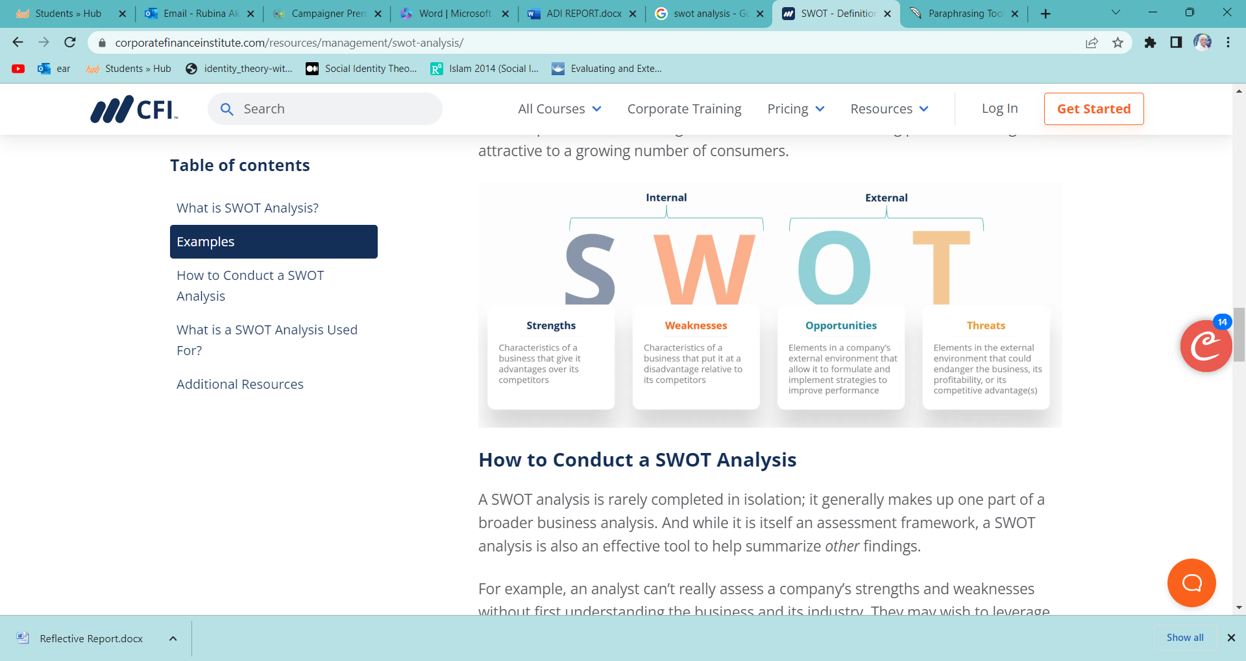
Corporate Finance Institution (2022)
In addition, the role requires me to work with the Trust Safeguarding Lead to develop strategic outreach and intervention assistance for disadvantaged families, utilising best practises within the Trust and beyond. Liaison with external organisations such as the Children with Disabilities Team, the Early Help Team, Housing, and the school nursing team. Also, be able to refer families to and provide information on other community services.
Image 2
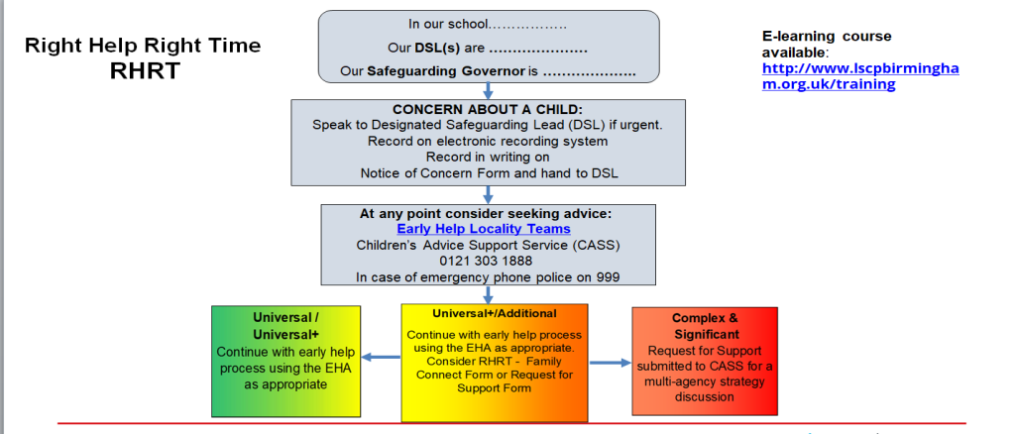
Birmingham City Council (2022)
I consider myself an activist because I accomplish a lot at work and in my spare time.
Working in education has taught me to be adaptable to engage circumstances. There may be significant flaws in activist, such as the fact that work is typically completed
at a cost. I always make it a point to complete my work because I don't want to be
overburdened or stressed. When I work, I make certain that my work is completed and
effective because cutting corners has an impact on the children and families with whom I
work, so I don't have time to make mistakes. I am also determined to deliver and go above
and beyond because I enjoy meeting and exceeding positive objectives. As I do not want to take a risk that will jeopardise my career. Neugebauer, and Evans-Brain, J. (2016) states that developing your workplace learning is important throughout your career for long-term employability, along with role development. There are certain skill and attributes that they require which I do not have but am willing to learn. Finally, to reach my goal I will ensure I meet my long term and short term goals in my PDF and ensure that I follow the time frame, activities and utilise the correct resources required.

Task 2: - Gibbs Reflective Cycle
The Gibbs reflective cycle was chosen as the model of reflection. Reflection allows the writer or reader to consider his or her own personal experiences, to examine one’s own thinking, and to accept new ideas. The Gibbs reflective cycle consists of six stages: description, feelings, evaluation, analysis, conclusion, and action plan. When you need to think about a situation, event or activity in depth, you use description. Then there are feelings, which require you to consider what your thoughts were during the event or activity. Following that, there is an evaluation in which they are asked whether their experience was positive or negative. Whereupon, consider what you’ve learned. After which comes the conclusion, in which you consider what you could have done differently. Finally, your action plan is based on your conclusion, and you should consider how you can grow in the future.
Image 3
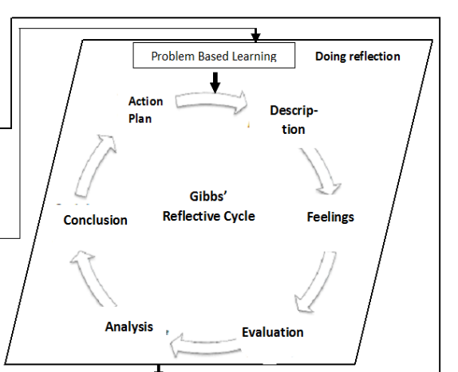
Sekarwinahyu, M. et al. (2019)

Open Book Assessment
Description
The open book assessment was an assessment that took place in the classroom. We were given choices of two questions and a case study to refer to which was about ‘How to Support Mental Health at Work’. Once I chose the question which was ‘Does having mental health affect how one performs in their role?’ I was comfortable with I referred back to the case study using my knowledge and understanding of mental health.
Feelings
Despite having prepared and studied the case study given to us, I felt a lot of anxiety during the assessment. I had a good understanding of mental health and hot it affects people in the workplace. Because it was an open book assessment, it was useful to know that we were given the opportunity to research and apply knowledge using the online resources such as the university library. This reassured and made me feel more at ease because I was able to access the necessary resources needed.
Evaluation
The case study was very interesting, but I know how to help someone who is affected. However, on the day of the mock assessment, my mind went blank, and I began writing whatever made sense to me at the time. I still believe I performed admirably, but I believe I could have done better. It was fascinating to investigate how mental health affects people and their daily lives.
Analysis
On the plus side, I now have a better understanding of mental health and how it can influence how people work and interact with colleagues. On the negative side, if given the chance again, I will believe in myself more and follow my heart because I know I have the ability and knowledge to explain mental health and how it affects someone's workplace, social, and home lives.
Conclusion
I have learnt that having a clear mind and faith in oneself is crucial during an assessment so that you can show your full potential to the tutor as nerves can get the better of me and effect how I want to perform.

Action Plan
If given the chance again, I would remain calm and collective so that I could read and understand the question clearly in my head and perform to the best of my ability and understanding.
CV and Cover Letter
Description
We were taught to write a CV and cover letter that identified our experiences, skills, and attributes so that we could apply for jobs and, if successful, proceed to the interview process. Meanwhile, we were taught how to write a cover letter that included specifics and information about the job I was interested in.
Feelings
I was feeling really confident when I was creating my detailed Cover Letter and CV because I already had a CV that needed to be revised. With the amount of experience I have in the workplace, writing the cover letter was a lot of fun.
Evaluation
My CV and Cover Letter were created and it assisted me in recognising how much experience I have as well as how to make it valuable and eye-catching for the employer. It also taught me how to effectively use key words and write.
Analysis
The advantages were that I could share the skills and attributes to fit into the role that I wanted to apply for. The disadvantages were, I had a lot of experiences and needed to make sure it wasn’t too long so that the person reading has lost interest. According to Teixeira da Silva et al., CVs provide a functional and straightforward solution to base on fact professional representation.
Conclusion
In summary, it now provides the hiring manager with additional information about how my skills are aligned with the job. Also, what I can offer the company and why I want the position.
Action Plan
As I have not received my results yet to see where I may have gone wrong, using my own initiative I feel that I could have added more skills and attributes as I have been working since I was 16 to show my level of knowledge and understanding in safeguarding, on training I had done and understanding of GDPR.
Mock Interview
Description
A mock interview was held to give us the experience we needed to understand the interview process and how to present ourselves from beginning to end. It was to assess how well we spoke, answered questions, and demonstrated our strengths in accordance with my CV and Cover Letter.
Feelings
At first I felt really nervous and did not know what to expect. Once I was in the flow of the interview I was much calmer and had a positive feeling about the whole experience.
Evaluation
The feedback I received was positive and I got the job I applied for which boosted my confidence. There were some areas of improvement which I expected but will ensure I take them into consideration. I received 70% marks which was amazing. (See Appendix)
Analysis
I can work on a few goals, such as referencing specific content from my CV and Cover Letter. The good news is that I was able to demonstrate my potential and ability to achieve my goal of getting the required role.
Conclusion
Overall, I am pleased with my results and will identify areas for improvement so that when I apply for a job in the near future, I can perform much better and demonstrate my potential. This interview has provided me with the opportunity to gain experience and set goals for myself so that I can continue to improve.
Action Plan
To ensure that I always review my feedback to remind myself of areas that need improvement and generates skills to achieve bigger and better goals. But most importantly not to forget what I did achieve and continue to do that.

Conclusion
In summary, I found the experience and learning to be beneficial and yielded a great deal of knowledge and understanding. This module has taught me skills and helped me to set career goals that will allow me to realise my dreams and aspirations. McAllister, M. and McKinnon, J (2009) stated that, both individuals and groups who exhibit survivability share a set of qualities that allow them to deal well with challenges of life.

References
Birmingham City Council (2022) What’s new in Keeping Children Safe in Education 2022? https://www.birmingham.gov.uk/download/downloads/id/20182/ppt_presentation_slides_-_safeguarding_update_what_s_new_in_keeping_children_safe_in_education_2022.pptx (Accessed: 20 November 2022)
CPD Online College, (2021) What is a personal development plan? Available at: https://cpdonline.co.uk/knowledge-base/business/what-are-personal-development-plans/#what-is-a-personal-development-plan/ (Accessed: 19 November 2022).
McAllister, M. and McKinnon, J., 2009. The importance of teaching and learning resilience in the health disciplines: a critical review of the literature. Nurse education today, 29(4), pp.371-379.
GOV.UK, (2021) Supporting Families-2021-22 and beyond Available at https://www.gov.uk/government/publications/supporting-families-2021-to-2022-and-beyond/supporting-families-2021-22-and-beyond/ (Accessed: 20 November 2022)
Neugebauer,J. and Evans-Brain, J. (2016) Employability:making the most of your learning career development. SAGE.
Sekarwinahyu, M. et al. (2019) ‘Development of problem based learning for online tutorial program in plant development using Gibbs’ reflective cycle and e-portfolio to enhance reflective thinking skills’, Journal of physics. Conference series, 1157(2), p. 22099–. https://doi.org/10.1088/1742-6596/1157/2/022099.
Teixeira da Silva, J.A., Dobránszki, J., Al-Khatib, A. and Tsigaris, P., 2020. Curriculum vitae: challenges and potential solutions. KOME: An International Journal of Pure Communication Inquiry, 8(2), pp.109-127.
Corporate Finance institute (2022) What is the SWOT Analysis? Available at: https://corporatefinanceinstitute.com/resources/management/swot-analysis/ (Accessed: 20 November 2022)

Appendix


