Business Plan
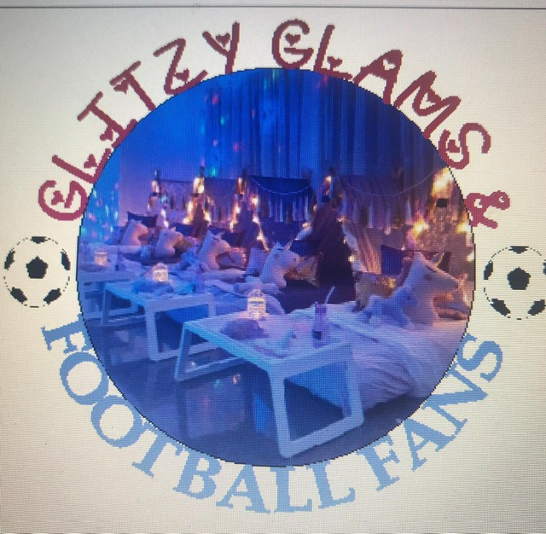

CARMEN CARTER
TEL. 07368260249
Glitzyglam.fan@yahoo.com

Contents:
- Your business and objective
- Your target customers
- Your market and competition
- Your marketing and sales plans
- Your operational plans
- Cashflow
- Supporting evidence (if applicable)

1. Your business and objectives

I am putting together a business plan that I will be the sole trader of. I will be naming my business “Glitzy Glams & Football Fans Sleepover Slumber Party’s” the idea of the parties are to go to people’s homes that book with me to set up mini inflatable beds with individual tepee tents over each bed, providing for either boys or girls or mixed parties, decorated with fairy lights and fairy’s, football theme and will also be providing neutral colours for non-theme bookings including bedding and pillows, I will also provide food trays set up with each tepee for the child to have all there sleep over snacks on the trays in front of them and a light up box with the child’s who’s birthday or occasion the party is for. I will also provide for each child prepacked sweets and popcorn. My business will be based at home as I have all the necessary storage space that will be needed for me to store all the equipment that is needed , I will also be using my own car for my business as I have a big enough car to deliver and do any set ups. I will be running my business alongside my current job so that I have a regular income to live off and not have to worry if my business don’t do as well as expected , but if it does take off in my first year and continue to grow I would then think about giving up my current job and run this business full time. I have decided that I will not be taking out any finance for this as I have savings that will cover me for everything that is needed to start me off and more, so I feel I will be saving myself with interest rates and the stress that if some months were quite or non-existent bookings I won’t have the worry of meeting loan repayments, I would take a percentage of the business profits to pay back what I’ve used but not until the business is up and running so I would give a few months before I would start to repay the money back to my savings. I will start off my business with advertising using social media via Instagram Facebook and family and friends sharing via social media.

Objectives:

First year plans:
- Within my first year I aim to build up a good reputation
- The first year I would like to advertise and get my business known to the community to build up clients

After my first year:
- Within year 2 I would like to further my advertising by setting up a website for my business in the hope I would bring in a lot more business so that I could solely rely on my business for my income and think of leaving my current job behind me.
- I would be looking to employ staff so I can do multiple parties.

My long-term plans:
- I would be hoping that by my 3rd year of my business that I would have built a thriving business and hope to widen further that just local to me.

- By then hope to have had my own premises and vehicle solely for the business uses only that I would also use for advertising with my business logo on the vehicle.

Your Start Up Loan:

My start up costs:
I will not be taking out a loan and will be using my own savings to cover my start-up costs as I will be a sole trader so I will not need to pay any staff to start with me. I will start to repay back into my savings by taking £200 a month from my profits until this is payed back. Maybe in year three if the need is there, I will look to take a loan to open a premise to store my stock and offer to hold slumber parties there.

2. Your target customers

Age: | Gender: | Income: | Types: | Target regions:
- 5- 12yrs | - All genders | - £0 - £25,000 | - Individuals  - Families | - Local?  - Within a 20-mile radius
My estimated covers for my first year will be:
I estimate to cover between 8 and 12 customers within a 20-mile radius of my business address. So, this would average around 416 to 624 customers a year, I estimate to recover my start-up costs with profit.

My business will target weekend parties for children between the ages of 5 and 12:
My business is targeted to cover for children aged between 5 and 12 years of age both boys and girls , I provide for mixed parties of boy’s and girl’s mixing up the theme’s to satisfy both , I aim to reach a target of maximum of 4 party’s each day of Friday and Saturday’s of every weekend, but I would expect to be busier with school holidays and half term and receive a lot more bookings adding in an extra day for bookings on a Sunday

My business Is to entertain children at the homes:
My business is designed to entertain children in the convenience of their own home, attached is a copy of my marketing leaflet to show my prices and available promotions.

I aim to provide cheaper services but supply the same quality of service as competitors:
After researching prices that are already out there with other businesses like my own, I have slightly lowered my prices to catch the attention of those who would prefer to save money and also have special offers in place , this will also help with customers passing my business name around to other friends and family if I’m providing cheaper services with the same quality of service as others, but I would still be making a profit.

3. Your market and competition

What research have you conducted to understand your market, including your industry, regions, customers, competitors?

- Social media research

- Family and friends

- Online research

Competitor 1:

Name, location, website: | Average prices:
Tepee wonderland  eBay  www.teepeewonderland.co.uk | Per night  3 tents £115  4 tents £140  5 tents £165  6 tents £190
Strengths: | Weaknesses:
- Well established company  - They have a massive variety of different themes | - They are not available within my area
Competitor 2:

Name, location, website: | Average prices:
Dusk to dawn tepees  www.dusktodawnteepees.co.uk  eBay | 1 Tepee £ 50  2 Tepee £75  3 Tepee £90  4 Tepee £100  5 Tepee £110  6 Tepee £120  7 Tepee £130  8 Tepee £140
Strengths: | Weaknesses:
- My competitors are more expensive. | - They are not in my area
Your business:

What sets your business apart from your competitors?
There is only a small number of what my business provides within my area and they do not offer any eye catching special offers for customers, so I have created my own special offers to start my business off and hope that does well.=, I, also have a brand new housing development currently being built on my door step on the mill that will when finished have 800 homes that are partnered with my housing association cadwyn, we have our own Facebook page that all the new families will be a part of so this will give me another opportunity to let my business be known to fresh new customers and right on their door step.

Your strengths: | Your weaknesses:
- Only 2 businesses to compete with in my area  - I have special offers and lower prices | - I will only provide part time for my first year.
future opportunities: | Current or future threats:
- I would hope that if my business were doing well, I would expand and take on staff to help me | - Current threat would be if existing companies try to compete with my prices.  - Future threat would be is my business did not do well in the first year

Sales supporting evidence for prices.

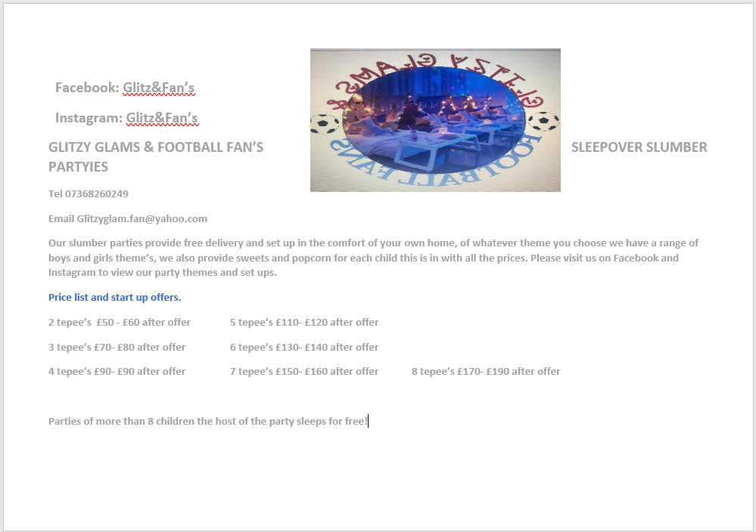

4. Your sales and marketing plans

Ways I will be promoting my business are:

- Social media
- Referrals
- Leaflets
- Events
To help my business grow I will be using social media networking pages to promote myself and give customers an idea of what I will provide for them and how the parties will look before they book in with me, I will use Facebook and Instagram which is free marketing , with this I will post photos of my parties all set up ready for the children for their parties , this will give people an idea of what I do and can also request if they wanted something similar to what I have got shown or mixed up a little to make it different for them , my aim is to provide for whatever the customers want , this also helps me with future ideas to add to my business , as if someone is to ask me could I provide certain extra’s them I can certainly try and look into this to provide for the customer , my social networking networking will also help my business with people leaving me valued feedback after there experiences with me, customers always look for feedback before trying or buying something this helps a lot reading what other customers thought of their experiences, I can also advertise all my special offers on social media that can then be shared amongst friends and relatives, if my business was to take off in the first year and was doing really well that I gave up work and took to this full time as my job I would then have my own website set up for me for extra marketing. I will provisionally book any bookings until deposits are paid then I will make formal bookings in my diary, I will also keep a copy of all receipts and invoices for my business spends for five years for my records.

Three promotional activities I would be offering are:
- I have discounted prices for the first 3 months of my business starting to bring in customers, after these offers finish my prices are still relatively lower that any other competitors.

- I also have an offer that I will provide as a continuous offer to all customers that a child is free with larger bookings of 8 or above.

- I also deliver to your home and set up and come back to pick up the following day, leaving no hassle for parents to anything free of charge

5. Your operational plans

Are there any suppliers or business relationships that are critical to delivering your products/services or otherwise running your business?
Detail as relevant in the boxes provided below.

Supplier
Organisation: | Relationship status:  Delete any answers not applicable to you.
I will be using eBay as my main suppliers for many of my materials, I have found that eBay is one of the cheapest places to buy most of my supplies. | - No contract/commitment  - Other
Supplier / Relationship 2:

Organisation: | Relationship status:  Delete any answers not applicable to you.
I will also be using amazon for some of my supplies and local shops like home bargains for my confectionary supply’s as they are cheaper that big brand stores and warehouses. | - No contract/commitment  - Contact under negotiation  - Project-based arrangement  - Contract or retainer in place  - Other
Other operational considerations:

Do you currently employ staff?
- Not yet but I have plans to take on staff if my business did well in the first year.

Where does or will your business operate from?
Delete any answers not applicable to you and provide some description as relevant.
- Home business
- Mobile business

What laws or regulations have you considered for your business and/or industry?
With laws and regulations, I have already in place my Health and safety with food hygiene and cleaning with my current job we go through training quite often and have to do online training to make sure that we are all fully aware of the procedures and doing it correctly using the correct cleaning products or equipment, so I know all that there is to know with my health and safety and food hygiene as I’ve completed my courses for this . I also have made sure that any kind of batteries that I will be using for lights I will be using are well covered and away from and children protected with cases securely. I will be using no electrical equipment.

What insurance do you currently have in place or do you intend to put in place for your business?
To cover all my equipment I would be contacting my home and car insurance to let them know I will be using both my home an car for business purposes as well as pleasure, I will also be taking out public liability insurance to cover for any accidents while my equipment is rented out. This is appendix 1

6. Cashflow

- 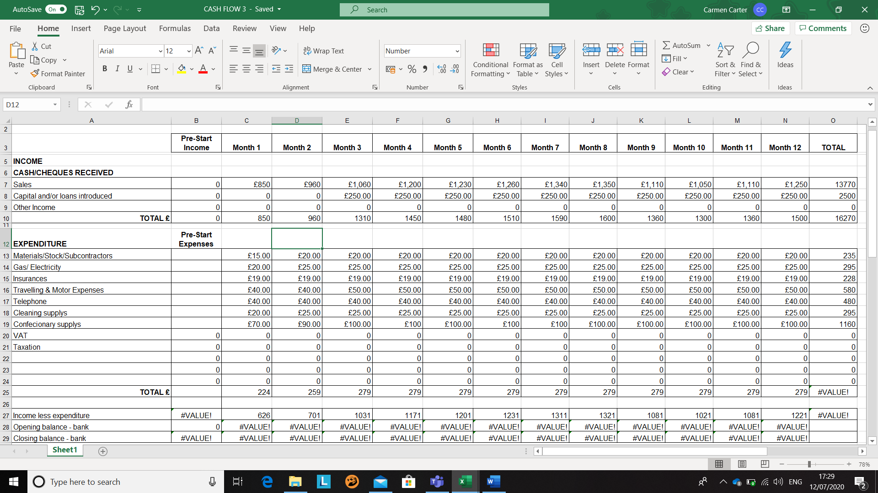

7 SUPPORTING EVIDENCE.
Appendix 1.

The chart above is my insurance quote from Finsbury Insurance Group.

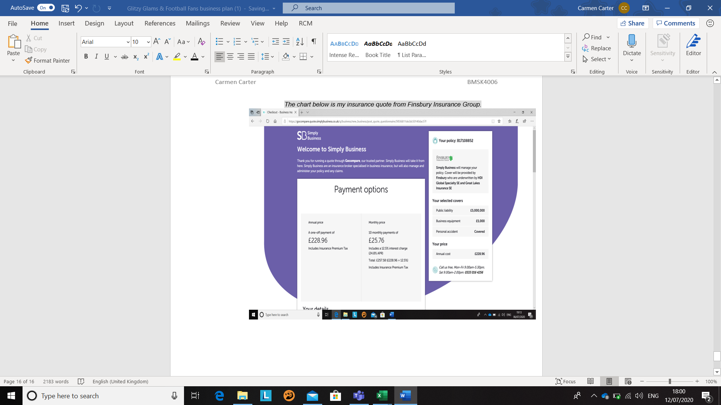

Appendix 2
Supporting evidence after researching a huge growth of population in my local area
. www.themill-canton.co.uk/

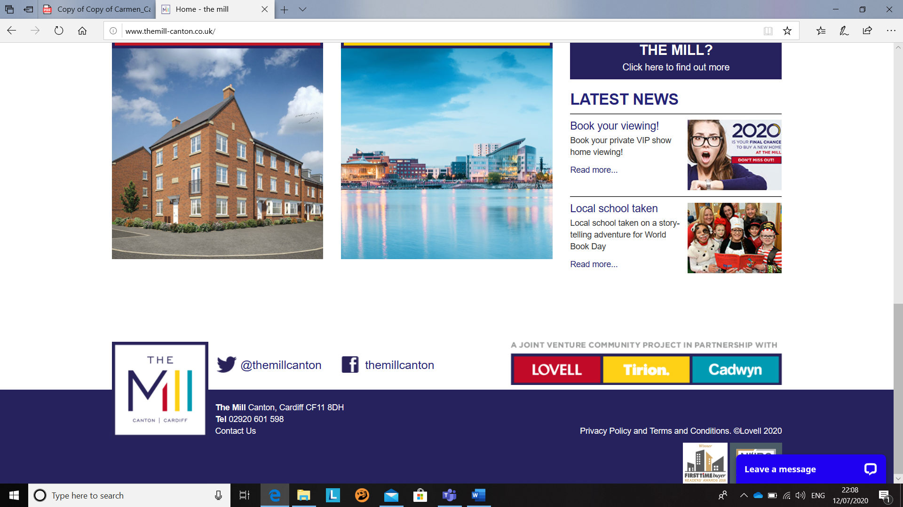

Copy of My CV

CARMEN CARTER 12 cwrt stan Richards ceaura, Cardiff, south glamorgancf5 5bf| H: 07368260249| M: 07368260249| carmenlou1979@yahoo.com
Hi, my name is carmen, I am currently working as a waitress at harvester restaurant while studying at UWTSD University to further my education to become a manager of my own team. I am a very outgoing person and find it very easy to interact and communicate with new people on a daily basis, I am very open minded and approachable as a person, I meet new people on a daily basis with the kind of work I am currently in, I am a hard worker and like to finish what I started, I am always open to new and fresh ideas whether it be for work or pleasure.
05/2012 to Current Waitress Assistant Harvester － llantrisant Completed opening and closing checklists according to set standards. Suggested additional items to customers to increase restaurant sales. Suggested additional items to customers, leading to [Number] % increase in average bill value. Maximised table turns and rotated seating for optimal guest satisfaction. Maintained safe food handling standards at all times. Anticipated and addressed guest service needs. Resolved problems promptly and escalated larger concerns to management. Recorded orders and partnered with team members to serve food and beverages. Served guests promptly to ensure food remained at proper temperatures. Educated guests on daily specials and menu offerings, enabling decisions on starters, entrees and desserts. Discussed alternative selections with chef for guests with food allergies or gluten-free requests. Inquired about guest satisfaction, anticipated additional needs and happily fulfilled requests. Prepared buffet and salad bar for dinner service. Added special garnishes and other finishing touches to dishes prior to serving. Checked on all tables at appropriate intervals to refill drinks and respond to requests. Delivered exceptional, friendly and fast service to up to [Number] tables per shift. Transported all dirty tableware from dining room to dishwashing area for proper cleaning. Complied with all health department regulations and rectified issues immediately. Washed buffet, restaurant and banquet items, including silverware, dishes, cooking utensils, equipment and displays. Answered phones politely and promptly while accurately recording and confirming reservations. Delivered exceptional, friendly and fast service.
Greeted new customers, answered initial questions and took drink orders. Cleaned and organised host stand and buffet area. Stocked and maintained silverware, linens and condiments. Performed additional tasks to keep dining room running smoothly. Hand-washed dishes and glassware thoroughly. Reset tables with spotless service ware routinely. Facilitated prompt and accurate seating and service of all guests. Maintained knowledge of current menu items, garnishes, ingredients and preparation methods. Assisted servers and dining room hosts, quickly responding to guests' needs. 01/2007 to 04/2012 Bar Assistant brains － Cardiff, south Glamorgan Served each guest with sincere, positive, pleasant and enthusiastic attitude. Monitored glassware and stemware inventory. Kept detailed inventories of bar supplies and kept work areas stocked to maintain workflow efficiently. Processed cash, credit card and voucher payments. Received beverage orders from wait staff and delivered beverages to guests. Created list of signature drinks that increased bar revenue by [Number]%. Opened and closed bar tabs and transferred tabs to dining area. Filled ice bins [Number] throughout shift and cleaned them [Number] times weekly. Managed bar area, including cocktail design and menu, inventory, regulation compliance and customer relationships. Ordered and maintained inventory of bar products, including alcohol, soft drinks and supplies to drive high volume of sales. Interviewed, hired and trained staff on bar practices, customer service standards and productivity strategies. Delivered quality food and beverage service to guests quickly. Cleaned and filled ice bins. Monitored different areas of bar to keep alcohol consumption stayed in designated areas. Upheld high standard of cleanliness in all work areas. Checked patron’s identification to ensure minimum age requirements for consumption of alcoholic beverages. Broke down bar after events and returned leftover spirits, glassware and banquet trolleys. Processed over [Number] transactions daily using cards, cash and voucher payment systems, applying any eligible coupons or promotions. Recognised VIP customers immediately and provided special treatment, including preferred tables. Created list of signature items to increase overall revenue. Checked identification of customers to verify age requirements needed for purchase of alcohol. Maintained facility compliance with health codes, sanitation requirements and licence regulations. Confirmed customers ages for alcohol service and discontinued service to intoxicated guests. Prepared over [Number] mixed drinks and poured wine, beer and non-alcoholic beverages for average of [Number] patrons per shift.
SKILLS
EDUCATION
Completed daily logs, updated computer tracking systems and filled out other relevant documentation. Maintained full knowledge of all menu items, contents and preparation methods. Waited on multiple customers at the bar and throughout the bar area. Inventoried glass and stemware and cut costs by [Number]% through effective inventory management. Prepared coffee and espresso drinks. Ensured alcohol was consumed in designated areas only. Kept close track of bar tabs and transferred open tabs to dining area seamlessly, providing pleasant dining experience to customers and smoothing process for wait staff. Oversaw bar inventory, restocked supplies and placed orders. Managed customer service by training staff, overseeing operations and resolve issues quickly. Stayed up to date on latest in mixology trends, bar equipment and sanitation standards. Promoted customer safety by maintaining current list of available ride services for inebriated customers.
Basic accounting Outgoing personality Problem solving Payment processing Strong communication skills Food preparation Food service Wine, beer and cocktails expertise Service-oriented mindset Strong organisational skills Employee training Excellent judgment Verbal communication
Cash register operation Organisational ability Anticipating guest needs Extensive spirits knowledge Able to stand [Number] hours Safe serving knowledge Balancing the cash register Cash and credit transactions Health codes compliance Marketing and sales experience Alcohol ordering Service-orientated mindset
1998 GCSE Michaelston community college － Cardiff
Mathematics C
English B
Science C+

