Lorraine Coombes ID 1911597
Timewise foundation Tuns House, 109 Borough High Street, London, England, SE1 1NL
Timewise foundation Audit and analysis Report

Executive summary

This report was carried out on the foundation Timewise, an award-winning social enterprise. (formally known as Women Like Us) bringing together Timewise Jobs and Timewise consultancy. Registered at Tuns House, 109 Borough High Street, London, England, SE1 1NL. Originally set up by Emma Stewart CEO founder, responsible for the strategic direction of both the business consultancy and the social structure of the organisation. Her leadership role aims to test and scale innovative solutions that deliver effective, sustainable, two-way flexibility with corporations, thought leaders, policy makers, and social reformers. Karen Mattison co-founder, is known in all aspects as a thought leader and influencer, contributing to corporate conferences and the media on a regular basis. She is particularly interested in the perspective and perspectives of the United Kingdom's flexible staff. There are executive board members, program director, and sales, a total of 30 employees employed with timewise.
The report will provide an audit and analysis on the economic, social value, benefits and prospective growth opportunities. Timewise mission statement reads “Flexible working helps make society more equal, by delivering opportunities for all. We collaborate with policymakers, industry bodies and employers, and share what we learn, to make the social impact of our work, even more powerful”.
Timewise foundation is trying to break down barriers into flexible working. Market percentages show only 15% of UK jobs advertised, have flexible working options.
Employees that are trapped in jobs beneath their skill set, zero-hour contracts or shift work, with little scope for progression tend to seek employment elsewhere. The knock-on effect to employers is that there may not be sufficiently qualified applicants to choose from. It's becoming increasingly clear that having a workforce that represents the outside world is better for business. Employment and unemployment are the driving forces behind inflation and economic growth. Locally or globally, where there is a high level of unemployment, economic growth declines.
Timewise has a theory for change and the results for this are that employer’s understanding has increased, and efficiency has improved, resulting in the company’s being invested in flexible work.
Timewise are a social enterprise with a double bottom line, one financial and one social, making a profit for social good, investing back into the company to fund their research and campaigns, building on their expertise.
The advantages of a company like timewise are that they will capture the market in part-time/flexible work for employees and employers because of the image it portrays in the changing working practices.

Contents Page: Page

- Executive Summary ……………………………………………………….1
- Contents page ……………………………………………………………...2
- Introduction ……………………………………………………………......3
- 1.1 scope ………………………………………………………………….3
- 1.2 purpose ………………………………………………………………..3
- 1.3 Background …………………………………………………………...3
- 1.4 Procedure ……………………………………………………………3
- Findings …………………………………………………………………….4
- Findings …………………………………………………………………….5
- Timewise theory for change ………………………………………………..6
- Timewise jobs …………………………………………………………….7
- SWOT analysis ……………………………………………………………..8
- Recommendations, Conclusion……………………………………………..9
- References………………………………………………………………….10

Introduction

  - Scope: This report is carried out on Timewise foundation, an award-winning social enterprise. (formally known as Women Like Us) bringing together Timewise Jobs and Timewise consultancy. It will discuss the role of timewise foundation in society and the regional economy, social value, benefits and prospective growth opportunities, and what’s behind the driving force of the company and its objectives. Also, to find out the reasons and theory’s behind the growth of the business as a social enterprise.

  - Purpose: To report and provide an audit and analysis on the company, and any recommendations.

  - Background: Timewise foundation was originally known as Women Like us. Created by two young mums named Emma Stewart and Karen Mattison back in 2005. The reason behind this was both being mum’s they were unable to find part-time jobs to suit their lifestyle qualifications and skills. In 2012 they secured investment and set up two further companies known as Timewise jobs and Timewise recruitment, and timewise foundation was founded to bring all three together under one umbrella. The core business being, getting people into Part-time and flexible employment and to change the ways in which companies think on flexible/part-time work creating and equal workplace.

  - Procedure: The data in this report has been gathered from research on information provided by Timewise jobs and Timewise consultancy websites and other sources.

Findings:
Timewise services offer, Flexible working consultancy to help companies develop innovative solutions that attract skilled, committed people and create workplaces that are equal.
There are Only 15% of UK jobs advertised with flexible working options. 1.5 million people are trapped in poorly paid part-time jobs beneath their skill set. Around 2 million people work in zero hours or GIG economy roles, having sacrificed employment rights and security for flexibility. A further 5 million people work in shift-based roles which are flexible in theory but have little scope for progression or predictability.
Gender pay gap is a huge issue with working parents as the trend seems to be that the mothers take a back seat from employment or take under skilled low paid jobs to be able to fit their other family commitments in around the job. Here are some examples.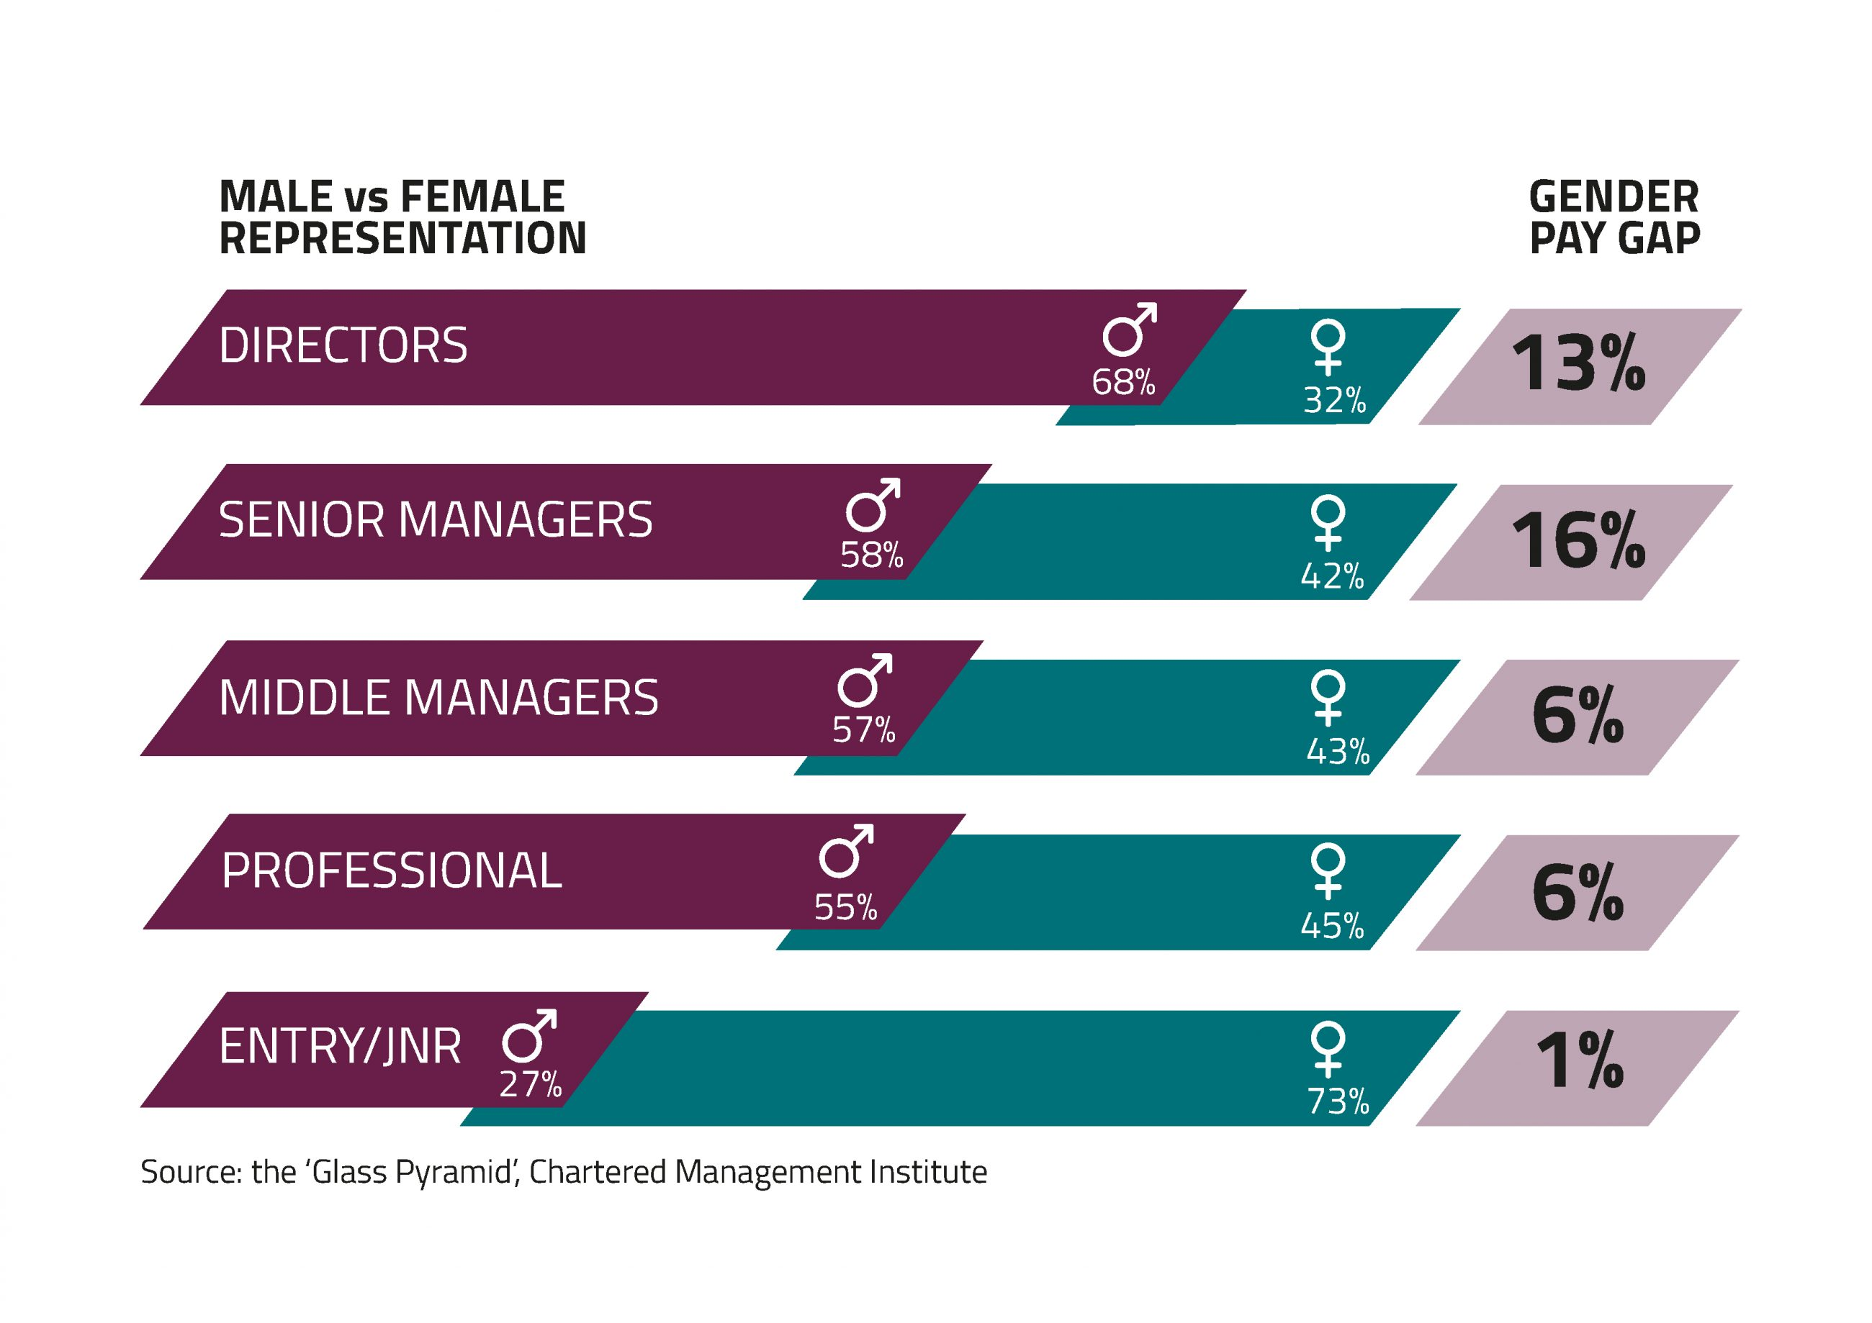
The knock-on effect to employers is that there may not be enough talented candidates to choose from. It is increasingly clear that it is easier for a company to have a workforce that represents the outside world. Employment and unemployment are the driving forces behind economic growth and stagnation. When a high level of unemployment exists locally or nationally, economic growth suffers.
Working lives report Aviva (2017) state that 64% of employees are more likely to stay with an employer who offers flexible working. Timewise consultancy works with businesses to overcome organisational and cultural barriers at management level, test ways to provide managers with a better work-life balance and develop more appealing, flexible career paths.
Timewise own research suggests 9 out of 10 employees want to work flexible. Timewise consultancy and training team design fully flexible roles within a business at all levels. Once they have flexible roles to offer timewise can help find talented candidates to fill them through timewise jobs.
The more control any of us feel we have over our working lives, the better we feel about work. (Dr Winwood M, Clinical Director of Psychological Services, Axa PPP Healthcare)
Health and wellbeing at work CIPD (2018) state 68% of organisations are taking steps to identify and reduce stress in the workplace, of which 69% are using flexible working options to achieve this. Timewise offers to design flexible roles, which suite the employee’s personnel circumstances.
Timewise own research (flexible working: A talent imperative.) states flexible working is highly important or essential for, 77% of women, 80 % of people with health concerns 91% carers, and 74% older workers. Timewise offer to design flexible roles that consider the needs of different groups of employees.
Timewise developed the Accreditation Program. A realistic toolkit, which provides strategic perspective, collaboration with leadership and hands-on training for a team. The aim is to support leaders in the public sector in developing and designing new flexible working approaches that will bring radical change. The organisation will be accredited as a Timewise Council or a Timewise Trust upon completion.
The social impact strategy for ttimewise sits at the heart of all their work and underpins everything they do. They measure themselves against the following outcomes:
- Driving actionable progress in flexible working for employers.
- Making a positive effect on workers by increasing access to good flexible work.
- Increasing the number of quality flexible employment in the current job market.
- Increasing wages for low- and middle-income families who need flexible work.
The framework timewise has set out to achieve this is below: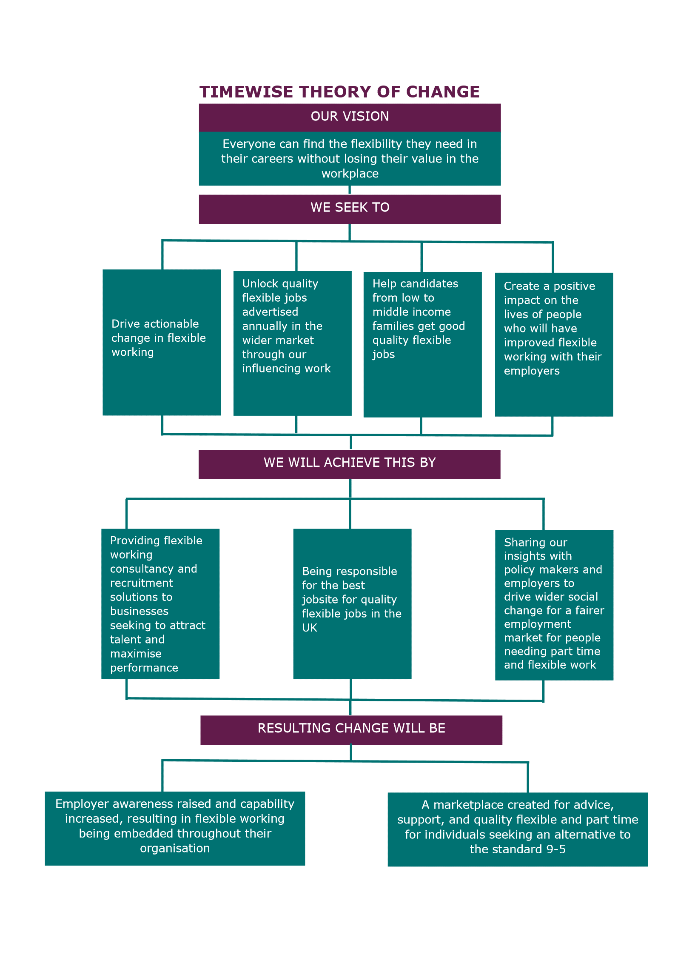

Timewise Jobs:
Timewise jobs, have been making an economic impact, with people that may not have ordinarily got employment due to their personal circumstances, needing flexibility or part-time employment. Replacing an employee costs an average of £ 30,000, so it makes no sense to train workers just to lose them to a more agile rival. Breaching the UK gap in the employment market, timewise jobs provides advice, ideas and a website dedicated to flexible and part-time jobs. It also allows employers a chance to advertise vacancies directly through them to find the right people with the right skill sets, ability and commitments for the job. They also provide further advice and ideas on how to ask for flexible hours, looking for jobs, CV’s , interviews, returning to work and careers advice. Provided on the website are inspiring stories from people who have been helped by timewise, flexible employers’ stories and other news. You register with the jobsite, so you can apply for positions that are available and to alert you to anything that they find would be appropriate. There are links through the search recruiters link, that takes you to other recruitment agencies offering further job opportunities.
Timewise Jobs is the only jobsite in the UK devoted entirely to flexible and part-time jobs. They aim to provide one place where people can find any and all kinds of vacancies of good quality, which are flexible in some way. In comparison to ordinary jobsites, timewise jobs, clearly advertise part-time and flexible jobs, were as others tend to advertise jobs, but until you look further, it’s not clear on hours or flexibility. This is something that timewise jobs specialise in. There website also offers a lot of other varied services, compared to the number 1 UK job site.
Timewise foundation is part of a multi-award-winning social enterprise that helps people find jobs, with skill and ability levels that match other life commitments. As most people know, social businesses or social enterprises have ' double bottom lines '-one financial and one social. They are ' for profit, ' making money locked in to social good. Timewise do all of this because they believe that the world of work is evolving, and the recruiting industry has not caught up. This causes a distinct social disadvantage for people who need part time work. Some have had gaps in their careers – often because they raised young children – and need a little support along the way. Timewise say “people should be encouraged to find part-time employment which will allow them to work to the best of their ability – not a tenth, and that such exceptional talent would be easy to hire and clear to employers”. That is good for business, good for candidates and good for the economy. Their overall aim is to build a fluid, vibrant part-time recruitment market and flexible jobs, so that anyone can find a job at their skill and ability level, regardless of their background or reason for needing part-time work.

The Swot analysis findings, conducted on timewise foundation is as follows:

Strengths:  Tackling the lack of quality part-time jobs.  Very established with a wide range of policymakers and business.  Partners with the government and business leaders.  Provide journalists with interviews, case studies and information, raising their profile.  Provide innovative solutions for employers to attract talented, loyal people and create a fair workplace helping the economic growth.  Flexible Working Audits to assess the status and highlight areas for improvement for businesses.  Workshops and training  Accreditation programme, designed for public sector bodies, aims to transform talent attraction and retention through flexible working.  Recruitment services, getting the right people in the right jobs.  Working with a large variety of recruiters.  Helping people to look for jobs, CV’s, interviews, returning to work and careers advice. | Weaknesses:  Other people could set up similar companies.  Not exclusive to recruiters.  Security with social backers(investors)  Cash flow
Opportunities  Optimize the job board.  Secure larger companies and more employers. | Threats  Cyber-attacks on their websites.  Protecting personal information.  Acts, Terms and conditions may change.  Change in government.  Economic changes.

Recommendations:
The logical next steps for the timewise foundation to take, are to try and gain exclusivity with recruiters, encouraging them to think about the impact on the economy, promoting the flexibility/part-time jobs and job share and discuss ways on how to close their gender pay gap. Keep working towards further investors. Watch the market trends with similar job sites. Be vigilant with regards to cyber-attacks and personal information. February 2020 will bring about many changes with Brexit. Once these changes are in place re-asses the business to check all policies and procedures are correct and legal. Promote the timewise accreditation programme to get more public sector companies accredited leading the way for other companies to follow.
Conclusion:
In conclusion there are significant benefits to using timewise jobs for people who want part-time/flexible work, because timewise Jobs are the only jobsite in the UK dedicated entirely to flexible and part-time jobs. They aim to provide a place where people can find any and all kinds of high-quality vacancies that are somehow flexible. Timewise foundation is part of a multi-award-winning social enterprise that helps people find work, with levels of skill and capacity matching certain life commitments. Given that employees can on occasions end up being trapped in a job that is under their skills and ability, and do this to maintain their versatility, many end up going elsewhere, with more flexible employees, to find more suitable positions. According to the timewise jobs website, they help people to achieve this through advice, ideas, and providing flexible/part-time jobs, and can do this with the help from their strong employer base. However timewise consultancy is more about helping business and employers make changes, this in turn creates a fairer workplace. They are all about tackling inflexible working structures, achieving a work life balance for employers. How they achieve this? through analysing, auditing, reporting and recommending changes. As a result of these methods they have been very successful, which will have an impact on the reginal and local economic growth. Given that employment and unemployment are the driving forces behind economic growth and stagnation, then timewise foundation appears to be doing good for society.

References:
https://timewise.co.uk/
https://www.timewisejobs.co.uk/
https://beta.companieshouse.gov.uk/company/05274371/filing-history?page=1
https://www.indeed.co.uk/
Glass Pyramid Charted management institute https://www.managers.org.uk/insights/news/2018/march/exclusive-new-cmi-analysis-reveals-scale-of-glass-pyramid-across-uk-business
Working lives report Aviva (2017) https://www.aviva.co.uk/adviser/documents/view/workinglivesreport2017.pdf
Health and wellbeing at work CIPD (2018 https://www.cipd.co.uk/Images/health-and-well-being-at-work-2019.v1_tcm18-55881.pdf)
WWW.acas.org

