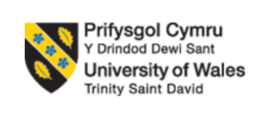

Programme: Master of Business Administration

Module: International Marketing: Principles and Practices

Module code: LCMB7026

Assignment Title: International Marketing: Principles and Practices

Student Name: Yousaf Ali

Student ID:2430960

Table of Contents

Introduction 3
Brand Overview 3
Comparison of the socio-cultural context of the UK and Germany 4
PESTLE Analysis 4
Country Comperion 8
Comparison of BMW’s STP Strategies in the UK and Germany 10
Segmentation 10
Targeting 11
Positioning 12
Comparison of BMW’s Marketing Mix (7Ps) in the UK and Germany 12
Product Strategy 13
Price Strategy 13
Place (Distribution) 14
Promotion 14
People 14
Process 15
Physical Evidence 15
Evaluation of the Performance of BMW’s Marketing Strategies 16
UK Market Performance 16
German Market Performance 16
Comparative Analysis and Key Metrics 17
Evaluation of Market Leadership Across Both Countries 17
Evaluation of Marketing Ethics Practices 18
Advertising and Pricing Transparency 18
Environmental Claims and Greenwashing 18
Data Privacy and Safety Communication 18
Supply Chain Issues and Comparative Context 19
Ethical Evaluation 19
Recommendations & Conclusion 20
Recommendation 20
Market Strategy Improvements 20
EV Penetration Strategy 20
Digital Marketing and Cultural Adaptation 20
CSR and Ethical Improvements 21
Conclusion 21
Reference List 23
Appendices 29

Introduction
This report is aimed at evaluating the effectiveness of the international marketing of BMW. In 2024, BMW sold about 2,450,804 vehicles all over the world, which indicates a powerful market position (BMW Group, 2024). BMW can be analysed in terms of international marketing due to its luxury world brand recognition. The United Kingdom and Germany were selected because of their strategic importance in the automotive market. BMW is based in Germany and hence will provide an understanding of aspects of domestic versus international orientation. Exports-UK market are vital in the export and right-hand-drive product approach by BMW. This report begins with macro-environmental influences in the two countries through PESTLE comparison. It evaluates the segmentation, targeting and positioning dissimilarity between the selected markets. The report gives advice and concludes with a summary of all findings.

Brand Overview
BMW started as an aircraft-engine factory in Munich in 1916 and has grown to become one of the most powerful premium brands in the automotive context of the globe. The company has strategically diversified after World War II increasing its operations, which has over time given it a global footprint in Europe, Asia and North America (BMW Group, 2025). This growth endowment has seen BMW assume a market leadership in the premium automotive market across the world. In 2023, BMW shipped about 2,253,835 vehicles across the globe and this represents an annual growth of 7.3%, which illustrates a continuous demand for its products in the global market (BMW Group, 2024a). The product portfolio of BMW demonstrates its wide appeal to the market, including sedans, SUVs, electric cars, plug-in hybrids and high-performance vehicles. There are the BMW 3 Series, X5, i4 and M-performance products that have enhanced the brand reputation of excellence in engineering and technological and dynamic driving experiences.
BMW has a high level of competition in the United Kingdom. The BMW Group recorded 111,734 vehicle registrations in 2023, which constitute the BMW-branded product range. (BMW Group, 2023) Electrification has become more active in the UK where 28,723 BMW cars are registered as fully electric, which is an improvement of 34% annually. The expansion of the power of BMW in the rapidly growing market of the electric car industry in the UK. BMW's home market is Germany, which is vital to the operations of the company and brand. The firm has a total market share of about 6.9% which supports the best automotive companies in the country (BMW Group, 2025b). In Germany, BMW's manufacturing and innovation as well as electrification projects have a strategic base.
In both markets, the main strategic objectives of BMW are the extension of the electrified product portfolio, the expansion of digital services and commitment to sustainability. In the UK, BMW emphasise expanding its battery-electric range and dealership infrastructure. Germany prioritises being at the forefront of the e-mobility change, investing in local manufacturing and incorporating sophisticated sustainability measures across the entire value chain.

Comparison of the socio-cultural context of the UK and Germany

PESTLE Analysis
A macroenvironmental analysis of the United Kingdom and Germany shows that there are various structural differences that affect the operation of the automotive industry. The political situation in the United Kingdom focuses on the industrial adaptation of the country after Brexit, changes in regulations and governmental programmes to promote the development of electric vehicles (The Global Economy, 2025). Germany is committed to political leadership in the automotive field and its efforts have been supported by alignment of industrial policies that strengthen the manufacturing power. These political differences define the predictability in regulation, investment climate and long-term business reliability for the manufacturers. The United Kingdom exhibits moderate economic instability which is influenced by currency devaluations and changes in the trading agreements. (Refer to Appendix 1)
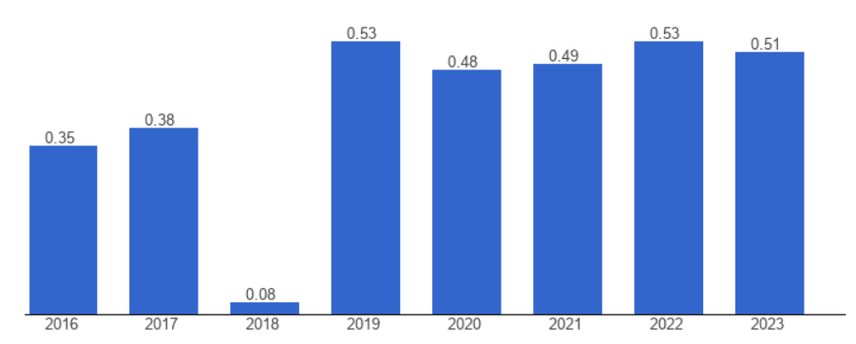
Figure 1: UK political stability index
(Source: The Global Economy, 2025)
The economy of Germany shows strong performance, which is based on the capacity to produce automobiles on a large scale. The decision-making in pricing, supply-chain localisation, as well as competitive positioning is influenced by these economic differences. The two markets are further distinguished by sociocultural factors especially on environmental expectations, mobility preference and brand preference of consumers. Consumers are focused on zero emissions and flexible mobility in the United Kingdom (GOV.UK, 2025).
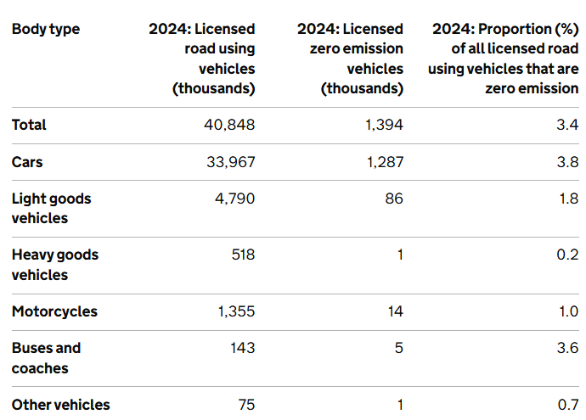
Figure 2: UK zero emission vehicles
(Source: GOV.UK, 2025)
Germany has brand loyalty and appreciation of engineering and increased conformity to the sustainability requirements of mobility. Through these sociocultural contexts, communication strategies, priorities of the product and the customer interactions framework are defined. The technological settings in the two countries are at an advanced stage but with varied levels of innovation ecosystems, infrastructural preparedness and integration in industries. The United Kingdom is putting in large-scale investment in battery technologies, together with charging networks to promote further electrification (Large, 2024). Germany has remained ahead in terms of technology by way of excellence in engineering, research centres and complete production centres.
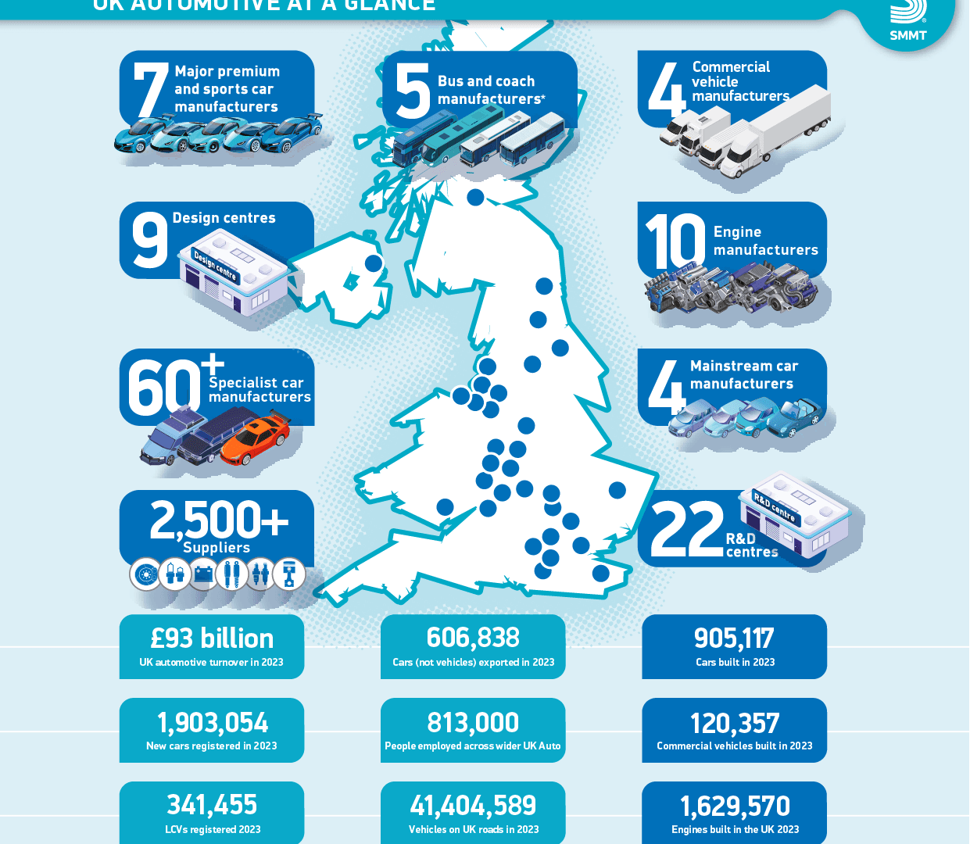
Figure 3: UK automotive performance
(Source: Large, 2024)
The technological environments have effects on innovation adoption, production efficiency and the opportunities of digital transformation. Two countries have legal environments that portray strict regulations, safety measures and emission-cutting regulations to reduce the sustainability challenges at a long-term partnership. Following the Brexit, the United Kingdom has variable regulatory frameworks influenced by local law making institutions (SMMT, 2025). Germany follows the standards set in the European Union closely and has impact on compliance issues and operational planning. Legal differences influence the process of homologation, reporting and general governance frameworks.
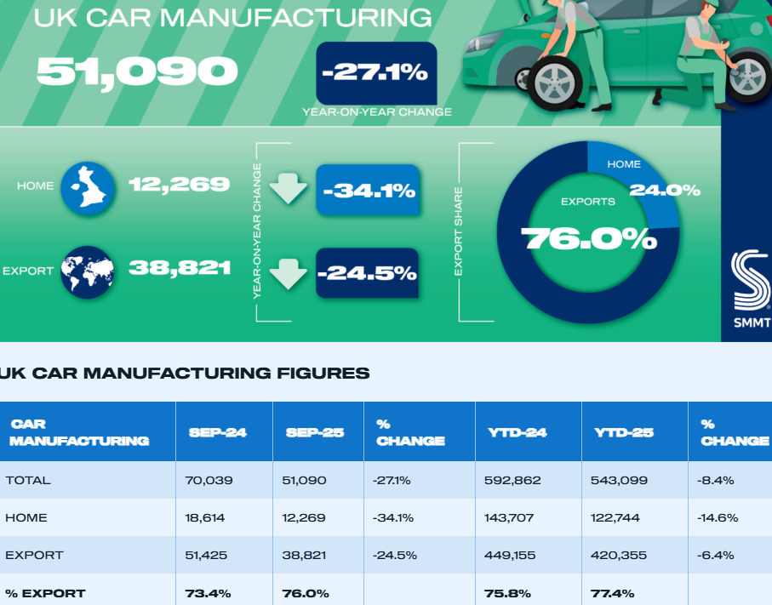
Figure 4: UK car manufacturing market
(Source: SMMT, 2025)
Due to the heightened climate promises and green demands, environmental factors become a central concern. Reduction of carbon emissions, encouraging electric mobility and redesigning transport systems are some of the priorities of the United Kingdom. Germany has a focus on industrial sustainability, circular production and large-scale pollution-cutting plans throughout the production networks. These are environmental pressures that affect the lifecycle strategies, the investment plan as well as the long term product planning strategies. The two markets are very environmental-conscious however, they have diverse regulatory levels. The process of electrification in the United Kingdom enhances rare market opportunities favouring early technology adoption.
The production strength of Germany gives it a strong base in production as a strategic manufacturing hub. The differences in politics require caution in the policy expectations and long-term government priorities. The difference in the economy demands strategic adjustments with regards to supply-chain resilience and investment in operations. Sociocultural disparities emphasise the necessity of regionalising messages and specific customer responses techniques. Technological differences highlight different innovation partnerships in the development of electric-vehicles and digital-mobilities. Legal differences need continuous surveillance of regulatory transformation to provide proactive regulatory adherence. The environmental expectations require that the operations be sustainable to national recommendations and the requirements of the society. Macroenvironmental conditions in both markets are attractive, structurally different and impact the automotive strategic planning. The knowledge of these comparative differences can help manufacturers make context-specific moves that will maximise their competitive advantage. (Refer to Appendix 1)

Country Comparison
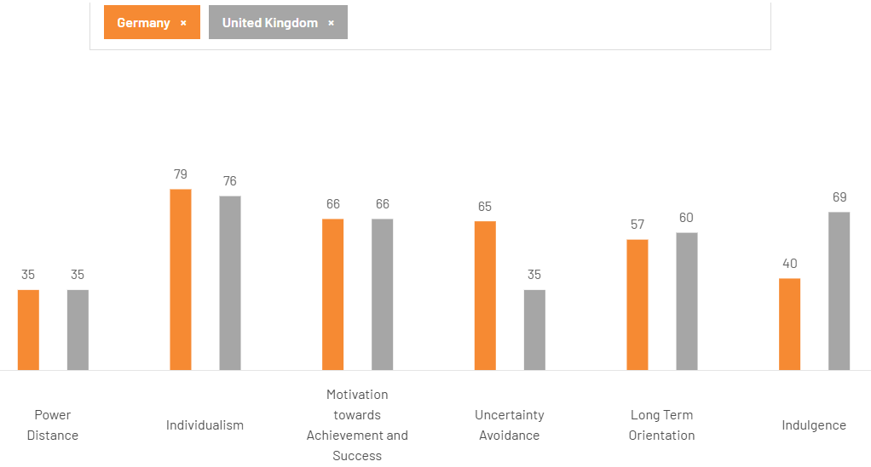
Figure 5: Country Comparison
(Source: The Culture Factor, 2025)
The cross-cultural comparison of United Kingdom and Germany indicates that there are distinct differences. In every market, employees demand to be treated rudely by the management and subjected to reasonable transparency. In both, individualism is reinforced and advocates individual ambition and free decision-making. Customers have been focusing on individual product experiences and self-expression. Both cultures place more importance on performance, ambition and success but motivation is expressed in a different way across the cultures. Germany is known to favour accuracy, uniformity and strict winning forward in the workplace (CEIC, 2022). The United Kingdom tends to offer pliable definitions of achievement that are related to adaptability. Management of uncertainly in the two countries shows significant differences in terms of culture. The United Kingdom follows rather permissive attitudes to uncertain situations and possible ambiguity. These disparities have an effect on consumer confidence, risk propensity and response towards new propositions.
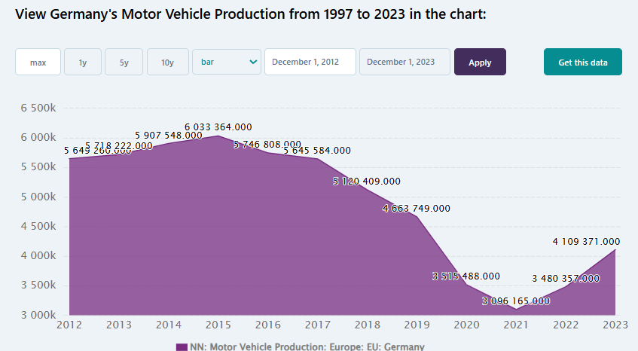
Figure 6: Germany’s motor vehicle production
(Source: CEIC, 2022)
Marketing communication should provide a balance between being understandable and creative based on the audience's inclination. Germany tends to have long-term development, visionary planning and long-term engagements (Bekker, 2023). The UK has been observed to have similar preferences of both tradition and the future at the same time in a rather balanced manner. The differences help to add to the different responses to technological change and sustainability efforts. Companies need to change the strategic communications and match to the national expectations and progressive priorities. The United Kingdom has a higher disposition towards entertainment and experience consumption. Germany exhibits relatively tempered manifestations of hedonistic desires and recreational ways of life.
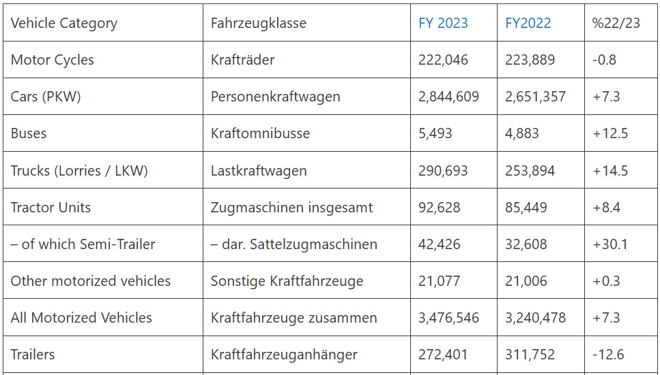
Figure 7: Vehicle market in German
(Source: Bekker, 2023)
Behavioural trends affect the marketing appeals based on luxury, comfort and experience. The knowledge of these culture differences facilitates appropriate making of successful global marketing strategies. Organisations should be aware of how certain cultural forces create perceptions, preferences and decision-making which are subtle. BMW which is operating both in the markets face a need of adapting the communication, branding and consumer engagement. German customers can respond positively to the methodical message that focuses on the competence of engineering (R&M, 2024). The United Kingdom can participate more in the adaptable messages with an emotional appeal. Existence of ways to synchronise cultural expectations and marketing strategies helps increase the resonance and the competitive positioning. Companies with cultural realities meeting adapted strategies realise better penetration and long-term operations.
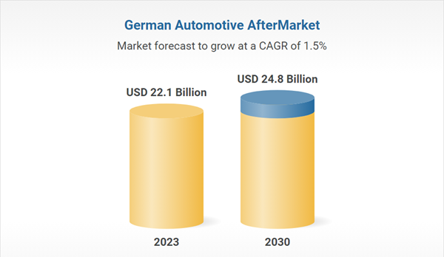
Figure 8: German automotive aftermarket
(Source: R&M, 2024)

Comparison of BMW’s STP Strategies in the UK and Germany

Segmentation
BMW divides the market in the United Kingdom based on its demographic, psychographic, behavioural and geographic factors. In terms of demographics, in 2023, BMW and MINI together registered 159,328 units in the UK in the premium-automotive segment, which is associated with increased growth (BMW Group, 2024a). The UK buyers are psychographically focused on innovation, sustainability, high-end brand experience and convenience. In terms of behaviour, customers in the UK are growing their consumption of electrified vehicles, 28723 all-electric BMW units in 2023, a 34% annual growth (BMW, 2025). In terms of geographics, BMW UK targets cities (hotspots, London, South East) and high-income commuter belts. German consumers are psychographically oriented towards engineering perfection, brand background and performance lettering, which are deeply entrenched in their national culture. In terms of behaviour, German BMW registrations in 2023 reached 233,160 units, which is a positive year-over-year increase of +11.2% (Marklines, 2023). In terms of geography, Germany's segmentation will be done in all the federal states, concentrates on the manufacturing and affluent regions of Bavaria and Baden-Württemberg. The segmentation structures are nation-specific because the UK focuses on younger, urban, tech-savvy consumers. Germany focuses on old establishment loyal consumers with legacy brands and performance-focused products.
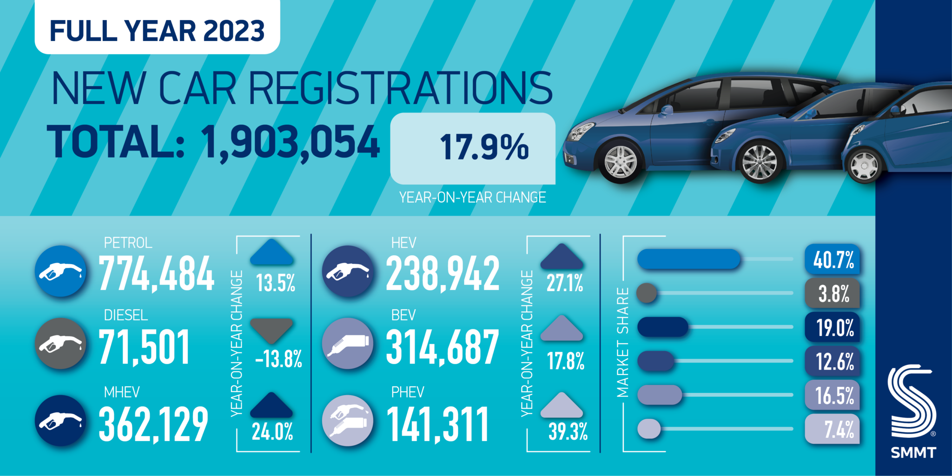
Figure 9: UK new carregistrations
(Source: Large, 2024a)

Targeting
BMW is appealing to the mobile life and premium electrified mobility of affluent professionals in the UK market aged 35-55 years old. UK targeting focuses on the tech-savvy young early-adopters, who value the technology of BEV and sustainable mobility. In the UK BMW is oriented at corporate fleet customers and it has been awarded as Fleet Manufacturer of the Year for five years in a row (BMW, 2025b). The German targeting varies and incorporates performance enthusiasts as a new BMW M sub-brand as well as family oriented premium SUV buyers from the metropolitan areas. The targeting strategies are based on the market maturity: UK focuses on future-oriented electrification and lifestyle branding, whereas Germany focuses on the heritage, performance and domestic manufacturing roots.
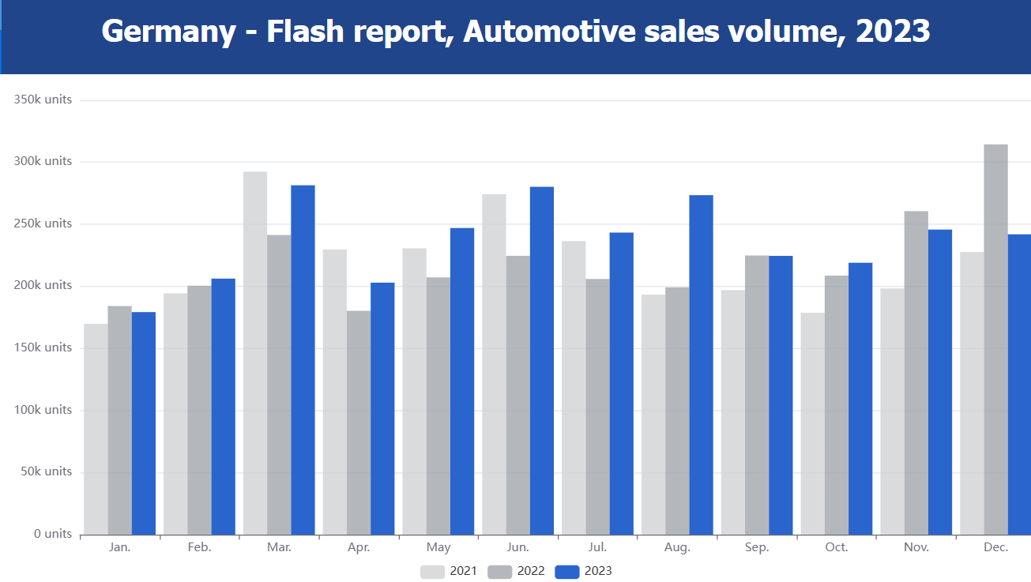
Figure 10: German automotive sales
(Source: Marklines, 2023)

Positioning
In the UK, BMW markets itself as queer Driving Pleasure Meets Electric Future with focus on innovation, leadership in EV and luxury lifestyle. UK brand messaging is aimed at high-tech design, connectivity, sustainability and the experience of being owned (Large, 2024a). BMW is recognised by customer perception as market leader in the UK as a premium brand with BEV development. 125,265 units of BMW in the UK were registered in 2024 up 12%. Germany's positioning puts an accent on “Engineering Excellence + Premium Heritage” referring to German culture, technological advancement and domestic production of BMW. German brand messages emphasise on the accuracy of the engineering, the customs of performance, the production in Munich and Bavaria and the tradition of continuity. In Germany, customer perception places BMW very squarely within the top premium marques, as German new car markets registered 2,844,609 cars in 2023 up 7.3% (Bekker, 2023). According to the positioning map of Germany, BMW occupies a top position in terms of engineering reputation and premium performance and acquires electrification qualities steadily. Brand messaging differences UK advertisement focuses on lifestyle, freedom of mobility and sustainability. (Refer to Appendix 3)

Comparison of BMW’s Marketing Mix (7Ps) in the UK and Germany

Product Strategy
BMW UK comes with a well-developed range of petrol, hybrid and electric vehicles. The UK BEV sales have risen to 381,970 cars in 2024 (S&P Global, 2025). In Germany, the BEV registration in 2024 amounted to 380,609 units, which was a share of 13.5 (European Commission, 2025). BMW Germany puts a strong focus on locally-made models that are customised in terms of high-performance and precision engineering. The safety standards of the UK are in line with European and UK-based testing regimes and consumer safety standards. The German safety and technical feature package is demonstrating stringent engineering and high driver help technology based on local anticipation. The UK local customisation covers right-hand drives, UK hot-climate specifications and personalised features to make an urban purchase. Germany localisation focuses on the German driving dynamics, high-speed motorway performance and tuning to the local high-end customers.
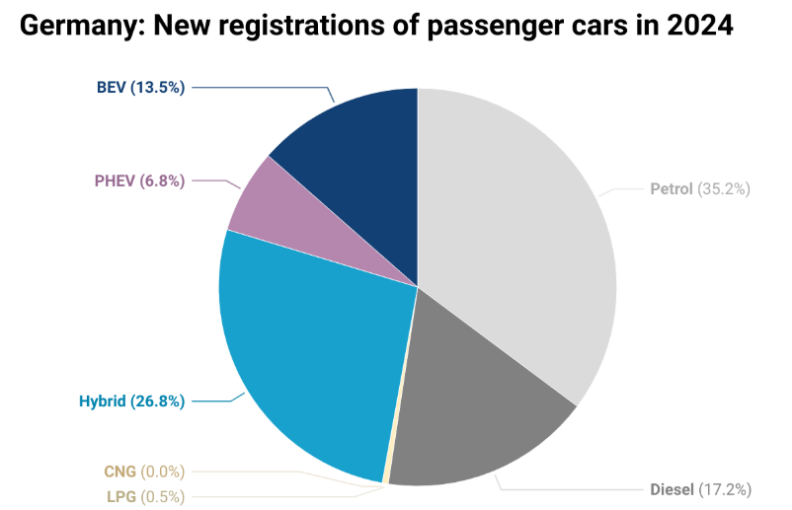
Figure 11: German new registration of passenger cars
(Source: Marklines, 2023)

Price Strategy
BMW UK holds high premium prices in keeping with brand's luxurious positioning in the UK market. Taxation, inflation and other competitive premium marques influence the UK pricing. In the case of BMW Germany, they are applying an equally premium pricing system; however, they utilise positive domestic brand loyalty and reduced cost burden of import-dependency. Value-added tax, vehicle excise duty and insurance premiums are part of ownership costs in the UK, which strain the price strategy. The buyers of Germany have alternative tax systems and insurance conventions, which allow a more stable pricing in the long run. The UK market demonstrates that 19.6% of automobile systems will be in 2024 (S&P Global, 2025). The scale and pricing power in exports. The size and pricing power in German car exports in 2024 were US$40.6 billion. Strategies of premium pricing should thus be moderated to value perception, service offering as well as local cost structures.

Place (Distribution)
BMW UK has a wide system of showrooms as well as official dealerships that encompass most areas of the UK. The UK online sales channels are rapidly expanding and online configurators are now a matter of standard as well as home delivery. The UK market is comprised of imported models through UK ports, warehousing and distribution centres of the country. BMW Germany has the advantage of its manufacturing plants and it can easily distribute the product to domestic dealerships. The German infrastructure is effective in supporting deliveries and servicing with short domestic supply chains and optimised logistics in Germany (Ibrahim, 2025). The place strategies indicate the geographic infrastructure of each country, the purchasing channels and brand service promises of the consumers.

Promotion
BMW UK promotional messages focus on electrification, the message of luxury lifestyle and sustainability to appeal to the UK consumers. The UK advertisements and social media emphasise innovation, connectivity and high-quality brand experience in the urban markets. The UK has some cultural differences such as the focus on the urban lifestyle, online interaction and the younger and more affluent population. The target of the promotion of BMW Germany is to host engineering heritage, performance and German craftsmanship in their communications. The usage of social media in Germany is based on technical specifics, stories of brand heritage and fan life groups. In the UK, business-sector fleets registered an improvement by 11.8% in 2024, the promotion of business customers (Keywood, 2025). Promotion is market-customised to promote cultural preferences, as well as channel behaviours.

People
BMW UK sales personnel training is focused on digital advisory, EV knowledge and high-level customer experience. UK service staff emphasise convenience to customers, hospitality and customised purchasing experiences among the high-end consumers. Training of staff at BMW in Germany is aimed at strong technical competence, engineering knowledge and performance model knowledge. German service experience focuses more on being precise, reliable and efficient to ensure high customer expectations (Witkowski and Wolfinbarger, 2025). UK services are ensuring the smooth servicing, mobile booking and premium lounge services. Technical mastery, high-end maintenance, quick diagnostics and after-sales services are the priorities of German. Recruiting and training in the two markets below echoes the local requirements of staffing of luxury brands and the service levels of the brands.

Process
The service processes in the UK are focused on online reservation and mobile servicing and customer feedback technologies. The UK post-sales processes are made convenient and flexible pick-up services as well as subscription services are becoming a reality. Germany's service process focuses on accuracy in engineering, diagnostic completeness and direct customer engagement in accordance with German standards of the high-end brand. The UK process innovations show wider tendencies of digital and mobility services in the British market (GOV.UK, 2025a). German processes are an indication of the high-quality automotive servicing expectations of the traditional past. The process strategies in the two markets should be in line with local behaviours, regulatory demands and brand expectations of the service delivery of luxury.

Physical Evidence
The showrooms of BMW UK are built to create modern high-end brand impressions with a high focus on digital and clean, experience-oriented spaces. The UK showrooms are integrated with EV-zones, digital configurators and lifestyle displays, specifically aimed at the affluent city clients. The BMW Germany showrooms focus on luxury heritage, display of technology and performance-oriented areas that reflect German engineering identity. German showrooms can have high test tracks, driving simulators and performance demonstration activities as a symbol of brand strength (Braidy, Pokharel and ElMekkawy, 2025). The consistency of branding in both markets is essential, which has to offers international BMW visual identity and service standards. UK physical evidence accentuates lifestyle assimilation, superior hospitality and trendy cityscape as per UK market anticipations. In Germany, the emphasis of physical evidence is on engineering heritage, performing image and brand heritage, which shows national consumer culture. Brand promise is delivered tangibly to suit the market culture of any specific country, with the physical evidence component. (Refer to Appendix 4)

Evaluation of the Performance of BMW’s Marketing Strategies

UK Market Performance
In 2024, BMW UK gained well performance in the market, which is an indication of effective marketing. BMW UK recorded 125,265 registrations, which is an increase of 12% (BMW, 2024). In 2024, the brand had a share of 22.6% in the premium car segment in the UK. BMW held 20.4% of the total premium BEV market share in the UK in the premium battery-electric vehicle market (Miles, 2025). These values indicate the successful orientation of product, pricing, digital and service strategies that BMW achieves. The performance of dealerships in the UK is good, the network of retailers mentioned a high level of satisfaction with digital innovations and EV counselling. The Customer satisfaction rates demonstrate the increased loyalty and repeat purchases decisively revealed to the entire community. According to social-media metrics, the UK level of activity is very high and the lifestyle-oriented campaigns are working with younger urban professionals. The concentration on electrification, urban experts and the integration of digital services in the UK strategy seems to be a fruitful endeavour. The UK macro-economic strains like inflation, disruption of the supply chain and regulatory unpredictability limit the expansion of the markets. The BMW UK marketing mix capitalises on the position as a high-quality of life, high-end EV and customer satisfaction with a smooth customer experience both digitally and physically. BMW UK is highly performing in terms of share, volume, EV penetration and branding measures compared to several others.

International distribution intensity approach
The international distribution intensity approach consists of the three main types of distribution which all have different market strategies. These strategies can be a good explanation for seeing how BMW's international marketing is done and who the target consumers are in the important regions such as the UK and Germany. BMW, on the other hand, is not a candidate for intensive distribution, which is a practice reserved for the mass-market products, since it has a luxury image that relies on selective and exclusive distributions. The company has an elaborate network of dealers with whom it has exclusive agreements and high service standards in order to protect the prestige of the brand (BMW, 2024a). Through this practice, BMW not only reinforces its market position and consistency of the global brand but also takes care of the regional market's changing needs. Thereby, the company’s strategic aims are supported in the different international markets where the company operates.

German Market Performance
In Germany, BMW position three in the full-year rating of brand sales in the domestic market after Volkswagen and Mercedes-Benz. BMW recorded a market share of 9.3% and 22,540 units in the new car market in Germany in April 2024 (Marklines, 2023). Germany was the home market of BMW, the macro-economic headwinds and competition were a threat to its growth. There is growing penetration in EVs in Germany and BMW Germany enjoys a domestic manufacturing base. Using customer satisfaction surveys indicates that BMW has high ratings in technical quality however, greater competition in terms of brand perception with rivals Audi and Mercedes-Benz at home. The rise of social media in Germany focuses on performance traditions and engineering depth, as opposed to urban life, which could restrict the younger audience. In Germany, competitive strength is stable and facing pressure. The competition between German premium brands is fierce and BMW's domestic manufacturing power is increasingly being questioned by the new EV developments. In Germany, the marketing approach is continued with engineering excellence, heritage and high performance, as opposed to lifestyle or digital-first marketing approaches.

Comparative Analysis and Key Metrics
In the two comparison countries, it can be seen that BMW UK is performing better in terms of relative growth, expressing a bigger share in the premium segment, and momentum in EV-adoption. In Germany, BMW has a great brand legacy and manufacturing foundation however, challenging competitive environments and reduced growth of the market. BMW UK has a strategic advantage because of the market penetration of EVs in the UK which has been a result of regulatory compulsion as well as consumer willingness in the urban frontier (Ozan, 2024). In the meantime, the older premium ecosystem of Germany is advantageous yet could hold it back in quick repositioning to newer mobility models. The networks of dealerships of both nations are very strong, the networks of dealerships in the UK have some slight benefits in the attraction and retention of customers due to digital transition and lifestyle branding. The social-media strategies split UK social-media approaches are more lifestyle and EV-innovation sentiments, whereas Germany presents a more heritage- and performance-centric approach, with the UK approaches possibly being considered more future-proofed. BMW UK seems to win over similar-positioned competitors far better than BMW Germany could do in Germany. Findings in the German market demonstrate the presence of stability and strength of the brand, yet less dynamic growth in the key areas like EV and younger consumer reach. The UK market is more favourable to BMW because it has better growth, segment share and electronic service trends compared to Germany.

Evaluation of Market Leadership Across Both Countries
The UK marketing plans of BMW are now more effective and yielding greater growth, shares and EV success. The regulatory environment provided by the UK environment towards electrification, the acceptance of premium EVs by consumers and the positioning decided by BMW, which is highly unique towards the premium segment are all well positioned to grow. BMW is a premium brand leader and has manufacturing quality in Germany with saturation of the market, heavy domestic competition and in consumer transition rates. The UK represents the best performance, BMW has applied its marketing mix more forcefully towards electrification, digital service and lifestyle positioning, which is highly appealing to the urban affluent consumers in the UK. EV market penetration, digital engagement and competitive advantage the UK market is providing better performance to BMW. Germany remains strategic regarding the performance in marketing within the 7Ps perspective, the UK is leading at the moment.

Evaluation of Marketing Ethics Practices

Advertising and Pricing Transparency
Advertising BMW has been criticised for making false claims on its environmental and performance claims severally times. In August 2023, in the UK, one advertisement was banned due to the claim of zero emissions, which it asserted to be false (ET, 2024). Pricing transparency also creates ethical concerns on the over-pricing of premium brands, products with optional features and terms of financing promotions. The compliance structures used in BMW focus on responsible practices; these cases indicate the discrepancies between the responsible conduct policy and the practice. Straight communication regarding prices and claims about the environment is essential towards being ethically credible and winning the trust of consumers.

Environmental Claims and Greenwashing
BMW advertises electric and sustainability in the US and the German market is under scrutiny. BMW was criticised by the activists on its billboard campaigns that depicted it as having a full green status in terms of issues, production and material emission. More than 77 million pounds on ten automobile manufacturers such as BMW by the UK regulator discovered covert action in the field of green advertising (Goodley, 2025). However, BMW under-reports lifecycle emissions, downstream environmental impacts and this casts appropriate doubts on green-washing. The sustainability pledge of BMW should correspond to the quantifiable indicators to prevent reputational and regulatory risk.

Data Privacy and Safety Communication
The connected-vehicle era BMW is gathering and analysing huge amounts of car and individual data in marketplaces. The data-privacy statement of BMW reinforces Privacy by Design, user-controllability and GDPR all around the world. Ethics are reflected in BMW policies, the practices of device-and-user-data reflect the presence of weaknesses. Free and accountable communication regarding vehicle capability, information management and safety is ethically mandatory in both nations.

Supply Chain Issues and Comparative Context
The ethics of the BMW supply chain are questioned in terms of human rights, environmental ethics and materials sourcing, in both global operations. BMW's domestic production in Germany can have more powerful control due to the domestic manufacturing, there is an ethical risk of the upstream sourcing of raw materials and global logistics. The UK context factors in that imported components provide complexity of the supply chain and ethical risk of indirect sourcing. Ethical requirements require a uniform adherence, correction processes and complete disclosure via all levels of the supply network.

Ethical Evaluation
BMW has institutionalised compliance and ethics frameworks, such as a company-wide Code of Conduct and compliance system, which encompasses human rights and data privacy. Nevertheless, various regulatory and activist interventions by the public indicate that in some cases, practice and promise are out of sync in advertising, pricing transparency, supply-chain and data-privacy areas. BMW has been publicly fined and ruled guilty of deceptive advertising in the UK and Germany. There exist significant gaps in policy in terms of implementation, despite the strength of policy in data privacy and safety communication. The ethics of the supply chain are a contentious issue due to global complexity and indirect sourcing risks.
BMW tends to address most of the ethical requirements regarding disclosure and policy, real performance differs based on geography, reassurances and stakeholders' perception. The German domestic setting has better brand control and domestic controls, the global sourcing brings about exposure to problems (Mardenli et al., 2025). The UK market is highly regulated and with changing consumer demand for transparency, digital services ethics and claims of sustainability. In Germany as regards supervision and heritage-based governance, the case in the UK portrays greater regulatory intervention and more demand for transparency.
BMW possesses sound ethical systems, requires more investment in the linkage between policy and practice in both markets. The contexts of the UK and Germany introduce ethical challenges that are differentiated because the UK requires strict transparency and consumer protection, whereas Germany insists on the engineering quality and global supply-chain complexity. To address the complete ethical expectations, BMW should provide proper and stable communication, clear pricing, disclosure of the lifecycle environmental impacts, solid data-privacy protection and supply-chain remediation (Keywood, 2025). This can lead to loss of reputation, regulatory penalties and decreasing consumer confidence in either nation in case of failure to do so.

Recommendations & Conclusion

Recommendation

Market Strategy Improvements
Corporate fleet strategies should be increased at BMW the registration of more than 300,000 vehicles each year. This will allow building stronger business involvement and faster adoption of premium professional customer segmentation (BMW Group, 2024b). Germany needs more penetration of the company into engineering-oriented organisations which value reliability and performance properties as their top priorities. The provision of custom leasing schemes will enhance brand loyalty and promote the luxury image of BMW in the various markets. Retailing relationships within the region ought to be reinforced through dealership presence to make customers more accessible at all times. This can be improved strategically, yielding competitive exposure and dynamic ability in changing European car-driving landscapes.
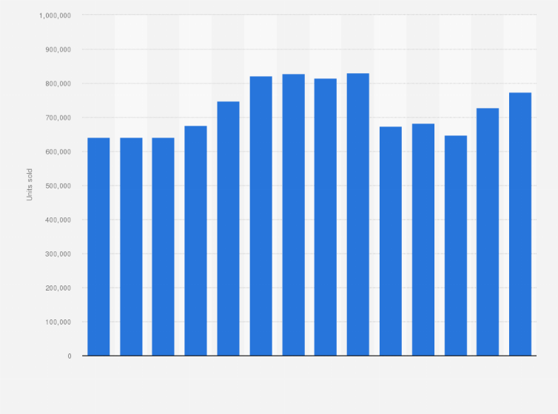
Figure 12: BMW car sales
(Source: Statista)

EV Penetration Strategy
The decision to hasten the adoption of EVs should be made by BMW since Reuters reported that the European BEV demand changed 15%. The two markets demand price elasticity that will make them affordable and maintain the perception of the luxury brands (BMW, 2024). BMW must focus on the benefits of total-cost-ownership to convince the reluctant customers who are weighing between electric mobility. The collaboration with charging providers is needed to build the infrastructure trust and brand reputation competently. Local energy-collaboration programmes are to encourage integration of renewable energy that would help wider sustainability transformation goals in the region. Enhancing EV promotional activities will also raise the awareness of more customers and position BMW more favourably in electrification.

Digital Marketing and Cultural Adaptation
BMW needs to reinforce virtual-showroom environments that provide engagements where digitally involved customers can experience configuration experiences across the world. The UK digital approaches are recommended to emphasise the benefits of a lifestyle that would attract the young urban demographic, particularly often. The German digital communication must focus on engineering accuracy in the form of interactive content based on performance-based consumer expectations. Cultural adjustment is important mentioned that more than half of the buyers attach great importance to culturally appropriate messaging (Novotny et al., 2022). Localising the storytelling to the interests of the nation will make it more locally relevant and maximally effective on a campaign level. The combined cross-market online ecosystems will help enhance engagement and assist in creating the consistent growth of the international brands.

CSR and Ethical Improvements
BMW needs to enhance visibility in terms of the supply-chain sourcing, reporting on emissions and strictness in human-rights adherence. The release of the sustainability dashboard every year will boost the sustainability confidence of stakeholders in the environmentally sensitive high-end motor industry products worldwide. Minimised risks linked to regulatory inspection and false environmental reporting entail stronger green-communication practices. Ethical supply-chain management is important due to the fact that indicated that there are 1,000 audits per year in major manufacturers (Yu et al., 2023). BMW needs to extend corrective-action systems that provide accountability to sophisticated international networks of suppliers. Enhanced CSR commitment enhances plausibility and increases the competitive advantage of BMW under responsible car leadership.

Conclusion
This report revealed the way BMW can implement its strategies in different UK and German markets. Segmentation, difference in targeting and positioning that affects consumer behaviour and competitive performance were identified in the analysis. Marketing mix analysis revealed high congruence with cultural anticipations and business forces. EV strategies revealed that there are considerable opportunities that would need specific enhancement in both national settings. Ethical evaluation showed areas of strength and revealed areas of serious weaknesses that the organisation should focus on at all times. The comparison of performance revealed higher UK growth based on digital innovation and electrification. Germany is imperative because of its production background and engineering-based brand images. In sum, international marketing allows BMW to have a sustained competitiveness in various changing global automotive conditions.

Reference List
Bekker, H. (2023) 2023 (Full Year) Germany: Car Market Overview and Analysis - Car Sales Statistics, www.best-selling-cars.com. Available at: https://www.best-selling-cars.com/germany/2023-full-year-germany-car-market-overview-and-analysis/ (Accessed: 30 October 2025).
BMW (2020) The history behind the BMW slogan ‘Sheer Driving Pleasure’ | BMW.com, www.bmw.com. Available at: https://www.bmw.com/en/automotive-life/the-history-of-the-bmw-slogan.html (Accessed: 30 October 2025).
BMW (2024) BMW Group UK Leads the Premium Segment in 2024 with Strong Electric Growth., BMW Group PressClub. Available at: https://www.press.bmwgroup.com/united-kingdom/article/detail/T0447261EN_GB/bmw-group-uk-leads-the-premium-segment-in-2024-with-strong-electric-growth?language=en_GB (Accessed: 30 October 2025).
BMW (2024a) BMW-Group-Report-2024 [Online] Available at: https://www.bmwgroup.com/en/report/2024/downloads/BMW-Group-Report-2024-en.pdf (Accessed: 30 October 2025).
BMW (2025a) BMW Group posts third-quarter sales growth, Bmwgroup.com. Available at: https://www.press.bmwgroup.com/united-kingdom/article/list/809 (Accessed: 30 October 2025).
BMW (2025b) BMW UK secures top honours at the Business Car Awards 2025., BMW Group PressClub. Available at: https://www.press.bmwgroup.com/united-kingdom/article/detail/T0452742EN_GB/bmw-uk-secures-top-honours-at-the-business-car-awards-2025 (Accessed: 30 October 2025).
BMW Group (2023) BMW Group UK 2023 Sales Growth Driven by All-Electric Model Range, BMW Group PressClub. Available at: https://www.press.bmwgroup.com/united-kingdom/article/detail/T0438949EN_GB/bmw-group-uk-2023-sales-growth-driven-by-all-electric-model-range?language=en_GB& (Accessed: 30 October 2025).
BMW Group (2024a) A successful 2023: BMW Group posts record sales, meets ambitious e-mobility growth targets, www.press.bmwgroup.com. Available at: https://www.press.bmwgroup.com/global/article/detail/T0438999EN/a-successful-2023:-bmw-group-posts-record-sales-meets-ambitious-e-mobility-growth-targets?language=en (Accessed: 30 October 2025).
BMW Group (2024b) BMW Group maintains BEV growth path in challenging market situation in 2024, BMW Group PressClub. Available at: https://www.press.bmwgroup.com/global/article/detail/T0447427EN/bmw-group-maintains-bev-growth-path-in-challenging-market-situation-in-2024?language=en (Accessed: 30 October 2025).
BMW Group (2025a) BMW Group History, BMW Group. Available at: https://www.bmwgroup.com/en/company/history.html (Accessed: 30 October 2025).
BMW Group (2025b) BMW Group profitability in line with expectations in first quarter, BMW Group PressClub. Available at: https://www.press.bmwgroup.com/global/article/detail/T0449978EN/bmw-group-profitability-in-line-with-expectations-in-first-quarter?language=en (Accessed: 30 October 2025).
Braidy, A., Pokharel, S. and ElMekkawy, T.Y. (2025) ‘Research Perspectives on Innovation in the Automotive Sector’, Sustainability, 17(7), p. 2795. Available at: https://www.mdpi.com/2071-1050/17/7/2795 (Accessed: 30 October 2025).
CEIC (2022) Germany Motor Vehicle Production, 1997 – 2022 | CEIC Data, www.ceicdata.com. Available at: https://www.ceicdata.com/en/indicator/germany/motor-vehicle-production (Accessed: 30 October 2025).
ET (2024) Electric cars can’t advertise as ‘zero emissions’: UK body, ETEnergyworld.com. AFP. Available at: https://energy.economictimes.indiatimes.com/news/power/electric-cars-cant-advertise-as-zero-emissions-uk-body/107514434 (Accessed: 30 October 2025).
European Commission (2025) Germany: BEV market share at 13,5% | European Alternative Fuels Observatory, Europa.eu. Available at: https://alternative-fuels-observatory.ec.europa.eu/general-information/news/germany-bev-market-share-135 (Accessed: 30 October 2025).
Global Economy (2024) Germany Political stability - data, chart | TheGlobalEconomy.com, TheGlobalEconomy.com. Available at: https://www.theglobaleconomy.com/Germany/wb_political_stability/ (Accessed: 30 October 2025).
Goodley, S. (2025) UK regulator fines 10 carmakers and two trade bodies over green ad collusion, the Guardian. The Guardian. Available at: https://www.theguardian.com/business/2025/apr/01/uk-regulator-fines-10-carmakers-and-two-trade-bodies-over-green-ad-collusion.
GOV.UK (2025a) The Wider Economic Impacts of Emerging Technologies in the UK (HTML), GOV.UK. Available at: https://www.gov.uk/government/publications/the-wider-economic-impacts-of-emerging-technologies-in-the-uk/the-wider-economic-impacts-of-emerging-technologies-in-the-uk-html (Accessed: 30 October 2025).
GOV.UK (2025b) Vehicle licensing statistics, United Kingdom: 2024, GOV.UK. Available at: https://www.gov.uk/government/statistics/vehicle-licensing-statistics-2024/vehicle-licensing-statistics-united-kingdom-2024 (Accessed: 30 October 2025).
Ibrahim (2025) Logistics Industry in Germany: Insights and Opportunities, Duscons.com. Available at: https://duscons.com/logistics-industry-in-germany-insights-and-opportunities/ (Accessed: 30 October 2025).
ITA (2024) Germany Electric Vehicles and Charging Infrastructure, International Trade Administration | Trade.gov. Available at: https://www.trade.gov/market-intelligence/germany-electric-vehicles-and-charging-infrastructure (Accessed: 30 October 2025).
Keywood, S. (2025) Fleets credited for annual UK car registrations growth and record EV take-up - Business Car, Business Car. Available at: https://www.businesscar.co.uk/news/fleets-credited-for-annual-uk-car-registrations-growth-and-record-ev-take-up/?cf-view (Accessed: 30 October 2025).
Large, P. (2024a) New car market delivers best year since 2019 as fleets fuel growth - SMMT, SMMT. Available at: https://www.smmt.co.uk/new-car-market-delivers-best-year-since-2019-as-fleets-fuel-growth/.
Large, P. (2024b) SMMT Motor Industry Facts 2024 - SMMT, SMMT. Available at: https://www.smmt.co.uk/smmt-motor-industry-facts-2024/ (Accessed: 30 October 2025).
Leggett, T. (2025) ‘Germany’s car industry crisis - this is what may fix it’, bbc, 12 February. Available at: https://www.bbc.com/news/articles/cz6pzwj6qq7o (Accessed: 30 October 2025).
Mardenli, A., Sträter, K.F., Herrmann, C. and Sackmann, D. (2025) ‘The German Act on Corporate Due Diligence Obligations in supply chains: An empirical assessment of the agri-food supply chain based on experts’ perspectives’, Cleaner Logistics and Supply Chain, p. 100239. Available at: https://doi.org/10.1016/j.clscn.2025.100239.
Marklines (2023) Germany - Flash report, Automotive sales volume, 2023 - MarkLines Automotive Industry Portal, www.marklines.com. Available at: https://www.marklines.com/en/statistics/flash_sales/automotive-sales-in-germany-by-month-2023 (Accessed: 30 October 2025).
Miles, T. (2025) BMW Group UK sees strong electric growth in 2024 - MM Media, Machinery Market. Available at: https://www.machinery-market.co.uk/news/38890/BMW-Group-UK-sees-strong-electric-growth-in-2024 (Accessed: 30 October 2025).
Murray, A., Harari, D., Webb, D., Ilze Jozepa, Booth, L. and Tyers, R. (2025) Government support for employment in the automotive manufacturing sector, House of Commons Library. Available at: https://commonslibrary.parliament.uk/research-briefings/cdp-2025-0093/ (Accessed: 30 October 2025).
Novotny, A., Szeberin, I., Kovács, S. and Máté, D. (2022) ‘National Culture and the Market Development of Battery Electric Vehicles in 21 Countries’, Energies, 15(4), p. 1539. Available at: https://doi.org/10.3390/en15041539.
Ozan, S. (2024) BMW’s Strategic Surge in the Electric Vehicle Market: A 2024 Mid-Year Review, ReportLinker. Available at: https://www.reportlinker.com/article/7253.
Prez, M. de (2022) UK car finance debt soars to £40bn, www.am-online.com. Available at: https://www.am-online.com/news/finance/2022/11/02/uk-car-finance-debt-soars-to-40bn (Accessed: 30 October 2025).
R&M (2024) Germany Automotive Aftermarket Size, Share & Trends Analysis Report 2024-2030, GlobeNewswire News Room. Research and Markets. Available at: https://www.globenewswire.com/news-release/2024/11/20/2984191/28124/en/Germany-Automotive-Aftermarket-Size-Share-Trends-Analysis-Report-2024-2030.html (Accessed: 30 October 2025).
Reuters (2025) ‘UK new car sales rise in 2024 but miss EV target, industry data shows’, Reuters, 6 January. Available at: https://www.reuters.com/world/uk/uk-new-car-sales-rise-2024-industry-data-shows-2025-01-06/ (Accessed: 30 October 2025).
S&P Global (2025) UK DATA: EV sales reach record high of 381,970 units in 2024, S&P Global Commodity Insights. Available at: https://www.spglobal.com/commodity-insights/en/news-research/latest-news/metals/010625-uk-data-ev-sales-reach-record-high-of-381970-units-in-2024 (Accessed: 30 October 2025).
Sattar, S.B. (2022) Pricing Strategies of Mercedes-Benz, The Strategy Watch. Available at: https://www.thestrategywatch.com/pricing-strategies-mercedes-benz/ (Accessed: 30 October 2025).
SMMT (2025) UK Car Manufacturing & Production Data | UK Car Exports Statistics | SMMT, SMMT. Available at: https://www.smmt.co.uk/vehicle-data/car-manufacturing/ (Accessed: 30 October 2025).
Statista (2025) Shared Mobility - Germany | Statista Market Forecast, Statista. Available at: https://www.statista.com/outlook/mmo/shared-mobility/germany?srsltid=AfmBOoqnJnVGhhZg3J3lsDfNEAnlkHOdgwAp2ahCj5zblPCkhlV9rg9N (Accessed: 30 October 2025).
The Culture Factor (2025) Country comparison tool, Theculturefactor.com. Available at: https://www.theculturefactor.com/country-comparison-tool?countries=germany%2Cunited+kingdom (Accessed: 30 October 2025).
The Global Economy (2025) United Kingdom Political stability - data, chart | TheGlobalEconomy.com, TheGlobalEconomy.com. www.theglobaleconomy.com. Available at: https://www.theglobaleconomy.com/United-Kingdom/wb_political_stability/ (Accessed: 30 October 2025).
Witkowski, T.H. and Wolfinbarger, M.F. (2025) ‘Comparative service quality: German and American ratings across service settings’, Journal of Business Research, 55(11), pp. 875–881. Available at: https://doi.org/10.1016/s0148-2963(01)00206-5.
Yermolenko, H. (2025) Car production in Germany amounted to 4.1 million units in 2024, GMK. GMK.CENTER. Available at: https://gmk.center/en/news/car-production-in-germany-amounted-to-4-1-million-units-in-2024/ (Accessed: 30 October 2025).
Yu, Y., Xu, J., Huo, B., Zhang, J.Z. and Cao, Y. (2023) ‘The impact of supply chain social responsibility on sustainable performance’, Journal of Cleaner Production, 385, p. 135666. Available at: https://doi.org/10.1016/j.jclepro.2022.135666.

Appendices
Appendix 1: PESTLE for the automotive industry in the UK
Factor | Description relevant to the UK automotive industry | Evidence
Political | UK government policies push for zero-emission vehicles and greater localisation of supply chains. | The motor vehicle manufacturing industry contributed £21 billion or 0.9 % of UK economic output in 2024 (Murray et al., 2025). UK political stability was 0.51 in 2023 (The Global Economy, 2025).
Economic | Automotive manufacturing & exports remain key economic contributors despite production decline. | Automotive-related manufacturing in the UK had a turnover of £93 billion and a value added of £22 billion.
Sociocultural | Consumer shift to electric vehicles and changing mobility preferences affect demand and brand strategy. | At the end of December 2024, there were 1,394,000 licensed zero-emission vehicles in the UK (3.4 % of all road-using vehicles) (GOV.UK, 2025).
Technological | Rapid advancement in EV, battery, autonomous and connectivity tech demands industry adaptation. | The UK produced 905,117 cars, 120,357 commercial vehicles and 1.6 million engines in 2023 (Large, 2024).
Legal | Regulations, including emissions mandates, trade agreements and manufacturing, impact the UK auto industry. | UK new car registrations grew about 2.6 % to 1.95 million units in 2024 (Reuters, 2025).
Environmental | Pressure for sustainability, emissions reduction and life-cycle impacts shape strategic decisions. | UK vehicle production in 2024: car exports down 15.5% to 603,565 units, representing 77.4% of total production (SMMT, 2025).

Appendix 2: PESTLE for the automotive industry in Germany
Factor | Key implications for Germany’s automotive industry | Evidence
Political | Government industrial policy supports EV & mobility transition, but regulatory burden increases. | Automotive manufacturing in Germany accounts for 6% of GDP (Leggett, 2025). Germany's political stability was 0.59 in 2023 (Global Economy, 2024).
Economic | Production and export remain critical, but growth is uneven and competition is rising. | Germany produced 4,109,371 motor vehicles in 2023 (CEIC, 2022).
Sociocultural | Consumer behaviours shifting: EV uptake, mobility services, changing brand attitudes. | New passenger-car registrations in Germany in 2023 were 2,844,609, up 7.3% (Bekker, 2023).
Technological | Strong innovation in EVs, batteries and connectivity; supply-chain pressures remain. | Germany’s plants manufactured almost 4.1 million passenger cars in 2024 (Yermolenko, 2025).
Legal | Emission mandates, EU regulations and trade rules have a considerable effect on the operations of the companies. | 2023 export car volumes from German plants: 3,110,100 units (+17%) (Bekker, 2023).
Environmental | Sustainability demands, carbon reduction and the impact over the entire lifecycle of the product are influencing the companies' strategies and financials. | The German automotive aftermarket is projected to be USD 24.80 billion by 2030 (R&M, 2024).

Appendix 3: STP comparison of BMW in the United Kingdom and Germany
Category | United Kingdom (UK) | Germany
Segmentation | Demographic: Total BMW and MINI car registrations in the UK reached 159,328 units in 2023 (BMW Group, 2023). Psychographic: UK premium-buyers expect new tech, attractive design and electric options. Behavioural: UK customers are increasingly opting for the BEV/PHEV variants (53,655 units in 2023) (BMW Group, 2023). Geographic: UK segmentation includes the main metropolitan areas (London, South East) and the affluent regions. | Demographic: In Germany, BMW sold 281,986 units in 2023 in its home market. Psychographic: German buyers highlight the quality of engineering, brand heritage and performance credentials. Behavioural: Germans show a strong loyalty towards the domestic premium brand and demand a full range of drivetrains. The geographical segmentation in Germany covers all federal states, with strong concentrations in Bavaria, Baden-Württemberg and major cities.
Targeting | BMW UK focuses on the wealthy professionals who want luxurious, eco-friendly transport. UK targeting strategy goes for urban professionals and tech-savvy early adopters of EVs. The UK market is seen to consist of younger executive buyers who move into premium EV crossover segments. | BMW Germany serves the traditional high market segment, with many of them being of the performance and brand legacy type. Another exercise by Germany is to target loyal domestic consumers and consumers who hope of a sustainable future (Statista, 2025). It offers business clients and organisations that like luxury sedans and powerful cars.
Positioning | UK positioning: Sheer Driving Pleasure and Electric Future with a message on the concepts of innovation, sustainability and premium lifestyle (BMW, 2020). Perception in the UK: BMW is regarded as the preferred premium brand in 2024, boasting a large BEV share. | BMW has an important premium space, it is threatened by other local manufacturers and the dynamics of EVs.

Appendix 4: Comparison of BMW’s Marketing Mix (7Ps) in the UK and Germany
7Ps Element | BMW UK Strategy | BMW Germany Strategy
Product Strategy | BMW UK offers a complete fleet of models, such as petrol, hybrid and electric models. The UK government is the most interested in electric vehicles and the electric vehicle records attain 314,687 up to 2024 (Large, 2024a). Special local trim packages tailored to the requirements of the UK driving environment are offered with right-hand-drive use. The primary concerns of safety features are advanced driver-assistance systems that fulfil the expectations of the UK consumers. | BMW Germany is highly concentrated on precision in engineering with more attention to the performance-based models and registered 524,219 new electric vehicles in Germany in 2024, which is a measure of the national development in the EVM (ITA, 2024). The German market is customised to feature such needs as dynamic handling packages first. The safety has been based on very strict and strict EU regulation frameworks which dictate the feature specifications.
Price Strategy | The prices in the UK are comprised of the high-end brand positioning, but are largely affected by inflation, taxes and competition. The demand for vehicle financing is high car-finance lending in the UK reaches above 40 billion every year (Prez, 2022). In the UK, the costs of ownership are higher because of taxes and insurance as compared to Germany. | The pricing strategy of Germany remains on the premium consistent in the market supported by high brand loyalty. German inflation is still manageable as to the UK. Local competition, such as Audi and Mercedes-Benz is also related to the competitiveness of pricing (Sattar, 2022). The ownership economics is also favourable due to lower insurance premiums.
Place (Distribution) | BMW UK operates an extensive dealership network supported by online retail integration. Logistics depend on imported vehicles supported by national distribution hubs. | BMW Germany benefits from proximity to manufacturing plants in Munich, Dingolfing and Regensburg. Domestic distribution is streamlined due to shorter logistics routes. Online sales support is growing, though traditional dealerships remain dominant.
Promotion | UK promotional campaigns highlight sustainability, electrification and lifestyle messaging. Cultural framing emphasises innovation and freedom of movement. Social-media use is strong, with BMW UK engaging heavily on Instagram and YouTube. | German promotional campaigns emphasise engineering quality, precision and heritage. Messaging reflects performance excellence and domestic craftsmanship. Social-media content highlights technical detail and brand legacy more prominently.
People | BMW UK staff receive training emphasising premium experience, EV knowledge and digital tools. Service interactions focus on convenience and hospitality. | BMW Germany staff focus on technical expertise, engineering understanding and product-specific performance details. Service interactions reflect efficiency and precision aligned with German expectations.
Process | UK service processes emphasise digital systems, online maintenance booking and convenience. After-sales processes support high customer service expectations and quick turnaround priorities. | Germany’s processes prioritise technical accuracy and diagnostic precision in maintenance workflows. Online booking exists but is less emphasised due to structured in-dealership engagement.
Physical Evidence | UK showrooms showcase contemporary premium design, sustainability messaging and EV-focused displays. Branding is consistent with BMW’s global identity. | German showrooms highlight engineering heritage, performance models and traditional premium aesthetics. Physical branding aligns closely with the national BMW heritage.

