An investigation into the rise of Primark

Student name and number: Stephanie Gordon, 1813658
Name of host organisation: Primark
Date of report publication: 30th August 2019

Executive Summary
This is a report that will be looking into the rise of Primark, it will outline any major developments the organisation has had, look at any faults the organisation may have and undertake an analysis of the causes of the problems at Primark by using a SWOT, PESTLE and stakeholders analysis of the company.

Contents Page

Terms of reference……………………………………………………………………………………… Pg 4
Procedure…………………………………………………………………………………………………… Pg 5
Findings……………………………………………………………………………………………………… Pg 6
3.1: Development faced since 1969……………………………………………………………. Pg 6
3.2: Current product and store location……………………………………………………… Pg 6
3.3: How Primark has planned, communicated, monitored and reviewed
Previous attempts to resolve its problems…………………………………………………. Pg 6&7
3.4: Analysis of Primark……………………………………………………………………………… Pg 7
3.4.1: Pestle analysis………………………………………………………………………………….. Pg 7&8
3.4.2: Stakeholder analysis…………………………………………………………………………. Pg 8
4.0: Conclusion…………………………………………………………………………………………… Pg 9
5.0: Appendices…………………………………………………………………………………………… Pg 10
6.0: Reference list……………………………………………………………………………………… Pg 11&12

1.0Terms of Reference

This report is an investigation into the rise of Primark and was requested on the 5th June 2019, the CEO of Primark requested this report in order to examine the rise of Primark. This report was compiled by the researcher and will include a timeline diagram to outline the major development the organisation has faced since opening, describe its current product and store location, investigate and discuss how Primark has planned, communicated, monitored and reviewed previous attempts to resolve problems with suppliers, describe the nature, scope and impact of any current problems facing Primark, undertake an analysis of the causes of the problems at Primark by following the SWOT, STAKEHOLDERS and PESTLE analysis models, a conclusion that clearly identifies the main issues Primark have and suggesting any possible business options that enables decision makers at Primark to resolve the problems identified in this report.

- Procedure

To put this report together the researcher will be using websites

- Findings

3.1 Development Primark has faced since 1969
Primark is a major retail group, it was founded in Ireland in 1969 under the name Penney’s, by 2000 there were over 100 stores across Britain and Ireland and by 2012 they had 238 branches across the UK, Ireland and Europe. Primark has become one of the biggest stores on the high street with stores operating in the UK, republic of Ireland, Spain, Portugal, Germany, the Netherlands, Belgium, Austria, France, Italy and the US, they now directly employ around 68,000 people. (Fashionunited,2017)
Primark has come a long way since first opening its doors in1969. It now operates over 350 stores worldwide, its largest store, located in Birmingham opened its doors to the public on 11 April 2019. The store has over five floors, one of which has a Disney café, barber shop and a beauty studio as well as Primark’s affordable fashion located on all the other floors. (BBCNews,2019) Primark has grown excessively since first presenting itself to the public and continues to expand and thrive. (see appendices 1 for timeline diagram)
3.2 Current product and store location portfolio
The company is an international retailer that supplies customers with the latest fashion trends at a lower cost than other high street retailers, they offer a wide range of products including new born and kids clothing, women’s wear, men’s wear, home wear, accessories, footwear, beauty products and confectionary. Primark (branded Penney’s in Ireland) is an Irish retailer that operates in Austria, Germany, Ireland, Portugal, Spain, the Netherlands, the UK, the US and Italy. Its international headquarters is registered in Ireland with its UK operations registered in England and wales. Primark is now stocked in Selfridges in Trafford centre, Manchester, The bull ring, Birmingham and Oxford street, London.
3.3 How Primark has planned, communicated, monitored and reviewed previous attempts to resolve its problems
Primark has been struggling to overcome the tragedy of Rana Plaza since the collapse on the 24th April 2013. The collapse of the site was the deadliest accident in the history of the garment industry, bad construction turned the building into a death trap and when the garment complex collapsed it threatened to damage Primark’s reputation. This was a wakeup call for the international fashion industry, until this accident occurred no international brand had been checking the structure of these buildings where the company’s clothes were being made. Rana Plaza was not the first factory to collapse in Bangladesh, in 2005 64 workers died in the collapse of the spectrum sweater factory, used by Inditex, the owner of Zara. (Butler,2013)
Since the tragedy Primark has taken action to monitor its factories, the retailer now has 40 staff in 8 countries, including Vietnam and Turkey, to monitor and help improve standards. The companies ethical trade team is also working to collect as much information as possible to assess which communities the workers came from in order to provide support where possible. Primark was among the first retailers to sign the Accord on Fire and Building Safety in Bangladesh and more than 150 companies have signed since. A survey taken after the disaster showed that out of 1,436 survivors found 202 of the victims were under 18 and that 8 out of 10 of these victims were women. Primark was shocked by the Rana Plaza disaster and has made sure to help all victims and the families affected, whether they worked for Primark’s supplier or not. The company has also put in place a long-term compensation scheme for victims and or the families who have been affected, with payments considered, injury, loss of earnings and vulnerability.

3.4 Analysis of Primark
SWOT analysis of Primark analyses the brand and company with its strengths, weaknesses, opportunities and threats. Primark has become one of the most recognised names within the fashion industry and continues to grow.
Strengths of Primark
Primark has grown quite rapidly over the years and the success has enabled the company to expand in the UK and many other countries. It currently has nearly 300 stores across Europe, one under the name of Penney’s in Ireland. Primark offers a wide range of products, these include, women, men, kids, home and beauty.
Weaknesses of Primark
Primark does not sell any of its products online which is a disadvantage to them as they could potentially bring a wider range of customers in if they did this, less able bodied people may not be able to attend the stores resulting in them not purchasing any of the products. Whilst they offer trendy clothes at a low cost, many of their customers complain that their products are of poor quality and not true to size.
Opportunities of Primark
Primark has the opportunity to grow further in the UK and Ireland which offers great prospects for expansion.
Threats of Primark
Threat is the last to address in the SWOT analysis of Primark, Primark faces threats from several competitors, these include, TK Maxx, ASDA, JD sports etc. Primark’s supply chain is also venerable to natural disasters and other incidents.

3.4.1 PESTLE analysis
Technological- Primark is yet to take its store online, the change in technology has a big effect on business all over the world. Many businesses are continuing to grow even further by using the latest technology to distribute their goods online, this is appealing to a wider range of customers and has a huge advantage over Primark, with technology growing and more people being reliant on it Primark may feel the effects of not selling its items online in years to come. Although there are downsides to this there are also positives, by Primark not selling online its ensuring stores stay open and staff are kept in jobs, this also ensures a steady income for its workers and providing stability for them, but if they chose to embrace this change they may find themselves boosting sales and potentially getting bigger profits. Although Primark is yet to offer any online facilities to its customers, they do offer Primark shoppers a blog where they can search for new arrivals and see Primark’s latest trends.
Social- Primark will continuously be affected by the social factor, the preference of each customer will change with the times, meaning that when fashion changes the customers like for certain products will change too. Primark is constantly bringing in new stock and seems to be able to keep up with the latest trends which will keep customers happy.
Environmental- Primark’s bags seem to be their biggest issue, although they are recyclable they tend to continuously litter the streets around the stores, Primark say they are committed to recycling wherever possible, they ensure they manufacture responsibly and have a longstanding partnership with the children’s charity “New life” in which they donate unsold items from their European stores. This enables them to reduce the number of unsold items, which without this could end up in landfill. (Primark.com,2019)

3.4.2 Stakeholder analysis
Stakeholders are individuals, groups and organisations that have an interest in the decisions and actions of a particular business, all businesses rely on a variety of stakeholders, some are internal to the business, such as employees and others are external to the company, such as suppliers, customers and the communities in which they operate.

Level of interest
Low High
Minimal effort | Keep informed  Customers  Employees  Managers
Keep satisfied  Trade unions  Government | Key players  Shareholders  Suppliers

In the stakeholder’s analysis shown above, the researcher has created and analysis that she thinks the organisations stakeholders belong.

Primark’s employees and customers have been placed under keep informed as they should have a high interest in the company, but they have low power when it comes to any decision making the company may do.
Trade unions and government have been placed under keep satisfied as they have a low interest in the company but have a high power when it comes to what they do as an organisation.
When it comes to suppliers and shareholders they have been placed under key players as they have a high interest and high power in the company, without these two key stakeholders Primark would not be a trading company as they wouldn’t have the money to do so or any products to supply their customers.

4.0 Conclusion

The main issue found in this report is the struggle Primark has had to overcome the tragedy of the Rana Plaza incident. The collapse of the site had a major impact on Primark as it threatened to damage the companies reputation but it also gave the international fashion industry the wake up call they needed as they now make sure everything is checked and safe before staff begin their work. Primark is taking the necessary actions to overcome the devastation of the Rana Plaza, they are putting a code of conduct in place to ensure this does not happen again and they have also made sure to help any families affected by this, whether they worked for the company or not.
From undertaking a SWOT analysis on the organisation, Primark faces several threats from competitors and their supply chain is also venerable to natural disasters. They also don’t sell any of its products online which is a disadvantage to the company as many chain stores these days do. By taking certain opportunities Primark will be able to turn any current weaknesses into strengths and as a result of this the company will excel further and boost its profits.

5.0 Appendices

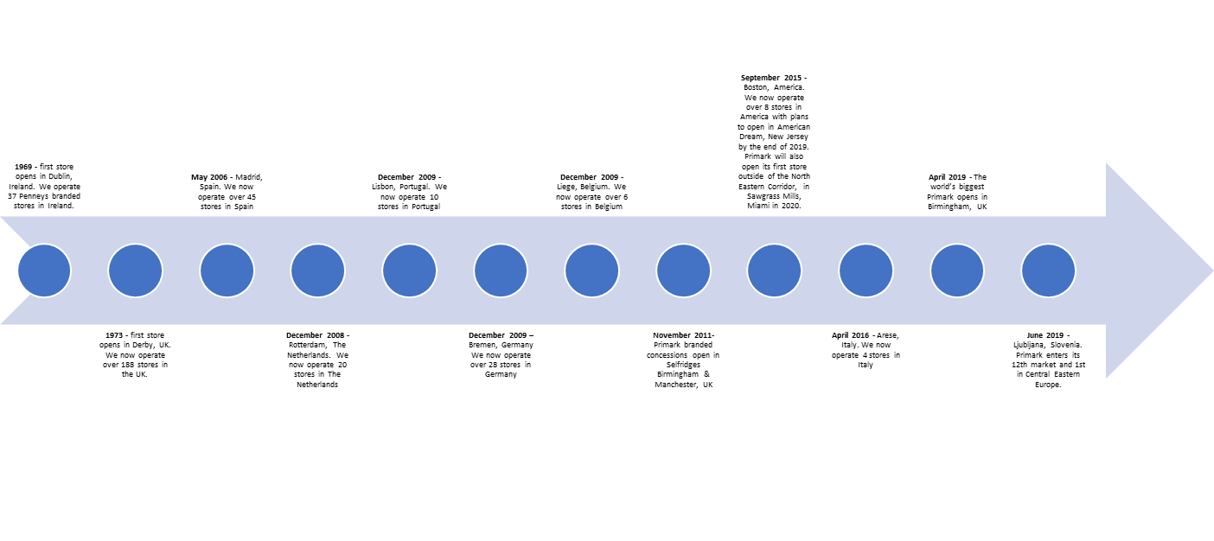
Appendices 1 (Primark,2019)

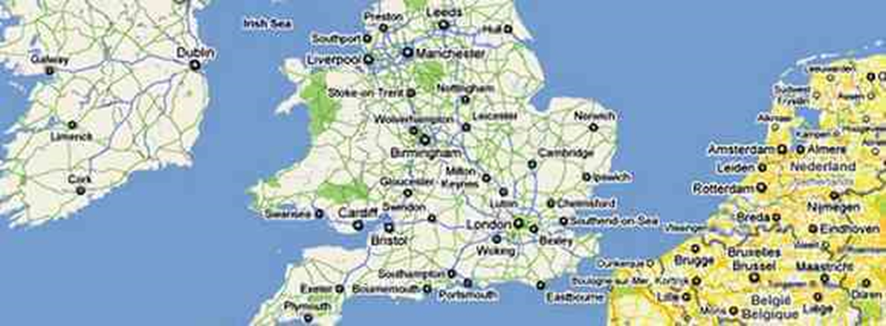

Appendices 2 (Uk.images.search.yahoo.com. 2019)

Reference list

BBC News. (2019). Pri-mania as world's largest store opens. [online] Available at: https://www.bbc.co.uk/news/uk-england-birmingham-47867785 [Accessed 19 Jun. 2019].

Google.com. (2019). what preblem is primark facing at the moment - Google Search. [online] Available at: https://www.google.com/search?q=what+preblem+is+primark+facing+at+the+moment&rlz=1C1CHBF_en-gbGB841GB841&oq=what+preblem+is+primark+facing+at+the+moment+&aqs=chrome..69i57.19715j0j4&sourceid=chrome&ie=UTF-8 [Accessed 19 Jun. 2019].

Hendriksz, V. (2017). Case study on Primark sustainability, ethics, supply chain.. [online] Fashionunited.uk. Available at: https://fashionunited.uk/primark-sustainability [Accessed 19 Jun. 2019].

Ipfs.io. (2019). Primark. [online] Available at: https://ipfs.io/ipfs/QmXoypizjW3WknFiJnKLwHCnL72vedxjQkDDP1mXWo6uco/wiki/Primark.html [Accessed 19 Jun. 2019].

Metro.co.uk. (2019). Rana Plaza collapsed five years ago and 1,100 people died for your clothes – remember them | Metro News. [online] Available at: https://metro.co.uk/2018/04/24/rana-plaza-collapsed-five-years-ago-and-1100-people-died-for-your-clothes-remember-them-7490888/ [Accessed 19 Jun. 2019].

Martin Strydom, D. (2013). Primark 'shocked' by Bangladesh building collapse. [online] Telegraph.co.uk. Available at: https://www.telegraph.co.uk/finance/newsbysector/retailandconsumer/10017011/Primark-shocked-by-Bangladesh-building-collapse.html [Accessed 19 Jun. 2019].

Primark.com. (2019). About Us | Primark UK. [online] Available at: https://www.primark.com/en/aboutus [Accessed 19 Jun. 2019].

Primark.com. (2019). Planet | Primark UK. [online] Available at: https://www.primark.com/en/our-ethics/planet/a/7a31a843-1476-44ba-9aed-010d9fdcb7c0 [Accessed 30 Aug. 2019].

Primark.com. (2019). Recycling | Primark UK. [online] Available at: https://www.primark.com/en/our-ethics/planet/recycling/a/a896b3f6-be42-494f-a10e-9c6f7ef54bab [Accessed 30 Aug. 2019].

Primark.com. (2019). Newsroom | Primark UK. [online] Available at: https://www.primark.com/en/our-ethics/newsroom/a/f3ccbff7-23dd-4809-be98-bab9be58074a [Accessed 30 Aug. 2019].

Research-topics.blogspot.com. (2019). PESTLE analysis of Primark in UK. [online] Available at: http://research-topics.blogspot.com/2011/09/pestle-analysis-of-primark-in-uk.html [Accessed 30 Aug. 2019].

Scholar.google.co.uk. (2019). Google Scholar. [online] Available at: https://scholar.google.co.uk/scholar?q=technological+factors+affecting+primark&hl=en&as_sdt=0&as_vis=1&oi=scholart [Accessed 30 Aug. 2019].

