SOILS EXAM REVISION – to be used alongside power points.
- Know the parameters of the SOIL MECHANICS EQUATIONS and their inter-relationships.

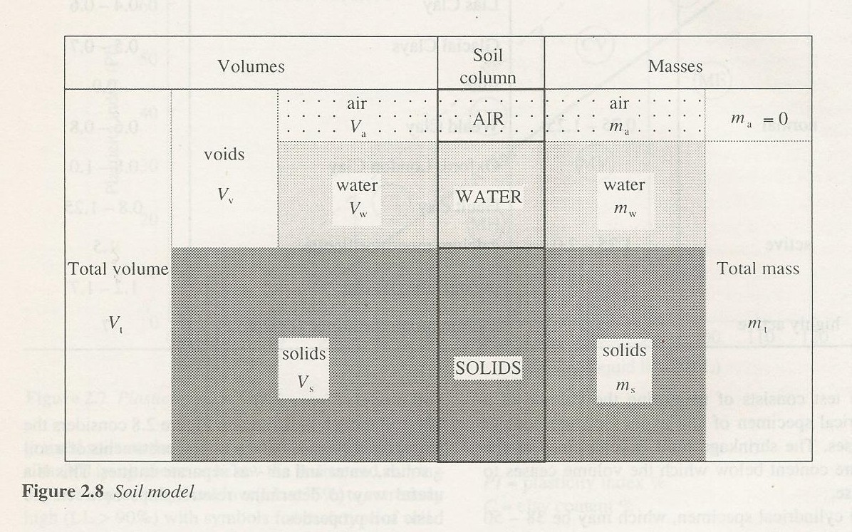

Permeability of Soils

- q (Flow rate) = V x A where V is velocity and A is cross section area.

- Average Hydraulic Gradient (i) is defined as:
Where
h = hydraulic head difference
L = The length of the flow line

i = Δ h
L

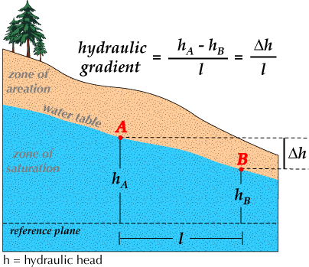

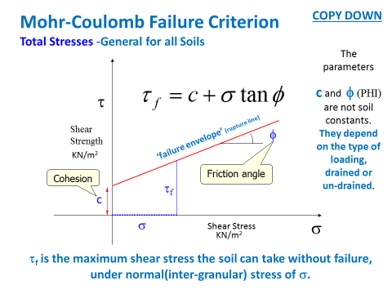
Mohr-Coulomb Failure Criterion
Total Stresses -General for all Soils

TRI –AXIAL and SHEAR BOX TEST for shear strength testing.
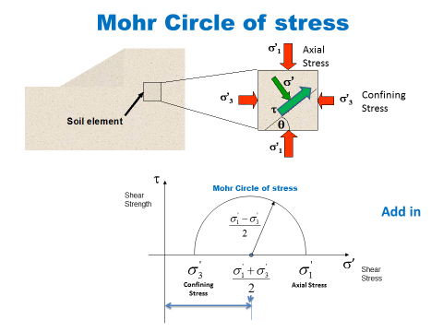
THE TRI-AXIAL TEST
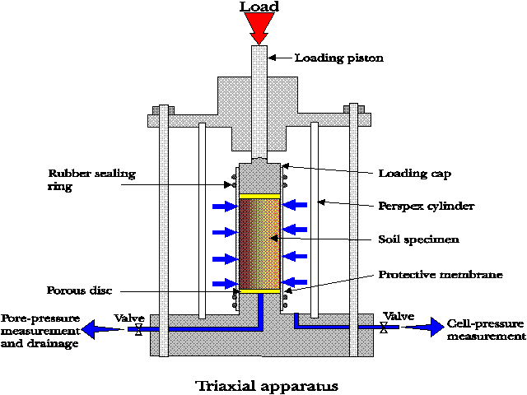
CONSOLIDATION and COMPACTION
Definitions:
Consolidation is “any process which involves decrease in water
content of a saturated soil without replacement of water by air.” – Settlement Types?

Compaction is ‘densification of soil using external compactive effort’.
Densification is done through reducing voids – Equipment used?
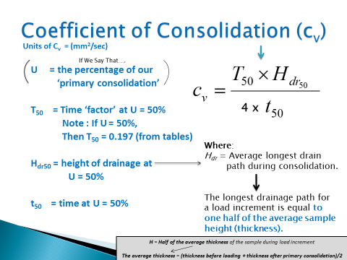

Testing using the OEDOMETER apparatus for Consolidation.
For compaction……. THE PROCTOR (DROP HAMMER) TEST

Know ALL procedures and apparatus for Laboratory testing of Soils (as covered in lectures).
Review Video links to required procedures from Lecture presentations on Moodle.

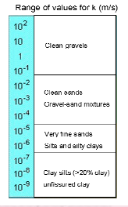
- DARCY’s LAW = Flow is proportional to a coefficient, K, which is called the…
Hydraulic Conductivity or the Coefficient of Permeability

K = Q x L
A x h x t
1) Constant Head Permeability test
2) Falling Head Permeability test
Calculating K from the Falling Head Permeability test

a = cross sectional area of the stand pipe
L = Length of the sample
A = cross sectional area of the soil
column
t = length of time for the head to drop in secs
Ho = Head before the test
H1 = Head after the test
K = 2.3 x a x L x (Log (ho))

h1
A x t

