1/1/2020
Joseph Garland (1707750)
Tata steel
Computer Aided Manufacturing and Design for Additive Manufacturing Technologies – Task 2
M5X02070

Summary

Contents
Summary 1
Introduction 4
Appraisal of Original System 5
Cylinder 7
Motor 8
Jaw 9
Join 10
Drive Plate 11
Shaft 12
Worm 13
13
Manufacturing Process Proposal 14
Casting 14
Sand Casting 15
Lost Wax Moulding 15
Machining. 16
Hand Operated 16
CNC 16
Rapid Prototyping 17
3D Printing 17
Design and Development Work Undertaken 19
Jaw 19
Drive Plate 21
Shaft 22
Worm Screw 23
Cylinder 24
Worm Screw Cap End 25
New Assembly 25
Manufacturing Process Design 27
Conclusion 29
Bibliography 30
Reference List 31
Appendices 32
Lucas method Design For Assembly Before Vs After 32
Cylinder Lucas Method DFA Before and After 32
Motor 33
Jaw 34
Join 36
Drive Plate 37
Shaft 39
Design Failure Mode and Effect Analysis 43
Lean Manufacturing 44

Introduction
The following report is a study into the design of a three-jaw end effector gripper. The study will be looking into the design and operation of the End effector. The study will include various forms of product analysis whereby they will be implemented to improve the functionality and operation of the end effector.
A review of different manufacturing techniques will also help determine the most suitable methods of production for each component within the End effector assembly.
The report will look to implement the necessary technology such as CAD software to carry out design analysis and improvement to the end effector components provided on Moodle.

Appraisal of Original System
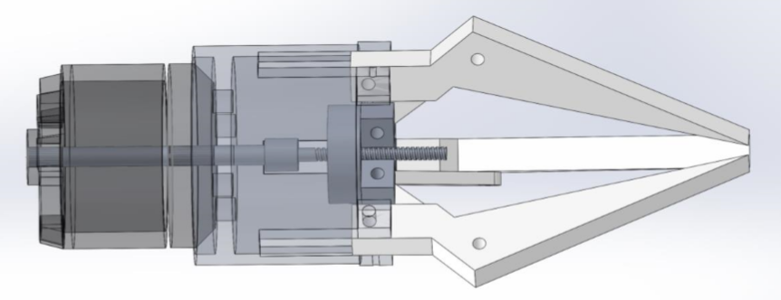
Figure 1 – Original Three-Jaw gripper design.
The original design of the 3 Jaw Gripper is made up of the following components; three gripping jaws, a cylinder, drive plate, motor, 3 joins, a shaft and worm screw. After close inspection of the original assembly it appear to have very little fasteners in place in order for the part to function as intended. A careful review of the missing/needed parts will be carried out in the following report as well as new parts being created where needed.
Following inspection of the original assembly within Solidworks it was found that none of the part components have had been constrained allowing the parts to move freely and interfere with one another creating an unrealistic representation of how it would function in real life.
As a way of analysing the importance/need for each component within the assembly the Lucas method Design for Assembly. A table will be generated for both the handling and fitting aspects of assembly for each part. The Lucas method of Design for Analysis aims simplify the design in order to create a more efficient product. Benefits of using this method include improved product quality and reliability and reduces the need for unnecessary production methods.

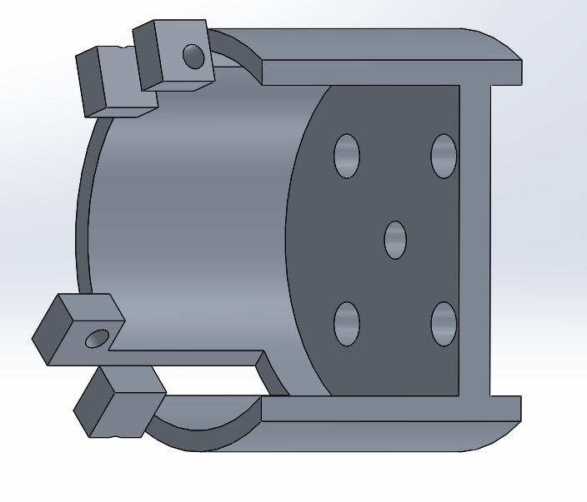
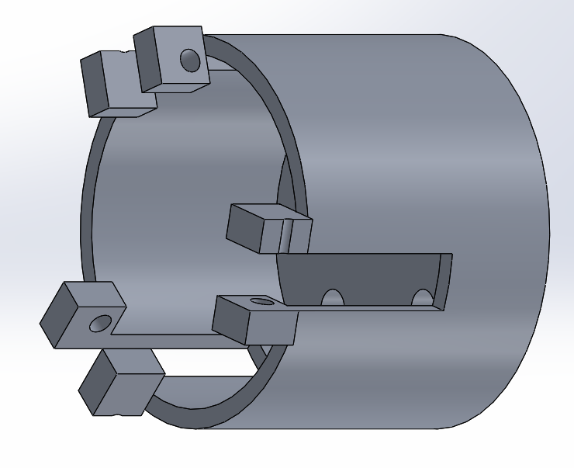
Cylinder
Figure 2 – Cylinder (External)
Figure 3 – Cylinder (Internal)

Both internal and external views of the cylinder can be seen in above in figure 2 and 3. The cylinder exhibits 5 3mm holes in the top flat face of its body however it is only the hole central to the cylinder that is of any use. This centre hole is used to locate the worm screw in order to ensure the grippers function. Located at the bottom of the cylinder there are six 5mmx5mmx3mm blocks with 2mm diameter through holes in each of them. These blocks are used to give the gripper jaw a pivot point with each jaw pivoting around the 2mm hole. Due to the motion of the jaws pivoting and the dimensions of the jaws there are slots 15mmx5mm in the side of the cylinder to allow the jaws fully operate without interference with the side of the cylinder body. The cylinder body has a mass of 16.67 grams, volume of 6173.39 cubic millimetres and a surface area of 6841.33 mm².

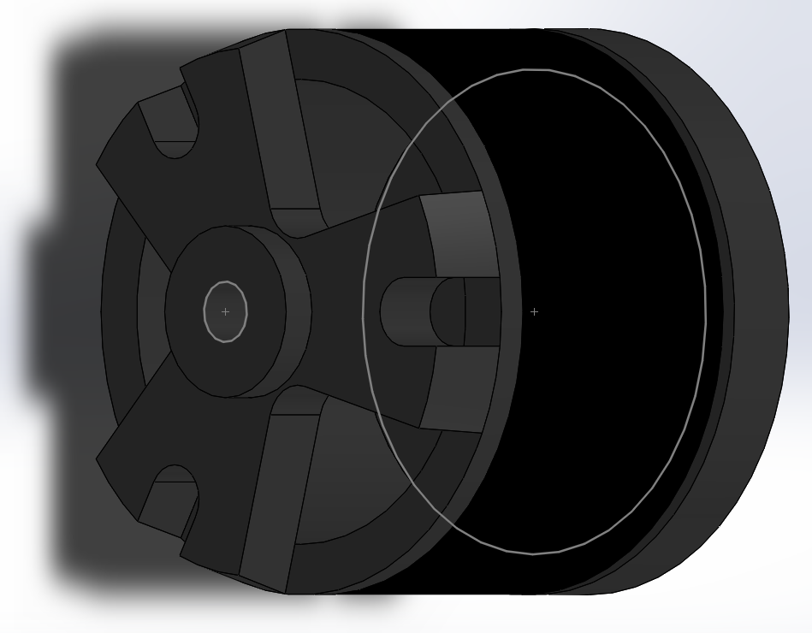
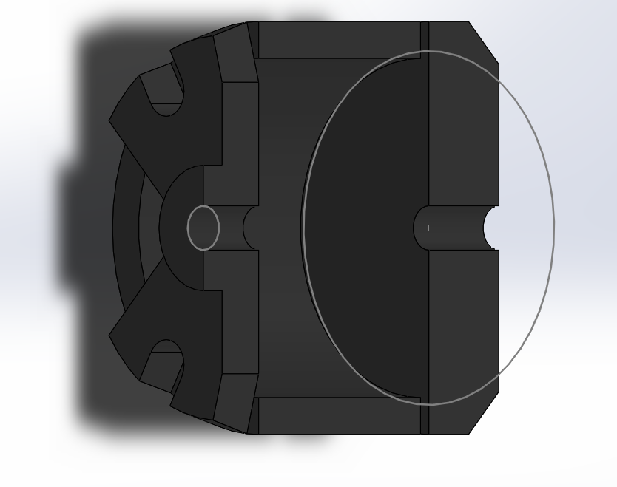
Motor
Figure 4 – Motor (Internal)
Figure 5 – Motor (External)
An external and internal view of the motor can be viewed below in figures 4 and 5. The internal view of the motor shows that it does not have any internal mechanical or electrical systems. Instead the motor is being used as an example of what exact size it would be and how it would fit in the assembly. The motor has a mass of 55 grams, a volume of 7923.78 cubic millimetres and a surface area of 5559.64mm². the motor is used to drive the assembly, rotating the centre shaft causing the worm to traverse vertically along the shaft.

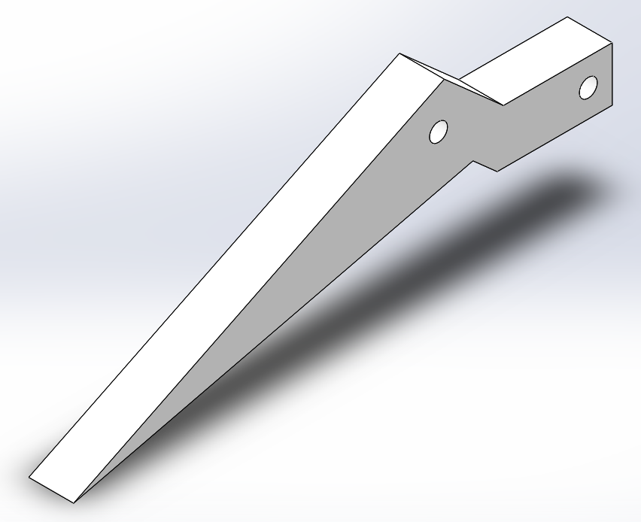
Jaw
Figure 6 – Gripper Jaw.
Above is the design for the gripper jaws used in the original assembly. In total there are three jaws used in the assembly. The gripper jaws are operated by the drive plate moving transversely along the central axis of the worm screw within the assembly. During operation the jaws are opened up by the drive plate being driven further up the worm screw. Each gripper jaw has a mass of 2.11 grams, a volume of 1638.98 cubic millimetres and a surface area of 1394.19 mm².

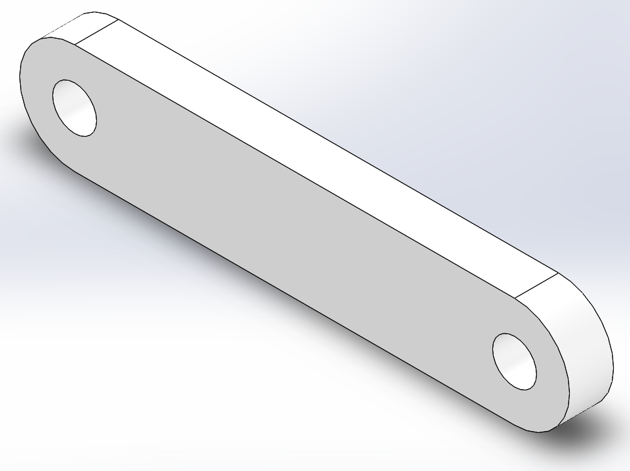
Join
Figure 7 – Join.
Figure 7 shows the join used to connect the gripper jaws to the drive plate. There are three joins within the assembly. The joins are used as a connecting arm to move the gripper jaws according to the position the drive plate along the worm screw. In their original assembly position, the joining arms currently foul with each other, this could result in the gripper not being able to operate as intended as well as causing unnecessary stress and strain on the assembly parts in time causing a potential failure. This is something that would need to be rectified in the re-designing process. The joining arms have dimensions of 25mm long, 5mm wide, 2mm thick, a radius of 2.5mm at either end and hole diameters of 2mm.
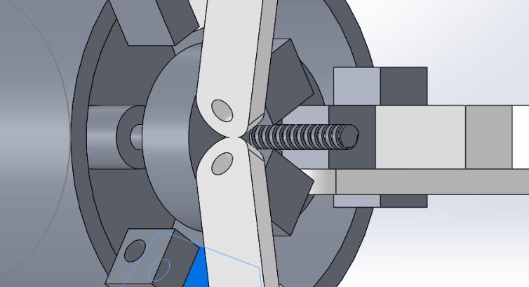
Figure 8 clearly shows the point at which the joining arms foul on each other. Each joining arm has a mass of 0.29 grams, volume of 226.70 cubic millimetres and a surface area of 363.25mm².
Figure 8 – Join (Conflict).

Drive Plate
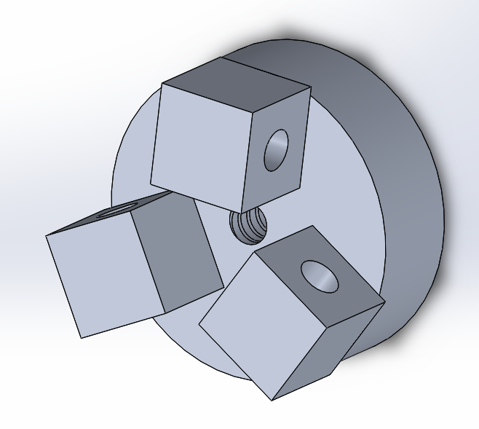
Figure 9 – Drive Plate.

The drive plate for the original gripper assembly is as exhibited in figure 9 above. As can be seen above the drive plate has a 2mm threaded through hole at its centre. This hole is mated with the worm screw and allows the drive plate to travel vertically along the worm screw. It is this motion that allows the gripper to operate as intended. The drive plate also exhibits three holding blocks used to hold the joining arms in the assembly. The joining arms pivots axially around the 2mm through holes in each block on the drive plate. The drive plate has a mass of 3.23 grams, volume of 1195.48 cubic millimetres and surface area of 995.19mm².

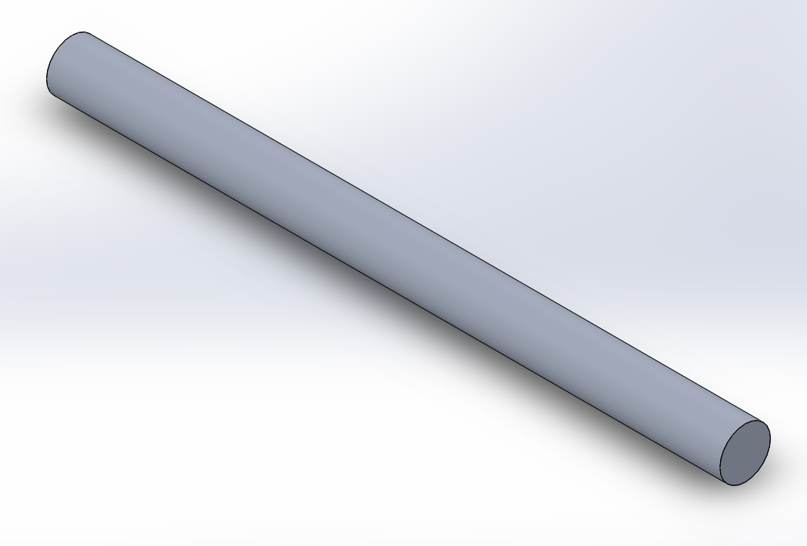
Shaft
Figure 11 – Shaft.
The orginally assembly shaft can be seen in figure 11 above. The shaft is connected to the motor and is used to drive the worm screw. The direction of the shaft rotation determines whether the gripper jaws open or close. Clockwise rotation causes the gripper jaws to open and anit-clockwise rotation causes the gripper arms to close. The shaft drives the worm screw via an interference fit with the head of the worm screw. Over time this design feature is likely to fail as the friction created during roation will cause the material to wear away until the shaft and worm screw no longer engage each other thus failing to drive the worm screw. a way of combating this problem could be to make the end that engages with the worm screw and square drive. The shaft has a mass of 0.77 grams, volume of 282.74 cubic millimetres and a surface area of 391.13mm².

Worm
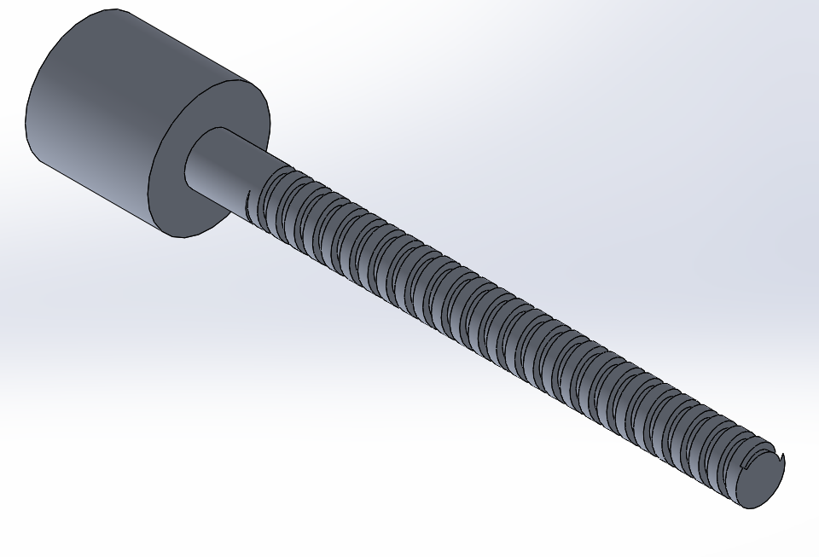
Figure 12 – Worm Screw.
The worm screw above is used as a way of drive the drive plate along itself, this in turn operates the gripper jaws. Like the shaft the worm shaft relies on an inference fit between to end of the shaft and head of the worm screw to drive the drive plate. The interference fit could proof to be problematic over time as previous discussed. To combat this problem the drive mechanism of both the shaft and worm screw must match. The worm shaft for the assembly has a mass of 0.35 grams, volume of 130.03 cubic millimetres and surface area of 347.10mm².

Manufacturing Process Proposal
There are numerous viable manufacturing processes suitable for the production of each part needed for the assembly of the gripper. Each viable manufacturing method will be evaluated in order to gain a better understanding of what processes are most suited to the gripper components. Manufacturing processes should be considered during the design process to ensure the appropriate manufacturing processes are selected. One way of doing this would be by carrying out a DFMA of the components within the product. Boothroyd and Dewhurst software (2020) list the benefits of carrying out a DFMA include;
- A reduction in product development costs
- Simplifies the product structure
- Provides good practice for designers

Casting

(Different Types of Casting Processes used in Manufacturing, 2020) states that casting is one of the oldest and most common processes used in industry, used by companies to manufacture a wide variety of different parts. Products of casting manufacturing can be found in the automotive, engineering and aerospace industries. The process of casting manufacturing is a simple process, molten metal is poured into a cavity/mould(die) where it is then left to cool eventually solidifying and forming the shape of the mould. The simplicity of casting manufacturing is perhaps the reason for its popularity and reason it has been used for thousands of years.
When considering casting as a manufacturing process used for the gripper components it was apparent that almost all components within gripper assembly could be manufactured via casting. However, it may be more suitable for components that require detail and may prove time consuming or difficult to machine. These components may include the cylinder, motor housing and jaws.

Sand Casting
Sand casting is the oldest form of casting process with evidence of sand-casting dating back to 1000BC as stated by (Olsen, 2020). Sand casting stereotypically consists of molten metal being poured into a cavity/mould. However, the mould/dies are made up of fine grain sand and clay mixture that has been firmly packed to form the desired shape of the component for casting. One advantage of sand casting allows the freedom of being able to mould almost any shape. A disadvantage of sand casting is that each mould is individualistic, meaning it can only be used once as the mould is destroyed during its removal.
Sand casting is suitable for most components within the gripper assembly however may not be the most efficient way of manufacturing each part during to the moulding process being time consuming and non-reusable. Components most suited to sand casting within the assembly include the cylinder, motor housing and jaws.

Lost Wax Moulding

Much like casting and sand-casting wax moulding requires a cavity for molten metal to be poured into. However, unlike the previously spoken about casting methods (Lost-wax process | metal casting, 2020) states that wax moulding uses a pre modelled sacrificial sculpture of the intended design that the molten metal takes shape of creating a replica casting of the design. Wax moulding can used numerous times however new wax moulds will need to be created for each repetition of the process.
When considering wax moulding for the production of the gripper component it is apparent that it is possible to manufacture many of the components using the method. Wax moulding is a low-cost production method however may not be suitable for components that require high levels of detail or have small features. For this reason, it may not be to most suitable form of manufacturing to use for the component of the gripper assembly.

Machining.
Machining includes an array of different types of manufacturing processes however the majority of these processes are split between manually operated machining and CNC Machining. The following will be a detailed look at how each form of machining is carried out and whether it is applicable to the manufacturing of the gripper components.

Hand Operated
There are two main methods of hand operated machining these include lathes and milling. Lathes consist the either a three or four jaw chuck to hold the material being machined during rotation and a tool holder that travel transversely along the lathe bed. Unlike the lathe a milling machine holds the material in situ and the tool rotates creating the cut. Both lathe and milling hand operations require a high level of skill and knowledge in order to attain a high-quality finish. Handing machining is often overlooked by companies as the machines require constant manning throughout the manufacturing process leading to high labour costs and can prove to be more time consuming than other automated machining alternatives. Hand machining however does have benefits as experience machinist are able to identify material defects during machining which can potentially save companies the cost and waste of manufacturing defected goods.
The gripper components best suited for hand operated machining would be the shaft and worm screw. The shaft, worm screw and joins are all well suited to hand machining operations as they have straight forward designs and would not require a lot of time to produce whilst maintaining high product quality. This means labour cost during manufacturing of the parts would be low.

CNC
CNC stands for computer numerical control and is a relatively new method of manufacturing. CNC manufacturing processes are constantly under review and are rapidly improving as technology progresses. Machines such as lathes and milling machines are now CNC operated allowing them to perform the functions needed to create components via a pre uploaded program. (CNC Machining Definition, Processes, Components, & Equipment, 2020) states CNC machining removes the need for constant manning on machines as well as eliminating the likelihood of human error. CNC machining also proves to be a much more efficient way of manufacturing mass production products, allowing operators to carry out other sub processes whilst the machine is in operation (Reed, 2016)
CNC machining methods would be capable of manufacturing all the components within the gripper assembly. However, the components most applicable to being produced via CNC machining would be the drive plate, cylinder, joins and jaws.

Rapid Prototyping
Rapid prototyping is used as a way of producing a quick fabrication of a product using Computer aided design. Rapid prototyping incorporates and variety of different manufacturing processes such as high-speed machining, casting and extruding. Rapid prototyping can be used to provide designers with scaled down versions of the product they intend on manufacturing. These prototypes allow designers to identify any fault with design features and rectify them before putting a product into full manufacturing. Due to it operating via CAD drawings uploaded to the machines it does not require manning (TWI, 2020).

3D Printing
3D printing is also referred to as additive manufacturing and was originally used as a way of producing rapid prototypes. As technology has improved the uses for £d printing have changed, with it now being used in tooling aides, functioning prototypes and even in production of final parts (AFMG, 2020).

Products produced using 3D printing include dental products, prosthetics, industrial items and consumer goods (3D Printing,com, 2020). 3D printing can be done using a variety of different materials ranging from polymers to metals such copper, bronze or aluminium. During operation semi solid material is deposited through the machines nozzle to form the desire shape.
3D printing could be used to produced the joins of the gripper.

Design and Development Work Undertaken

The design stage of a product is perhaps the most important stage of development of any product. Brian Read quotes “Everything is design. Few things are designed well” it is crucial the products successful that it is design well. In order to ensure a successful product a number of things should be considered during the design process. Some of the considerations that need to be noted during the design period include;
- Production Cost
- Manufacturability
- Reliability
- Assembly
Following the study of the original assembly components, it was decided that improvement would be made to some of the gripper assembly components. It was decided that not all components within the gripper assembly needed to be improved as over development can sometime prove troublesome during manufacturing processes. The changes made are as follows below. All manufacturing processes chosen to produce the components below are available at TATA Steel Trostre. It is also to be assumed that all relevant fasteners needed for the assemble are already stocked at Tata Steel Trostre.

Jaw
The changes decided to made to the original design of the jaws were at the end of the jaw where the jaw came to a point, the holding face of the jaw and the main outer angle exhibited in figure 11 below. It was decided that changes were necessary to the gripper jaw design in order to improve the safety and functionality of the design. As can be seen in figure 13 the ends of the gripper jaws all come to a fine point. Points like this are sharp and have potential to cause anyone handle the components harm and needed to be rectified immediately. The part also exhibited sharp corners with potential to cause harm on the outer angle of the jaw. After studying the operation of the jaws within the assembly it was clear that the points at the ends of each jaw restricted how close a grip of an object gripper was able to achieve, they were also identified as potential weak point and so it was decided that this should be considered during the improvement of the design.
Figure 13 - Original jaw points of concern
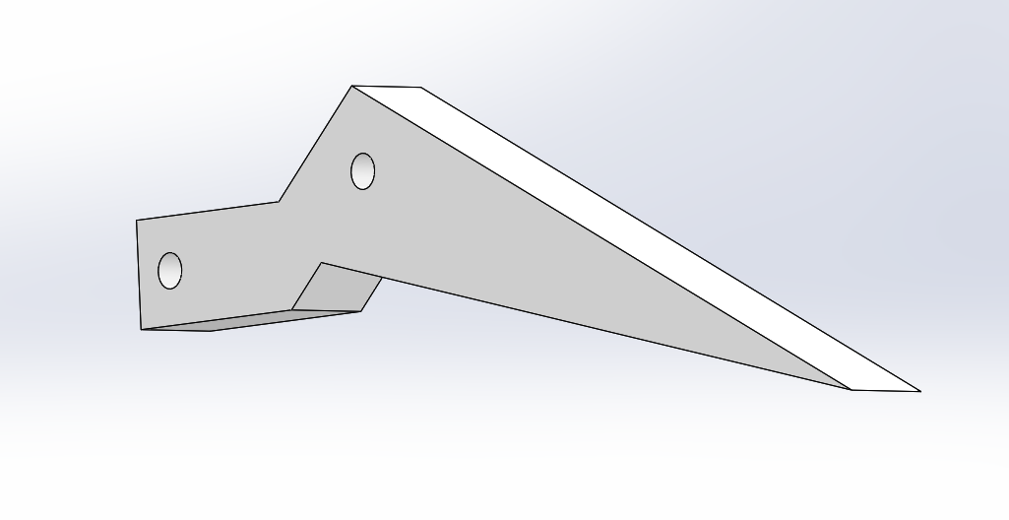
Figure 14 – updated jaw design
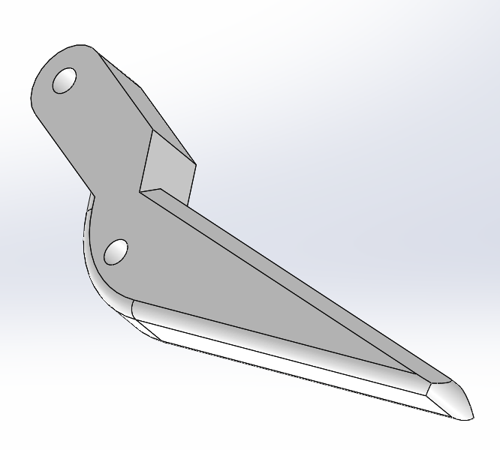
As can be seen above in figure 14 the updated design for the gripper jaw has very little to no sharp edges. These were removed by place fillets and chamfers were appropriate using the edit feature function on solidworks. By doing this it reduces the risk of harm to handlers during assembly or maintenance tasks. It can also be noted that the inside face of the gripper has been altered so that it has a chamfer. This removes the structural weak points of the original part at the end of the gripper and improves functionality as it also the jaws to gain a closer grip thus allowing the product to pick up smaller objects. This can be seen below in figure 15.
Figure 15 - updated closed gripper
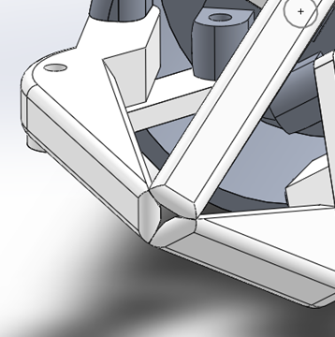
The manufacturing process chosen to product the gripper jaws would be die casting.

Drive Plate
Figure 16 – Drive Plate (Updated)
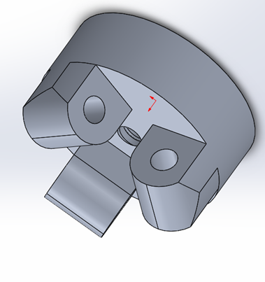
As can be seen in figure 9 and original assembly the original design for the drive plate was fully functional however it included a number of sharp edges that increase the risk of harm during handling. These edges also created weak points on the design increasing the chance of failure. Figure 16 shows the updated drive plate design this design eliminates the weak points and sharp edges by using the feature fillet and extrude cut of the three blocks at the bottom of the drive plate. In order to produce this part, the manufacturing process used will be C-axis CNC machining. Due to the shape and feature of the part C-axis CNC machining is the only form of manufacturing process that would be able to create all feature without requiring a second process. It is important to consider whether a part will require the need of a second manufacturing process in-order to keep production as lean as possible.

Shaft
The original shaft seen in figure 11 was fully functional however relied on an interference fit to drive the worm screw. over time this design is likely to fail as wear due to friction will cause the shaft to disengage with the worm screw resulting in the gripper no longer functioning.
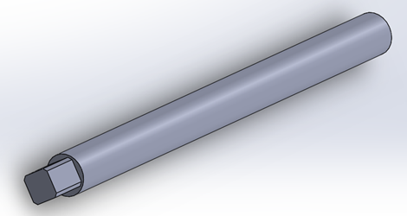
Figure 17 – Shaft (Updated)
The updated shaft has been designed so that the shaft drives the worm screw via a square drive. This should improve the overall longevity of the product as the it will become less likely to fail due to wear making it more reliable.
The manufacturing process best suited to producing the shaft would be CNC Milling. This manufacturing process was chosen due to it being the most efficient way of producing the part.

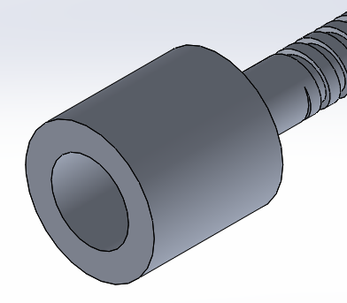
Worm Screw
Figure 18 – Worm Screw Head (Original)
In original design of the worm screw relied on it being drive by the shaft via an interference fit, this may prove to be problematic as dicussed above. In order the increase reliabilty of the component the design for the drive of the worm screw needed to be changed. The updated design for the head of the worm screw features a female square drive matching the male square drive of the updated shaft as seen in figure 17 and 19.
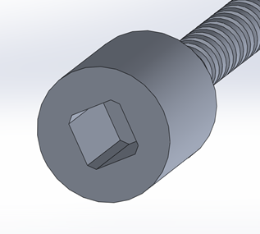
Figure 19 – Worm Screw (Updated)

The most appropriate for of manufacturing for the worm screw would also be CNC milling.

Cylinder
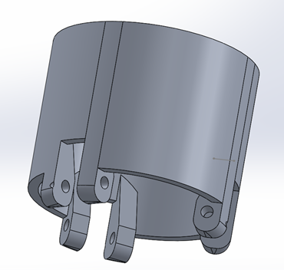
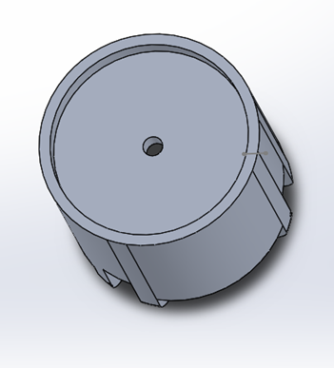
Figure 21 – Cylinder (Updated)
Figure 20 – Cylinder (Updated)
Seen above in figure 20 and 21 is the updated design of the cylinder within the gripper assembly. One of the updated design features of the gripper cylinder is it longer exhibits any of the sharp edges on the holding blocks at the bottom of the cylidner that can be seen in figure 2 and 3. The sharp edges of the bolck were remove using the fillet and extrude cut feature. The hole features surrounding the centre hole at the top of the cylinder were also removed as it was deemed a feature that proved to be unecessary and time consuming to create. A structural improvement was also made to the blocks at the bottom of the cylinder by creating supportive struts use the extrude feature along the inside of the cylinder. This improvement was necessary I order to improve the components structure ingerity, as the original design exhibted weak points along the inside join between the block and the cylinder. The final change to the cylinder was made to the three blocks at the bottom of the cylinder that did not feature any hole. The change was made whereby the pre-existing hole opposite was replicated on each neighbouring block.
The cylinder is best suited to be manufactured via dies casting as its complex shape would prove difficult to machine.

Worm Screw Cap End
Figure 22 – Worm Screw End Cap
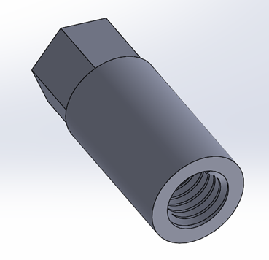

The Worm screw cap end is a new component incorporated into the gripper design. The purpose of the worm screw end cap is the create a mechanical limit for the drive plate to stop at during the opening operation. This will also prevent the drive plate from disengaging from the worm screw during operation. The worm screw cap end would be best suiting to be produced via CNC milling.

New Assembly

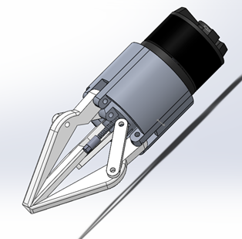
Figure 22 – Gripper Assembly (Updated)
Figure 22 shows the updated assembly featuring all newly amended components. The adjustments made to each component are subtle but necessary changes. None the changes made have affected the grippers ability to perform as intended however they have improved the quality of performance at which the gripper can operate. The changes have directly improved the performance, reliability and safety of the gripper allowing it to operate more efficiently.
During the re-design of the assembly components poka-yoke techniques were taking into consideration identifying 5 or more potential modes of failure within the original assembly i.e sharp edge, structural vulnerability and performance limitations. Design alterations were made to the components as a way of negating these potential modes of failure. Appropriate manufacturing options for each component were also made in order to keep the production process of the gripper as lean as possible. Following these changes, the updated assembly’s ability to function correctly was then tested using the Solidworks assembly program, where appropriate mates were applied to in order to see the gripper in operation.
After the relevant tests were carrying out the changes made to the gripper were deemed to be successful, improving it performance and reducing waste.

Manufacturing Process Design

Below is a flow chart diagrams specific to the producing and assembly of the Three Jaw End Effector components.
Figure 23- Process Flow diagram
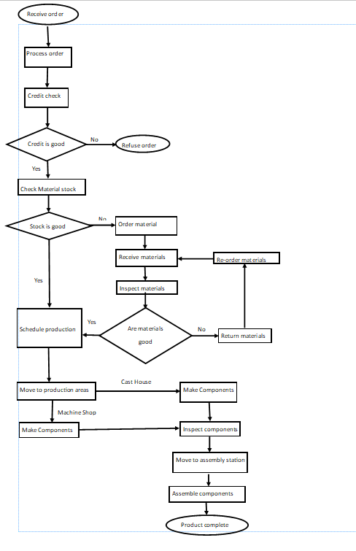
Figure 24 - Floor plan flow of material
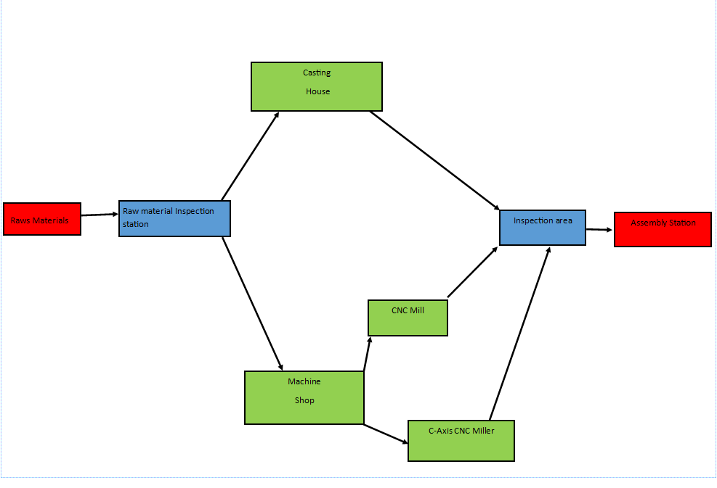
The flow chart and floor plan diagram above has been created using the facilities at Tata Steel Trostre as the place of production for the components.

Conclusion

The design study into the three jaw gripper-end effector as a whole was successful. Following the study of the grippers design a number of faults and potential modes of failure were identified. These faults were detected using visual inspections of each components. Research into different manufacturing techniques was also carried in order to better understand what manufacturing processes were best suited to each individual component. Whilst identifying suitable manufacturing techniques for each gripper component, lean manufacturing techniques were considered to minimise waste, namely waiting, overproduction and unnecessary movement during production thus improving customer satisfaction.
A design for mode and effect analysis (DFMEA) was performed prior to making the amendments to the gripper components as a way of knowing whether the design changes would benefit the product.
Finally comparisons of the original design features and the amended feature were carried out using Lucas Method design for assembly (DFA) tables as a way of knowing if the handling and fitting of the components had been improved.

Bibliography

- ResearchGate. 2020. (PDF) DESIGN FOR MANUFACTURE AND ASSEMBLY (DFMA): INTRODUCTION TO BOOTHROYD DEWHURST SOFTWARE. [online] Available at: <https://www.researchgate.net/publication/265687114_DESIGN_FOR_MANUFACTURE_AND_ASSEMBLY_DFMA_INTRODUCTION_TO_BOOTHROYD_DEWHURST_SOFTWARE> [Accessed 23 June 2020].
- Thomasnet.com. 2020. CNC Machining Definition, Processes, Components, & Equipment. [online] Available at: <https://www.thomasnet.com/articles/custom-manufacturing-fabricating/understanding-cnc-machining/> [Accessed 23 June 2020].
- Thomasnet.com. 2020. Different Types Of Casting Processes Used In Manufacturing. [online] Available at: <https://www.thomasnet.com/articles/custom-manufacturing-fabricating/types-of-casting-processes/> [Accessed 23 June 2020].
- AMFG. 2020. Industrial Applications Of 3D Printing: The Ultimate Guide - AMFG. [online] Available at: <https://amfg.ai/industrial-applications-of-3d-printing-the-ultimate-guide/> [Accessed 23 June 2020].
- Reliance Foundry Co. Ltd. 2020. Introduction To Cast Iron: History, Properties, And Uses. [online] Available at: <https://www.reliance-foundry.com/blog/cast-iron> [Accessed 21 June 2020].
- Encyclopedia Britannica. 2020. Lost-Wax Process | Metal Casting. [online] Available at: <https://www.britannica.com/technology/lost-wax-process> [Accessed 23 June 2020].
- Olsen, D., 2020. What Is Sand Casting And How Does It Work?. [online] Marketing.metaltek.com. Available at: <https://marketing.metaltek.com/smart-blog/what_is_sand_casting_and_how_does_it_work> [Accessed 23 June 2020].
- Twi-global.com. 2020. What Is Rapid Prototyping? - Definition, Methods And Advantages. [online] Available at: <https://www.twi-global.com/technical-knowledge/faqs/faq-manufacturing-what-is-rapid-prototyping> [Accessed 23 June 2020].
- Kanban Software for Agile Project Management. 2020. What Is The Poka Yoke Technique?. [online] Available at: <
- Process Street. 2020. 9 Lean Manufacturing Principles To Kill The Jargon And Get Quality Results | Process Street | Checklist, Workflow And SOP Software. [online] Available at: <https://www.process.st/lean-manufacturing-principles/> [Accessed 24 June 2020].
- Hartwell, J., 2020. DFMEA - Complete Guide To The Design FMEA | Iqasystem. [online] IQASystem. Available at: <https://www.iqasystem.com/news/dfmea/> [Accessed 24 June 2020].

Reference List

- https://www.researchgate.net/publication/265687114_DESIGN_FOR_MANUFACTURE_AND_ASSEMBLY_DFMA_INTRODUCTION_TO_BOOTHROYD_DEWHURST_SOFTWARE> [Accessed 23 June 2020]
- https://www.thomasnet.com/articles/custom-manufacturing-fabricating/understanding-cnc-machining/> [Accessed 23 June 2020].
- https://www.thomasnet.com/articles/custom-manufacturing-fabricating/types-of-casting-processes/> [Accessed 23 June 2020].
- <https://amfg.ai/industrial-applications-of-3d-printing-the-ultimate-guide/> [Accessed 23 June 2020].
- https://www.reliance-foundry.com/blog/cast-iron> [Accessed 21 June 2020].
- https://www.britannica.com/technology/lost-wax-process> [Accessed 23 June 2020].
- https://marketing.metaltek.com/smart-blog/what_is_sand_casting_and_how_does_it_work> [Accessed 23 June 2020].
- https://www.twi-global.com/technical-knowledge/faqs/faq-manufacturing-what-is-rapid-prototyping> [Accessed 23 June 2020].
- https://kanbanize.com/lean-management/improvement/what-is-poka-yoke> [Accessed 24 June 2020].
- https://www.process.st/lean-manufacturing-principles/> [Accessed 24 June 2020].
- https://www.iqasystem.com/news/dfmea/> [Accessed 24 June 2020].

Appendices

Lucas method Design For Assembly Before Vs After

Cylinder Lucas Method DFA Before and After

Handling Index
A. Size of Part | B. Handling Difficulties
Very Small - Requires Tools | Sharp/Abrasive
Very Small - Requires Tools | Severely Nest
C. Orientation of Part | D. Rotational Orientation of Part
End to End, Not Visible | Rotational Orientation, Easy to See
Total
3.2
Table 1 – Lucas DFA Original Cylinder (Handling index)
Fitting Index
A. Part Placing & Fastening | B. Process Direction
Requires Holding | Straight Line from Above
Screwing | Straight Line from Above
C. Insertion | D. Access &/or Vision
Simultaneous Multiple Insertions | Restricted
E. Alignment | F. Insertion Force
Easy to Align | No Resistance to Insertion
Total
8.7
Table 2 – Lucas DFA Original Cylinder (Fitting Index)

Handling Index
A. Size of Part | B. Handling Difficulties
Very Small - Requires Tools | Handling with no difficulty
C. Orientation of Part | D. Rotational Orientation of Part
End to End, Not Visible | Rotational Orientation, Easy to See
Total
2.2
Table 3 - Amended Cylinder (handling index)
Fitting Index
A. Part Placing & Fastening | B. Process Direction
Requires Holding | Straight Line from Above
Screwing | Straight Line from Above
C. Insertion | D. Access &/or Vision
Simultaneous Multiple Insertions | Direct
E. Alignment | F. Insertion Force
Easy to Align | No Resistance to Insertion
Total
7.2
Table 4 - Amended Cylinder (fitting index)

Motor

Handling Index
A. Size of Part | B. Handling Difficulties
Very Small - Requires Tools | Delicate
C. Orientation of Part | D. Rotational Orientation of Part
End to End, Easy to See | Rotational Orientation, Hard to See
Total
2.4
Table 5 – Lucas DFA Motor (Handling Index)

Fitting Index
A. Part Placing & Fastening | B. Process Direction
Requires Holding | Straight Line from Above
Self – Securing | Straight Line from Above
C. Insertion | D. Access &/or Vision
Simultaneous Multiple Insertions | Restricted
E. Alignment | F. Insertion Force
Easy to Align | No Resistance to Insertion
Total
6
Table 4 – Lucas DFA Motor (Fitting Index)
No design changes were made to original motor design therefore there will be no change in the Lucas method totals generated for handling and fitting.

Jaw

Handling Index
A. Size of Part | B. Handling Difficulties
Convenient - Hands Only | Delicate
Convenient - Hands Only | Sharp/Abrasive
Convenient - Hands Only | Gripping Problems/Slippery
C. Orientation of Part | D. Rotational Orientation of Part
End to End, Easy to See | Rotational Orientation, Easy to See
Total
2.2

Fitting Index
A. Part Placing & Fastening | B. Process Direction
Requires Holding | Straight Line not from Above
Riveting | Straight Line not from Above
C. Insertion | D. Access &/or Vision
Single | Restricted
E. Alignment | F. Insertion Force
Easy to Align | No Resistance to Insertion
Total
7.6
Table 7 – Lucas DFA original Jaw (Handling Index)
Table 8 – Lucas DFA original Jaw (Fitting Index)

Handling Index
A. Size of Part | B. Handling Difficulties
Convenient - Hands Only | Delicate
Convenient - Hands Only | Gripping Problems/Slippery
C. Orientation of Part | D. Rotational Orientation of Part
End to End, Easy to See | Rotational Orientation, Easy to See
Total
1.9
Table 9 - Amended Jaw (Fitting index)

Fitting Index
A. Part Placing & Fastening | B. Process Direction
Requires Holding | Straight Line not from Above
Riveting | Straight Line not from Above
C. Insertion | D. Access &/or Vision
Single | Direct
E. Alignment | F. Insertion Force
Easy to Align | No Resistance to Insertion
Total
6.1
Table 10 - Amended jaw (Fitting index)

Join

Handling Index
A. Size of Part | B. Handling Difficulties
Very Small - Requires Tools | Delicate
Very Small - Requires Tools | Gripping Problems/Slippery
C. Orientation of Part | D. Rotational Orientation of Part
Symmetrical, No Orientation Required | Rotational Orientation, Easy to See
Total
2.3
Table 7 – Lucas DFA Join (Handling Index)
Fitting Index
A. Part Placing & Fastening | B. Process Direction
Requires Holding | Straight Line not from Above
Riveting | Straight Line not from Above
C. Insertion | D. Access &/or Vision
Multiple Insertions | Direct
E. Alignment | F. Insertion Force
Easy to Align | No Resistance to Insertion
Total
6.8

Table 8 – Lucas DFA Join (Fitting Index)
No alterations were made to the design of the joins of the three jawed end effector therefor the Lucas method totals did not change.

Drive Plate

Handling Index
A. Size of Part | B. Handling Difficulties
Very Small - Requires Tools | Delicate
Very Small - Requires Tools | Sharp/Abrasive
C. Orientation of Part | D. Rotational Orientation of Part
End to End, Easy to See | Rotational Orientation, Easy to See
Total
2.5
Table 9 - Lucas DFA Original (handling index)

Fitting Index
A. Part Placing & Fastening | B. Process Direction
Requires Holding | Straight Line from Above
Screwing | Straight Line from Above
C. Insertion | D. Access &/or Vision
Multiple Insertions | Direct
E. Alignment | F. Insertion Force
Difficult to Align | Resistance to Insertion
Total
8
Table 10 – Lucas DFA Original Drive Plate (Fitting index)
Handling Index
A. Size of Part | B. Handling Difficulties
Very Small - Requires Tools | Delicate
C. Orientation of Part | D. Rotational Orientation of Part
End to End, Easy to See | Rotational Orientation, Easy to See
Total
2.2
Table 11 - Lucas DFA Amended Drive Plate (Handling index)
Fitting Index
A. Part Placing & Fastening | B. Process Direction
Requires Holding | Straight Line from Above
Screwing | Straight Line from Above
C. Insertion | D. Access &/or Vision
Multiple Insertions | Direct
E. Alignment | F. Insertion Force
Easy to align | No resistance to insertion
Total
6.7
Table 12 - Lucas DFA Amended Drive Plate (fitting index)

Shaft

Handling Index
A. Size of Part | B. Handling Difficulties
Convenient - Hands Only | Delicate
Convenient - Hands Only | Gripping Problems/Slippery
C. Orientation of Part | D. Rotational Orientation of Part
Symmetrical, No Orientation Required | Rotational Symmetry
Total
1.6
Fitting Index
A. Part Placing & Fastening | B. Process Direction
Requires Holding | Straight Line from Above
Self – Securing | Straight Line from Above
C. Insertion | D. Access &/or Vision
Single | Restricted
E. Alignment | F. Insertion Force
Difficult to Align | No Resistance to Insertion
Total
5.5
Table 13 - Lucas DFA Original Shaft (Handling index)
Table 14 - Lucas DFA Original Shaft (Fitting index)

Handling Index
A. Size of Part | B. Handling Difficulties
Convenient - Hands Only | Delicate
Convenient - Hands Only | Gripping Problems/Slippery
C. Orientation of Part | D. Rotational Orientation of Part
Symmetrical, No Orientation Required | Rotational Symmetry
Total
1.6

Table 15 - Lucas DFA Amended Shaft (Handling Index)

Fitting Index
A. Part Placing & Fastening | B. Process Direction
Requires Holding | Straight Line from Above
Self – Securing | Straight Line from Above
C. Insertion | D. Access &/or Vision
Single | Direct
E. Alignment | F. Insertion Force
Easy to align | No Resistance to Insertion
Total
4
Table 16 - Lucas DFA Amended Shaft (Fitting index)
No change exhibited in the Lucas DFA for the shaft of Handling index. This is due to the amendments made to the shaft being minor and not effecting the shape as a whole.

Handling Index
A. Size of Part | B. Handling Difficulties
Very Small - Requires Tools | Delicate
Very Small - Requires Tools | Gripping Problems/Slippery
C. Orientation of Part | D. Rotational Orientation of Part
End to End, Easy to See | Rotational Orientation, Hard to See
Total
2.6
Table 17 - Lucas DFA Original Worm Screw (Handling Index)
Fitting Index
A. Part Placing & Fastening | B. Process Direction
Requires Holding | Straight Line from Above
Screwing | Straight Line from Above
C. Insertion | D. Access &/or Vision
Multiple Insertions | Restricted
E. Alignment | F. Insertion Force
Easy to Align | Resistance to Insertion
Total
8.8
Table 18 - Lucas DFA Original Worm Shaft (Fitting index)
Handling Index
A. Size of Part | B. Handling Difficulties
Very Small - Requires Tools | Delicate
Very Small - Requires Tools | Gripping Problems/Slippery
C. Orientation of Part | D. Rotational Orientation of Part
End to End, Easy to See | Rotational Orientation, Hard to See
Total
2.6
Table 19 - Lucas DFA Amended Worm Screw (Handling Index)

Due to only minor changes being made to the worm screw the handling index saw no change in value.
Fitting Index
A. Part Placing & Fastening | B. Process Direction
Requires Holding | Straight Line from Above
Screwing | Straight Line from Above
C. Insertion | D. Access &/or Vision
Multiple Insertions | Direct
E. Alignment | F. Insertion Force
Easy to Align | Resistance to Insertion
Total
7.3
Table 20 - Lucas DFA Amended Worm Screw (Fitting Index)

Design Failure Mode and Effect Analysis

Figure 25- DMFEA of Three Jaw Gripper 1
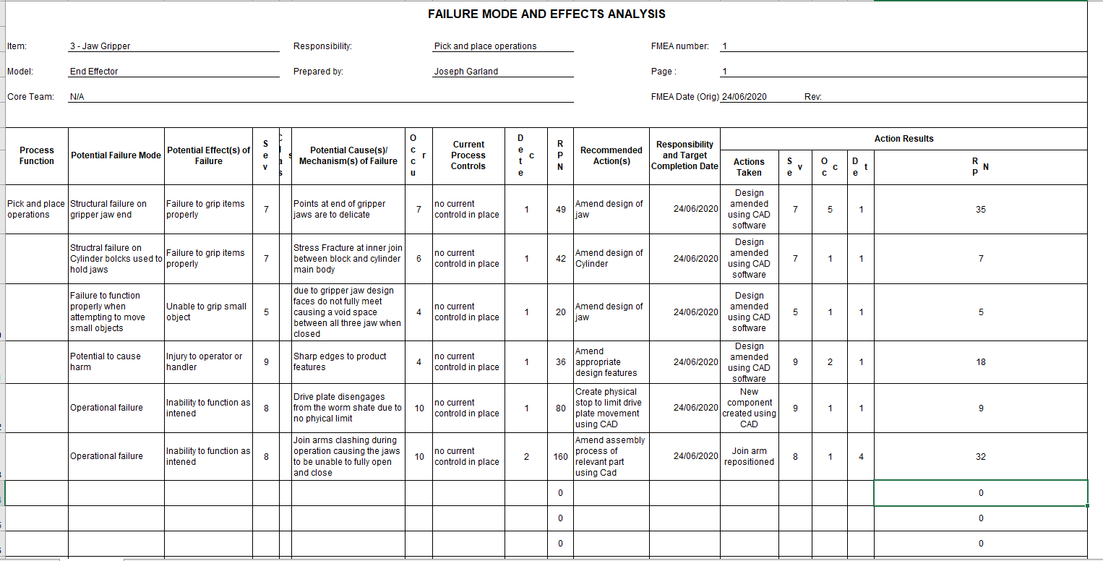
DFMEA are used as a way of guaranteeing quality during the design process. They look to analyse potential modes of failure and their effect on the production time taken for the product. DMFEA’s should be used to ensure all design specifications are met before scheduling a product for manufacturing. It is crucial that DFMEA’s are used prior to production to ensure the

Lean Manufacturing

Kaizen states that waste and continuous improvement go hand-in-hand in terms of lean manufacturing. As a result of continually striving to improve a process or business the likelihood of reducing the waste encountered increases. Processes can be improved via means of removing unnecessary stages within the process and eliminating any reoccurring problems. This in turn makes for a more efficient process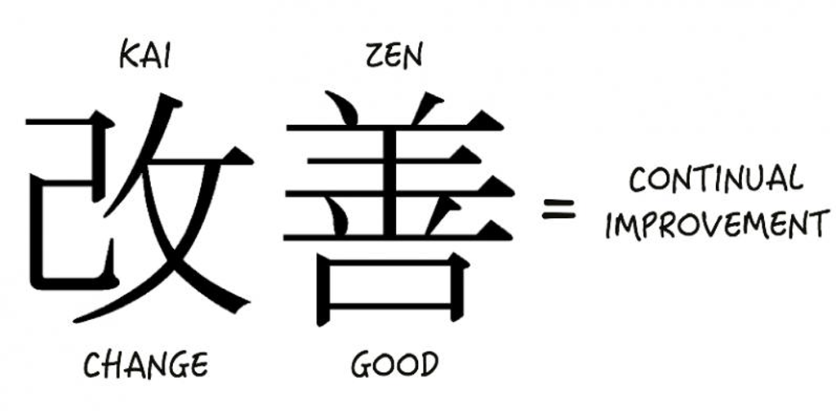
Figure 26 - Kaizen continual improvement
The best way to ensure continuous improvement of a process is to make sure all stages of the process are documented so that when problems that hinder the process occur you are able to easily locate and eliminate them. Reducing waste allows businesses to identify any inefficiencies that may pre-exist within the processes they have in place.
There are 7 main different type of waste in lean manufacturing are over production, inventory, motion, defects, over-processing, waiting and transport.

