Hospitality and Guest Service



Module cod: M4X01915

Student: Maria Madalina Vrincianu
Student number: 1815243

Lecturer: Mr. Dale Clarke

Table of content:

First page …………………………………...... page 1
Table of content ……………………………... page 2
Introduction …………………………………… page 3
Excelsior Hotel (Critical Analysis) ………… page 5
Conclusion …………………………………… page 9
References ………………………………….... page 10

Introduction

A hotel institution format is far-reaching idea propose by a hotel proprietor to define departmental activities and responsibilities. This format brings order to every aspect of hotel operation from the front desk and room service to the human resources department. Hotel format structures are necessary to ensure maximum profitability from each room, restaurant and bar on a daily basis. A hotel's institution format is useless without an initial listing of organizational objectives.
The purpose of services in hospitality industry spins around the customer. Even the biggest hotel chains could confirm that the customer helped them to gain the competitive advantages needed. “There is only one boss. The customer. And he can fire everybody in the company from the chairman on down, simply by spending his money somewhere else.” (Sam Walton) Hotel services, their number and the amount of people engaged in them depends on the size of the hotel as well as on its status. Typically, the basic hotel services include reception guests, room service, food service, including restaurants in the hotel, and security. Sometimes in the small hotels the duties of security, a cook and a cleaner are performed by the owner himself.
Taking care of the customer is the heart of the hospitality business. Doing so means understanding and anticipating what the customer needs and then knowing how to meet and exceed those needs. Adopting an approach with insights from all areas of hospitality, Guest Service in the Hospitality Industry explores the intricacies of quality guest service with solid and proven concepts across the industry. By providing several frameworks for thought, this book opens readers’ minds to the idea of taking care of the guest. Assimilating quality service into the identity and individual operations of the overall business is the key to success in the hospitality industry. Guest Service in the Hospitality Industry prepares hospitality managers to meet and exceed guests' expectations through quality service that is evident in all the operation, its people, and its plan.
Businesses who offer their customers excellent customer service will stand out. These are some of the key elements of excellent customer service:
- Patience
Dealing with distressed customers or perhaps customers who are letting out their anger, it is important not to fold under the pressure. Being patient is an important way to deal with this kind of situation. If you take the time to listen to your customer (even if it is a complaint!) and try hard to offer a solution, they will be much less tense. As a result, the customer will feel like you have offered a great service and it will be more likely to use your services again.
- Engage
Show an interest in your customers by engaging with them. This doesn’t just mean talking, but really listening to what they’re saying. The ability to engage and build a rapport is a great ingredient for future business.
- Knowledge
Knowledge is key and there is nothing worse than going to a hotel to discuss a product or service and they don’t have any knowledge about it. To ensure that your business offers the customers a great service, provide the employees with in-depth training. It may seem like a huge expense, but it will pay off in the future.
- Honesty
The employees won’t know the answer to every single query they get – but they can still deliver excellent service, if they are honest. It is much better to be honest and give the customer an answer later, than making up an answer, in the hope it’s correct!
- Respect
It is important to respect what customers say, even if you don’t particularly agree with them. Everyone is entitled to their own opinion and there is no need to disrespect someone because their opinion is different to yours.
Nowadays customer service is a crucial component in hotel industry. Every hotel tries to please their customers and offer the best experiences, hoping that they will come back. More and more hotels want to upgrade and to be unique, some of them last in time and have more success, for example Excelsior Hotel from New York.

Excelsior Hotel (Critical Analysis)
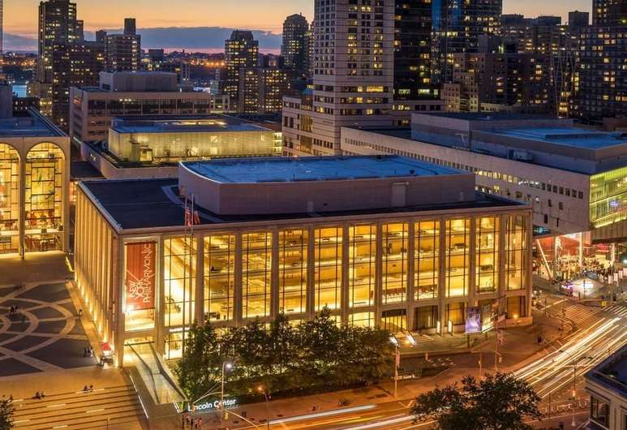
Manhattan is known around the world for its skyscrapers, but the famous steel structures are only a small part of the story. Located in a beautifully restored landmark building, The Excelsior is one of the city’s most authentic Central Park hotels, located uptown where rows of brownstones on quiet side streets still have the power to make you feel like you’ve stepped out of a classic New York movie. Built 1910, the Excelsior is a recently refurbished hotel that overlooks the American Museum of Natural History, just opposite Central Park. In the middle of New York's Upper West Side shopping and restaurant area.
Excelsior Hotel provides a large assortment of product and services. The hotel restaurant is all inclusive and offers a wide range of food. The customers can enjoy a satisfying meal at Calle Coho serving guests of Excelsior Hotel or quench their thirst with a tasty drink at the bar/lounge. And the hotel has also a buffet breakfasts available daily from 7 AM to 11 AM for a fee. And regarding the services offered it can be said that the guests will have almost anything they want. Here are some examples:
- Bar/lounge
- Elevator/lift
- Fitness facilities
- 24-hour front desk
- Conference space
- Restaurant
- Express check-out
- Tours/ticket assistance
- Dry cleaning/laundry service
- Wi-fi
- Self-parking
- Smoke-free property
- Safe-deposit box at front desk
- Luggage storage
- Offsite parking discounted rates available
- Breakfast available
- Concierge services
- Gift shops or newsstand
- Accessible bathroom
- One meeting room
- Roll-in shower
- In-room accessibility
- Multilingual staff
The factors that differentiates Excelsior Hotel from other competitors, the unique selling point, are the placement of the building ( just minutes away from Times Square and Midtown, close means of transport like taxi, subway and surrounded by restaurants, cultural attraction) and the variety of rooms offers ( Deluxe Suit, Classic Queen, Superior Room). The hotel must aim to attract new customers and keep current customers. This can be achieved by providing a good customer service to keep longstanding relationship with them. Customer service entails providing efficient, quick and friendly service, building strong relationships with customers, handling complaints quickly and responding to customers' issues on time.
Service Setting:
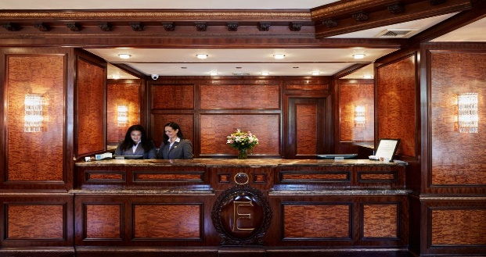
The front desk of Excelsior Hotel offers a calm, rustic atmosphere due to the design
with different shades of brown and geometry. The 24-hour front desk has multilingual staff ready to assist with concierge services, securing valuables, and dry cleaning/laundry. Additional amenities include a business centre, express check-out, and a gift shop.

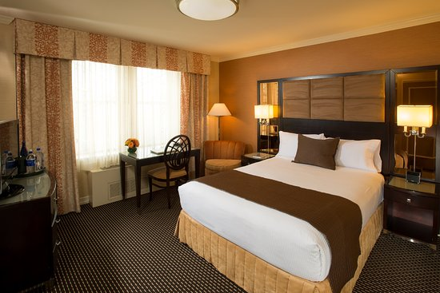
The rooms are very clean, always set to look elegant and to smell fresh. The guest can choose between different types depending on their need. Customers can anticipate to discover free Wi-Fi and 32-inch a smart TV with satellite channels and pay movies. Pillowtop beds sport premium bedding and the bathroom offers a hair dryer and free toiletries. Other standard amenities include free newspapers, a safe, and a phone
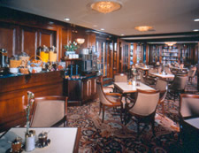
The bar/restaurant has the 20th century charm, an environment where customers can enjoy their food and drinks in a peaceful, warm and quiet place.
The hotel offers more facilities to raise the quality of the services like fitness centre, one restaurant, one bar/lounge with breakfast, brunch and dinner available.
Service Quality:
The quality of the services is high and the hotel try’s very hard to maintain it. The different types of rooms :Classic Queen ( one queen bed), Excelsior Deluxe (one king bed), Classic Room (two double beds), Excelsior Deluxe Suite ( two double beds), Deluxe Suite (one king bed), Superior Room (one king bed), Superior Junior Suite (two double beds), Deluxe Suite (two beds) and the guest have at their disposable:
- Private bath (bathtub/shower)
- Hair dryer and free toiletries
- Hypo-allergenic bedding
- Smart TV with satellite service
- Counter and phone
- In-room safe
- Free newspapers
- Housekeeping
- Central Air
- Free crib rentals
To maintain a good quality service in a hotel with 199 rooms it can be easy but with good management it can be manage. The managers are very interested in guest needs, they pay attention to the wants and needs of customers and make every effort to make them feel at home. The well trained, multilingual staff is trying their best to be kind and courteous, giving the customers a feel of security and closeness. The management of the business tries to employ people that love their job and that can put their heart and soul in the things they do, believing that this is a good strategy of maintaining a better-quality service. “The only way to do great work is to love what you do.” (Steve Jobs)
Service Delivery:
Most of the publicity about the hotel is done online where the business delivers the information about the hotel and the offers. Offers like Sizzling summer sale- save 25 %, Stay 5- Get 20 % off, Suite escape, Non-Refundable Offer – Save up to 30 %. The rest of the services provided is done by the employees, by their behaviour and attitude towards the customers. The staff is well trained and knows how to please the guests and to make their stay as smooth and pleasant as possible.
To be prepared for the changing customer preferences the Excelsior Hotel keeps improving, changing and adding new services or offers. Continuously improving is one of the important characteristics a business is require to have in order to succeed and remain in business through time. Updating the offers depending of customers’ requests, being more attentive to the feedback they receive to see what it can be done differently, small gifts or discounts to loyal customers, improving the appearance of the hotel( exterior and interior) are just examples why Excelsior Hotel stayed in business this long. And in terms of employees the discounts to boost their work capacity so they treat everyone around better, frequently training optional to advance and add to their knowledge and just kindness in general are just some incentives to improve the guest service of the business.

Conclusion
To conclude, it can be said that the customer and his satisfaction weigh heavily in the development and improvement of hotel industry. Every decision and change are influence by the guest and his wishes. As well as the big range of hotels, from one star to five, due to their needs and requirements. With the help of a plan, some good ideas and people that love their work and want to evolve it can be born a great hotel or business. Depending on the customer service that a hotel offers the business can bloom or die. The facilities they have, the staff, the training of the employees, the placement of the building, the design, the close attractions, the warm the guest are welcome, how their complains are handle, how their need are full field, the environment given, every little thing counts when it comes to have a quality customer service and a thriving business.

References

Brennan, C. (1997). Proactive customer service. New York: American Management Ass.
Canoed, A. (1992). Sam Walton, the giant of Wal-Mart. Ada, Okla.: Garrett Educational.
Frederick F. Reichheld (2001). The Loyalty Effect: The Hidden Force Behind Growth, Profits, and Lasting Value. Harvard Business Review Press
Garber, P. (2005. 25 reproducible activities for customer service excellence. Amherst, MA: HRD Press.
Griffin, J. (2002). Customer Loyalty: How to Earn It, How to Keep It, Jossey-Bass. New and Revised edition
Jobs, S., Lera, C. and Bove-Nielsen, J. (2011). Insanely great quotes. Viably: Libris Business.
Juran, J. and Fuchs, E. (2001). Quality in Customer Service. New York: McGraw-Hill Professional Pub.
Kainthola, V. (2009). Principles of hotel management. Chandni Chowk, Delhi [India]: Global Media.

