Student:Ileana Gabriela Juganaru
Student ID :2106753

University Name: University of Wales Trinity Saint David
Module Coordinator : Richmond Lamptey
Module code : BMSW4002

Assignment title :
Effective team working for team success

Executive summary

This report will focus on effective team building strategies in order to prevent team failures among organizations. As for the current scenario Vodafone UK has been working on a new project in order to deliver a community event with local and voluntary organizations. The company has set a project where there are 18 members in order to cater the client needs and project communication leads. There are certain problems related with the roles and responsibilities of the team members as they are working remotely. The only communication is through emails which seems to be lacking interpersonal communication with each other. The report will focus on effective team building strategies and put light on effective team building theories in order to combat against the teams problems.

Contents

Executive summary 1
Introduction 3
How can Abdul develop an effective team and what theoretical model can be used 3
GRPI Model of Team Effectiveness 3
What are the types of roles that are needed to create an effective team 5
Leaders 5
Creative Directors 6
Facilitator 6
Coach 6
Team players 6
What type of impact can effective team working have on team success? 6
Better problem solving 7
Increased potential for innovation 7
Enhance personal growth 7
What are the barriers to effective team working identified in this scenario 7
Lack of interpersonal communication 7
Poor level of communication with clients 8
Lack of team commitment 8
Conclusion 8
References 9

Introduction
Team can be defined as a group of people with similar interests, skills, and attitudes as well. They might have distinctive thought processes to complete certain tasks (Omar and Ahmad, 2014). A team ought to work together for a common purpose in order to achieve certain goals in the company. People working as a team must have common goals, common objectives, and must work on the same things. Another important thing among the team is compatibility among each other. If the individuals are not compatible with each other, they can never make a good team. They must be on the same page, if they have not similar interests then they should bring together through process, attitude, and perception. According to the scenario provided it is evident that COVID-19 has brought its social restrictions due to which the team was not able to meet with each other personally. Abdul on the other hand is also trying to find the root cause of failure to complete the project tasks as per the deadlines. Meanwhile he also observed that team members seemed unconcerned about other people. They are less connected with each other in terms of supporting and providing help via email communication. According to this scenario the report will primarily focus on ways to develop an effective team according to the theoretical model. The report will also focus on analyzing teams working in terms of combining success and innovation.

How can Abdul develop an effective team and what theoretical model can be used

GRPI Model of Team Effectiveness
Teams are the workhorses of any business. There are some situations where few people sit in the same room, and they might be sitting separately during certain situations. Apart from their size and location, teams are complex and often tend to face problems which can stop them from performing at their best level. Often people associate these problems with interpersonal issues but on the other hand there are a series of other possible causes as well. Dick Beckhard, who is a well-known organizational theorist, developed the GRPI model precisely to diagnose the cause of team dysfunction. GRPI model stands for Goals, Roles, Processes, Interpersonal Relationships. the model often known as gripper shown in pyramid form (see fig 1). It has certain steps and components which focus on four possible causes of team troubles. As per the above scenario, the situation will be analyzed through GRPI to diagnose the trouble spots:
Goals: In the current scenario, it is evident that the team has been working remotely and their communication among each other is through emails. Goals ought to be an organizing principle for any successful team (Tartell, 2016). But in the present situation, it is evident that the team has low understanding towards their goals or commitment. Abdul has witnessed some communication problem from the project community liaison leads which clearly depicts low understanding of goals. In many cases goals seem to be ambiguous when team members show less commitment towards them but these are openly mistaken as interpersonal issues. If we explore more about them, it may be due to lack of understanding or commitment towards the team's goals (Sheldon, Kasser, Smith and Share, 2016).
Roles: It is another step in the GRPI pyramid, if the goals are understood clearly then other problems might be with roles. A team who has clear and defined roles help them to fulfill their responsibilities. if people have been overlapping their roles in the company, then it can cause conflict over who does what. This situation can lead to poor performance. In the current scenario it is evident that team members seem to be less concerned with each other which means that they are unaware of other people's roles and responsibilities. The need of the hour is to redefine roles and responsibilities of the team as per their skills and capabilities.
Processes: This step in the pyramid typically aligns how the work has been completed involving team decisions, allocating the resources, communication, and solving the inevitable problems if it arises. In certain situations, it is evident that the team has not met each other personally due to COVID-19. their communication has been impacted since then which increases low understanding of the process.
Interpersonal Relationships: It involves examination of personal communication styles among each other. As per the scenario, it is evident that the team is not communicating with each other. They are not helpful and failed to provide support to each other via emails. Abdul needs to focus on reshaping their interpersonal skills in order to make them supportive for each other (Tartell, 2016).

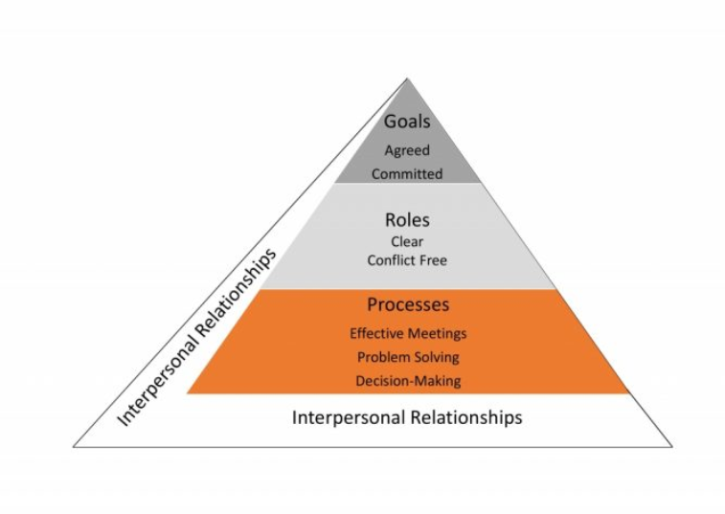
Figure 1 GRPI Model (Tartell, 2016)

What are the types of roles that are needed to create an effective team
When building an effective team, it is important to ensure inclusion of the right people while having the right roles and responsibilities to complete the goals. It is also important that the team must know how to communicate with each other and build virtual team networking in order to encourage team bond and knowledge sharing ideas. In order to build a team, the following are the types of roles which help to create an effective team:

Leaders
For an effective team it is important that they must have a person who will be in charge as a leader to ensure better performance. A leader is someone who builds ground rules for their team members and provides motivation and direction to achieve goals. Leader is a person who builds trust with their team members on the basis of interpersonal skills (Soltanzadeh and Mooney, 2018).

Creative Directors
For any effective team it is important to embed creativity and innovation among team members. A creative director is a person who will assign the role to develop unique ideas. This person will typically focus on helping teams to think out of their comfort zone and maintain a progressive energy in the organization (Khanna¸2022).

Facilitator

A facilitator is someone who's not formally given a title in any company but takes an important role while helping in the decision making process of the team. This person is responsible in order to manage and understand the objectives in order to provide help for team members to achieve these goals (Sheldon, Kasser, Smith and Share, 2016).

Coach
A coach is someone who is aiming to support and train the team members. For example, in the current scenario it is evident that the team is not trained enough to work remotely. They seem to be unconcerned in terms of responding to emails and reading all the goals and objectives while finding their roles and responsibilities. Hence coaching facilitates training.

Team players
Team players are the people who will be assigned roles and responsibilities in order to achieve certain goals (Khanna, 2022). They are the members who must be present in every meeting and work on their allocated task in order to complete it on a given deadline.

What type of impact can effective team working have on team success?
It is evident that effective team working always results in problem solving leads in order to enhance the outcomes (Ingvaldsen, Holtskog and Ringen, 2013). Much research has been done which has shown progressive leads towards collaborative problem-solving techniques where people are more likely to take calculated risk which resulted in innovation. These are the possibilities if there is an effective team working behind it. Working in an effective team always encourages personal growth. increases job satisfaction and reduces the stress level at the workplace. The following are some type of impact which and effective team working have on the success of team:

Better problem solving
The article by Middleton (2022), describes the fact that behind every genius there is a team where people play off each other's skills and knowledge in order to create a unique solution that would be practical and useful for the upcoming generations. It is evident that even Albert Einstein gets all the credit for his discovery but in reality, he always said that it is teamwork. According to science, reinforcing the idea is the result of many brains working on a single cause. Group of three or four people who are outperforming the best on how to enhance the performance and work together to adopt correct responses and reject faulty responses as well (Johnson, Baur and Meissner, 2011).

Increased potential for innovation
One impact of effective team working would be increased potential for innovation. a group of people who are constantly working towards innovative ideas and they are surrounded with others who are more likely to breakthrough innovation and discomfort would always push it to grow. diversity is also a well-documented pathway to unlock new chances and overcome new fears in order to gain new insights.

Enhance personal growth
Another type of impact due to an effective team would be enhancing personal growth of individuals as well. When a team works all together, there would be more knowledge sharing activities which will help to flourish each member individually. While sharing ideas with other colleagues there might be new discoveries and concepts through which one can learn and help to sidestep future errors (Middleton, 2022).

What are the barriers to effective team working identified in this scenario

Lack of interpersonal communication
One evident barrier in terms of effective team working according to this scenario would be lack of interpersonal communication. It is evident that the team members have been working remotely and their only way of communicating with each other is through email. There are also incidents where team members are unable to share knowledge and support each other. This is one of the most palpable challenges in terms of building an effective team. If team members are unable to communicate with each other effectively then they would be unable to work together on a common goal.

Poor level of communication with clients
Another barrier towards effective teams would be poor level of communication from the project community liaison Leads. As the team was unable to communicate and provide services for relevant stakeholders and voluntary organization in order to promote project for Vodafone UK.

Lack of team commitment
Another barrier towards an effective team would be lack of commitment among team members (Sheldon, Kasser, Smith and Share, 2016). As per the scenario, it was evident that each of the team members failed to complete the project tasks in the given deadline and seems to be apathetic about other members on the team. Moreover, when they were called for an important meeting one of the project staff members failed to attend or give his apology. The meeting was about discussing with the local MP and community groups. It was an important call and if the staff member was unable to come then he must be notified before time. This shows lack of commitment towards the company. Commitment is one of the most important elements in terms of building an effective team where team members must be responsible about their roles and presence in the project. if they seem to be casual in terms of attending meetings or other parts of the project then they would be unable to complete it according to the requirement. Another loophole is that many of the members related to this project are looking to resign. rather than stepping out of their comfort zone they are likely to resign and leave the space. This also shows a lack of commitment towards their job duties.

Conclusion

This report concludes with the fact that effective team members are the important pillars of successful organizations. If the company has been failing to build an effective team, then they are unlikely to complete their projects and gain success. Their organizational goals would likely fail as well. It is very important that leaders must play their role to build an effective team where they can handle any problems with interpersonal communication. Another crucial factor in forming a team is team compatibility. Individuals that are incompatible with one another will never create a good team. They must be on the same page; if they do not share comparable interests, they must work together to achieve this through procedure, attitude, and perception.

References
Ingvaldsen, J., Holtskog, H. and Ringen, G., 2013. Unlocking work standards through systematic work observation: implications for team supervision. Team Performance Management: An International Journal, 19(5/6), pp.279-291.
Johnson, S., Baur, C. and Meissner, H., 2011. Back to Basics: Why Basic Research Is Needed to Create Effective Health Literacy Interventions. Journal of Health Communication, 16(sup3), pp.22-29.
Khanna, S., 2022. What Are The 5 Roles Of An Effective Team?. [online] Available at: <https://wheon.com/what-are-the-5-roles-of-an-effective-team/> [Accessed 24 February 2022].
Middleton, T., 2022. The benefits of teamwork (as proven by science) - Work Life by Atlassian. [online] Work Life by Atlassian. Available at: <https://www.atlassian.com/blog/teamwork/the-importance-of-teamwork#:~:text=Research%20 shows%20that%20collaborative%20problem,job%20 satisfaction%2C%20and%20 reduces%20stress.> [Accessed 24 February 2022].
Omar, Z. and Ahmad, A., 2014. Factors Contributing to Research Team Effectiveness: Testing a Model of Team Effectiveness in an Academic Setting. International Journal of Higher Education, 3(3).
Sheldon, K., Kasser, T., Smith, K. and Share, T., 2016. Personal Goals and Psychological Growth: Testing an Intervention to Enhance Goal Attainment and Personality Integration. Journal of Personality, 70(1), pp.5-31.
Soltanzadeh, S. and Mooney, M., 2018. Players Within a Team: Understanding the Structure of Team Performance Through Individual Functions and Team Objectives. International Sport Coaching Journal, 5(1), pp.84-89.
Tartell, R., 2016. Understand Teams by Using the GRPI Model. [online] Training. Available at: <https://trainingmag.com/understand-teams-by-using-the-grpi-model/> [Accessed 24 February 2022].

