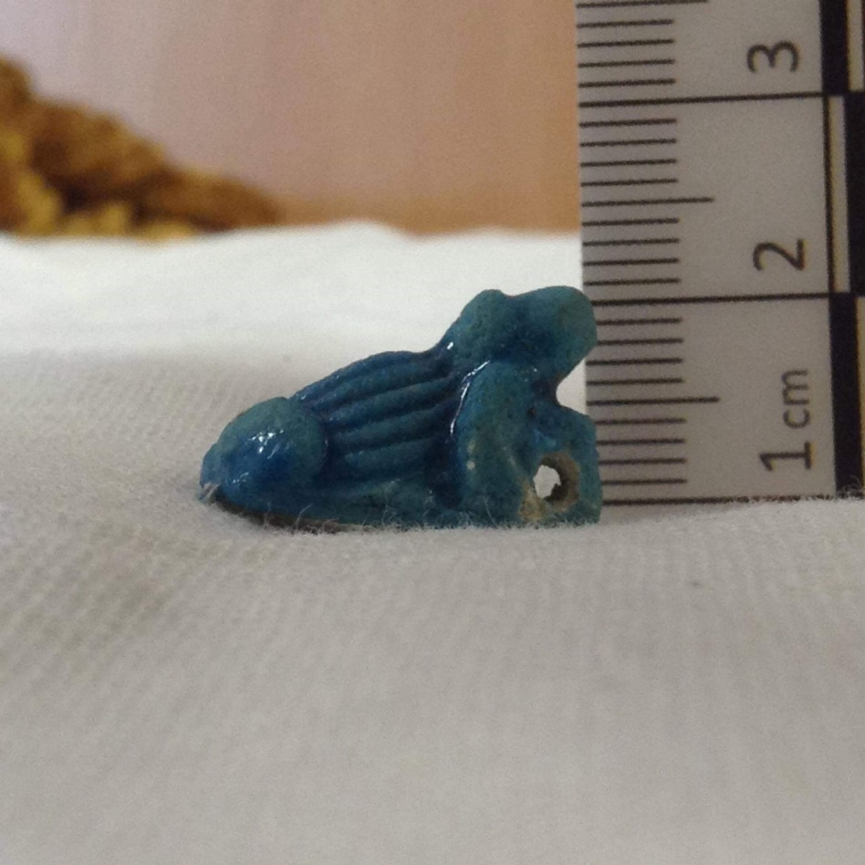
Frog Amulet

Cyfarthfa Castle Museum and Art Gallery, Merthyr Tydfil
CCM 1725.004
Unknown, Egypt
Estimated New Kingdom
Faience
This frog amulet is approximately 1.8cm long, 1.2cm wide and 1.1 cm high. The frog itself is positioned as if it were sat up, with its head and front legs pointing up and its hind legs relaxed alongside the body. It does not appear to be sat on any kind of bass like one would expect from a scaraboid, however it does have a circular extension of faience under its chin and between the two front legs with a hole cut into the centre of it, presumably for the purpose of threading a string through. There is damage around the otherwise quite clean cut hole, possibly from wear and tear but also could just be general damage as this is the weakest part of the amulet. Its body contains vertical stripes from head to rear going all along the body, though the head, neck and legs remain unmarked. It is made of faience and as a result is a beautiful shiny turquoise colour, darker in places such as the ridges on its back and where the body parts meet (e.g. in the crease between the eyes and the snout).
Amulets like this could be taken in two different contexts, in life and in death. In life, frog amulets such as these could be worn by pregnant women hoping for the blessings of Heket, the frog-headed goddess of fertility and childbirth. It was thought she could breathe life into not only new-borns, but also the dead too, so this amulet could also be a funerary item. Looking simply at the objective it would be easy to say that this was an item worn in life due to the only real damage on it being centred around the hole in which a thread would enter, therefore we can deduce that it has been worn a lot, possibly rethreaded again and again, passed down between females in a family when they are pregnant? However, the fact that this is made of faience, a material that the Egyptians thought to be associated with rebirth as it is ‘filled with the undying shimmer of the sun’ would be foolish to ignore. A frog on its own was a symbol of resurrection and regeneration due to its life cycle which would have been highly visible to the Ancient Egyptians as the Nile provides the perfect breeding ground for them during the annual floods. The way an egg changes to a tadpole then a frog is similar to the Ancient Egyptian belief that in death they transition into a new, eternal body. Because of this reoccurring motif concerning resurrection, this object has been determined to be funerary.

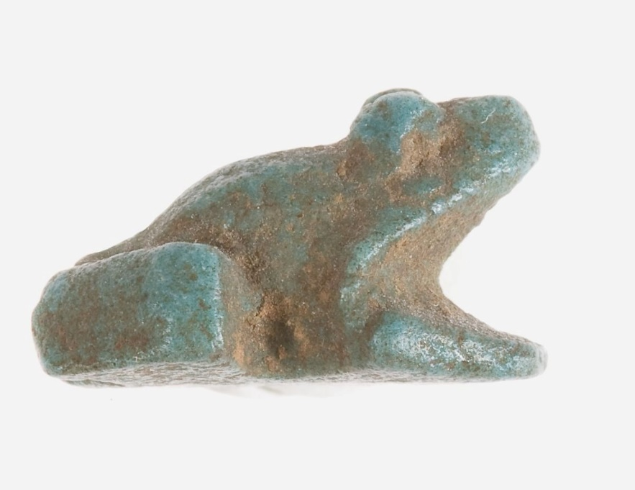
Dating this object is difficult due to the popularity of frog iconography, with frogs been a popular symbol associated with resurrection from the pre-dynastic period all the way through to Roman times when frogs were used to symbolise Jesus’ resurrection in Christian ideology. However, due to the fact that the New Kingdom saw an increase in faience production (possibly due to Western Asiatic influence) and the fact that the positioning of the frog with its head upraised is more common amongst later designs, it is likely that this is when our frog is from. An example of this can be found in the Metropolitan museum archives (Figure 1) in which the frog is a similar size and shape and made of the same material (faience) yet is not as detailed and doesn’t have an obvious hole to make into jewellery.
Figure 1
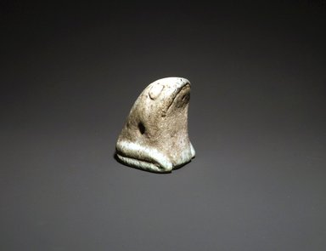
In contrast, a frog figure from the early dynastic period is on display in the Brooklyn museum and it shows a clearly different style. (Figure 2) This frog is almost four times the size of CCM 1725.004 and the design of the frog is so drastically different, that dating our frog to New Kingdom Egypt seems a lot more plausible. The early Dynastic frog is a more triangular shape, with clear emphasis being put on the face as it has very clear big eyes and mouth, although interestingly it is still looking up. Could this be important? Is the frog looking up into sky a sign of hopefulness rather than looking down in misery? Or maybe it is looking forward into the future? Pointedly not looking at the mummy it’s been buried with. Though, with our frog, the placement of the holes indicate that the frog will be looking at the face of the wearer- perhaps to establish a more intimate connection with Heket whether in life or death?
Figure 2
Figure of a Frog, ca. 3000-2675 B.C.E. Faience, 1 7/8 in. (4.8 cm). Anonymous loan, L58.2.2. Creative Commons-BY (Photo: Brooklyn Museum, L58.2.2_transp5524.jpg)
Frog Amulet, ca. 1550-1070 B.C.E. Metropolitan Museum of Art, 10.130.1918
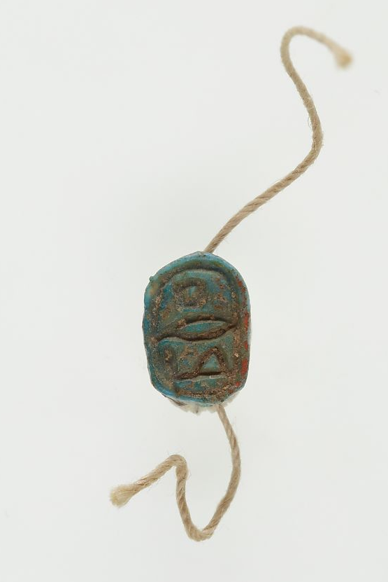
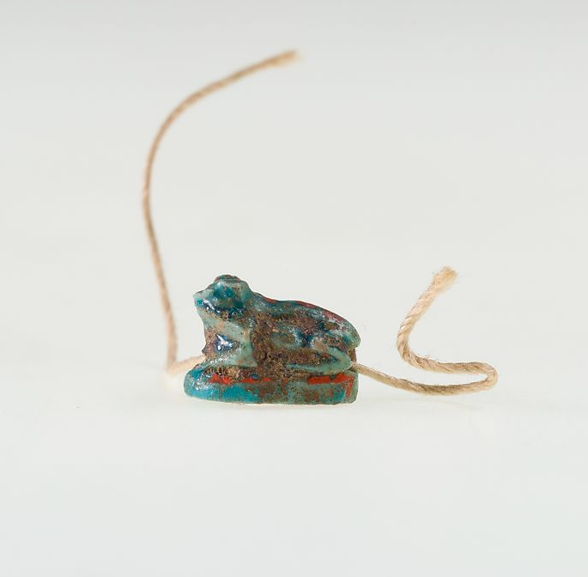
Another interesting feature about CCM 1725.004 is the lack of hieroglyphic text on the base. At first glance, this amulet seems to be in a scaraboid type fashion, however, it is missing a key element of this, It does not appear to be sitting on anything and has no text on the base like you would expect to see from a scaraboid. This difference is clearly seen by looking at item 20.1.32 from the Metropolitan Museum of Art (figures 3 and 4) Which is a frog scaraboid, also made of Faience, also a similar size and design, only the position of the holes makes the frog face a different way to our frog. Also it has clear hieroglyphs on the base. Why leave this feature out? Maybe the iconography of the frog is so well understood by the New Kingdom that this is rendered pointless? Or perhaps the placement and direction of the frog told a tale that has since been lost to us?
Figure 3
Scaraboid, ca. 1981-1295 B.C.E Metropolitan Museum of Art, 20.1.32
Figure 4
In Conclusion, Item CCM 1725.004 is most likely a funerary amulet from the New Kingdom purchased so that the deceased can have the intercession of Heket, the frog headed goddess who’s breath brings eternal life. Though it is possible that this was used in life as well as shown by the wear around the hole in which a string would have been threaded.

Bibliography
- [Author Unknown] (2002) Faience in the New Kingdom (about 1550-1069 BC) University College London [retrieved at https://www.ucl.ac.uk/museums-static/digitalegypt/faience/nk.html]
- Andrews, C (1994) Amulets of Ancient Egypt. British Museum Press, London
- Arnold, D (1995) An Egyptian Bestiary. The Metropolitan Museum of Art Bulletin [retrieved from https://www.jstor.org/stable/3269051]
- Assmann, J (2001) Death and Salvation in Ancient Egypt. Cornell University Press, New York
- Hill, J (2010) Heqet [retrieved from https://ancientegyptonline.co.uk/heqet/]
Images
- Figure 1: https://www.metmuseum.org/art/collection/search/544109?&searchField=All&sortBy=Relevance&ft=frog+amulet&offset=0&rpp=20&amp;pos=4
- Figure 2: https://www.brooklynmuseum.org/opencollection/objects/126589
- Figures 3&4: https://www.metmuseum.org/art/collection/search/545710

https://ancientegyptonline.co.uk/heqet
https://www.metmuseum.org/toah/hd/egfc/hd_egfc.htm
Assmann (2005) p142
Arnold, D (1995) p34
https://www.ucl.ac.uk/museums-static/digitalegypt/faience/nk.html
Andrews (1994) p63
https://ancientegyptonline.co.uk/heqet

