Charlotte Morton
2104149
Independent Project portfolio

Content Page:

Element 1:

Page 2 – Introduction/ Proposal
Page 4 - Literary Review

Element 2

Page 6 - Development, Collaboration and Exploration
Page 12 – Link to Performance
Page 13 - Script
Page 27 - Bibliography

Proposal

Subject:

Procrastination At Its Finest: A play presenting how ADHD can affect a person during essays, exams etc… and how this can lead to procrastination and people misunderstanding how this can affect them.

Overview of Aims:

I believe as a person who struggles with ADHD, society sometimes doesn’t understand what can come with it. Through the play I want to highlight the differences between a person who lives with ADHD (neurodivergent) and a person with what society classes as a “normal brain” (neurotypical) are like completing a piece of work. My goal is to showcase the difficulties that come from both parties during the process of being tasked with a large writing piece of work and how they tackle it.

Research:

Me: I will be using myself as a source because this topic is very close to me. I got diagnosed at 9 with ADHD and I have learnt what comes with ADHD for my brain. I wanted to use my personal experiences as a source of research which will help the character become more realistic and bring depth.

Book: https://books.google.co.uk/books?hl=en&lr=&id=IXdKDgAAQBAJ&oi=fnd&pg=PT4&dq=books+on+procrastination&ots=xOXNe2FpLz&sig=ZM7XL6EGi7hDwudCMYgaDEm3nO8&redir_esc=y#v=onepage&q=books%20on%20procrastination&f=false (where I found it)

This book gave me have a deeper understanding on all different types of ways you procrastinate. It has clear examples of roots, reasons and even mentions perfectionism. This is a good source as it isn’t just about being neuro divergent it is something that happens on a daily to many people who are neurotypical.

Websites: https://www.nhsinform.scot/healthy-living/mental-wellbeing/stress/what-to-do-if-you-are-struggling-with-stress#:~:text=Stress%20is%20the%20feeling%20of,be%20motivating%20to%20someone%20else.
This website creates a good insight into the idea of stress. It covers the ways in which you could experience stress and you it also covers things that stress could induce. It also gives you help lines and places to talk so that you don’t feel alone and could get some help.

https://www.bbc.com/future/article/20180219-toxic-perfectionism-is-on-the-rise

I found this website which shows that perfectionism isn’t something that should always be praised. It shows the dangers of always wanting everything to be 100% perfect. However, in this world nothing will ever be perfect so reaching for perfect can be a hard and a painful thing to try reach. It is always good to try understanding 2 sides of a title that is so highly valued but not understood for the negatives.

Videos:

https://www.youtube.com/watch?v=H_IQfxM4oMQ

This video was interesting to me as she made it very watchable and relatable yet informative. It shows some of the mindsets people have towards ADHD. There are very common ideas on ADHD that are correct yet also so wrong. She makes points in ADHD that people miss but need to be known.

Podcasts:

https://podcasts.apple.com/gb/podcast/the-anxiety-guy-podcast/id1080900600?mt=2

This podcast has had multiple good reviews on how he has helped them overcome their own anxiety. Although he hasn’t cured it as it isn’t something to be cured, he has helped them learn how be themselves while having it. Opening them up to be okay with going out as just them. He has shared his own experience to show people it is okay. It has shown me about when you open up, it helps other people to open about themselves and have a safe place.

Literary Review

An investigation looking into the similarities between perfectionism and procrastination in the event of writing essays, exams and any academic work.

Through a range of sources, I will review the similarities between perfectionism and procrastination in an academic environment. I am writing this review to highlight the importance to understand both parties’ perspectives on this situation. As a person who struggles with procrastination, I find it is important to show the facts of why we are the way we are instead of people assuming it is because of laziness. I also find it is important to make people understand the thought process of perfectionists and how both parties have some similarities. I believe that the naive opinions of society give the wrong impression towards both parties so I will be showing the facts through different a medium of websites, books and other points of research.

Everyone’s wish is that they could be the perfect version of themselves whether this be in work, social life or self-image but researchers have found “that it is nothing short of dangerous, leading to a long list of health problems” (Ruggeri, 2018). Perfectionism in this world is praised yet no one understands how dangerous it can be. This website has given me an insight into how it is a “self-defeating way to move through the world” (Ruggeri, 2018). When you are someone who doesn’t have perfectionistic tendencies, you only see the upsides of wanting everything to go right. We see them as a perfect student or top employee but behind the mask of what they present, perfectionists have been linked to “depression and anxiety, self-harm, social anxiety disorder and agoraphobia, obsessive- compulsive disorder, eating disorders……” (Ruggeri, 2018) The list goes on. The one fact that people miss on a daily occurrence is when a perfectionist are described as having OCD; obsessive- compulsive disorder, however, “OCD is a diagnosable mental health condition, whereas perfectionism is a personality trait. That said perfectionism can be a trait seen in OCD” (Heath, 2023). Even with OCD people view it as a good thing, they instantly think they are clean, they get their work done on time, they are in control, but they don’t look at the facts. OCD has 2 parts obsession and compulsion. The obsession part can come with “unwelcome thoughts, images, urges, worries or doubts that repeatedly appear in your mind” (Anon., 2019) these people think could just be a random funny joke coming into your mind or doubting your crush likes you. However, in some cases it is doubting you’re enough to be in the world or you want to commit suicide. These are things people should look at and view as a good thing they should understand the facts and the consequences that can come with it. The other part of this disorder is Compulsion “repetitive activities that you do to reduce the anxiety caused by the obsession” (Anon., 2019) The understanding of facts is needed when society now makes statement unknowing what the meanings mean.

Procrastination on the other hand is something people look down on however it isn’t something someone does because they are lazy however I found an article that took multiple people who have struggled with procrastination and some have stated “procrastination wasn’t as black and white as they thought” (Sederlund, 2020) it is often because of the emotional state of the person, this includes there “fears, hopes, memories, dreams, doubts and pressures” (Burka, 2008) Underneath the lack of attention and distraction and anything that stops them from doing the work, there is panic of failure. This is where my statement of similarities come in for perfectionist and procrastination. “Often without realizing it, people who procrastinate are perfectionists” (Burka, 2008). From my own personal experience, I put things off because I’m scared of messing up, the idea that once I start, I can fail sends me into a panic. “Many people who procrastinate are apprehensive about being judged by others or by the critic who dwells within” (Burka, 2008). For both perfectionist and procrastinators there is an anxiety that kicks in when set any work “you’re fuelled by anxiety, you may feel that you are inadequate, incapable, or a failure. You may put off tasks because you are afraid of not achieving “perfect” results” (Anon., 2022).

People like to join a personality trait with a mental health condition but in some cases, they are linkable, but they are not the same. “For people with ADHD, procrastination is often strongly influenced by the symptoms of their condition.” (Low, 2023) just like OCD linking with perfectionism. While procrastination isn’t a symptom of having ADHD it is something that can be noticed to make you look for the symptoms, “people with ADHD can seem restless, may have trouble concentrating and may act on impulse (Anon., 2021). The NHS was the first site my parents went to when I got diagnosed with ADHD so I found it important to add it in here as anyone who think their kid, their friend or even themselves might be neurodivergent in some way it’ll be the first place they look.

Development, Collaboration and Exploration
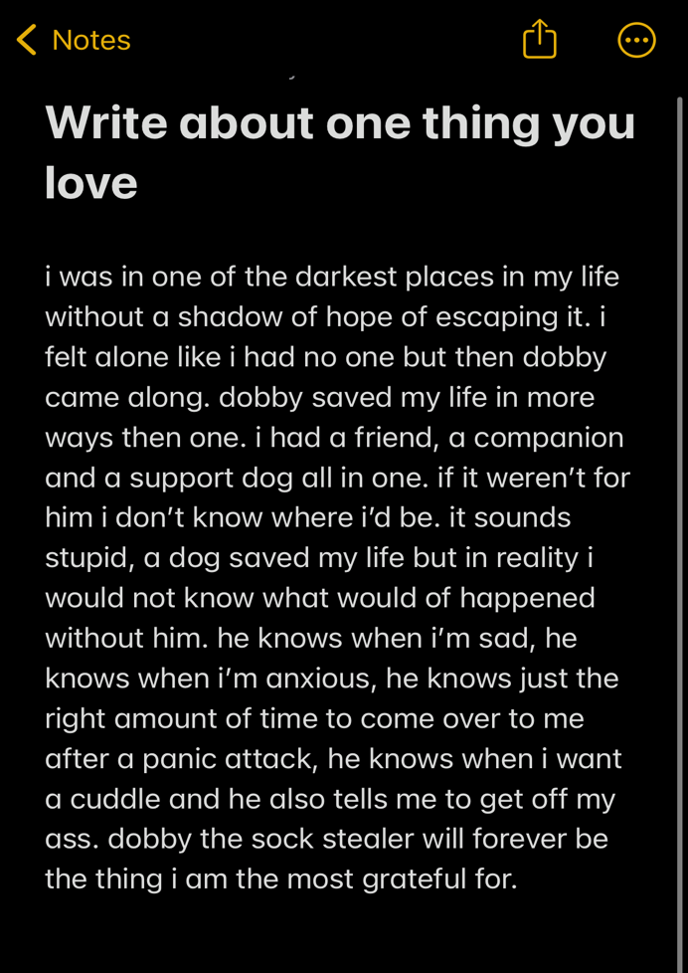
At the start of this process, I was lost and hated the idea. I view myself as a performer not a creator but in many ways being a performer makes you a creator. In our first few sessions we were presented with some tasks which I hated the idea of. With many of my class knowing some idea of what they were doing, it made me undermine myself and the project I had to come up with. At the start we were told to find something we loved and appreciated and write about it for 2 minutes straight without stopping to let us know that it is okay to blab if it led to us getting some ideas out. I spoke about my dog; dobby (task presented on the right). This task made no sense to me however I did it. Although this didn’t help with my idea, it got me to just write. This made me realise there were small parts of it that could be used if needed.
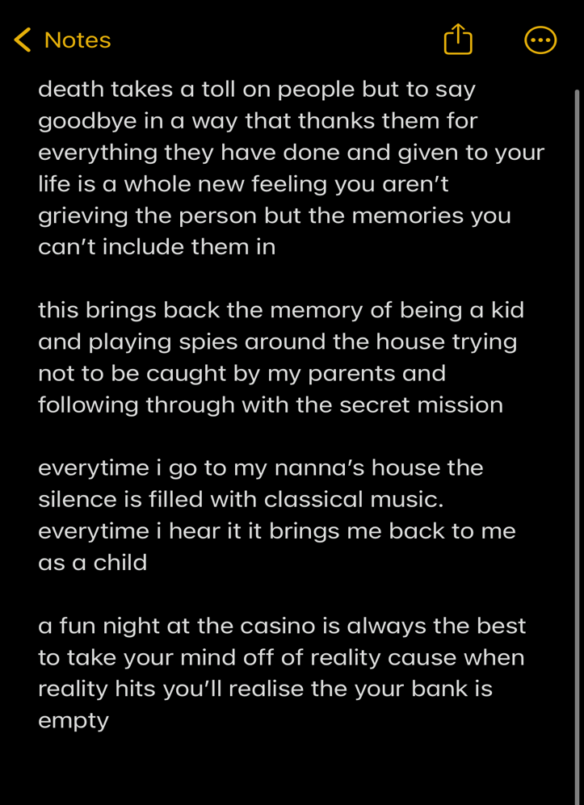
One of the tasks that stood out to me was listening to different types of music. We were told to write about what memory it brings you back to when listening to the short clip (task show to the left). I did not understand how this was going to help however I found really interesting to see how different genres of music can bring different types of memories up. I believe it came clear to everyone at this stage that I had no idea on what I was doing, and it made me feel very uncomfortable and I kind of shut myself down during the classes as I felt embarrassed that I was the only one struggling with this topic
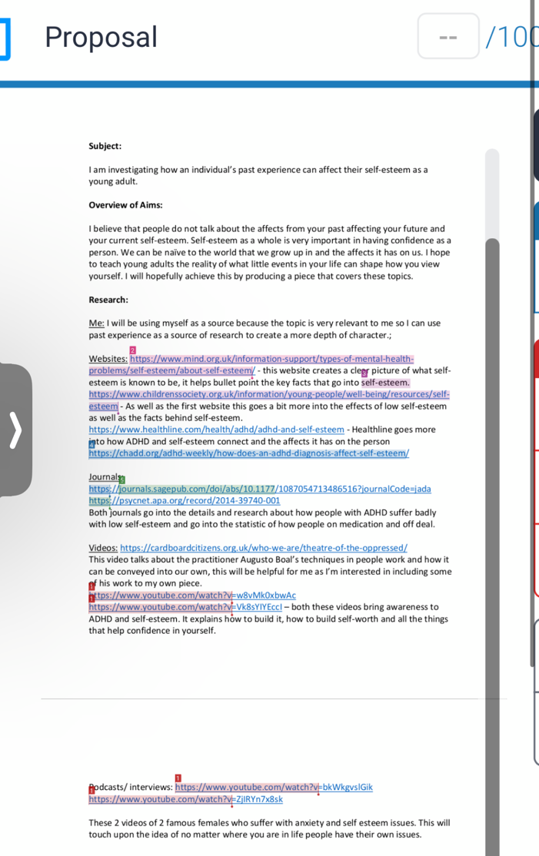
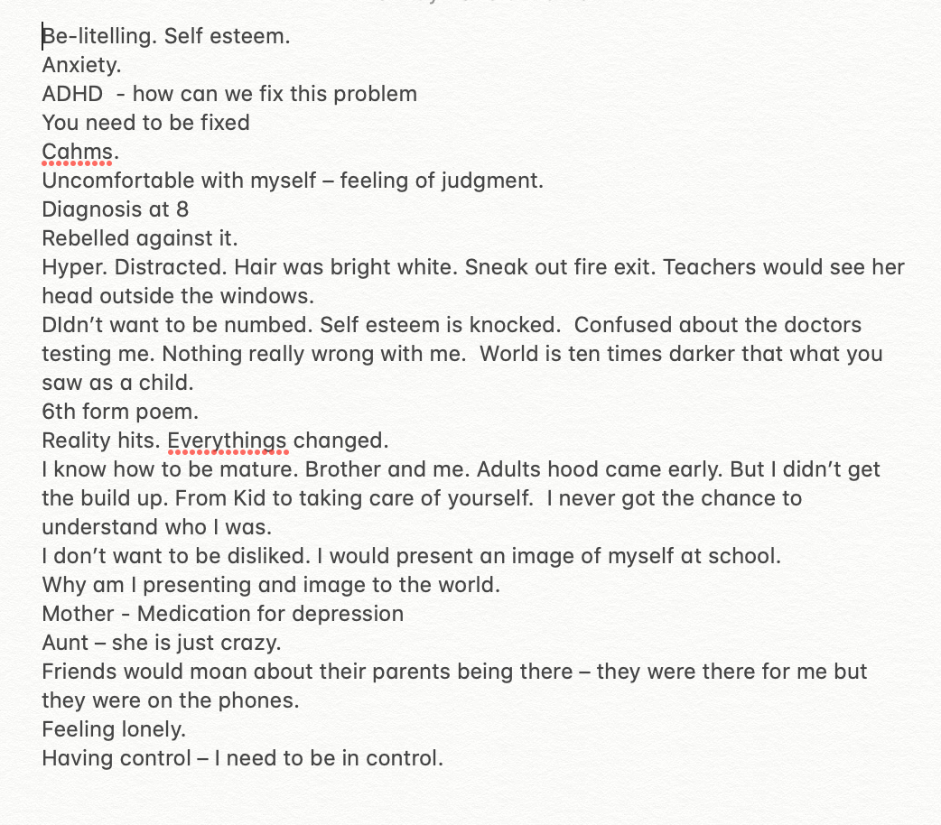
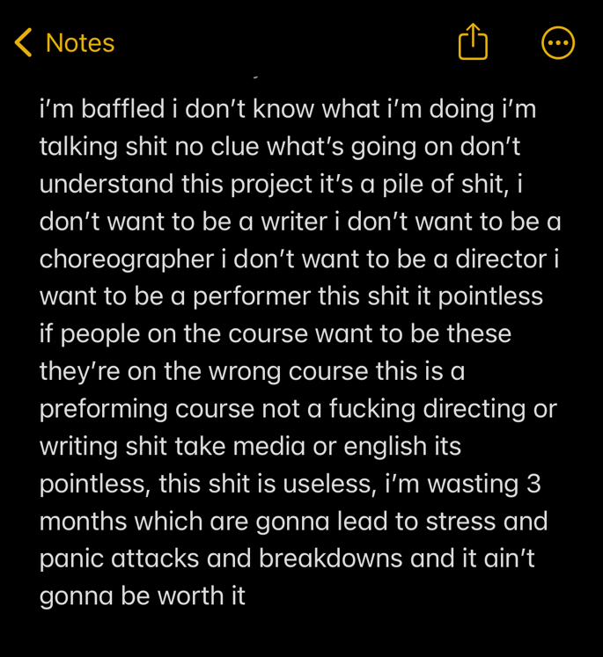
We were set a 1 on 1 with the head of our project to see where we were at. Instead of me having an idea, it was more of a therapy chat to pull out bits if my life that we could talk about and maybe see what parts are adaptable into a project (To the right is the notes the head of my project pulled out). We spoke about two main things that kept recuring in our chat: my lack of self-esteem and my ADHD. This made me believe I wanted to write a play about how your past can affect your self-esteem as a young adult. I started writing a proposal for the task (shown on the right) which I ended up handing in as first draft. At first, I thought this was a good idea for me as it’s something I have struggled with for years and had a lot of information about it and information I could also find. It was my idea for weeks for it to be on this, but it was an idea that I really struggled to find a way to adapt it into a play. At the time I thought I was struggling because I couldn’t find a way to start it but now, I am reflecting on the situation I don’t think I was completely comfortable to let everyone know that my self-esteem was so low that I could write a full play on it. Because of this I went to my head of project and told her how I was feeling, she told me to reflect on my previous work in classes and our 1 on 1 to see if anything else stood out to me which led me to find one of our previous tasks (shown on the left). This was one of the first things I wrote. I was very angry in all honesty with this piece of work because it doesn’t show me as person. I am dyslexic and I have ADHD what leads me to not understanding certain things and that leads me to procrastinate. Once I found this, I realise it would be a good start to a monologue in whatever thing I decided to. I looked through my Head of projects notes on me and realised that my ADHD is something I would want people to be more about and more educated about, as society only sees it as something that only makes people be hyper and loud where in reality it is so much more. I ended up with the idea of making a play around Procrastination as it is something that I always do and have especially done with this project.
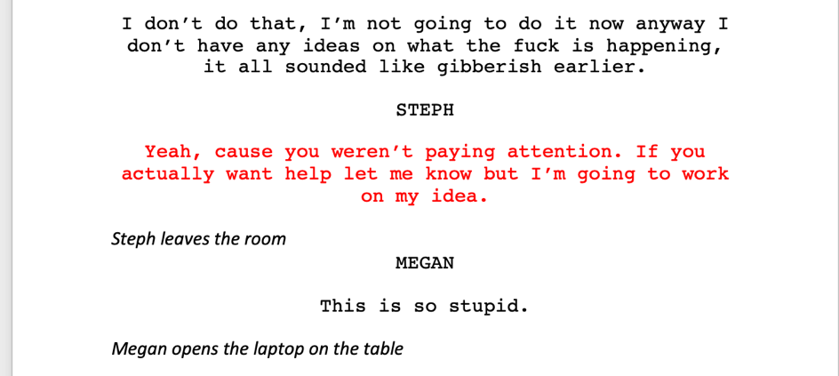
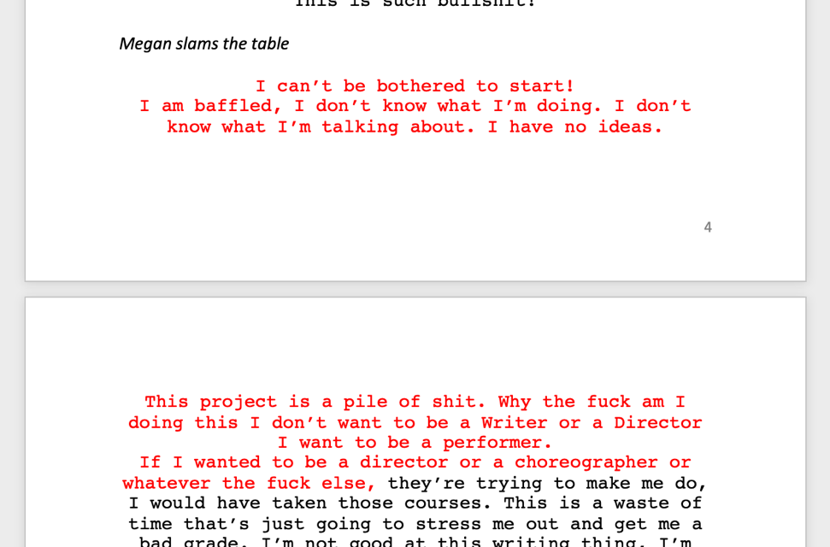
Once I figured out what I wanted to do I started on my script. ( On the left in red is where I got to in my “first draft” that I sent to get feedback ).Getting started was okay but after a while I didn’t know where to go with it. Script writing or any writing at all is not my strong suit but I wanted to get an idea across. My thought process for this script was for me and my house mate to be set our independent project. I wanted to show one person who struggled with ADHD and Procrastination and the other house mate to be a Perfectionist with traits of OCD. I added my monologue in that I had written in class as I wanted to make the main character me as a person as it would make it easier for me to make the character more realistic.
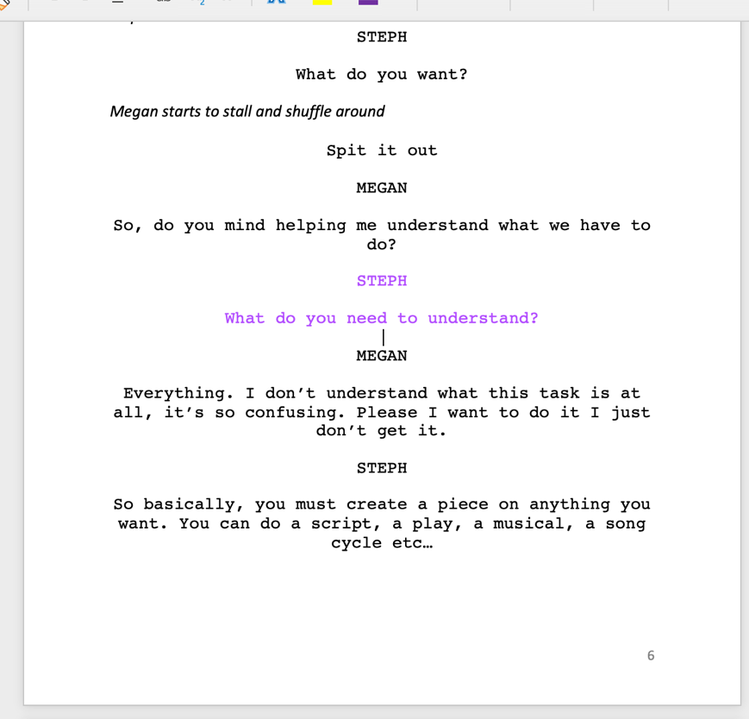
I was given feedback to extend my monologue and to add some comedic elements however I don’t know how to write comedically. I took the lesson I learnt in the first few groups session of writing continuously and then picking out parts. This helped me get a good chunk of monologue out and I felt was quite successfully written. (To the left is where I got up to in my “second draft” which I sent to get feedback on) I never completed my script before sending it off because I like working in order and getting feedback to bounce off.

After getting my last feedback I went onto the final draft. There was no conflict, and my script was quite one level, I was told that my house mate was too helpful and there needed some level of fight or for her to disappear. I was panicked at this stage because I wasn’t doing my work fast enough. At this point I was a week away from the performance and had one actor that I hadn’t met yet. I added one of my favourite parts in the script on the weekend what was them arguing. It included information about perfectionism, ADHD, stress, doubt all of the above and I finally got the points I needed in. I met with my actor on the Monday after nearly finishing but the whole time I was writing I wanted her input into the script as it was something we were preforming together. Me and Lily (my actor) went through the whole script changed little details adapted her way of speech into it and created an end together of how we would both like for it to be resolved. I finally completed it and was happy with how it ended. After weeks of having this assignment, I had procrastinated the script ending till 4 days before the performance, but I find that I work best under pressure.

Although I work best under pressure I regret starting so late because I feel like I would have taken a lot of stress off me. Although I'm saying this, I know I never would have started earlier because I'm stubborn and I didn't let myself try understanding. The script was the hardest part for me overall and going through all those stages of trying to write the Script. Forming a speak able script was hard for me as I am dyslexic and going back and reading over what I have written was like reading Scrabble I had to pull apart the parts that I had just sped wrote because I had got an idea in my head that just had to come. The one thing I was lucky to do in this script was bring awareness the ADHD isn't just about laziness or loudness. There is so many negatives for so many positives at the same time because without it I wouldn't be the performer I am to this day. I also got to Showcase that the stereo type of perfectionist isn't what it's just made out to be. It is the pressure they put on themselves to make themselves proud, but they never end up doing it because they are so scared of being judged and judging themselves.

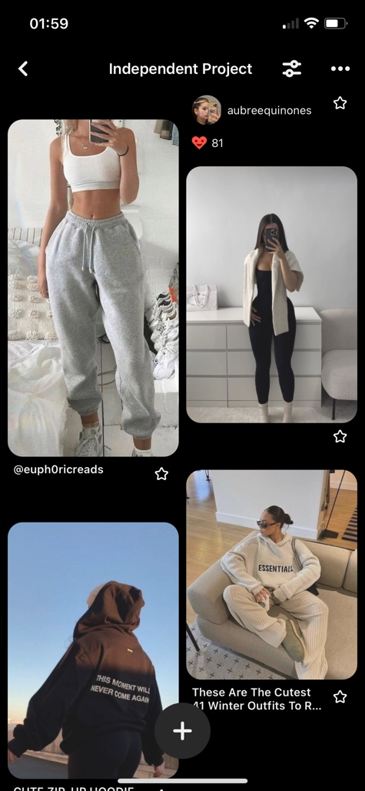
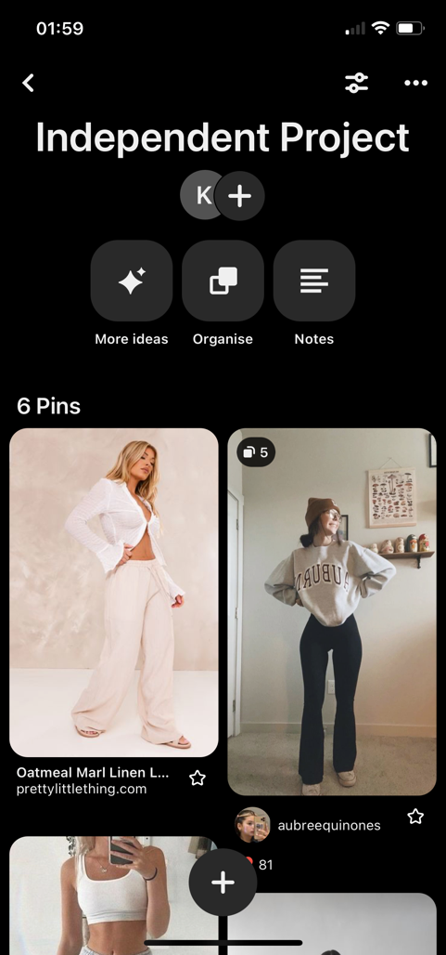
I worked with Lily on staging and Performance for the next two days. I had a bit of trouble connecting to the character seeing as my character was based on my housemate and lily’s character was based on me. The reason I was playing the character Steph was because there weren’t enough actors to go around. For me to get comfortable enough to play in my piece was a bit hard because I wanted to be able to watch and Direct and for me directing myself and someone else while I'm in the play was very difficult. However, I loved working with the Lily because she understood me as a person, she projected her ideas, we had good conversations about what we thought we should do, and we got along really well. I really appreciate her input into my piece, and I also loved how she conveyed the character in rehearsals.
I was looking into costume, and I decided on a comfy/ cosy look because it gave me the homely feel and seeing as my script was set in a house, I decided to have comfy clothing I spoke the housemate who I was setting my character on to see their perspective on what I should do and they agreed with me that it was comfy. I spoke with Lily and we both agreed that it was good we looked at leggings, joggers, jumpers and big t-shirt and in the end, I sent her my Pinterest board and we had set the costume.

For the staging I decided on a wooden table in the middle of the stage with two chairs even sides and a laptop on the right side of the table I decided this is I thought I wanted it in the kitchen, and I thought that gave a good feel of sitting at home especially when we were in comfy home clothes as well. The table was landscape, and we use the left side of the stage as leaving the room. Although my scenery wasn't complex, I thought it didn't need much as it was a very simple scene in a home and that the dialogue was in good enough to fill the set looking back at it now I could have added a table cloth or a kettle or some kind of kitchen appliance to put a bit more effort into it but I still feel like I did a good job with the set.

When it came to my tech, I was a bit worried because it was finally becoming real. I had printed out my script which was highlighted and yellow for lighting and highlighted and blue for sound to make it clear for the Tech to see what was coming up and what wasn't. I had made the markings clear so that it was an easy run. While working with the person who was teaching us how to do the Tech in the sound, I found it was really informative to see what levels we could do how much was too much and the lighting that was too light or too dim. I found that the tech when well, but we didn't have loads and loads of time. After I left my tech, I went through all the bits I was worried about. I went to the Script I double checked all the sound was okay I double check that I wanted that lighting and I double checked with everyone around me to see if they were okay what with what we had set up. For me this was a really scary process because I didn't want to fail, and I wanted to do a good job and for it to look like I tried.

From the start I have hated this independent Project. Writing has never been my strong suit and I didn't want that to affect my grade because of what I couldn't do. Still after this process I agree I don't want to be a director, or a choreographer and my passion is to be performing however this was a great opportunity to see that I could post myself out of my comfort zone and I could succeed it. I got to work with my head of Project who helped me realize my potential and to finally made me push myself because I doubt myself.

Link to Performance: https://uowtsd-my.sharepoint.com/:v:/g/personal/e_griffiths_uwtsd_ac_uk/Ebh3xhpA049ImXTfadbHT8wBE2UizJBmyy9qhvvZB8qi6g?email=2104149%40student.uwtsd.ac.uk

Procrastination at Its Finest

Script by Charlotte Morton

The Scene starts with the lights fading up into a whitewash that covers the stage. A table is set up in the middle of the stage with Megan and Steph entering from the side. There is a laptop closed on the table.

MEGAN

What the fuck was that. Did you understand any of that shit?

STEPH

Yeah, I was kinda confused at the start, but she explained it better after a while. I think I have a few ideas.

MEGAN

How? None of it made sense, I’m not here to write, if I wanted to do that, I’d take English.

STEPH

Well, they did say you could create a dance or a song cycle, that doesn’t take writing.

MEGAN

You know what I mean, don’t act stupid, I can’t create a dance. Give me a script, I can learn it, ask me to write one, I’m useless.

STEPH

That’s a bit dramatic.

MEGAN

Not really, its facts, do you think I can write a script?

STEPH

Yes, but as per usual you’re gonna say you can’t, put it off till last minute and then complain that you haven’t done it.

MEGAN

I don’t do that, I’m not going to do it now anyway I don’t have any ideas on what the fuck is happening, it all sounded like gibberish earlier.

STEPH

Yeah, cause you weren’t paying attention. If you actually want help let me know but I’m going to work on my idea.

Steph leaves the room
MEGAN

This is so stupid.

Megan opens the laptop on the table

Where do I even start… Idea, I need an idea

Megan gets a notification on her phone; she pulls her phone from her pocket.

OH MY GOD, OH MY GOD
STEPH! STEPH! STEPH!
STEPH

WHAT! I’m trying to do my work

MEGAN

Come here!

Steph walks into the room
Miley Cyrus’s new song is out!

Song starts playing from chorus

*Megan starts singing along to the song ‘Flowers’*

STEPH

Thanks for letting me know but start your work

MEGAN

But I haven’t got an idea and I NEED to listen to this album

STEPH

The magical thing about starting your work is you’ll get the idea when you turn on your brain.

MEGAN
*Speaks under her breath*

You can be so irritating!

Megan turns off song

STEPH

What?

MEGAN

I didn’t say anything.

Steph walks out the room
MEGAN

This is such bullshit!

Megan slams the table

I can’t be bothered to start!
I am baffled, I don’t know what I’m doing. I don’t know what I’m talking about. I have no ideas.
This project is a pile of shit. Why the fuck am I doing this I don’t want to be a Writer or a Director I want to be a performer.
If I wanted to be a director or a choreographer or whatever the fuck else, they’re trying to make me do, I would have taken those courses. This is a waste of time that’s just going to stress me out and get me a bad grade. I’m not good at this writing thing, I’m not good at this concentrating thing. This work isn’t working for me.

Megan stands and starts to pace around the room mumbling about what she wants to do where she ends up on the right side of the stage in a spotlight

For as long as I can remember I have always expressed myself through preforming never writing. I was never good at writing. I was always the one being told off in class for not concentrating, like shock horror no one saw that coming. Or I was told off for not handing stuff in on time.

Megan looks at her laptop and looks back at audience

Ummmm well Steph did say I put things off till the last minute, but that isn’t happening this time! Well once I get an idea. But as I was saying I don’t do essays, I don’t know how to write them, well not just essays anything, my English isn’t the best. But like seriously what fuck is P.E.E anyway. Like Point, Evidence, Explain, like school drilled P.E.E into our brains and has that helped… no. Like who actually understood that shit. I am not in school anymore I am in uni for something I want to do, and I’m being forced into writing a stupid script or whatever, that in the end might make or break my degree like how fucking stupid is that. It’s basically reliving trauma from going through 5 years of school where you’ve been marked on 1 exam that’ll tell you if you failed the last 5 years of your life. Like get this, I failed my dance GCSE however I am here in a university course that is 1/3 dance and somehow, I ain’t been kicked out yet so obviously I wasn’t that shitty or maybe this course just doesn’t have high standards.

Lights switch back to a whitewash, Megan pauses in disbelief that she said that

Um well, so, no, um anyway. I need to do the work for the university (that has great standards) and have control of my grade.

Megan walks back and sits by her computer

Um, Steph. STEPH!

Steph walks in the room
STEPH

What do you want?

Megan starts to stall and shuffle around

Spit it out

MEGAN

So, do you mind helping me understand what we have to do?

STEPH

What do you need to understand?

MEGAN

Everything. I don’t understand what this task is at all, it’s so confusing. Please I want to do it I just don’t get it.

STEPH

So basically, you must create a piece on anything you want. You can do a script, a play, a musical, a song cycle etc…

MEGAN

Ok, but what do I do it on, how do I pick?

STEPH

That is for you to decide.

MEGAN

I get what you’re telling me, but I don’t get how I must come up with this and write and research a whole thing on it. This is your sort of thing not mine. You’re a perfectionist you’ll have this done in no time.

STEPH

Yes, I can do it but am I stressed. This makes or breaks our degree if I do this wrong, I won’t get a good mark and I need a good mark. This isn’t just “I’m a perfectionist, I have it in the bag”. I’m stressed. I need to be good at it, I need to get this right.

MEGAN

You need to chill. You have an idea you, will get this right.

STEPH

I get that I have an idea, but you aren’t just marked on the idea. You’re marked on the research, the lighting, the script, the portfolio, the

MEGAN

Whoa Slow down. You have lots of time. Why are you so stressed. You’ve only just started there is no need to look at stressed as you do.

STEPH

Do you understand it or not, I need to get back to my work.

MEGAN

Jeez Ok, I can figure it out from here.

STEPH

Just do the work this time.

MEGAN

I’m trying. Do you not see I’m trying.

STEPH

Honestly no I don’t. You haven’t tried. You’ve sat on your ass distracting yourself and me and not once have you sat down and actually tried. It isn’t hard to think. You’re acting like doing this work would actually kill you, get a grip. Just fucking do the work. Trying to make you understand is painful.

MEGAN

For fuck sake Steph, you’re taking the piss! I am trying, I have asked you what it’s about, I have told you I don’t understand. Why don’t you get that. I don’t find this easy, I’m sorry my brain works differently to you, but I literally have ADHD I can’t just focus. My brain is in full speed all the time it doesn’t shut off. One little noise and I’m distracted! No noise and my brain will overthink. It’s not simple and you need to get that into your brain that I don’t function like you. I’m sorry I’m not little miss perfect like you.

STEPH

“Little Miss Perfect” Yeh? You think this comes easy, it doesn’t. But unlike you I actually care about failing. I want to succeed. I want to do myself proud. I am my biggest critic. I want to push myself. Yes, I want everything to be perfect but that isn’t a choice it’s an automatic thing, my brain won’t stop till I think it’s perfect and the funny thing is I’ll complete it, send it and start to doubt and hate my work and myself. So yes, I’m little miss perfect but at least I’m not gonna fail. At least I’m not you.

MEGAN

Wow Ok. If that’s really how you feel leave me to do it. I’m going to do it. I’m going to get it done with or without your help and I will do a good job, no thanks to you. You are wrong.

STEPH

I am leaving you to do it. I have my own work to worry about, I’m not gonna baby you. I am not your mother.

MEGAN

Just fuck off Steph. Go do your precious work.

STEPH

Whatever

Steph leaves the room
MEGAN

I can’t believe she said that I need to tell to Will

Megan starts calling Will, goes to voicemail

Will you’ll never guess what just happened. Steph started being a bitch just cause she stressed out. I don’t know why she’s the one who’s stressed I’m the one who doesn’t understand the idea. Like just cause she loves to be perfect at everything doesn’t mean she gets to have a go at me cause I don’t work the way she does. Just ring me when you can.

Megan puts her phone down and sits at the table

OK. I need to start this. What am I going to do… like I could do a play maybe about, um about, umm umm ummm, what’s something I know a lot about umm me? Me and my friends? Serial killers?

Car horn sound goes off, Megan walks to window, lights slowly drift into a blue/ whitewash and Steph walks in

STEPH

I’ve completed my proposal!

MEGAN

Already? How you literally only just went to go do it!

STEPH

Um I haven’t seen you in like 3 hours

MEGAN

What? Fuck! What time is it?

STEPH

9? Why?

MEGAN

I haven’t done it yet

STEPH

Aww, course you haven’t, why am I not surprised!

MEGAN

Don’t start this again, if you’re gonna be a prick just go back to your room

STPEH

Look, I’m sorry I snapped at you, I didn’t mean most of it, I’m finished now if you need help, I’m here, I can help.

MEGAN

What do you mean “Most of it”?

STPEH

Most of it, I understand you can’t help it, but you push stuff to the last minute, and you give up before you even give it a real go. You’ve got great ideas and you’re creative, but you knock yourself down. I understand you have ADHD, and you find it difficult to concentrate but it isn’t just about you putting stuff off, you just don’t trust yourself enough to try.

MEGAN

I know I do doubt myself, but I just get overwhelmed when I don’t understand the task. I am smart, people forget that but I when I don’t get something you need to speak to me like I’m 5. I know that literally makes me sound thick, but I don’t think that you can relate to or even understand why I work like that. I’ve lived with it and even I don’t understand why I can pick up stuff so fast or not pick it up at all.

STEPH

I know I can’t relate but I would like to understand. But right now, I don’t need to understand I just need to help you. So, have you got any ideas for where to start?

MEGAN

OK, I think I’m going to do a script/play.

STEPH

Ok what you going to do it on. Like have you got any ideas on what it can be about?

MEGAN

Maybe I’ll go for something I’ve been through or know. Something I can talk a lot about. I know I can focus better if I’m working on something that interests me or if I like the subject.

STEPH

I guess that’s the good thing about this Task, you have freedom to talk about anything you want to. You just need to know where to start.

MEGAN

Exactly, I feel a bit better now I know what I’m doing.

STEPH

You know, if you did want to do it based around yourself. I think that’s great, you’re pretty fascinating.

MEGAN

Ha, thanks.

STEPH

No, I mean it.

MEGAN

Hmmm
STEPH

No genuinely you are. Your brain works so differently to mine. Like the minute you find what you are good at you learn everything about it and you pick up stuff so fast. It’s so impressive. Yes, you have some challenges living in your brain, but they make you, you. It's your little superpower.

MEGAN

I guess I don’t see it that way, but I in some ways you’re right. I wouldn’t change it. It’s what makes me creative.

STEPH

Well get that creative part into gear you need to pick an idea.

MEGAN

Yes mum.

STEPH

I wasn’t joking about that. I’m not gonna baby you. I am not your mother.

MEGAN
*Singing*

You are my mother
I listen to you

STEPH

Shut up. All you’ve been doing is procrastinating this shit. Just open your laptop and think of an idea.

MEGAN

Oh Yeh. That’s something I do a lot.

STEPH

You do it the best out of everyone I know.

MEGAN

Well, I guess I found my topic

STEPH

That’s actually a really good idea for you

MEGAN

Yeh, I know so shut up and let me do my work. You’re distracting me.

Lights fade into a blackout.

THE END

Bibliography
Anon., 2019. Mind. [Online]
Available at: https://www.mind.org.uk/information-support/types-of-mental-health-problems/obsessive-compulsive-disorder-ocd/about-ocd/#:~:text=Obsessive%2Dcompulsive%20disorder%20(OCD)%20has%20two%20main%20parts%3A,discomfort'%20rather%20than%20anxiety).
[Accessed 1 may 2003].
Anon., 2021. NHS. [Online]
Available at: https://www.nhs.uk/conditions/attention-deficit-hyperactivity-disorder-adhd/
[Accessed 1 MAY 2022].
Anon., 2022. Mclean Hospital. [Online]
Available at: https://www.mcleanhospital.org/essential/procrastination#:~:text=One%20of%20the%20most%20common,may%20also%20fear%20being%20criticized.
[Accessed 1 may 2002].
Burka, J. B., 2008. Porcrastination: Why You Do It, What to Do About It Now. 2nd Edition ed. Massachusetts: Da Capo Lifelong Books .
Heath, K., 2023. Choosing Therapy. [Online]
Available at: https://www.choosingtherapy.com/perfectionism-and-ocd/
[Accessed 1 may 2002].
Low, K., 2023. Very Well Mind. [Online]
Available at: https://www.verywellmind.com/adhd-and-chronic-procrastination-20379
[Accessed 1 may 2003].
NHS, 2023. NHS Inform. [Online]
Available at: https://www.nhsinform.scot/healthy-living/mental-wellbeing/stress/what-to-do-if-you-are-struggling-with-stress#:~:text=Stress%20is%20the%20feeling%20of,be%20motivating%20to%20someone%20else
[Accessed 29 may 2023].
Ruggeri, A., 2018. BBC. [Online]
Available at: https://www.bbc.com/future/article/20180219-toxic-perfectionism-is-on-the-rise
[Accessed 1 june 2003].
Sederlund, A. P., 2020. MDPI. [Online]
Available at: https://www.mdpi.com/1660-4601/17/14/5099
[Accessed 1 may 2002].

