A Research Report on Data Centre
Silviu Iulian Surel-1807050
University of Wales – Trinity Saint David
BSc Cloud Computing
Module: Data Centre Technologies -ACUA 6000-London
Module Tutor: Sadeque Shaikh

Abstract—A data centre has an essential significance in any business. Nowadays, any business is highly dependent on the web and information. Subsequently, information reinforcement and data back-ups are the initial steps of any organisation to guarantee smooth operation. These steps can protect the organisation from data theft, disaster, etc. With a well-designed data centre, the organisation can recover the organisational data during a disaster situation. This research study designs a centralised data centre for UWTSD. Moreover, this study discusses the current best practices of data centre design for UWTSD, including layer 2 and 3 design with server farms and load balancer, storage area network etc.

Index Terms— Data centre, layer 2, storage area network, data theft.

INTRODUCTION
The business world is moving at an inconceivably quick movement that coordinates the mind-boggling interest for data. With the always-changing prerequisites of the cutting-edge plan of action, numerous organisations place their trust in Data Centres. Data centres can resolve the serious issue of the advanced world. New data channels are sufficiently grown to move terabytes of information [1].
Nevertheless, data becomes information when it put away, investigated, and gave by secure exchange suitable solicitation. Datacentres encourage the cycle of data, putting away, examination, and recovery.
Physical assets can reclaim from insurance in the event of fire or catastrophic event. Still, lost data cannot retrieve without any back-up. This is the reason the data centre is especially significant for a business. A data centre should meet the following three criteria [1] -
- Well planned – The data centre must be well designed.
- Highly Secured - The data centre must be planned in a secured way to overcome security threats and disasters.
- Cost-effective – the data centre must be financial plan benevolent.
Organisations implement different goals and objectives depending on expected output. As such, it makes sense that other organisations have customised data centres that are
specific to the results the organisation hopes to achieve. The data centres for various organisations might not take on similar approaches. Still, they do have a baseline that draws the inspiration to design these centres.
As seen in the following figure, the data centre life cycle presents a baseline that organisations can use to build data centres were elements on reference designs, planning, cost analysis, and design staple concepts to utilise. For organisations that operate the data centre life cycle as a baseline for building data centres, it is essential to note that all stages carry equal importance, as they are all responsible for the success of the data centres.
It is important to determine crucial areas like a business needs using elements like capacity, density, efficiency, and criticality when designing the data centre as this determines the centre structure and budget for the project [3]. After selecting the project parameters for the system, the next step involves designing the future data centre by using a reference. Once the concept for the future data centre is drawn up, the next step involves planning for the future data centre. This involves combining the user preference and technical design restraints.
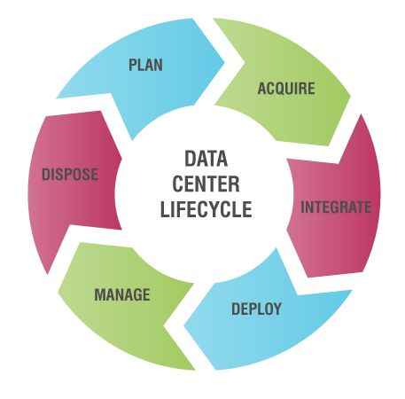
Figure 1 Data Centre Lifecycle
The next step involves pre-implementation where all elements needed for implementation considered. In addition to combining and contrasting various process requirements and standards, among others, information on best practices, compliance criteria by regulatory bodies and many more are documented [3].
It, in turn, paves the way for policies, rules and procedures that shape the IT sector of the organisation. The final step is crucial as it involves evaluating all previous efforts to discover loopholes in the design; this step can tag the quality control stage.
This study aims to provide a centralised data centre architecture design of the newly formed UWTSD where it can keep and manage the ICT infrastructure. The research progresses by discussing the secured network design with server and application infrastructure, storage area network design, and security concerns.

network and Server Infrastructure design phase
Data centres are useful for sending and receiving requests from workers in the organisation. The data centre utilises a network designed to complete requests in the organisation. It is fit for the workload of the organisation. Networking has evolved from using structures useful for conventional networks to cloud computing networks. This is why setting up the network has two different options for organisations. For UWTSD, it is required to design a data centre that utilises the traditional networking structure for the data centre; devices like routers, servers, controllers, clients, switches, and gateways are necessary. The design consideration for UWTSD includes a multi tire data centre design, including the layer 3 and layer 2 design.

Data Centre Multi-Tier Design Outline
This proposed UWTSD is a multi-tier data centre topology. The following figure shows the multi-tier model topology of UWTSD DC, which constitutes application, web, and database servers as the primary servers running on its platform as well as mainframes. The proposed data centre design contains the core tier, aggregate tier or the distribution tier, and access tier. The core tier consists of the core router and core switch, the aggregation or distribution layer consists of the aggregation or distribution switch and server farms. The access layer consists of the access switch and workstations. The detailed network design is discussed in the next parts.

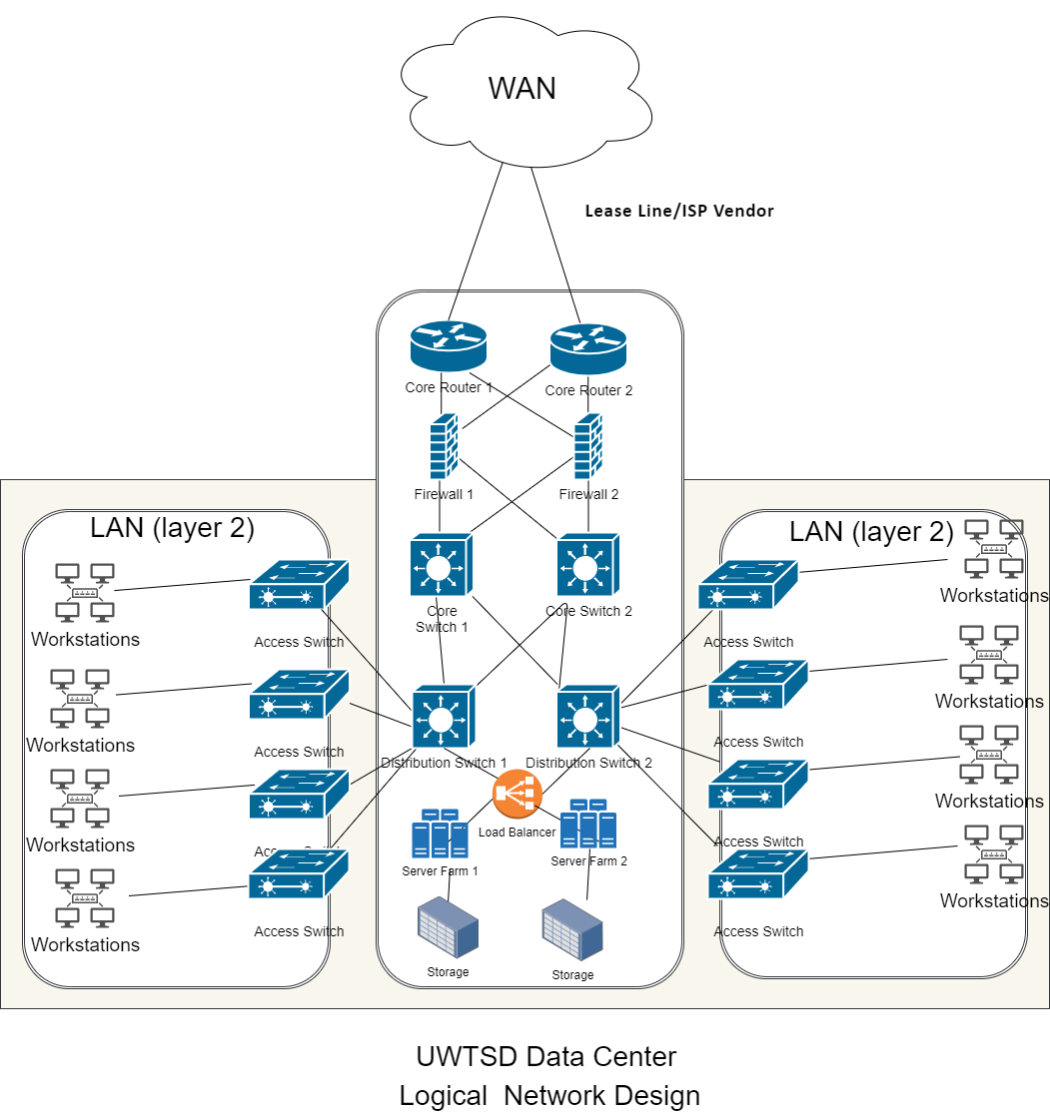
Figure 2 - UWTSD data centre design

Core Tier Design
As seen in the figure above the DC core is at the top of the data centre hierarchy and is responsible for high-speeds during transmission of packets from source to destination. The DC core provides a link to the UWTSD core layer, but these two have very different functions. The data core is not as necessary as the UWTSD core. Still, it is useful when numerous aggregation modules are used to scale the process. The core tier is more critical for smaller aggregate modules as a means for it to connect to the data centre fabric. For UWTSD data centre, here are the things to consider when deciding whether to include the data centre core as a connection medium in the data centre fabric -
- 10 GigE port density - When there are numerous 10 GigE ports and data centre aggregation lawyer switches, needed to connect to the distribution layer, using a single pair of core switches as a link to the data centre fabric might not be the best idea, as they might not be able to maintain these devices.
- Executive domains and strategies - Single cores combine the enterprise's distribution tiers and data centre aggregation tiers, while separate cores isolate these layers. Administration domains and policies that can be affected by decisions on which cores to utilise are access lists, maintenance, troubleshooting, and QoS.
- Prospects: Including the DC core to the enterprise core layer and operating a separate data centre layer might be worthwhile in the future when the business expands. In terms of scalability, a particular layer is always a good plan.

Recommendation for UWTSD Core Tier
Based on the above analysis the following can recommend for UWTSD core tier –
A single pair of data centre core switches will use 10 GigE layers 3 interfaces to connect to numerous multiple aggregation modules. The DC core layer will use the Cisco Catalyst modules [2]. Catalyst 6509 is usually the recommended platform and for a good reason; it provides high speeds for packet switching, 10 GigE density, and a large switch fabric.
For enterprises that need multiple aggregation modules, numerous 10 GigE ports are necessary for this operation and in turn, the Catalyst 6509. This is because this DC core platform can provide support to the 10 GigE modules in all positions. Unlike other platforms like 6513, Catalyst 6509 has slots, and all the slots support dual channels to the switch fabric [2].
This core is important for UWTSD as it ensures the data centre tier is efficient by preventing disasters like a single-point failure while ensuring that core nodes are transmitted with a single supervisor module. This core can achieve this because it is linked with the core and aggregation layer.

Traffic flow of Core Tier in UWTSD
10 GigE links for layer 3 are the transmission medium for the core layer, and they support connection to the enterprise core layer and the aggregate layer. These links are expected to provide speed and bandwidth scalability when transmitting data while trying to prevent collisions or extending to layer 2 domains [2]. The DC core chooses optimum paths when moving aggregation module traffic to the enterprise core. Back-up and replication traffic use the DC core to travel between aggregation modules. In contrast, server-to-server traffic travels within the aggregation module.

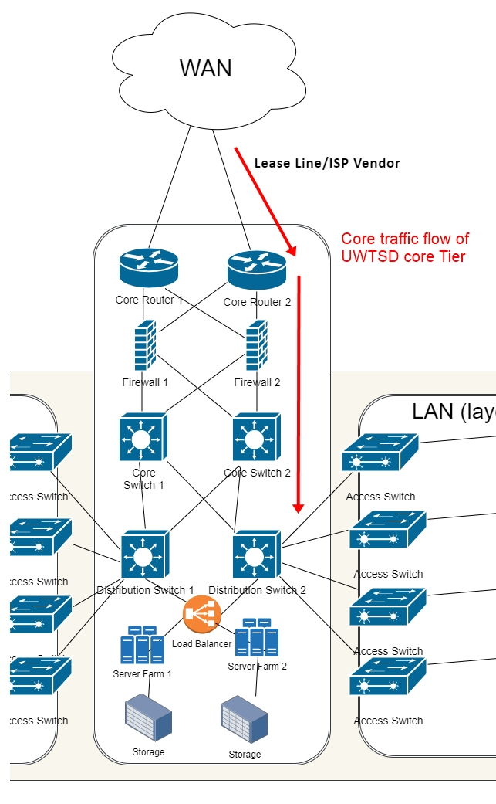
Figure 3 - UWTSD core traffic flow
It is possible to route all traffic into specific aggregation nodes where the main service modules are deployed. The traffic path is subject to certain factors. Some of the factors include the type of working access layer structure used, as well as the existence of service modules.
It is possible to transport traffic via each aggregation switch in a particular module to allow the core load-balance flows on that module. This method improves load distribution and is initiated by using Layer 3 IP plus Layer 4 port based CEF load balance hashing algorithms. The command to load the algorithm is: CORE1(config)#mls ip cef load full.
There is a default way to load-balanced flows on every single aggregation switch in a specific mode. This is using CEF-based load balancing on Layer 3 source/destination IP address hashing.

UWTSD Data Centre Aggregation/Distribution Layer
This layer is possibly the most important in the UWTSD data centre. This tier functions as an aggregator of the number of sessions being transported in and out of the data centre. This layer must provide a high forwarding rate, high-speed switching fabric, and it also must support numerous 10 GigE, and GigE links while offering high-speed switching and transmission rates. The aggregation layer can balance the load, put up firewalls, and offload SSL to servers throughout the access layer switches [2].

Recommended Platforms and Modules
This layer must be fitted with two aggregation layer switches that collaborate to ensure the architecture is redundant and the maintain session state while giving the access layer valued services. Cisco Catalyst 6509 and 6513 switches are the recommended platforms for the aggregation layer and should be linked to Sup720 processor modules for support. Aside from the large switch fabric, quick packet transmission, and backing for numerous 10 GigE ports, some other requirements in the application layer include supporting application and security services like Intrusion detection, Cisco firewall services modules (FWSM), distributed denial-of-service attack protection (Guard), and devices like cisco application control engine (ACE) and network analysis module (NAM).
This platform has many slots and is suitable for the aggregation layer, but it consists of a combination of single and double slots. The 1 to 8 slots are single-channel, and 9 to 13 slots are dual slots.
Catalyst 6509 which is the perfect fit for the DC core layer supports twin channel modules in all its slots, but it does not have as many slots as the Catalyst 6513 which is more useful for the aggregation layer.

UWTSD Aggregation Layer and the Traffic flow
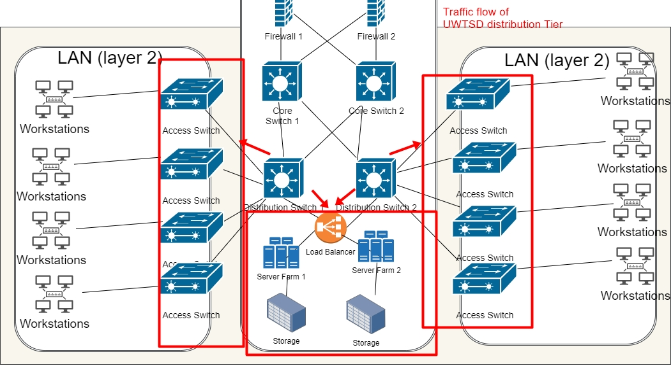
Figure 4 - Aggregation Layer Traffic Flow
The traffic flows in the aggregation layer are -
• Core tier to access tier - This layer has two equal-cost routes to its destination and load balancing for the traffic is determined by the CEF-based L3 plus L4 hashing algorithm. The flows from his layer consist of HTTP-based request to the web server farm [2]. These requests might be transmitted to a load balance in the aggregation tier or might be sent straight to the web server farm. If it goes through the load balancer, it can go through an SSL offloader module and then the firewall before going to the web server farm.
• Access tier to access tier - The aggregation layer is the primary medium for server-to-server transport in the access layer. The types of traffic for this layer include web-to-application, application-to-database, server-to-server, back-up, and replication.

Path selection in the Aggregation layer between service
The factors to consider when using traffic path during transmission of data is the type of access layer tier and the existence of service modules which are usually used in an active-standby resolution and are put in the two aggregation tier switches redundantly. To place the switches redundantly means that the main active service modules are placed in the first aggregation switch, and the subordinate active service modules are placed in the second aggregation switch. Establishing the service modules redundantly and combining it with the implementation of the routing configuration protocol, allows for an alternate path to be created in aggregate switch 2 if aggregate switch 1 fails [2].

Traffic Flow for Server Farm with Service Modules
The traffic that comes into the webserver farm is mostly multi-layer communications. Still, the server also allows other traffic like back-up, storage access, and replication. To ensure that these traffic types flow to the server farm at high speed while exposing behaviour that can be monitored for easy troubleshooting, it is essential to connect active module servers in an aggregation layer switch.
The network design shows the looped access layer topology, and it shows how the implementation of the active/standby service module works for communication. It is possible to create symmetry in traffic paths by connecting the STPT and HSRP main default gateway services on the first aggregation switch [2].

Layer 2 Fault Domain Size
Application layers like NIC teaming and clustering cause Layer 2 domains to increase in size, which in turn means there is a need for scalability. The fault domain size ensures the efficiency and stability of the Layer 2 domain, but there is also the challenge of broadcast storms from human error or malfunctioning hardware. Another challenge for the fault domain size is the network performance that can be affected by the looping system. The loops ensure all the links are not in a forwarding state all the time, which in turn creates an endless loop for the broadcast/multicast packets that, saturates the VLN and negatively affects the performance of the network. It is possible to break this loop with spanning tree protocols like Rapid PVST+ or MST. The aggregation layer is responsible for establishing a base in the Layer 2 domain by instituting and managing the layer's domain size with spanning tree protocols like Rapid-PVST+ or MST [2].
It is possible to determine failure exposure before they happen in layer 2 by putting in place thresholds and using numerous aggregation modules.

Spanning Tree Scalability
It is necessary to manage the data centre environment by implementing changes where needed. For organisations that need to combine and manage VLAN or IP subnet departmental servers, it is necessary to extend VLANs across the application. This will aid organisations to meet up requirements like server administration flexibility and layer 2 adjacency [3]. Looping is implemented with a spanning tree protocol, and the recommended protocols for data centres are 802.1w-Rapid PVST+ and 802.1s-MST. These two protocols are similar for convergence applications by are not so similar for flexibility and operation.
VLANs should be extended to meet up with scalability in the Layer 2 domain, but the looping affects VLANs and in turn, affects network performance. The level of extension affects the spanning tree protocol for convergence and scalability. Still, the aggregation layer corrects this since it is in charge of distributing and scaling spanning tree processing.
10 GigE links were mostly useful in DC core layers or the enterprise layer. Still, recently even the access layer is experiencing a shift from GigE or Gigabit EtherChannel speeds, this is due to the increase in bandwidth demands. The demands in the access layer will keep increasing, and the next questions hover around using greater density 10 GigE line cards and more superior switch fabrics. For now, the answer lies in utilising numerous aggregation modules.

Default Gateway Redundancy with HSRP
HSRP, VRRP, or GLBP protocols work the aggregation layer to provide router addresses for all servers on the access layers for Layer 2 access topology. HSRP is the common protocol out of all the protocols for providing default gateway redundancy. It is recommended that the highest number of HRSP instances in an aggregation module should be around 500 and timers with a one-second hello and a three-second hold time. For cases where more HRSP models are needed, the recommendation is to distribute the load on multiple aggregation module switches.

Access Tier Design
The access layer is needed to support services like clustering, NIC teaming, and broadcast repression functions in Layer 2 or 3 domains, and connects the physical level attachment to server resources by connecting the server traffic to Gigabit EtherChannel or 10 GigE/10 Gigabit EtherChannel uplinks to the aggregation layer [2].
There are three major models in the access layer, which are: Layer 2 looped, Layer 2 loop-free, and Layer 3. The access layer is important for UWTSD. Some of the reasons are -
• The service modules are interoperable.
• It is possible to extend VLAN which ultimately means more servers can be added to a particular VLAN in the access layer.
• These types of topologies are inherently redundant.
• The service requirements for this type of topology supports clustering and NIC teaming.

The illustration, as seen in the following figure is an access layer topology that uses in loop-free U, 2 loop-free models, and loop-free inverted U topologies. This system is useful when looped technologies are not needed. Some of the reasons why looped technology is not desirable could range from requiring active uplinks, not enough experience with Layer 2 spanning-tree protocols, terrible experience with STP installations. These reasons lead to the difference between looped and loop-free topology, which include [2]:
• loop-free topology does not block uplinks which means all links are active.
• VLAN extension is supported in inverted U topology but not loop-free U topology.
• Limited Layer 2 adjacency in loop-free topology.
The loop-free model is still like a looped topology as it is crucial to run STP.

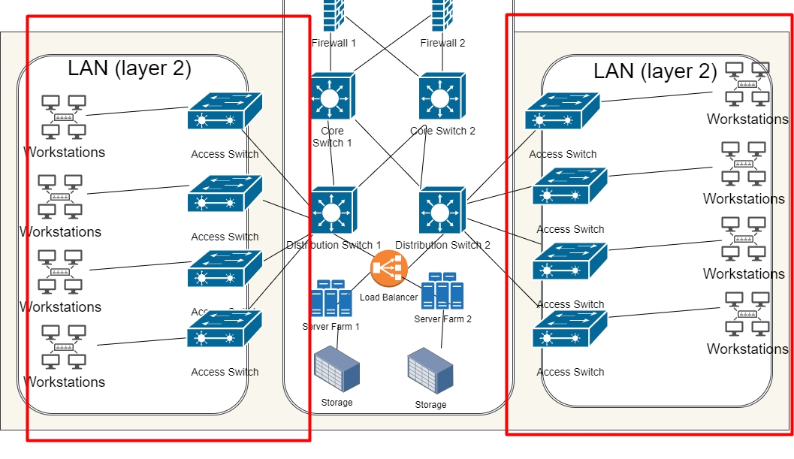
Figure 5 - UWTSD access layer
The figure above is an illustration of the access layer using a Layer 3 model and is mostly useful for containing broadcasts. The Layer 3 access model functions as a prevention mechanism for servers that can be negatively affected on a specific broadcast level. It is recommended by Cisco that the Layer 3 access model execute the STP as loop prevention even though the protocol is only active at the server ports and inter-switch trunk.
The Layer 3 model does not allow VLAN extension across the data centre. Other characteristics of the Layer 3 access model are [2] -
• It consists of active links, which means all links uplinks are active
• It balances load with CEF with a maximum ECMP of 8.
• It has limited Layer 2 adjacency which is restricted to one pair of access switches.

Sharing Services at the Aggregation Layer
Layer 2-looped access topology benefits from its ability to combine and utilise service module services or devices on the aggregation layer. Some of the services useful to layer 2 looped access topology on the access layer servers are firewalling, load balancing, network monitoring, cache engines, SSL offloading, intrusion detection, and prevention.

Other options for UWTSD data centre design
Another option for networking when designing data centres is to approach the data centre using a software-defined network (SDN). This approach utilises a specialised SDN controller to regulate the workload in organisations with dynamic workflow alterations.
This second option is open to organisations interested in utilising cloud computing as part of the IT structure of the organisation. Cloud computing is more advantageous when compared to traditional computing methods using scalability, storage, and redundancy as comparison factors. On the other side, when security is compared between the two technologies, cloud computing is lacking. The exposure to many vulnerabilities for cloud computing is understandable as it is still a relatively new technology. Regardless of the problems with security, cloud computing is becoming increasingly more popular within organisations that need computing services. Many companies are choosing "software-as-a-service" as an option for computing [4].
The virtualisation of networking and computing services in general, has provided users with an opportunity to store and access resources virtually. This technology allows the use of unlink flies in distributed systems from their physical storage, which is organised by SDN networks of large). It is also possible to pool resources virtually with a smaller enterprise network using workload players. At the same time, virtual ones run small ones, which are usually enterprise networks that work with workload orchestrators [4].
The evolution of cloud computing is reducing the need for data centre networking, meaning that data centres as a physical space are becoming increasingly obsolete. Data centres in the cloud computing world no longer must be the responsibility of specific organisations; rather, these organisations can access IT resources from third-party cloud services.

Data centres are tasked with providing resourceful information to end-uses like IT personnel, for instance, and to accomplish this. The data centre has to combine software and OS to connect and ensure the hardware storage works efficiently while providing user requirements to the end-user.

Storage Area Network Recommendation for UWTSD data Centre

Storage Area Network
Storage Area Network (SAN) works to connect computer systems with storage devices by ensuring the efficient transfer of information between these two devices. The storage area network is a multi-layered device made up of a physical layer and a logical layer. The physical layer for the SAN consists of communication infrastructure, while the logical layer has components like storage devices, computer system, and a process to manage the connections of these devices. SAN is sometimes defined as a network behind servers, due to its specialised functions for connecting servers to storage devices [3].
SAN in addition to providing a medium where storage devices and computer systems can connect also provides speed when transferring information from one point to the other. The advantages of a storage area network range from business continuity to more convenient infrastructure.
Disadvantages of the storage area network also exist. For one, this solution is very costly, and as such, it is the best use by large-scale businesses. There is also the installation complexity to consider.
SAN solution is more suitable for large-scale businesses but is also available for small to medium scale businesses. However, small businesses might not be able to utilise all the functions of the storage area network properly. Besides, this solution is not cost-effective, and as such small to middle scale, businesses are not advised to utilise this networking solution. Other benefits of implementing SAN is its operational reliability and zero fault tolerance. These benefits have to be continued by ensuring standard redundancy levels. The redundancy levels can be maintained by utilising numerous power supplies, controllers as well as increasing RAID configurations for every SAN scheduled to be implemented. These extra components make the cost of SAN and implementation even higher, making SAN more expensive [5].
SAN offers speed and reliability. Reliability is ensured by the extra components like doubling or tripling RAID configurations, while the speed is possible via the technologies used in SAN. Some of the technologies used in SAN are fibre channel, iSCSI, Ethernet (up to 10Gbps), SCSI, TOE, and so on.

Fibre channel
The fibre channel is the main structure for the storage area network, and it is usually designed with fibre-optic cables. These cables are known to provide speed for connectivity. Other benefits of the fibre channel include reliability and the improvement of the restrictions that come with SCSI usage. The disadvantage of the fibre channel is the cost of this solution [5].

iSCSI
This transport protocol is utilised in data and storage networks; ergo, it is a data storage protocol. This protocol transports SSCI messages using TCP/IP technology from source to destination. This protocol ensures that there is no need to use another network solution for storage [5].

10 Gbps Ethernet
This technology is used to connect servers or workstations, but it is well known for being unreliable and obsolete. This technology functions with a common bus topology.

SCSI
The common topology for this device is the terminated bus. A popular technology, it is most useful for handling errors, numerous initiator requests, and management of the connection to devices. This device is limited by a cable length of about 25 meters which can be overcome with a fibre channel and the use of a maximum number of 16 devices per one SCSI bus [5].

TOE
This technology makes it easier for network controllers to process the information being sent or received and lowers the overhead connected to IP storage protocols. This technology is utilised by network cards to offload the processing of TCP/IP stacks and can achieve this objective by using Gigabit Ethernet and 10 Gigabit Ethernet as applications.

Network Attached Storage
This solution provides file services like file-sharing or storage by using network protocols. The network-attached storage operates as a LAN attached file server and uses systems like the Network file system (NFS) to provide file services [6]. It is open to use in any network protocol, and it has the same features as regular file servers but is more custom fitted to file sharing. This solution can do without the redundancy SAN offers and is designed to be majorly a storage device that provides the data that is being managed by the server. This technology can be customised according to business size and objectives and is not as expensive or classy as SAN [6].
Unlike the SAN systems that need doubling or tripling of certain components or applications to allow for redundancy, NAS does not need this, because it's designed simplistic and is tailored to delivering files that are stored on the SAN [6]. This means it is a storage/transport medium and needs little to no processing. This simplistic design also means that end-users do not need fibre channel adapters for this technology.
This technology has similarities with file servers, which means that they can either be reached directly by the client or by application servers.

The disadvantage of this technology is the back-up data process. The back-up process is usually time-consuming, and even implementing services like data back-up is not enough to protect the device from system-level failure. This technology is not as reliable as SAN, due to its simple design. Unlike SAN, NAS does not use many applications, and its cost-effective nature might cost it a great deal considering factors like Security and data integrity.

Conclusion
Institutionalising a data centre without considering the safety of said data centre can be very damaging to UWTSD. Organisations house information, some of which are sensitive and should be stored with criticality as a considered factor, hence making it important for security to be at the forefront of the elements utilised in setting up a data centre. These days employees can access the work network with personal gadgets which lends a hand to more security loopholes and creates the need for new security approaches to data centre infrastructure.
The function of data has changed during the previous century. The appearance of data innovations has reshaped a large portion of the activities and prepared in practically every circle or zone. Organisations, governments, non-benefits, and numerous different associations of various kinds confronted the significant test: it was obligatory to adjust to the impending changes, executing advancements that should permit to gather, cycle, and store gigantic volumes of information, created inside a new reality. The need for data centre has arisen. The present-day data centre is an intricate framework that incorporates organising, equipment, programming, and authoritative arrangements, directed at accomplishing most high viability, security from inside and outside attacks, and arrangement of good repetition. The significant assignment of a data centre worked for a business, government office, or non-benefit association is interruptible and consistent admittance to data put away in it. Subsequently, suitable strategies and methods must be used during the way toward arranging, building, and keeping up of data centre.

References
[1] M. Arregoces and M. Portolani, Data Center Fundamentals. Cisco Press, 2012.

[2] "Data Center Multi-Tier Model Design", Cisco, 2008. [Online]. Available: https://www.cisco.com/c/en/us/td/docs/solutions/Enterprise/Data_Center/DC_Infra2_5/DCInfra_2.html. [Accessed: 27- Nov- 2020].

[3] T. Lammle and T. Montgomery, CCNA Data Center: Introducing Cisco Data Center Technologies Study Guide: E. John Wiley & Sons, 2016.

[4] G. Santana, Data Center Virtualization Fundamentals. Cisco Press, 2013.

[5] "Storage Considerations in Data Center Design", snia.org, 2020. [Online]. Available: http://techgenix.com/datacenter-storage-design/. [Accessed: 01- Dec- 2020].

[6] R. Sheldon and R. Sheldon, "Storage 101: Data Center Storage Configurations - Simple Talk", Simple-Talk, 2020. [Online]. Available: https://www.red-gate.com/simple-talk/sql/database-administration/storage-101-data-center-storage-configurations/. [Accessed: 01- Dec- 2020].

