

LOCATION: Swansea | LLEOLIAD: abertawe
LEVEL 4 | LEFEL 4
EXAMINATION PERIOD | CYFNOD ARHOLIADAU
JuLY 2024 | GORFFENNAF 2024

MODULE CODE: ACDA4009
Signals and System

TIME: 2 HOURS

Equipment or materials required – Calculator
Adnoddau neu ddefnyddiau sydd eu hangen - Cyfrifiannell

QUESTION 1
- For functions given below.
- $u[n]=\left\{\begin{aligned}1, n≥0 \\ 0, n<0\end{aligned}\right.$
- $r(t)=\left\{\begin{aligned}t, for t≥0 \\ 0, for t<0\end{aligned}\right.$

Answer the Following
- Identify the Signals and provide the name of the function. [4 Marks]
- Illustrate its graphical representation. [6 Marks]
- Identify the name of the Function given shown in the below Figure. [1 Mark]
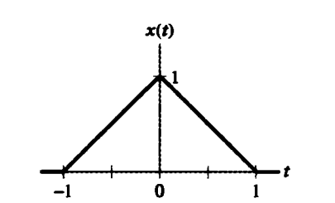
Figure: 1
Also, Sketch the time scaling for each of the following derived from x(t)
  - $x(3t)$ [3 Marks]
  - $x(3t+2)$ [3 Marks]
  - $x\left(3t\right)+x(3t+2)$ [3 Marks]

QUESTION 2

- Consider the signal $x\left[n\right]$ in the below Figure 2.
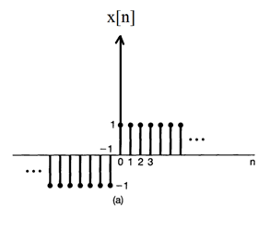
Figure: 2
- Find the Even signal $x_{e}[n]$ , and the Odd Signal $x_{o}\left[n\right]$ from the above given signal $x\left[n\right].$ [11 Marks]
- Also, Prove that $x_{e}[n]$ +$x_{o}\left[n\right]$ = $x\left[n\right]$ [5 Marks]
- If $w[n]=x_{o}\left[n\right]$ then, find the value of $w[-n]$ [4 Marks]

QUESTION 3
- Figure below shows a data transmission system with devices connected via several signal wires.
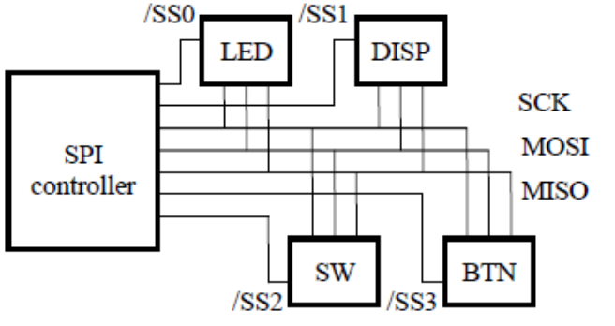
Figure 3 : A data transmission system
- Identify the transmission protocol shown above. [2 Marks]
- Classify this type of transmission method. [2 Marks]
- With a neat diagram, explain its operation. [7 Marks]
- Give the full name of the signals present. [5 Marks]
- Give 2 examples of where this protocol might be used and provide a brief explanation of each of them. . [4 Marks]
QUESTION 4
- Provide answers to the below questions related to Counter type ADC.
  - Draw the block diagram of the counter type ADC. [4 Marks]
  - List the components used in counter type ADC. [3 Marks]
  - Explain in detail about how working principle of comparator utilised in the Counter type ADC. [7 Marks]
  - Explain why DAC is needed in the counter type ADC? [6 Marks]
QUESTION 5
- Consider a UART communication scenario where the string "SONAR" is transmitted.
- Provide the binary representation of each ASCII character in the string.
[5 Marks]
- Demonstrate how the UART data frame would be constructed for each
character by providing relevant diagram. [15 Marks]

Diwedd/End

Standard ASCII character table

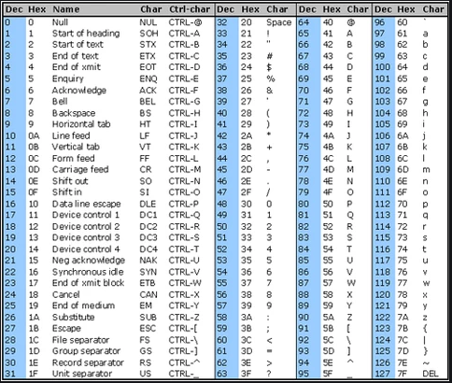

Diwedd/End

