
Skills for the Workplace
Module Assignment Submission
Student Name: | Anis Miah
Student Number: | 1818723
Module No: | BMSK4005
Module Title: | Professional Career Development

Statement of Confirmation of Authenticity
By the act of making this submission, the student declares that this is the work of the student named above. The work has not, in whole or in part, been knowingly presented elsewhere for assessment, or where assessment has been built on a previous assessment, this has been identified. Where materials have been used from other sources it has been properly acknowledged. If this statement is untrue, the student acknowledges that an assessment offence has been committed.
Attention is drawn to the plagiarism and unfair practice policies of both the University and of ILM.

Table of Contents
Section 1: Know how to identify development needs 8
Strengths- 8
Weakness- 8
Opportunity- 8
Threats- 8
Identify learning styles for self and another 9
Activists- 9
Reflectors- 9
Theorists- 9
Pragmatists- 9
1.2 Use a simple technique for identifying development needs for self & another 10
The Johari Window showed in detail below- 10
Open or self-contained space- 10
Blind self or blind spot- 11
Hidden area or façade- 11
Unknown area- 11
1.3 Identify potential barriers to learning for self and another. 14
The report's author discusses the following learning barriers: 14
Disorganised- 14
Easily distracted- 14
Luck of IT knowledge- 14
Luck of education- 14
The author of the report, Pear, discusses learning barriers below: 14
Hate change- 14
Luck of time management- 14
No work experience related to academic studies- 14
1.4 Explain how these barriers to learning can be overcome. 15
Team working- 15
Time keeping- 15
Quick learner- 15
Work experiences- 15
Transferable skills- 15
Hard worker- 15
Section 2: Know how to develop self & others to achieve organisational objectives 16
Experience- 16
Reflection- 16
Theorising- 16
Planning- 16
Specific- 16
Measurable- 16
Achievable- 17
Realistic- 17
Time-Based- 17
Specific- 17
Measurable- 17
Achievable- 17
Time-Based- 17
2.1 Analyse learning/development options to meet needs of self & another. 17
Communication- 17
Problem-solving- 18
Self-confidence- 18
Listening skills- 18
Leadership- 18
2.2 Identify support mechanisms for the development of self & another 18
Online courses and surveys- 18
Ask trusted friends- 18
Get regular feedback at work- 19
2.3 Prepare development plans for yourself and another person 19
2.4 Method used to monitor the development of self & another. 21
Section 3: Know how to prepare for the recruitment process 24
(Rosenblatt, 1988). 24
Reflection on the recruitment process 24
3.1 Description 25
3.2 Feelings 25
3.3 Evaluation 25
3.4 Analysis 26
3.5 Conclusion 26
3.6 Action Plan 27
References 28
Appendices A 30
38
Appendices C 38
39
Appendix D 40

Section 1: Know how to identify development needs
Self-assessment, which is defined as "the participation of learners in making judgments about their achievements and the results of their learning," is a useful strategy for assisting student learning,
especially when applied in a structured manner. As it increases students' capacity to evaluate their own learning, self-assessment promotes student learning and is one of the most crucial abilities for future professional development and lifelong learning. This booklet introduces self-assessment for academics who are thinking about using it in their instruction. It offers a "theory into practise" methodology, describes strategies, and offers illustrations for more effectively incorporating self-assessment into the development of curriculum. In order to aid students in learning more successfully, it makes the case for making its use in the classroom more obvious.
(Smith & Butler Ellis, 2001).
The report writer will do a SWOT analysis to gain a better understanding of herself and be able to recognise where she needs to grow. SWOT analysis will keep an eye on the report writer's strengths, weaknesses, opportunities, and threats.
In order to determine her SWOT analysis, the report's author asked herself the following questions:

Strengths-
1.What benefits do you enjoy that others don't?
2.What skill do you possess that no one else does?
3.What qualities do others think you possess?
4.What are you most proud of among your accomplishments?

Weakness-
1.What tasks tend to you to avoid?
2.What flaws do you and those around you think you have?
3.Do you have complete faith in the education and training you've received? Where are you most vulnerable if not?
4.What unfavourable work habits do you have?

Opportunity-
1.Is your sector or industry expanding?
2.What patterns do you notice, and how can you benefit from them?
3.What cutting-edge technologies can you use?
4.Do any of your rivals consistently do something crucially wrong?

Threats-
1.What challenges are you currently dealing with at work?
2.Are any of your co-workers vying for the same jobs or projects as you?
3.Is the future of technology a threat to your position?
4.Could any of your flaws make you vulnerable to danger?
The report writer will use strategies to turn weaknesses into strengths and threats into opportunities after determining his own development needs through a SWOT analysis.
The report's author made smart choices for the demands of development. She will reach his development purpose by adhering to her wise objective. He will describe the entire procedure for his assignment in full below.

Identify learning styles for self and another
Two British psychologists, Honey, and Mumford have created a method for determining how humans learn most successfully. Learners are asked to agree or disagree with 80 statements on the process of picking up new skills and knowledge in their learning styles questionnaire. Based on the questionnaire results, four different learner types—activist, reflector, theorist, and pragmatist—have been established.
The author of the report uses Honey and Mumford's Learning Styles Questionnaire to assess both her own learning preferences and those of her learning peers in order to determine how these preferences differ from one another.
Honey and Mumford Summary below-

Activists-
This kind of learner does best when they "have a go" and experiment without necessarily being prepared. They will enjoy role-playing games and be eager to take chances in the real world. According to the learning cycle, activists are seen as the people who are most eager to "DO."

Reflectors-
Those who learn in this way are considerably better observers and listeners. They are adept at analysing what happened and why, as well as reflecting on their own and others' experiences. Reflectors are people who excel in the 'MONITOR' position beyond all others in the learning cycle.

Theorists-
This kind of learner excels in developing an idea or hypothesis based on their research. They excel at combining various kinds of data and creating models of how things work. They might decide to read about a certain subject as their first step in learning. The 'REVIEW and EVALUATION' phase of the learning cycle is when theorists believe their involvement to be most important.

Pragmatists-
This kind of learner is eager to put what they have learned into practise. They constantly consider how they may apply what they have learned in the real world and make plans for how to do so. Only if they can tie the knowledge or concepts to actual tasks, they must complete will they value what is being shared with them. It is the ‘PLAN’ stage that is most suited to pragmatists.
The report writer has a better score in the pragmatics learning style, which indicates that he learns by doing. To adopt the learning styles, he makes strategies and puts them into practise.
The report writer Honey & Mumford’s Learning Styles Questionnaire and Scoring and Plotting Results showed in Appendices A.
After completing the honey and Mumford questioners, the report writer pear scored higher in the categories of activists and theorists, indicating the report writer pear's preferred learning methods.
The report writer pear finds that "having a go" and trying something out without prior planning is the best way to learn. They will enjoy role-playing games and be eager to take chances in the real world. According to the learning cycle, activists are seen as the people who are most eager to "DO." The report writer's expertise lies in developing a concept or idea based on their analysis. They excel at combining various kinds of data and creating models of how things work. They might decide to read about a certain subject as their first step in learning. The 'REVIEW and EVALUATION' stage of the learning cycle is when theorists believe their role is strongest.
(McGrath, 2016).

The Learning Styles Questionnaire by Honey & Mumford, along with the scoring and plotting results, are shown in Appendices B of the study for the report writer pear.

1.2 Use a simple technique for identifying development needs for self & another
The report's author uses Johari window approaches to identify his own growth needs before moving on to a SWOT analysis to gain a better grasp of future development.

The Johari Window showed in detail below-
The Johari window model is employed to improve a person's perspective of others. This concept is based on the notions that trust may be built by disclosing personal information to others and by listening to their feedback. The four windowpanes or quadrants of the Johari model each represent one individual. In four different viewpoints, each of the four windowpanes represents personal information, feelings, motive, and whether that knowledge is known or unknown to oneself or others.
This model interprets how feedback is delivered and received. A four-paned common window is how a Johari is pictured. The other two panes reflect the portion of the self that is hidden from oneself but visible to others. Mutual trust, which can be developed through social interaction and input from group members, is what allows information to flow from one window to the next.

Open or self-contained space-
Here, both the individual and others will learn information about the person's attitudes, behaviour, emotions, feelings, skills, and viewpoints. The majority of communication takes place here, and as the region gets bigger, the relationship will become more active and effective. The process of "feedback solicitation" involves hearing and comprehending the opinions of others. In order to better understand himself as the second stage of blind spot is known to others but unknown to himself, the report writer will ask for feedback at this point.

Blind self or blind spot-
In a group, there may be information about you that the other members are aware of but you are not. It's possible that you won't be perceived the way you intend by others. By getting input from others, the blind area for effective communication is decreased.

Hidden area or façade-
Information that will remain private to you but not to others. Any private information that you are hesitant to disclose can be included in this. This comprises emotions, past events, worries, and other things. Because it influences our relationships, we tend to keep some of our thoughts and information private. As a result, the hidden area must be lowered by shifting the information to the open sections.
The Information which are unaware to yourselves as well as others. This includes the information, feelings, capabilities, talents etc. This can be due to traumatic past experiences or events which can be unknown for a lifetime. The person will be unaware till he discovers his hidden qualities and capabilities or through observation of others. Open communication is also an effective way to decrease the unknown area and thus to communicate effectively.

Unknown area-
Information that neither you nor others are aware of. This comprises knowledge, emotions, aptitudes, and so forth. This can be the result of terrible previous occurrences or mysterious current happenings. The person won't be aware of it until he unearths his hidden talents and abilities or learns about them through watching others. Open communication is another powerful tool for reducing the uncertainty and improving communication.
(Davies, 2014).
After learning about the Johari window, SWOT analysis is simple to comprehend. SWOT analysis for the report writer is described below, along with other below-
Strengths, Weaknesses, Opportunities, and Threats is also known as SWOT. A strategic planning method known as SWOT analysis is used to assess a subject's competitive position by finding the traits that can be classed as strengths, weaknesses, opportunities, and threats, in that order. A SWOT analysis is a technique for determining and analysing internal strengths and weaknesses as well as external opportunities and threats that have an impact on current and future operations and aid in the formulation of strategic goals.

SWOT Person 1

STRENGTHS  - Team working  - Fluent English  - Time keeping  - Quick learner | WEAKNESSES  - Disorganised  - Easily distracted  - Luck of IT knowledge  - Luck of education
OPPORTUNITIES  - Training  - Progression opportunities  - Growing community of loyal customers  - Getting experience by working with people | THREATS  - Strong competition from other business  - Price increase from suppliers  - Being unsupported at work
The report writer SWOT below-

Other SWOT analysis below-
SWOT Person 2

STRENGTHS  - Work experiences  - Education  - Transferable skills  - Hard worker | WEAKNESSES  - Hate change  - Luck of time management  - No work experience related to academic studies
OPPORTUNITIES  - Good customer relationship  - Training  - Pay rise  - Work in a team | THREATS  - Time pressure  - Multiple responsibilities from family  - Competition from people with higher experiences

1.3 Identify potential barriers to learning for self and another.
Anything that inhibits a learner from giving their whole attention to the learning process is considered a learning barrier. When faced with learning obstacles, an individual or even a group of individuals experience frustration or reluctance and fail to meet their learning objectives.
Multiple variables can lead to learning obstacles. Some are entirely external, such as busy schedules, an excessive amount of labour, a lack of supplies or technology, and so forth. Others are internal and stem from people's past encounters, feelings, or perspectives. Both internal and exterior variables might interact at times. For instance, a trainee may experience fear of failure as a result of a hostile work environment, pressure from management, or a lack of the necessary understanding for the task.
(McCrossin, 2004).

The report's author discusses the following learning barriers:

Disorganised-
The report writer's lack of organisation and lack of preparation are his biggest learning obstacles. The report writer fails to recognise the significance and misses all deadlines.

Easily distracted-
Distractions abound in the realm of the disorganised. No matter how significant or insignificant the interruption, others around the report writer are aware that they can always interrupt them. He is prevented from reaching his objectives and concentrating on what matters by distraction.

Luck of IT knowledge-
Because the majority of work rules require IT skills, the report's lack of IT skills prevents him from applying for most positions.

Luck of education-
The report's author lacks academic credentials, which prevents him from applying for in-demand positions.

The author of the report, Pear, discusses learning barriers below:

Hate change-
The greatest learning obstacle for her is that she doesn't like to attempt new things. because learning new things is a constant requirement for success. Opportunities constantly take a risk by using novel techniques.

Luck of time management-
The other person's weakest point is that she is unable to manage her time and frequently rushes through tasks. Because of this, she frequently disappointed people at work and elsewhere.

No work experience related to academic studies-
The other person fails in competitions with others because she lacks academic experience relevant to her employment role.

1.4 Explain how these barriers to learning can be overcome.
With their strengths, the report writer and his pear will get through those obstacles.
The report's author explains in more detail below how he plans to get past his learning obstacles:

Team working-
Working as a team promotes development of the individual, boosts job satisfaction, and lessens stress. With teamwork abilities, the report writer can get past the obstacle of disorganisation. Because each team member is accountable for a specific task that must be completed in order to reach the objective, working in a team teaches you how to become organised. Working in a team requires constant planning, which is a characteristic of the organised individual.
The report writer will become a more concentrate individual who will enable him to overcome the obstacle of easily being side-tracked when he becomes a more organised team player.

Time keeping-
The report writer's these strengths will motivate him to continue learning because they are of such high calibre.

Quick learner-
The report's author is a quick learner; thus, he can easily overcome his learning obstacles related to IT education and abilities. He recently began his studies for higher education and enrolled in an IT course to overcome his obstacle.
The report's author, Pear, explains how she plans to get above her learning obstacles below:

Work experiences-
Education- Pear, the report's author, recently began studying for a degree in workplace management skills, which will enhance her job experience in relation to academic studies.

Transferable skills-
These abilities will encourage the other person to overcome a barrier of hatred and change their behaviour.

Hard worker-
The other person's diligent behaviour will encourage them to develop effective time management skills.
The author of the report and the other person can use their strengths to foster resilience and assist them get past challenges. They will both make a list of their current obstacles and the attributes that will enable them to overcome them. They only require a few concise actions to keep moving forward with your current duties or goals; they don't need a long-term plan.
(Tan, 2006).

Section 2: Know how to develop self & others to achieve organisational objectives
The author of the report will use the knob learning cycle to determine her own and other people's attainable organisational goals. In 1984, David Kolb presented the model of learning styles from which he derived his learning style inventory. The four-stage learning cycle and the four different learning styles are both components of Kolb's experiential learning theory. Kolb's theory gives internal cognitive processes of the learner a lot of attention. According to Kolb, learning entails acquiring abstract notions that may be flexibly used in a variety of contexts. According to Kolb's view, fresh experiences serve as with the report writer experience the catalyst for the creation of new ideas.
(Kolb, 1976).
Applying the kolb learning cycle, the report writer learning cycle is as follows:

Experience-
The report's author worked for his family's firm for the previous few years as a self-employed person. He has extensive time management skills from his work as a sole proprietor, but he lacks academic qualifications because he left school at a young age due to obligations to his family.

Reflection-
With his business expertise and self-reflection, the report writer has learned to multitask in order to reduce labour costs and boost productivity and profit margins. The report writer can help others with their jobs by utilising his multitasking abilities.

Theorising-
The author of the study has always desired to pursue a career in academia, and thanks to his self-employed work most of the time, he has had good fortune in his experiences. Recent training in management techniques will support the report writer's academic needs in the job.

Planning-
The report writer will establish plans to attain his goals for his family, job, and educational lives in order to accomplish his objectives and respond to others' comments.
The report writer stated his clever target of objectives below after applying the Kolb learning cycle.

Specific-
The author of the report will hunt for managerial positions where he can use his multitasking abilities and raise client satisfaction with the business.

Measurable-
After working for the company for three months, the report writer will do that.

Achievable-
The report writer will use the best candidates for each position in order to achieve this. He will often hold team meetings to ensure clear communication about the goals needed to satisfy customers. Everyone will know what they are responsible for by the end of the first year, and the business will be well-known.

Realistic-
The report will make the client the company's top priority. Everyone will strive to satisfy customers. The same emphasis will be extended to both new and returning clients.

Time-Based-
By a year, everything will be finished.
The second person works for a contact centre and hopes to get to the manager level in the future. Her smart goals are listed below-

Specific-
Another person desires to work as a manager. She will enrol in training to advance her career as a manager at work. She will complete all of her goals within the next six months in order to become a manager.

Measurable-
the other will give herself a six-month window to do everything she can to land a management position.

Achievable-
Another person who is just beginning higher education in management for the job will aid her in achieving her objective.

Time-Based-
The other guy will become a manager in six months.
(Murphy, 2011).

2.1 Analyse learning/development options to meet needs of self & another.

The following areas are discussed in detail below for the report writer and other individual to analyse in order to develop successfully:

Communication-
What are the advantages of communication skills in personality development? is one of the most effective questions a person may pose to themselves. The short answer to this is that they can assist you in realising your full potential and making the most of your own personality development efforts. No matter what their current talents or abilities are, everyone may have a significant impact on their own and others' development with the correct communication skills.

Problem-solving-
Everyone has to learn and practise problem-solving if they want to grow as individuals. To enhance oneself and develop one's personality, one must be able to recognise difficulties and know how to solve them. However, the majority of people lack the creative thinking and problem-solving abilities that are necessary for success. All people have the innate ability to solve problems, thus everyone should take the time to improve this skill.

Self-confidence-
It is impossible to overstate the value of self-assurance in personality development. We are what we do, not what we own, as has been said, and this is a fact. That ought to be sufficient incentive for us to increase and strengthen our self-confidence. In personality development, having strong self-confidence might mean the difference between failing and succeeding in anything you try to do in life. The process of boosting one's self-confidence is simple.

Listening skills-
The capacity to listen well and be open to learning from others is one of the most crucial aspects of personality development. People can increase their listening abilities through experiences that foster personal growth in addition to the schooling or employment they receive. A competent listener will be able to discern the subtleties of another person's speech and discern the message that is being intended.

Leadership-
In any organisation, the star is the leader. As a leader, you must set a good example for your team, motivate them to aim for the unachievable, inspire them with your traits and accomplishments, and inspire yourself. Success in the workplace, in sports, in daily life, and in the development of your personality are all included.

2.2 Identify support mechanisms for the development of self & another
The author of the report and the other person will make use of the following support systems for their personal growth-

Online courses and surveys-
An online course that is free of charge could be the solution if you want to learn the fundamentals of a particular subject. These have a higher likelihood of being self-paced, which frequently means less immediate direction from an instructor. Almost any topic area that comes to mind has offerings, including both soft and hard abilities. To increase his knowledge, the report's author completed surveys and online courses.

Ask trusted friends-
The author of the report and other people often solicit feedback from friends and family in order to better themselves.

Get regular feedback at work-
The report writer and other individuals routinely seek input from the manager and fellow employees to advance their professional development.
(Wain, 2017).

2.3 Prepare development plans for yourself and another person

Part 1: Personal Analysis
showed in 1.2

Part 2: Setting Goals
Setting Goals for the report writer below-
What do I want to learn? | What do I have to do? | What support and resources will I need? | How will I measure success? | Target Date for Review
How to organise your work? | Plan out your day, prioritise your tasks, and avoid becoming easily distracted. | Keep track of your daily learning diary and solicit comments from your friends, family, and co-workers. | accomplishment of work. Attend all events on time and solicit feedback from peers and managers. | 25/06/2023
How can I sharpen my IT skills? | conduct IT training, continue your education, and choose a mentor to assist you in work. | both inside and beyond the workplace relevant resources. | gain more IT self-assurance and workplace technological proficiency. | 25/06/2023
How can I get involved in education? | Choose a study topic that is both relevant to your job and interesting to study. | choose a university that will work with your employment and family schedule. | I submitted my assignments on time and got top scores for them. | 25/12/2023

Part 3: Personal Objectives
Personal Objectives for the report writer below-
Short Term Goals (next 12 months)
Become a more disciplined person in life, learn new skills, and begin participating in higher education.
Medium Term Goals (2-3 years)
become a training manager, and as you achieve your goals, progressively apply for permanent management positions.

Long Term Goals (3-5 years)
finish my degree, achieve first-class honour, and seek for opportunities for growth

Part 2: Setting Goals for the other person below-
What do I want to learn? | What do I have to do? | What support and resources will I need? | How will I measure success? | Target Date for Review
How can I love a change? | search for fresh opportunities to succeed. need to begin relishing and trying new things. | ask the management to begin training new employees in the office to demonstrate their desire to advance | seek for comments from the management and colleagues | 25/12/2023
How can I manage my time better? | Everything should be planned out in advance, and daily learning records should be followed to ensure deadlines are met. | Obtain input from your management, peers, and family members. | finishing tasks before deadlines and not rushing to complete tasks | 25/12/2023
How to raise academic performance? | take up education | searches for relevant academic programmes that will fit into daily lives | complete the assignment on time and receive a passing grade. | 25/12/2024

Personal Objectives for the other person below-
Short Term Goals (next 12 months)
begin implementing new staff each day to transform your personality and your outlook on life.
Medium Term Goals (2-3 years)
become the best time manager by making advance plans
Long Term Goals (3-5 years)
finish my degree, achieve first-class honour, and seek for opportunities for growth

2.4 Method used to monitor the development of self & another.
the document in order to track their development, the author and another individual will adopt a personal development plan.
Lifelong personal development is inevitable. At work, it begins with establishing your goals and objectives and considering your skills and areas that require improvement. Then, in order to achieve your goals and maximise your skill, you set goals. A personal development plan (PDP) is an action plan that aids in organisation, pinpoints areas that require learning and growth to advance your career or your job performance, and then tracks your progress.
(Watton, Collings, Moon, 2001).

PDP Monitoring Learning Log for the report writer below-
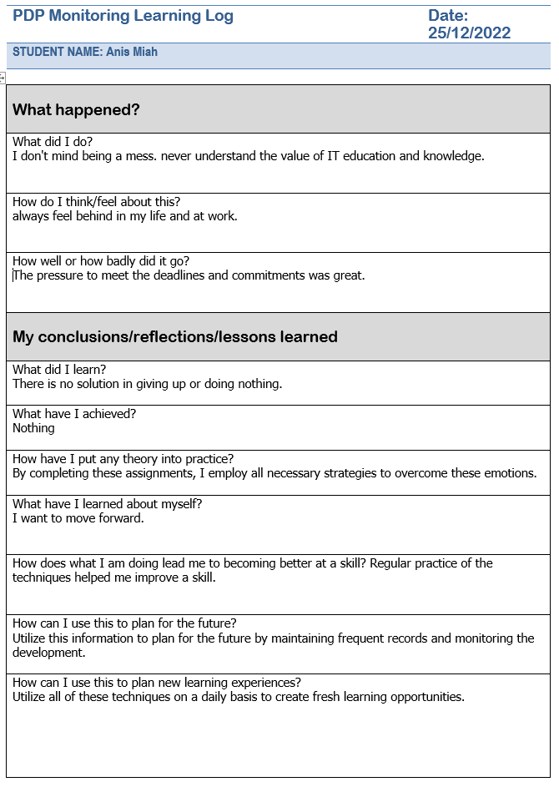
PDP Monitoring Learning Log for the other person below-
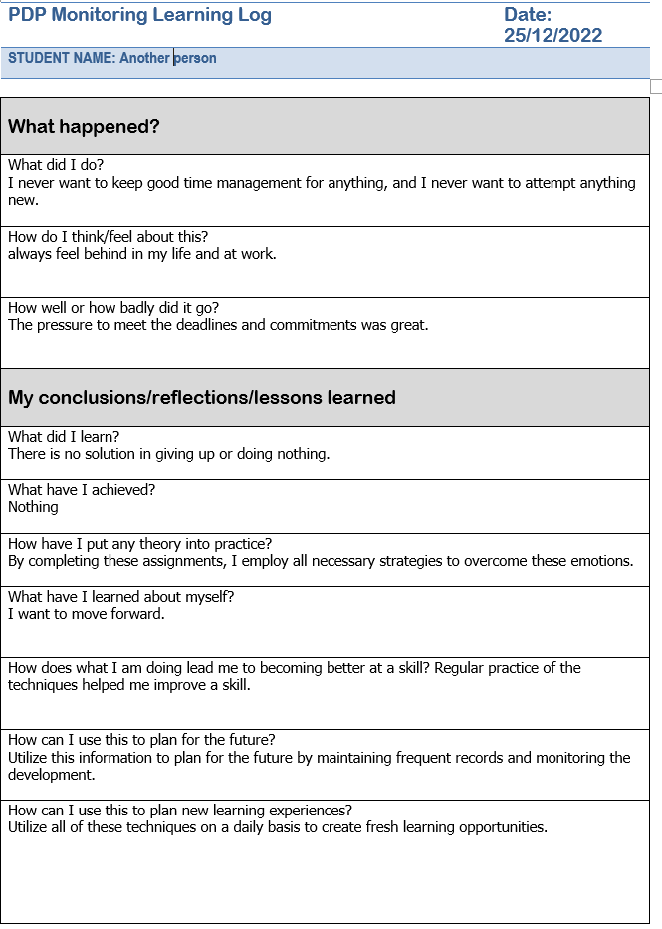

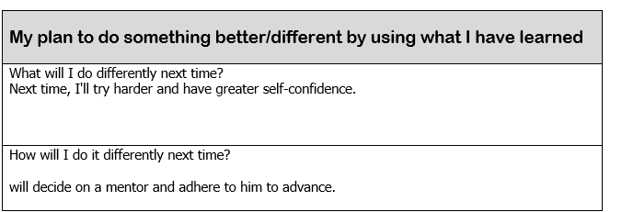

Section 3: Know how to prepare for the recruitment process

Graham Gibbs created the Gibbs Reflective Cycle in 1988 to organise learning from experiences. It provides a framework for analysing events and, given that it is cyclical, lends itself particularly well to repeated encounters, allowing you to draw lessons and make plans from both good and bad situations. It has six stages:
Description of the experience
Feelings and thoughts about the experience
Evaluation of the experience, both good and bad
Analysis to make sense of the situation
Conclusion about what you learned and what you could have done differently
Action plan for how you would deal with similar situations in the future, or general changes you might find appropriate.
(Gibbs, 1998).
This model is useful for processing an experience. This could be a one-time occurrence or something you encounter repeatedly, like meetings with a team you need to work with. Although Gibbs initially recommended using it in repetitive situations, the stages and principles also hold true for one-time events. If the action plan is created for a standalone event, it may become more general and focus on how you may use your conclusions moving forward.

(Rosenblatt, 1988).

Reflection on the recruitment process
the report's author Gibbs model will be used to describe each stage of the recruitment process reflection. The list below includes a number of useful questions for each level of the model. You don't have to respond to all of them but doing so will help you determine the kinds of things that might be appropriate to include at that moment. Other prompts could be more effective for you.

3.1 Description

At this point, the following query is possible:
What transpired?
What time and location did it occur?
Who were there?
What actions did you and the others take?
What happened in the situation?
The report writer wants to apply for a management position in a good industry, but his lack of IT expertise and his educational background are obstacles in the hiring process.

3.2 Feelings
To better understand feelings at this level, the following questions will be posed. - What emotions did you experience at the time?
How did you feel both before and after the incident?
What do you suppose other people were thinking and feeling at the time?
How do you believe other people currently feel about the circumstance?
What were you contemplating at the time?
After failing a few job interviews, the report's author lost confidence and began looking for a solution to the problem of the barrier limits.

3.3 Evaluation
We'll ask the following queries to help you better understand the evaluation stage.
What aspects of the event were positive and negative?
What succeeded?
What went wrong, exactly?
What positive or bad contributions to the situation did you and others make?
What knowledge—my own or that of others—can aid in my comprehension of the situation?
The report writer became convinced of his own desire to better himself through education and the acquisition of IT skills, but he was unsure of where to begin.

3.4 Analysis
At this point, the questions listed below can be asked:
How come things went well?
Why did it not work out?
What kind of sense can I make out of this?
What knowledge—my own or that of others—can aid in my comprehension of the situation?
The report's author delayed making decisions until it was too late, which caused him to falter in a few interviews. He will now get ready before going to another interview.

3.5 Conclusion
At this point, the questions listed below can be asked:
What did I take away from this experience?
How could things have turned out better for everyone concerned?
What abilities do I need to cultivate in order to better handle this situation?
What other options did I have?
The report writer learned that staying put is not a viable option and that progressing is necessary if he is to succeed at work. As a result, he will now incorporate all of the techniques and methods he learned from his assignment and regularly monitor them so as not to miss out on the journey toward advancement.

3.6 Action Plan
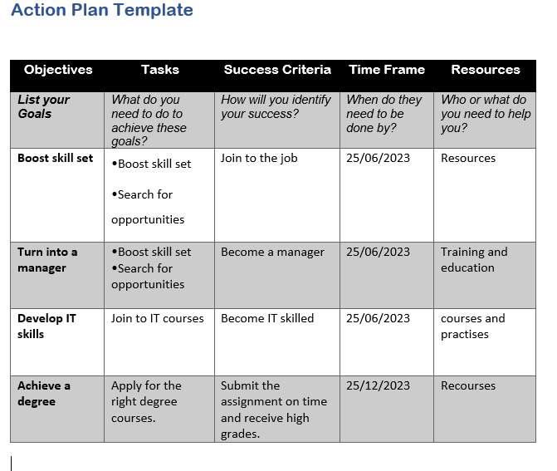

References

Gibbs, G. (1988). Learning by doing: A guide to teaching and learning methods. Oxford: Oxford Further Education Unit
Kolb, D. A. (1976). The Learning Style Inventory: Technical Manual. Boston, MA: McBer.
Murphy, M.A. (2011) Hard goals: The secret to getting from where you are to where you want to be. New York: McGraw-Hill.
McCrossin, S. (2004) Breaking the learning barrier: Eradicating ADD, ADHD, and dyslexia. Boulder, CO: Learning Enhancement Center.
McGrath, J. (2016) The little book of big decision models the 70 most useful models to help you say yes or no. Harlow, United Kingdom: Pearson.
Rosenblatt, L. (1988). Writing and reading the transactional theory. Wahington DC: The National Institute of Education.
Smith, S., & Butler Ellis, J. (2001). Memorable messages as guides to self-assessment of behavior: an initial investigation. Communication Monographs, 68(2), 154–168. https://doi.org/10.1080/03637750128058
Tan, A. (2006) The joy luck club. New York: Penguin Print
Wain, A. (2017), Learning through reflection, British Journal of Midwifery, 25(10). 662-666
Watton, P., Collings, J., Moon, J., (2001). Reflective writing: Guidance notes for students. England: Exeter University

Appendices A

Honey & Mumford’s Learning Styles Questionnaire for The Report Writer Below-
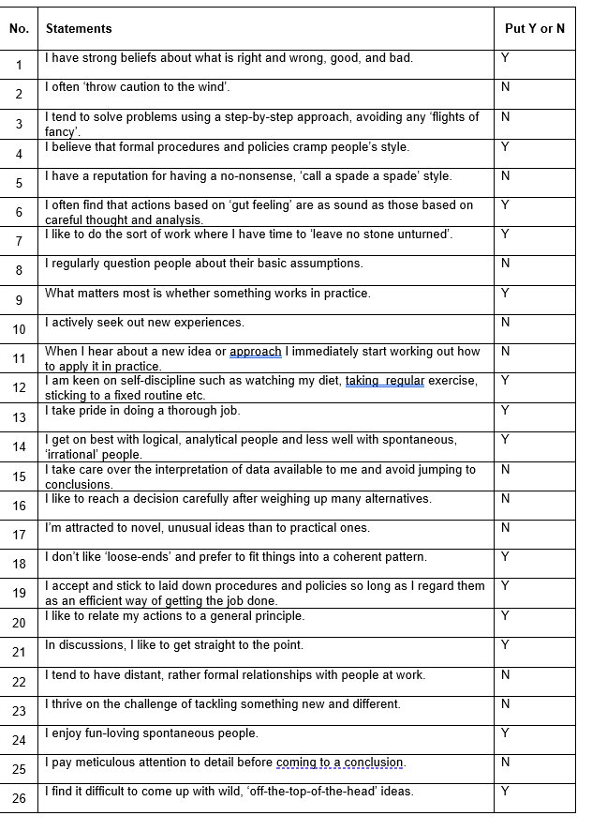
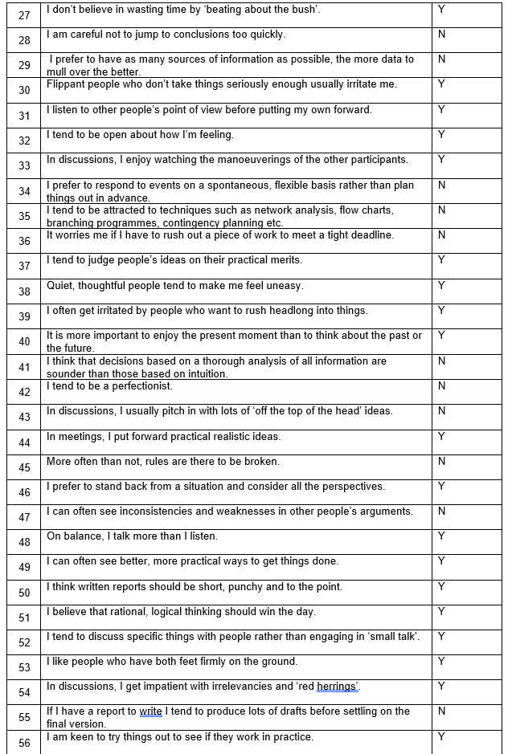
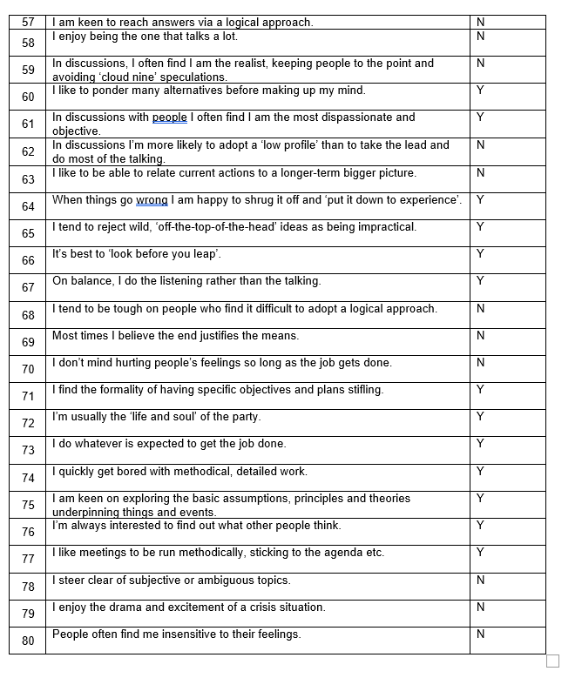

Scoring and Plotting Results for the report writer
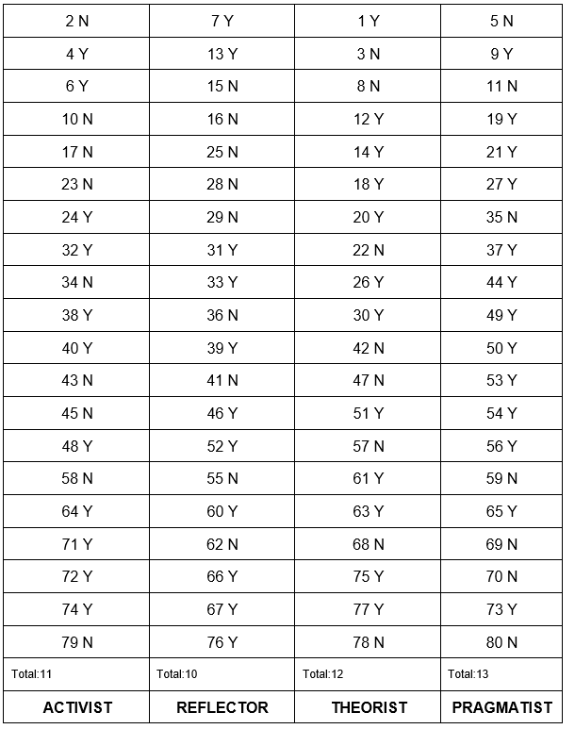Appendices B
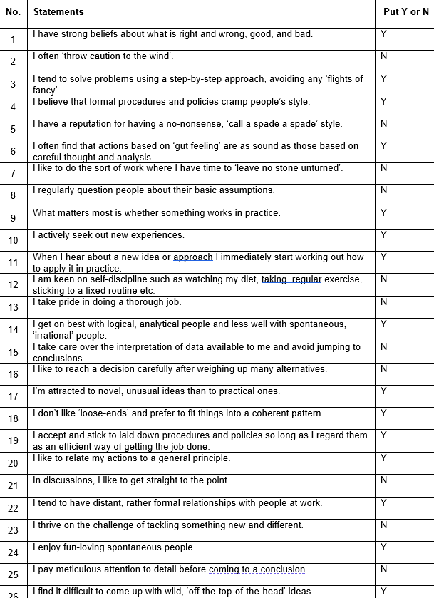
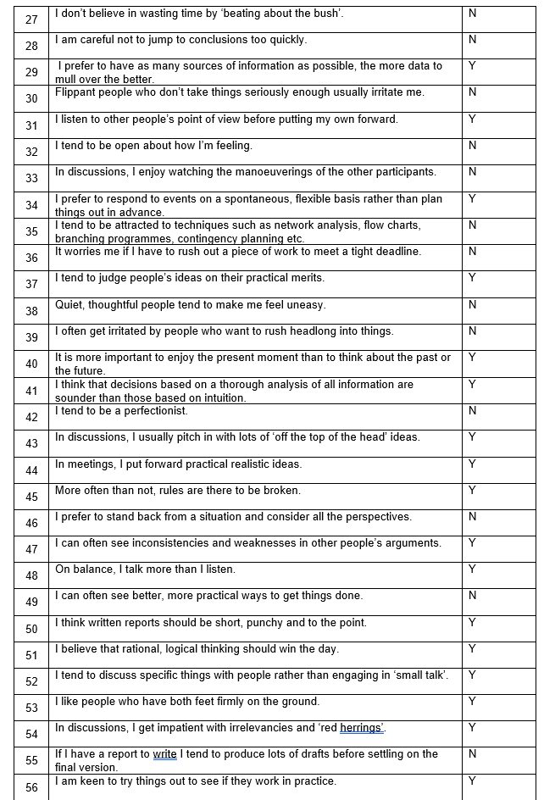
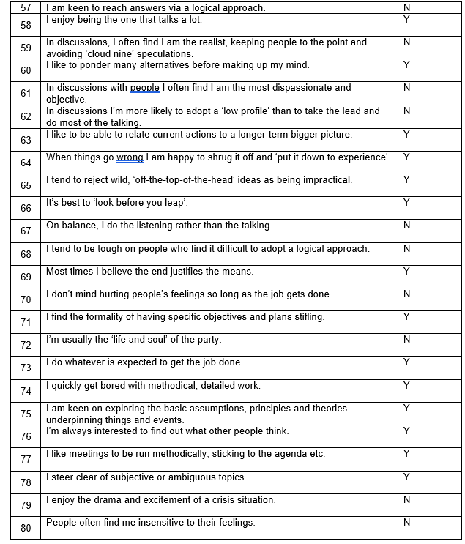

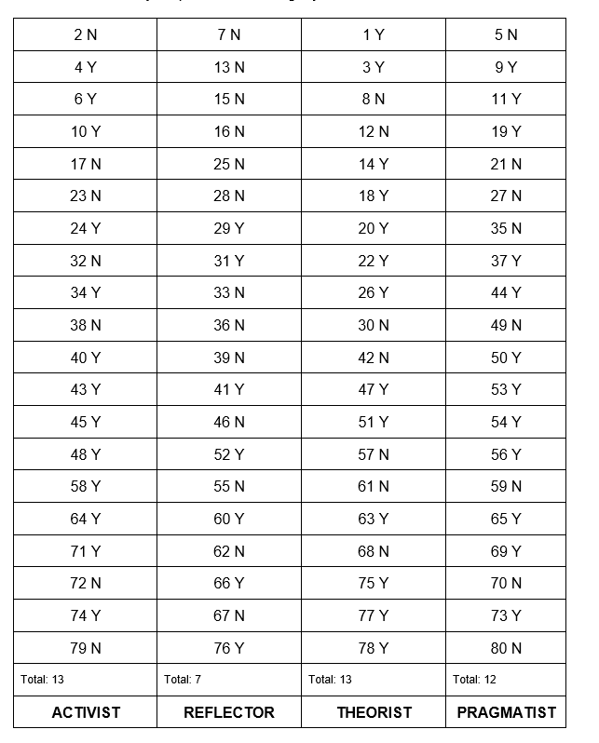

Appendices C
The report writer covering letter below-

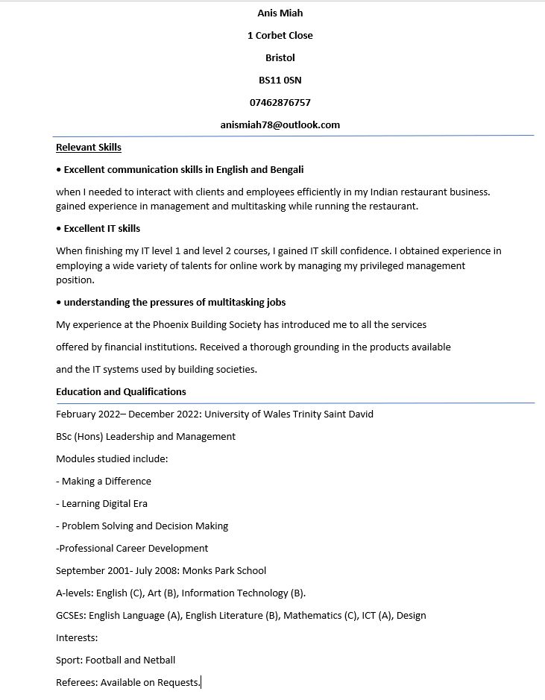

Appendix D
The report writer covering letter below-


