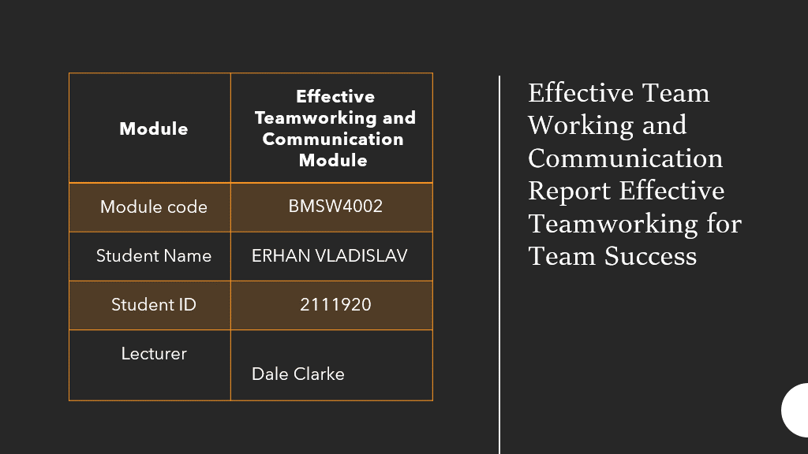

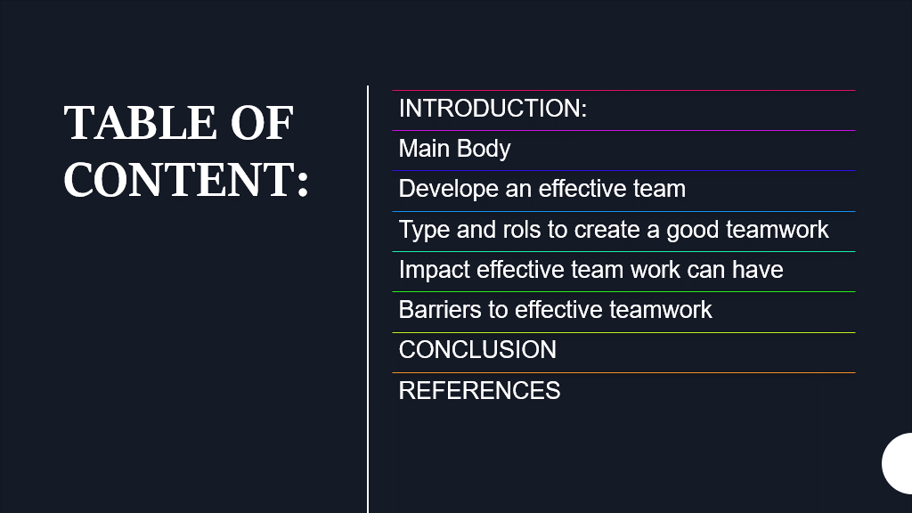

. INTRODUCTION
In our case, the study is talking about the effective teamwork of Abdul and his team. Teamwork is an effective way to solve workplace challenges.
The main objective of every organization is to grow. To meet an increasingly important role and grab more public interest, an organization must develop financially, logistically, and enrich the effectiveness of its work. This is dependent on how the organization achieves maximum potential resources, which may either make or break the organization.
The ability to collaborate as part of a team is amongst the most important qualities necessary in today's workplace. Every member of the organization is vital to its success and should significantly contribute to its achievement Abdul will need to follow some models of team formation to achieve success because A company's success is dependent on its personnel. Despite shifting market trends, successful teams adapt and flourish, whereas ineffective teamwork may destroy any enterprise. But what factors contribute to a team's success? For many decades, modern psychologists have sought a solution to this topic, and there are now several models and approaches for assessing teamwork success criteria.

MAIN BODY
The ability of a team to achieve the targets or objectives set by authorized persons or the organization is referred to as team effectiveness (also known as group effectiveness). [1] A team is a group of individuals that interact and work on tasks together, share responsibility for results, or consider themselves as a unit established in an institutional or organizational structure that operates within its defined parameters. [2] Within the limits of methods and efficacy studies, teams and groups have created a synonymous connection. [3] (linear patterns, coherence, collaboration) yet keeping their autonomy as different entities, because groupings and their members are not dependent on each other's position, talent, knowledge, or goal, in contrast to teams and their members, who are...In 1965, Bruce Tuckman created the Forming-Storming-Norming-Performing (FSNP) model, which depicted the successive stages of group growth. As per the professor, all of these cycles are necessary and unavoidable for the team to grow and achieve peak performance.
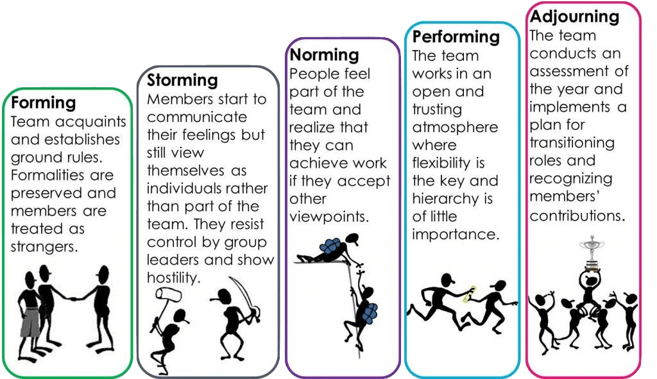

The forming–storming–norming–performing model of group development was established by Bruce Tuckman in 1965[1], who said that these phases are all essential and unavoidable for a team to grow, confront challenges, solve issues, discover answers, plan work, and achieve outcomes. Tuckman presumed that, in addition to these factors, interpersonal relationships and task activity would enhance the four-stage model that is required to successfully navigate and create an effective group function because he knew these inevitable phases were critical to team growth and development.. ^{[2]}
Forming
The group meets to discuss possibilities and challenges, then establishes goals then gets to work on specific tasks. Team members get the capacity to act. They may be dedicated, but they are usually unaware of the player's problems and objectives. Team members are normally at their best behavior, but they have a lot of egos. Even at this initial point, the senior team was able to provide an example of proper behavior. The meeting environment is also influential in shaping each person's first behavior. One of the most fundamental and critical functions is orientation. Members make an effort to get acquainted with their responsibilities, including those of one another. Individuals inside the company test limits, establish ground rules and define goals at this stage.
    - Abdul is going to create a website where team members can place information that represents them
    - There should be a lot of training on what to do next once they attain their goal.
Storming
This is the second stage of group formation when the group attempts to sort itself out and increase the confidence of one another. When leadership and status are allocated, this stage is typically triggered by their expressing their viewpoints; conflicts may erupt among team members.
Norming
"Resolved disputes and personality clashes result in increased familiarity and the formation of a cooperative spirit."
This happens when everyone in the group is aware of the competition and also has a shared goal. At this point, everyone in the team has accepted responsibility and is ready to help the team achieve its goals. They learn how to put up with the personal preferences of other group members. People accept people for who and what they are and want to move on with their lives. Individuals may be so bent on preventing conflict that they have been afraid to give disputed views, which poses a danger. Performing
"Group members aim to achieve common goals with specified group norms and responsibilities, often with shockingly high levels of success."
They've been encouraged and educated up till this. The team members are now competent, self-sufficient, and strong enough to make decisions without supervision. Dissent is expected and welcomed as long as it is routed via authorized methods to a team.
Impact of a team of Effective teamwork can have:
Communication is the most fundamental building element in developing an effective team, thus it is critical to learn the required abilities to communicate effectively with one another.
Effective teamwork in the workplace is characterized by the following advantages:
- Increased productivity - According to this case study, first and foremost, working in a team allows for the task to be distributed based on each participant's skill set. Instead, an individual working alone, for example, after some period of time "Several members of the team are thinking about leaving" may impact the entire project team..
- It encourages innovation - Individuals who work in groups are more likely to come up with innovative, inventive, and viable solutions to problems, which is crucial to the success of any business. An open-door policy allows staff to engage more openly and casually, as well as energize one another to work to their strengths. In contrast, someone working alone will usually suggest the safest option to their superior.
- It establishes strong relationships In addition, collaboration can lead to the gradual build-up of strong relationships among team members, which allows people to speak more freely and directly, such as "when someone asks for help, no one responds to or supports the email communications. As long as Abdul had been doing this from the beginning, everyone would have been able to help him
- It allows flexibility - As team members work together for a similar purpose, they get used to resolving conflicts individually for the sake of the project and the team. Their habits and work styles are generally very different, which can be irritating to one another. Nevertheless, in a team, they are one.
- Barries in our case study are the following:
Ineffective leadership:
For teams to function well, they must be led by personnel who can advise others, give insight, and continually promote collaboration. Teams may feel disconnected and disengaged as a result of poor leadership, limiting their ability to communicate. Leadership may exert influence over these situations by increasing opportunities for cooperation, aiding team members in improving their skills, and establishing ways to recognize and promote successful collaboration.
Goal confusion:
The Team needs to have a The identification of shared goals toward which team members may cooperate is often the starting point for successful cooperation. As a result, teams may face issues if they do not truly understand or agree on the work's objectives. To reduce goal ambiguity, teams can establish a clear framework for setting objectives, monitoring them, and structuring procedures to fulfill them efficiently.
Communication gaps:
The entire team must perform excellently. Working with other team members necessitates strong communication, which allows professionals to connect with colleagues, clarify their points of view, listen to others, and clarify expectations. As a result of communication issues, team members may lack clarity on expectations and responsibilities. Teams may choose to work on improving their communication skills to cross these gaps and engage more effectively.
Lack of trust:
To work together toward a set of common goals, professionals in a team must generally trust one another and develop respectful relationships in which they have faith in each other's skills. If there is a lack of trust, team members may not feel comfortable making observations or expressing their opinions during collaborative activities. Furthermore, a lack of trust can lead to misunderstanding and dispute, impeding collaboration. Professionals can more effectively cultivate trusted relationships through team-building exercises and regular opportunities for collaboration.
Inequitable decision-making:
It is usual for one team member to take on more responsibility than others and to make decisions in a team atmosphere. This unfair working atmosphere is typically caused by some team members being so much more extroverted, possessing better talents, or enjoying an autonomous work style. Team members who are more introverted and want a collaborative setting, on the other hand, may begin to contribute less if you think their ideas are useless. Teams may solve inequitable decision-making processes by democratizing workflow and guaranteeing that all team members contribute equally.

CONCLUSION
We can learn from the case study of the Abdul team that if he will take some action by the end of the project, it will be a great finish.
- Deadlines met – the team should decide that working alone will result in less work accomplished in a certain amount of time, whereas working in teams will increase productivity, helping to meet tight deadlines faster.
- Problem-solving - group members who discuss a problem together are often more effective than an individual trying to solve it alone.
- Building strong professional relationships - teamwork helps build strong partnerships between colleagues. By working together, team members gain a better understanding of one another's strengths, weaknesses, and personal characteristics. A stronger relationship creates a foundation of trust and promotes more natural, open, and free communication.
- Flexibility – a member of a team can help transfer skills and knowledge when having some problems between members. This can help Abdul in case of emerges to apply to other members of the team
- Conflict resolution skills – Abdul needs to show his skills as a leader and sort any conflict
- Boost morale – Team leader organizes some zoom meeting and place o video about work alone and in team Video need to be fun but with context.

REFERENCES
December 14, 2018, by Prachi M, Leave a Comment
Ferguson, D. P., Wallace, J. D. and Chandler, R. C., 2018. Hierarchical consistency of strategies in image repair theory: PR practitioners’ perceptions of effective and preferred crisis communication strategies. Journal of Public Relations Research, 30(5-6), pp.251-272.
https://www.careeraddict.com/5-benefits-of-teamwork-in-the-workplace
https://www.careeraddict.com/5-benefits-of-teamwork-in-the-workplace
https://www.nibusinessinfo.co.uk/content/advantages-effective-teamwork
Kang, E. and Hwang, H. J., 2021. Quantitative Analysis: Team management for Better Employee Performance in the US Retail Supply Chain. Journal of Distribution Science, 19(7), pp.19-27.
Meredith Belbin | Team Roles at Work pg21-22 2010
www.belbin.com

