Programme: BEng Mechanical Engineering Module: Independent Project Module Code: ACMA6013. Author: Rhys Holmes Student Number: 2117889 Word Count: 11,120

University of Wales Trinity Saint David School of Engineering Independent Project: Dissertation Final Report. Title: Investigation and Mitigation of Corrosion in the CDU Overhead System at Valero Pembroke Refinery
2026

Declaration of Authenticity

This thesis is the result of the author’s original research. It has been composed by the author and has not been previously submitted for examination which has led to the award of a degree.


Signed:
Rhys Holmes

Date: 26/05/2026

Abstract

The crude distillation unit (CDU) overhead system at Valero Pembroke Refinery experienced persistent corrosion between 2005 and 2024, causing pipe leaks, emergency composite wrap repairs and unplanned section replacements despite ongoing chemical treatment. This study investigated the root cause of the corrosion and evaluated the effectiveness of the 2024 overhead velocity modification project.
A structured 5 Whys root cause analysis was applied to inspection records, ultrasonic thickness data, online corrosion monitoring results and process operating data from 2022–2025. The analysis identified excessive vapour velocity within the original 30” overhead line as the primary root cause. Pre-project average velocity was 31.3 m/s, exceeding the NACE-recommended limit of approximately 20 m/s for carbon steel piping in corrosive condensate service. This high-velocity two-phase flow promoted wall shear stress and liquid droplet impingement, continuously removing protective corrosion films from pipe surfaces.
The engineering response replaced the original 30” overhead vapour line with a 48” diameter pipe, increasing cross-sectional flow area by approximately 156% and reducing average vapour velocity to 14.2 m/s. Post-project data confirmed that crude throughput remained stable or increased, demonstrating that the velocity reduction resulted from the engineering modification rather than reduced production. Permanent ultrasonic monitoring recorded corrosion rate reductions of 91–96% across all three monitored locations, from pre-project averages of 0.30–0.59 mm/year to post-project rates of 0.023–0.050 mm/year.
The results demonstrate that pipe diameter increase is an effective primary corrosion control intervention where CDU overhead corrosion is driven by hydrodynamic erosion-corrosion rather than chemical attack alone.

Table of Contents

Declaration of Authenticity 1
Abstract 2
Acronyms 6
Table of Figures 8
Table of Tables 8
1.0 Introduction 9
1.1 Aims and Objectives 10
1.2 Project Timing Plan 11
2.0 Corrosion Mechanisms in the CDU Overhead – Pre-project 12
2.1 Historical Pattern of Damage 12
2.2 Observed Damage Locations and Severity 13
2.3 Nature of the Corrosion Damage 15
3.0 Literature Review 16
3.1 Introduction 16
3.2 Sources of Corrosive Species in Crude Oil 16
3.3 Hydrochloric Acid Corrosion 18
3.4 Ammonium Chloride Salt Deposition 18
3.5 Organic Acid Corrosion 20
3.6 Naphthenic Acid Corrosion 20
3.7 Sulfidation Corrosion 21
3.8 Galvanic Corrosion in Mixed-Metallurgy Systems 21
3.9 Erosion-Corrosion Mechanisms in Refinery Piping 21
3.10 Influence of Flow Velocity on Corrosion 22
3.11 Industry Corrosion Mitigation Strategies 23
3.12 Protective Coatings and Surface Treatment Methods 26
3.13 Summary and Research Gap 27
4.0 Root Cause Analysis 29
4.1 Methodology 29
4.2 Application of the 5 Whys 29
Why 1: Why did the overhead piping repeatedly fail? 30
Why 2: Why was the erosion/corrosion occurring at an accelerated rate? 30
Why 3: Why was vapour velocity so high? 31
Why 4: Why had the undersized pipe not been replaced sooner? 32
Why 5: Why did the chemical treatment and localised repairs fail to control corrosion adequately? 32
4.3 Root Cause Summary 33
4.4 Engineering Response 34
5.0 Mitigation Strategy and Engineering Response 35
5.1 Root Cause Identification – Velocity and Maldistribution 35
5.2 Overhead Line Redesign – Velocity Mitigation 36
5.3 Metallurgy Strategy 38
5.4 Water Wash Optimisation 38
5.5 Summary of Engineering Response 39
6.0 Results and Data Analysis 40
6.1 Data Sources and Methodology 40
6.2 Crude Throughput 41
6.3 Velocity Reduction 44
6.4 Corrosion Rate Analysis 45
6.5 Discussion: Relationship Between Velocity, Throughput and Corrosion Rate 47
6.6 Fin-Fan Condenser Bank Reliability 48
7.0 Conclusion 50
Root Cause 50
Effectiveness of the Engineering Response 51
Economic and Reliability Impact 51
Contribution to Knowledge 52
Limitations 52
Author’s Engineering Contribution 53
Recommendations for Further Work 54
Bibliography 56
Appendix 61
Appendix 1 – 2012 Overhead Replacement 61
Appendix 2 – 2021 Top Elbow Replacement 62
Appendix 3 – 2018 Wrap Due to Leak on Lower 30” Elbow 62
Appendix 4 - 2024 Inspection Report and Grid Markup in the Field 63
Appendix 5 – Corrosion Rates 2022/2025 66
Appendix 6 – 2022 Overhead Line UT Reports (Emerson) 69
Appendix 7 – 2023 Overhead Line UT Reports (Emerson) 70
Appendix 8 – 2018 Leak Investigation (Inspection V. P., 2018) 72
Appendix 9 – Iris Reports for Fin-fan Plugged Tubes (Inspection V. P., 2018) 73
Appendix 10 – Overhead Calculation Correspondence with George Thomas (Snr Process Engineer Refining) 75
Appendix 11 - 1-E-9 vs 1-E9A Size Comparison (Planning, 2023) 76
Appendix 12 – Project Timing Plan, Microsoft Project Plan 77
Appendix 13 – 1-E-9 Repair Plan (Inspection V. P., 2018) 78
Appendix 14 – 1-E-9 Overhaul Costs (Miller, 2022) 79
Appendix 15 – Velocity Calculation and Snip of Raw Data Used 85

Acronyms

AMPP – Association for Materials Protection and Performance
ANSI – American National Standards Institute
API – American Petroleum Institute
°C – Degrees Celsius
CDU – Crude Distillation Unit
CFD – Computational Fluid Dynamics
HCl – Hydrogen Chloride
H₂S – Hydrogen Sulphide
IRIS – Internal Rotary Inspection System
MgCl₂ – Magnesium Chloride
CaCl₂ – Calcium Chloride
NaCl – Sodium Chloride
NaOH – Sodium Hydroxide
NH₃ – Ammonia
NH₄Cl – Ammonium Chloride
NACE – National Association of Corrosion Engineers
OVM – Overhead Velocity Modification
RCA – Root Cause Analysis
TAN – Total Acid Number
UT – Ultrasonic Thickness
UDC – Under-Deposit Corrosion
XHQ – E-Viewer Historian System (Valero process data system)
m/s – Metres per Second
m² – Square Metres
mm/yr – Millimetres per Year
ppm – Parts per Million
TSA – Thermal Sprayed Aluminium
USTM – Ultrasonic Thickness Scanning Measurement

Table of Figures

Figure 1 - Overhead System Schematic Valero Refinery Pembroke 12
Figure 2 -Under-Deposit Corrosion Pre/Post Jetting on 1-E-9's (Inspection V. P., 2018) 14
Figure 3 - Galvanic Corrosion 1-E-9 Condenser (Holmes, 1-E-9s fin-fan condenser galvanic corrosion observations (Internal document), 2026) 14
Figure 4 – Under-Deposit Corrosion Example (Aqua, 2025) 19
Figure 5 - Mechanism of Erosion/Corrosion via High Velocity Droplet Impingement (P., 2022) 36
Figure 6 – Cross-Sectional Area Comparison 30” vs 48” Holmes (2025) 37
Figure 7 – Crude Throughput Before/After OVM Project, 2023-2025 43
Figure 8 - Average Overhead Vapour Velocity Pre/Post Project 44
Figure 9 – Pre- and Post-Project Velocity Compared with NACE Guideline Limit 44

Table of Tables

Table 1 - Literature to Evidence Comparison Table 28
Table 2 - Contributing Factors Summary 34
Table 3 - Corrosion Rates Pre and Post OVM Project 46

1.0 Introduction

The crude distillation unit (CDU) is the primary processing unit within an oil refinery, responsible for separating crude oil into its constituent hydrocarbon fractions through atmospheric distillation. Crude oil is received from storage and passed through a preheat train before entering the crude furnace, where it is heated to temperatures typically in the range of 340–370°C. The heated crude then enters the atmospheric distillation column, where separation into fractions occurs based on differences in boiling point. Products withdrawn from the column include light naphtha, heavy naphtha, kerosene, diesel and atmospheric residue (Ahmed, 2021; Speight, 2014).
At the top of the atmospheric column, the lightest hydrocarbon fractions exit as vapour alongside steam, hydrogen chloride gas, hydrogen sulphide and other volatile species carried over from the crude oil feed. This vapour stream rises through the overhead vapour line and passes through a series of air-cooled fin-fan condensers, where it is partially condensed. The condensed liquid and remaining vapour then flow to the overhead accumulator drum, where liquid naphtha and sour water are separated. A portion of the liquid naphtha is returned to the column as reflux, while the remainder is routed to downstream processing. The overhead system at Valero Pembroke Refinery consists of the vapour line from column 1-C-1, two banks of fin-fan condensers (1-E-9 and 1-E-9A), associated wash water injection facilities and the naphtha reflux accumulator drum 1-C-5.
The overhead system represents the most corrosion-susceptible section of the CDU. As vapours cool within the overhead line and condensers, water condensation occurs. This condensed water phase dissolves corrosive species — principally hydrogen chloride — forming highly acidic solutions capable of rapidly degrading carbon steel and alloy materials (ANSI/API 571, 2020). The severity of corrosion is further influenced by the presence of ammonium chloride salts, sulphur compounds, and the hydrodynamic conditions within the piping, particularly vapour velocity.
The CDU overhead system at Valero Pembroke Refinery experienced persistent and escalating corrosion damage over a period spanning 2005 to 2024. Multiple leaks, emergency pipe wrap repairs and unplanned section replacements were required during this period, indicating that existing corrosion control measures were insufficient to manage the degradation occurring within the system. Despite documented investigations in 2005 and 2018, each of which identified excessive vapour velocity as a primary causal factor, the response in the intervening years focused on localised repair and chemical treatment rather than fundamental engineering intervention.

Aims and Objectives

The primary aim of this study is to identify the root causes of the persistent corrosion within the CDU overhead system at Valero Pembroke Refinery through a structured analytical approach, and to evaluate the effectiveness of the engineering mitigation strategy implemented in 2024 — specifically the replacement of the original 30” overhead vapour line with a 48” diameter pipe.
The objectives of the study are:
- To review the historical pattern of corrosion damage within the overhead system and identify the corrosion mechanisms present
- To conduct a critical review of relevant literature on CDU overhead corrosion mechanisms and industry mitigation strategies
- To apply the 5 Whys root cause analysis methodology to available inspection, monitoring and process data to identify the fundamental cause of the recurring corrosion
- To evaluate the engineering mitigation strategy implemented and assess its effectiveness using pre- and post-project operational and corrosion monitoring data
- To identify the limitations of the study and recommend areas for further investigation
The report is structured as follows: Section 2 documents the historical corrosion pattern and damage observed prior to the project. Section 3 presents a critical literature review of corrosion mechanisms and mitigation strategies relevant to CDU overhead systems. Section 4 applies the 5 Whys root cause analysis methodology to the available evidence. Section 5 describes the mitigation strategy and engineering response implemented. Section 6 presents the results of velocity reduction and corrosion rate monitoring before and after the modification. The Conclusion summarises the outcomes, acknowledges limitations, and draws recommendations for ongoing corrosion management and further work.

Project Timing Plan

A formal project plan was developed at the outset of the study and managed throughout using Microsoft Project. The plan is included at Appendix 12. The project was structured across four principal phases: historical data collection and literature review (September–October 2025), interim viva preparation and delivery (November–December 2025), data analysis and results write-up (January–March 2026), and final report completion (April–May 2026). The interim viva was delivered on 17 December 2025 and provided an opportunity to validate the direction of the study with the assessment panel. Progress against the plan was broadly maintained, though the literature review extended beyond its originally planned completion date due to the volume of technical standards and industry guidance reviewed. This was recovered during the Christmas period. The project was ready for submission by 18 May 2026; however, an extension was granted until 1 June.

Corrosion Mechanisms in the CDU Overhead – Pre-project

Prior to the overhead line modification project, the CDU overhead system at Valero Pembroke refinery (Figure 1) had experienced a sustained and escalating pattern of corrosion damage across multiple components. This section summarises the nature, location and severity of the corrosion observed, drawing on inspection records, ultrasonic thickness (UT) measurement reports and historical incident data collected over the period 2005–2024.
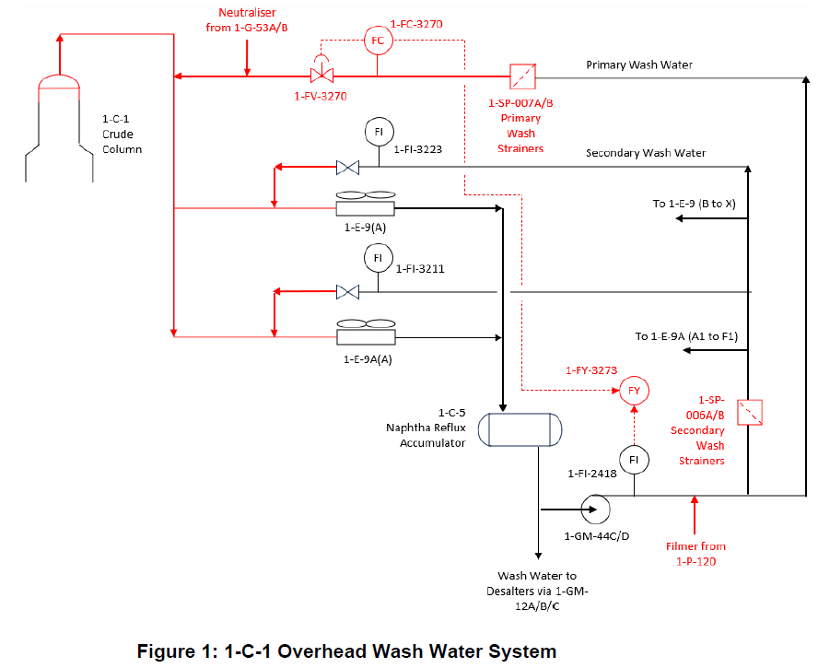
Figure 1 - Overhead System Schematic Valero Refinery Pembroke

2.1 Historical Pattern of Damage

The corrosion problem within the Pembroke refinery CDU overhead system has a documented history spanning several decades. As early as 2005, when the refinery operated under Texaco Limited ownership, a Computational Fluid Dynamics (CFD) investigation was commissioned to study the behaviour of liquid droplets within the overhead line following the identification of significant corrosion and leaks requiring unplanned shutdown (Kidger, 2005). That investigation concluded that the continuous impingement of liquid droplets — formed from the interaction of injected wash water and condensing hydrocarbons — was progressively stripping the protective corrosion film from the pipe wall inner surface, resulting in accelerating metal loss, particularly at the 30" to 24" diameter reducer and at the tee-sections supplying the 1-E-9 fin-fan cooler banks.
Despite a series of interventions over the following years — including section replacements in 2012 and 2021 (Appendix 1, Appendix 2), emergency pipe-wrap repairs in 2018 and 2024 (Appendix 3, Appendix 4), and ongoing chemical treatment programmes — the corrosion continued to recur. This pattern of repeated repair rather than elimination of the root cause indicated that the underlying driving forces had not been adequately addressed.

2.2 Observed Damage Locations and Severity

The most severe corrosion damage was consistently concentrated at a small number of locations within the overhead system, as documented by inspection reports and UT survey data:
The lower 30" elbow at the base of the vertical overhead vapour line was the most critically affected location. UT thickness surveys conducted in 2021 (Appendix 4) recorded significant wall thinning across a grid of measurement points on this elbow. Several sensor readings indicated corrosion rates classified as severe, with some locations reporting remaining thickness approaching retirement limits (Appendix 5). By 2024, the corrosion at this elbow had progressed to the point of producing an active leak, requiring an emergency composite wrap repair to maintain pressure containment whilst planned replacement was organised.
The 20" branch lines supplying the 1-E-9 fin-fan condenser banks also showed elevated corrosion rates. Permanent online ultrasonic monitoring sensors installed within lines PJ116 and PJ118 reported high rates of metal loss throughout 2022 and 2023, with multiple sensor locations classified as red status, indicating severe ongoing corrosion (Appendix 6, Appendix 7). In one case, a sensor recorded a remaining thickness below its retirement thickness, representing a situation where the pipe wall had corroded to within its minimum acceptable limit.
The 1-E-9 fin-fan condensers themselves also displayed evidence of damage consistent with the overhead system corrosion environment. Under-deposit corrosion was visually confirmed on condenser header internals during maintenance outages, with deposits of ammonium chloride salts and corrosion products identified on tube sheet surfaces (Figure 2).
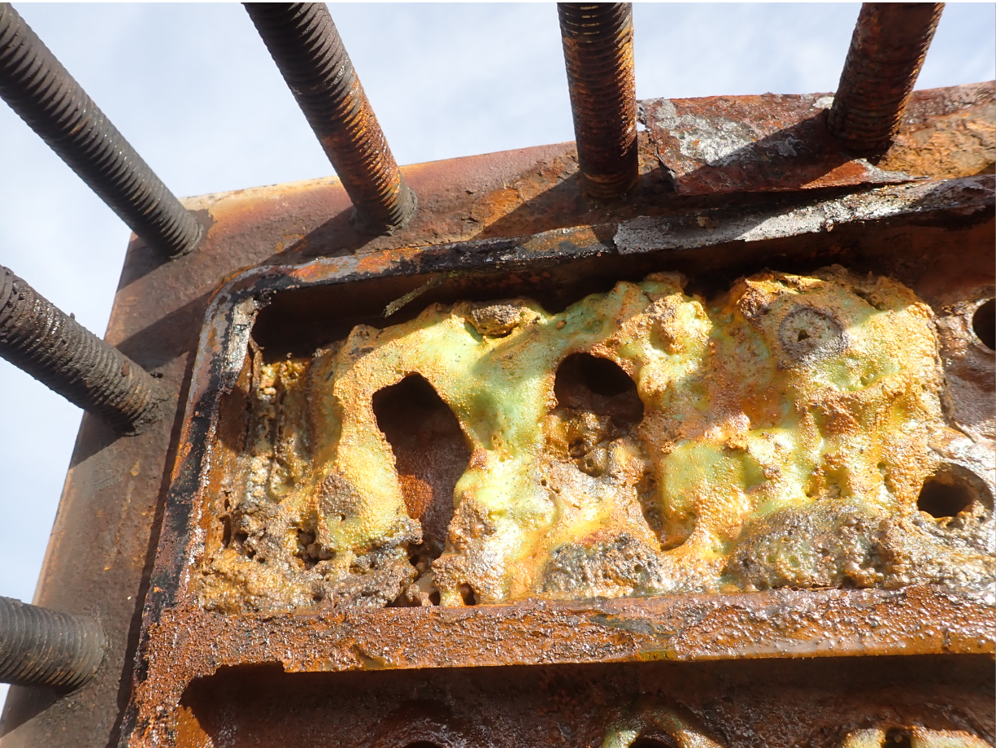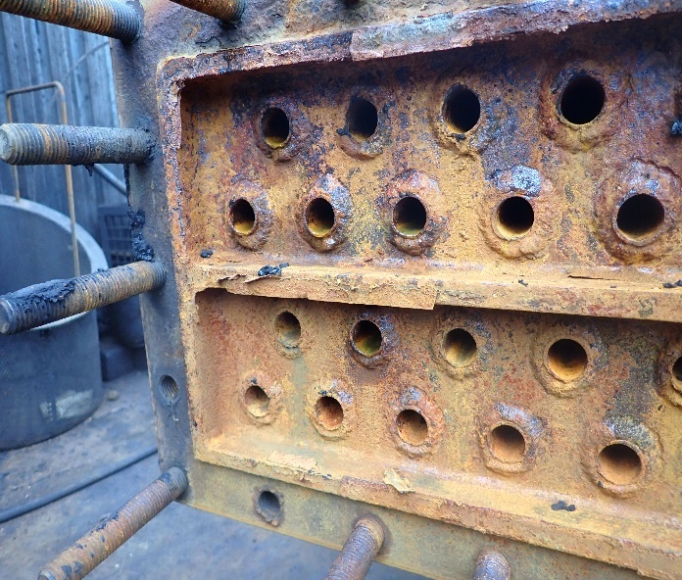
Figure 2 -Under-Deposit Corrosion Pre/Post Jetting on 1-E-9's (Inspection V. P., 2018)

The galvanic corrosion of carbon steel fasteners securing the galvanised condenser covers was also identified as a contributing damage mechanism at the condenser headers (Figure 3).

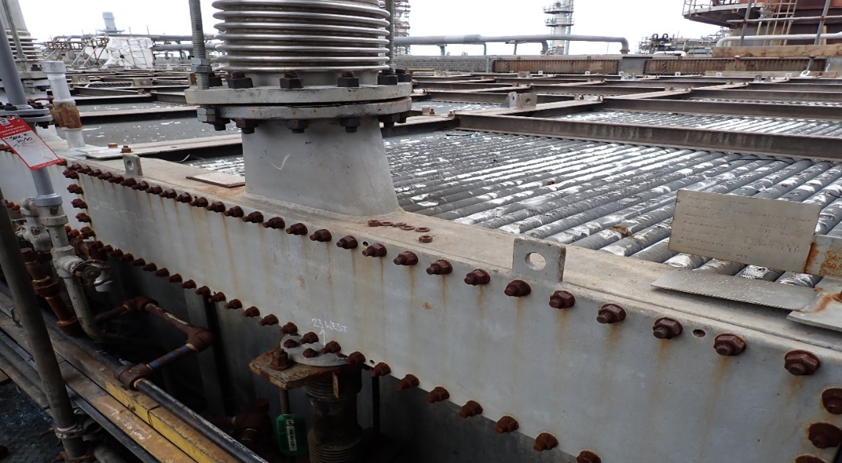
Figure 3 - Galvanic Corrosion 1-E-9 Condenser (Holmes, 1-E-9s fin-fan condenser galvanic corrosion observations (Internal document), 2026)

2.3 Nature of the Corrosion Damage

The pattern of damage observed — concentrated at elbows, reducers, tee-sections and points downstream of wash water injection — is characteristic of erosion-corrosion driven by high-velocity two-phase flow. API 571 (2020) specifically identifies elbows, tees, pipe reducers and areas downstream of injection points as preferential locations for velocity-driven corrosion attack, which aligns directly with the damage distribution observed at Pembroke.
The CFD study commissioned in 2005 had already demonstrated analytically that droplets of approximately 50 microns diameter produced the greatest erosion at the cooler nozzle walls, and that flow swirl generated within the overhead line by the pipe geometry was concentrating droplet impingement at specific locations rather than distributing it evenly (Kidger, 2005). This conclusion was reinforced by the 2018 incident investigation, which identified no velocity limit being applied to the overhead flow and inadequate control of wash water distribution as primary causal factors, recommending as a long-term solution that the overhead line diameter be increased to reduce vapour velocity (Appendix 8).
The corrosion environment was further complicated by the presence of ammonium chloride salt deposition within the condenser system, evidence of amine contamination in the crude feed influencing pH control (Appendix 7), and the mixed-metallurgy configuration of the system — with Monel alloy components originally installed alongside carbon steel piping — creating localised galvanic corrosion risk wherever condensate bridged dissimilar metals.

3.0 Literature Review

3.1 Introduction

Corrosion represents one of the most significant operational challenges within petroleum refining operations. Ahmed A. A., (2017) states that the degradation of process equipment caused by corrosion can lead to reduced operational reliability, increased maintenance costs and potentially catastrophic failures if not effectively managed. The global cost of corrosion has been estimated to exceed 3–4% of global GDP, highlighting the substantial economic impact of corrosion across industrial sectors.
Within refineries, the CDU overhead system is particularly susceptible to corrosion. As hydrocarbon vapours rise through the distillation column and begin to cool within the overhead line and condensers, water condensation occurs. This condensed water phase can dissolve corrosive species present in the vapour stream, forming highly aggressive acidic solutions capable of attacking metallic materials (ANSI/API, 571, 2020). Several corrosion mechanisms have been identified within CDU overhead systems, including hydrochloric acid corrosion, ammonium chloride salt deposition, organic acid corrosion, sulfidation, galvanic corrosion and erosion-corrosion. The severity of these mechanisms is strongly influenced by process conditions including crude oil composition, desalting efficiency, temperature gradients and vapour velocity (NACE, AMPP, 2023).

3.2 Sources of Corrosive Species in Crude Oil

Speight (2014) lists crude oil as containing a wide variety of contaminants that can contribute to corrosion during refining operations. Among the most significant are inorganic chloride salts, sulphur compounds, nitrogen compounds and organic acids. The concentration of these contaminants varies significantly depending on the geological origin of the crude oil and production conditions.
Inorganic chloride salts — principally sodium chloride (NaCl), calcium chloride (CaCl₂) and magnesium chloride (MgCl₂) — are commonly present in crude oil due to formation water associated with petroleum reservoirs. As documented by API 571 (2020), crude oil typically undergoes a desalting process before entering the crude furnace, using wash water and electrostatic separation to remove salts and suspended solids. However, incomplete desalting allows residual salts to enter the distillation system.
When crude oil containing residual chloride salts is heated within the crude furnace, hydrolysis reactions occur. Magnesium chloride and calcium chloride react with water at elevated temperatures to produce hydrogen chloride gas:

$${MgCl}_{2}+H_{2}O →MgO+2HCl$$

As shown in Ahmed (2017), MgCl₂ begins hydrolysing at approximately 120°C with around 90% conversion at 340°C, while CaCl₂ hydrolysis begins at approximately 210°C with only around 10% conversion at the same temperature. NaCl is largely stable below 500°C. This means that the degree of HCl generation is strongly influenced by the salt species present and the furnace outlet temperature. The hydrogen chloride gas produced is carried with the overhead vapour stream and, upon condensation, dissolves in water to form hydrochloric acid.
It should be noted that the hydrolysis conversion figures cited by Ahmed (2017) are derived from laboratory-scale experiments conducted under controlled temperature and residence time conditions. In an operational refinery furnace, local temperature gradients, crude oil composition variability and varying residence times mean that actual HCl yields may differ from these theoretical values. Consequently, while the relative contributions of MgCl₂ and CaCl₂ to HCl generation are well established in principle, the absolute conversion percentages should be treated as indicative rather than precise operational targets when designing desalting and neutralisation programmes.

3.3 Hydrochloric Acid Corrosion

Hydrochloric acid (HCl) corrosion is widely recognised as the dominant corrosion mechanism affecting CDU overhead systems. When hydrogen chloride gas dissolves in the first droplets of condensed water within the overhead line, it forms hydrochloric acid at very high concentration. These initial condensate droplets can exhibit pH values below 2, creating extremely aggressive corrosion conditions (ANSI/API, 571, 2020).
HCl corrosion may occur as either general wall thinning or highly localised pitting, depending on flow conditions. Localised corrosion frequently occurs at pipe elbows, changes in diameter, and areas where acidic water accumulates due to low-flow regions or poor drainage. Mohammed (2022) reports that the resulting acidic environment can cause rapid corrosion of carbon steel materials commonly used in refinery piping systems.
Several operational factors influence the severity of HCl corrosion, including crude oil chloride concentration, desalting efficiency, overhead system temperature, water condensation behaviour and vapour velocity. Aisha (2021) states that poor desalting efficiency allows larger quantities of chloride salts to enter the distillation system, resulting in increased HCl formation and higher corrosion risk. Consequently, improving desalting performance is widely recognised as one of the most effective strategies for reducing overhead corrosion.
Although HCl corrosion is the dominant mechanism, API 571 (2020) notes that corrosion in refinery overhead systems typically results from the combined effects of chemical environment, materials of construction and hydrodynamic conditions rather than any single factor in isolation.

3.4 Ammonium Chloride Salt Deposition

Ammonium chloride (NH₄Cl) deposition represents another significant corrosion mechanism affecting refinery overhead systems. Ammonium chloride forms when ammonia reacts with hydrogen chloride in the vapour phase:
$${NH}_{3}+HCl→{NH}_{4}Cl$$
Ammonia may originate from nitrogen compounds present in crude oil, from upstream hydrotreating processes, from neutralising amine injection programmes, or from boiler steam additives carried into the system (NACE, AMPP, 2023). As vapours cool within the overhead line, ammonium chloride salts condense and deposit on pipe walls above the aqueous dew point as dry solid deposits. These salt deposits attract moisture and create highly corrosive under-deposit environments that accelerate corrosion of the underlying metal surface (Akpanyung, 2019).
Figure 4 shows an example of under-deposit corrosion.
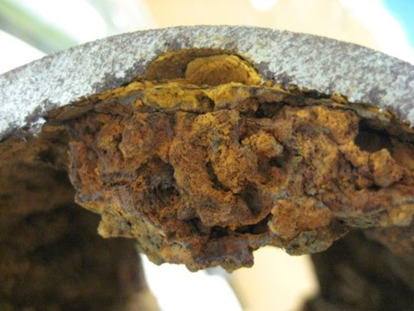
Figure 4 – Under-Deposit Corrosion Example (Aqua, 2025)

AMPP (2023) also identifies amine hydrochloride salts as a related concern. Where organic neutralising amines are used in the overhead system, they may react with HCl to form liquid amine hydrochloride salts rather than solid deposits, which are in some cases more problematic due to their ability to spread across a wider area of piping surfaces.
The relationship between vapour velocity and ammonium chloride deposition is complex. Higher velocities may increase erosion-corrosion risk through droplet impingement, whilst very low velocities may promote salt accumulation on pipe surfaces and condenser tubes (AMPP, 2023). Consequently, velocity management must be balanced against the risk of fouling.

3.5 Organic Acid Corrosion

In addition to HCl, light organic acids — principally formic, acetic, propionic and butyric acid — form through thermal decomposition of naphthenic acids in the crude furnace and partition into the condensed water phase, reducing pH and increasing neutraliser demand. API 571 (2020) notes that organic acids compete with HCl for available neutraliser, meaning unexpected increases in organic acid concentration can cause corrosion uplifts that may not be anticipated if monitoring focuses solely on chloride levels. Whilst generally less severe than HCl on a weight basis, organic acids become significant where HCl levels are low.

3.6 Naphthenic Acid Corrosion

Naphthenic acid corrosion (NAC) is a high-temperature corrosion mechanism associated with the presence of naphthenic acids in crude oil, most commonly affecting equipment operating above approximately 220°C. API 571 (2020) describes NAC as a function of naphthenic acid content (measured as total acid number, TAN), temperature, sulphur content, velocity and alloy composition. Corrosion severity increases with increasing temperature, with the most aggressive conditions typically occurring in the range of 220–400°C.
NAC is characterised by localised pitting and flow-induced grooving at high-velocity areas, particularly at elbows, tees, reducers and areas of flow disturbance. API 571 (2020) notes that NAC is most severe in two-phase flow conditions where hot vapours condense to form liquid droplets, a condition that closely mirrors the hydrodynamic environment within CDU overhead systems under high vapour velocity conditions.
Importantly, naphthenic acids also remove the protective iron sulphide scales that otherwise form on carbon steel surfaces and provide partial corrosion resistance, meaning that NAC can accelerate degradation even where some sulphide protection might otherwise be expected. Resistance to NAC generally requires upgrading to alloys containing at least 3% molybdenum, such as Type 317L stainless steel (ANSI/API, 571, 2020).

3.7 Sulfidation Corrosion

Sulfidation occurs when hydrogen sulphide reacts with metallic materials at elevated temperatures, forming iron sulphide scales that may provide limited protective benefit. However, this protection is unstable under high-velocity two-phase flow conditions. High-velocity flow within overhead systems can mechanically remove sulphide scales through erosion, exposing fresh metal to further attack — meaning sulfidation and erosion-corrosion can act synergistically to accelerate metal loss beyond what either mechanism would cause alone (ANSI/API, 571, 2020).

3.8 Galvanic Corrosion in Mixed-Metallurgy Systems

Galvanic corrosion occurs when two dissimilar metals are electrically connected within a conductive electrolyte. Differences in electrochemical potential result in preferential corrosion of the more anodic material. Aisha (2021) states that within refinery systems, galvanic corrosion may occur when carbon steel components are connected to more noble materials such as stainless steel or nickel alloys, with condensed water or acidic condensate acting as the electrolyte.
Mixed metallurgy configurations are common within refinery overhead systems where alloy components such as Monel (Alloy 400) are installed alongside carbon steel piping for specific corrosion resistance applications. As confirmed by the inspection data from Valero Pembroke, galvanic corrosion of carbon steel fasteners securing galvanised condenser covers was identified as an active damage mechanism in the 1-E-9 condenser banks (Figure 2). Whilst galvanic corrosion is typically less severe than acid corrosion as a standalone mechanism, it can significantly accelerate localised degradation in areas where dissimilar metals are joined within a condensate environment.

3.9 Erosion-Corrosion Mechanisms in Refinery Piping

Erosion-corrosion refers to the accelerated degradation of metal surfaces caused by the combined effects of corrosion and mechanical wear due to fluid flow. In refinery overhead systems, erosion-corrosion typically occurs when high-velocity vapour streams carry entrained liquid droplets or solid particles that impact pipe walls.
Li (2017) states that when fluid velocity increases, shear stresses acting on pipe walls increase, removing protective corrosion films and exposing fresh metal to corrosive species. Marzbali (2023) identifies droplet impingement as a particularly important mechanism in two-phase overhead flow, where liquid droplets entrained within the vapour stream strike pipe walls at high velocity, causing mechanical damage and continuously removing corrosion products before they can provide any protective benefit.
The CFD study conducted at Pembroke refinery in 2005 demonstrated analytically that droplets of approximately 50 microns in diameter produced the greatest erosion at pipe nozzle walls, and that flow swirl generated by the overhead pipe geometry concentrated droplet impingement at specific locations — particularly at reducers and tee-sections — rather than distributing it evenly (Kidger, 2005). This was consistent with the observed pattern of inspection findings at the site.
Industry guidance published by NACE recommends limiting vapour velocities within corrosive overhead environments to below approximately 20 m/s for carbon steel piping to reduce erosion-corrosion risk (NACE, AMPP, 2023).

3.10 Influence of Flow Velocity on Corrosion

Fluid velocity plays a critical role in determining corrosion behaviour within refinery overhead piping. High velocities promote corrosion through several mechanisms including the removal of protective corrosion films, increased mass transfer of corrosive species to metal surfaces, and enhanced droplet impingement erosion (API 571, 2020).
Fluid velocity within a circular pipe is governed by the continuity equation:
$$V=\frac{Q}{A}$$
Where: $A=\frac{{πD}^{2}}{4}$
This demonstrates that velocity is inversely proportional to pipe cross-sectional area. Because area increases with the square of diameter, relatively small increases in pipe diameter produce significant reductions in velocity. Increasing pipe diameter is therefore a commonly applied engineering strategy for reducing vapour velocity in overhead systems where excessive velocities are driving erosion-corrosion damage.
However, the relationship between velocity and corrosion is not always straightforward. Alexander (2002) suggests that moderate increases in velocity may improve corrosion control by reducing salt deposition and improving phase distribution. Consequently, refinery design guidelines aim to balance erosion-corrosion risk against the risk of fouling and salt accumulation by maintaining velocities within recommended operating ranges.

3.11 Industry Corrosion Mitigation Strategies

Effective corrosion management in CDU overhead systems requires an integrated approach addressing both the chemical and hydrodynamic drivers of corrosion. AMPP (2023) and API 571 (2020) identify several complementary strategies that are applied across the refining industry.
Desalting Optimisation: Desalting is described by AMPP (2023) as the primary line of defence against overhead corrosion, as effective removal of chloride salts from crude oil directly reduces HCl generation during distillation. Typical targets include desalted crude chloride content below 20 ppm, with desalter wash water pH controlled to optimise salt extraction. Tankage dehydration prior to desalting further reduces the water and salt load entering the desalter.
Caustic Addition: Small quantities of caustic soda (NaOH) may be injected into the desalted crude upstream of the furnace to neutralise residual HCl precursors before they enter the distillation column. However, AMPP (2023) cautions that excessive caustic addition can cause caustic stress corrosion cracking of susceptible materials and promote fouling, so injection rates require careful control.
Neutralising Amine Injection: Neutralising amines are injected into the overhead vapour stream to raise the pH of condensate above the dew point, reducing the corrosiveness of the initial condensate. AMPP (2023) notes that organic amines are generally preferred over ammonia as neutralisers because they can be selected to minimise amine hydrochloride salt formation temperatures. The neutraliser injection rate is typically controlled to maintain a target condensate pH of between 5.5 and 6.5, with the specific target depending on system design and crude composition.
Filming Inhibitor Injection: Organic filming inhibitors function by adsorbing onto metallic surfaces and forming a hydrophobic protective film that repels water and polar corrosive species. AMPP (2023) states that properly applied filming inhibitors are capable of reducing background corrosion rates by greater than 90%. They are typically injected upstream of the aqueous dew point to ensure the metal surfaces are wetted before condensation begins, and may be applied as either oil-soluble or water-soluble formulations depending on the phase distribution within the system.
Wash Water Injection: Water wash systems are used to dissolve and flush ammonium chloride and amine hydrochloride salt deposits from overhead piping and condensers, preventing their accumulation and the under-deposit corrosion they generate. AMPP (2023) recommends that wash water injection quills be designed to produce fine, well-distributed droplets and be located at least ten pipe diameters upstream of any elbows or tees to minimise droplet impingement erosion at direction changes. The volume of water injected must be sufficient to maintain a free liquid water phase throughout the system, typically 10–25% excess above the saturation volume.
Material Selection and Upgrading: Where chemical treatment alone is insufficient to control corrosion to acceptable rates, upgrading to more corrosion-resistant alloys is a widely used strategy. AMPP (2023) identifies Ni-Cr-Mo and Ni-Cu alloys as typical upgrade materials for overhead condensers and piping in severe service. For naphthenic acid service, alloys with a minimum of 3% molybdenum such as Type 317L stainless steel are generally required (API 571, 2020). Selective alloy upgrades at the most critical locations — such as column top heads, condenser inlet headers and wash water injection zones — are often preferred over wholesale replacement to balance cost against corrosion risk.
Pipe Geometry and Velocity Management: Engineering modifications to piping geometry — including increasing pipe diameter, removing unnecessary reducers and improving flow distribution to parallel condenser banks — represent a design-based mitigation approach that addresses the hydrodynamic driving forces of erosion-corrosion directly. Increasing pipe diameter increases the cross-sectional flow area, reducing velocity for a given throughput and bringing the system within recommended velocity limits. This approach is particularly valuable where chemical treatment has proven insufficient to manage erosion-corrosion at elevated vapour velocities.
Corrosion Monitoring: A comprehensive monitoring programme is essential for detecting corrosion trends before they lead to equipment failure. AMPP (2023) describes a successful CDU overhead corrosion monitoring programme as incorporating online corrosion monitoring (such as permanently installed UT sensors and electrical resistance probes), periodic inspection (manual UT surveys, IRIS for condenser tubes, radiographic testing), and process stream analysis (overhead water pH, chloride levels, iron content and amine concentrations). NACE TR34109 (2023) emphasises that online monitoring of CDU overhead systems is inherently complex due to the difficulty of predicting where aqueous condensation first occurs, since this location — where corrosion rates are typically highest — shifts with changing feed composition and process conditions. As a result, a multi-location monitoring strategy is recommended, correlating corrosion rate data with process historian variables such as velocity and temperature to provide the most reliable diagnosis of changing corrosion conditions. These data sources together provide the information needed to validate the effectiveness of mitigation measures, as demonstrated in this study where three independent UT sensor locations were used alongside process historian velocity and throughput data to establish a direct causal link between velocity reduction and corrosion performance improvement.

3.12 Protective Coatings and Surface Treatment Methods

Protective coatings represent a complementary corrosion mitigation strategy applied across refinery piping systems. Their fundamental role is to establish a physical or electrochemical barrier between the metal substrate and the corrosive environment. Three primary mechanisms by which coatings achieve corrosion control have been identified: barrier protection, which prevents direct contact between corrosive media and the pipe wall; sacrificial anode protection, in which a more electrochemically active coating material preferentially corrodes in place of the substrate; and passivation or inhibition, in which the coating releases species that suppress anodic dissolution (ANSI/API 571, 2020).
In refinery service, organic coatings — including epoxy, polyurethane and PTFE systems — are most widely applied for internal protection of carbon steel piping, offering strong adhesion, chemical resistance and flexibility. API 571 (2020) identifies epoxy phenolic and coal tar epoxy as established systems for corrosive water service. Epoxy resins in particular are widely used due to their chemical inertness, electrical insulating properties and strong adhesion to metallic substrates, making them effective barriers against corrosive agents including oxygen, water and chloride ions. However, a recognised limitation of organic coatings in high-velocity erosion-corrosion environments is their susceptibility to mechanical damage from droplet impingement and flow-induced shear stress, which can compromise coating integrity and expose the underlying substrate to accelerated attack.
For external protection of insulated above-ground pipework, where Corrosion Under Insulation (CUI) is the primary risk, Thermal Spray Aluminium (TSA) is widely specified. API 571 (2020) identifies TSA as an established system for carbon steel in insulated service, functioning through a combination of barrier and galvanic protection mechanisms — the aluminium coating corrodes preferentially by galvanic action, thereby providing sacrificial protection to the underlying carbon steel substrate even where minor coating defects occur. TSA was specified as the external coating system for the new 48" CDU overhead line at Valero Pembroke in accordance with Shell DEP 30.48.40.31 (Energy, 2024). This selection reflects the fact that the insulated overhead line operates across a temperature range that makes it susceptible to CUI, where moisture penetrating damaged insulation jacketing can initiate external corrosion of the carbon steel pipe wall in the absence of adequate coating protection.
However, a significant engineering trade-off exists with TSA in this application. The Basis of Design for the overhead velocity modification project explicitly records that TSA is known to produce poor results with ultrasonic thickness measurement scanning (USTM), which is the primary in-service inspection technique used for monitoring wall thickness on the overhead line (Energy, 2024). This creates a conflict between the corrosion protection benefits of TSA and the integrity management requirement for reliable periodic thickness monitoring — a conflict that requires resolution through Phase 3 engineering review of alternative coating systems or compatible inspection approaches.
Internal organic coatings are not applicable to the CDU overhead vapour line. The Basis of Design explicitly records epoxy linings as not applicable (Energy, 2024), reflecting the fact that under the high vapour velocities and erosion-corrosion conditions identified as the primary damage mechanism, internal coating integrity cannot be reliably maintained. The corrosion control strategy for the overhead line therefore correctly focused on velocity management, material selection and chemical treatment as the primary internal corrosion control interventions, consistent with AMPP (2023) guidance, with TSA providing the external protection layer against CUI on the insulated pipework.

3.13 Summary and Research Gap

The literature demonstrates that corrosion within CDU overhead systems results from a complex combination of chemical, thermal and hydrodynamic factors. Hydrochloric acid formation from chloride salt hydrolysis represents the primary corrosion mechanism, compounded by ammonium chloride deposition, organic acid attack, sulfidation, galvanic effects and erosion-corrosion driven by high vapour velocities.
Industry guidelines provide a well-established framework of mitigation strategies addressing both the chemical environment and the hydrodynamic conditions within overhead systems. However, relatively limited published research examines the effectiveness of large-scale pipe diameter modification — as opposed to chemical treatment or material upgrading alone — as a primary corrosion control intervention in refinery CDU overhead systems. This study therefore addresses a gap in the published literature by quantitatively evaluating the effectiveness of a large-scale overhead line diameter increase as a primary corrosion control intervention, using real plant corrosion monitoring data collected across a three-year pre-project period and a full post-project year. Unlike most published case studies, which rely on short-term laboratory data, modelled corrosion predictions, or qualitative operational assessments, the dataset presented here provides directly measured, continuous ultrasonic thickness monitoring results from three independent sensor locations, supported by process historian velocity data and crude throughput records. This combination of evidence allows a more rigorous causal link to be drawn between velocity reduction and corrosion performance improvement than has previously been reported for this type of engineering intervention in refinery CDU overhead systems.
Table 1 - Literature to Evidence Comparison Table

4.0 Root Cause Analysis

4.1 Methodology

This study adopted an applied industrial case-study methodology combining documentary analysis, root cause analysis and quantitative comparison of operational and corrosion monitoring data. Historical inspection records, ultrasonic thickness surveys, Emerson online monitoring reports, process historian data and project design documentation were reviewed to establish the pre-project corrosion condition and identify recurring failure patterns.
The analysis was structured in three stages. First, historical failure evidence was reviewed to identify the location, frequency and morphology of damage. Second, the 5 Whys method was applied to determine whether the primary cause was chemical, metallurgical, operational or hydrodynamic. Third, pre- and post-project process and corrosion data were compared to evaluate whether the engineering modification produced a measurable improvement.
To reduce bias, the conclusions were based on objective plant evidence rather than operator opinion. The main performance indicators were average vapour velocity, crude throughput and annualised corrosion rate at permanent UT monitoring locations. The validity of the comparison was assessed by checking whether crude throughput changed significantly before and after the project.
Root cause analysis is a structured engineering problem-solving approach used to identify the fundamental causes of recurring failure rather than treating symptoms. The 5 Whys method was selected because it provides a clear causal chain between observable failure, contributing mechanisms and underlying design or operational causes.

4.2 Application of the 5 Whys

Problem Statement: The CDU overhead system at Valero Pembroke refinery experienced repeated, escalating corrosion damage resulting in multiple leaks, emergency repairs and unplanned section replacements between 2005 and 2024, despite the application of chemical treatment programmes and localised pipe repairs.

Why 1: Why did the overhead piping repeatedly fail?

Objective evidence from UT thickness surveys conducted in 2021 (Appendix 4 and 6) showed significant progressive wall thinning at the lower 30" elbow and within the 20" branch lines supplying the 1-E-9 condenser banks. Permanently installed UT monitoring sensors in lines PJ116 and PJ118 recorded corrosion rates classified as severe throughout 2022 and 2023, with multiple sensor locations showing continuous metal loss at rates that placed remaining wall thicknesses at or below retirement limits (Appendix 6, and 7). A physical leak developed at the lower 30" elbow in 2024, requiring an emergency composite wrap repair (Appendix 4). The location and morphology of this damage — concentrated at elbows, tee-sections and areas downstream of wash water injection — is characteristic of erosion-corrosion driven by high-velocity two-phase flow, as documented by API 571 (2020).
Answer: The overhead piping failed repeatedly due to accelerated erosion-corrosion causing progressive wall thinning at high-risk locations faster than the rate at which corrosion could be managed by the chemical treatment programme in place.

Why 2: Why was the erosion/corrosion occurring at an accelerated rate?

The 2018 incident investigation (Appendix 8) identified that no velocity limit was applied to the overhead flow as a primary finding, with the investigation team recommending that flow velocity be calculated and a high-velocity alarm be established. Process data from the refinery E-Viewer system, covering the period prior to the overhead line modification, confirmed that average vapour velocity within the original 30-inch overhead line was 31.26 m/s, with frequent excursions to 35–40 m/s. These values significantly exceeded the industry-recommended maximum of approximately 20 m/s for carbon steel piping operating in corrosive condensate environments (AMPP, 2023). A CFD study commissioned at the same site in 2005 had already demonstrated analytically that droplets of approximately 50 microns diameter were continuously stripping the protective corrosion film from the pipe wall at specific locations driven by flow swirl within the pipe geometry (Kidger, 2005). The pattern of damage observed — particularly at the lower elbow, the 30" to 24" reducer zone and the condenser branch tee-sections — correlated directly with the high-impingement locations predicted by the CFD model.
Answer: Erosion-corrosion was occurring at an accelerated rate because vapour velocity within the 30-inch overhead line significantly and consistently exceeded the industry-recommended maximum, generating mechanical forces sufficient to continuously strip protective corrosion films from pipe surfaces through a combination of wall shear stress and liquid droplet impingement.

Why 3: Why was vapour velocity so high?

The original 30-inch overhead vapour line was sized for the throughput conditions prevailing at the time of its original design, when the refinery operated under Texaco ownership. In subsequent years, crude throughput through the CDU increased. Since velocity is inversely proportional to pipe cross-sectional area (V = Q/A), a constant or increasing volumetric flow rate through an undersized pipe will produce correspondingly high velocities. The cross-sectional area of the 30-inch line (internal diameter approximately 0.749 m) was:

$$A=π×\frac{{\left(0.749\right)}^{2}}{4}={0.441m}^{2}$$

For the throughput levels being processed, this area was insufficient to maintain velocity within safe operating limits. Additionally, the progressive reduction of the overhead pipe diameter from 30" to 24" and then to 18" along its length — as the original design distributed flow to successive condenser banks — further increased velocity in the downstream sections of the line, compounding the problem. The 2018 investigation findings explicitly listed the size of the overhead line as a long-term causal factor, with Finding 4 recommending a project to increase the overhead line diameter to 42" as a primary corrective action (Appendix 8).
Answer: Vapour velocity was excessively high because the original 30-inch overhead pipe diameter was undersized relative to the actual volumetric flow rates being processed, and the diameter-reducing geometry of the line as it progressed towards the condenser banks further increased local velocity beyond safe limits.

Why 4: Why had the undersized pipe not been replaced sooner?

The evidence shows that the connection between pipe diameter, velocity and corrosion severity had been identified as far back as 2005, when the CFD study concluded that droplet impingement driven by flow within the existing pipe geometry was the most likely cause of the corrosion, and recommended design changes including flow control modifications and alterations to the junction geometry (Kidger, 2005). The 2018 incident investigation similarly identified velocity and pipe size as root causes and recommended a diameter increase as the long-term solution. Despite this, the response in the intervening years focused on localised pipe section replacements, emergency wrapping and adjustment of chemical treatment programmes rather than the fundamental engineering change needed. This pattern of reactive rather than root-cause-driven maintenance allowed the problem to persist and escalate. AMPP (2023) specifically cautions that corrosion mitigation through chemical treatment alone is rarely sufficient when the dominant damage mechanism is hydrodynamic, as is the case with erosion-corrosion driven by excessive velocity.
Answer: The undersized pipe was not replaced sooner because the response to each corrosion event focused on localised repair and chemical treatment rather than implementing the engineering modification identified as the long-term solution, meaning the fundamental hydrodynamic root cause was repeatedly documented but not resolved.

Why 5: Why did the chemical treatment and localised repairs fail to control corrosion adequately?

Chemical treatment programmes — including neutralising amine injection, filming inhibitor application and wash water injection — are designed to manage the chemical environment within the overhead system by raising condensate pH, forming protective films on metal surfaces and flushing salt deposits. However, at vapour velocities of 31–40 m/s, these treatment approaches faced a fundamental physical limitation. Filming inhibitors function by adsorbing onto metal surfaces and forming a stable hydrophobic barrier (NACE, AMPP, 2023). At excessive velocities, the wall shear stress generated by the high-speed vapour stream and entrained liquid droplets mechanically strips these films before they can provide sustained protection. The 2005 CFD study explicitly described this mechanism — a protective film develops on the pipe wall but is continuously scoured away by droplet impingement, resulting in progressive thinning and ultimately penetration of the pipe wall (Kidger, 2005). Similarly, localised pipe section replacements addressed only the immediate consequence — the thinned section — without removing the velocity-driven mechanism that would simply re-attack the new pipe material at the same rate. The online UT monitoring data from 2022–2023 (Appendix 6, Appendix 7) confirmed that multiple replacement sections and monitored locations were experiencing similarly severe ongoing corrosion rates, consistent with a system-wide velocity problem rather than a localised material or chemistry issue.
Answer: Chemical treatment and localised repairs failed to control corrosion adequately because the dominant damage mechanism — mechanical removal of protective films by high-velocity droplet impingement — could not be overcome by chemical treatment alone at the velocity levels present. Localised repairs replaced damaged material without addressing the physical driving force that would cause equally rapid re-attack.

4.3 Root Cause Summary

The 5 Whys analysis, applied to objective inspection, monitoring and process data, identifies the following root cause:
The primary root cause of the recurring corrosion within the CDU overhead system at Valero Pembroke was excessive vapour velocity within the 30-inch overhead line, resulting from the pipe being undersized relative to actual process throughput. This caused continuous mechanical removal of protective corrosion films through wall shear stress and liquid droplet impingement — a hydrodynamic damage mechanism that could not be controlled by chemical treatment alone at the velocities present.
Contributing factors identified through the analysis are summarised in Table 2 below.
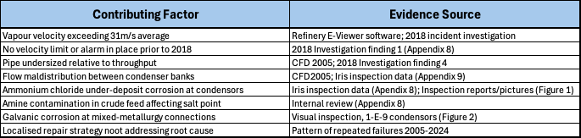
Table 2 - Contributing Factors Summary

4.4 Engineering Response

The 5 Whys analysis confirms that the only intervention capable of addressing the root cause was a fundamental change to the pipe geometry — specifically, increasing the overhead line diameter to reduce vapour velocity below the industry-recommended limit of 20 m/s (AMPP, 2023). This conclusion was consistent with the recommendations of both the 2005 CFD study and the 2018 incident investigation and forms the basis of the engineering response described.
Secondary engineering and chemical measures — including improved wash water distribution, updated neutraliser and filming inhibitor programmes, and selective metallurgy upgrades at critical locations — were implemented in parallel to address the contributing factors identified above, but only following velocity reduction to a level at which these measures could be effective.

5.0 Mitigation Strategy and Engineering Response

The root cause analysis confirmed that the primary intervention required was a fundamental change to the overhead pipe geometry. The engineering response therefore focused on three areas: overhead line diameter increases to reduce vapour velocity, targeted metallurgy upgrades at the highest-risk locations, and optimisation of the wash water and chemical treatment systems.
A simplified schematic of the crude distillation overhead system is shown in Figure 1, illustrating the major components involved in overhead vapour handling and corrosion control.

5.1 Root Cause Identification – Velocity and Maldistribution

Inspection reports and corrosion monitoring data collected prior to the overhead modification project identified significant metal loss within several sections of the CDU overhead system. The most severe corrosion was observed at pipe elbows and locations downstream of wash water injection points where high vapour velocities and two-phase flow conditions were present.
Analysis of historical operating data indicated that vapour velocities within the original 30-inch overhead line frequently exceeded 35–40 m/s. These values significantly exceeded recommended industry limits for carbon steel piping operating in corrosive refinery environments. Industry guidance published by corrosion organisations such as NACE International generally recommends vapour velocities below approximately 20 m/s in overhead systems where acidic condensates may be present.
High vapour velocity accelerates corrosion by increasing wall shear stress and liquid droplet impingement. These effects remove protective corrosion films and expose fresh metal to acidic condensate. This mechanism is consistent with the observed damage at elbows, reducers and downstream of wash water injection points.
Figure 5 – Mechanism of erosion–corrosion caused by high-velocity droplet impingement and removal of protective corrosion films from carbon steel pipe surfaces.
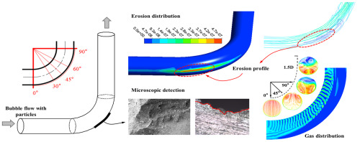
Figure 5 - Mechanism of Erosion/Corrosion via High Velocity Droplet Impingement (P., 2022)

The mechanism shown in Figure 5 is consistent with the 2024 lower elbow leak shown in Appendices 3 and 4, and with the 2021 inspection grid markup showing localised thinning in the same region. In addition to velocity effects, flow maldistribution within the overhead system was also identified as a contributing factor. Uneven distribution of vapour and liquid phases between parallel condenser banks created localised regions of elevated velocity and poor phase separation, further increasing corrosion risk.
Based on these findings, excessive vapour velocity was identified as the primary driver of corrosion within the CDU overhead system.

5.2 Overhead Line Redesign – Velocity Mitigation

To address the excessive vapour velocity present within the overhead system, the original 30-inch overhead vapour line was replaced with a 48” diameter pipe. Increasing the pipe diameter significantly increases the cross-sectional flow area available for vapour transport and therefore reduces fluid velocity for a given volumetric flow rate.
The cross-sectional area of a pipe is determined using the relationship:

$$A=\frac{{πD}^{2}}{4}$$
Where:
A = pipe cross-sectional area (m²)
D = pipe diameter (m)
For the original 30” overhead line, the internal pipe diameter of approximately 0.749 m produced a cross-sectional area of approximately:
A = 0.441 m²
For the redesigned 48-inch overhead line, the internal diameter of approximately 1.20 m resulted in a cross-sectional area of approximately:
A = 1.131 m²
This represents an increase in cross-sectional flow area of approximately 156%.
A visual comparison of the cross-sectional areas of the two pipe diameters is shown in Figure 6.
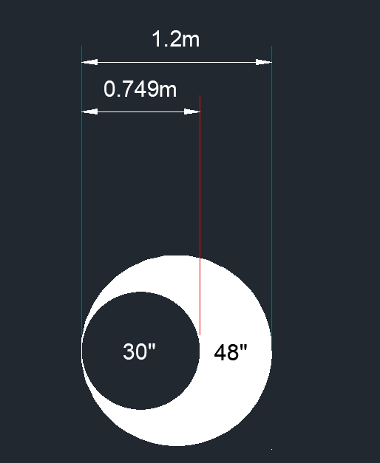
Figure 6 – Cross-Sectional Area Comparison 30” vs 48” Holmes (2025)

5.3 Metallurgy Strategy

The original overhead system utilised Alloy 400 (Monel). However, corrosion monitoring data indicated that degradation was primarily driven by process conditions rather than material incompatibility.
The IRIS inspection results for the 1-E-9 fin-fan banks, conducted in 2018 (Appendix 9), demonstrated the scale of tube degradation across the condenser fleet prior to the upgrade programme. For example, 1-E-9G recorded 29 tubes plugged (19% of total), with a further 27 tubes classified in the 20–29% wall loss category, whilst 1-E-9V showed 60 tubes plugged (39.2% of a 153-tube bank) by August 2018. These results illustrated that the mixed CuNi 70/30 and carbon steel tube specification was unable to withstand the corrosive overhead environment at the velocities and chemical conditions present. The selective upgrade to Hastelloy C-276 for the top inlet rows — which experience the highest impingement from overhead vapour — was therefore targeted at the locations of greatest vulnerability, representing a cost-effective and metallurgically sound approach to managing the residual corrosion risk following velocity reduction.
The redesigned system adopted ASTM A106 Grade B carbon steel for the replacement overhead piping, representing a cost-optimised solution appropriate for the improved hydrodynamic conditions following velocity reduction. Selective alloy upgrades were retained at the two most critical locations: an explosion-bonded clad top head at the column outlet, providing corrosion resistance where condensation first occurs and chemical concentrations are highest; and Hastelloy C-276 reinforcement at key nozzles where impingement risk remains elevated. This targeted metallurgy strategy reflects the principle that alloy selection should be matched to residual corrosion risk following primary engineering controls, rather than applied uniformly across all components regardless of local conditions.

5.4 Water Wash Optimisation

Improvements to the overhead wash system were implemented in parallel with the pipe diameter modification, focusing on three principal areas. New injection quills were installed to provide improved droplet distribution across the pipe cross-section, replacing the original quill configuration which had been identified in the 2018 investigation as providing inadequate primary wash water coverage (Appendix 8). Improved control and measurement instrumentation was installed to allow continuous monitoring of wash water flow rates and to enable adjustment of injection volume in response to changes in crude composition or throughput. Taken together, these improvements serve to reduce ammonium chloride salt deposition within the condensers, lower the acid concentration within the condensate phase, and minimise under-deposit corrosion at condenser tube surfaces.
Critically, these wash water improvements were only fully effective following the velocity reduction achieved through the pipe diameter modification. At pre-project velocities of 31–40 m/s, injected wash water droplets were subjected to the same high-momentum flow conditions responsible for stripping corrosion films from pipe walls, limiting their ability to wet and flush pipe and condenser surfaces effectively. The interdependence of hydrodynamic conditions and wash water effectiveness is consistent with the guidance published by AMPP (2023), which emphasises that wash water optimisation should be considered a complementary measure to velocity management rather than an independent corrosion control strategy.

5.5 Summary of Engineering Response

The mitigation strategy addressed both hydrodynamic and chemical drivers of corrosion, with velocity reduction forming the primary control mechanism. The effectiveness of this approach is evaluated through operational data in the following section.

6.0 Results and Data Analysis

6.1 Data Sources and Methodology

Operational data was obtained from the refinery E-Viewer (XHQ) historian system, providing continuous measurements of overhead vapour velocity and crude throughput. Corrosion rate data was sourced from permanently installed Emerson ultrasonic monitoring sensors located within the CDU overhead system at three positions: the mid-section (GN90/H46R), top section (GNJ2/H48N), and bottom section (GN91/H45S) of the overhead line. New sensor identifiers were assigned following installation of the 48” replacement pipe, reflecting new monitoring locations on the new pipework.
Data was analysed across four distinct periods:
- 2022: Pre-project, high-velocity operation (30” line, first full monitoring year)
- 2023: Pre-project, high-velocity operation (30” line, deteriorating condition)
- 2024: (Jan-Sept): Pre-project, high-velocity operation, project execution from October 2024
- 2025: Post-project, reduced velocity operation (48” line, full year of post-modification monitoring)
Statistical analysis included mean values and analysed corrosion rates calculated from the change in UT wall thickness measurement over each monitoring period.
The overhead vapour velocity tag used throughout this analysis was developed by the refinery process engineering team and implemented within the E-Viewer historian system. Rather than measuring velocity directly, the calculation derives actual volumetric flowrate from the sum of individual product stream flowmeters — covering off-gas, propane, butane, naphtha, and stripping steam — converted from standard to actual conditions using the ideal gas law, incorporating live overhead temperature and pressure measurements. The resulting actual volumetric flowrate is then divided by the pipe cross-sectional area to yield velocity in m/s. This approach accounts for the multi-component, multi-phase nature of the overhead stream and provides a more accurate representation of actual vapour velocity than any single-point flow measurement could achieve. The methodology was confirmed in correspondence with the site process engineer responsible for developing the calculation shown in Appendix 10, (Thomas, G., 2026). The RAW data and calculation used for the vapour velocity can be seen in Appendix 15.
The data used in this study is suitable for engineering evaluation because it is drawn from permanent plant monitoring systems, inspection records and process historian data used for operational decision-making. However, several uncertainties must be recognised. The calculated vapour velocity represents a bulk average value and does not capture local velocity peaks, turbulence or droplet impingement intensity at elbows, reducers and branch connections. Similarly, UT monitoring provides point-based wall thickness measurements and may not capture the most severe localised attack if corrosion occurs between sensor locations. Corrosion rates calculated from thickness change are also sensitive to measurement uncertainty, sensor positioning and short-term process variation.
Despite these limitations, confidence in the findings is increased because three independent forms of evidence show the same trend: bulk velocity reduced after the pipe diameter increase, crude throughput did not fall, and corrosion rates decreased substantially at all monitored locations. The consistency between these datasets supports the conclusion that the observed corrosion improvement was caused primarily by velocity reduction.

6.2 Crude Throughput

Figure 7 presents the crude throughput recorded through the CDU over the period January 2023 to December 2025. The data demonstrates that crude throughput remained broadly consistent throughout the pre-project period, averaging approximately 1,150–1,250 m³/hr, with an upward trend visible across the full dataset. The project execution window (October–November 2024) is clearly identifiable as the period of zero throughput corresponding to the planned shutdown during which the 48” overhead line was installed.
Importantly, post-project throughput has not decreased — the trend line indicates sustained operation at approximately 1,300–1,400 m³/hr through 2025, slightly above pre-project levels. This is significant because it confirms that the velocity reduction achieved following the pipe modification was not the result of reduced production rates but was entirely attributable to the increase in pipe cross-sectional area. Any reduction in velocity observed post-project therefore represents a genuine engineering improvement rather than an operational change and strengthens the validity of the comparison between pre- and post-project corrosion performance.

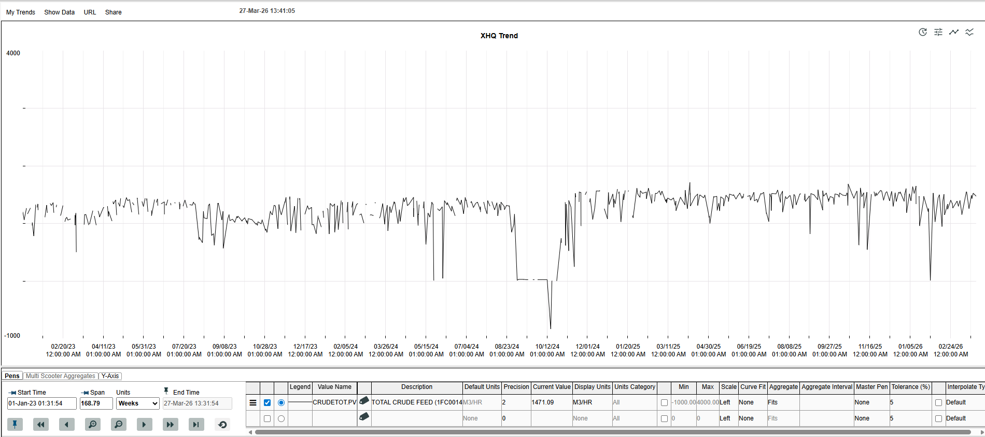

Figure 7 – Crude Throughput Before and After OVM Project, 2023-2025

6.3 Velocity Reduction

Figure 8 presents the average overhead vapour velocity before and after the OVM project, and Figure 9 presents the pre- and post-project velocity against the NACE recommended guideline limit.

Figure 8 - Average Overhead Vapour Velocity Pre/Post Project

Figure 9 – Pre- and Post-Project Velocity Compared with NACE Guideline Limit

Prior to modification, the average vapour velocity within the 30” overhead line was 31.3 m/s, significantly exceeding the NACE-recommended maximum of approximately 20 m/s for carbon steel piping in corrosive condensate service (NACE, AMPP, 2023). Peak excursions regularly reached 35–40 m/s as evidenced by the pre-project E-Viewer historian data.
Following installation of the 48” line, the average vapour velocity reduced to 14.2 m/s, representing a reduction of 54.7%. Figure 9 confirms that the post-project operating condition sits comfortably within the NACE recommended limit, with a margin of approximately 5.6 m/s below the 19.8 m/s guideline value. This margin is operationally significant, as it provides headroom to accommodate future increases in crude throughput without breaching the velocity limit — a direct improvement on the pre-project condition where the system was consistently operating beyond safe limits with no margin available.
This reduction is consistent with the theoretical prediction derived from the continuity equation $V=\frac{Q}{A}$. With pipe cross-sectional area increasing from 0.441 m² (30” line) to 1.131 m² (48” line) — an increase of 156% — and throughput remaining constant or slightly higher, the expected velocity at equivalent throughput would be:

$$V_{48}=V_{30}×\left(\frac{A_{30}}{A_{48}}\right)=31.3×\left(\frac{0.441}{1.131}\right)=12.2 m/s$$

The measured post-project average of 14.2 m/s is slightly above this theoretical prediction, which is consistent with the modest increase in crude throughput observed post-project. This close correlation between the measured and theoretical velocity confirms that the pipe diameter change is the primary driver of the velocity reduction and validates the engineering basis of the project.

6.4 Corrosion Rate Analysis

Table 3 presents the annualised corrosion rates derived from the permanent UT monitoring data across all three sensor locations for each monitoring period.
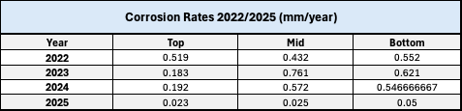
Table 3 - Corrosion Rates Pre and Post OVM Project

The pre-project data reveals a sustained and severe pattern of corrosion across all three sensor locations. The mid-section sensor recorded rates ranging from 0.43–0.76 mm/yr across 2022–2024, the top section 0.18–0.52 mm/yr, and the bottom section 0.55–0.62 mm/yr. These rates are consistent with the classification of multiple sensor locations as red status (severe corrosion) in the Emerson quarterly monitoring reports for 2022 and 2023 (Appendix 6, Appendix 7), and with the active leak at the lower 30” elbow recorded in 2024.
The escalation of the mid-section rate from 0.432 mm/yr in 2022 to 0.761 mm/yr in 2023 is particularly notable. This deteriorating trend, despite an active chemical treatment programme being in operation throughout, is consistent with the 5 Whys analysis conclusion that the dominant damage mechanism — mechanical removal of protective films by high-velocity droplet impingement — could not be controlled by chemical treatment alone at the velocity levels present. The bottom section sensor going out of service for part of 2023 further reflects the severity of the corrosion environment at that location.
Following commissioning of the 48” overhead line and the associated secondary mitigation measures — including improved wash water distribution and an updated filming inhibitor and neutraliser programme — the 2025 corrosion rates at all three monitoring locations fell dramatically. The mid-section rate reduced from a pre-project average of approximately 0.59 mm/yr to 0.025 mm/yr, a reduction of approximately 96%. The top section reduced from approximately 0.30 mm/yr to 0.023 mm/yr, a reduction of approximately 92%. The bottom section reduced from approximately 0.57 mm/yr to 0.050 mm/yr, a reduction of approximately 91%.
These reductions are of a magnitude that cannot be attributed to chemical treatment optimisation alone. AMPP (2023) states that well-applied filming inhibitor programmes can reduce background corrosion rates by up to 90% under appropriate hydrodynamic conditions — conditions which explicitly require velocity to be within acceptable limits. The pre-project corrosion rates, sustained across multiple years and multiple sensor locations despite an active chemical treatment programme throughout, confirm that no chemical intervention alone could have been effective at velocities of 31–40 m/s. The step-change reduction in corrosion rates observed following velocity reduction to 14.2 m/s therefore provides direct, quantitative confirmation that excessive vapour velocity was the primary driver of corrosion, consistent with the root cause conclusion of Section 4.
The practical significance of these rates is clear when considered against the retirement thickness of the new 48" pipework. With a nominal installed wall thickness of approximately 22 mm and a corrosion allowance of 3 mm, the worst-case post-project rate of 0.050 mm/yr projects a remaining service life exceeding 60 years — a fundamental improvement on the pre-project situation, where pipe walls approached retirement thickness within two to three years of installation. This directly reduces the frequency of unplanned shutdowns, emergency repairs and capital expenditure that characterised the pre-project period. NACE TR34109 (2023) identifies an acceptable background corrosion rate for carbon steel in well-managed CDU overhead service as typically below 0.1 mm/yr. The post-project rates of 0.023–0.050 mm/yr recorded across all three sensor locations fall comfortably within this benchmark, confirming that the system is now operating within the corrosion performance envelope expected for a well-controlled CDU overhead environment — a condition that could not be achieved at any point during the pre-project monitoring period.

6.5 Discussion: Relationship Between Velocity, Throughput and Corrosion Rate

The combination of throughput stability, velocity reduction and corrosion rate improvement provides a coherent and internally consistent dataset that supports both the root cause conclusion and the effectiveness of the engineering response. The throughput data confirms the velocity reduction was achieved through engineering rather than operational change. The velocity data confirms the pipe modification brought the system within NACE recommended limits with meaningful operational margin. The corrosion rate data confirms the consequence of that velocity reduction — a greater than 90% reduction in metal loss rates at all monitored locations, sustained consistently across three independent sensor positions.
Taken together, these three datasets provide strong quantitative evidence that increasing the overhead line diameter from 30” to 48” was an effective and durable engineering solution to the persistent corrosion problem within the CDU overhead system at Valero Pembroke refinery.
The improvement in corrosion performance is unlikely to be explained by reduced crude throughput, because throughput remained stable or increased following the modification. It is also unlikely to be explained by metallurgy alone, because the principal measured improvement occurred through reduction of the hydrodynamic driving force acting on the overhead line. Chemical treatment changes may have contributed to the final corrosion rate achieved, but the pre-project evidence shows that chemical treatment was unable to control corrosion while velocity remained above recommended limits.
The most convincing interpretation is therefore that the 48” line changed the dominant corrosion regime. Before the project, the system operated in a high-velocity erosion-corrosion regime in which protective films were repeatedly removed by shear stress and droplet impingement. After the project, velocity was reduced to a level at which chemical inhibition, wash water distribution and protective film formation could function effectively. This explains why the corrosion reduction was not marginal, but step-change in nature.

6.6 Fin-Fan Condenser Bank Reliability

A secondary measure of the project’s effectiveness is the improvement in fin-fan condenser bank reliability. Prior to the overhead velocity mitigation project, the 1-E-9 condenser banks experienced a sustained and high-frequency pattern of tube failures driven by the corrosive overhead environment. The 1-E-9 repair plan shown in Appendix 13 (Planning, Valero, 2025) records the full history of bank changeouts, IRIS inspections, tube plugging events and Hastelloy C-276 metallurgy upgrades across all 24 banks (A through X) from 1992 to 2025.
Between October 2022 and September 2024 — a period of exactly 24 months — thirteen banks required Hastelloy retube operations, equivalent to an annualised failure rate of 6.5 bank changeouts per year. At the quoted retube costs (Appendix 14), this represents an annualised expenditure of between £167,000 and £267,000 depending on bank size mix, excluding the operational costs of isolating banks from service during repair and the process performance penalty of reduced condenser capacity. The cost of each retube varies by bank size: small banks (153 tubes) are quoted at £25,656, medium banks (207 tubes) at £34,271, and large banks (263 tubes) at £41,105 (Miller, 2022).
Critically, since the completion of the overhead velocity modification project in October 2024, no new fin-fan bank failures have been recorded in the repair plan tracker (Appendix 13). This represents a clear break from a pattern of near-continuous bank interventions that had persisted for over a decade and is consistent with the corrosion rate reductions of 91–96% observed in the overhead line monitoring data. Although one year of post-project data is insufficient for definitive long-term reliability conclusions, the absence of new failures during a period when six or seven failures would previously have been expected is a strong early indicator of improved condenser reliability and reduced maintenance expenditure.

7.0 Conclusion

This study investigated persistent and escalating corrosion within the CDU overhead system at Valero Pembroke refinery over a period spanning 2005 to 2024, evaluated the engineering mitigation strategy implemented — specifically the replacement of the original 30” overhead vapour line with a 48” diameter pipe — and assessed its effectiveness using operational and corrosion monitoring data collected before and after the modification.

Root Cause

The structured 5 Whys root cause analysis, applied exclusively to objective inspection records, ultrasonic thickness survey data, corrosion monitoring results and process operating data, identified a clear and unambiguous primary root cause: excessive vapour velocity within the 30” overhead line, resulting from the pipe being undersized relative to actual process throughput. Pre-project average velocity of 31.3 m/s — significantly exceeding the NACE-recommended maximum of approximately 20 m/s for carbon steel piping in corrosive condensate service — generated mechanical forces sufficient to continuously strip protective corrosion films from pipe wall surfaces through a combination of wall shear stress and high-velocity liquid droplet impingement. At these velocities, the dominant damage mechanism was hydrodynamic rather than chemical in nature, meaning that chemical treatment programmes — however well-designed — faced a fundamental physical limitation that prevented them from providing adequate protection.
Contributing factors identified through the analysis included flow maldistribution between parallel condenser banks, ammonium chloride under-deposit corrosion at the condensers, amine contamination in the crude feed affecting overhead pH control, localised galvanic corrosion at mixed-metallurgy connections, and a historical pattern of reactive localised repair rather than root-cause-driven engineering intervention. Critically, the analysis demonstrated that these contributing factors could not be effectively addressed by chemical and maintenance measures alone while the dominant hydrodynamic driving force remained uncorrected.

Effectiveness of the Engineering Response

The operational and corrosion monitoring data collected following installation of the 48” overhead line provides strong quantitative evidence that the engineering response was effective. Average vapour velocity reduced from 31.3 m/s to 14.2 m/s — a reduction of 54.7% — bringing the system comfortably within the NACE recommended limit and providing a meaningful operational margin of approximately 5.6 m/s below the guideline threshold. The crude throughput data confirmed that this velocity reduction was achieved entirely through the pipe diameter increase, with post-project throughput remaining stable or slightly higher than pre-project levels, ruling out reduced production as a confounding factor.
The corrosion rate data provides the most compelling evidence of the project’s success. Following velocity reduction, annualised corrosion rates at all three permanently monitored locations fell by between 91% and 96%, from pre-project averages of 0.30–0.59 mm/yr to post-project rates of 0.023–0.050 mm/yr. These post-project rates represent manageable background corrosion consistent with a well-controlled CDU overhead environment, and project service lives for the new pipework many times longer than was achievable under pre-project conditions. The magnitude of reduction — exceeding 90% at every monitored location — is consistent with the elimination of the dominant hydrodynamic damage mechanism rather than incremental improvement through chemical treatment, further validating the root cause conclusion.
The secondary measures — improved wash water distribution, updated chemical treatment, and selective metallurgy upgrades — addressed the contributing factors identified in the root cause analysis and are described in Section 5.

Economic and Reliability Impact

The economic dimension of the project further underscores its value. The sustained pattern of fin-fan bank failures prior to the project generated significant and recurring maintenance expenditure — with individual Hastelloy retube costs ranging from £25,656 for small banks to £41,105 for large banks, and thirteen such operations recorded between 2022 and 2024 alone (Planning, 2023); (Miller, 2022). The velocity reduction achieved through the pipe modification, by reducing the corrosion driving force across the entire overhead system, has the potential to substantially reduce this expenditure over the coming years. The project also eliminates the ongoing risk of unplanned shutdowns associated with overhead line leaks — which, beyond their direct repair costs, carry consequences for production continuity, process safety and environmental compliance.

Contribution to Knowledge

This study contributes to the limited published literature on the effectiveness of large-scale pipe diameter modification as a primary corrosion control intervention in refinery CDU overhead systems. Industry guidance provides a well-established framework of chemical and operational mitigation strategies, but relatively few published case studies quantify the corrosion-rate impact of fundamental pipe geometry changes using real plant monitoring data over an extended pre- and post-project period.
The dataset presented in this study spans three years of pre-project deterioration and one full year of post-project monitoring across three independent sensor locations, supported by continuous throughput and velocity historian data. This provides a well-evidenced case study demonstrating that velocity reduction through pipe diameter increase can achieve corrosion-rate reductions that would not be attainable through chemical treatment alone where the dominant damage mechanism is hydrodynamic.

Limitations

Several limitations of this study should be acknowledged. First, the post-project monitoring period covers one full year (2025) following commissioning of the 48” line. Whilst the corrosion rate reductions observed are dramatic and consistent, a longer monitoring period would provide greater confidence that the improvement is sustained under varying crude slates, throughput levels and seasonal operating conditions. Second, the secondary mitigation measures — improved wash water distribution and updated chemical treatment — were implemented concurrently with the pipe replacement, meaning it is not possible to precisely quantify the individual contribution of each intervention to the overall corrosion rate reduction. The magnitude of the reduction strongly implies that velocity reduction was the dominant factor, consistent with the theoretical and analytical evidence, but complete isolation of variables was not achievable in an operational industrial environment. Third, the corrosion monitoring data is limited to three sensor locations on the main overhead line; the branch lines supplying the condenser banks (PJ116 and PJ118) are not represented in the post-project dataset, and their post-modification corrosion performance warrants continued monitoring to confirm equivalent improvement. Fourth, the velocity calculation used throughout this study is based on the ideal gas law applied to metered flowrates, which is an appropriate engineering approximation but does not capture the complexity of two-phase flow behaviour or local velocity variations at elbows and tee-sections, which NACE TR34109 (2023) identifies as significantly more aggressive than bulk average velocity alone would suggest.
A further limitation is that the post-project monitoring period does not yet capture the full range of crude slates processed at Pembroke Refinery. Crude compositions vary in chloride content, sulphur loading and organic acid concentration, all of which influence overhead corrosion rates independently of velocity. A longer monitoring period encompassing a wider variety of crude inputs would provide greater confidence that the post-project corrosion performance improvements are robust across all operating conditions.

Author’s Engineering Contribution

The author’s contribution was the integration of historical inspection evidence, process historian data, corrosion monitoring results and engineering design information into a single root cause evaluation of the CDU overhead corrosion problem. The study demonstrates that the corrosion issue was not simply a chemical inhibition failure, but a hydrodynamic design limitation requiring a geometry-based engineering solution. This provides practical value by showing how corrosion monitoring data can justify capital modification rather than repeated reactive repair.

Recommendations for Further Work

Based on the findings and limitations of this study, the following areas are recommended for further investigation:
Continued corrosion rate monitoring at all sensor locations through 2026 and beyond should be maintained to confirm the sustained effectiveness of the velocity reduction across a wider range of operating conditions and crude slates. Attention should be given to any periods of elevated throughput approaching the operational headroom below the NACE velocity limit.
The branch lines PJ116 and PJ118 supplying the 1-E-9 condenser banks, which exhibited red-status corrosion rates prior to the project, should have their post-modification corrosion performance formally assessed using permanent UT monitoring or periodic manual surveys to confirm that the velocity reduction in the main line has translated to equivalent improvement in the branch piping.
A computational fluid dynamics study of the new 48” pipe geometry — analogous to the 2005 Fluent Europe study (Kidger, 2005) — would provide valuable confirmation of improved droplet distribution within the redesigned system and identify any residual locations of elevated wall shear stress or droplet impingement concentration. The 2005 study identified that flow swirl within the pipe geometry was concentrating droplet impingement at specific locations; verifying that the new geometry does not reproduce this behaviour would further strengthen confidence in the long-term corrosion performance.
Wall shear stress modelling, as recommended by NACE TR34109 (2023), should be considered as a complementary assessment tool alongside bulk velocity monitoring. As noted in the literature review, wall shear stress provides a more mechanistically accurate representation of erosion-corrosion driving force than bulk average velocity, particularly in two-phase flow at elbows and geometry changes. Developing a wall shear stress monitoring approach for the new 48” system would represent a meaningful advancement in the site’s corrosion management capability.
A formal review should be undertaken into the external coating applied to the new 48” overhead line. Thermal Spray Aluminium (TSA), specified in accordance with Shell DEP 30.48.40.31, provides effective external protection against corrosion under insulation; however, it is known to produce poor results with ultrasonic thickness measurement scanning, which is the primary in-service inspection technique used on the overhead system. Alternative coating systems should therefore be assessed for compatibility with inspection techniques and performance under the thermal cycling conditions of large-bore insulated overhead pipework. The outcome should be incorporated into the site corrosion management plan and Written Scheme of Examination.
Finally, the galvanic corrosion of carbon steel fasteners at the 1-E-9 condenser headers, identified as an active damage mechanism during this study, should be formally addressed through a fastener replacement programme using compatible materials, as the velocity reduction in the overhead line does not directly mitigate this localised mechanism.

Bibliography

34101, N. (2001). Refinery Injection Experience. Refinery Injection and Process Mixing Points, 9.

Ahmed, A. A. (2017). Corrosion in Crude Oil Distillation Unit Overhead. Elazig: Department of Chemical Engineering.

Ahmed. Ezz, L. J. (2025). Mechanisms, Challenges, and Control Strategies. Alberta: University of Alberta.

Aisha, H. (2021). Corrosion challenges in petroleum refinery operations: Sources, mechanisms, mitigation, and future outlook. Journal of Saudi Chemical Society, 110.

Akpanyung, K. V. (2019). An Overview of Ammonium Chloride (NH4. Journal of Physics:, 10.

al, K. A. (2019). An Overview of Ammonium Chloride Corrosion in the Refining Unit. Journal of Physics, 10.

Alexander, B. (2002). The use of amines to minimise corrosion in the overhead system of a crude distillation unit. Ann Arbor: ProQuest.

Allison, A. (2018). The continuity Equation and Flow.

America, S. S. (2025). SSINA. Retrieved February 3rd, 2026, from https://www.ssina.com/education/corrosion/pitting-and-crevice-corrosion/#:~:text=Chloride%20salts%2C%20pollutants%20and%20moisture,passive%20film%20and%20anodic%20dissolution.

AMPP. (2023). Distillation Tower Overhead System Corrosion. Crude Distillation Unit , 97.

ANSI/API 571. (2020). Damage Mechanisms Affecting Fixed Equipment in the Refining Industry. S & P Global.

Aqua, C. (2025). Chem Aqua. Retrieved from Chem Aqua: https://www.chemaqua.com/en-us/blog/2018/08/08/identifying-types-of-corrosion-in-water-systems/
Armoloy. (2024). Armoloy. Retrieved from https://armoloy.com/understanding-galvanic-corrosion-causes-prevention-and-solutions/#:~:text=What%20is%20Galvanic%20Corrosion:%20Key,and%20the%20surface%20area%20effect.

Babu, D. (2023). Emerson Connected Service Report. Pembroke: Emerson.

Brown. B, M. J. (2017). Under-Deposit Corrosion. Athens : Nalco.

Chambers, B. (2011). One Petro. Retrieved November 27th, 2025, from https://onepetro.org/NACECORR/proceedings-abstract/CORR11/CORR11/NACE-11360/119776

Cmpionline. (2025, February 4th). Cmpionline. Retrieved from The impact of flow accelerated corrosion on steel pipes: https://www.cmpionline.com/the-impact-of-flow-accelerated-corrosion-on-steel-pipes#:~:text=What%20Is%20Flow%2DAccelerated%20Corrosion,way%20and%20things%20go%20wrong.

Du, X. (2026, February 13th). Corrosion analysis and anti-corrosion measures of oil casing of sulphur content gas wells. Retrieved from Research Gate: https://www.researchgate.net/figure/The-occluded-cell-of-pitting-schematic-diagram_fig9_349634258

Energy, V. (2024). CDU Overhead Velocity Mitigation - Basis of Design 1-ENG-BOD-0014 rev 0.3. Pembroke: Valero Energy.

Fisher, J. (2022). Monel V Hastelloy. Pembroke.

Gunn, M. (2025). Galvanic Corrosion in Closed Loop Water Systems. Retrieved from R2J: https://www.r2j.com/blog/galvanic-corrosion/#:~:text=Any%20time%20two%20metals%20are,in%20otherwise%20well%2Ddesigned%20systems.

Gutzeit, J. (2016). Crude Unit Corrosion Guide: A Manual for Plant Operators, Process Engineers, Metallurgists, Maintenance Engineers, Inspectors, and Equipment Specialists. NACE.

Holmes, R. (2024). CDU overhead velocity modification project photographs (Internal document). Pembroke, Pembroke Refinery, Pembrokeshire: Valero Energy Ltd.

Holmes, R. (2026, February 24th). 1-E-9s fin-fan condenser galvanic corrosion observations (Internal document). Pembroke, Pembroke Refinery, Pembrokeshire: Valero Energy Ltd.

Inspection, V. (2024). 2024 Temp Repair. Pembroke, Wales.

Inspection, V. P. (2018). Cause Map. Pembroke: Valero .

J, F. (2023). Pembroke Crude Overhead Reliability Project. Pembroke.

Kidger, J. &. (2005). Liquid Droplet Modelling in the Crude Column Overhead Line at Pembroke Refinery. Sheffield: Fluent Europe.

Laboratories, M. a. (2024). MTL. Retrieved February 3rd, 2026, from https://mtlabs.co.nz/sea-salt-corrosion/#:~:text=This%20moisture%2Dchloride%2Dmetal%20combination,the%20pH%20and%20increase%20acidity.

Li, Z. Z. (2017). The Influence of Critical Flow Velocity on Corrosion. 1240.

Ltd, V. E. (2026, February 13th). CDU overhead system data (Internal Document). Pembroke, Pembroke Refinery, Pembrokeshire.

Marzbali, M. (2023). Liquid–Solid Impact Mechanism, Liquid Impingement Erosion, and Erosion-Resistant Surface Engineering: A Review. Dubai: University of Dubai.

Matthew, T. (2025). Journal of Bio-and Tribo-Corrosion.

Melchers, X. W. (2014). Laboratory study of under-deposit corrosion of steel pipelines in a seawater environment. Newcastle: University of Newcastle.

Miller, I. (2022, October 19th). Retube Air Cooled Heat Exchanger Quotation. Poole Process Equipment LTD. Poole, Dorset, United Kingdom: Poole Process Equipment LTD.
Mohammed, A. K. (2022). Corrosion Control Mechanisms and the Effect of pH on Corrosion in the Crude Oil Refining Process. Journal of Petroleum Research, 289.

NACE. (2010). 10358. Saint John: NACE.

NACE. (2014). 2422 Overview of Sulfidation (Sulfidic) Corrosion in Petroleum Refining Hydroprocessing Units. Calgary: NACE.

NACE. (2020). SP0472. Houston: NACE International.

NACE. (2021). 34101. Houston: NACE International.

NACE. (2023). 34109. Overhead System Corrosion, 97.

NACE. (2023, September 11th). AMPP. Retrieved November 27th, 2025, from file:///H:/Higher%20Education/B%20Eng%EF%80%A8/Year%203/Dissertation/NACE%20TR34109%20-%202023.pdf

P., C. (2022). Particle Erosion Under Flow in Horizontal and Vertical Elbows. Powder Technologies, 178.

Payne, B. J. (2019). Mitigating Overhead Corrosion. Retrieved from Digital refining: https://www.digitalrefining.com/article/1002257/mitigating-overhead-corrosion#:~:text=While%20the%20crude%20overhead%20system,to%20dilute%20and%20wash%20them.

Planning, V. P. (2023). CDU Planning. Pembroke.

Revie, R. W. (2008). Uhlig's Corrosion Handbook. Hoboken: John Wiley & Sons.

Robinson, P. R. (2019). Crude Storage, Blending, Desalting, Distillation and Treating. In M. A. Quddus (Ed.), Petroleum Science and Technology (p. 352). Boca Raton: CRC Press & Taylor & Francis Group.

Serrat, O. (2017). The Five Whys Technique. Asian Development Bank.

SP0472, N. (2020). Methods and Controls to Prevent In-Service Environmental Cracking of Carbon Steel Weldments in Corrosive Petroleum Refining Environments. Houston: NACE.

Speight, J. G. (2014). The Chemistry and Technology of Petroleum. Boca Raton: CRC Press.

Taylor, J. W. (2017). Corrosion Reduction in Power Distribution. New York: IEEE.

Technologies, E. (2025). Corrosion Inspection. Retrieved from Eddyfl Technologies: https://www.eddyfi.com/en/application/corrosion-inspection#:~:text=Galvanic%20corrosion%20occurs%20when%20two,hidden%20by%20corrosion%20produced%20compounds.

Appendix

Appendix 1 – 2012 Overhead Replacement
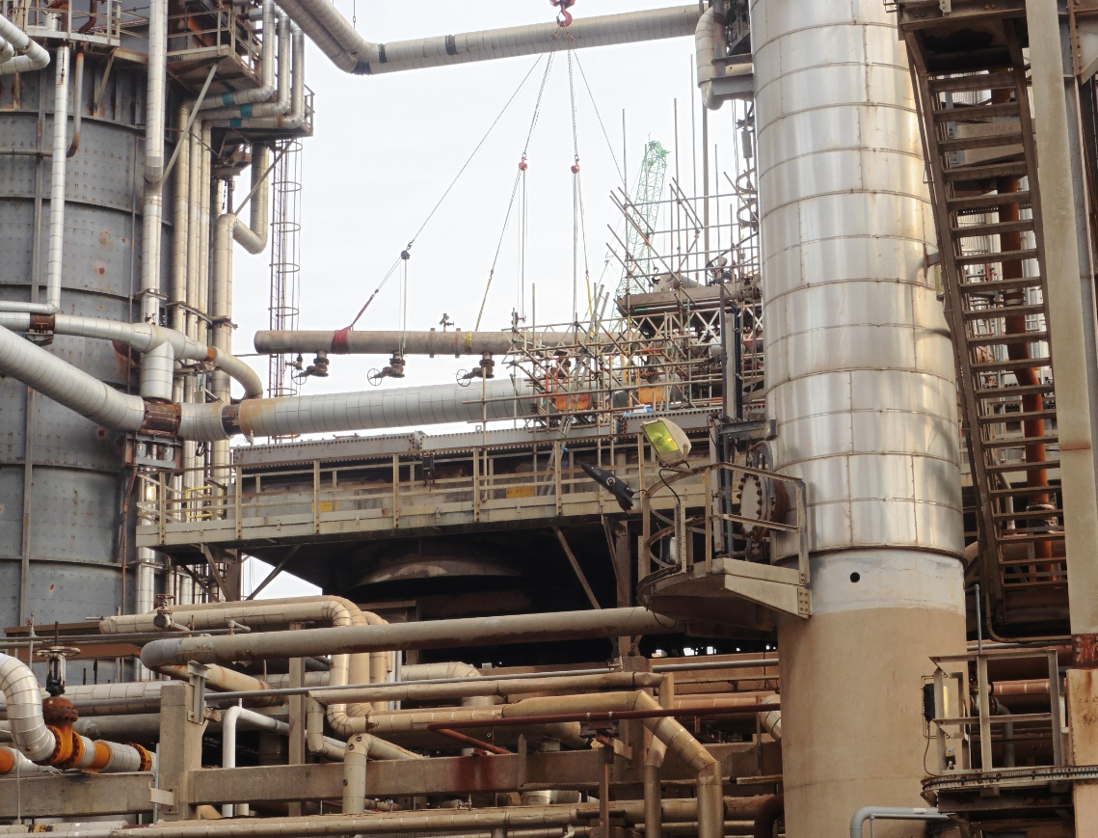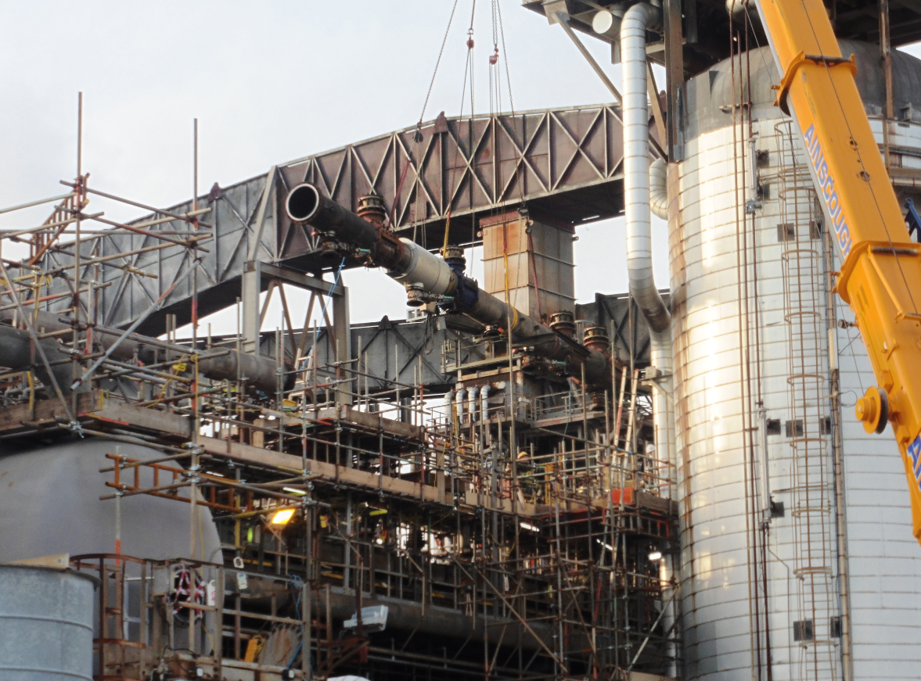

Appendix 2 – 2021 Top Elbow Replacement
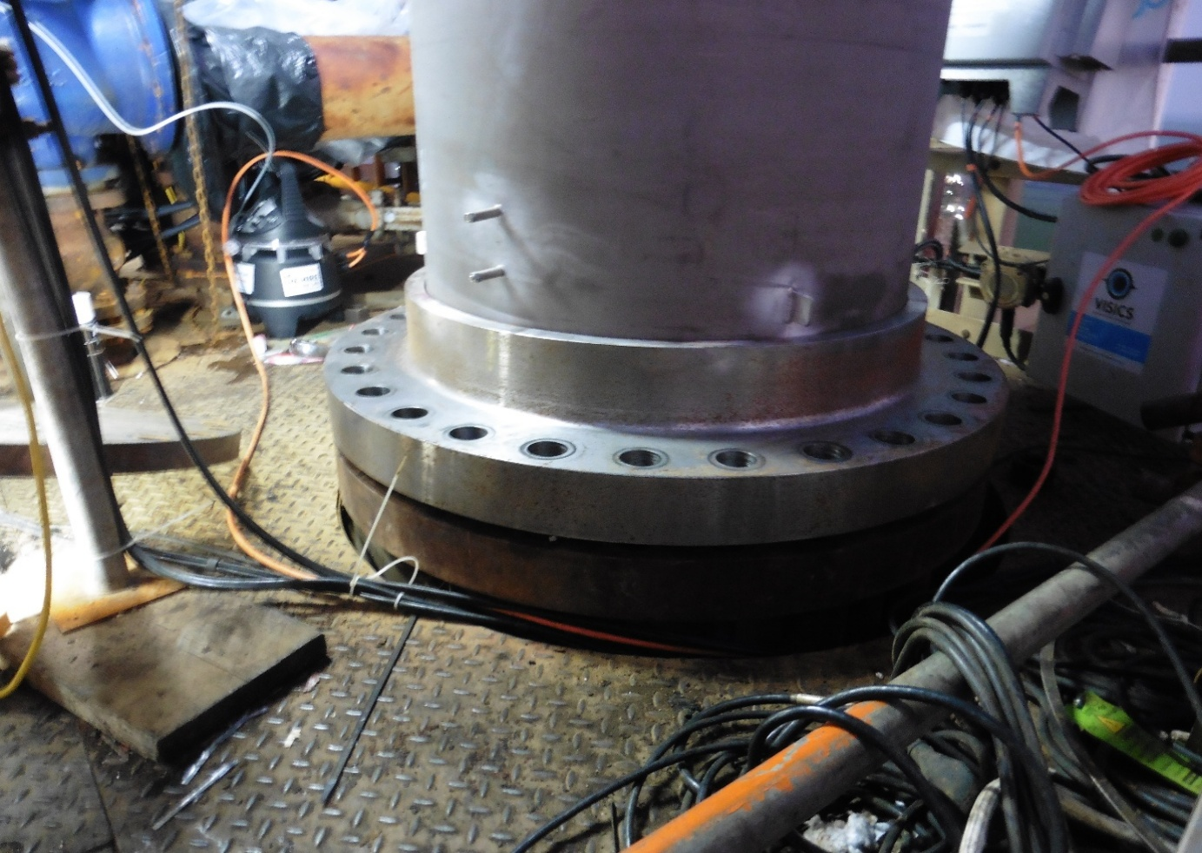
Appendix 3 – 2018 Wrap Due to Leak on Lower 30” Elbow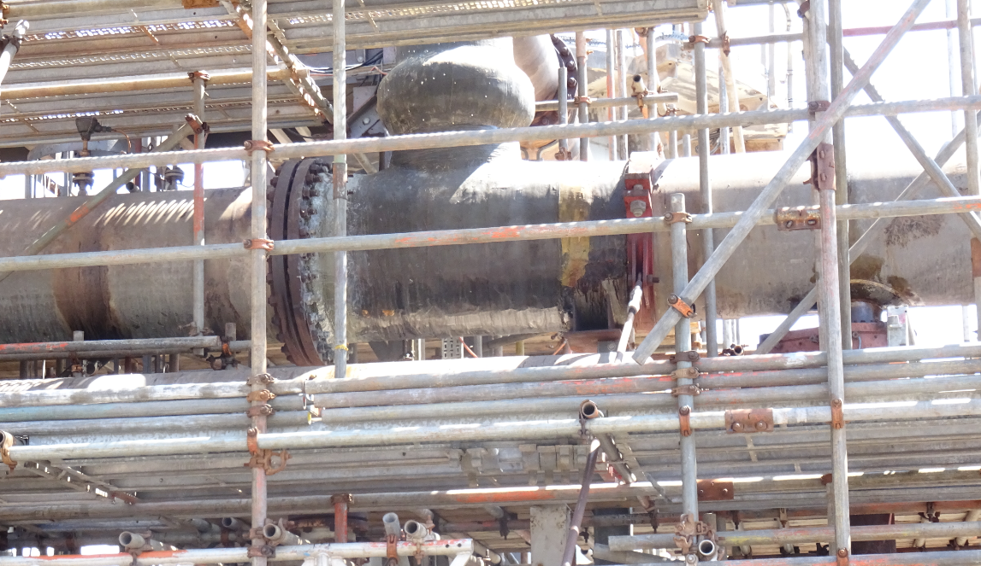

Appendix 4 - 2024 Inspection Report and Grid Markup in the Field
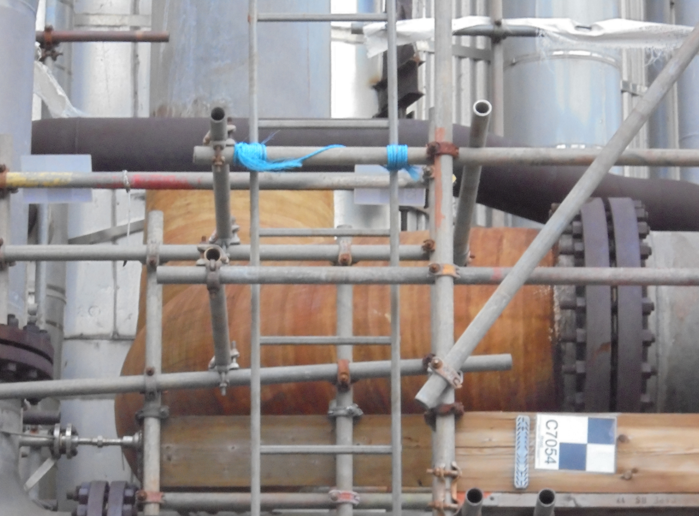
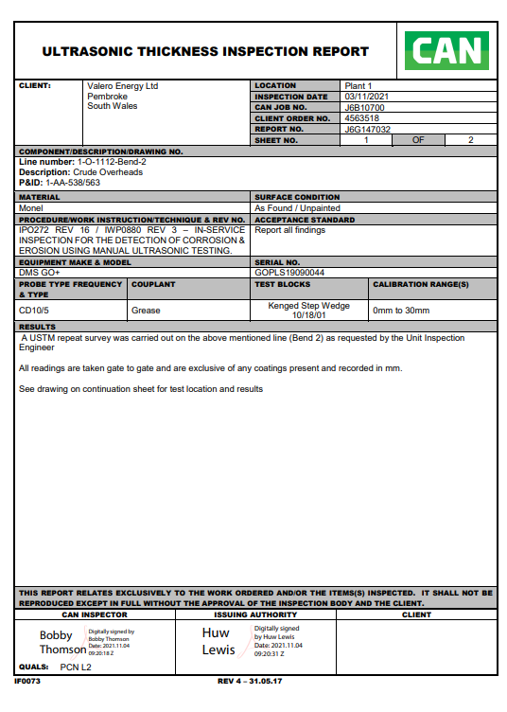

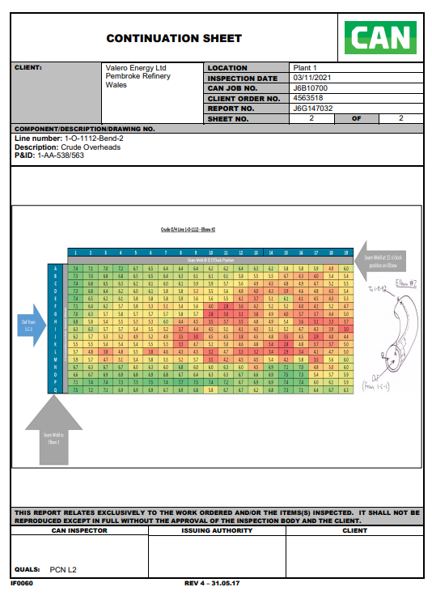
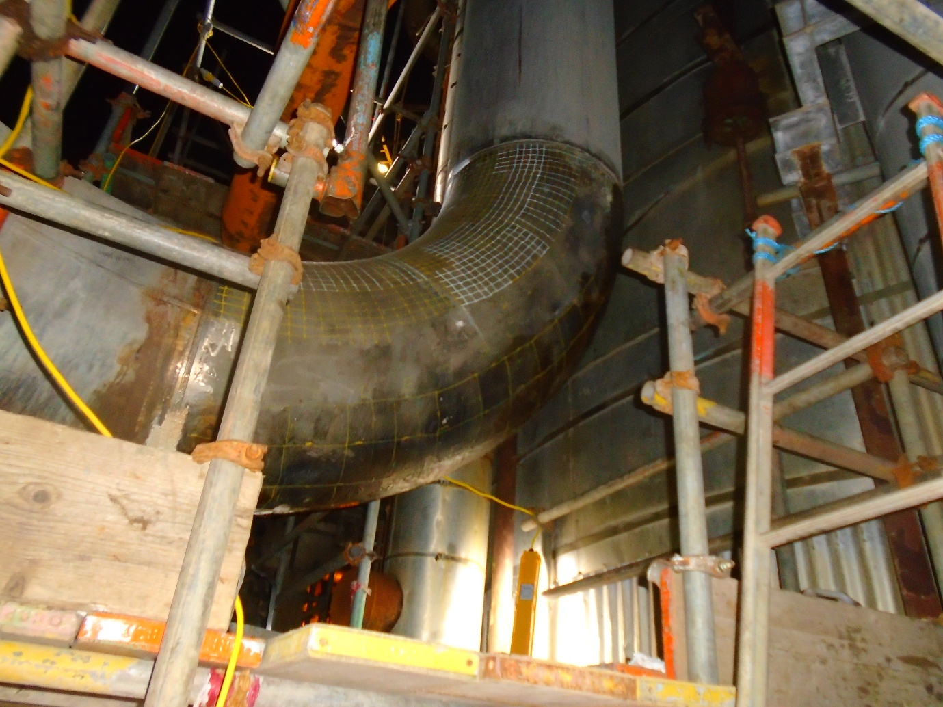

Appendix 5 – Corrosion Rates 2022/2025

The corrosion rate data presented below was derived from permanently installed Emerson ultrasonic monitoring sensors at three locations on the CDU overhead line: the mid-section (GN90/H46R), top section (GNJ2/H48N) and bottom section (GN91/H45S). New sensor identifiers (H46R, H48N, H45S) were assigned following installation of the 48” replacement pipe in October–November 2024, reflecting new monitoring positions on the new pipework. Annualised corrosion rates were calculated from the change in recorded wall thickness over each twelve-month monitoring period (nine months for 2024, which excludes the project execution window). The bottom section sensor was out of service between April and August 2023 due to the severity of corrosion at that location; the 2023 rate for that sensor is therefore based on the available nine-month dataset. All thickness values are in millimetres; all rates are in mm/year.

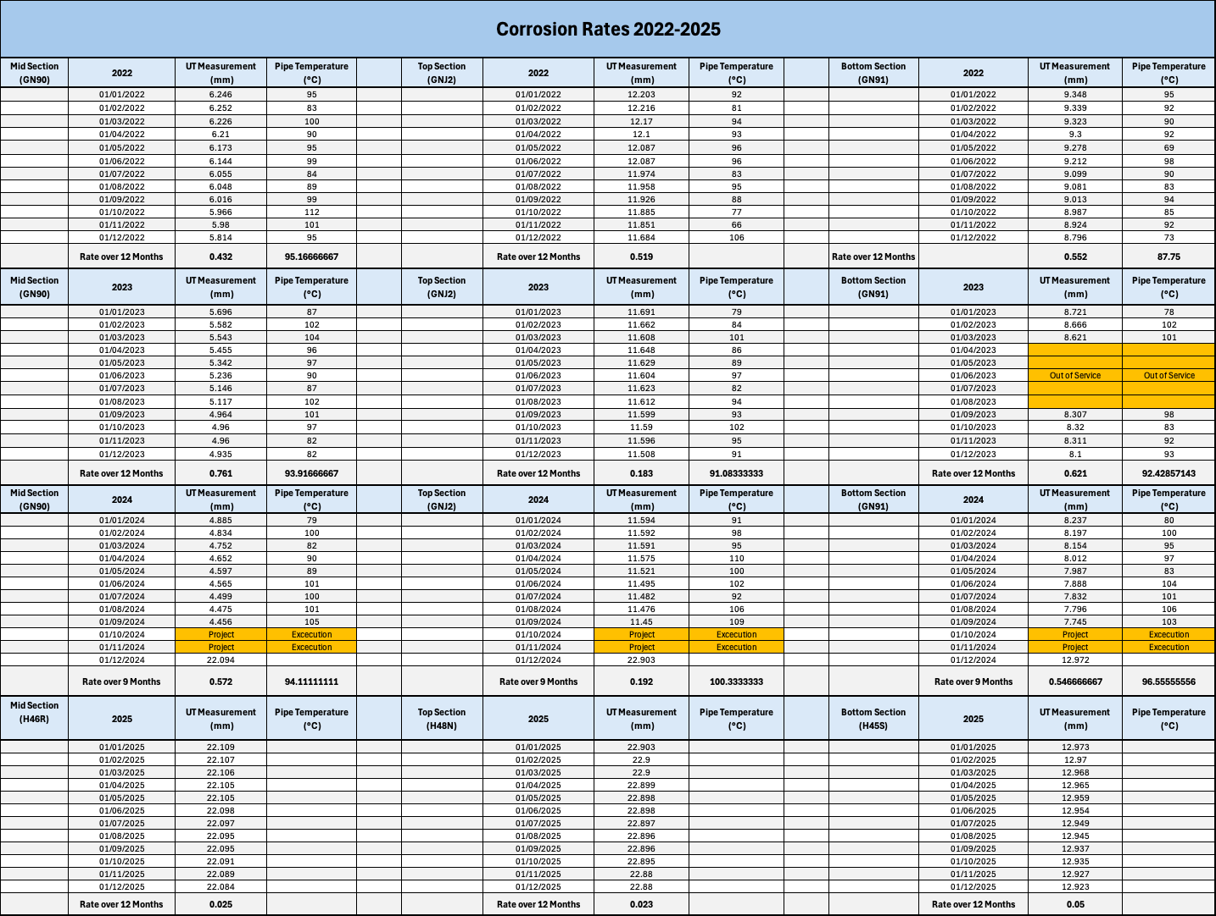

Appendix 6 – 2022 Overhead Line UT Reports (Emerson)
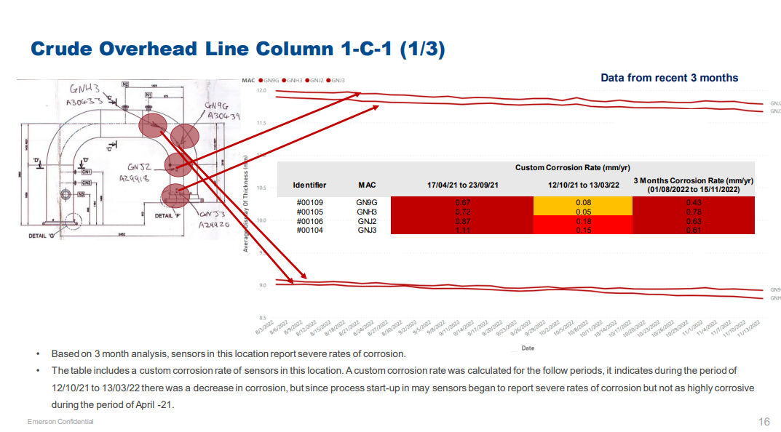
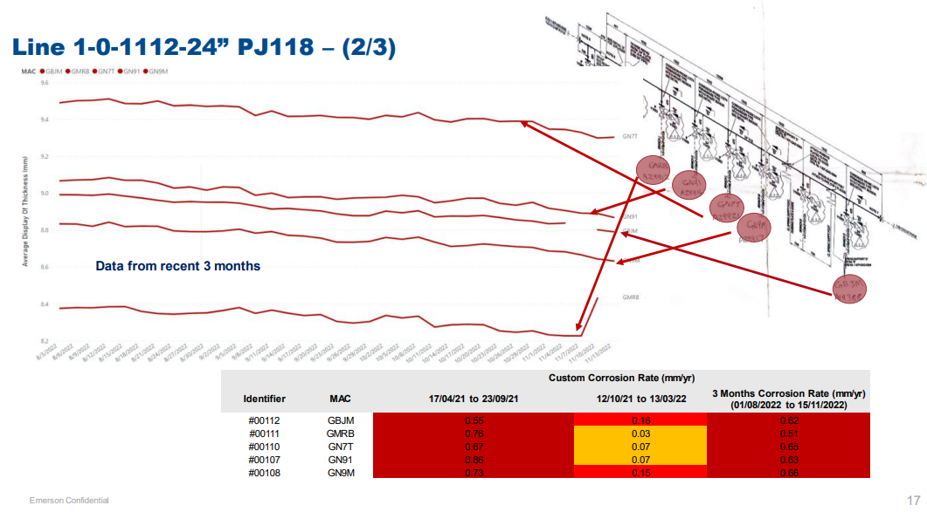
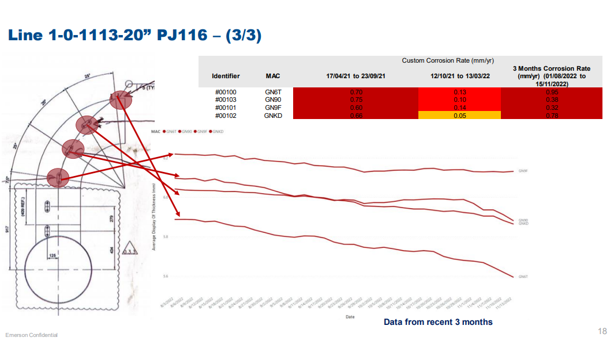

Appendix 7 – 2023 Overhead Line UT Reports (Emerson)
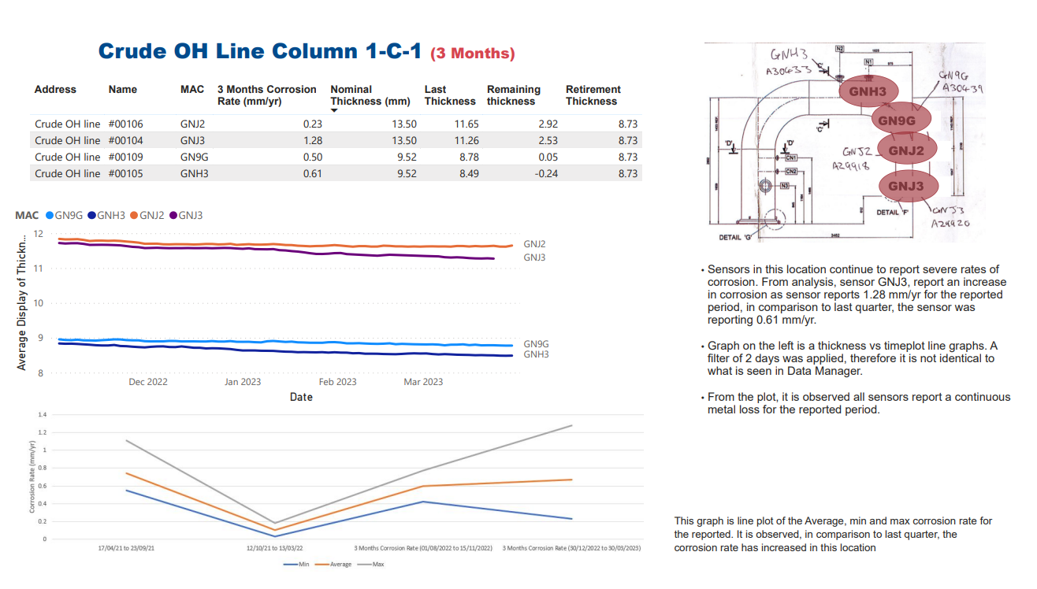
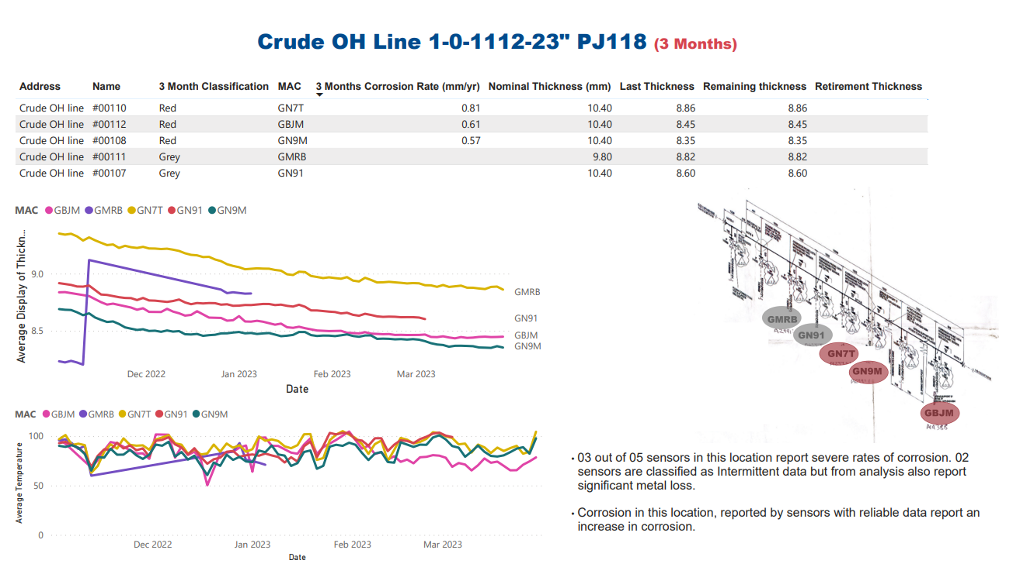
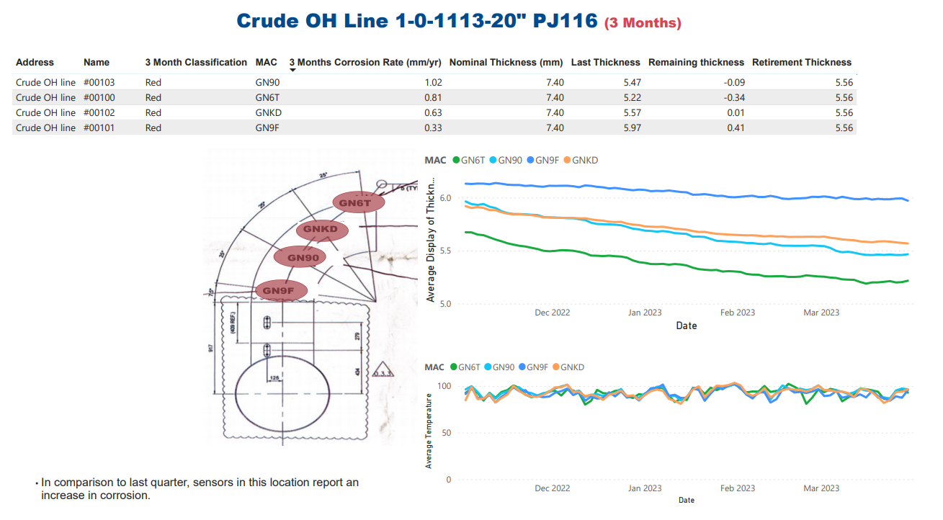

Appendix 8 – 2018 Leak Investigation (Inspection V. P., 2018)
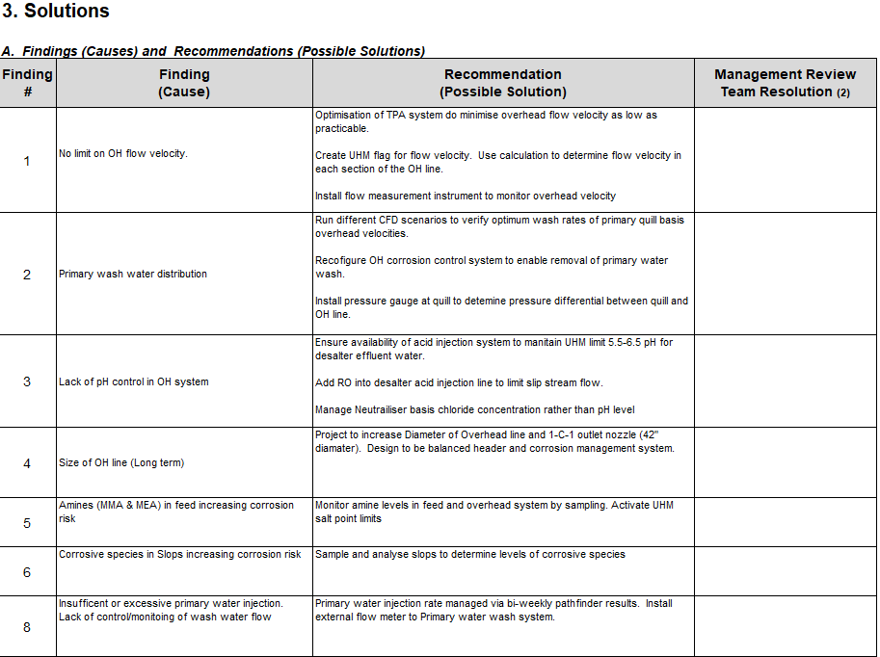

Appendix 9 – Iris Reports for Fin-fan Plugged Tubes (Inspection V. P., 2018)
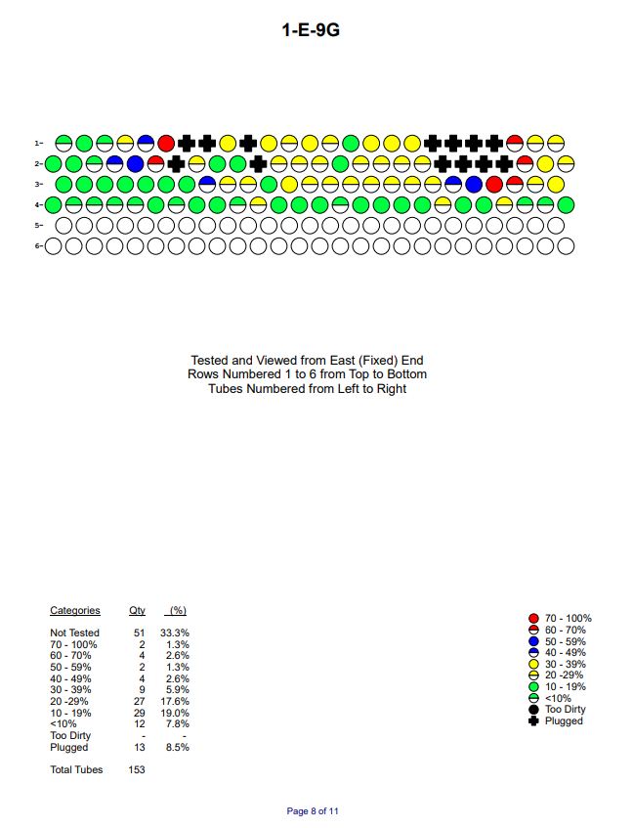
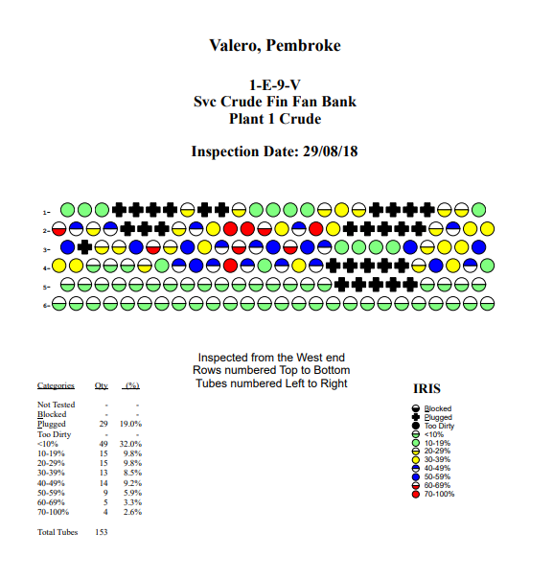
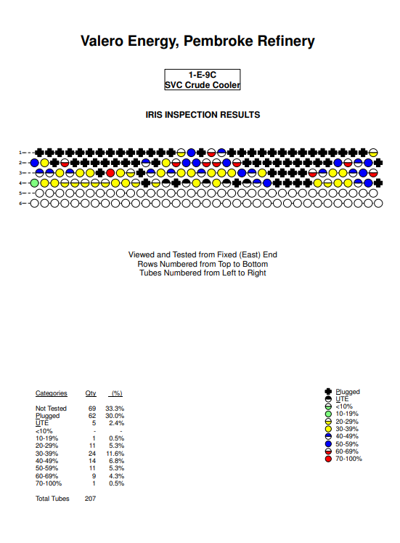

Appendix 10 – Overhead Calculation Correspondence with George Thomas (Snr Process Engineer Refining)

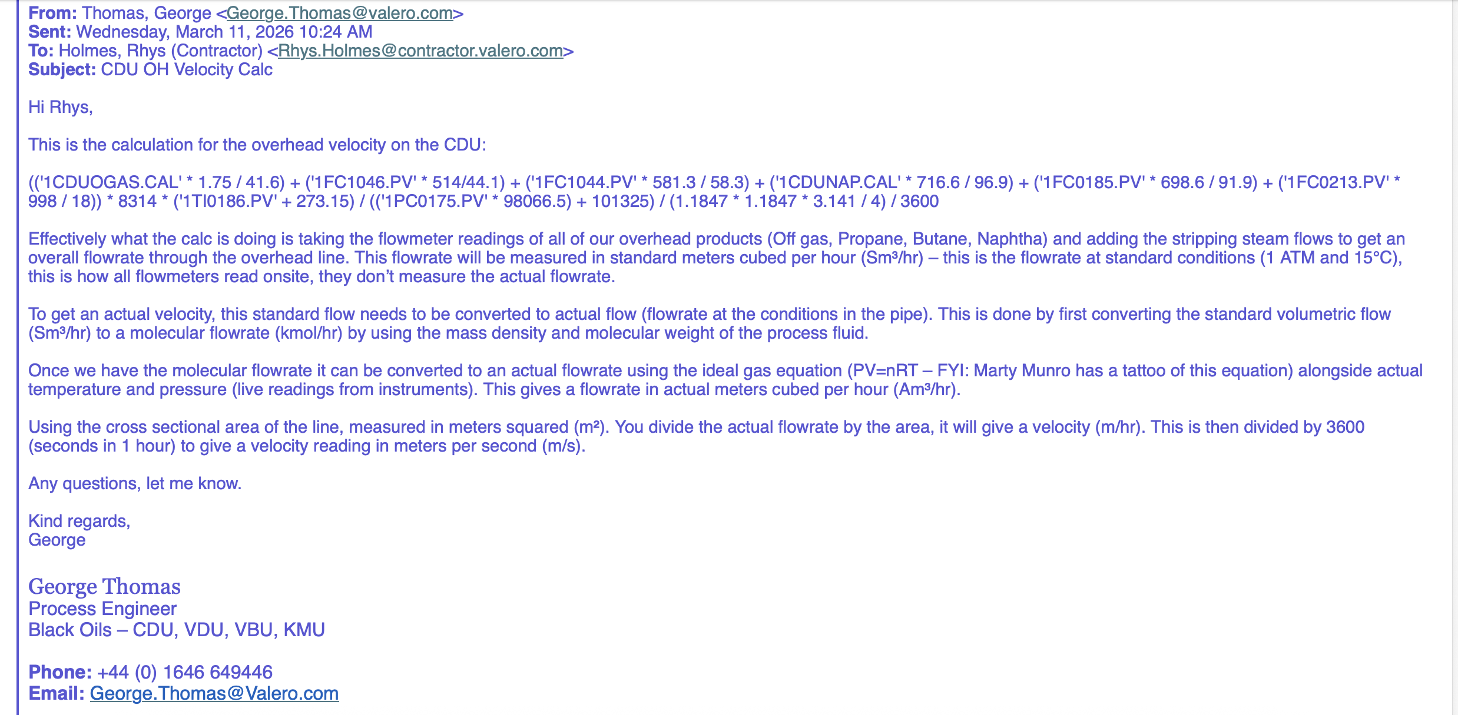
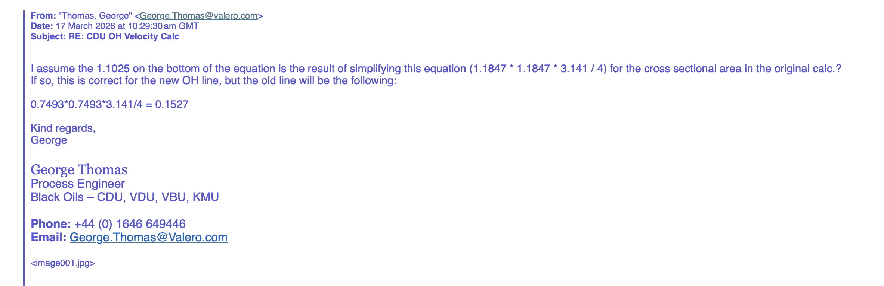

Appendix 11 - 1-E-9 vs 1-E9A Size Comparison (Planning, 2023)
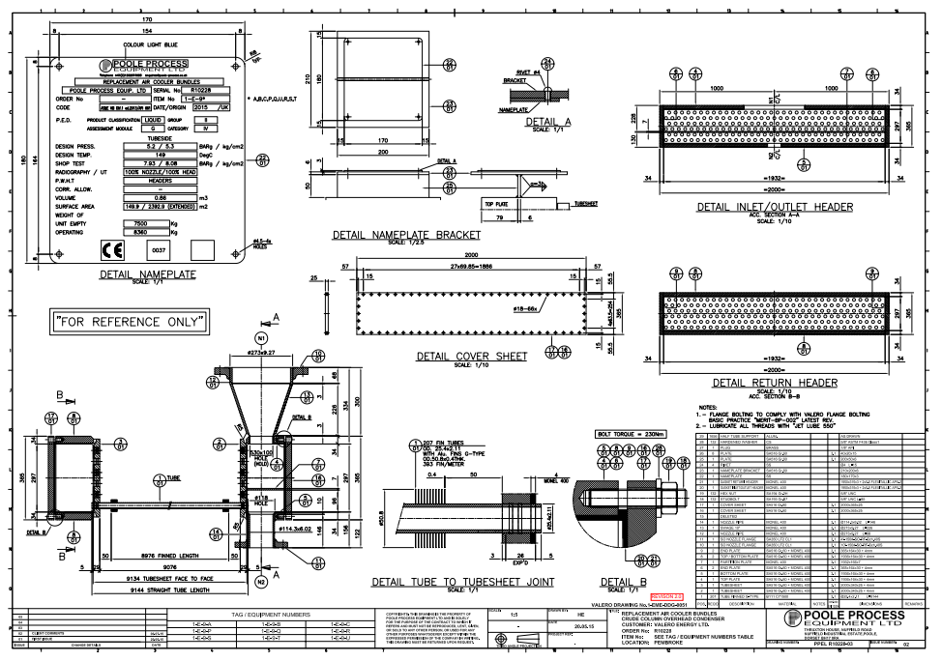
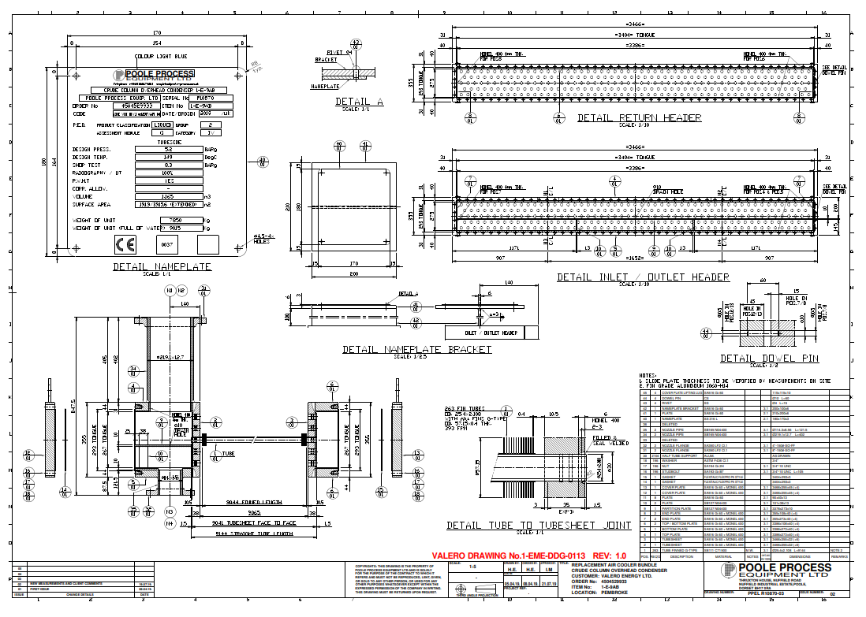

Appendix 12 – Project Timing Plan, Microsoft Project Plan
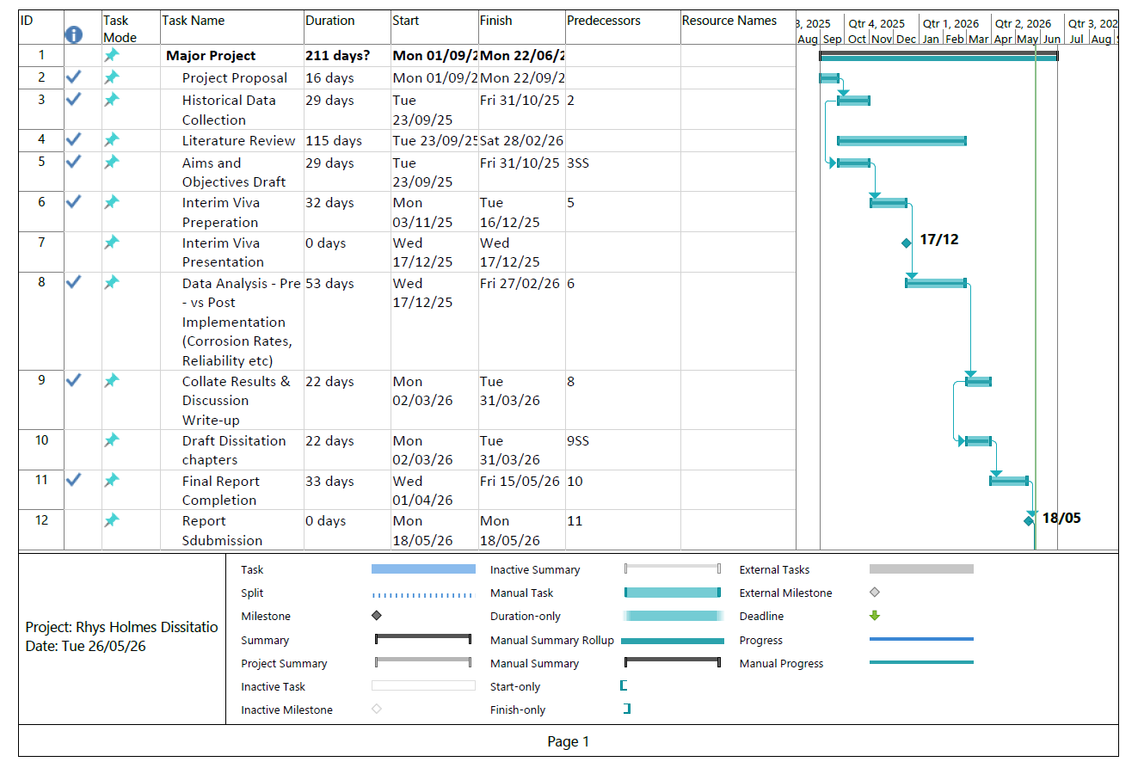

Appendix 13 – 1-E-9 Repair Plan (Inspection V. P., 2018)

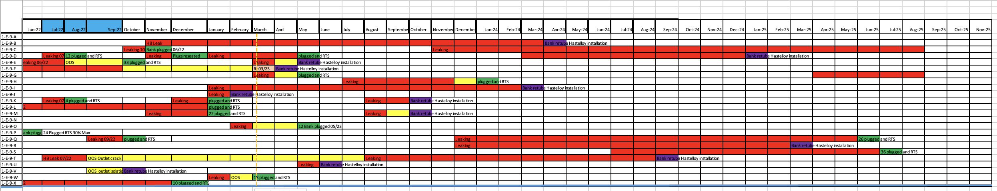

Appendix 14 – 1-E-9 Overhaul Costs (Miller, 2022)
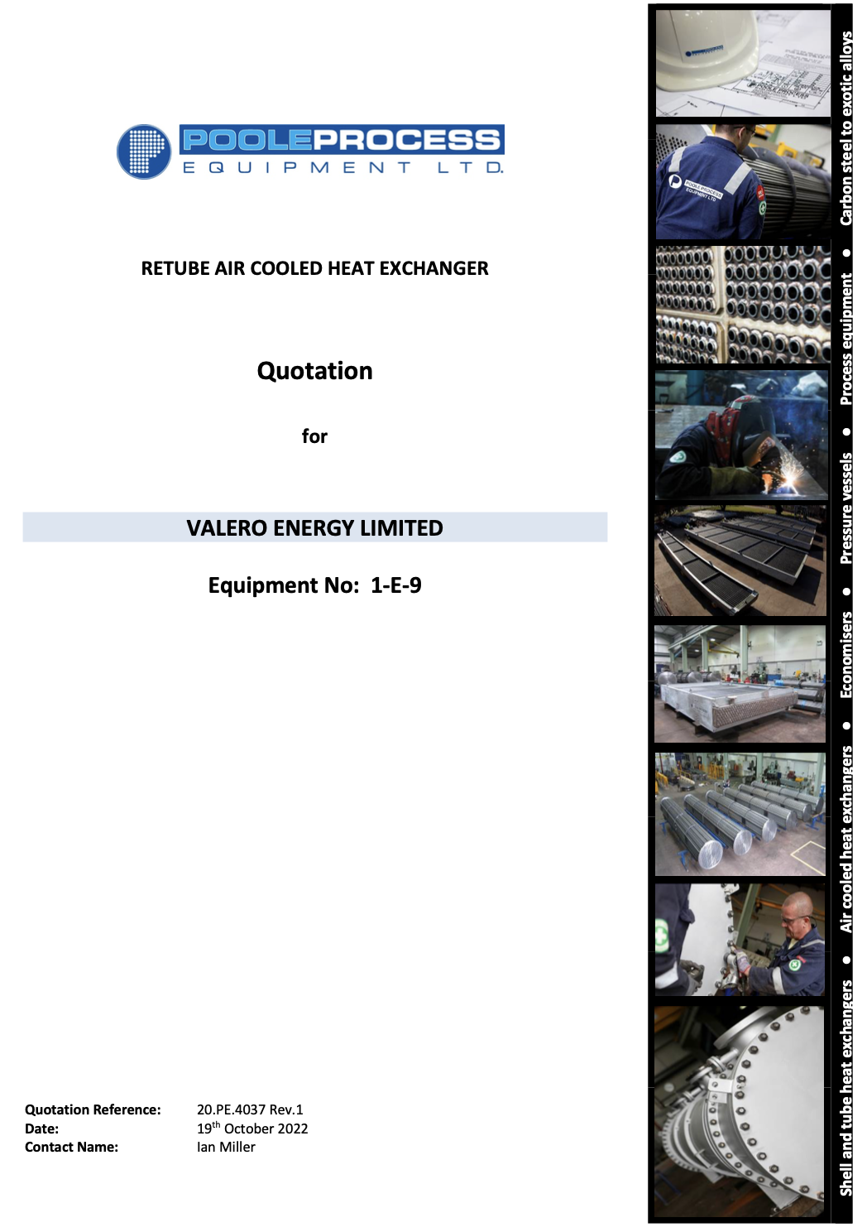

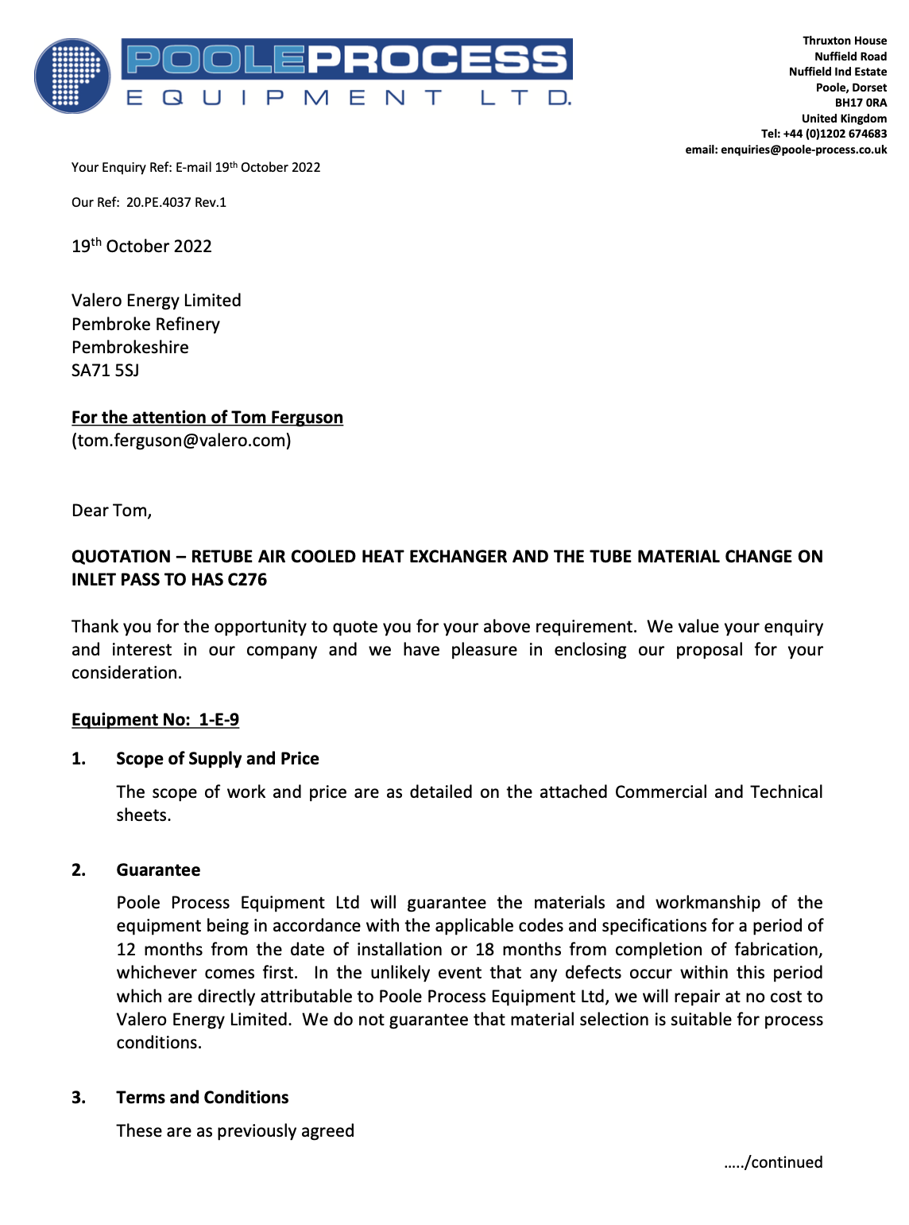

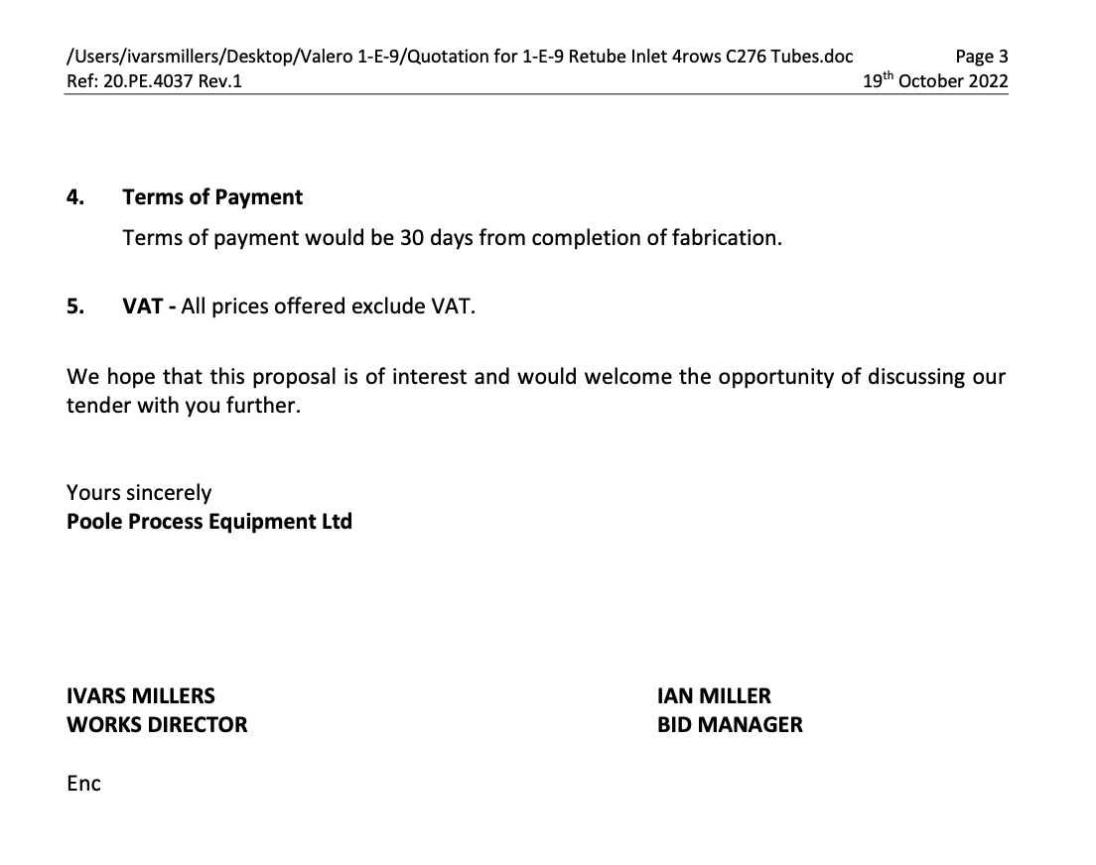
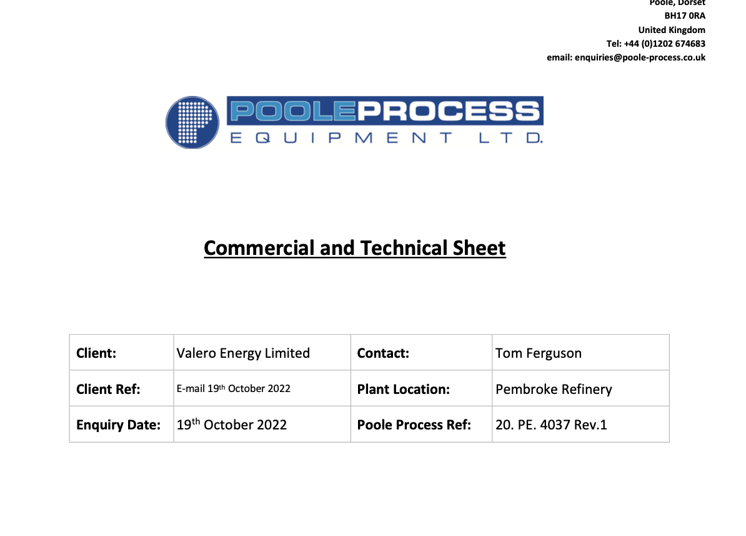
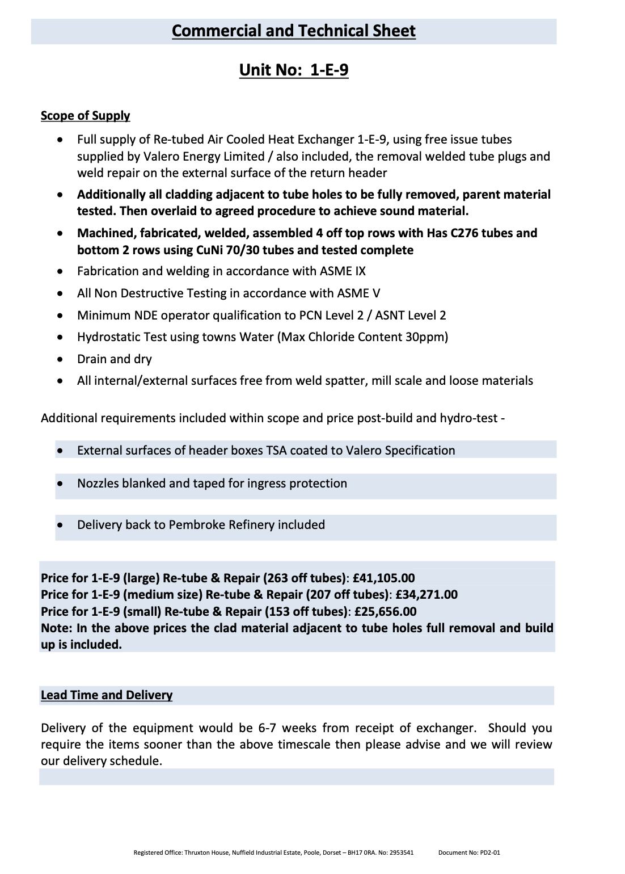
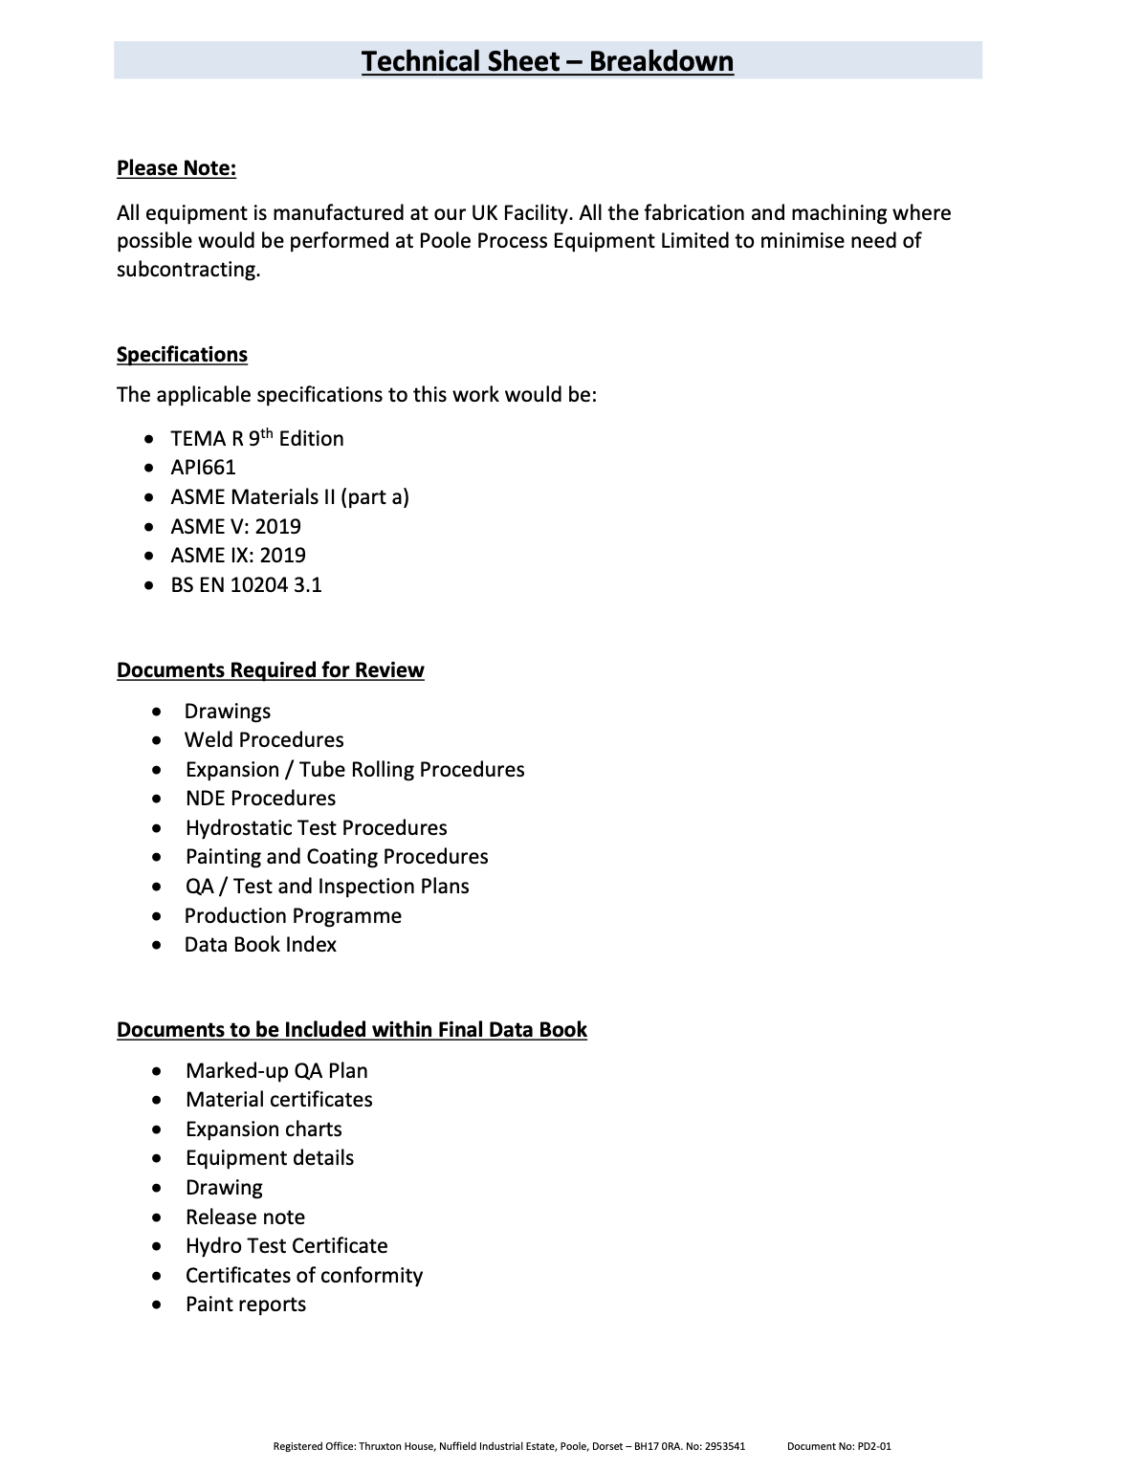


Appendix 15 – Velocity Calculation and Snip of Raw Data Used


