Dossier : In-betweenness

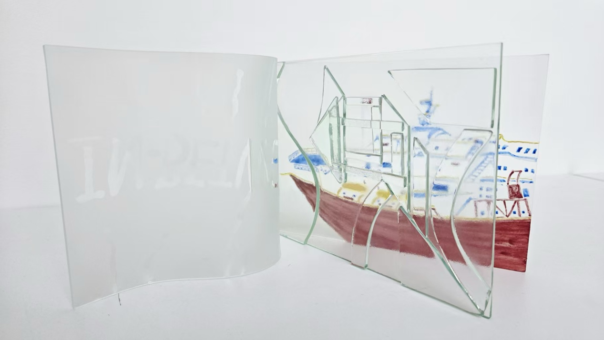

Chapter 1: Manifesto of In-Betweenness
I live, work and study between China, France and the United Kingdom. I am a trans-cultural artist and educator. My practice begins with movement: travelling, walking, waiting, observing and being unsettled by unfamiliar places. These bodily experiences enter my work through painting, glass, moving images and digital jewellery.
I do not see art as the production of images alone. Art is a practice of the body, material, memory and relationship. It begins in lived experience, but it does not end with the artist. Meaning can emerge through encounter, dialogue and shared practice.
I reject the idea that trans-cultural experience can be reduced to a recognisable visual style. I reject the idea that an audience should remain a passive receiver of an artist’s meaning. I reject the belief that an AI-generated image is equivalent to lived experience.
Artificial intelligence can produce images with extraordinary speed. It can imitate visual patterns and reproduce recognisable styles, but it cannot automatically preserve the conditions from which an experience emerged: the movement of the body, the weather, hesitation, language, memory, cultural misunderstanding and uncertainty. The body knows what data cannot measure.
My experience of China, France and Britain has shaped how I look at landscapes, people and spaces. Living across languages and cultures has made movement, translation and misunderstanding part of my creative material. My teaching has also shown me that artistic knowledge does not only move from expert to learner. It can develop through guidance, conversation, negotiation and shared making.
I believe that translation is never neutral. When a travel experience moves into a painting, something is retained, something is transformed and something is lost. When the painting enters glass, the material resists a perfect translation. Glass is transparent yet concealing, fragile yet rigid. Its thickness, reflections, irregularities and sharp edges interrupt the image. This resistance does not represent failure. It reveals another form of knowledge: knowledge carried through material, light, bodily movement and changing points of view.
I understand this space of transformation as in-betweenness. In-betweenness is not a fixed identity and not a smooth fusion between cultures. It is an unresolved condition of being between languages, places, images, materials and meanings. It is also a space where new possibilities can emerge.
I learn from Donald Schön that reflection does not only happen after practice. It happens during making, through unexpected material responses, failed experiments and necessary adjustments. I learn from Jacques Rancière that the viewer is not simply a receiver, but an interpreter. I therefore ask how an artwork can remain grounded in the artist’s embodied experience without controlling the meaning that others produce. How can I remain the author of the work without becoming the sole author of its meaning?
I will not use AI simply to copy my style. I will use it as a mediating and generative partner between body, image and viewer response. AI may transform the image, but it must not replace lived experience or claim to know a participant’s inner emotion. Its output remains open to questioning, interpretation and cultural difference.
I want to develop an artist-led participatory curatorial approach through a mirror-based, AI-mediated digital jewellery installation. This work will extend my travel paintings through glass, moving image and digital material, and invite participants from different cultural backgrounds to engage through their bodies, narratives and choices.
The artist will initiate the experience, but will not possess its final meaning. The material, the technology, the exhibition space and the participant will all take part in its formation. Meaning will be produced through encounter.
I stand for an art that preserves the difficulty of experience rather than making it instantly clear. I stand for translation that allows misunderstanding, transformation and loss. I stand for technology that expands dialogue rather than flattening experience into data. I stand for an audience that can respond, interpret and change the work.
I live between cultures, languages and media. My experience cannot be completely reproduced as an image. My research begins in this impossibility and remains in the space between.

Chapter 2: Among other voices
In this polyphonic dialogue, A represents the artist’s voice, grounded in personal, embodied and practice-based experience, while B represents a more distanced and critically reflective voice that adopts a broader perspective and questions the assumptions emerging from the practice. B does not claim absolute objectivity; rather, it creates space for analysis, contextualisation and self-questioning.
A: I have long been troubled by experiences of linguistic misunderstanding. As I move between China, France and the United Kingdom, I often feel situated within these cultures without ever fully belonging to any one of them.
B: This condition need not be understood solely as a difficulty. It may also become a productive space for creative thought and practice.
Georg Simmel (1908): This resembles the concept of the ‘stranger’ that I proposed. The stranger is simultaneously near and distant: physically situated within a group, yet maintaining a certain distance because of differences in knowledge, memory and perspective. What the stranger sees is therefore not identical to what the group sees.
A: The traveller, then, is not simply moving from one country to another. Rather, the traveller occupies a position between belonging and non-belonging.
Simmel: Precisely. Such distance can sometimes sharpen perception. Someone who is not completely immersed in a situation may perceive its structure more clearly than someone who is fully absorbed within it.
B: This recalls a Chinese saying: those who are involved in a chess game may lose a clear view of the overall situation, while an observer outside the game may see its structure more clearly. My travel paintings often begin from this unstable position. I am situated within a place, while simultaneously looking at it from elsewhere.
Arnold van Gennep (1909): Transitions between social states are never completed instantaneously. They require a liminal phase situated between separation and reintegration.
Victor Turner (1967): This liminal phase is a period of transition. The individual is no longer fully within the previous state, but has not yet entered the new one. The subject therefore occupies a position that is ‘neither here nor there’.
A: This is close to my experience of travelling, waiting and moving through unfamiliar environments. In railway stations, on trains or along streets in another country, I am temporarily separated from a familiar environment without yet becoming part of the new one.
Turner: Liminality is not merely a period of confusion. It can also temporarily suspend established classifications. Within this suspension, new relationships and meanings may emerge.
B: In-betweenness, then, is not an empty gap, but an active condition in which something takes place.
Maurice Merleau-Ponty (1945): However, this condition should not be understood only as an idea. It is first lived through the body. Perception does not take place from outside the world; the body is always already involved in the spaces, materials and situations it perceives.
A: This is why travel painting is important to my practice. I do not paint only what I see. I paint through walking, waiting, weather, movement, memory and bodily attention. A landscape is not merely an external object; it is encountered and experienced through the body.
B: Yet if this experience is so personal, how can it acquire significance for others? Does it risk becoming excessively subjective?
Stuart Hall (1990): Identity is not a fixed and unchanging point of departure. It is continually produced through history, representation and cultural positioning.
Gloria Anzaldúa (1987): The border is not merely a line separating two territories; it is also a condition lived through the body. It may be painful, unstable and difficult, but it can also generate another form of consciousness—one capable of reconciliation, transformation and enrichment.
A: My trans-cultural experience therefore does not need to be translated into a clear and fixed identity. The contradictions themselves can remain.
Anzaldúa: Yes. Do not rush to eliminate difference. Learn to dwell with it.
Homi K. Bhabha (1994): This is why the concept of the ‘Third Space’ is important. Meaning is not simply transferred from one fixed culture to another. It is negotiated within an intermediate space, where identities, languages and meanings are reorganised.
B: So, the Third Space is not a hybrid space in which all differences disappear?
Bhabha: No. It is not a smooth fusion, but an unstable space of translation, negotiation and cultural hybridity. New meanings become possible precisely because existing meanings cannot remain unchanged.
Edward Soja (1996): This space is also spatial in character. The Third Space is not merely an abstract cultural concept. It is lived through actual places, imagined spaces and social relations. It connects bodily movement with memory, representation and interpretation.
Michel Foucault (1967): Space can accommodate multiple realities simultaneously. Heterotopias, or ‘other spaces’, can interrupt everyday order and make different relationships visible.
A: This helps me move beyond understanding the artwork as an isolated image. A glass book, a moving image or a mirror-based digital jewellery installation can each become a temporary space within which body, image, memory, technology and viewer encounter one another.
B: But how can such a space become artistic practice rather than remaining only theoretical?
Donald Schön (1983): Knowledge is generated through action. Reflection does not take place only after a work has been completed; it also occurs during the making process, when practice produces an unexpected response.
A: This is precisely what occurred when I translated my travel paintings into glass. Initially, I hoped that the glass book would reproduce the structure of a paper book, but glass cannot fold in the same way. Its weight, thickness, rigidity, reflective surface and sharp edges resisted my original intention.
Schön: The material therefore becomes part of your thinking. You are not simply applying an idea to a material; the material is changing the idea.
A: The failure of a perfect translation became part of the research.
Hervé Guibert (1981): An image does not necessarily acquire greater significance because it has been successfully recorded. At times, the absence of an image may preserve an experience more profoundly than a technically accurate record.
B: This is important to my understanding of AI. AI can generate a refined image very rapidly, but a refined result may conceal the process through which it came into being: the walking, hesitation, uncertainty and memory involved.
Guibert: Invisible images, failed images and images that were never made can nevertheless shape the artist’s memory and identity.
A: The things lost in translation are therefore not necessarily defects. They may also constitute a form of knowledge.
Chen Zhen (1995): Relations are not an accessory external to the artwork. Relations themselves can become the artwork. In Round Table, chairs from different cultural and social contexts are placed around a single table. The meaning of the work does not exist only in the chairs as independent objects, but in the relationships among them.
B: This is close to my understanding of in-betweenness. It does not exist only within an individual, a material or an image; it emerges through relations.
Chen Zhen: Cultural difference does not need to be resolved into harmony. Tension, imbalance and compelled proximity can remain present. These relationships can generate a new artistic language.
Nicolas Bourriaud (1998): The artwork can function as a social interstice. It is not merely an autonomous object that carries a fixed meaning; it can also create a situation in which people encounter one another.
A: This is why I do not want digital jewellery to be understood only as wearable technological objects. I want it to become an embodied and poetic extension of painting onto the body.
Bourriaud: Meaning can emerge through shared presence, participation and response.
Jacques Rancière (2009): The spectator is not simply a passive recipient. Each spectator interprets, makes connections and reconstructs the things they encounter.
A: But if spectators can create meaning, what remains of my authorship?
Rancière: The openness of meaning does not mean that the artist’s authorship disappears. The artist can organise the conditions under which an encounter takes place without determining every meaning that emerges from it.
B: The central question, then, is not which party—artist or spectator—possesses meaning.
A: It is rather this: how can I remain the author of the work without becoming its sole author of meaning?
Joanna Zylinska (2020): Technology should not be understood as a neutral tool positioned outside culture and the body. Images, bodies, machines, environments and forms of knowledge are entangled with one another. Creativity is distributed across relations between human and non-human agencies.
A: This is where AI enters my research. I do not want AI to reproduce my visual style, nor do I want it to replace my experience. I want to investigate what happens when my embodied travel paintings enter a technological system and return as transformed images.
B: We must nevertheless remain ethically cautious. If a system responds to facial expressions or bodily movements, this does not mean that it genuinely understands a person’s inner emotions.
Zylinska: What the machine produces is a transformation, not a complete truth about the human subject.
A: AI therefore becomes a mediator rather than an authority. Its responses can be questioned, altered and reinterpreted by participants.
B: The viewer is not merely using a technological installation. Through the body, the viewer encounters the image, the mirror, the space and their own cultural memories.
A: Different voices are therefore gradually converging. Simmel offers the concept of the ‘stranger’; van Gennep and Turner provide the concepts of liminality and transition; Hall and Anzaldúa help me understand identity as continually produced through contradiction; Bhabha and Soja enable me to understand the Third Space as a site of cultural and spatial negotiation; Merleau-Ponty returns me to the lived body; Schön reveals how knowledge develops through making, failure and adjustment; Chen Zhen and Bourriaud show how relations can become artistic material; Rancière gives the spectator interpretive agency; Guibert reminds me that absence and failure can also preserve experience; and Zylinska helps me think through the entanglement of human and technological creativity.
B: These voices, however, are not identical.
A: They do not offer the same account of where in-betweenness is located or how it operates. In-betweenness may be situated in social position, ritual transition, identity, border consciousness, space, materiality, encounter or technological mediation.
B: Perhaps this disagreement is valuable.
A: Yes. My research does not need to select one final definition. It needs to hold these voices together and test them through practice.
B: What, then, does your research add?
A: My research asks how in-betweenness is lived through the body, translated through artistic materials and reconfigured through interactions among the artist, AI and participants. It begins with trans-cultural travel painting, moves through glass and moving digital imagery, and ultimately develops into a mirror-based, AI-mediated interactive digital jewellery installation.
B: What, then, will happen within this installation?
A: The artist provides the experiential point of departure and organises the conditions for an encounter. Materials generate resistance, technology performs transformations, participants interpret what they encounter, and meaning remains unfinished.
B: In-betweenness, then, is not simply a theory about existing between different cultures.
A: It also becomes a practice of movement between body and image, artist and viewer, human intention and machine transformation, certainty and uncertainty.

All voices: Meaning is not transmitted as a complete entity. It is negotiated through encounter, lived through bodies and continually generated anew.

Chapter 3: The Confession of the Glass Book
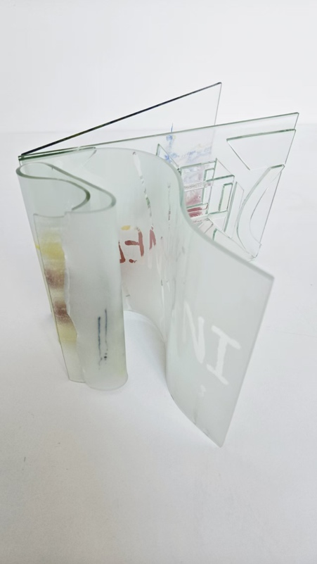
I was not born from paper. I came into being between travel painting, glass, light and a pair of hesitant hands.
My maker entrusted me with landscapes encountered in different countries. They had passed through her body – through walking, waiting, weather, language, unfamiliar streets and memories that could not be expressed completely. She painted these experiences on paper and then attempted to transfer them into me.
She wanted a book. I was therefore divided into pages. She wanted me to open, fold and turn like paper, leading viewers through a clear route into her memory.
For her, the book was also a way of giving travel a physical sequence. A page could hold one place, one pause or one fragment of attention, while the movement from page to page could suggest a journey. She believed that if I followed the familiar logic of a book, viewers might enter the experience in an ordered way.
But a journey is not experienced as a perfectly ordered sequence. It includes delays, detours, missed signs and moments when attention shifts unexpectedly. The gaps between my pages can therefore hold more than missing information. They can suggest the interruptions and uncertainty through which memory is actually formed.
Yet I could not follow her wishes. I was too rigid, thick and reflective. My edges were sharp, and my pages would not obey the logic of paper. At first, she treated this as failure. She remeasured my edges and tried to make me thinner, flatter and more like a transparent container for an image.
But I was never paper. My transparency does not reveal everything. Light, reflection and the viewer’s position continually alter what can be seen. I am transparent and obscuring, fragile and rigid. I can preserve an image, but not an entire experience.
My maker hoped to bring the Chinese dragon-scale scroll and Turkish map-fold structures into relation. She described this as trans-cultural: a space between cultures, materials and memories. But I remain uneasy. Do these forms retain their histories, or are they reduced to attractive visual symbols? Culture is not an ornament that can be cut apart and recombined at will, and experience cannot be transported intact.
This unease does not require the two traditions to remain completely separate. It requires their meeting to be treated as a question rather than a decorative solution. My form can hold the tension between translation and appropriation, but it cannot resolve that tension on behalf of the viewer.
She wanted me to be handled like a book. I refused. My pages cannot be opened in a fixed sequence. Viewers must move, change their angle and wait for light to pass across me. An image may become visible, obscured by reflection, or reduced to colour, line and a blurred memory.
I offer no single direction of reading. As viewers move around me, they see their own bodies, shadows and positions as well as her paintings and my pages. Their experiences begin to enter my transparent layers. I become a relational space among artist, material and viewer.
A viewer who stands still may see a different work from one who walks around me. Someone looking through a page may notice the image; someone looking across it may notice reflection, distance or the room behind it. These differences are not accidental visual effects. They make viewing a bodily and interpretive act.
My maker once wanted to hide the pages that could not fold, the thick edges and the unclear images. I preserve these failures in my weight, reflections and sharpness. They are not merely mistakes; they show that I have participated in the research.
Her fear of an unfinished object has gradually become an acceptance of an unfinished meaning. I do not complete the journey for her or for the viewer. I make the conditions of encounter visible, and leave the work open to what another body may notice.
My resistance compelled her to reconsider practice. Reflection occurs when I resist her intention and she changes the design. This is close to Schön’s (1983) ‘reflection-in-action’: knowledge emerges not only from the artist’s prior idea, but through material response, failure and adjustment.
She once wanted to preserve a journey. Now she understands that she cannot possess it or give it to another person in its entirety. I can preserve only what remains after translation: visible images, obscured layers, absences and relationships that viewers bring into being through their bodies.
My confession is this: I refuse to be a silent container. I cannot turn my pages, but I can make viewers move. I cannot narrate memory in full, but I can make loss visible. My incompleteness is not a deficiency; it is the way I participate in the work.

Reflection on the monologue：
Writing from the perspective of the glass book made me recognise three assumptions within my practice：

First, I had assumed that glass was a support for an image. I treated the material as something that should receive and preserve the travel painting. Its resistance revealed a different ontology. Glass does not simply contain an image; it changes the conditions under which the image can be seen. Its weight, thickness, reflection and fragility make the material an active participant in the relationship between image, body and memory.

Second, I had assumed that bringing different cultural forms together would automatically create a trans-cultural dialogue. My attempt to relate Chinese dragon-scale scroll and Turkish map-fold structures made this assumption more complicated. A formal combination can produce visual interest, but it can also reduce distinct cultural histories to interchangeable motifs. I therefore need to treat cultural encounter as an ethical question rather than as a finished visual solution. Difference should remain present instead of being smoothed into harmony.

Third, I had assumed that the viewer would understand the work through a sequence determined by me. When the glass could not fold like paper, this model became impossible. I began to design for partial visibility, bodily movement and multiple readings. The viewer would not simply follow the route of my memory; they would construct a temporary relation with the work through their own position and attention. This process reflects Schön’s (1983) concept of reflection-in-action. Knowledge emerged while I was making, responding to failure and revising the design. The glass book therefore changed not only the form of the artwork but also the method of my research.

The same principle will guide the later AI-mediated installation. AI may transform images or generate responses to movement, but it cannot be presented as an authority on a participant’s inner emotion. Any technological response should remain provisional and open to interpretation. Participants should understand how their data is used and retain the ability to pause or withdraw.

The glass book has not solved the problem of translation. Instead, it has made the problem visible. I now understand my role as creating the conditions for an encounter rather than controlling its final meaning.
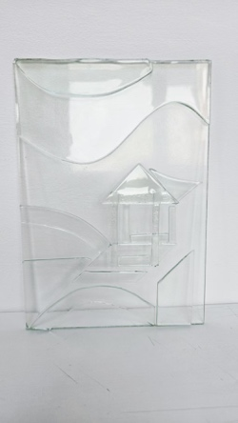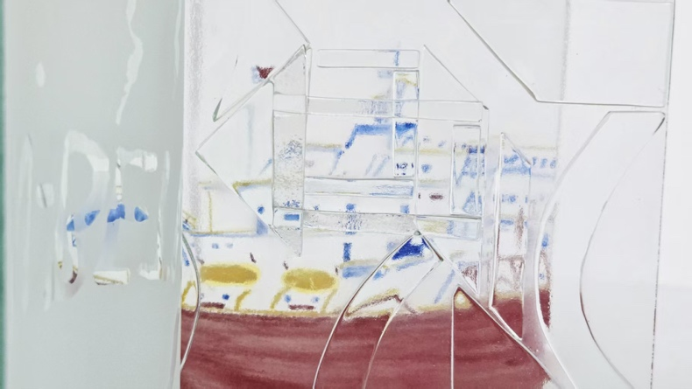
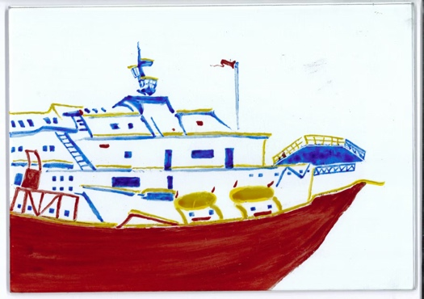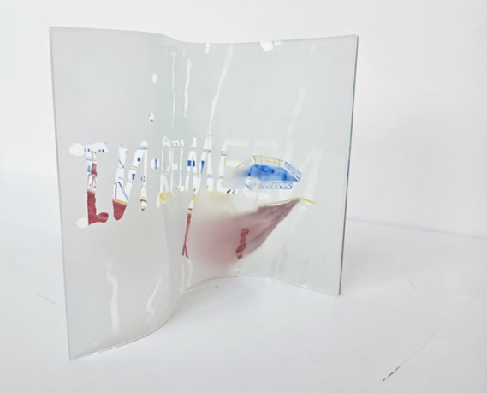
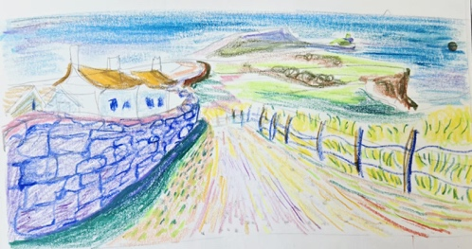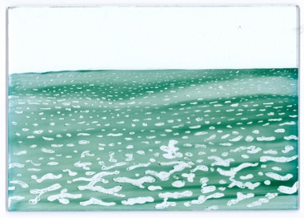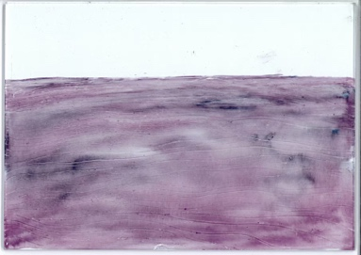
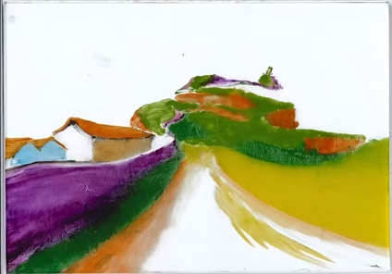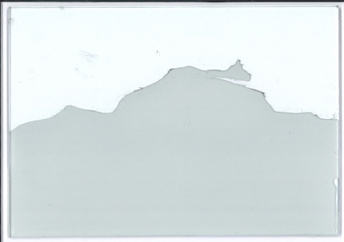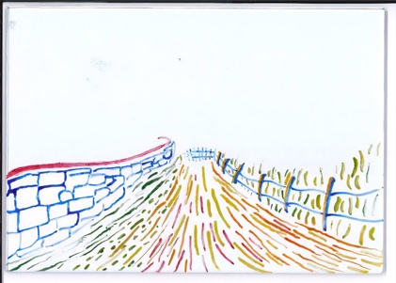
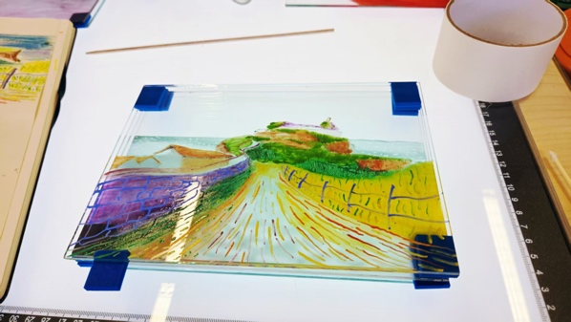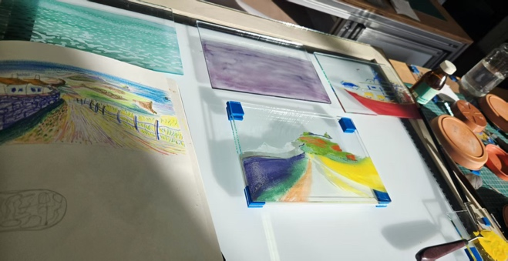

Chapter 4: Ecologies -Interrelationship Mapping
An Allegorical Ecology of In-Betweenness
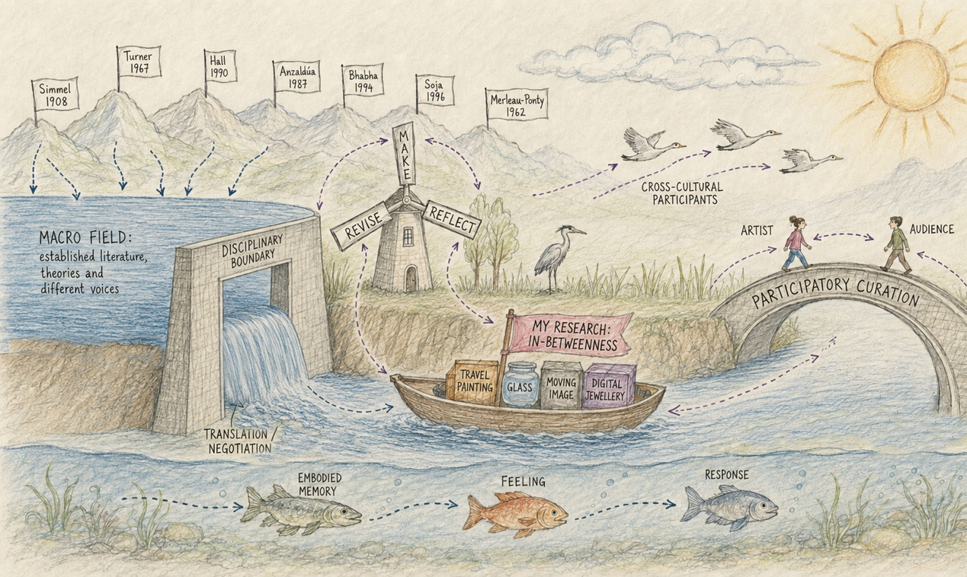
Figure 1. An allegorical ecology of my research: from existing literature to an embodied participatory encounter.

Rather than presenting my research as a collection of separate theories, materials, technologies and participants, this allegorical map represents it as an ecology of interdependent relationships. Each element influences and is influenced by the others. The visual structure follows the movement: Existing literature → Translation and negotiation → My practice → Participatory encounter → Plural meanings.
However, this movement should not be understood as a fixed linear sequence. The dashed arrows indicate circulation, translation, negotiation and feedback. They suggest that theoretical ideas enter practice, while material, technological and participant responses return to influence subsequent artistic and curatorial decisions.

1. The mountains and high-water level: the macro field
The mountains and high-water level represent the wider field of literature and theory. Simmel (1908), Turner (1967), Hall (1990), Anzaldúa (1987), Bhabha (1994) … offer different perspectives on social distance, liminality, identity, borders, cultural negotiation, space and embodiment. They do not form one unified foundation; together they show that in-betweenness can be social, cultural, spatial and bodily.
The high water suggests accumulated concepts and questions. It has potential energy, but cannot enter the lower landscape unchanged. Theories must be selected and reinterpreted through the particular conditions of my travel, materials and participants.
2. The dam and Translation Lock: disciplinary translation
The dam marks the boundary between the wider field and my specific research. The opening, labelled the Translation Lock, represents the process through which theory enters practice. This is not direct transfer; it involves selection, negotiation and transformation. The water that crosses the dam changes as it moves between travel painting, glass, moving image, contemporary jewellery, digital jewellery, interaction design, AI and participatory exhibition.
3. The windmill: the dynamic process of thinking
The windmill is marked MAKE, REFLECT and REVISE. It represents a cycle rather than three completed stages. Making produces an unexpected response; reflection examines it; revision changes the next stage. Schön's (1983) reflection-in-action, practice-based research and action research inform this movement. Autoethnographic experience enters through travel painting and documentation, but material and participant feedback open it to further interpretation (Candy and Edmonds, 2018; Sullivan, 2010).
4. The boat: my specific research
The boat labelled MY RESEARCH: IN-BETWEENNESS carries four connected practices: travel painting, glass, moving image and digital jewellery. Travel painting records embodied movement and cultural encounter; glass introduces weight, rigidity, transparency and fragility; moving image introduces duration and transformation; digital jewellery extends the image towards the body and interaction. AI mediates between moving image and digital jewellery rather than replacing the artist's experience. The boat remains in motion because knowledge develops between forms.
5. The bridge: artist-led participatory curation
The bridge connects artist, participants and wider audience. The artist establishes the initial images, materials, spatial conditions, interaction rules and ethical boundaries, but does not determine every meaning. Participants contribute memories, bodily experiences and cultural interpretations. Their responses can revise the artwork, interaction design and curatorial conditions. This develops the artist-as-curator position discussed by Jeffery (2015) into an artist-led participatory model.
The bridge therefore represents responsibility as well as openness. The artist still controls some conditions, including consent procedures and the limits of data collection. Participation is meaningful only when participants understand the encounter and can choose how far to enter it.
6. The migratory birds: consciousness shaped by cross-cultural experience
The birds represent consciousness moving between places, languages, memories and cultural positions. Their different trajectories suggest that cross-cultural experience does not produce one unified interpretation. Participants may perceive the work from more than one location, holding belonging and distance at the same time.
7. The underwater sequence: embodied memory, feeling and response
The fish represent processes that may not be visible in the final artwork: embodied memory, felt experience and response. These enter through the participant's body, cultural history and previous experience, and may be expressed through interpretation, dialogue, movement or other responses. AI should not be treated as accurately identifying inner emotion. Camera or movement responses are artistic triggers; feeling must be explored through observation, interviews and feedback rather than inferred from behavioural data alone.
8. The ecology as a whole
Taken together, the map shows how literature, translation, practice, participation, cultural memory and embodiment depend on one another. The project does not seek one final definition of in-betweenness. It creates a relational system in which theory, material, technology, artist, participant and audience continually affect one another. Meaning is translated, negotiated, embodied and reconfigured through encounter.
The ecology is thus both a map of the current project and a reminder that it will change. As prototypes are tested and participant responses are collected, the arrows will not simply confirm the existing structure; they may redirect it. The map leaves space for that future movement.

Chapter 5: Reflective Meditation - Lived Practice or the Perfect Image?
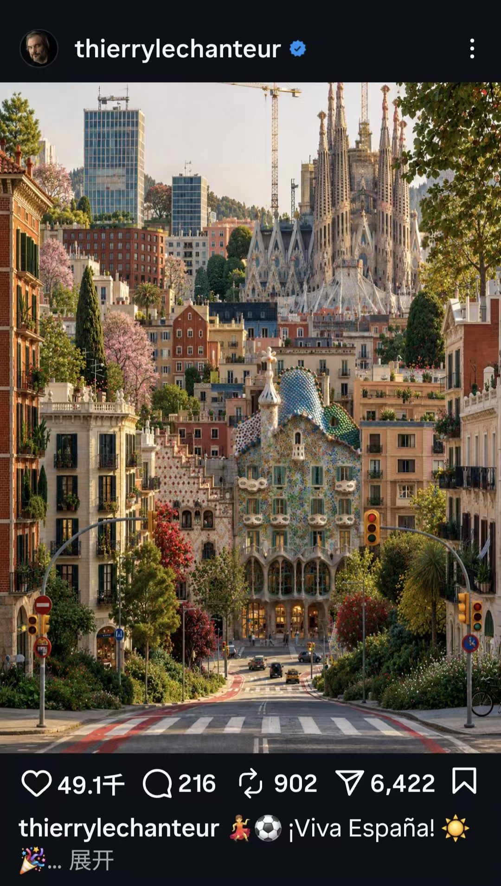
Figure 2. An AI-generated travel image encountered through a social-media platform. The image is used as a prompt for reflecting on visual coherence, lived experience and the conditions of image-making.
1. Beginning with an image that appears to be right
I begin with an image that appears remarkably 'correct': an AI-generated travel image with clear composition, harmonious colour and coherent style. It looks like a finished travel painting and seems more accurate, beautiful and immediately understandable than the rough sketches I make while travelling.
Yet the image depicts a landscape without having lived through it. It contains neither the tiredness after walking, the anxiety of waiting at a station nor the uncertainty of changing weather. It does not know why I stopped, what I noticed or which details made a place exciting, unfamiliar or unsettling. It reproduces a visual result without carrying the bodily process through which that result emerged.
Its coherence is therefore both attractive and troubling. Because the image looks finished, it can appear to contain the whole experience. Yet the conditions that gave the experience meaning - time, effort, attention and uncertainty - have been removed from view. The image resembles memory without necessarily preserving how that memory was formed.
The issue is therefore not simply that the image was generated by AI. It is what happens when an image appears complete while the lived experience behind it remains invisible.
2. The distance between image and practice
Travel painting contains more than the appearance of a landscape. It records how I reached a place, how long I waited, how I looked, the viewpoint I selected and the decisions made under time pressure. Its lines and colours register an encounter between body and environment. If hesitation, failure, revision and waiting are removed, is the same artistic experience still present?
I do not want to call AI images simply false or oppose lived practice to the perfect image. I want to ask what is concealed when an image cannot carry the conditions of experience, and what new possibilities appear when experience enters another image-making system. Walking, painting, waiting and adjusting allow the body to establish a relationship with the world; meaning develops through action and encounter, as Merleau-Ponty's (1962) account of embodied perception suggests.
Practice also keeps open the possibility of change. A sketch may contain an incomplete line, a wrong colour or a pause that later becomes important. These imperfections are not automatically valuable, but they show that an image has developed through decisions and circumstances rather than appearing as a neutral, finished answer.
3. The glass book: a material turning point
Glass offers another way to explore in-betweenness. It is shaped by fire but can evoke water through transparency and moving light. It is hard and fragile, transparent and obscuring. I wanted its layers, reflections and light to hold different levels of feeling within travel memory, and initially imagined a glass book inspired by the Turkish map fold.
Glass could not fold like paper. Its rigidity, thickness, sharp edges and fixed structure prevented the perfect translation I had imagined. Through repeated making and adjustment, I realised that this was changing my research question. I was no longer asking only how to reproduce a painting on glass, but how bodily memory might be re-experienced through layers, light, changing viewpoints and material resistance.
The glass book consequently became less like a container and more like an encounter. Its pages cannot be read through one stable route. Reflection may hide an image, a change of position may reveal it, and the surrounding room may enter the work. What is lost from the original painting is not simply absent; it is reorganised as a demand for movement and attention.
This is Schön's (1983) 'reflection-in-action': reflection occurs while a material produces an unexpected response, not only after completion. The resistance of glass required me to reassess my decisions, and failure became a moment of knowledge. This also reflects practice-based research, in which knowledge emerges through the development and critical examination of artistic practice (Candy and Edmonds, 2018; Sullivan, 2010).
4. From the AI image to digital jewellery
I continue to work with AI and digital jewellery not to reject technology, but to place it within a relationship among artist, material, body, participant and system. In the proposed installation, travel-based material will be transformed, fragmented and reorganised by AI, then brought into relation with the participant through a mirror-screen.
As a participant approaches, a stable travel image may become moving lines, particles or abstract forms that gather around the body like digital jewellery. The interaction raises a design question: does the participant contribute to meaning, or merely activate effects already programmed? I need an encounter in which movement, attention, memory and interpretation can shape how the work is understood.
The mirror is central because it places the image beside the participant's changing body rather than keeping it at a distance. It can make the image appear wearable, while also making clear that the participant is not receiving my experience intact. Their position, memories and expectations help determine what the encounter becomes.
Ethical limits are equally important. A system responding to facial expression, presence or movement does not demonstrate that AI understands an inner emotional state. The response must be described as a technical and artistic trigger. Participants must know what data is collected, how it is used and how they can pause or withdraw. AI is therefore a mediator rather than an authority, and its output can be questioned and reinterpreted. Creativity emerges through the entanglement of bodies, images, technologies and environments rather than belonging exclusively to human or machine (Zylinska, 2020).
5. Open meaning: how do I remain the author?
I still determine the starting point, materials, visual language, interaction rules and display conditions. Participant involvement does not erase the artist's role. However, I do not want the audience to be limited to triggering predetermined effects. Genuine participation should influence how the work is encountered and understood.
Rancière (2009) argues that spectators interpret, connect and reconstruct what they encounter. I can design the conditions of an encounter without controlling every interpretation. This is the basis of my artist-led participatory curatorial approach: the artist establishes a framework but does not monopolise meaning. Observation, semi-structured interviews and follow-up responses will help me assess whether participation produces more than a technical effect.
This evaluation is important because participation can easily become a promise rather than a reality. I will need to examine what participants actually do and say, whether their interpretations diverge from my intention, and whether their feedback changes the next artistic or curatorial decision.
Practice itself has become a form of thinking. Glass changed my research question, while AI has made me reconsider image, experience and authorship. Lived practice and the perfect image are not simple opposites. The important issue is whether the processes behind an image can remain visible, and what changes when experience is translated between bodies, materials and technologies. My work begins with my experience, but it should continue through the memories and interpretations of those who encounter it.

Chapter 6: Letter
Dear Stranger,
You may first encounter my research in a room. In front of you is a mirror. A landscape first appears - perhaps a mountain, coastline, railway station or unfamiliar place. As you approach, it becomes lines, particles and fragments gathering around your body like digital jewellery: visible, but impossible to hold.
I am writing to you because the value of this research cannot be understood through the final image alone. It depends on what happens between the image, the body and the memories brought into the room.
Have you ever felt between places, languages or identities? I live, study and work between China, France and the United Kingdom. For me, in-betweenness is not only theoretical; it is felt when moving through an unfamiliar city, waiting at a station, struggling with another language or seeing a landscape through more than one cultural memory.
Cross-cultural experience is not a fixed image. It is a process of moving, observing, waiting, adapting and remembering. When I paint while travelling, I record not only a place's appearance, but my body's response - walking speed, weather, tiredness, uncertainty and the reason I stop.
AI can generate a beautiful and coherent image quickly, but can it preserve the waiting, physical effort, difficulty of communication and unfamiliarity of travel? If visual quality is the only measure, these conditions may disappear. My research asks how embodied cross-cultural experience can be translated through painting, glass, AI and digital jewellery, and how its meaning changes when it meets another person.
The gap I address is not simply whether AI can make art. I ask what happens to lived experience when it enters an image-making system, and whether participation changes meaning or merely activates programmed effects. If a participant triggers a fixed animation, are they participating or only operating a system? Is AI expanding expression, or reducing complex experience to classifiable data?
My experiments begin with travel painting and move into a glass book. Glass is made through fire, yet can appear fluid like water; it is hard and fragile, transparent and obscuring. When I tried to make it behave like a Turkish map-fold book, its thickness, rigidity and sharp edges resisted. This failure changed my question: how might bodily memory be re-experienced through layers, light, changing viewpoints and material resistance?
The glass book showed me that translation is not the transfer of a stable message from one medium to another. The material changes the experience. This is why the research moves towards digital jewellery: I want to test how an image changes again when it is brought into relation with a living body and a responsive space.
In the proposed installation, AI-transformed images meet the viewer through a mirror. Movement or facial expression may trigger visual change, but this is an artistic interpretation, not evidence that the system understands inner emotion. Participants should know what data is collected, how it is used and that they can withdraw.
Artist-led participatory curation means that I establish the images, materials, space, interaction rules and ethical boundaries, while leaving meaning open. Merleau-Ponty helps me understand the body as our way of encountering the world (1962); Bhabha's Third Space describes what can emerge when cultural experiences meet (1994); and Rancière reminds me that viewers interpret rather than passively receive (2009). Your memories, cultural background and bodily responses should enter the encounter and may help me revise the work.
This is the significance of the project. If we value only perfect images, we may forget the bodies and conditions behind them. Cross-cultural experience may become a copyable style, while viewers become data or triggers. I propose an encounter in which AI acts as a mediator, digital jewellery connects image and body, and uncertainty, difference and interpretation remain possible.
The project also has a practical and ethical significance. It asks designers to treat interaction as a relationship rather than a technical spectacle, and to treat participant data with caution. A system may respond to a face or movement, but the meaning of that response must remain open to the person's own account.
Future research should ask not only what AI can generate, but what its images leave out. Participation should contribute to meaning, and data practices should be transparent about the limits of emotional inference. Comparing responses from people with different cultural backgrounds may show how meaning changes as an image moves between bodies, languages and memories.
When you stand before this mirror, I hope you will ask not only, 'What is this image trying to tell me?' but also: Which part belongs to me, and which part begins with you? My research begins with my experience, moves through AI and materials, meets your body and opens into another interpretation. Your response is part of what the research needs to discover.
Yours from the space in between, Celine

Chapter 7: Afterword
Looking back over this dossier, I can see that my research has moved from a personal concern with cultural in-betweenness towards a more relational and practice-led investigation. At the beginning, I understood in-betweenness mainly through my experience of living between China, France and the United Kingdom. Travel, language and cultural difference appeared as the central materials of the project. I now understand them as conditions that connect bodies, materials, technologies and other people.
My thinking changed most clearly through the glass book. I initially treated glass as a medium that could carry a travel image, and I measured success by how closely it could imitate paper. Its rigidity and fragility disrupted that assumption. Through making, failing and revising, I began to see material resistance as knowledge rather than obstruction. The glass book made visible the impossibility of transferring experience without transformation, and it shifted my practice from reproducing images towards designing encounters.
This shift also changed my understanding of AI. I do not position AI simply as a threat to authorship or as a tool for efficient image production. It is a mediator that can transform visual material, but it cannot guarantee the preservation of bodily time, cultural context or lived memory. Its value in my research depends on how critically it is framed, questioned and encountered by participants.
My understanding of participation has developed in parallel. I no longer see the audience only as viewers who receive an artist's experience, nor as users who activate a pre-programmed effect. The artist must still establish the conditions of the work, but participants should bring their own memories, bodies and interpretations into it. This is why I describe the project as artist-led participatory curation: authorship remains present as a framework, while meaning remains open to negotiation.
The project is not yet complete. The mirror-based installation remains a proposed and developing form, and its ethical and technical limits will need to be tested through prototyping, observation, interviews and participant feedback. In particular, I must ensure that any emotional or behavioural response is presented as an artistic trigger rather than a claim to read inner feeling, and that participants retain clear knowledge and control over their data.
I also recognise that the project has limits. My account is shaped by my own routes, languages and professional position; a small group of participants cannot represent every cross-cultural experience. The aim is not to generalise from their responses, but to use situated encounters to understand how meaning is negotiated and how the practice should change.
In practical terms, my next stage is to translate these principles into a working prototype. I will test how the mirror, moving image and interaction operate together, then use participant responses to decide what should be retained, revised or removed. The research will remain accountable to what the prototype actually makes possible, not only to what I intend it to communicate.
At the start of the project, I often imagined research as a process of clarifying an idea and then producing an object that expressed it accurately. The work has taught me to accept a less stable model. A research object can be a question, a material situation or a set of relationships. Its success may lie in the questions it makes possible rather than in the completeness of its appearance.
My experience as an educator also remains part of this position. I have learned that guidance should create enough structure for people to act, while leaving enough openness for their own decisions. I now bring the same principle to the installation: the artist provides a framework, but participants must have room to affect what the encounter means.
My current position is therefore neither fully inside nor outside the work. I am the artist who selects the starting materials and designs the encounter, but I am also a researcher whose assumptions must remain open to material resistance, cultural difference and participant response. I no longer seek a final definition of in-betweenness. I seek a practice that allows it to remain active - between body and image, intention and interpretation, human experience and technological transformation.
The research began with the question of how experience might become an image. It now ends with a different question: what new relations become possible when an image remains unfinished? My work begins with my experience, but its knowledge will be developed through what happens when that experience meets other bodies, memories, materials and ways of seeing.

References

Anzaldúa, G. (1987) Borderlands/La Frontera: The New Mestiza. San Francisco, CA: Aunt Lute Books.
Astfalck, J., Broadhead, C. and Derrez, P. (eds.) (2005) New Directions in Jewellery II. London: Black Dog Publishing.
Barrett, E. and Bolt, B. (eds.) (2010) Practice as Research: Approaches to Creative Arts Enquiry. London: I.B. Tauris.
Bhabha, H.K. (1994) The Location of Culture. London: Routledge.
Bourriaud, N. (2002 [1998]) Relational Aesthetics. Translated by S. Pleasance and F. Woods, with the participation of M. Copeland. Dijon: Les presses du réel.
Candy, L. and Edmonds, E. (2018) ‘Practice-based research in the creative arts: Foundations and futures from the front line’, Leonardo, 51(1), pp. 63–69. doi: 10.1162/LEON_a_01471.
Cheung, L., Clarke, B. and Clarke, I. (2006) New Directions in Jewellery. London: Black Dog Publishing.
Chen Zhen (1995) Round Table [Installation]. Centre Pompidou, Paris. Available at: Centre Pompidou (Accessed: 27 August 2026).
Crawford, K. (2021) Atlas of AI: Power, Politics, and the Planetary Costs of Artificial Intelligence. New Haven: Yale University Press.
Den Besten, L. (2011) On Jewellery: A Compendium of International Contemporary Art Jewellery. Stuttgart: Arnoldsche.
Edmonds, E. (2010) 'The art of interaction', Digital Creativity, 21(4), pp. 257-264.
Foucault, M. (1986 [1967]) ‘Of other spaces’, translated by J. Miskowiec, Diacritics, 16(1), pp. 22–27.
Guibert, H. (1981) L’Image fantôme. Paris: Éditions de Minuit.
Hall, S. (1990) ‘Cultural identity and diaspora’, in Rutherford, J. (ed.) Identity: Community, Culture, Difference. London: Lawrence & Wishart, pp. 222–237.
Jeffery, C. (ed.) (2015) The Artist as Curator. Bristol: Intellect.
Kemmis, S., McTaggart, R. and Nixon, R. (2014) The Action Research Planner: Doing Critical Participatory Action Research. Singapore: Springer.
Koulidou, N., Carvalho, L., Gleadow, T. and Petrelli, D. (2025) 'The development and (mis)appropriation of a digital kit for jewellers', ACM Transactions on Computer-Human Interaction, 32(1), Article 1, pp. 1-31. doi: 10.1145/3702316.
Merleau-Ponty, M. (1962 [1945]) Phenomenology of Perception. Translated by C. Smith. London: Routledge & Kegan Paul.
Nelson, R. (2013) Practice as Research in the Arts: Principles, Protocols, Pedagogies, Resistances. Basingstoke: Palgrave Macmillan.
Rancière, J. (2009) The Emancipated Spectator. Translated by G. Elliott. London: Verso.
Schön, D.A. (1983) The Reflective Practitioner: How Professionals Think in Action. New York: Basic Books.
Simmel, G. (1950 [1908]) ‘The stranger’, in Wolff, K.H. (ed. and trans.) The Sociology of Georg Simmel. Glencoe, IL: Free Press, pp. 402–408.
Skinner, D. (2013) Contemporary Jewelry in Perspective. Asheville: Lark Crafts.
Soja, E.W. (1996) Thirdspace: Journeys to Los Angeles and Other Real-and-Imagined Places. Oxford: Blackwell.
Sullivan, G. (2010) Art Practice as Research: Inquiry in the Visual Arts. 2nd edn. Thousand Oaks, CA: SAGE.
Turner, V. (1967) The Forest of Symbols: Aspects of Ndembu Ritual. Ithaca, NY: Cornell University Press.
van Gennep, A. (1960 [1909]) The Rites of Passage. Translated by M.B. Vizedom and G.L. Caffee. London: Routledge & Kegan Paul.
Zylinska, J. (2020) AI Art: Machine Visions and Warped Dreams. London: Open Humanities Press. Available at: Open Humanities Press (Accessed: 27 August 2026).

