
‘Data Warehousing’
Data Mining and Data Warehousing (ACCA6026)

Jonathan Lesmond (2300728)
BSc Applied Computing

Table of Contents
1. Introduction 3
1.2 Data Warehouse Architecture 4
1.3 Data Marts 5
1.4 Normalisation in OLTP vs Dimensions in a Data Warehouse 6
2. Designing Data Warehouse Schema 7
2.1 Star Schema 7
2.1.1 Dimension Tables 8
2.1.2 Facts 10
2.2 Data Marts 11
2.3 ETL Plan 12
2.4 Data Governance Issues 17

Table of Figures
Figure 1 - Data Warehouse Architecture. 5
Figure 2 - Example Star Schema. 7
Figure 3 - Proposed Data Warehouse Star Schema. 8
Figure 4 - Aggregate Data, Master Data and Metadata for Star Schema. 9
Figure 5 - Products and Category Dimension. 9
Figure 6 - Shop, InventoryCheck and Date Dimensions. 10
Figure 7 - Customer, Suppliers, Warehouse and Offers Dimensions. 10
Figure 8 - Rental and Return Order Facts. 11
Figure 9 - Invoices Fact. 12
Figure 10 - Finance Data Mart. 12
Figure 11 - Advertising Data Mart. 12
Figure 12 - Transport Team Data Mart. 12

Tables
Table 1 - Defining Internal and External Source Systems. 8
Table 2 - RentalOrders ETL Plan. 13
Table 3 - ReturnOrders ETL Plan. 14
Table 4 - Invoices ETL Plan. 15
Table 5 - Inventory ETL Plan. 16
Table 6 - Acquisitions ETL Plan. 16
Table 7 - FuelCosts ETL Plan. 17
Table 8 - DamageCosts ETL Plan. 17
Table 9 - Deliveries ETL Plan. 17

1. Introduction
An online transaction processing (OLTP) database is a database system designed specifically for handling large volumes of transactions in parallel and in a normalised structure so that it functions in compliance with the ACID standard.[1][2] ACID is a set of de facto standards which stand for atomicity, consistency, isolation and durability. OLTP databases are primarily used to execute create, read, update and delete operations on records within in the database to track the daily operations of a particular system, and do not provide any sophisticated data analysis features [3][2].
A data warehouse is a large-scale data system made to integrate structured data from multiple operational sources such as OLTP databases into a centralised area for data mining or analysis using a feature called online analytical processing (OLAP), which is a database technology that is optimised for quick analytical, querying and reporting operations. Data warehouses structure data in a subject oriented format allowing users to easily examine data based on business objectives. Other benefits of using a data warehouse include its design being tailored towards assistance with business decisions through its support for machine learning algorithms, creation of summaries of the data for easier interpretation along with more detailed versions etc [4][5][6].

1.2 Data Warehouse Architecture
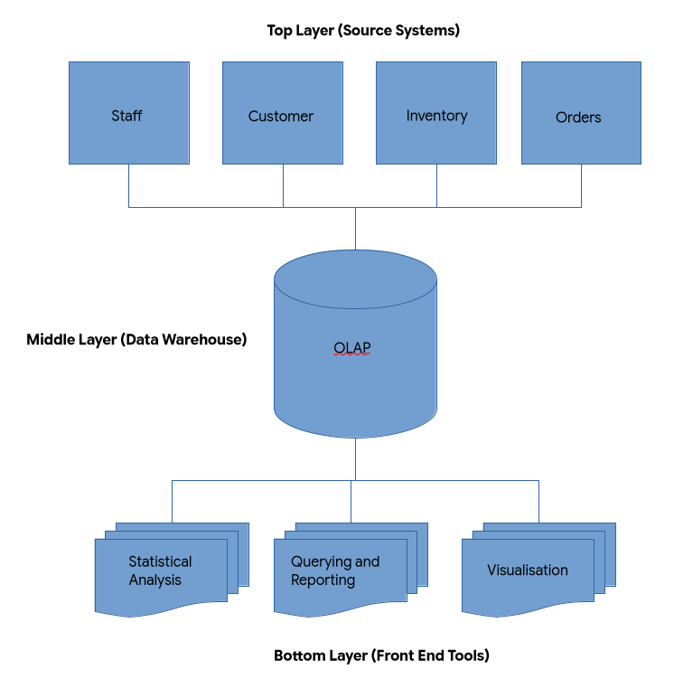
Figure 1 - Data Warehouse Architecture.
Most data warehouses are designed with a three-layer architecture, where in the bottom layer, unstructured data from source systems are received and processed into a database in a structured format using the ETL process, which is a common practice is data storage which stands for extract, transform and load, where extract describes raw data being collected from source systems and being placed in a staging area where the collected data can be closely examined before it progresses into the further stages. Transform is about applying various preprocessing techniques on the collected data to remove excess data and to ensure the data conforms to the requirements of the data warehouse. Load refers to inserting the processed data into the data warehouse. Data warehouses can be configured to execute ETL processes at regular intervals to ensure it has the most recent information and to reduce manual work [6][7][8].
The source systems in which a data warehouse gets its data from can be categorised into two groups which are internal and external. Internal sources refer to data systems that a company manages direct as part of their business operations, an external source refers to data systems that are managed by an entity outside the company.[9]
In the middle layer, the collected and processed data remains in this layer for use by various users along with its metadata and organises the data in a way makes it quicker and easier for users to access data, the middle layer also includes the use of an OLAP system to analyse the structured data making a collection of visualisations for interpretation. The top layer represents the front end in which users of the data warehouse interact with to access data. The tools used in the top layer vary depending on the task, these include querying and reporting, statistical analysis etc [6][7][8].

1.3 Data Marts
Data marts are a smaller data storage system in a data warehouse which collects specific types of data from the operational databases which are tailored for use in certain departments, data marts can significantly reduce the scale and complexity of a data warehouse and make it easier for users of different departments to access necessary data. Data marts are also optimised for query performance allowing users to quickly access data for their requirements. They also improve data governance as a sufficient data mart would prevent access to specific data by unauthorised staff [10][11][12].
Data marts are categorised into three types which are Dependant, independent and hybrid. A dependant data mart gathers its data from a central data warehouse, an advantage of using a dependant data mart is that it offers better control over information access, however, in the event that the data warehouse it sources its data from fails, the data mart will also fail. An independent data mart gathers collects its data directly from a company’s source systems, the main advantage of using an independent data mart is that it is quicker to setup, however, communication problems can occur in the case that multiple departments need to share data with each other, unless rigorous procedures are set. A hybrid data mart implements the features of a dependant and independent data mart simultaneously [10][11][12].
Some examples of how a data mart can be used within Rags n Riches include sourcing sales data from kiosks, online orders, invoices etc. into a data mart that can be accessed easily by the company’s finance director. For the managing director a data mart consisting of sales data and company acquisitions will allow them to quickly monitor the performance of Rags n Riches, a data mart for the advertising director would consist of shop details, customer details, product details and acquisitions should allow them and their team to evaluate and lead advertisement strategies.

1.4 Normalisation in OLTP vs Dimensions in a Data Warehouse
The data in an OLTP database is presented in a normalised structure, Normalisation in a database can be described as a process in which database tables are designed according to a set of rules to reduce inconsistencies in the data, normalisation in this case has 4 levels which are known as normal forms with each normal form building upon each other and having a more complex set of rules, OLTP databases typically implement third normal (3NF) [13].
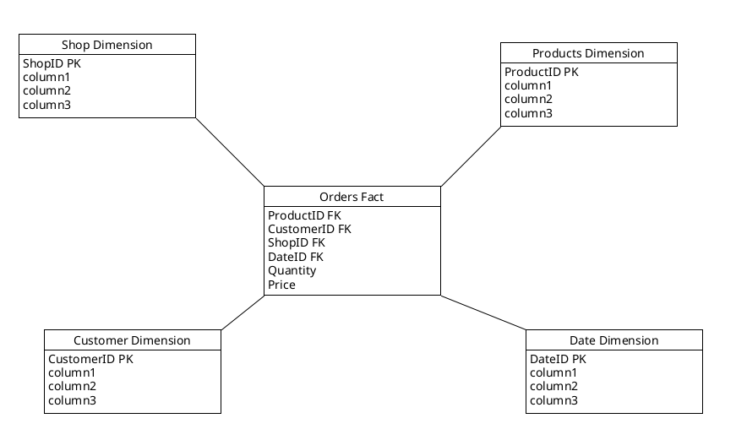
Figure 2 - Example Star Schema.
Data in a data warehouse are presented in a dimensional structure using popular schemas such as a star schema or snowflake schema. These schemas include dimension tables, fact tables and data marts. Dimensions are a type of table responsible for holding a subset of data, which are indexed by a primary key. While facts are another type of table which is responsible for providing the context behind the data within a business and summarising it by aggregating the data from each dimension into a single table, facts are usually made up of foreign keys from other dimensions. Data marts as previously mentioned store certain types of information for easier access, data marts are derived from fact tables and the dimensions that they retrieve their data from [14][15][8][16].

2. Designing Data Warehouse Schema
Source Type | Systems
Internal | - Point of Sales  - Inventory systems  - Customer Relationship Management (CRM)  - Discounts/Offers  - Warehouses
External | - Regional population data  - Inflation rates
Table 1 - Defining Internal and External Source Systems.

2.1 Star Schema
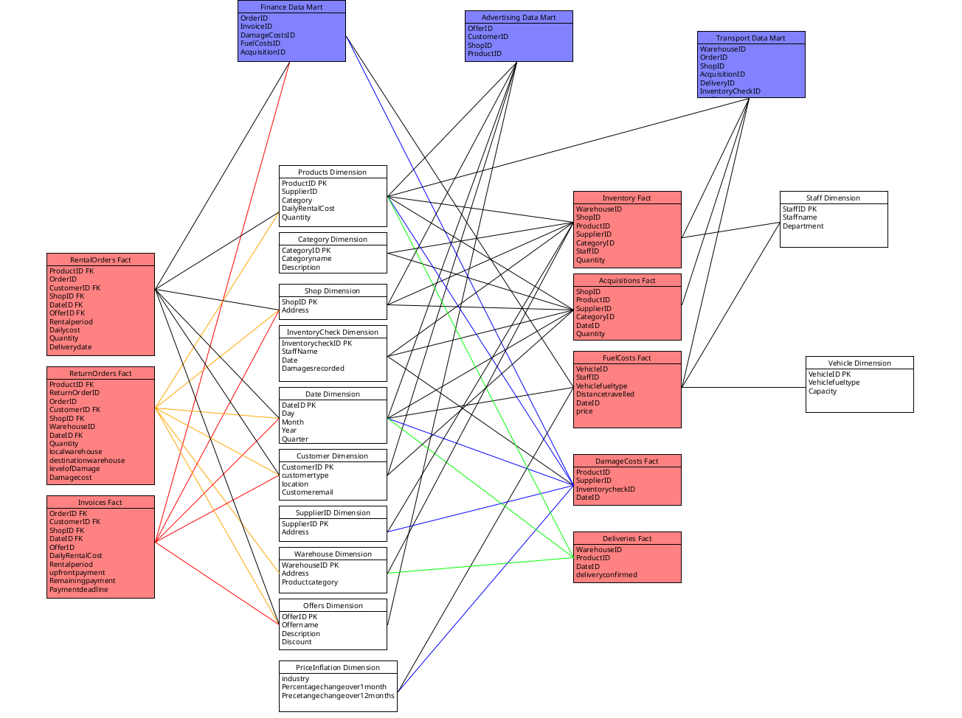
Figure 3 - Proposed Data Warehouse Star Schema.
Figure 2 shows the entire proposed data warehouse schema. An in-depth explanation of the dimension and fact tables will be provided in the next sections
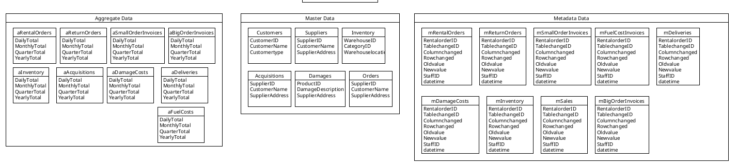
Figure 4 - Aggregate Data, Master Data and Metadata for Star Schema.

2.1.1 Dimension Tables
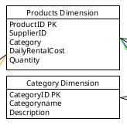
Figure 5 - Products and Category Dimension.
The screenshot above show the products, categories and delivery check dimension. The products dimension table is responsible for keeping records of the products offered by Rags n Riches, the dimensions records attributes such as the manufacturer of the product, the category of the product, the price and the quantity in available. The categories dimension holds all the information regarding the main specialisations which the products are categorised into, including a description of it.
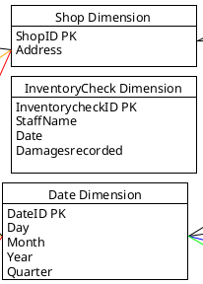
Figure 6 - Shop, InventoryCheck and Date Dimensions.
The shop dimension is a smaller table and only records the unique identifier of the shop and its location. The inventory check dimension is where all the results from the regular inventory checks at Rags n Riches are stored, in this dimension the staff name who did the check is recorded which is part of the pre-existing procedures, the date that the check was done and a description of the damages recorded. Lastly, the date dimension provides the various time measurements that data is frequently recorded in at Rags n Riches.
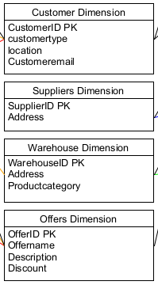
Figure 7 - Customer, Suppliers, Warehouse and Offers Dimensions.
The customer dimension table keeps track of the collection of customers associated with Rags n Riches, the customer type is recorded in this dimension and is used to determine if a customer is an individual or another company, the location of the customer is also recorded. Similarly to the customers dimension, the supplier dimension also records the various suppliers associated with Rags n Riches, the location of the supplier is also recorded and the product categories they specialise in. the warehouse dimension tracks all of the warehouse Rags n Riches manage, within it they record the location and the category of products that they store since Rags n Riches use certain warehouse for specific types of products. Finally, the offers dimension contains all of the discounts, schemes and offers that Rags n Riches have.

2.1.2 Facts
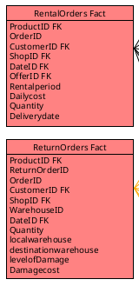
Figure 8 - Rental and Return Order Facts.
Since the delivery of the ordered item and the return of that item to the warehouse are recorded as separate orders, the creation of two fact tables representing the delivery and return was done. The rental orders fact table utilises the products, customer, shop, date and offer dimensions. The return orders fact table utilises the similar dimensions with the exception of the offers dimension and the addition of the warehouse and inventory check dimensions.

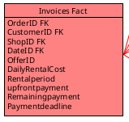
Figure 9 - Invoices Fact.
Fact tables for the invoices have also been made, both fact tables use the customers, shops, offers and date dimensions. The table accounts for the different procedures taken for orders below or over £10,000 using the upfront and remaining payment attributes.

2.2 Data Marts
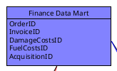
Figure 10 - Finance Data Mart.
This is the data mart for the finance department of Rags n Riches, the finance data mart uses the orders, invoices, damage costs, fuel costs and acquisitions fact tables. Access to those facts will allow the finance team to create sufficient reports for senior management.
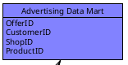
Figure 11 - Advertising Data Mart.
The data mart for the advertising team utilises the offers, customers, shops and products dimensions. This would allow them to advertise their available offers to customers at certain shops or products
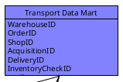
Figure 12 - Transport Team Data Mart.
The transport department’s data mart gives them access to the staff, products and warehouse dimensions alongside the fuel costs, deliveries, acquisitions and inventory facts. This is so that they can process customer or company orders and manage inventory accordingly.

2.3 ETL Plan
RentalOrders Fact
Attribute | Source | Transformations
ProductID | db.Products | None
CustomerID | db.Customers | None
ShopID | db.shops | None
DateID | db.Date | Link to Date dimension table
OfferID | db.Offers | None
Rentalperiod | db.Date | End date – start date
DailyCost | db.Products | None
Quantity | None | None
Deliverydate | db.Date | Generated
Table 2 - RentalOrders ETL Plan.
ReturnOrders Fact
Attribute | Source | Processes
ProductID | db.Products | None
CustomerID | db.Customers | None
ShopID | db.shops | None
DateID | db.Date | Link to Date dimension table
Quantity | db.Orders | None
localWarehouseID | db.Warehouse | None
DestinationwarehouseID | db.warehouse | None
Levelofdamage | None | Manually recorded
Damagecost | None | None
Table 3 - ReturnOrders ETL Plan.
Invoices Fact
Attribute | Source | Processes
OrderID | db.Orders | None
CustomerID | db.Customers | None
ShopID | db.shops | None
DateID | db.Date | Link to Date dimension table
OfferID | db.Offers | None
DailyRentalCost | db.Products | None
Rentalperiod | db.Date | End date – start date
Upfrontpayment | db.Orders, db.products | (Products.dailycost * orders.rentalperiod) / 2
Remainingpayment | db.Orders | (Products.dailycost * orders.rentalperiod) - upfrontpayment
Paymentdeadline | db.Date, db.Orders | Orders.enddate + 7 days
Table 4 - Invoices ETL Plan.
Inventory Fact
Attribute | Source | Processes
WarehouseID | db.Warehouse | None
ShopID | db.Shops | None
ProductID | db.Products | None
SupplierID | db.Supppliers | None
CategoryID | db.Category | None
StaffID | db.Staff | None
Quantity | None
Table 5 - Inventory ETL Plan.
Acquisitions Fact
Attribute | Source | Processes
ShopID | db.Shops | None
ProductID | db.Products | None
SupplierID | db.Suppliers | None
CategoryID | db.Category | None
DateID | db.Date | Link to Date dimension table
Quantity | None
Table 6 - Acquisitions ETL Plan.
FuelCosts Fact
Attribute | Source | Processes
VehicleID | db.traveldistance | None
Vehiclefueltype | db.traveldistance | None
DateID | db.Date | None
Price | None | None
Table 7 - FuelCosts ETL Plan.
DamageCosts Facts
Attribute | Source | Processes
ProductID | db.Products | None
SupplierID | db.Suppliers | None
Inventorycheck | db.inventorycheck | None
DateID | db.Date | None
Table 8 - DamageCosts ETL Plan.
Deliveries Fact
Attribute | Source | Processes
WarehouseID | db.Warehouse | None
ProductID | db.Products | None
DateID | db.Date | None
StaffID | db.Staff | None
Deliveryconfirmed | None | Manual check
Table 9 - Deliveries ETL Plan.

2.4 Data Governance Issues
One of the issues that could arise when using the data warehouse is consistency in data collection, having inconsistent methods in data collection across the different databases can lead to a breakdown in communication, which could result in a loss of productivity.

References
[1] J. Z. A. Chung, M. M. L. Chang and S. K. Phang, "Recent Advances and Benchmarking of NewSQL for OLTP and OLAP in the Big Data Age," 2023 IEEE 13th Symposium on Computer Applications &Amp; Industrial Electronics (ISCAIE), pp. 168, 2023. . DOI: 10.1109/iscaie57739.2023.10164996.
[2] Oracle. (Aug 1). What Is OLTP?. Available: https://www.oracle.com/database/what-is-oltp/.
[3] MongoDB. What is ACID Compliance?. Available: https://www.mongodb.com/resources/products/capabilities/acid-compliance.
[4] Oracle. (Jun 8). What Is a Data Warehouse?. Available: https://www.oracle.com/database/what-is-a-data-warehouse/.
[5] Amazon Web Services (AWS). What is a Data Warehouse?. Available: https://aws.amazon.com/what-is/data-warehouse/.
[6] J. Holdsworth, M. Kosinski and A. Jonker. What is a data warehouse?. Available: https://www.ibm.com/think/topics/data-warehouse.
[7] B. Khan et al, "An Overview of ETL Techniques, Tools, Processes and Evaluations in Data Warehousing," JBD, vol. 6, (1), pp. 1, 2024. . DOI: 10.32604/jbd.2023.046223.
[8] P. Bhatia, Data Mining and Data Warehousing : Principles and Practical Techniques. 2019Available: http://ebookcentral.proquest.com/lib/trinity/detail.action?docID=5879469.
[9] A. Rahman and Ermatita, "Data Warehouse Design for Soil Nutrients with IoT Based Data Sources," pp. 182, .
[10] Snowflake. Data Mart Guide: Types, Benefits & How It Works. Available: https://www.snowflake.com/en/fundamentals/what-is-a-data-mart/.
[11] IBM. What is a data mart?. Available: https://www.ibm.com/think/topics/data-mart.
[12] Amazon Web Services. What is a Data Mart?. Available: https://aws.amazon.com/what-is/data-mart/.
[13] M. Fotache et al, "The effects of database normalization on decision support system performance," Information Systems, vol. 136, pp. 2, 2026. . DOI: 10.1016/j.is.2025.102636.
[14] Kimball Group. Fact Table Structure. Available: https://www.kimballgroup.com/data-warehouse-business-intelligence-resources/kimball-techniques/dimensional-modeling-techniques/fact-table-structure/.
[15] Kimball Group. Dimension Table Structure. Available: https://www.kimballgroup.com/data-warehouse-business-intelligence-resources/kimball-techniques/dimensional-modeling-techniques/dimension-table-structure/.
[16] I. Bojičić et al, "A Comparative Analysis of Data Warehouse Data Models," pp. 153–154, .

