

A COMPARISON OF THE MARKETING METHODS OF TWO MULTINATIONAL HOTEL BRANDS
Student name Ionela: Madalina Cananau
student ID number: 2243593
Module title: Marketing Essentials BMIH4005
Module Lead: Scott James
Word Count:1573

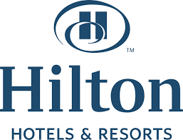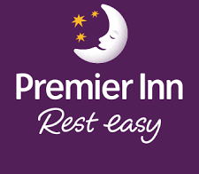

Table of content

1. Introduction 3
1.1 General statement 3
1.2 Thesis statement 3
1.3 Ourtlining the main points 3
2. Main body 3
2.1 Situational analysis 3
2.2 Marketing mix 6
2.3 Segmentation, targeting and positioning 8
3. Conclusion 9
3.1 Restating thesis 9
3.2 Summary of main points 9
3.3 Final comment 10
References 11
Appendixes 14
Appendix 1: Website of Premier Inn 14
Appendix 2: Website of Hilton Hotel 15

1. Introduction

1.1 General statement
Marketing methods and strategies are the integrated promotional efforts that helps in allocating resources across the spectrum of a wide range of channels, platforms to increase the sales activity. It is one of the highly competitive aspect for the organisation and amplifies the mode of communication to the target customer profile. The marketing methods island strategies helps in reaching out to the customer and make them aware about the diversified product of the organisation. The illustrated discussion focuses on the comparison of the marketing methods and strategies of two premiere Hotel brands namely Hilton Hotel and Premier Inn. Hilton Hotel is a global brand of hotel service and resorts that has its present across different parts of the globe (Hilton, 2022). It is present across 94 countries and it is one of the largest hotel brands across the globe. Premier Inn on the other hand is a British hotel chain and is one of the UK is largest hotel brands (Premier Inn, 2023). It is present across variety of locations and has been existence since 1987.

1.2 Thesis statement
Premier Inn and Hilton hotels are successful luxury hotel chains with different marketing and targeting strategies. These differences propel the innovative business lines in their own manner.

1.3 Ourtlining the main points
The comparison between the two brands will be focused by incorporating relevant frameworks of situation analysis, marketing mix and segmentation, targeting and positioning aspects of the brands.

2. Main body

2.1 Situational analysis
The situation analysis between Premier Inn and Hilton Hotel is illustrated as follows.
SWOT analysis
Name of hotels | Strengths  (Internal factors) | Weaknesses  (Internal factors) | Opportunities  (External factors) | Threats  (External factors)
Premier Inn | - 800 hotels across UK (Premier Inn, 2023b)  - High service standards  - 77000 rooms for customer service (Premier Inn, 2023b)  - Access to safe and tasty foods | - £1bn loss amidst pandemic situation (Kollewe, 2021)  - Losses reesulting in cut of almost 6000 jobs (Nadkar, 2020)  - £725m loss in the inoitial phase of pandemic (Kollewe, 2020) | - Expansion across other lucrative markets nationally  - Internal expansion  - Wider enforcement into sustainable model for customer inclusion | - Pressure of market competition  - After impacts of the pandemic  - BREXIT impact
Hilton Hotels | - 19 Hotel brands (Hilton, 2023)  - Globally present across 7000 locations (Hilton, 2023)  - Premium service for different range of tourist | - Pandemic Impacting The Profit Margins (Reuters, 2021)  - Long recovery phase after the pandemic situation (Hancock , 2020) | - Expansion across the national markets  - More internal expansion  - Wider marketing and publicity | - Market competition  - Demand fluctuations  - BREXIT situations
Table 1: SWOT analysis of Hotels
(Source: Self-developed)
PESTLE analysis
Hotels | Political | Economical | Social | Technological | Legal | Environmental
Premier Inn | Strong government presence (Government of UK, 2023)  Presence of Corruptions (Transparency.org.uk, 2023)  Threat | 0.2% GDP escalation (Government of UK, 2023a)  4.6% inflation in UK (Clark, 2023)  Opportunity | Strong preference of customer towards hotel service  Opportunity | Growth in the technology sector (Institutmontaigne.org, 2023)  Opportunity | Stronger presence of consumer laws (Government of UK, 2023a)  Threat | Wider sustainability preference  Threat
Hilton Hotels | Supportive trade policies (Government of UK, 2023c)  Opportunity | 0.2 % GDP growth impacting business (Government of UK, 2023a)  BREXIT situation affecting business (David, 2023)  Threat | Supportive customer section towards brand portfolio  Opportunity | Technology leverage supporting businesses Institutmontaigne.org, 2023)  Opportunity | Wider enforcement of consumer laws Government of UK, 2023a)  Threat | NGO pressures  Wider sustainability influence  Opportunity
Table 2: PESTLE analysis of Hotels
(Source: Self-developed)
Analysis:
Both SWOT and PESTLE analyses reveal a critical understanding of the internal structure of the business. Both brands have challenges pertaining to pandemic issues, international competition, market fluctuations, Brexit impact and so on. The challenge also can emerge from economic disturbance, inflationary pressures, stronger legal enforcement and so on. These are the areas where both the companies have same threats. However, the opportunities are also high for both brands likewise Premier Inn can target expansion into other markets, the inclusion of a sustainability model can be profitable whereas more publicity can be useful for Hilton Hotels.

2.2 Marketing mix
Premier Inn provides great value and is filled with dedicated team members who love to serve the customer segment. Free Wi-Fi, tasty food, and effective service is the key aspect of the brand. On the contrary, Hilton Hotels is also a Global brand of hospitality. It was founded with the sole purpose of serving customers that uplift its brand presence and its presence across 94 countries and is one of the top most preferred Hotel chains. The marketing mix of each brand is described as follows.
Factors of the marketing mix | Premier Inn | Hilton Hotel
Product | Hotel service | Hotel service
Price | Costly room rate with an escalation of £97 to £112 per night (Kollewe, 2023) | Luxury hotel chains with a high price (Hilton, 2023a)
Place | Mainly in the UK and across other places | Global presence (Hilton, 2023a)
Promotion | Website, social media | Social media, customer referrals
People | Customers-oriented service, employees subjected to training | Stakeholders focus, customers
Physical evidence | Official logo, branding | Branding, logo,
Process | Customer focus, technology infusions | Customer focus, technology infusions, service modifications
Table 3: 7Ps of marketing mix of Hotels
(Source: Self-developed)
Analysis:
The table depicts the 7Ps of the marketing mix for each of the brands. Both hotel chains operate in the hotel service and are costly Hotel chains. Premier Inn mainly operates in the UK and across other places but Hilton Hotel leads the global presence. Premier Inn focuses on website modification and social media as a promotional tool. On the contrary, social media, and customer referrals are the main unique promotional strategies of Hilton Hotels. Both branch focuses on customer orientation, stakeholder focus and so on. Official logo and branding strategies are similar physical evidence for both brands. However Premier Inn focuses on technology infusions, and customer focus as the process whereas technology, customer focus, and service modifications are the process focus of Hilton Hotels. The differences between approaching the market based on the marketing mix for the two brands means that both the brands focus on different modes of influencing the stakeholders and the customers. It can be assumed that constant service line modification is largely focused on by Hilton Hotels.

2.3 Segmentation, targeting and positioning
STP analysis | Premier Inn | Hilton Hotel
Segmentation | Demographic segmentation  Customers and travellers with friends and family (Premier Inn, 2020)  Customers in the age range of 18- 60 years  Behavioural segmentation  Loyal customers  Customers preferring premium services | Geographic segmentation  Hotel chains across multiple locations based on the national preferences of customers  Demographic segmentation  High level of income-earning customer
Targeting | Websites support for customer service (Refer To Appendix 1) | Social media strategies, superior branding, and amplified online presence through website support (Refer To Appendix 2)
Positioning | Wider spectrum of services such as good food, free parking, wifi and so on. Value for money and employee focus are also sound positioning methods (Refer To Appendix 1) | The use of advanced technologies, key partnerships for service differentiations, and global-scale operations are the positioning tools integrated (Hilton, 2023a)
Table 4: STP analysis of Hotels
(Source: Self-developed)
Analysis:
The STP analysis focuses on the respective differences between the brands. The Premier Inn targets customers, travellers with friends and families and those in the age range of 18 to 60 years. Whereas Hilton Hotel targets national customers and modifies services based on the national preference and high-income level customers. The targeting strategies are also divided on the use of website support for customer service, in Premier Inn. Whereas, Hilton Hotel uses social media strategies, branding, and verified online presence for customer support. Both brands use different positioning tools that are also differentiated from other brands such as Marriott, Airbnb and so on. Likewise, the focus on good food, Wi-Fi and additional services are focused on by Premier Inn. On the contrary, key partnerships, advanced technology infusions, and global-scale operations are the main differentiations. that position the brand among other market competitors. The findings can be linked back to the marketing mix and situation analysis in terms of the promotional methods, the process, technological supporting factors and so on.

3. Conclusion

3.1 Restating thesis
Premier Inn and Hilton hotels are luxury hotel chains operating across different parts of the globe that use different marketing, targeting, and positioning strategies in terms of service modifications, technology inclusions and so on. These unique strategies support the business proliferation of the brands.

3.2 Summary of main points
The finding states that both brands have unique strengths however weaknesses and threats due to the pandemic impact, The BREXIT situation can hamper the business in the longer perspective. Through the PESTLE analysis, it can be established that most of the factors are extremely supportive and can provide opportunities. However, the economic factor can create a huge threat for the business. Both brands are differentiated in the marketing mix in terms of the place of operations, promotional strategies and so on. Likewise, the Premier Inn focuses on demographic segmentation, and behaviour segmentation, whereas Hilton Hotel focuses on geograpgic and demographic segmentation. These companies also differ based on targeting approach and positioning tools. These companies can be recommended to improve their pricing mechanism and online presence for more effective inflows of customers.

3.3 Final comment
In the future the study can be used for analysing the mode of influence of the customers by these brands and how the brands can recalibrate their marketing mechanism for driving profit margins.

References
Clark, D. (2023). UK inflation rate 2022. [online] Statista. Available at: https://www.statista.com/statistics/306648/inflation-rate-consumer-price-index-cpi-united-kingdom-uk/#:~:text=The%20UK%20inflation%20rate%20was [Accessed 2023].
David, D. (2023). What impact has Brexit had on the UK economy? BBC News. [online] 31 Jan. Available at: https://www.bbc.com/news/business-64450882 [Accessed 2023].
Government of UK (2023a). Consumer Protection. [online] Available at: https://assets.publishing.service.gov.uk/media/5b17ee2ae5274a18fc321c02/9.pdf [Accessed 2023].
Government of UK (2023b). Gross Domestic Product (GDP) - Office for National Statistics. [online] Ons.gov.uk. Available at: https://www.ons.gov.uk/economy/grossdomesticproductgdp [Accessed 2023].
Government of UK (2023c). Preparing for our future UK trade policy. [online] Available at: https://assets.publishing.service.gov.uk/media/5e9ff7aee90e07048c84e79f/Preparing_for_our_future_UK_trade_policy_Report_Web_Accessible.pdf [Accessed 18 Nov. 2023].
Government of UK (2023d). The UK Government’s Approach to Stabilisation. [online] Available at: https://assets.publishing.service.gov.uk/media/5c7ff0ebe5274a39d4e4736d/Chapter_1_The_UK_Government_s_Approach_to_Stabilisation__incl._exec_sum_.pdf [Accessed 2023].
Hancock , A. (2020). Subscribe to read | Financial Times. [online] www.ft.com. Available at: https://www.ft.com/content/6bf546e6-014f-4520-8691-4a3b26e295ea [Accessed 2023].
Hilton (2022). Hotels by Hilton - Book the Best Rates Across All Brands. [online] Hilton. Available at: https://www.hilton.com/en/ [Accessed 2023].
Hilton (2023a). Hilton Corporate Site. [online] www.hilton.com. Available at: https://www.hilton.com/en/corporate/development/hilton-performance-advantage/#:~:text=Through%20advanced%20technologies%2C%20global%20scale [Accessed 2023].
Hilton (2023b). Hotel Locations. [online] Hilton. Available at: https://www.hilton.com/en/locations/ [Accessed 2023].
Hilton (2023c). Luxury Hotel Locations - Find Hotels. [online] Hilton. Available at: https://www.hilton.com/en/locations/luxury/ [Accessed 18 Nov. 2023].
Hilton (2023d). Our Hotel Brands - Learn More About our Brands. [online] Hilton. Available at: https://www.hilton.com/en/brands/ [Accessed 2023].
Institutmontaigne.org (2023). What’s Driving Britain’s Tech Growth. [online] Institut Montaigne. Available at: https://www.institutmontaigne.org/en/expressions/whats-driving-britains-tech-growth#:~:text=The%20British%20tech%20sector%20has [Accessed 2023].
Kollewe, J. (2020). Premier Inn owner hit by £725m loss as local lockdowns dent bookings. The Guardian. [online] 27 Oct. Available at: https://www.theguardian.com/business/2020/oct/27/premier-inn-owner-whitbread-loss-local-lockdowns-bookings-profits-covid-hotel-closures [Accessed 2023].
Kollewe, J. (2021). Premier Inn owner Whitbread swings to £1bn loss amid Covid lockdowns. [online] the Guardian. Available at: https://www.theguardian.com/business/2021/apr/27/premier-inn-whitbread-loss-covid-lockdowns-beefeater-brewers-fayre [Accessed 2023].
Kollewe, J. (2023). Premier Inn room rates soar as budget hotel era ‘evaporates’. The Guardian. [online] 22 Jun. Available at: https://www.theguardian.com/business/2023/jun/22/premier-inn-profits-buoyed-by-king-charles-coronation [Accessed 2023].
Nadkar, T. (2020). Premier Inn owner to cut 6,000 jobs due to pandemic hit. Reuters. [online] 22 Sep. Available at: https://www.reuters.com/article/whitbread-layoffs/update-2-premier-inn-owner-to-cut-6000-jobs-due-to-pandemic-hit-idINL3N2GJ114/ [Accessed 18 Nov. 2023].
Premier Inn (2020). Kid-friendly. [online] Available at: https://www.premierinn.com/gb/en/why/family.html [Accessed 2023].
Premier Inn (2023a). Premier Inn Home. [online] Premier Inn. Available at: https://www.premierinn.com/gb/en/home.html [Accessed 2023].
Premier Inn (2023b). Why We’re Premier. [online] www.premierinn.com. Available at: https://www.premierinn.com/gb/en/why.html [Accessed 2023].
Reuters (2021). Hilton earnings disappoint as pandemic pains linger, shares fall. Reuters. [online] 5 May. Available at: https://www.reuters.com/business/hilton-posts-quarterly-loss-pandemic-hit-2021-05-05/#:~:text=While%20Hilton%20cut%20expenses%20by [Accessed 2023].
Transparency.org.uk (2023). Corruption and the UK | Transparency International UK. [online] www.transparency.org.uk. Available at: https://www.transparency.org.uk/corruption-and-uk [Accessed 2023].

Appendixes

Appendix 1: Website of Premier Inn
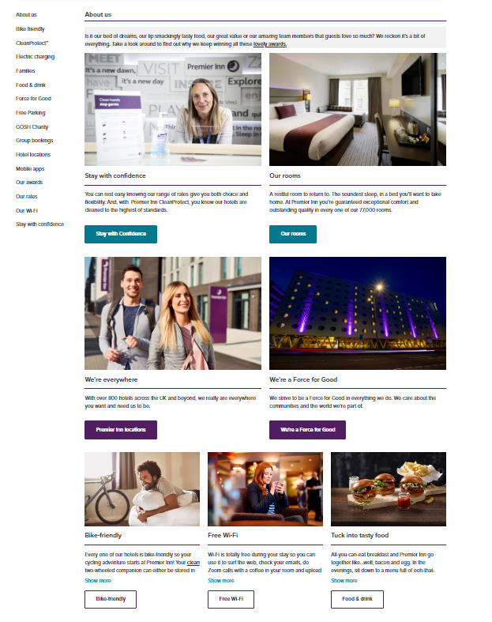
(Source: https://www.premierinn.com/gb/en/why.html)

Appendix 2: Website of Hilton Hotel
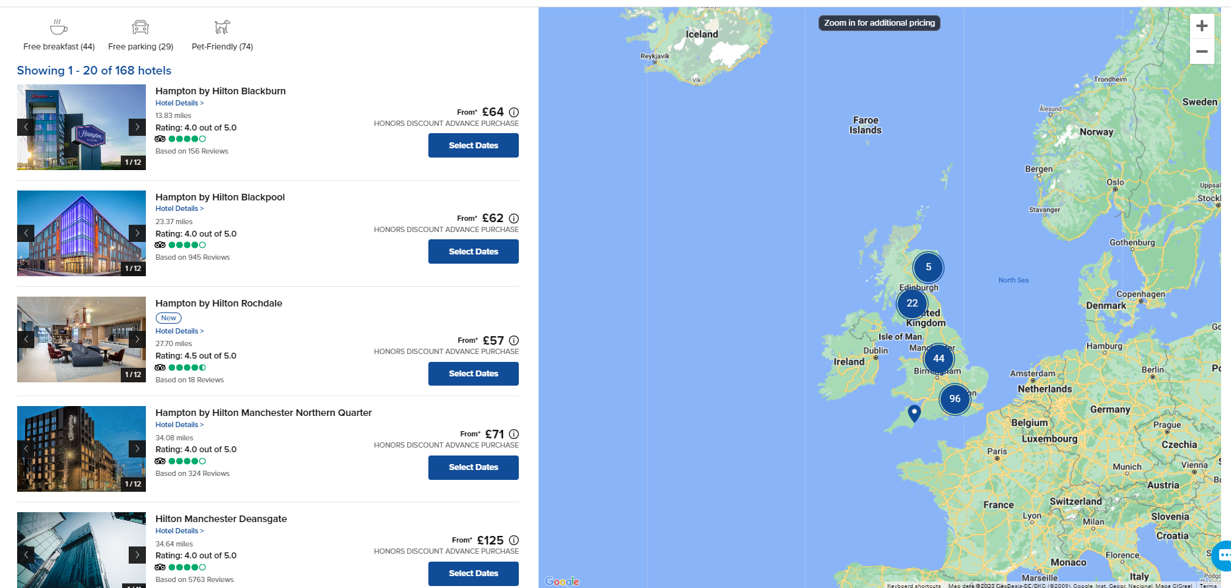
(Source: https://www.hilton.com/en/locations/united-kingdom/)

